***NAME: Aniket Biyani***

***DATA ENGINEERING- BATCH 1***

***DAY 6 ASSIGNMENT***

* **OVER AND PARTITION BY CLAUSE**

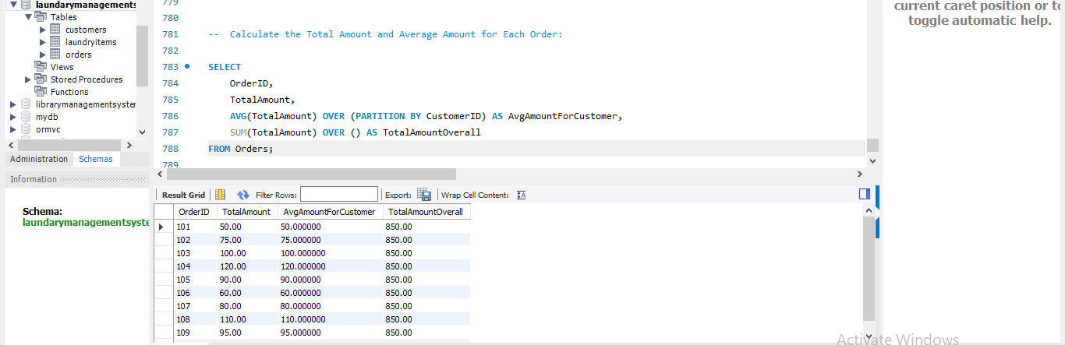

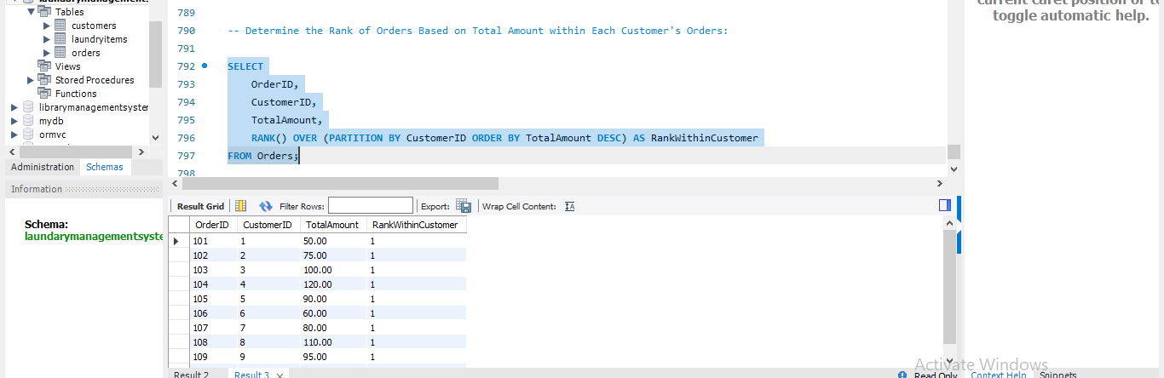

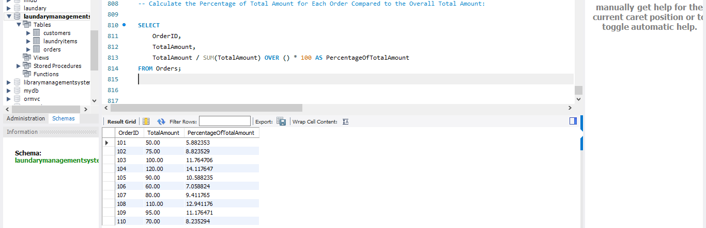

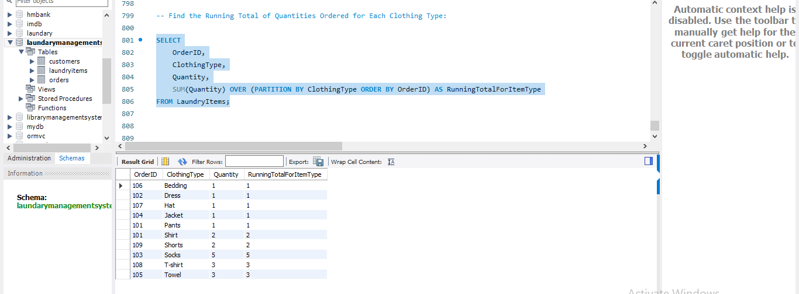

* **TOTAL AGGREGATION USING OVER AND PARITION BY**

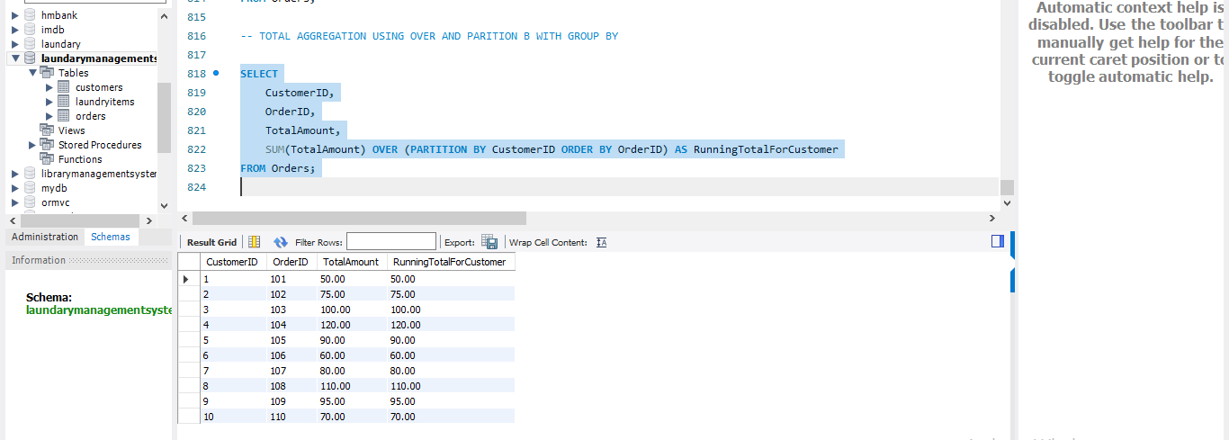

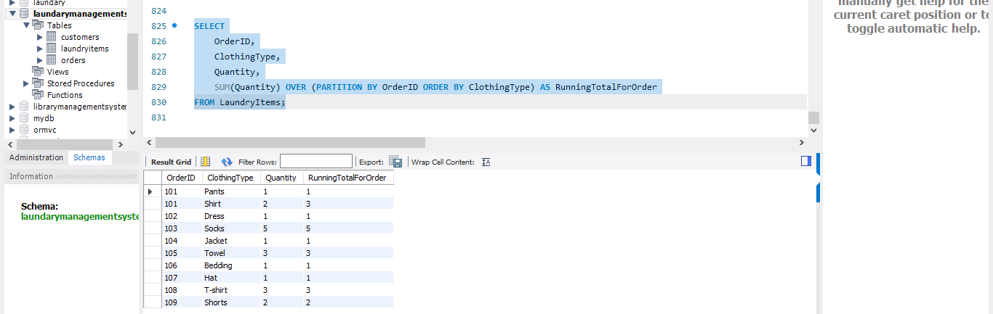

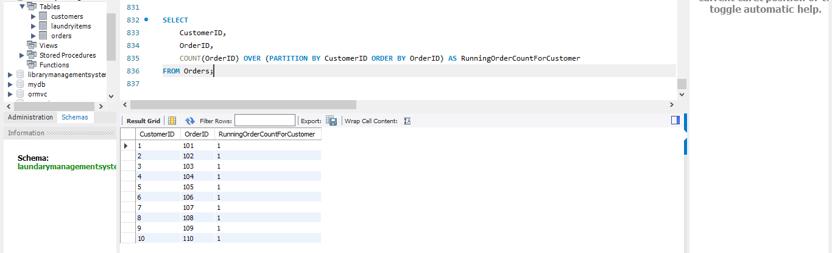

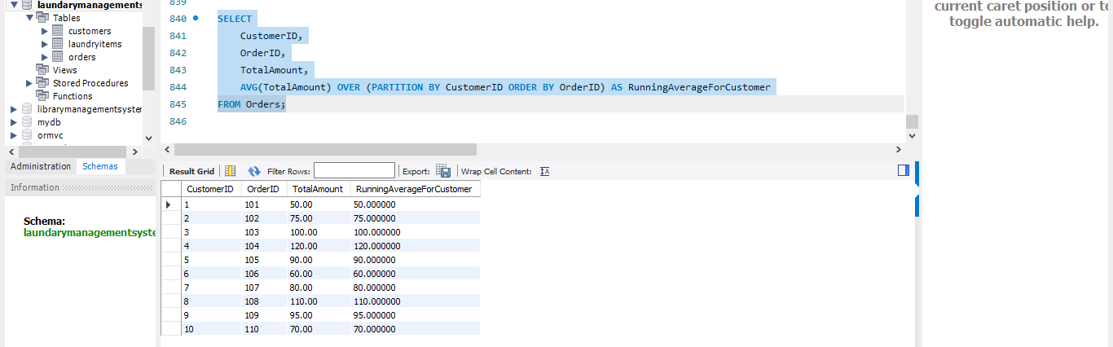

* Snowflake and Star schemas
* Snowflake and Star schemas are two common database design techniques used in data warehousing to organize and structure data for efficient querying and reporting.
* Both schemas involve structuring data in a way that facilitates easy analysis and retrieval, but they have different approaches.
* **Star Schema:**
* The Star Schema is a type of data warehouse schema where a central fact table is connected to multiple dimension tables through foreign key relationships.
* It resembles a star when diagrammed, with the fact table at the center and dimension tables surrounding it.
* Components:
* Fact Table:

Contains quantitative data (measures) such as sales, revenue, or quantity.Often has a surrogate key as its primary key. Foreign keys in the fact table link to the primary keys of dimension tables.

* Dimension Tables:

Contain descriptive attributes.Each dimension table typically corresponds to a specific aspect (e.g., time, product, location).Primary keys of dimension tables are used as foreign keys in the fact table.

* Advantages:
* Simplifies queries and makes them more straightforward.
* Provides fast query performance for aggregations and reporting.
* Easy to understand and use for business intelligence.
* **Snowflake Schema:**
* The Snowflake Schema is an extension of the Star Schema where dimension tables are normalized into multiple related tables, forming a snowflake-like structure.
* It is characterized by additional levels of hierarchy in the dimensions.
* Components:

Similar to the Star Schema, but dimension tables may have sub-dimensions or additional related tables.

Dimension tables are normalized, meaning they are broken down into multiple related tables to eliminate redundancy.

* Advantages:
* Reduces data redundancy and saves storage space.
* Easier to maintain and modify when dimensions change.
* Suitable when storage space is a critical concern.