# **Introduction**

## **Purpose**

The main objective of this document is to illustrate the requirements of the project of Visual-Based Translator for Android Operating System. The document gives the details description of both functional and non-functional requirements proposed by the clients. The purpose of this project is to provide a friendly environment to translate the text from images. It is the specific intent of this document to clarify any and all aspects of the Visual-Based Translator Application for the Android Operating System. This document also describes the hardware and software interface requirements using use-case diagram and class diagram.

## **Document Conventions**

Font used : Times New Roman

Font size : 12

This document follows IEEE Format. Normal text is in Times New Roman with font size 12. Bold-faced text has been used to emphasize section and subsection headings. Highlighting is to point out words in the glossary and italicized text is used to label and recognize diagram

## **Intended Audience and Reading Suggestions**

The intended audiences for this document are:

1. The people who are the clients.
2. The team members of the software development.
3. The mentor who is in charge of the software development team.

## **Product Scope**

This project is to allow the user to to extract text from images and perform in situ translation. This app can automatically recognize texts in simple plain images such as book, sign, and map and overlays the translated text on top of the original one, while preserving information such as location, color, font size, etc. This is often needed when a user tries to know the meaning of a segment of

text in another language. The image processing pipeline includes text detection, OCR, and translation overlay.

## **References**

* IEEE Standards Description : 830-1998

# **Overall Description**

## **Product Perspective**

The prevalence of mobile devices has given rise to a lot of images processing apps that benefit our lives. In this project, we try to build an app that helps translating words in images from one language to another. Currently, the most common way of translation on mobile device is typing the words into a dictionary or search engine to find the result. Typing is tiresome and some apps let users to take a picture on camera, select a region of interest, and then do OCR plus translation automatically, and finally output the translation results.

## **Product Functions**

The functions that are available to the users are mentioned below :-

* Login facilities
* Option of choosing camera or custom image
* Text Detection
* Optical Character Recognition
* Perform translation on extracted text
* Store the translations history

## **User Classes and Characteristics**

This app will be available as a freeware application. It will use a simple graphical user interface. Users are expected to have android mobile with latest version of android. It will only be available in English, so the user is expected to be an English speaker seeking to translate for non-English speakers.

## **Operating Environment**

The product will be operating in Android Mobile Operating System. Also it will be compatible with Older version of Android.

## **Design and Implementation Constraints**

This project runs best on latest version of android. Also it requires Google Vision API for optical character recognition and Yandex Translator for Text translation. There are some constraints to detection by Google Vision API. It doesn’t detect rotation so it doesn’t perform well when characters in an images is not upright.

## **User Documentation**

The product will include user manual. The user manual will include product overview, complete configuration of the software, technical details and contact information which will include an email address.

## **Assumptions and Dependencies**

The end user should have Mobile with Android Operating System. The user must give permission to Camera and Storage to the App.

# **External Interface Requirements**

## **User Interfaces**

* The design or layout will be clear and very interactive.
* In the login window the user can easily enter the username and password.
* Help support present in every window.
* The interface is user friendly.
* The interface provides option for both camera and custom image.

## **Hardware Interfaces**

No specific hardware is required for this software except for the Mobile with Android Operating System. The user enters the data using the keyboard in Mobile.

## **Software Interfaces**

This App requires Google Mobile Vision Library for text detection and recognition. For Database it uses Firebase.

## **Communications Interfaces**

It uses Networking for Firebase Authentication and to connect database. For connection protocol it uses HTTP protocol.

# **System Features**

## Register/ SignUp

4.1.1 Description and Priority :

This feature is of the highest priority, each of the users ie : the user with a email address and password or google account will allow to register and use the app..

4.1.2 Stimulus/Response Sequences :

First the user will be asked to register. If the user is already registered then it will automatically be logged in. The user can also register with google account.

4.1.3 Requirements

In the case of invalid credentials the user would not be granted access to the software.

REQ-1: Email Address

REQ-2: Password

## Login

4.1.1 Description and Priority :

This feature allow user to login. The registered user with a email address and password or google account will allow access to use the software.

4.1.2 Stimulus/Response Sequences :

First the user will be asked to login. If the user is already registered then it will automatically be logged in. The user can also login with google account.

4.1.3 Requirements

In the case of invalid credentials the user would not be granted access to the software.

REQ-1: Email Address

REQ-2: Password

## Scanning and Translation

4.1.1 Description and Priority

This feature allows the user to scan image for detection. The user will have options to choose how to scan.

4.1.2 Stimulus/Response Sequences

The user will have two options. First one is Camera. Camera Option allow user to detect and recognize text in image and translate text on the surface view only. The second option is to choose custom image for detection and translation.

# **Other Nonfunctional Requirements**

## **Performance Requirements**

The objective of this project is to allow the user to to extract text from images and perform in situ translation. This app can automatically recognize texts in simple plain images such as book, sign, and map and overlays the translated text on top of the original one, while preserving information such as location, color, font size, etc. The image processing pipeline includes text detection, OCR, and translation overlay. To do this, it is necessary for the viewer to be capable of real time image rendering, as the image must continually update to seamlessly detect, recognize and translate text..

## **Safety Requirements**

During use of the app, user experiencing eye strain should take a break to avoid further strain and/or possible damage. Otherwise there is no safety requirements.

## **Security Requirements**

The Visual Based Translator, running as an application on the Android device should need no additional information or permission other than camera and storage to capture image for detection and translation. Wireless security settings on the device must allow for the application to connect to the Firebase server so it can feed information to and from the server. Otherwise, access to the user’s personal information from other apps, i.e. calendar information, email, contacts, etc. is under no circumstance necessary and should be considered a breach of privacy in the event it occurs.

## **Software Quality Attributes**

The Visual Based Translator should be able to work on any Android device with a good camera. Installing the app should be a simple process, ideally identical to downloading and installing any application from the Android App Market. The software should run smoothly without crashing or freezing, regardless of any translations. It should have a very intuitive interface that is easy to learn. At the end of the project, all source code, documentation, as well as any other material related to the development of the app may be made freely available to other developers where it may be used as reference or for further development.

## **Business Rules**

* Not yet done as application is still in the requirement phase.

# **Other Requirements**

Currently there are no other known requirements for the project. However this may change in the event of unforeseen circumstances encountered during the duration of the project.

**Appendix A: Glossary**

* **Android** - An operating system designed for mobile devices (i.e. cell phones, tablet computers) by Google, Inc.
* **Android device** - Any device running Android. In this document, synonymous to “smart phone running Android.”
* **OCR** - Optical Character Recognition
* **SRS -** Software Requirement Analysis
* **GUI -** Graphical User Interface

**Appendix B: Analysis Models**

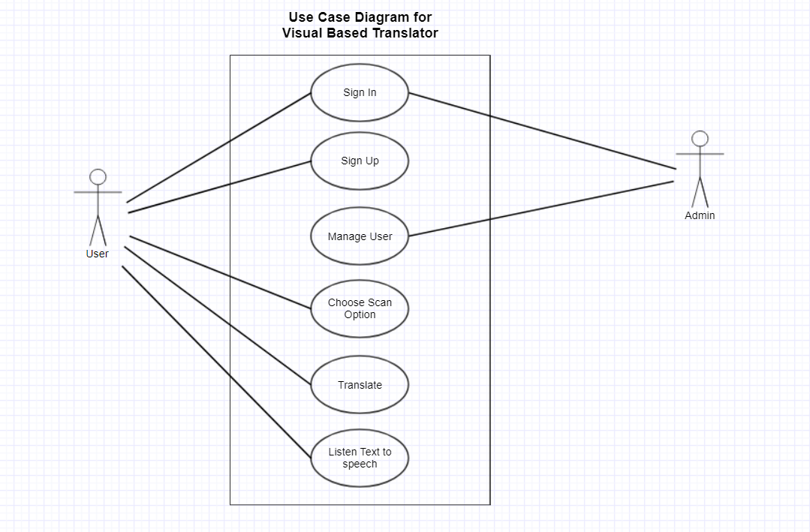

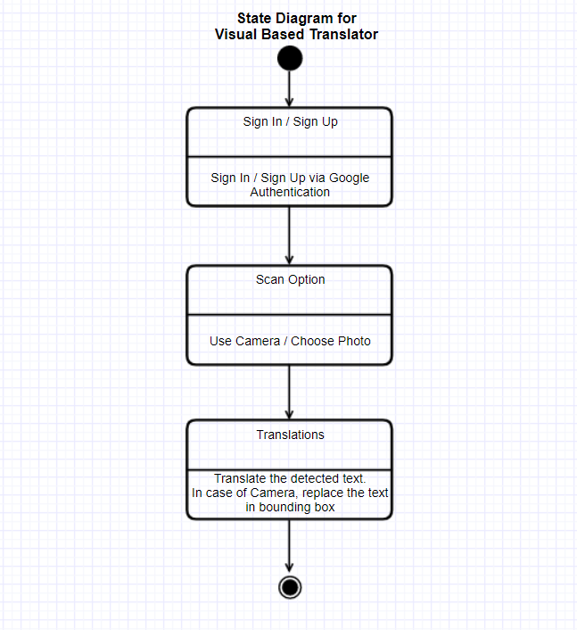

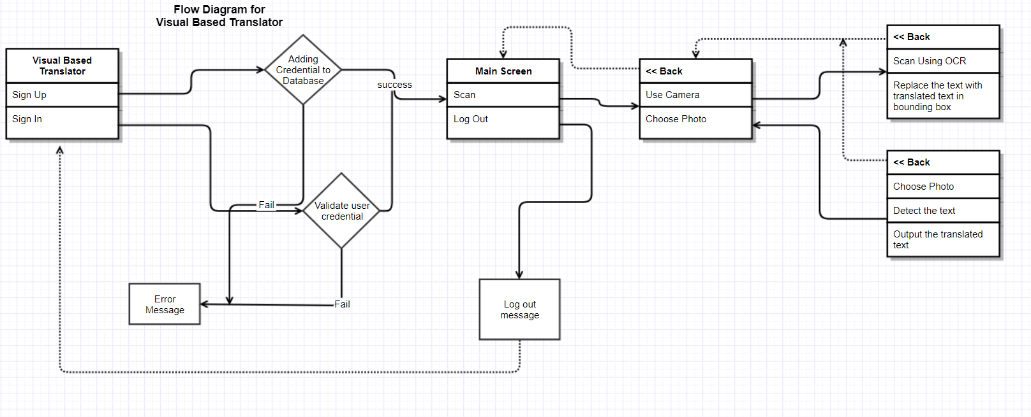

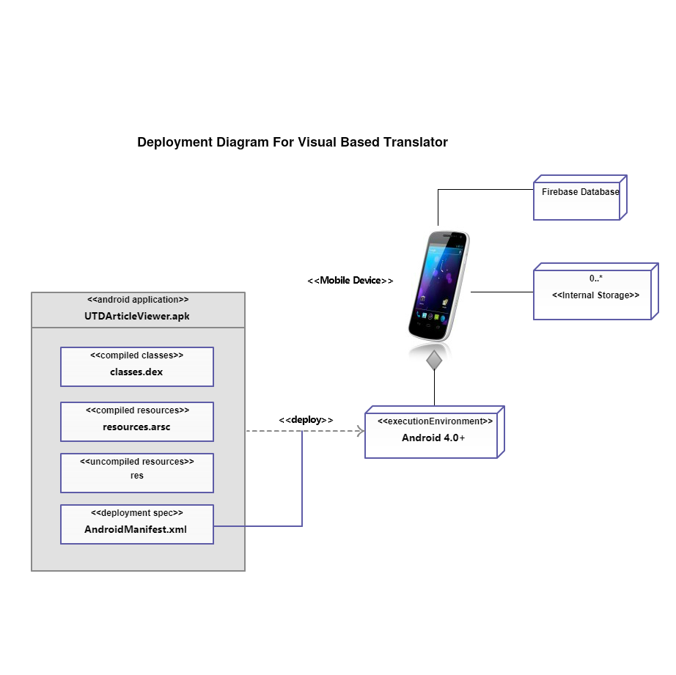

**Appendix C: To Be Determined List**

* Not yet done as application is still in the requirement phase.