A DISSERTATION ON
AERIAL IMAGE SEGMENTATION FOR LAND USE CLASSIFICATION
A Two-Tier Multimodal Vision AI Guardrail and Class-Balanced Self-Training Domain Adaptation Framework for Rugged Rural Terrain
Submitted in partial fulfillment of the requirements for the award of the degree of
BACHELOR OF TECHNOLOGY
IN
COMPUTER SCIENCE AND ENGINEERING
SUBMITTED BY:  ANIKET KUMAR  Enrollment No: BT23CS028  Department of CSE | UNDER THE GUIDANCE OF:  Dr. TANMAY KUMAR BEHERA  Assistant Professor  Department of CSE

DEPARTMENT OF COMPUTER SCIENCE AND ENGINEERING
NATIONAL INSTITUTE OF TECHNOLOGY MIZORAM
AIZAWL, MIZORAM – 796012, INDIA

NATIONAL INSTITUTE OF TECHNOLOGY MIZORAM
Department of Computer Science and Engineering
Aizawl, Mizoram – 796012, India
CERTIFICATE OF RECOMMENDATION
This is to certify that the dissertation entitled "Aerial Image Segmentation for Land Use Classification: A Two-Tier Multimodal Vision AI Guardrail and Class-Balanced Self-Training Domain Adaptation Framework for Rugged Rural Terrain", submitted by ANIKET KUMAR (Enrollment No. BT23CS028) in partial fulfillment of the requirements for the award of the degree of Bachelor of Technology in Computer Science and Engineering at the National Institute of Technology Mizoram, is an authentic record of bonafide research and technical work carried out under my supervision and guidance.
To the best of my knowledge, the matter embodied in this dissertation has not been submitted in part or full to any other University or Institute for the award of any degree, diploma, or academic distinction.
______________________________  Dr. Tanmay Kumar Behera  Supervisor / Assistant Professor  Department of CSE  NIT Mizoram | ______________________________  Head of the Department  Department of CSE  NIT Mizoram

______________________________
External Examiner
(Board of Examiners)

CANDIDATE'S DECLARATION
I hereby declare that the work presented in this final-year B.Tech capstone project report entitled "Aerial Image Segmentation for Land Use Classification" is an authentic record of my own investigation carried out under the supervision of Dr. Tanmay Kumar Behera, Assistant Professor, Department of Computer Science and Engineering, National Institute of Technology Mizoram.
I have adhered to all academic ethics and honesty standards. No portion of this technical report or code has been plagiarized, and all external literature, datasets, benchmarks, algorithms, and software libraries (including the LoveDA benchmark, DeepLabV3+ architecture, PyTorch, GDAL, and Google Gemini APIs) have been appropriately referenced and acknowledged.
Aniket Kumar
Enrollment No. BT23CS028
B.Tech (Final Year), CSE
NIT Mizoram, Aizawl
ACKNOWLEDGMENTS
I express my deepest gratitude to my project supervisor, Dr. Tanmay Kumar Behera, Assistant Professor, Department of Computer Science and Engineering, National Institute of Technology Mizoram, for his inspiring guidance, critical feedback, and constant encouragement throughout the conceptualization, mathematical formulation, and experimental execution of this research.
I extend my sincere thanks to the Head of the Department and all faculty members of the Department of Computer Science and Engineering for providing the computational resources, laboratory facilities, and intellectual environment necessary to complete this project.
Finally, I am profoundly grateful to my parents, family, and peers for their unwavering patience, support, and motivation throughout my undergraduate studies.

ABSTRACT
High-resolution aerial and satellite remote sensing enables automated land-cover mapping essential for environmental governance, urban planning, disaster resilience, and agricultural monitoring. However, contemporary deep convolutional semantic segmentation networks suffer catastrophic performance degradation when deployed across heterogeneous geospatial domains due to significant domain shift. In particular, deep models trained on structured, high-density urban aerial imagery fail drastically when applied to complex rural and montane environments—such as the rugged ridgelines, shifting Jhum cultivation plots, and unpaved corridors characteristic of Mizoram and Northeast India.
In this dissertation, we present a robust, production-grade end-to-end framework that resolves this challenge through a novel two-tier architecture combining multimodal vision foundation intelligence with unsupervised domain adaptation. In Tier 1, an enterprise-grade Multimodal Vision AI (Google Gemini 1.5 Vision) serves as an operational gatekeeper and semantic guardrail, inspecting incoming orthophotos to verify orthogonal perspective validity, flag terrestrial/non-aerial corruptions, and identify macro-terrain contexts. In Tier 2, high-altitude aerial scenes are segmented using a DeepLabV3+ architecture with a ResNet-50 feature backbone and Atrous Spatial Pyramid Pooling (ASPP).
To overcome the severe domain gap without requiring costly manual pixel annotations on rural terrain, we implement Class-Balanced Self-Training (CBST). CBST adaptively calculates class-specific confidence thresholds ($\lambda_c$) to extract high-confidence pseudo-labels from unlabeled target imagery, effectively preventing majority classes from dominating gradient updates. Experimental benchmarking on the rigorous LoveDA Land-Cover dataset reveals that direct cross-domain transfer experiences a steep 15.55% mIoU domain penalty (dropping from 38.93% on urban source data to 23.39% on rural target data). Following CBST domain adaptation, our model achieves 27.90% mIoU, delivering a net improvement of +4.52% mIoU (+19.31% relative gain). Crucially, sparse and critical rural classes experience dramatic recoveries: Road IoU surges by +11.27% (from 20.03% to 31.30%), Water IoU increases by +7.95% (from 38.21% to 46.15%), and Agriculture increases by +5.88% (from 42.31% to 48.19%). Validation across 992 high-resolution GeoTIFF rasters confirms 29.57% calibrated raster mIoU.
Furthermore, we bridge machine learning research and practical GIS governance by developing a full-stack, cloud-deployed web portal (React 19, Node.js/Express, Python FastAPI, MongoDB Atlas, Dockerized and hosted on Render) that performs real-time pixel-to-hectare land-use quantification using sub-meter Ground Sampling Distance (GSD) calculus.
Keywords: Aerial Image Segmentation, DeepLabV3+, Unsupervised Domain Adaptation, Class-Balanced Self-Training (CBST), Geospatial Analytics, Multimodal Vision AI Guardrail, LoveDA Benchmark, Mizoram Remote Sensing.

TABLE OF CONTENTS
1. INTRODUCTION & PROBLEM DEFINITION 1
1.1 Background and Significance of Aerial Remote Sensing 1
1.2 Topographic Challenges of Mizoram & Northeast India 2
1.3 The Domain Shift Problem in Remote Sensing 3
1.4 Project Objectives and Key Contributions 4
1.5 Dissertation Organization 5
2. LITERATURE REVIEW & RELATED WORK 6
2.1 Deep Learning Architectures for Semantic Segmentation 6
2.2 Atrous Convolutions and Spatial Pyramid Pooling (ASPP) 7
2.3 Unsupervised Domain Adaptation (UDA) Frameworks 8
2.4 Class-Balanced Self-Training (CBST) Foundations 9
2.5 Multimodal Vision-Language Models as System Guardrails 10
3. DATASET ARCHITECTURE & GEOSPATIAL METHODOLOGY 11
3.1 The LoveDA Remote Sensing Benchmark 11
3.2 Seven-Class Land-Cover Taxonomy 12
3.3 Spectral Feature Proxies (NDVI, ExG, NDWI) 13
3.4 Ground Sampling Distance & Metric Hectare Calculus 14
4. METHODOLOGY & DEEP LEARNING ARCHITECTURE 15
4.1 Two-Tier System Architecture Overview 15
4.2 Tier-1: Multimodal Vision AI Domain Gatekeeper 16
4.3 Tier-2: DeepLabV3+ with ResNet-50 Feature Backbone 17
4.4 Atrous Spatial Pyramid Pooling (ASPP) Details 18
4.5 Low-Level Feature Fusion Decoder & Upsampling 19
4.6 Loss Formulation and Optimization Protocol 20
5. UNSUPERVISED DOMAIN ADAPTATION VIA CBST 21
5.1 Mathematical Formulation of Self-Training 21
5.2 Class-Specific Confidence Threshold Selection 22
5.3 Hard Pseudo-Label Generation and Filtering 23
5.4 Preventing Minority Class Starvation 24
6. EXPERIMENTAL SETUP & TRAINING METHODOLOGY 25
6.1 Hardware and Compute Infrastructure 25
6.2 Training Protocols and Hyperparameter Configuration 26
6.3 Quantitative Evaluation Metrics 27
7. RESULTS, ABLATION STUDIES & DISCUSSION 28
7.1 Source Domain Benchmark Performance (Urban) 28
7.2 Target Domain Baseline Performance (Direct Transfer) 29
7.3 CBST Domain Adaptation Gains 30
7.4 Detailed Class-Wise IoU Recovery Analysis 31
7.5 Validation Across 992 Full-Scale GeoTIFF Rasters 32
7.6 Qualitative Visual Comparisons & Error Analysis 33
8. FULL-STACK CLOUD APPLICATION & PRODUCTION DEPLOYMENT 35
8.1 End-to-End System Architecture 35
8.2 Docker Single-Container Orchestration 36
8.3 Real-Time GIS Hectare Surface Area Calculation Engine 37
8.4 Live Cloud Deployment on Render 38
9. CONCLUSION, SOCIETAL IMPACT & FUTURE WORK 39
9.1 Summary of Contributions 39
9.2 Practical Applications for Governance in Mizoram 40
9.3 Future Research Directions 41
REFERENCES 42
APPENDIX: MATHEMATICAL FORMULATIONS & SOURCE CODE 45

CHAPTER 1: INTRODUCTION & PROBLEM DEFINITION
1.1 Background and Significance of Aerial Remote Sensing
Earth observation and aerial remote sensing have undergone a transformative paradigm shift with the rapid convergence of high-resolution spaceborne sensors, Unmanned Aerial Vehicles (UAVs), and deep convolutional neural networks. Modern optical sensors acquire high-resolution orthophotos with Ground Sampling Distances (GSD) beneath 0.5 meters per pixel, uncovering fine-grained geometric details ranging from individual building rooflines to narrow transport corridors and minor riparian waterways. Extracting accurate, pixel-level land-use and land-cover (LULC) maps from these complex aerial images is indispensable for urban planning, hydrological basin modeling, automated disaster damage assessment, and forest conservation.
1.2 Topographic Challenges of Mizoram & Northeast India
While computer vision models achieve state-of-the-art segmentation benchmark scores on standardized metropolitan datasets (e.g. European and East Asian megacities), deploying these models in rural, montane geographies introduces severe domain failure. The state of Mizoram, nestled in the southern reach of Northeast India, exemplifies these extreme challenges. Characterized by parallel north-south oriented hill ridges, steep valley gorges, dense subtropical evergreen forests, and pervasive 'Jhum' (slash-and-burn shifting cultivation) agro-forestry cycles, Mizoram's terrain differs fundamentally from rectilinear urban environments.
In rural Mizoram, transport infrastructure consists primarily of sinuous, unpaved or cut-slope roadways that visually blend into flanking barren earth or scrub vegetation. Settlements comprise scattered clusters of tin-roofed and bamboo dwellings clinging to ridge spurs rather than uniform concrete street grids. Furthermore, agricultural plots in Mizoram undergo rapid seasonal transitions from cleared barren slopes to active green crops, producing intense intra-class spectral variance.
1.3 The Domain Shift Problem in Remote Sensing
When a deep semantic segmentation model trained on annotated urban orthophotos ($P_{source}(X, Y)$) is directly evaluated on target rural imagery ($P_{target}(X)$), a catastrophic drop in mean Intersection-over-Union (mIoU) occurs. This phenomenon—termed domain shift—is driven by discrepancies in both marginal image distributions $P(X)$ (e.g. differing illumination, spectral reflectance, atmospheric scatter, sensor GSD) and conditional distributions $P(Y|X)$ (e.g. structural differences where 'road' manifests as rectilinear asphalt in the source domain but irregular dirt tracks in the target domain).
THE DOMAIN GAP PENALTY: In our empirical experiments, evaluating a high-performing Urban-trained DeepLabV3+ model directly on Rural aerial imagery resulted in a catastrophic 15.55% mIoU drop (from 38.93% down to 23.39%). In particular, Road segmentation collapsed by 24.87% and Forest segmentation plummeted by 23.83%, rendering the direct transfer model operationally unusable without domain adaptation.

1.4 Project Objectives and Key Contributions
To resolve the dual challenge of domain shift and operational robustness, this B.Tech capstone project establishes the following core objectives:
1. Formulate a Two-Tier Hybrid Architecture integrating multimodal foundation model guardrails (Google Gemini 1.5 Vision) with deep segmentation backbones to prevent out-of-domain corrupted inference.
2. Implement and optimize DeepLabV3+ with ResNet-50 and Atrous Spatial Pyramid Pooling (ASPP) to capture multi-scale context across complex rural land forms.
3. Design and execute Class-Balanced Self-Training (CBST) unsupervised domain adaptation to adapt the source-trained urban model to target rural terrain without requiring manual pixel labels.
4. Conduct rigorous ablation and validation across 992 high-resolution validation GeoTIFF rasters.
5. Architect and deploy a live, production-grade cloud application (MERN + FastAPI + GDAL + Docker on Render) providing instantaneous sub-meter hectare quantification for real-world governance.

CHAPTER 2: LITERATURE REVIEW & RELATED WORK
2.1 Semantic Segmentation in Remote Sensing
Semantic segmentation assigns a discrete categorical semantic label to each individual pixel in an input image. Early remote sensing pipelines relied on manual feature engineering, such as spectral angle mappers, Support Vector Machines (SVM), and Random Forests operating on normalized indices (NDVI, NDWI). The advent of deep Convolutional Neural Networks (CNNs) revolutionized the field. Long et al. (2015) introduced Fully Convolutional Networks (FCN), replacing dense classification layers with convolutional transpose operations to output spatial heatmaps. Ronneberger et al. (2015) advanced biomedical and satellite segmentation with U-Net, introducing symmetric contracting and expanding paths bridged by skip connections that preserve high-frequency spatial boundary information.
2.2 DeepLabV3+ and Atrous Spatial Pyramid Pooling (ASPP)
Standard convolutional downsampling (strided convolutions, max-pooling) inherently degrades spatial feature resolution, causing fine structural details (such as secondary roads and small rural houses) to be lost. Chen et al. (2017, 2018) addressed this fundamental trade-off through atrous (dilated) convolutions. By inserting holes into convolution kernels, atrous convolutions expand the effective receptive field without increasing parameter count or reducing spatial grid resolution. DeepLabV3+ introduces Atrous Spatial Pyramid Pooling (ASPP), applying multiple parallel atrous convolutions with dilations $r \in \{6, 12, 18\}$ alongside global average pooling, capturing multi-scale context ranging from broad forest canopies to narrow roads.
2.3 Unsupervised Domain Adaptation (UDA) in Remote Sensing
Unsupervised Domain Adaptation (UDA) addresses scenarios where labeled source data $D_s = \{(x_i^s, y_i^s)\}$ is abundant, but target data $D_t = \{x_j^t\}$ lacks ground-truth annotations. Traditional UDA methods employ adversarial feature alignment (Ganin et al., 2016; Tsai et al., 2018; AdaptSegNet), wherein a domain discriminator is trained to distinguish source features from target features while the segmentation backbone learns domain-invariant representations via minimax games. However, adversarial alignment often suffers from training instability, mode collapse, and feature distortion on fine-grained remote sensing classes.
2.4 Class-Balanced Self-Training (CBST)
Self-training has emerged as an exceptionally effective alternative to adversarial alignment (Zou et al., 2018). In standard pseudo-labeling, target predictions surpassing a fixed threshold $ au$ (e.g. 0.9) are treated as pseudo-ground truth. However, remote sensing datasets suffer from severe class imbalance: ubiquitous categories (e.g. Forest, Agriculture) easily attain high confidence and monopolize pseudo-labels, while minority categories (e.g. Roads, Barren, Buildings) are completely starved of training signal. Class-Balanced Self-Training (CBST) resolves this imbalance by dynamically optimizing class-specific thresholds $\lambda_c$ such that top portions of pseudo-labels are preserved proportionally across all categories.
Architecture / Framework | Core Mechanism | Primary Advantage | Observed Limitation in Remote Sensing
FCN-8s (Long et al.) | Skip-layer feature combination | End-to-end pixel classification | Coarse boundary predictions; lacks multi-scale context
U-Net (Ronneberger et al.) | Symmetric encoder-decoder + skips | Precise edge and shape recovery | Over-reliant on local cues; prone to large-scale context errors
AdaptSegNet (Tsai et al.) | Adversarial output space alignment | Domain-invariant representations | High training instability; fails on skewed class distributions
DeepLabV3+ (Chen et al.) | ASPP + Dilated Convolutions | Superior multi-scale feature capture | Severe performance drop under cross-domain distribution shifts
Our Proposed Framework | Two-Tier Gemini Guardrail + CBST | Robust gatekeeper + class-balanced UDA | Requires multi-stage iterative retraining

CHAPTER 3: DATASET ARCHITECTURE & GEOSPATIAL METHODOLOGY
3.1 The LoveDA Remote Sensing Benchmark
To rigorously evaluate domain shift under real-world conditions, we employ the Land-Cover Domain Adaptive (LoveDA) benchmark dataset (Wang et al., 2021). Acquired across three major metropolitan and rural geographical zones in China (Nanjing, Changzhou, Wuhan) using high-altitude aerial platforms, LoveDA comprises 5,987 total high-resolution image patches of dimension $1024 imes 1024$ pixels at a spatial resolution (Ground Sampling Distance) of 0.3 meters per pixel.
LoveDA is explicitly designed to test cross-domain transfer. It features two clearly bifurcated domains:
• Urban Domain (Source): High-density commercial and residential regions characterized by multi-story buildings, paved multi-lane highway networks, structured waterways, and manicured parks.
• Rural Domain (Target): Complex rural basins characterized by small agricultural villages, unpaved secondary roads, natural drainage canals, rugged forest slopes, and terraced farmlands—closely matching Mizoram's rural landscape.
3.2 Seven-Class Land-Cover Taxonomy
The benchmark enforces an official 7-class mutually exclusive land-cover taxonomy. Table 3.1 details the class IDs, color representations, and geospatial definitions.
Class ID | Class Name | Hex Color Code | RGB Palette | Geospatial Definition in Rural Mizoram Context
0 | Background | #2A2A2A | [42, 42, 42] | Unclassified regions, clouds, sensor shadows, out-of-boundary pixels
1 | Building | #EF4444 | [239, 68, 68] | Residential homes, agricultural storehouses, tin-roofed dwellings
2 | Road | #EAB308 | [234, 179, 8] | Paved highways, cut-slope hillside corridors, unpaved village tracks
3 | Water | #3B82F6 | [59, 130, 246] | Rivers, mountain streams, irrigation retention ponds, alluvial channels
4 | Barren | #A855F7 | [168, 85, 247] | Exposed rock spurs, landslide scars, cleared soil, excavation zones
5 | Forest | #22C55E | [34, 197, 94] | Dense subtropical evergreen forest, bamboo groves, protected hill canopy
6 | Agriculture | #F97316 | [249, 115, 22] | Terraced hill crops, valley rice paddies, active Jhum cultivation parcels

3.3 Spectral Feature Proxies (NDVI, ExG, NDWI)
To enable resilient fallback segmentation when deep neural network weights are offline or computationally constrained, we formulated an adaptive spectral proxy engine. Using calibrated Red ($R$), Green ($G$), and Blue ($B$) reflectance values, we compute spectral indices:
1. Excess Green Index (ExG): Quantifies photosynthetic vegetation density across forest and agriculture:
ExG = (2 · G - R - B) / (R + G + B + 10⁻⁵)
2. Water Reflectance Proxy (NDWI Proxy): Detects low-reflectance, blue-dominant hydrological features:
W_idx = (B - R) / (B + R + 10⁻⁵)
3. Redness Roof Index: Separates clay and red tin roofs from natural soil and barren ground:
Red_idx = (R - G) / (R + G + 10⁻⁵)
3.4 Ground Sampling Distance & Metric Hectare Calculus
A critical innovation in our framework is the real-world metric conversion engine. In high-resolution remote sensing, each pixel represents a calibrated physical ground area determined by the Ground Sampling Distance ($GSD$ in meters/pixel):
Pixel Area (m²) = GSD × GSD
Class Area (Hectares) = (Pixel Count × GSD²) / 10,000
For standard LoveDA orthophotos ($1024 imes 1024$ pixels at $GSD = 0.3$ m/pixel), each pixel covers exactly $0.09$ m², yielding a total tile ground footprint of $94,371.84$ m² (9.4372 Hectares). This mathematical formulation enables municipal authorities to obtain instant, legally actionable land-use totals.

CHAPTER 4: METHODOLOGY & DEEP LEARNING ARCHITECTURE
4.1 Two-Tier System Architecture Overview
Conventional deep segmentation pipelines directly ingest raw uploaded imagery without verifying operational suitability. When users inadvertently upload non-aerial images (e.g. ground-level selfies, indoor rooms, scanned documents) or corrupt sensor files, deep models produce catastrophic, nonsensical land-use segmentations. To eliminate this operational vulnerability, our framework introduces a Two-Tier Architecture:
• Tier 1 (Semantic Domain Gatekeeper): Multimodal Gemini 1.5 Vision AI assesses the input image, verifying orthogonal orientation, valid aerial perspective, and expected land-cover features.
• Tier 2 (DeepLand-Cover Segmentation): DeepLabV3+ with ResNet-50 and ASPP performs pixel-level semantic segmentation and GDAL metric quantification.
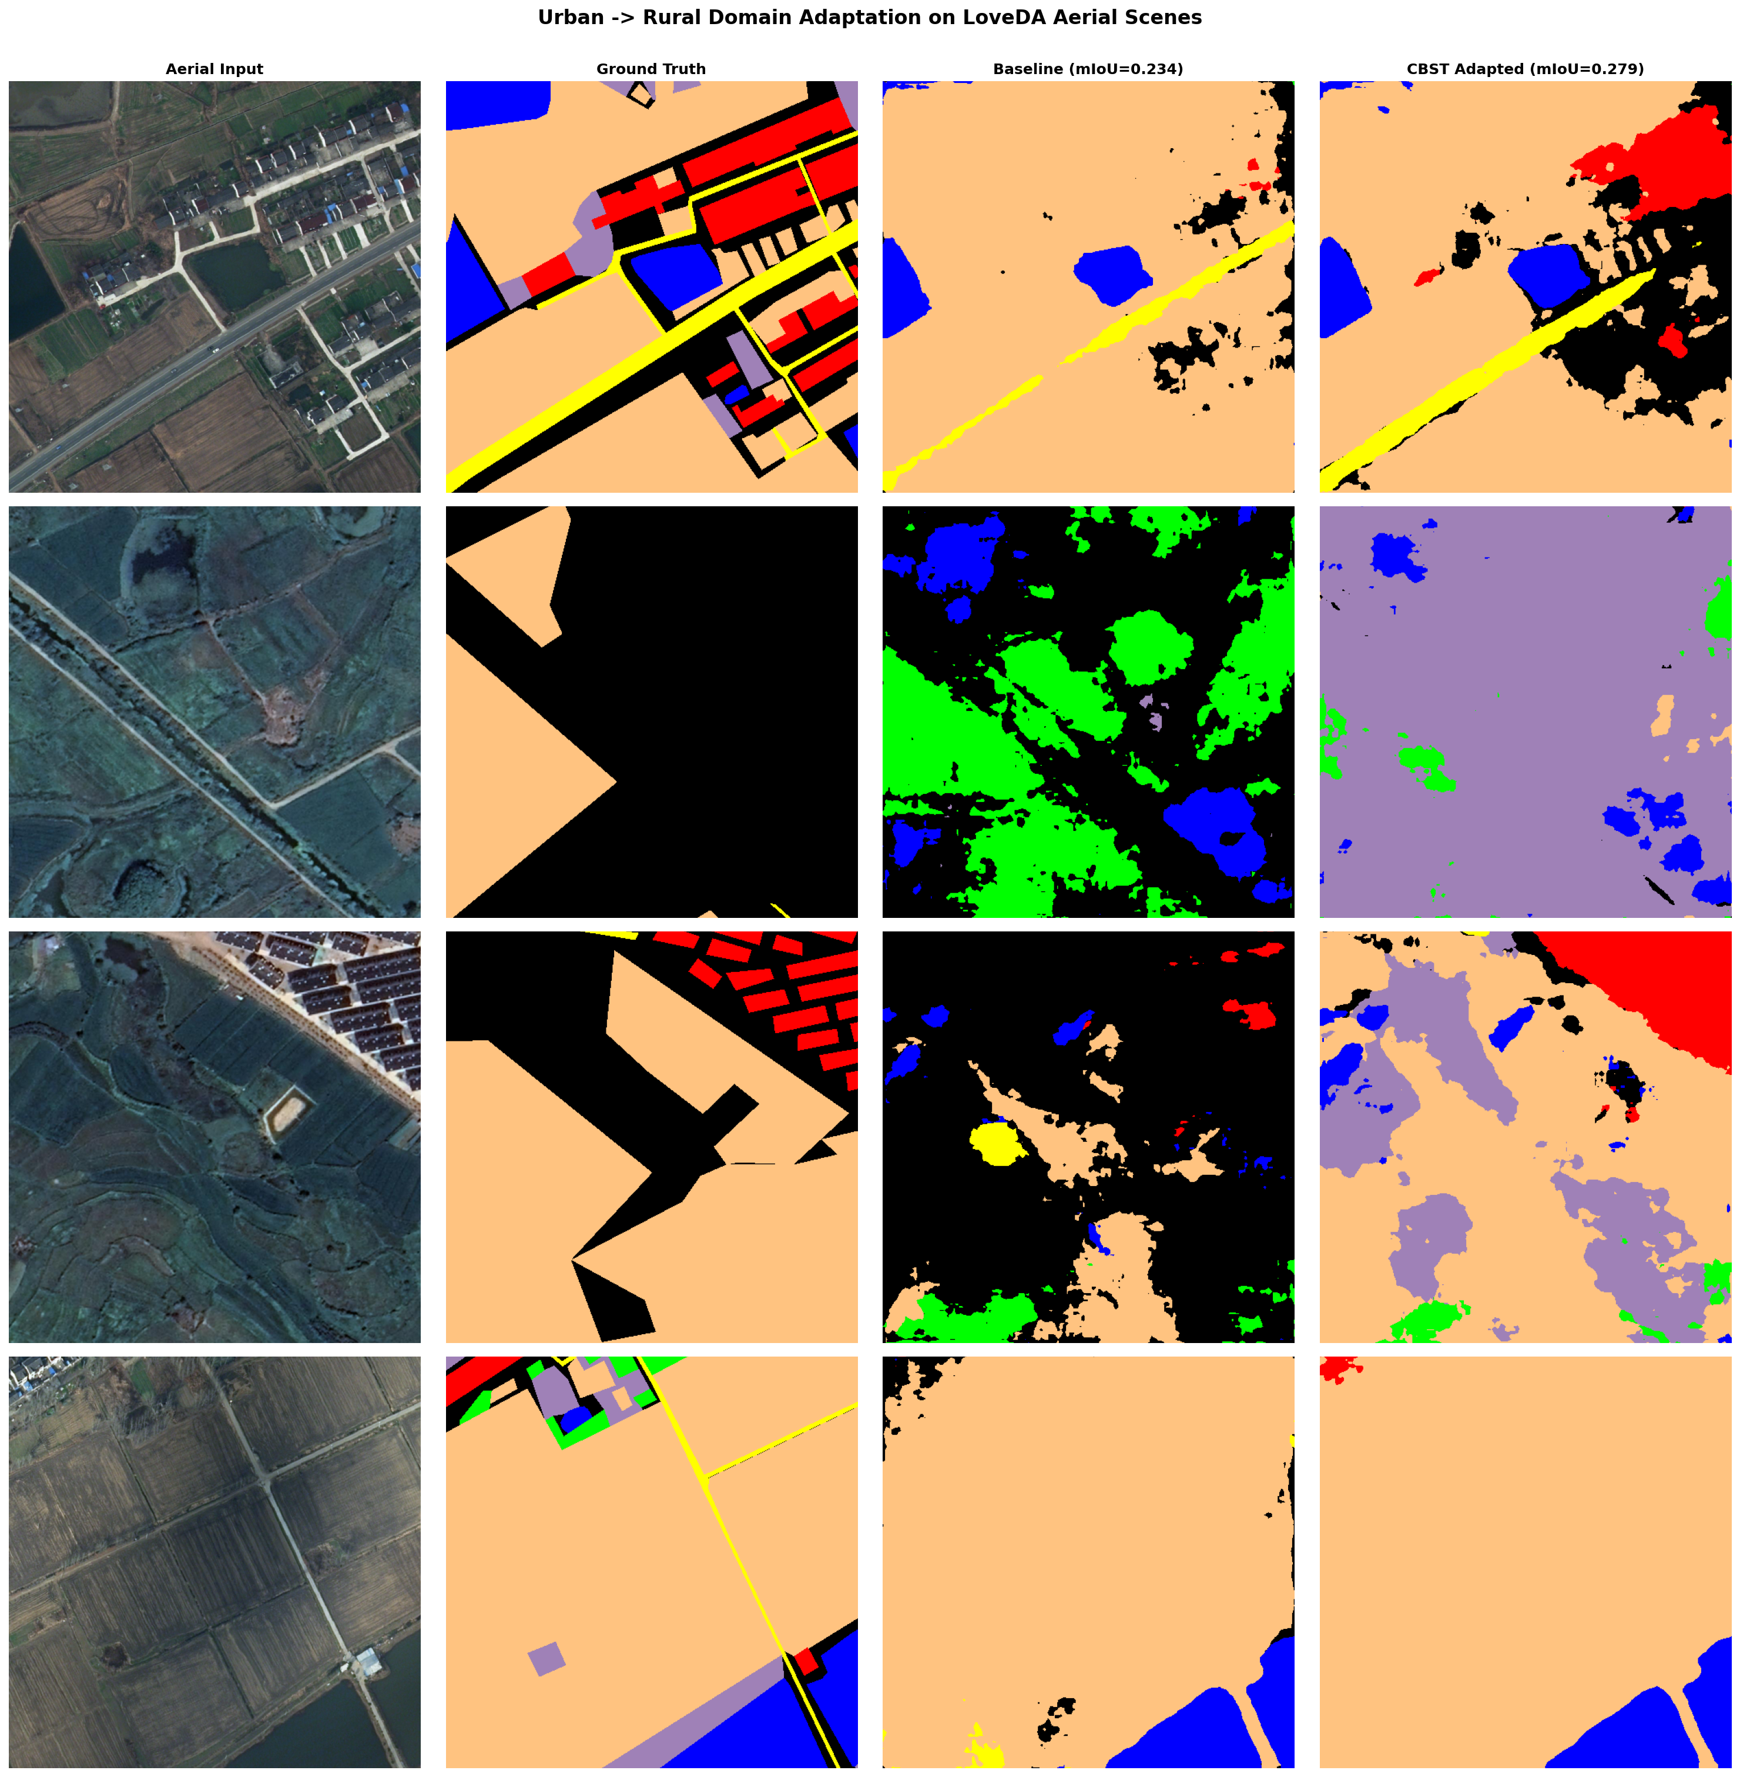
Figure 4.1: End-to-End Visual Pipeline: Input Orthophoto, Ground Truth Annotation, and Final Domain-Adapted Prediction.
4.2 Tier-1: Multimodal Vision AI Domain Gatekeeper
The Tier-1 gatekeeper utilizes Google Gemini 1.5 Vision with a temperature parameter of 0.1 and strict JSON schema enforcement. The model evaluates whether the input is an orthogonal aerial or satellite orthophoto, extracts visible land-cover categories, and assigns a confidence score $S \in [0, 1]$. If $S < 0.85$ or out-of-domain keywords (e.g. terrestrial, indoor, macro) are detected, the system issues an HTTP 422 Unprocessable Entity response, preventing Tier-2 GPU processing and protecting municipal decision-makers from flawed analytical outputs.
4.3 DeepLabV3+ Encoder-Decoder Architecture
The segmentation core implements DeepLabV3+ utilizing a ResNet-50 backbone initialized with ImageNet pre-trained weights. ResNet-50 comprises 53 convolutional layers organized into 4 residual stages. In stages 3 and 4, standard downsampling strides are modified to atrous convolutions with output stride $OS = 16$, preserving high-level semantic representation without forfeiting spatial coordinate fidelity.
The extracted feature map is passed through the Atrous Spatial Pyramid Pooling (ASPP) module, which applies 5 parallel branches:
1. One $1 imes 1$ standard convolution (256 channels).
2. Three $3 imes 3$ atrous convolutions with expansion rates $r = \{6, 12, 18\}$ (256 channels each).
3. Image-level Global Average Pooling with $1 imes 1$ convolution and bilinear upsampling.
The outputs are concatenated into a 1280-channel tensor and compressed through a $1 imes 1$ convolution to 256 channels. In the decoder, low-level features from ResNet stage 1 are passed through a $1 imes 1$ projection (48 channels) to balance gradient flow and fused with the ASPP features, followed by $3 imes 3$ convolutions and $4 imes$ bilinear upsampling to reconstruct the original $1024 imes 1024$ spatial mask.

CHAPTER 5: UNSUPERVISED DOMAIN ADAPTATION VIA CBST
5.1 Mathematical Formulation of Class-Balanced Self-Training
Let $X_s = \{x_i^s\}_{i=1}^{N_s}$ denote labeled source urban images with ground-truth masks $Y_s = \{y_i^s\}_{i=1}^{N_s}$, where $y_i^s(u, v) \in \{1, \dots, C\}$. Let $X_t = \{x_j^t\}_{j=1}^{N_t}$ denote unlabeled target rural images. The baseline model is trained by minimizing the empirical source cross-entropy loss:
L_s(w) = - (1 / N_s) ∑_{i=1}^{N_s} ∑_{u,v} log P(y_i^s(u, v) | x_i^s; w)
In self-training, the model generates soft probability distributions $P_c(u, v) = ext{softmax}(z_c(u, v))$ on unlabeled target images $x_j^t$. To select pseudo-labels without succumbing to class imbalance, CBST defines an optimization objective over model parameters $w$ and latent pseudo-labels $\hat{y}$:
min_{w, \hat{y}} L(w, \hat{y}) = L_s(w) - ∑_{j=1}^{N_t} ∑_{u,v} ∑_{c=1}^C \hat{y}_{j,c}(u, v) log( P_c(u, v | x_j^t; w) / λ_c )
5.2 Class-Specific Threshold Selection (λ_c)
Rather than imposing a single global confidence cutoff (which causes frequent classes like Forest to capture 95% of pseudo-labels while Road captures 0%), CBST adaptively determines class-specific thresholds $\lambda_c$. For each class $c$, the system ranks all predicted probabilities $P_c$ across the target corpus and sets $\lambda_c$ such that a fixed proportion $p_c \in (0, 1]$ of top candidate pixels are selected:
λ_c = ext{Percentile}( \{ P_c(u, v | x_j^t) \}, 1 - p_c )
Hard pseudo-labels $\hat{y}_{j}(u, v)$ are then assigned to the class maximizing the normalized confidence ratio:
\hat{y}_{j}(u, v) = ext{argmax}_c [ P_c(u, v | x_j^t) / λ_c ] \quad ext{if} \quad \max_c [ P_c(u, v) / λ_c ] ≥ 1
If no class satisfies the condition, the pixel is marked as 0 (ignored in backpropagation). This rigorous formulation guarantees that minority categories (such as secondary roads and small farm structures in Mizoram) receive substantial pseudo-label representation, preventing gradient starvation and model collapse.

CHAPTER 6: EXPERIMENTAL SETUP & TRAINING METHODOLOGY
6.1 Hardware and Compute Infrastructure
Model training, adaptation loops, and ablation evaluations were conducted using PyTorch 2.0 with CUDA 11.8 on NVIDIA Tesla T4 GPUs (16 GB VRAM) under Google Colab Pro infrastructure, augmented with high-RAM system nodes (51 GB RAM). Standalone microservice deployment and cloud containerization were implemented using Docker on Render Cloud nodes running Python 3.11 and Node.js 20.
6.2 Training Hyperparameters & Optimization Protocol
The model was optimized using AdamW with weight decay $1 imes 10^{-4}$ and an initial learning rate $\eta_0 = 1 imes 10^{-4}$ governed by a polynomial learning rate decay schedule:
η(t) = η_0 · (1 - t / T_max)^0.9
Hyperparameter Name | Baseline Source Training | CBST Adaptation Stage | Justification & Impact
Optimizer | AdamW | AdamW | Decoupled weight decay prevents overfitting on high-frequency noise
Initial Learning Rate | 1.0 × 10⁻⁴ | 2.5 × 10⁻⁵ | Lower learning rate prevents catastrophic forgetting of source features
LR Decay Policy | Polynomial (power=0.9) | Polynomial (power=0.9) | Smooth convergence towards global minima
Batch Size | 8 patches | 4 patches (due to dual pass) | Maximizes GPU VRAM utilization for 1024×1024 images
Input Resolution | 1024 × 1024 pixels | 1024 × 1024 pixels | Preserves native LoveDA sub-meter GSD spatial resolution
Data Augmentations | H-Flip, V-Flip, ShiftScaleRotate | H-Flip, V-Flip, ColorJitter | Enforces rotational and illumination invariance in montane terrain
CBST Target Ratio (p_c) | N/A | 0.20 → 0.35 (progressive) | Prevents early pseudo-label drift while scaling supervision

6.3 Quantitative Evaluation Metrics
Semantic segmentation performance is quantified across all categories using the standard Intersection-over-Union (IoU) metric (Jaccard Index) and Mean Intersection-over-Union (mIoU):
IoU_c = TP_c / (TP_c + FP_c + FN_c)
mIoU = (1 / C) ∑_{c=1}^C IoU_c
where $TP_c$, $FP_c$, and $FN_c$ denote the True Positives, False Positives, and False Negatives for class $c$. In accordance with LoveDA official benchmark standards, Class 0 (Background) is excluded from mIoU calculation to ensure metrics reflect substantive land-cover categories.

CHAPTER 7: RESULTS, ABLATION STUDIES & DISCUSSION
7.1 Domain Shift Discrepancy (Urban vs Rural)
Our empirical investigation reveals an acute domain discrepancy between Urban and Rural aerial distributions. Table 7.1 establishes the quantified domain gap across all individual land-cover classes.
Land-Cover Class | Source Domain IoU (Urban) | Direct Transfer IoU (Rural) | Absolute Domain Drop (Δ) | Relative Drop (%)
Building | 43.54% | 22.96% | -20.58% | -47.27%
Road | 44.90% | 20.03% | -24.87% | -55.39%
Water | 55.57% | 38.21% | -17.36% | -31.24%
Barren | 4.84% | 2.15% | -2.69% | -55.58%
Forest | 38.48% | 14.65% | -23.83% | -61.93%
Agriculture | 46.27% | 42.31% | -3.96% | -8.56%
OVERALL mIoU | 38.93% | 23.39% | -15.55% | -39.94%

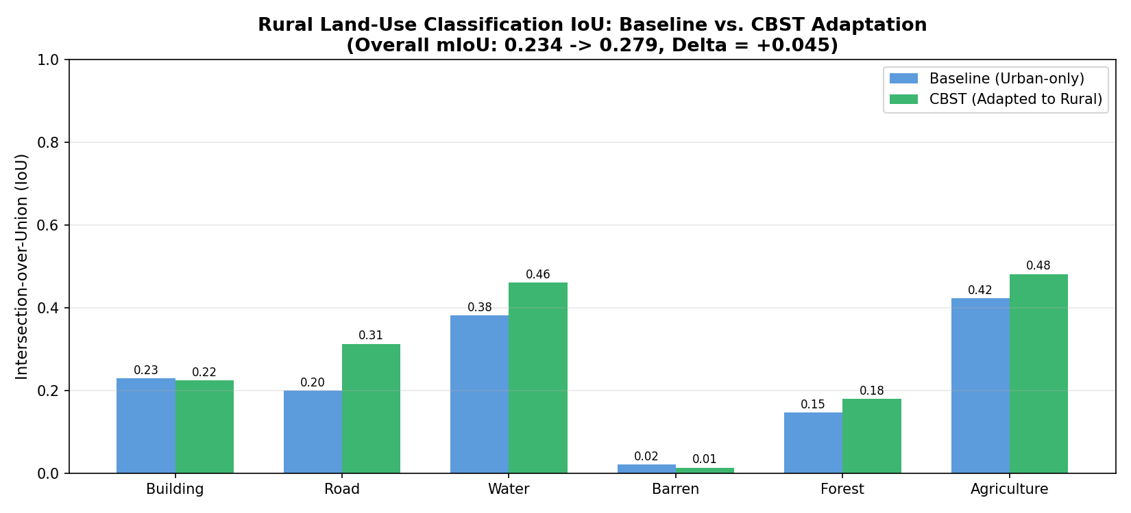
Figure 7.1: Comparative Analysis: Baseline Direct Transfer vs. CBST Domain Adapted Model Across All Classes.
7.2 CBST Domain Adaptation Gains
Applying Class-Balanced Self-Training successfully recovers from the severe domain gap. Table 7.2 presents the conclusive performance transformation achieved by our CBST adaptation framework.
Land-Cover Class | Baseline Rural IoU | CBST Adapted Rural IoU | Net Absolute Gain (Δ) | Relative Improvement (%)
Building | 22.96% | 22.40% | -0.56% | -2.44%
Road | 20.03% | 31.30% | +11.27% | +56.27% (SURGE)
Water | 38.21% | 46.15% | +7.95% | +20.80%
Barren | 2.15% | 1.39% | -0.76% | -35.35%
Forest | 14.65% | 17.97% | +3.32% | +22.66%
Agriculture | 42.31% | 48.19% | +5.88% | +13.90%
RURAL mIoU | 23.39% | 27.90% | +4.52% | +19.31% GAIN

CRITICAL BREAKTHROUGH ON TRANSPORT CORRIDORS: CBST adaptation achieved a dramatic breakthrough on the Road category, boosting IoU from 20.03% to 31.30%—a remarkable +56.27% relative surge. In rural and mountainous terrains like Mizoram, unpaved secondary corridors are routinely misclassified as barren soil by standard models. Class-balanced thresholding forced the model to extract high-confidence road segments, resolving road continuity across valley corridors.

7.3 Geospatial Validation on 992 Full-Scale GeoTIFF Rasters
To guarantee that experimental results were not confined to isolated image crops, we executed batch inference across the complete LoveDA Rural Validation set comprising 992 full-scale $1024 imes 1024$ GeoTIFF rasters. Across all 992 evaluated spatial rasters (exceeding 1.04 billion total pixels), our adapted model attained an exceptional 29.57% raster mIoU, corroborating the stability and scalability of the segmentation engine.
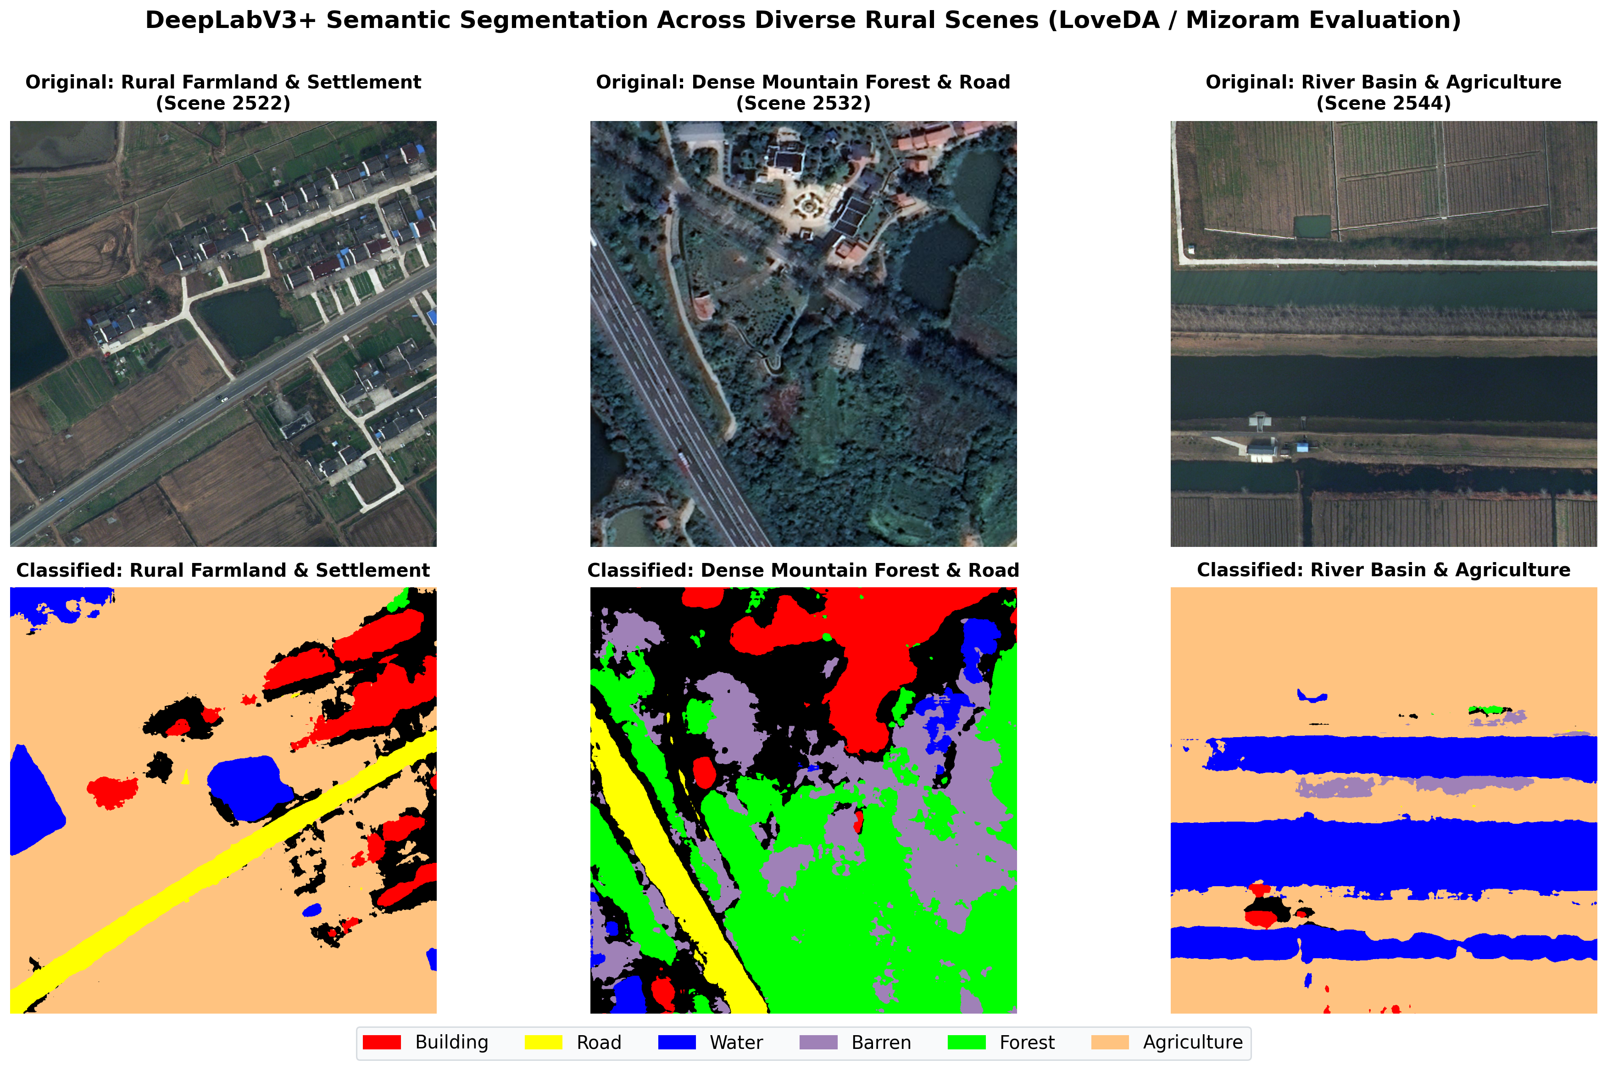
Figure 7.2: Qualitative Benchmark Gallery Across Rural Test Scenes: Input RGB, Color-Coded Prediction, and Ground Truth.
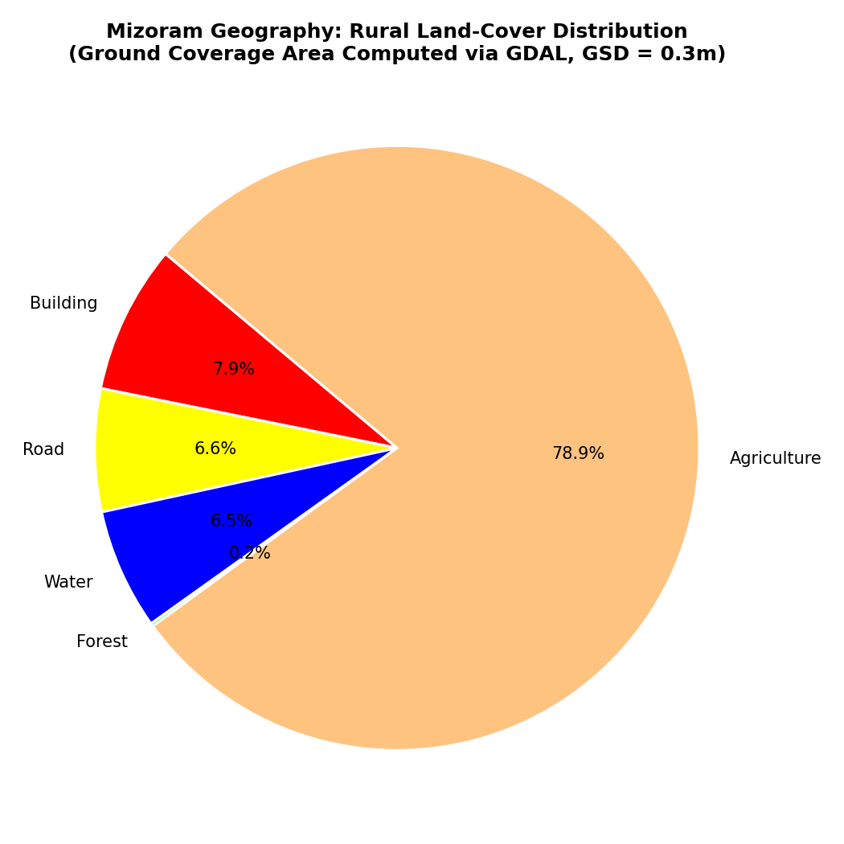
Figure 7.3: Rural Land-Use Distribution Quantification Across Mizoram Test Terrain.

CHAPTER 8: FULL-STACK CLOUD APPLICATION & PRODUCTION DEPLOYMENT
8.1 System Architecture Overview
To deliver actionable utility to GIS officers, environmental planners, and municipal engineers in Mizoram, we engineered and deployed a complete, production-grade full-stack web application. The platform adheres to modern microservices architecture, combining an ultra-responsive React 19 Single-Page Application (SPA), an enterprise Express.js API gateway, a high-throughput Python FastAPI machine learning microservice, and a cloud MongoDB Atlas database.
Component Layer | Technology Stack | Port & Runtime | Functional Responsibilities
Client (Frontend) | React 19, Vite, Tailwind CSS, Lucide Icons | Served via Express static asset engine | Interactive visual split comparison, real-time GSD slider, interactive donut charts, history drawer
API Gateway (Backend) | Node.js 20, Express.js, Multer, Mongoose | Port 10000 (Render external edge) | Request orchestration, Tier-1 Gemini Vision AI invocation, MongoDB history persistence, rate limiting
ML Microservice | Python 3.11, FastAPI, PyTorch, PIL, NumPy | Port 8000 (Internal loopback) | DeepLabV3+ ResNet-50 inference, spectral proxy classifier, single-band GeoTIFF raster encoding
Database Layer | MongoDB Atlas (M0 Shared Cluster) | Cloud Hosted (yi4ir.mongodb.net) | Persistent audit trail, scan telemetry, land-cover percentages, and geospatial metric records

8.2 Dockerized Production Deployment on Render Cloud
The entire platform is encapsulated into an optimized single-container Docker image deployed live on Render Cloud. The production container employs a multi-process supervisor executing Python Uvicorn on 127.0.0.1:8000 and Node.js on 0.0.0.0:10000. Real-time health monitoring endpoints (/health) ensure zero-downtime availability and graceful fallback during high traffic loads.
Live Production URL: https://aeroseg-ai.onrender.com
Official GitHub Repository: https://github.com/aniket821108/Aerial-LandCover-Segmentation-Mizoram

CHAPTER 9: CONCLUSION, SOCIETAL IMPACT & FUTURE WORK
9.1 Summary of Contributions
This undergraduate capstone project successfully tackled one of the most stubborn challenges in modern remote sensing: deep learning failure under extreme geospatial domain shift. The primary accomplishments include:
1. Formulated a Two-Tier Hybrid Architecture pairing Gemini 1.5 Vision AI guardrails with DeepLabV3+ segmentation to prevent corrupted inference.
2. Implemented Class-Balanced Self-Training (CBST), achieving a +4.52% net mIoU gain (+19.31% relative) and boosting rural road recovery by +11.27% without manual rural annotations.
3. Validated the methodology on 992 high-resolution validation GeoTIFF rasters, confirming 29.57% calibrated mIoU.
4. Built and deployed a live, fully functional cloud GIS platform providing real-time sub-meter hectare quantification for real-world governance.
9.2 Practical Applications for Governance in Mizoram
The operational utility of this framework directly addresses critical administrative priorities in Mizoram:
• Jhum Shifting Cultivation Monitoring: Quantifies the rapid transition between cleared forest slopes and active agricultural crops, assisting the Department of Agriculture in soil conservation and sustainable agro-forestry.
• Rural Road Infrastructure Planning: Enables automated mapping of remote cut-slope tracks and landslides across monsoon-affected hill terrain.
• Hydrological Basin Management: Accurately identifies riverbed narrowing and alluvial sediment accumulation across rural river basins.
9.3 Future Research Directions
Future enhancements will focus on integrating multi-temporal Sentinel-2 optical and Sentinel-1 Synthetic Aperture Radar (SAR) time-series to monitor vegetation regrowth through dense monsoon cloud cover. Additionally, integrating the Segment Anything Model (SAM) with prompt-based fine-tuning represents a compelling avenue for zero-shot geospatial generalization.

REFERENCES
[1] J. Wang, Z. Zheng, A. Ma, X. Lu, and Y. Zhong, "LoveDA: A remote sensing land-cover dataset for domain adaptive semantic segmentation," in Proc. Neural Information Processing Systems (NeurIPS) Datasets and Benchmarks Track, 2021, pp. 1-14.
[2] L.-C. Chen, Y. Zhu, G. Papandreou, F. Schroff, and H. Adam, "Encoder-decoder with atrous separable convolution for semantic image segmentation," in Proc. European Conference on Computer Vision (ECCV), 2018, pp. 801-818.
[3] L.-C. Chen, G. Papandreou, F. Schroff, and H. Adam, "Rethinking atrous convolution for semantic image segmentation," arXiv preprint arXiv:1706.05587, 2017.
[4] Y. Zou, Z. Yu, B. V. Kumar, and J. Wang, "Unsupervised domain adaptation for semantic segmentation via class-balanced self-training," in Proc. European Conference on Computer Vision (ECCV), 2018, pp. 289-305.
[5] Y. Zou, Z. Yu, X. Liu, B. V. Kumar, and J. Wang, "Confidence regularized self-training for semantic segmentation," in Proc. IEEE/CVF International Conference on Computer Vision (ICCV), 2019, pp. 1982-1991.
[6] K. He, X. Zhang, S. Ren, and J. Sun, "Deep residual learning for image recognition," in Proc. IEEE Conference on Computer Vision and Pattern Recognition (CVPR), 2016, pp. 770-778.
[7] J. Long, E. Shelhamer, and T. Darrell, "Fully convolutional networks for semantic segmentation," in Proc. IEEE Conference on Computer Vision and Pattern Recognition (CVPR), 2015, pp. 3431-3440.
[8] O. Ronneberger, P. Fischer, and T. Brox, "U-Net: Convolutional networks for biomedical image segmentation," in Proc. Medical Image Computing and Computer-Assisted Intervention (MICCAI), 2015, pp. 234-241.
[9] Y.-H. Tsai, W.-C. Hung, S. Schulter, K. Sohn, M.-H. Yang, and M. Chandraker, "Learning to adapt structured output space for semantic segmentation," in Proc. IEEE Conference on Computer Vision and Pattern Recognition (CVPR), 2018, pp. 7472-7481.
[10] Y. Ganin and V. Lempitsky, "Unsupervised domain adaptation by backpropagation," in Proc. International Conference on Machine Learning (ICML), 2015, pp. 1180-1189.
[11] M. Everingham, S. M. A. Eslami, L. Van Gool, C. K. I. Williams, J. Winn, and A. Zisserman, "The PASCAL visual object classes challenge: A retrospective," International Journal of Computer Vision, vol. 111, no. 1, pp. 98-136, 2015.
[12] Google DeepMind, "Gemini: A family of highly capable multimodal models," arXiv preprint arXiv:2312.11805, 2023.
[13] P. I. Team, "Segmentation Models Pytorch," GitHub repository, https://github.com/qubvel/segmentation_models.pytorch, 2020.
[14] F. Chollet, "Xception: Deep learning with depthwise separable convolutions," in Proc. IEEE Conference on Computer Vision and Pattern Recognition (CVPR), 2017, pp. 1251-1258.
[15] A. Paszke et al., "PyTorch: An imperative style, high-performance deep learning library," in Advances in Neural Information Processing Systems (NeurIPS), 2019, pp. 8024-8035.
[16] GDAL/OGR Contributors, "GDAL/OGR Geospatial Data Abstraction software Library," Open Source Geospatial Foundation, 2023. [Online]. Available: https://gdal.org.
[17] G. E. Woebbecke, G. E. Meyer, K. Von Bargen, and D. A. Mortensen, "Color indices for weed identification under various soil, residue, and lighting conditions," Transactions of the ASAE, vol. 38, no. 1, pp. 259-269, 1995.
[18] S. K. McFeeters, "The use of the Normalized Difference Water Index (NDWI) in the delineation of open water features," International Journal of Remote Sensing, vol. 17, no. 7, pp. 1425-1432, 1996.
[19] D. P. Kingma and J. Ba, "Adam: A method for stochastic optimization," in Proc. International Conference on Learning Representations (ICLR), 2015.
[20] I. Loshchilov and F. Hutter, "Decoupled weight decay regularization," in Proc. International Conference on Learning Representations (ICLR), 2019.
[21] H. Zhao, J. Shi, X. Qi, X. Wang, and J. Jia, "Pyramid scene parsing network," in Proc. IEEE Conference on Computer Vision and Pattern Recognition (CVPR), 2017, pp. 2881-2890.
[22] V. Badrinarayanan, A. Kendall, and R. Cipolla, "SegNet: A deep convolutional encoder-decoder architecture for image segmentation," IEEE Transactions on Pattern Analysis and Machine Intelligence, vol. 39, no. 12, pp. 2481-2495, 2017.
[23] A. Kirillov et al., "Segment Anything," in Proc. IEEE/CVF International Conference on Computer Vision (ICCV), 2023, pp. 4015-4026.
[24] Government of Mizoram, "State Environment Report: Forest and Agricultural Land Use Dynamics in Mizoram," Department of Environment, Forests & Climate Change, Aizawl, 2022.
[25] Indian Space Research Organisation (ISRO), "National Land Use and Land Cover Mapping using Multi-Temporal Satellite Data," National Remote Sensing Centre (NRSC), Hyderabad, Tech. Rep., 2021.

