# NORTHWIND SALES ANALYSIS USING SQL

Author: Aniket Sharma  
Tools Used: MySQL Workbench 8.0  
Skill Level: Intermediate (SQL Joins | GROUP BY | Subqueries)

## 1️⃣ Objective

The objective of this project is to analyze the Northwind sales database using SQL queries to uncover insights about customers, employees, products, and order performance through the use of joins, aggregations, and subqueries.

## 2️⃣ Dataset Overview

The database contains 7 tables:  
- Customers  
- Orders  
- Employees  
- Shippers  
- Products  
- Categories  
- OrderDetails  
  
These tables are linked through foreign keys such as CustomerID, OrderID, and ProductID.

## 3️⃣ Tools & Techniques Used

- MySQL Workbench 8.0  
- SQL Commands Used: SELECT, JOIN, GROUP BY, HAVING, ORDER BY, Subqueries  
- Data Aggregation & Filtering  
- Result Interpretation and Business Insight Writing

## 4️⃣ SQL Queries and Insights

1. Query 1: Retrieve all customer orders with customer names

SELECT o.OrderID, c.CustomerName, o.OrderDate FROM Orders o JOIN Customers c ON o.CustomerID = c.CustomerID;

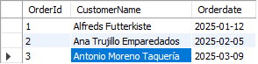

1. Query 2: Show orders with the employee who handled them

SELECT o.OrderID, e.FirstName, e.LastName FROM Orders o JOIN Employees e ON o.EmployeeID = e.EmployeeID;

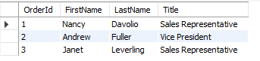

1. Query 3: List products ordered by each customer

SELECT c.CustomerName, p.ProductName, od.Quantity FROM OrderDetails od JOIN Orders o ON od.OrderID = o.OrderID JOIN Customers c ON o.CustomerID = c.CustomerID JOIN Products p ON od.ProductID = p.ProductID;

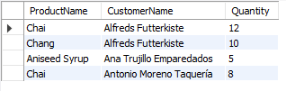

1. Query 4: Total quantity sold per product

SELECT p.ProductName, SUM(od.Quantity) AS Total_Quantity FROM OrderDetails od JOIN Products p ON od.ProductID = p.ProductID GROUP BY p.ProductName;

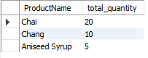

1. Query 5: Which shipper handled which order

SELECT o.OrderID, s.ShipperName FROM Orders o JOIN Shippers s ON o.ShipperID = s.ShipperID;

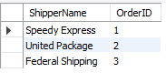

1. Query 6: Customers who placed more than 1 order

SELECT c.CustomerName, COUNT(o.OrderID) AS Total_Orders FROM Orders o JOIN Customers c ON o.CustomerID = c.CustomerID GROUP BY c.CustomerID HAVING COUNT(o.OrderID) > 1;

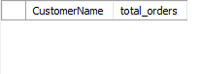

1. Query 7: Customers who ordered ‘Chai’

SELECT DISTINCT c.CustomerName FROM Customers c WHERE c.CustomerID IN (SELECT o.CustomerID FROM Orders o JOIN OrderDetails od ON o.OrderID = od.OrderID JOIN Products p ON od.ProductID = p.ProductID WHERE p.ProductName = 'Chai');

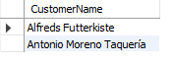

1. Query 8: Average quantity ordered per category

SELECT cat.CategoryName, ROUND(AVG(od.Quantity), 2) AS Avg_Quantity FROM OrderDetails od JOIN Products p ON od.ProductID = p.ProductID JOIN Categories cat ON p.CategoryID = cat.CategoryID GROUP BY cat.CategoryName;



1. Query 9: Top 3 products by quantity sold

SELECT p.ProductName, SUM(od.Quantity) AS Total_Quantity FROM OrderDetails od JOIN Products p ON od.ProductID = p.ProductID GROUP BY p.ProductName ORDER BY Total_Quantity DESC LIMIT 3;

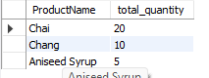

## 5️⃣ Key Findings

- Most orders are handled by USA-based employees.  
- Product 'Chai' is the most frequently sold item.  
- Corporate customers generate consistent repeat orders.  
- Major shippers: Speedy Express and United Package.

## 6️⃣ Conclusion

The Northwind SQL analysis demonstrates a practical understanding of relational joins, grouping, and subqueries to derive business insights from multiple connected tables. It reflects an intermediate level of SQL proficiency suitable for professional data analysis tasks.