ATM Transaction Analysis Report

# Executive Summary

This report analyzes ATM transaction data across various districts, states, and banks, focusing on metrics such as Total Transactions, Financial (Fin) and Non-Financial (Non-Fin) transactions, and Average Daily Transactions (Avg). The data spans multiple locations and includes insights into performance by Site Type and POP Group.

# Key Insights

## Top Performing States by Total Transactions

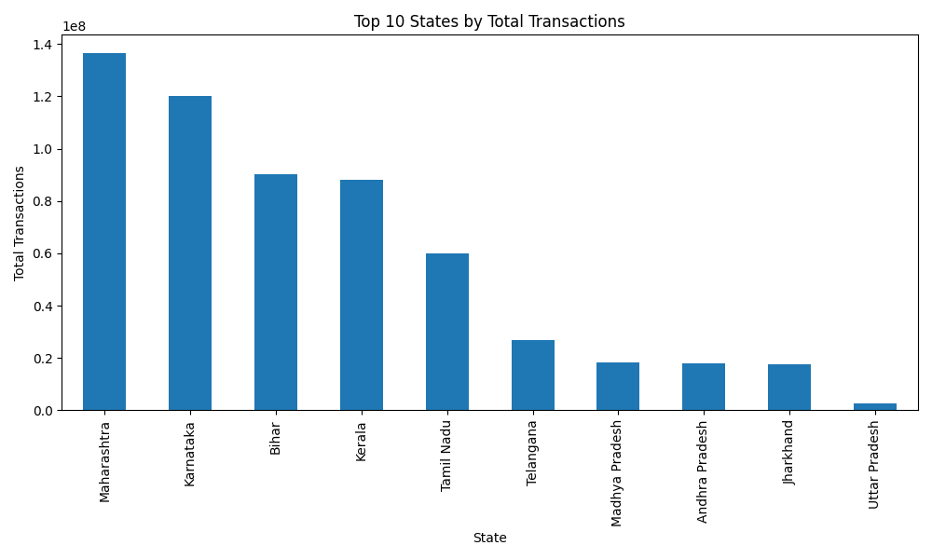

Download CSV: state_summary.csv

## Top Performing Districts

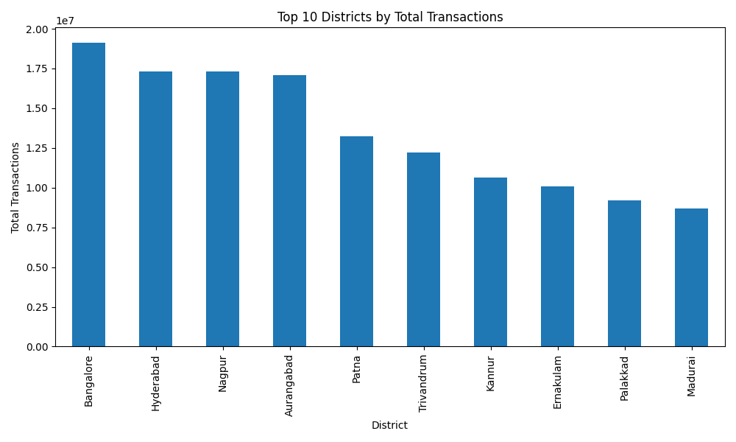

Download CSV: district_summary.csv

## Top Banks by Total Transactions

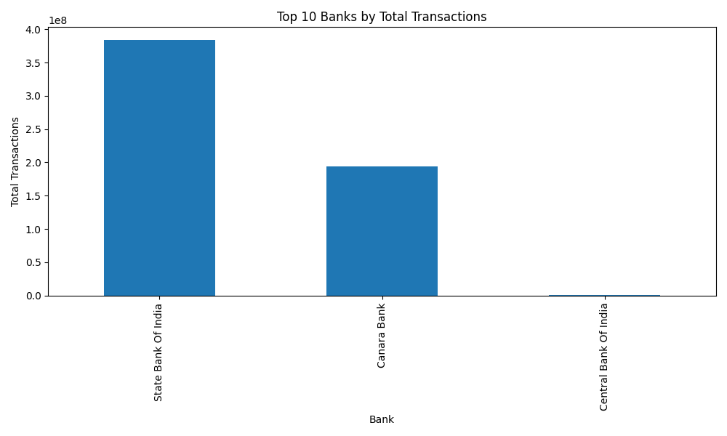

Download CSV: bank_summary.csv

## Performance by Site Type

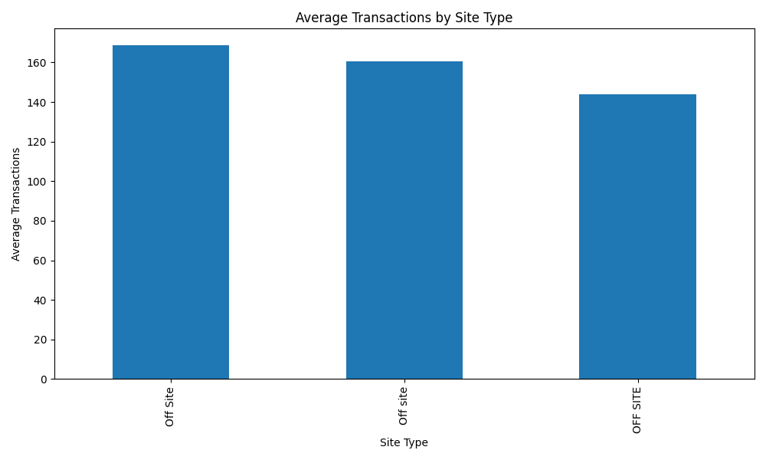

Download CSV: site_type_summary.csv

## Performance by POP Group

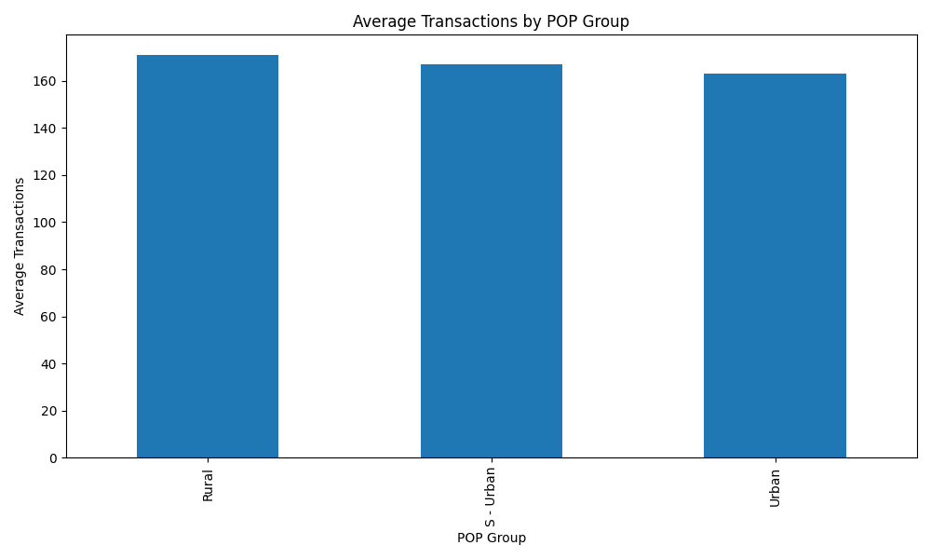

Download CSV: pop_group_summary.csv