Investor Report: ATM Transaction Analysis

# Executive Summary

This report provides an investor-focused analysis of ATM transaction data across various regions and banks. The total number of transactions recorded is 578,563,242, with 430,989,909 financial and 147,573,333 non-financial transactions. The average daily transaction volume is approximately 165.96 per ATM.

# Top Performing States

The following chart shows the top 10 states by total ATM transactions:

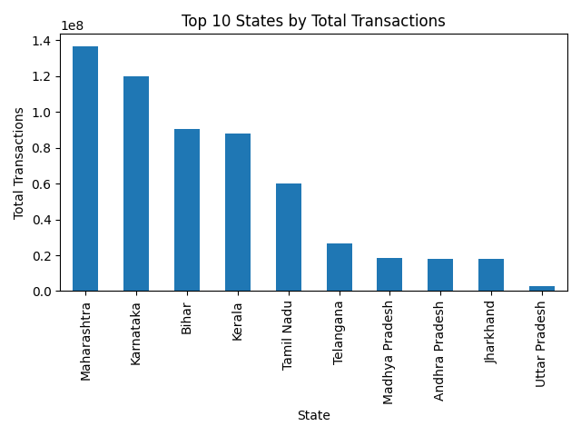

# Top Performing Districts

The following chart shows the top 10 districts by total ATM transactions:

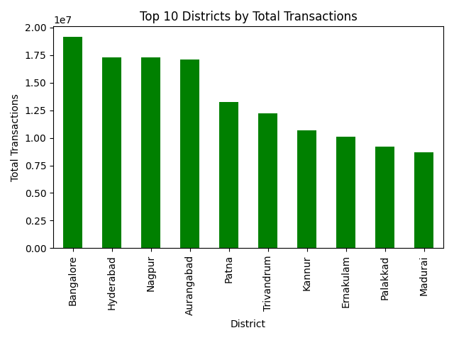

# Top Performing Banks

The following chart shows the top 10 banks by total ATM transactions:

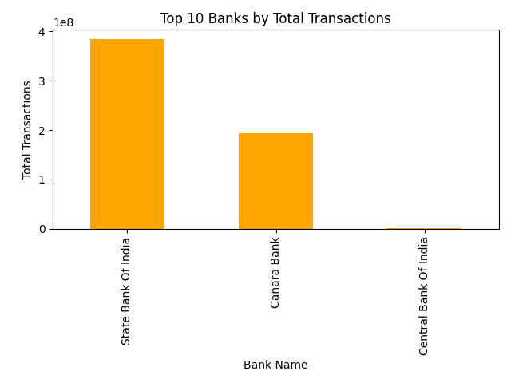

# Operational Efficiency by Site Type

The following chart shows the average daily transactions by ATM site type:

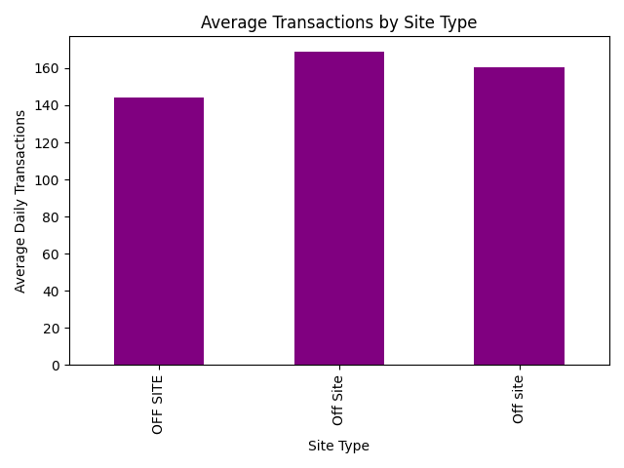

# Regional Trends by POP Group

The following chart shows the average daily transactions by POP group:

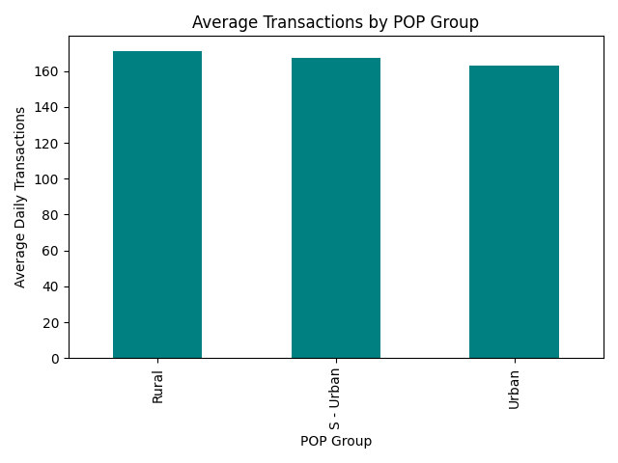

# Investment Opportunities

High transaction volumes in urban and semi-urban areas suggest strong demand and potential for expansion. Banks with high transaction volumes, such as State Bank of India, present opportunities for strategic partnerships. Improving ATM accessibility in rural areas could unlock untapped potential and enhance financial inclusion.

# Conclusion

This analysis highlights key areas of financial performance, operational efficiency, and regional trends. Investors may consider focusing on high-performing regions and banks, while also exploring growth opportunities in under-served areas.