LAB REPORT

Submission Required Element
- What operating system (including revision) did you use for your code development?
Answer) Operating system used for code development was “Windows 7 Enterprise – Service Pack 1.

- What compiler (including revision) did you use?
Answer) The below compilers were used for compiling code:
SDCC Rev 2.3.1 – Lab4 Required element, Supplemental Element and Challenges

- What exactly (include name/revision if appropriate) did you use to build your code (what IDE, make/makefile, or command line)?
Answer) Code::Blocks IDE Release 12.11 Rev 8629 was used to build the C.

- Did you install and use any other software tools to complete your lab assignment?
Answer) Tera Term terminal emulator and Flip 3.4.7 Programming utility were the other software tools installed and used to complete the lab assignment.

- Did you experience any problems with any of the software tools? If so, describe the problems.
Answer) No significant problems were encountered with the software tools.

Lab 4 Required Elements:
The required element involved two parts:
- LCD driver for HD44870U which included the implementation of given specific functions
- EEPROM driver for ATMLU214 using I2C interface

Below is the user interface for the required and supplemental element combined:

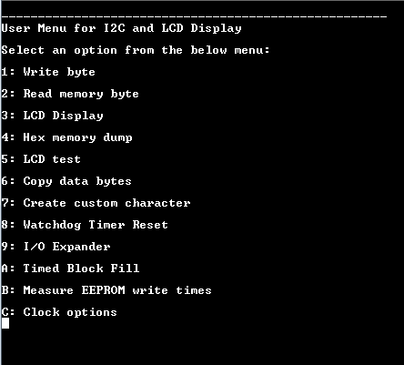

- LCD:
I wrote my own code for the LCD driver referring only to the data sheets and application notes provided on the course website.

LCD hardware implementation:
LCD SPLD

Microcontroller

The hardware implementation involves providing LCD control signals E,RW,RS via SPLD. The LCD has been memory mapped for instruction read, instruction write, data read and data write commands.
The data lines of microcontroller have been connected to the data lines of LCD. The VEE signal of the LCD has been controlled via a potentiometer which controls the contrast on the LCD screen.

LCD driver:
The LCD driver has been implemented to support LCD display and cursor handling using the given function prototypes:
lcdinit(): Initialization sequence
lcdbusywait(): Poll busy flag
lcdgotoaddr(): Set cursor to specified DDRAM address
lcdgotoxy(): Set cursor to specified x,y location on screen
lcdputch(): Write specified character to current cursor position on LCD screen
lcdputstr():Write specified null terminated string to LCD screen

Timing considerations:
Required write timing diagram:

Lab write timing diagram:
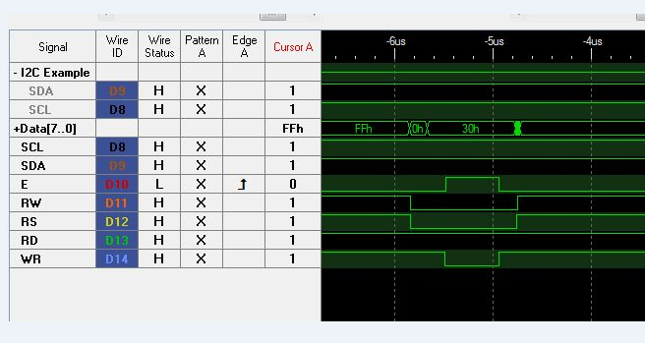

The above timing diagrams show that the R/W and RS signals (driven by the address lines of the microcontroller) change as soon as the address/data bus holds valid data. The Enable signal goes high when the write signal goes low. The LCD is enabled when the driver writes to a certain address in memory and thus in turn sends a particular command to the LCD.
The Enable signal allows data bus to stabilize before the LCD can actually read the command from the data bus. It can be seen that the LCD implementation does take care of the write operation timing requirements in the snapshot above.
Required read timing diagram:
Lab read timing diagram:
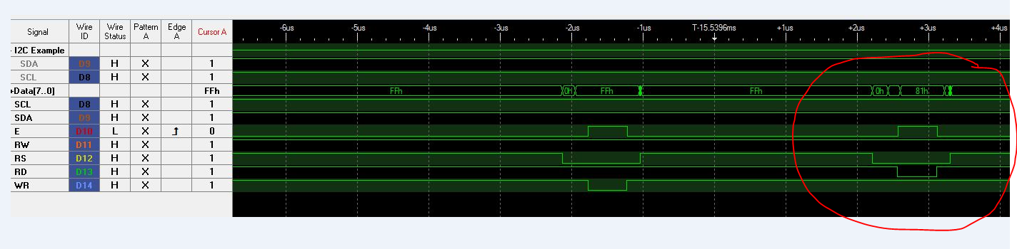

The above timing diagram (part circled in red) shows the read timing analysis. The R/W and RS signals follow the address lines of the microcontroller. The Enable signal responds to the address line in conjunction with the Read signal issued by the microcontroller.
The Enable signal goes high only after the data line stabilizes and has valid data from the LCD. It can be seen that the LCD implementation does take care of the read operation timing requirements in the snapshot above.
The snapshots above prove that the LCD enable signal goes high only when LCD is being accessed.
LCD putstr() problem fixed:
Problem: The problem here was that if the string to be written to LCD is not starting from 0,0 the cursor would not wrap goto the next line on the lcd and would follow the addresses i.e. 0x80 – line 1, 0x90 – line 3, 0xC0 – line 2, 0xD0 – line 4. So the cursor was going to line 3 after line 1 only if the string does not start from 0th position. I had handled the cursor such that it considered the string would always start from 0th position.
Solution: The cursor was being tracked in an incorrect manner earlier. I have corrected this with the following code.

void lcdputch(unsigned char str1)
{
__xdata __at (0xA000) unsigned char ldata;

ldata = str1;
delay(1);
if(cursorread == 0x8f)
lcdgotoxy(1,0);
else if(cursorread == 0xCf)
lcdgotoxy(2,0);
else if(cursorread == 0x9f)
lcdgotoxy(3,0);
else if(cursorread == 0xdf)
lcdgotoxy(0,0);
else
cursorread++;
}

void lcdgotoxy(unsigned char row, unsigned char column)
{
unsigned char addr_xy = 0;
switch(row)
{
case 0:
row = 0x80;
addr_xy = row + column;
break;

case 1:
row = 0xC0;
addr_xy = row + column;
break;

case 2:
row = 0x90;
addr_xy = row + column;
break;

case 3:
row = 0xD0;
addr_xy = row + column;
break;
}
cursorread = addr_xy;
lcdgotoaddr(addr_xy);
}

The cursorread variable is a global one. It keeps track of the cursor position on the lcd screen. Whenever, the user goes to a certain x,y position, the cursorread is updated. Also, the cursorread is incremented every time a putchar is done. In this way, the correct cursor position is tracked and if it matches the end of line for that row, the position is changed to start address of the next row.
The corrected code was shown during the supplemental sign off to the TA and worked fine.

LCD implementation:

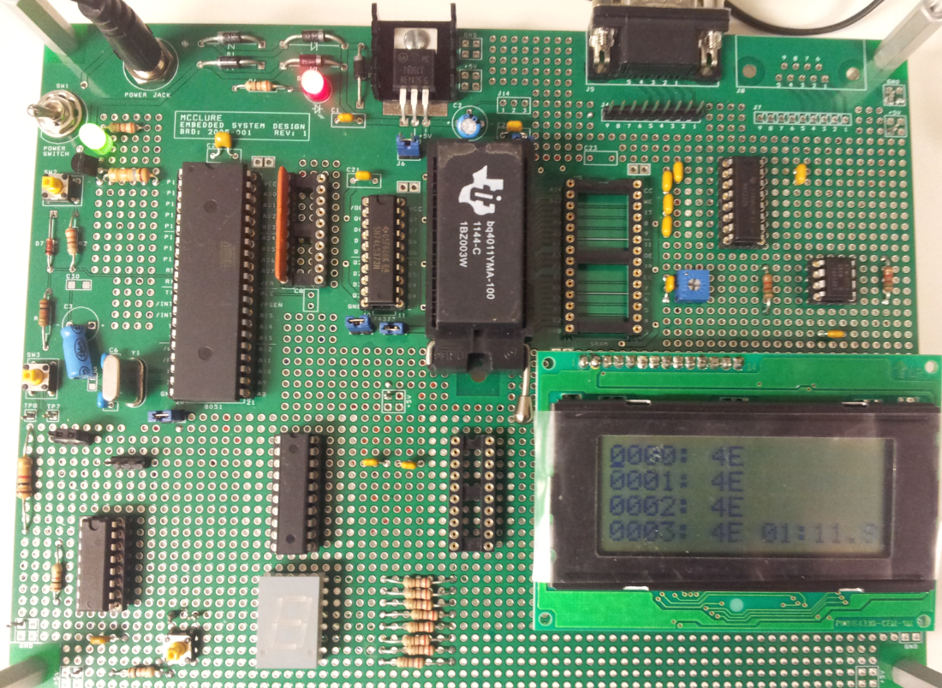

- EEPROM using I2C: I2C protocol was used to interface EEPROM ATMLU214 with the microcontroller.

EEPROM hardware implementation:
EEPROM 89C51 micrcontroller

The EEPROM has been connected to P1.1 and P1.2 which act as SCL and SDA lines for the EEPROM respectively. These two lines have been pulled up to ensure bus free condition. Another reason for a pull up at the EEPROM is that the CMOS inputs should not be allowed to float as this can cause problems for internal operation of the device.

EEPROM driver:
The EEPROM I2C driver code was entirely written by me without reference to any existing implementations on the web.
The basic idea is to write and read data from an EEPROM.

Byte Write operation:
Below is the byte write operation from the datasheet:
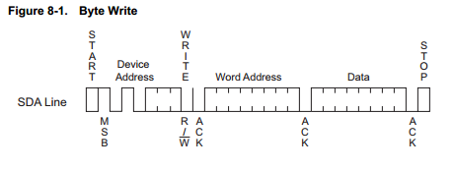
Below is the byte write implementation snapshot:
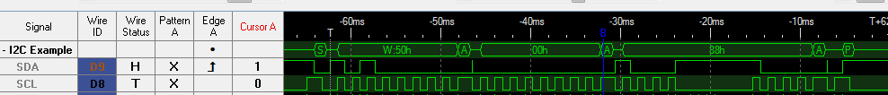

As it can be seen the byte write involves writing start signal followed by the device address, the word address and the data byte followed by a stop signal.

The user interface at the terminal for byte write is given below:

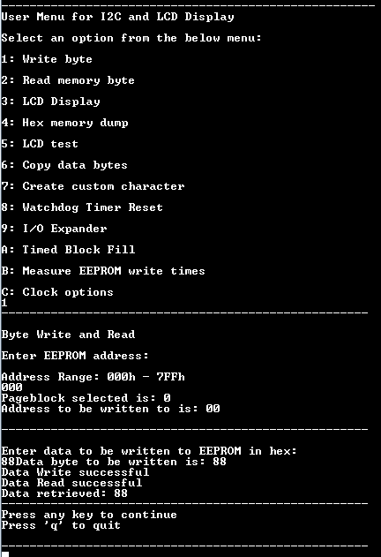

Byte Read operation:
Below is the byte read operation from the datasheet:

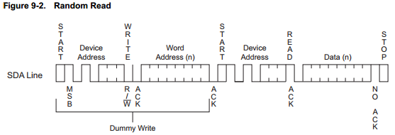

Below is the byte read implementation snapshot:
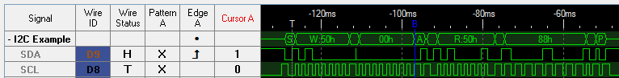

The byte read shown here is the random address read as per the datasheet. We specify the address to the EEPROM to read from. This involves sending a start condition, device address, word address and the data byte followed by a stop condition. This sequence can be seen correctly on the logic analyzer snapshot above.

The user interface at the terminal for byte read is given below:
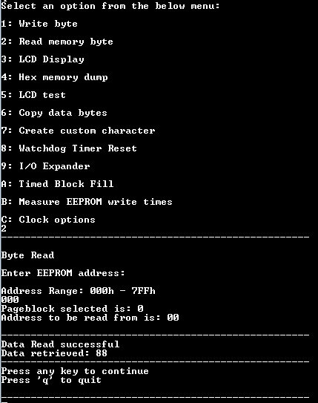

It was verified that byte write and byte read work fine. As a part of the main program, the byte write and byte read were implemented with a user interface for the user to enter bytes to a specific location and read bytes from a specific location.

LCD Display:
As a part of LCD display, the contents of the EEPROM were to be shown on the LCD screen in the format “AAAA: DD”.
Below is the user interface for the part:

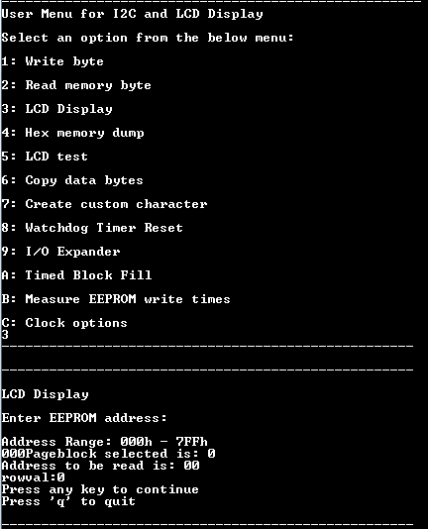

Below is the snapshot of the LCD display:
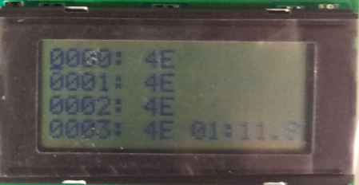
Hex dump:
The hex dump shows a memory dump within a range specified by the user.
The user needs to enter the start and end address. The program shows the memory contents of that range on the terminal. Below is an implementation snapshot of the memory dump:

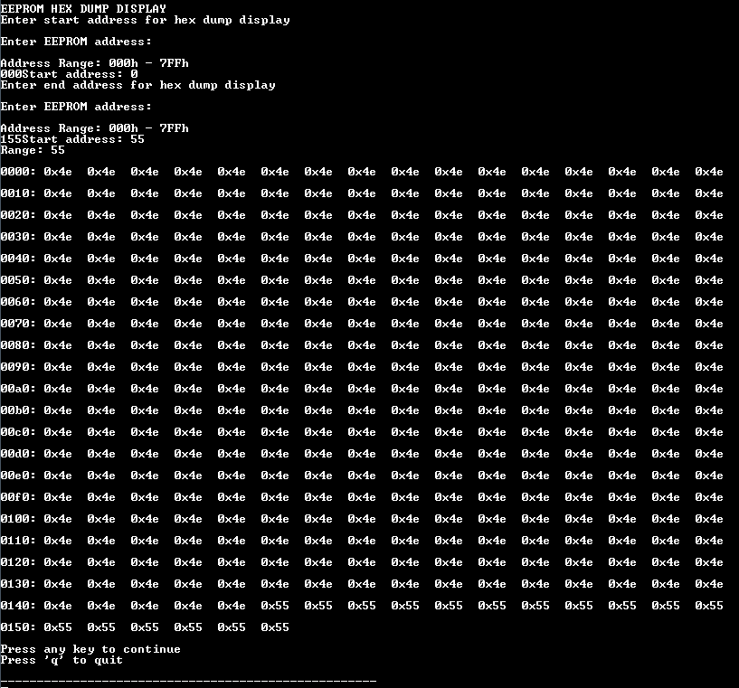

The start address entered was 000h and end address was 155h.

Limitation for hex dump fixed: During the required elements sign off there was a problem with the hex dump. The hex dump could show the memory contents of a single 256 byte block at a time.
The limitation existed as I had not tracked memory contents of multiple page block at the time of printing the memory.
Solution: The hex memory dump limitation was fixed in the code. The snapshot given above is the snapshot of the fixed and working code.
Below is the code for printing hex dump, where page blocks have been tracked. The conditions hacve been highlighted to give a context for the solution.
s=0;
// if single block
if(pageblock == pageblockw)
{
printf("\n\r0%x%02x: ",(pageblock & 0x0F),(startaddr & 0xFF));
for(i=0;i<=((endaddr & 0xFF)-(startaddr & 0xFF));i++)
{
readbyte = eebyter(startaddr+i,pageblockw);
s++;
if(s < 17)
{
printf("0x%02x ",(readbyte & 0xFF));
}
else
{
putchar('\n');
putchar('\r');
s = 1;
printf("\n\r0%x%02x: ",(pageblockw & 0x0F),((startaddr+i) & 0xFF));
printf("0x%02x ",(readbyte & 0xFF));
}
}
}
else
{
printf("\n\r0%x%02x: ",(pcount & 0x0F),(startaddr & 0xFF));
while(pcount<=pageblockw)
{
// Print (N-1) blocks
if(pcount<pageblockw)
{
for(i=0;i<256;i++)
{
readbyte = eebyter(startaddr+i,pcount);
s++;
if(s < 17)
{
printf("0x%02x ",(readbyte & 0xFF));
}
else
{
putchar('\n');
putchar('\r');
s = 1;
printf("\n\r0%x%02x: ",(pcount & 0x0F),((startaddr+i) & 0xFF));
printf("0x%02x ",(readbyte & 0xFF));
}
}
}
// Last block N
else if(pcount == pageblockw)
{
for(i=0;i<=((endaddr & 0xFF)-(startaddr & 0xFF));i++)
{
readbyte = eebyter(startaddr+i,pageblockw);
s++;
if(s < 17)
{
printf("0x%02x ",(readbyte & 0xFF));
}
else
{
putchar('\n');
putchar('\r');
s = 1;
printf("\n\r0%x%02x: ",(pageblockw & 0x0F),((startaddr+i) & 0xFF));
printf("0x%02x ",(readbyte & 0xFF));
}
}
}
pcount++;
}
}

The start pageblock has been read from the start address. And each time the data crosses 256 bytes, the pageblock is incremented by 1. This is done until we reach the last pageblock. In the final pageblock, the contents upto the end address are printed.
The fixed code was shown to the TA during supplemental elements sign off.
- Additional feature:
Copy bytes in EEPROM
This additional feature enables the user to copy data bytes from source to destination. The source and destination address have to be entered. One needs to enter how many bytes need to be copied from the start to end address.
This is an implementation similar to memcpy function of C where you physically copy data bytes.
Below is the snapshot demonstrating memory copy.
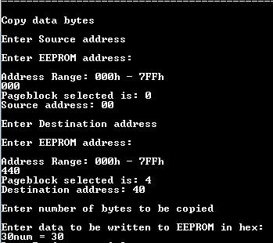
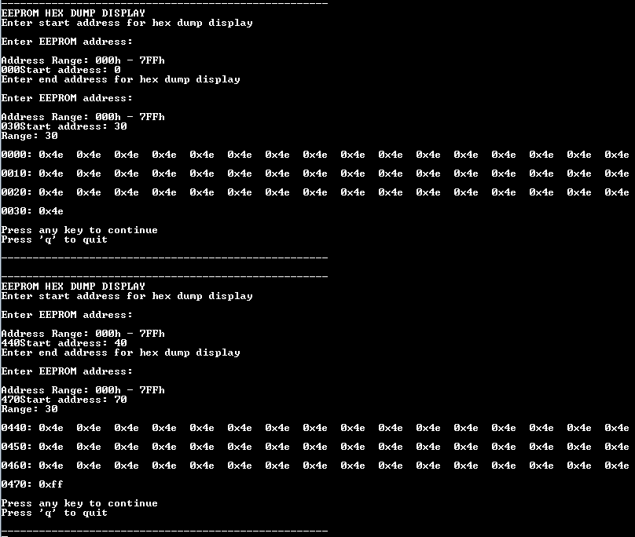

The first snapshot shows that the user can enter the source, destination address and the number of bytes to copy.

The second snapshot is a hex dump of the source and destination addresses denoting the copy operation.

Lab 4 Supplemental Elements:
Lab 4 involved 4 supplemental elements:
- Clock display and options
- Create custom character
- PCF8574 I/O Expander
- EEPROM eereset() and watchdog timer

- Clock display and options:

A digital clock has been displayed at the right bottom corner of the LCD displaying the time in the format MI:SS.MS
The clock starts as soon as the board is turned on.
Three options are provided with the clock:
- Stop Clock: Stops the clock at that point
- Restart Clock: Restarts the stopped clock
- Reset Clock: Resets the clock to 00:00.0

The most important part with clock display is that it should not impact the functioning of the rest of the elements in the program.
Implementation: The clock has been implemented using Timer0 of the 89C51RC2 in 16bit timer mode 1.
Below is a snapshot of the clock implementation:
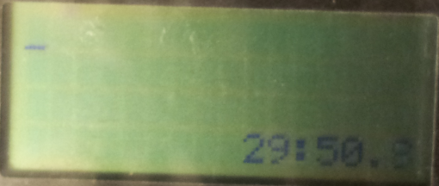

- Create custom character:
A custom character creation interface has been provided to the user as a part of the supplemental elements.
The custom characters have been created by allowing the user to input each row of the desired 8X5 pixels character. These 8 bytes would be stored at a specific CGRAM address. The addresses available are 0x01 to 0x07. We can create 7 different custom characters using the user interface and display them on the LCD screen.

Below is the snapshot of the user interface and a fun logo prepared using the custom character interface.
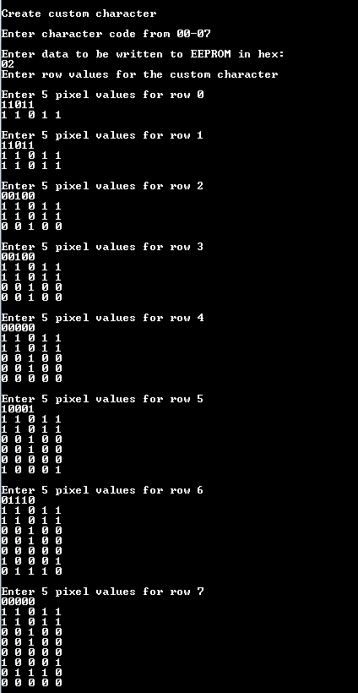

LCD Display of custom character/fun logo:

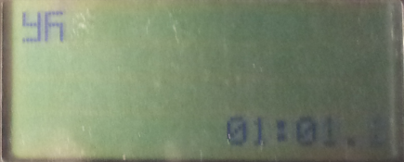

This is a fun logo generated out of the custom character interface. This symbol is a “swastik” .
- PCF 8574 I2C I/O Expander
The I/O expander has been interfaced to the microcontroller using I2C protocol.
I/O expander hardware implementation:
I/O Expander driver:
The I/O expander driver performs three functions:
- Configure a port pin on I/O expander as an input or output port
- Read data from I/O expander port
- Write data to I/O expander port
- Stopwatch timer on key press
The I/O expander follows the I2C protocol to write or read data from the ports. Below are the timing diagrams taken using logic analyser.
The write data condition sends a slave address with the write bit low. The next data byte is the data word. The read data signal sends a slave address with the read bit high. The next data byte is thedata word sent by the I/O expander.
Write data from datasheet:
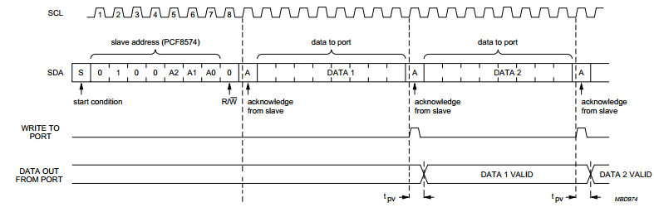
Write data from implementation:

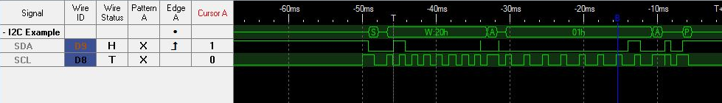
Read data from datasheet:
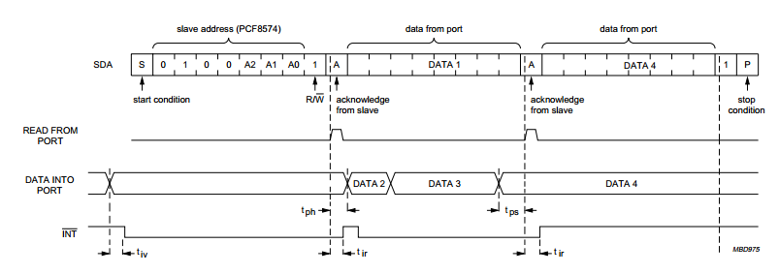

Read data from implementation:

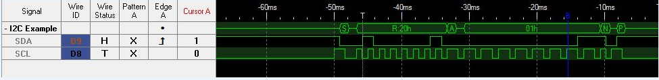

Implementation of stopwatch timer:
A stopwatch timer has been implemented which starts on receiving an input on the I/O expander port pin. This input is given via a switch press which makes the INT pin low of the I/O expander. This INT pin is connected to the INT0 of microcontroller.
So, the sequence would be:
- Configure the port pin to which the switch is connected as an input by writing a ‘1’ to that particular bit of the port.
- Press a switch to generate an interrupt and start the stopwatch timer

The stopwatch timer supports lap timing. Once the timer is started with an interrupt, a timer appears at the right top corner and starts counting.
On the next switch press a lap timing is displayed at (0,0), on the next press at (1,0) and so on till (3,0). Only four lap timings will be displayed after which the stopwatch timer stops counting.
Below is the snapshot of the user interface:
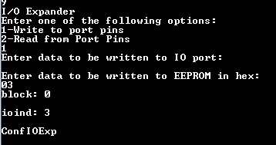

Below is the snapshot of the stopwatch:

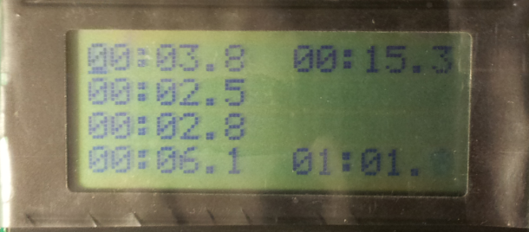

- EEPROM eereset() and watchdog timer
eereset()
The eereset() function is used to reset the EEPROM. The EEPROM can enter a hang condition where it is expecting to receive data from the microcontroller or to guard against an erroneous write.
The reset condition is achieved by sending a start condition, 9 bits of ‘1’s followed by another start condition and a stop condition.
The reset does not erase the data from the EEPROM. After the reset, on doing a current address read, the data returned is the data from the first location of the EEPROM.

Below is a snapshot of the reset vector being implemented at the initialization of the main program:

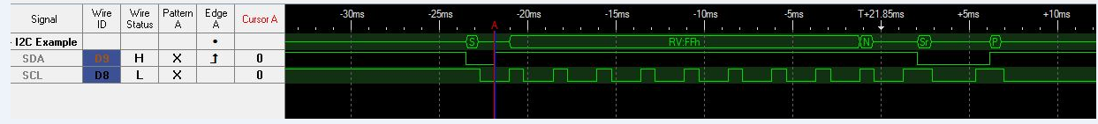

Watchdog timer:
The watchdog timer resets the microcontroller once the watchdog counter overflows. Once the counter is set, it keeps on counting up and on overflowing resets the microcontroller.
The watchdog timer is used to get the microcontroller out of a hang condition.
In the normal program operation, the watchdog counter is reset to the maximum count value before it overflows each timer. I have used Timer 2 to reload the watchdog timer so that it does not overflow.
One function has been implemented to show that the watchdog timer works which basically stops timer 2. Hence, the watchdog counter counts to FFFF and the controller is reset.

Lab 4 Challenges:
Two challenges were completed by me as a part of lab assignment 4:
- Measure EEPROM Write Times
- Timed Block Fill

- Measure EEPROM Write Times

Byte Write and Page Write have been implemented as a part of the challenge. We needed to measure the write times for both these cases.

Byte write:

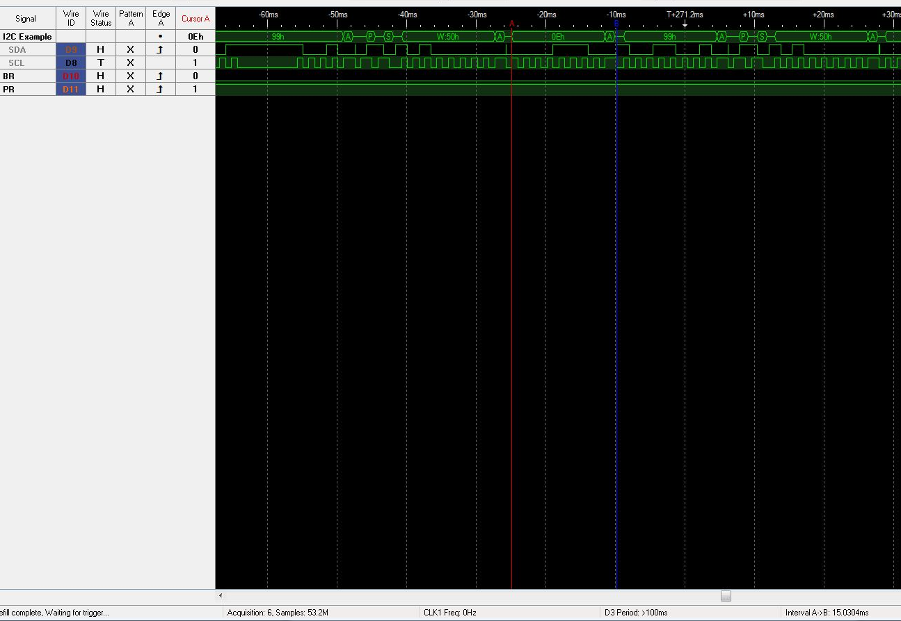

Byte write takes 15.03ms for a single byte. This matches with the byte write time of EEPROM datasheet. For an entire write operation, it takes around 46ms. Taking into account the start and stop bits for each byte write, the time required for 16 bytes to be written is 872ms.

Page write:

Page write takes 332ms for a single page.

The capture for an entire page is not clear.

The Page write does not consist of start and stop bits at the end of each byte. It consists of a start condition, device address, word address, 16 continuous data bytes and a stop condition.

- Timed Block Fill

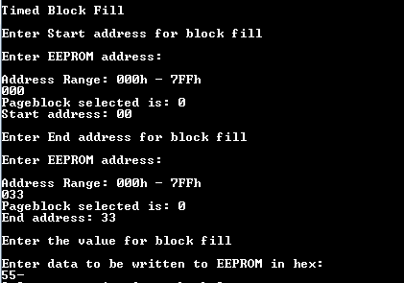

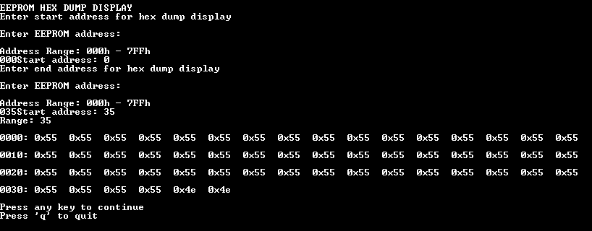

The above two snapshots show the block fill capability of the program.

The time required for writing a byte is around 16ms. This time matches with the datasheet write time of 15ms.

