Social Media — Task Sheet
Instructions: Do not change the question text. Write your answer directly below each question. For Objective questions, the expected output columns and row counts are given below the question. For Subjective questions, no such details are given, work out and write the answer on your own.

Objective Questions
Q1 Are there any tables with duplicate or missing null values? If so, how would you handle them?
ANSWER
To ensure data accuracy and consistency, SQL queries were used to identify and handle duplicate records and missing (NULL) values in the dataset. The same validation approach can be applied across different tables within the dataset.

After performing these checks on each table, it was observed that no duplicate records or missing NULL values were present in the tables.

users — rows with NULL username
Output columns (in order): id, username, created_at (3 columns)
Row count: Varies — this is what O1 is asking you to determine. Run the query and report what you find.
(SELECT id, username, created_at
FROM users
WHERE username IS NULL; )
users — duplicate usernames
Output columns (in order): username, count (2 columns)
Row count: Varies — this is what O1 is asking you to determine. Run the query and report what you find.
(SELECT username, COUNT(*) AS count
FROM users
GROUP BY username
HAVING COUNT(*) > 1; )
photos — rows with NULL image_url / user_id / created_dat
Output columns (in order): id, image_url, user_id, created_dat (4 columns)
Row count: Varies — this is what O1 is asking you to determine. Run the query and report what you find.
(SELECT id, image_url, user_id, created_dat
FROM photos
WHERE image_url IS NULL
OR user_id IS NULL
OR created_dat IS NULL; )
photos — duplicate (image_url, user_id) pairs
Output columns (in order): image_url, user_id, count (3 columns)
Row count: Varies — this is what O1 is asking you to determine. Run the query and report what you find.
(SELECT image_url, user_id, COUNT(*) AS count
FROM photos
GROUP BY image_url, user_id
HAVING COUNT(*) > 1; )
comments — rows with NULL comment_text / user_id / photo_id / created_at
Output columns (in order): id, comment_text, photo_id, user_id, created_at (5 columns)
Row count: Varies — this is what O1 is asking you to determine. Run the query and report what you find.
(SELECT id, comment_text, photo_id, user_id, created_at
FROM comments
WHERE comment_text IS NULL
OR user_id IS NULL
OR photo_id IS NULL
OR created_at IS NULL; )
comments — duplicate (comment_text, user_id, photo_id) triples
Output columns (in order): comment_text, user_id, photo_id, count (4 columns)
Row count: Varies — this is what O1 is asking you to determine. Run the query and report what you find.
(SELECT comment_text, user_id, photo_id, COUNT(*) AS count
FROM comments
GROUP BY comment_text, user_id, photo_id
HAVING COUNT(*) > 1; )
likes — rows with NULL user_id / photo_id / created_at
Output columns (in order): user_id, photo_id, created_at (3 columns)
Row count: Varies — this is what O1 is asking you to determine. Run the query and report what you find.
(SELECT user_id, photo_id, created_at
FROM likes
WHERE user_id IS NULL
OR photo_id IS NULL
OR created_at IS NULL;
)
likes — duplicate (user_id, photo_id) pairs
Output columns (in order): user_id, photo_id, count (3 columns)
Row count: Varies — this is what O1 is asking you to determine. Run the query and report what you find.
(SELECT user_id, photo_id, COUNT(*) AS count
FROM likes
GROUP BY user_id, photo_id
HAVING COUNT(*) > 1; )
follows — rows with NULL follower_id / followee_id / created_at
Output columns (in order): follower_id, followee_id, created_at (3 columns)
Row count: Varies — this is what O1 is asking you to determine. Run the query and report what you find.
(SELECT follower_id, followee_id, created_at
FROM follows
WHERE follower_id IS NULL
OR followee_id IS NULL
OR created_at IS NULL; )
follows — duplicate (follower_id, followee_id) pairs
Output columns (in order): follower_id, followee_id, count (3 columns)
Row count: Varies — this is what O1 is asking you to determine. Run the query and report what you find.
(SELECT follower_id, followee_id, COUNT(*) AS count
FROM follows
GROUP BY follower_id, followee_id
HAVING COUNT(*) > 1; )
Q2 What is the distribution of user activity levels (e.g., number of posts, likes, comments) across the user base?
Output columns (in order): user_id, username, total_posts, total_likes_given, total_comments_made (5 columns)
Row count: 100 rows (verified — 1 row per user).
ANSWER
The following SQL query generates a summary of user activity by retrieving the number of posts, likes, and comments made by each user. The query includes all users from the users table, even those who have not performed any activity, by using LEFT JOIN. Unique posts, likes, and comments are counted for each user to avoid duplication caused by joins.
( SELECT
u.id AS user_id,
u.username,
(SELECT COUNT(*)
FROM photos p
WHERE p.user_id = u.id) AS total_posts,
(SELECT COUNT(*)
FROM likes l
WHERE l.user_id = u.id) AS total_likes_given,
(SELECT COUNT(*)
FROM comments c
WHERE c.user_id = u.id) AS total_comments_made
FROM users u
ORDER BY u.id;)
The results are grouped at the user level, providing a consolidated view of user engagement.
This query provides a user-level summary of activity across the platform. The results can be used to identify highly active users, understand participation patterns, and find users who may benefit from engagement initiatives.
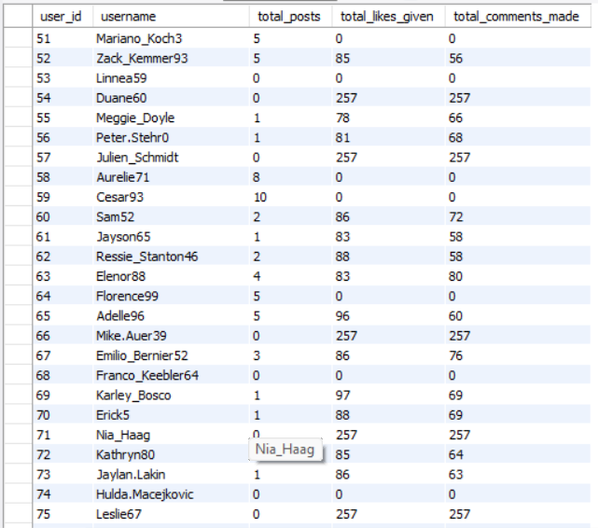
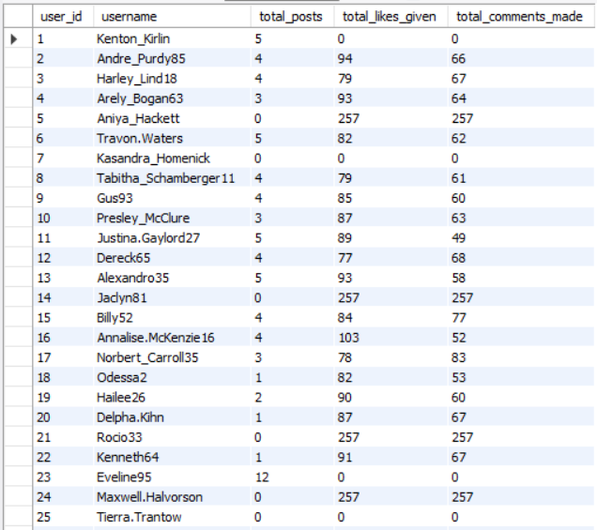
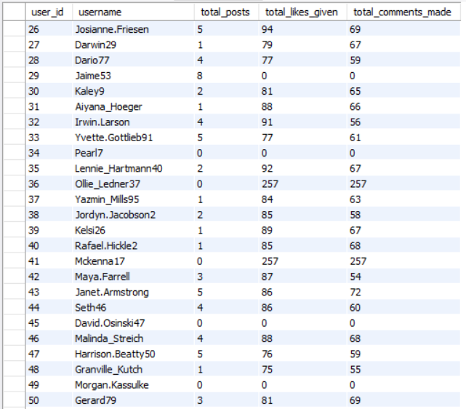
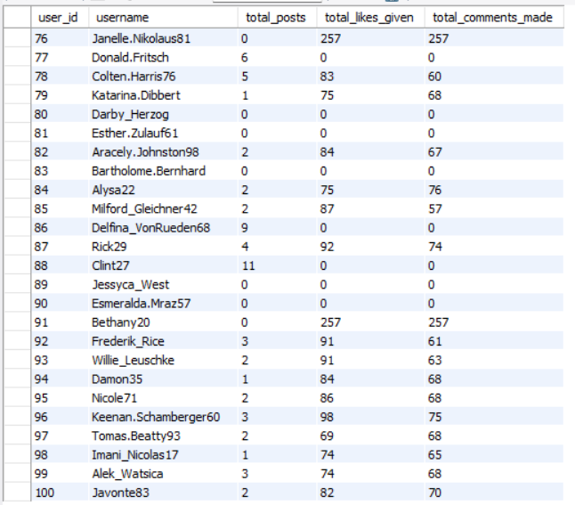

Q3 Calculate the average number of tags per post (photo_tags and photos tables).
Output columns (in order): AverageTags (1 column)
Row count: 1 row (single aggregate value).
ANSWER = 1.95

(SELECT ROUND(AVG(tags),2) AS avg_tags_per_post
FROM (SELECT p.id,COUNT(t.tag_id) AS tags
FROM photos p
LEFT JOIN photo_tags t ON p.id = t.photo_id GROUP BY p.id) AS num_tags; )
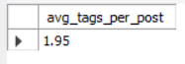
Q4 Identify the top users with the highest engagement rates (likes, comments) on their posts and rank them.
Output columns (in order): user_id, Total, rnk (3 columns)
Row count: 74 rows (verified — 1 row per photo-owner whose photos have ≥1 like AND ≥1 comment).
ANSWER
(SELECT
p.user_id AS user_id,
COUNT(DISTINCT l.user_id) + COUNT(DISTINCT c.id) AS Total,
RANK() OVER (ORDER BY COUNT(DISTINCT l.user_id) + COUNT(DISTINCT c.id) DESC) AS rnk
FROM photos p
JOIN likes l
ON p.id = l.photo_id
JOIN comments c
ON p.id = c.photo_id
GROUP BY p.user_id
ORDER BY rnk, user_id
LIMIT 25; )
This query calculates the total engagement of users by counting the distinct users who liked their photos and the comments received. The RANK() function ranks users in descending order based on their total engagement score. The results are sorted by rank and user ID, and the LIMIT 25 clause displays a maximum of 25 records.
If we remove limit 25 and keep the record intact, it will display a total of 74 rows.

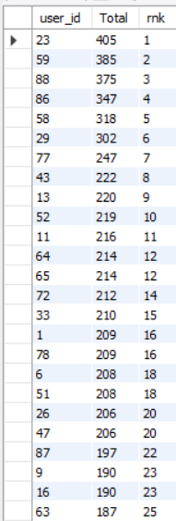
Q5 Which users have the highest number of followers and followings?
Output columns (in order): user_id, username, followers, following (4 columns)
Row count: 100 rows (verified — 1 row per user).
ANSWER

This query calculates the number of followers and following for each user using Common Table Expressions (CTEs). It uses COUNT() to count followers and following, while LEFT JOIN ensures all users are included. The COALESCE() function replaces NULL values with zero. Finally, the results are sorted by followers, following, and user ID in descending order for the first two columns.

(WITH CTE_FOllOWERS AS
( SELECT
followee_id,
COUNT(*) AS followers
FROM follows
GROUP BY followee_id),
CTE_FOLLOWING AS
(SELECT
follower_id,
COUNT(*) AS following
FROM follows
GROUP BY follower_id)
SELECT
u.id AS user_id,
u.username,
COALESCE(f.followers, 0) AS followers,
COALESCE(g.following, 0) AS following
FROM users u
LEFT JOIN CTE_FOLLOWERS f
ON u.id = f.followee_id
LEFT JOIN CTE_FOLLOWING g
ON u.id = g.follower_id
ORDER BY followers DESC, following DESC, u.id; )
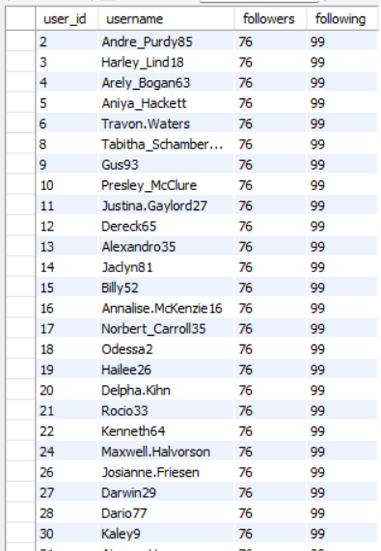
Q6 Calculate the average engagement rate (likes, comments) per post for each user.
Output columns (in order): id, username, avg_engagement (3 columns)
Row count: 74 rows (verified — 1 row per user who has posted ≥1 photo).
ANSWER
This query calculates the average engagement of each user’s photos by combining the number of likes and comments. CTEs calculate likes and comments separately for each photo. The COALESCE() function replaces NULL values with zero, and AVG() calculates the average engagement per user. Finally, the results are sorted in descending order of average engagement.
(WITH CTE_LIKE_COUNT AS
(SELECT
photo_id,
COUNT(*) AS like_count
FROM likes
GROUP BY photo_id),
CTE_COMMENT_COUNT AS
(SELECT
photo_id,
COUNT(*) AS comment_count
FROM comments
GROUP BY photo_id
)
SELECT
u.id AS id,
u.username,
AVG(COALESCE(l.like_count, 0) + COALESCE(c.comment_count, 0)) AS avg_engagement
FROM users u
JOIN photos p
ON u.id = p.user_id
LEFT JOIN CTE_LIKE_COUNT l
ON p.id = l.photo_id
LEFT JOIN CTE_COMMENT_COUNT c
ON p.id = c.photo_id
GROUP BY u.id, u.username
ORDER BY avg_engagement DESC; )
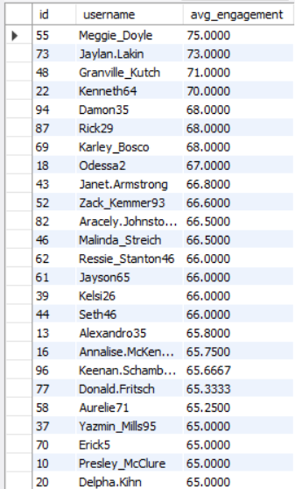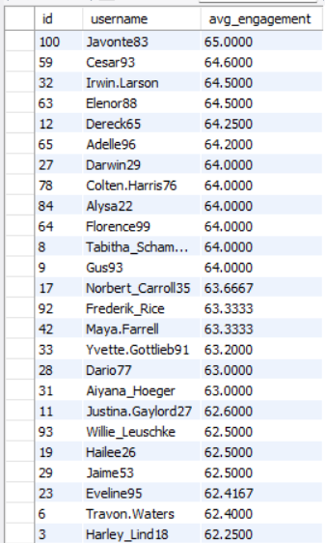

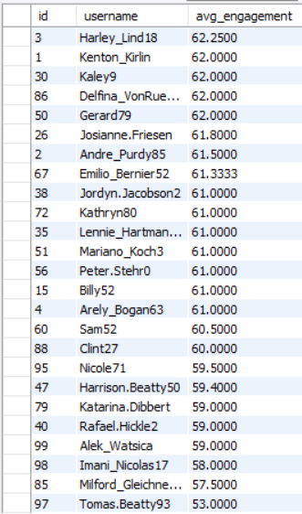
Q7 Get the list of users who have never liked any post (users and likes tables)
Output columns (in order): id, username (2 columns)
Row count: 23 rows (verified).
ANSWER
This query identifies users who have never liked any photo. The NOT EXISTS operator checks whether a user has any matching records in the likes table. Users without any matching records are displayed, sorted by user ID in ascending order.
(SELECT
u.id,
u.username
FROM users u
WHERE NOT EXISTS (
SELECT 1
FROM likes l
WHERE l.user_id = u.id
)
ORDER BY u.id; )
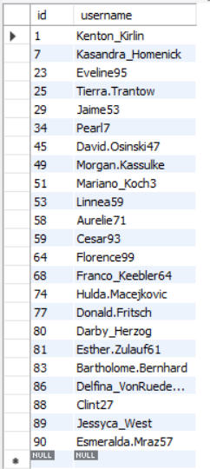
Q8 How can you leverage user-generated content (posts, hashtags, photo tags) to create more personalized and engaging ad campaigns?
Output columns (in order): user_id, username, tag_name, tag_usage, total_likes_received, total_comments_received, total_engagement (7 columns)
Row count: 459 rows (verified — 1 row per user/tag combination that appears in that user's posts).
ANSWER
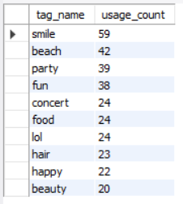
The first query identifies the top 10 most frequently used photo tags by counting their occurrences and sorting them in descending order. The second query identifies each user’s most frequently used tag using CTEs and the ROW_NUMBER() window function. This analysis helps understand user interests and create targeted advertisements.

(SELECT t.tag_name, COUNT(*) AS usage_count
FROM photo_tags pt
JOIN tags t ON pt.tag_id = t.id
GROUP BY t.tag_name
ORDER BY usage_count DESC
LIMIT 10;

-- Also, to run targeted ads, we analyze users most frequently used tags from their posts.

WITH user_tags AS (
SELECT p.user_id, t.tag_name, COUNT(*) AS tag_count
FROM photos p
JOIN photo_tags pt ON p.id = pt.photo_id
JOIN tags t ON pt.tag_id = t.id
GROUP BY p.user_id, t.tag_name
),
ranked_tags AS (
SELECT *,
ROW_NUMBER() OVER (PARTITION BY user_id ORDER BY tag_count DESC) AS rn
FROM user_tags
)
SELECT user_id, tag_name, tag_count
FROM ranked_tags
WHERE rn = 1;)
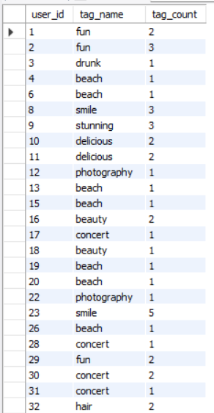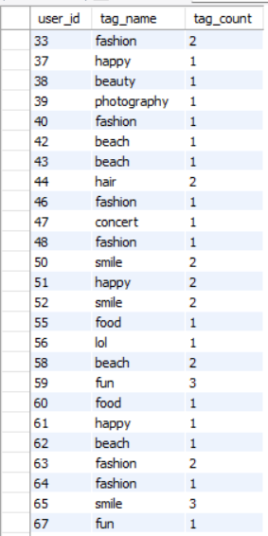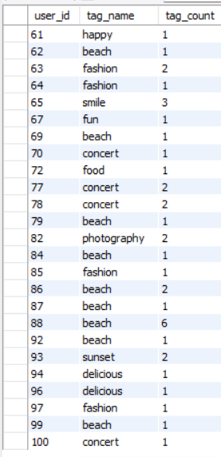

Q9 Are there any correlations between user activity levels and specific content types (e.g., photos, videos, reels)? How can this information guide content creation and curation strategies?
Output columns (in order): user_id, total_posts, total_likes, total_comments, total_engagement (5 columns)
Row count: 74 rows (verified — 1 row per user_id with ≥1 photo).
ANSWER

Based on the query results, there appears to be a positive relationship between user activity and engagement across certain content types. Content categories such as delicious, beauty, foodie, sunset, stunning, and food have the highest average engagement per photo, ranging from 64 to 65 interactions per photo.

(WITH CTE_PHOTO_LIKES AS (
SELECT
p.id AS photo_id,
p.user_id,
COUNT(DISTINCT l.user_id) AS likes_count
FROM photos p
LEFT JOIN likes l
ON p.id = l.photo_id
GROUP BY
p.id,
p.user_id
),

CTE_PHOTO_COMMENTS AS (
SELECT
p.id AS photo_id,
p.user_id,
COUNT(DISTINCT c.id) AS comments_count
FROM photos p
LEFT JOIN comments c
ON p.id = c.photo_id
GROUP BY
p.id,
p.user_id
),

CTE_PHOTO_ENGAGEMENT AS (
SELECT
pl.photo_id,
pl.user_id,
COALESCE(pl.likes_count, 0)
+ COALESCE(pc.comments_count, 0) AS total_engagement
FROM CTE_PHOTO_LIKES pl
LEFT JOIN CTE_PHOTO_COMMENTS pc
ON pl.photo_id = pc.photo_id
),

CTE_PHOTO_TAGS AS (
SELECT
pe.photo_id,
pe.user_id,
pe.total_engagement,
t.tag_name
FROM CTE_PHOTO_ENGAGEMENT pe
JOIN photo_tags pt
ON pe.photo_id = pt.photo_id
JOIN tags t
ON pt.tag_id = t.id
)

SELECT
tag_name AS content_type,
COUNT(DISTINCT photo_id) AS total_photos,
COUNT(DISTINCT user_id) AS active_users,
AVG(total_engagement) AS avg_engagement_per_photo
FROM CTE_PHOTO_TAGS
GROUP BY tag_name
ORDER BY avg_engagement_per_photo DESC; )
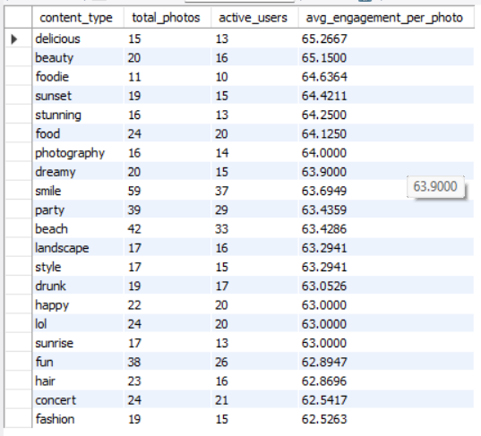

Q10 Calculate the total number of likes, comments, and photo tags for each user.
Output columns (in order): user_id, username, total_likes, total_comments, total_tags (5 columns)
Row count: 100 rows (verified — 1 row per user).
ANSWER
The following query calculates the total number of likes , total number of comments, and total number of tags for each user.
(WITH CTE_TOTAL_LIKES AS (
SELECT
p.user_id,
COUNT(*) AS total_likes
FROM photos p
JOIN likes l
ON p.id = l.photo_id
GROUP BY p.user_id
),
CTE_TOTAL_COMMENTS AS (
SELECT
p.user_id,
COUNT(*) AS total_comments
FROM photos p
JOIN comments c
ON p.id = c.photo_id
GROUP BY p.user_id
),
CTE_TOTAL_TAGS AS (
SELECT
p.user_id,
COUNT(*) AS total_tags
FROM photos p
JOIN photo_tags pt
ON p.id = pt.photo_id
GROUP BY p.user_id
)
SELECT
u.id AS user_id,
u.username,
COALESCE(l.total_likes, 0) AS total_likes,
COALESCE(c.total_comments, 0) AS total_comments,
COALESCE(t.total_tags, 0) AS total_tags
FROM users u
LEFT JOIN CTE_TOTAL_LIKES l
ON u.id = l.user_id
LEFT JOIN CTE_TOTAL_COMMENTS c
ON u.id = c.user_id
LEFT JOIN CTE_TOTAL_TAGS t
ON u.id = t.user_id
ORDER BY u.id; )
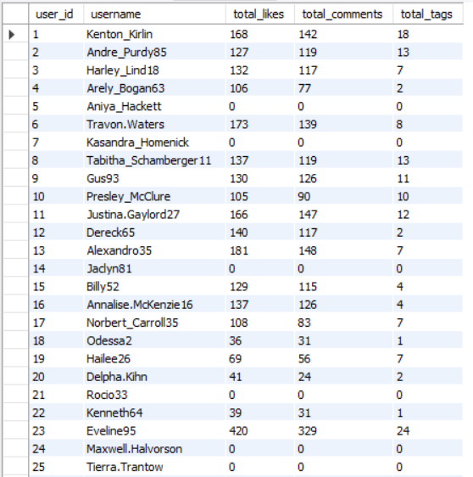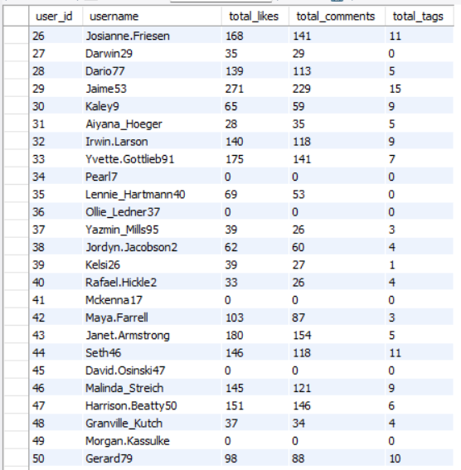

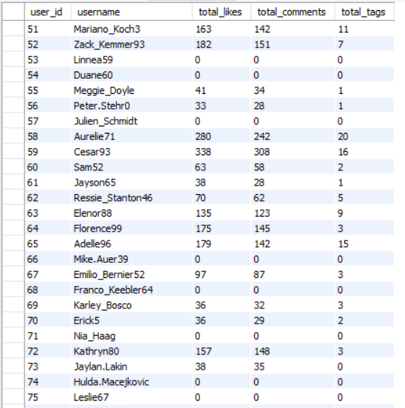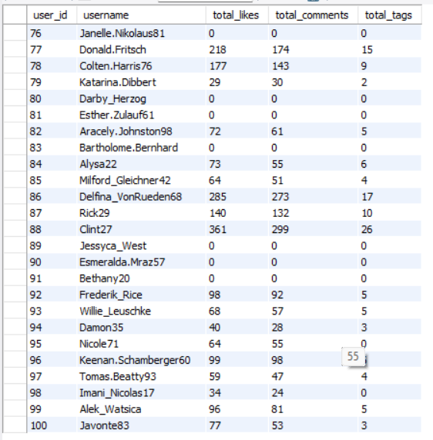
Q11 Rank users based on their total engagement (likes, comments, shares) over a month.
Output columns (in order): user_id, username, likes_given, comments_made, total_engagement, engagement_rank (6 columns)
Row count: 100 rows (verified — 1 row per user).
ANSWER
The following query ranks user based on their total engagement.
(WITH CTE_LIKES AS (
SELECT
p.user_id,
YEAR(p.created_dat) AS year,
MONTH(p.created_dat) AS month,
COUNT(l.user_id) AS likes_received
FROM photos p
LEFT JOIN likes l
ON p.id = l.photo_id
WHERE p.created_dat IS NOT NULL
GROUP BY
p.user_id,
YEAR(p.created_dat),
MONTH(p.created_dat)
),
CTE_COMMENTS AS (
SELECT
p.user_id,
YEAR(p.created_dat) AS year,
MONTH(p.created_dat) AS month,
COUNT(c.id) AS comments_received
FROM photos p
LEFT JOIN comments c
ON p.id = c.photo_id
WHERE p.created_dat IS NOT NULL
GROUP BY
p.user_id,
YEAR(p.created_dat),
MONTH(p.created_dat)
),
CTE_ENGAGEMENT AS (
SELECT
u.id AS user_id,
u.username,
l.year,
l.month,
COALESCE(l.likes_received, 0)
+ COALESCE(c.comments_received, 0) AS total_engagement
FROM CTE_LIKES l
JOIN users u
ON u.id = l.user_id
LEFT JOIN CTE_COMMENTS c
ON c.user_id = l.user_id
AND c.year = l.year
AND c.month = l.month
)
SELECT
user_id,
username,
year,
month,
total_engagement,
DENSE_RANK() OVER (
PARTITION BY year, month
ORDER BY total_engagement DESC
) AS engagement_rank
FROM CTE_ENGAGEMENT
ORDER BY year, month, engagement_rank, user_id; )

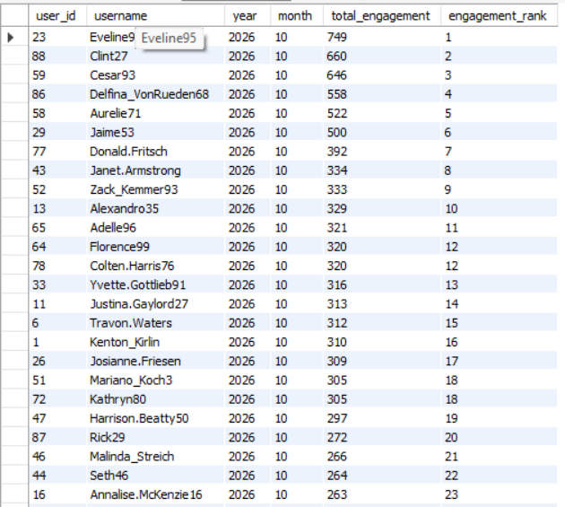
Q12 Retrieve the hashtags that have been used in posts with the highest average number of likes. Use a CTE to calculate the average likes for each hashtag first.
Output columns (in order): tag_id, tag_name, avg_likes_per_photo, total_likes, total_photos (5 columns)
Row count: 10 rows (LIMIT 10; 21 tags exist in total, so the limit is reached).
ANSWER
The following query retrieves the hashtags that have been used in posts with the highest number of likes.
(WITH CTE_HASHTAG_STATS AS (
SELECT
t.id AS tag_id,
t.tag_name,
COUNT(DISTINCT pt.photo_id) AS total_photos,
COUNT(l.user_id) AS total_likes,
(COUNT(l.user_id) * 1.0 / COUNT(DISTINCT pt.photo_id)) AS avg_likes_per_photo
FROM tags t
JOIN photo_tags pt
ON t.id = pt.tag_id
LEFT JOIN likes l
ON pt.photo_id = l.photo_id
GROUP BY
t.id,
t.tag_name
)
SELECT
tag_id,
tag_name,
avg_likes_per_photo,
total_likes,
total_photos
FROM CTE_HASHTAG_STATS
ORDER BY avg_likes_per_photo DESC, tag_id
LIMIT 10; )

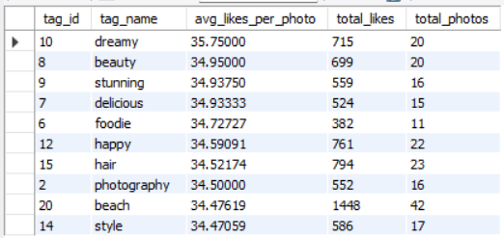
Q13 Retrieve the users who have started following someone after being followed by that person.
Output columns (in order): id, username (2 columns)
Row count: 77 rows (verified).
ANSWER
No such users.
The following query shows the output.
(WITH CTE_FOLLOWING AS (
SELECT
follower_id,
followee_id,
created_at
FROM follows
)
SELECT DISTINCT
u.id,
u.username
FROM users u
JOIN CTE_FOLLOWING f1
ON u.id = f1.follower_id
JOIN CTE_FOLLOWING f2
ON f1.followee_id = f2.follower_id
AND f1.follower_id = f2.followee_id
WHERE f1.created_at > f2.created_at
ORDER BY u.id; )

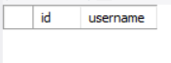

Subjective Questions
Q1 Based on user engagement and activity levels, which users would you consider the most loyal or valuable? How would you reward or incentivize these users?
ANSWER
The most loyal or valuable users are those who actively participate on the platform over time. Based on the dataset, I would identify them using the following factors:
- Users whose posts receive many likes and comments.
- Users who regularly post photos, like posts, and comment on other users content.
- Users who actively follow other users and interact with the community.
- Users who use hashtags frequently to make their content discoverable.
- Users who remain active over a longer period rather than participating only once.
How I would reward these users
Incentive | Description
Exclusive badges | Award badges such as “Top Contributor” or “Most Engaged User.”
Featured posts | Highlight their popular content on the platform.
Special recognition | Provide monthly awards to highly active users.
Exclusive features | Give loyal users early access to new features.
Personalized recommendations | Help their content reach users who may be interested in it.
Community rewards | Organize contests and offer rewards for meaningful participation.
Conclusion: I would prioritize users who demonstrate both high engagement and consistent activity. Rewarding them through recognition, featured content, and exclusive benefits could encourage continued participation, improve user retention, and strengthen the platform’s community.
(WITH CTE_POSTS AS (
SELECT
user_id,
COUNT(*) AS total_posts
FROM photos
GROUP BY user_id
),
CTE_LIKES_RECEIVED AS (
SELECT
p.user_id,
COUNT(*) AS likes_received
FROM photos p
JOIN likes l
ON p.id = l.photo_id
GROUP BY p.user_id
),
CTE_COMMENTS_RECEIVED AS (
SELECT
p.user_id,
COUNT(*) AS comments_received
FROM photos p
JOIN comments c
ON p.id = c.photo_id
GROUP BY p.user_id
),
CTE_LIKES_GIVEN AS (
SELECT
user_id,
COUNT(*) AS likes_given
FROM likes
GROUP BY user_id
),
CTE_COMMENTS_MADE AS (
SELECT
user_id,
COUNT(*) AS comments_made
FROM comments
GROUP BY user_id
),
CTE_USER_ACTIVITY AS (
SELECT
u.id AS user_id,
u.username,
COALESCE(p.total_posts, 0) AS total_posts,
COALESCE(lr.likes_received, 0) AS likes_received,
COALESCE(cr.comments_received, 0) AS comments_received,
COALESCE(lg.likes_given, 0) AS likes_given,
COALESCE(cm.comments_made, 0) AS comments_made,
(COALESCE(lr.likes_received, 0) + COALESCE(cr.comments_received, 0)) AS engagement_received,
(COALESCE(lg.likes_given, 0) + COALESCE(cm.comments_made, 0)) AS engagement_given
FROM users u
LEFT JOIN CTE_POSTS p
ON u.id = p.user_id
LEFT JOIN CTE_LIKES_RECEIVED lr
ON u.id = lr.user_id
LEFT JOIN CTE_COMMENTS_RECEIVED cr
ON u.id = cr.user_id
LEFT JOIN CTE_LIKES_GIVEN lg
ON u.id = lg.user_id
LEFT JOIN CTE_COMMENTS_MADE cm
ON u.id = cm.user_id
)
SELECT
*,
(engagement_received + engagement_given) AS total_activity_score,
DENSE_RANK() OVER(ORDER BY engagement_received + engagement_given DESC) AS user_rank
FROM CTE_USER_ACTIVITY; )

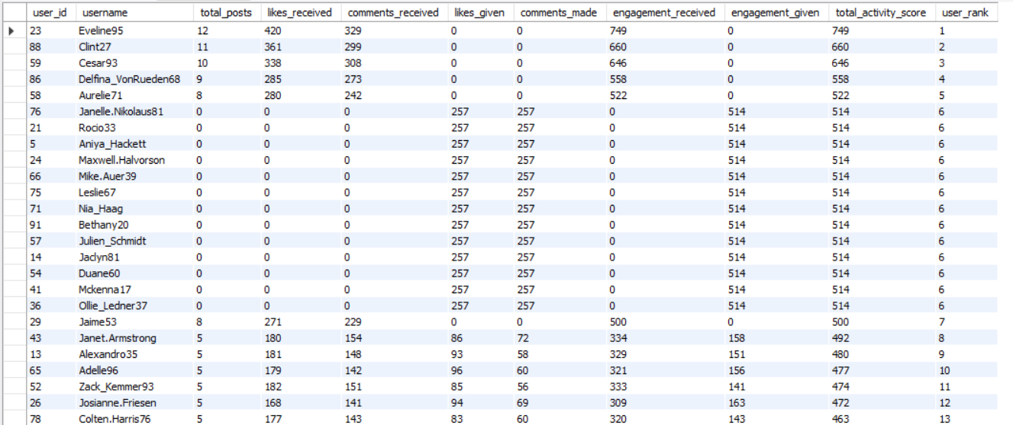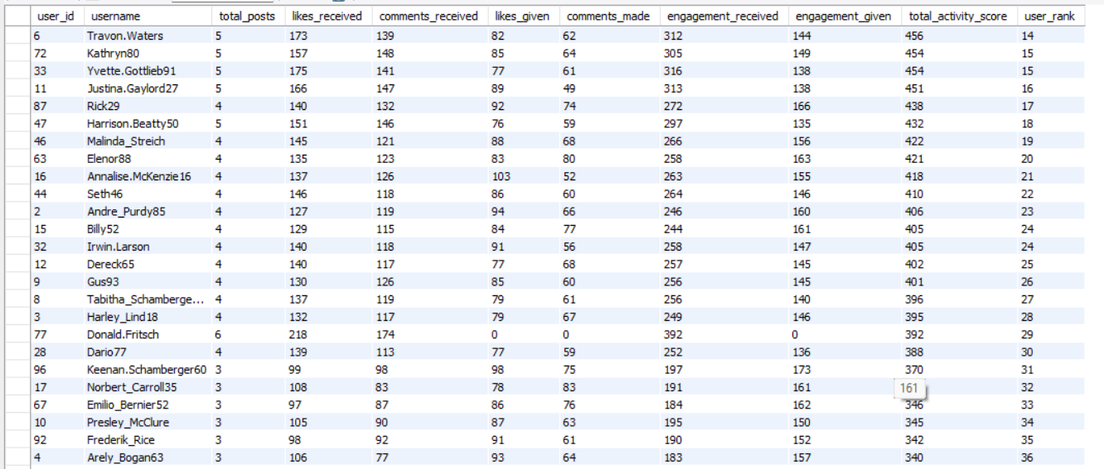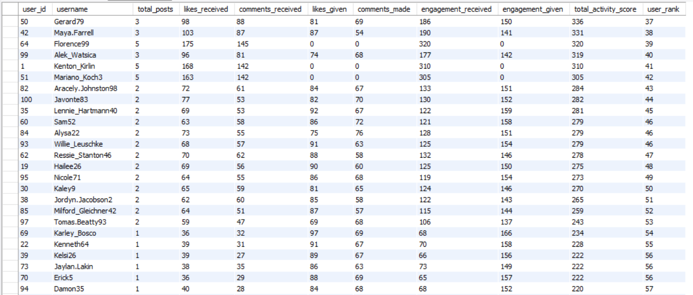
Q2 For inactive users, what strategies would you recommend to re-engage them and encourage them to start posting or engaging again?
ANSWER
Inactive users are those who have not posted photos, liked posts, or commented for a long period.
Recommended Re-engagement Strategies
Personalized notifications - | Remind users about popular posts and relevant content.
Email campaigns - | Send a friendly reminder to users who have been inactive.
Posting challenges - | Encourage users to share photos through weekly themes or contests.
Personalized recommendations | Suggest hashtags, accounts, and posts based on their interests.
Incentives and badges - | Reward users for returning and participating again.
Feedback surveys - | Ask inactive users what prevented them from using the platform.
3. Measure Success
Track these metrics after launching the campaigns:
- Reactivation rate: Percentage of inactive users who return.
- Posting rate: Number of reactivated users who publish a photo.
- Engagement rate: Likes and comments generated after reactivation.
- Retention rate: Percentage of reactivated users who remain active over the following weeks.
Conclusion: I would first identify inactive users with SQL, then send personalized reminders and offer simple posting challenges. Finally, I would compare reactivation and retention rates to determine which strategies work best.
The following query gives the inactive users
(WITH CTE_USER_ACTIVITY AS
(SELECT
u.id AS user_id,
u.username,
COUNT(DISTINCT p.id) AS photos_posted,
COUNT(DISTINCT l.photo_id) AS likes_given,
COUNT(DISTINCT c.id) AS comments_made
FROM users u
LEFT JOIN photos p
ON u.id = p.user_id
LEFT JOIN likes l
ON u.id = l.user_id
LEFT JOIN comments c
ON u.id = c.user_id
GROUP BY u.id, u.username
)
SELECT
user_id,
username,
photos_posted,
likes_given,
comments_made,
CASE
WHEN photos_posted = 0 AND likes_given = 0 AND comments_made = 0 THEN 'Totally Inactive'
WHEN photos_posted = 0 THEN 'Does Not Post But Engages'
WHEN likes_given = 0 AND comments_made = 0 THEN 'Posts But Does Not Engage'
ELSE 'Fully Active User'
END AS activity_status
FROM CTE_USER_ACTIVITY ; )

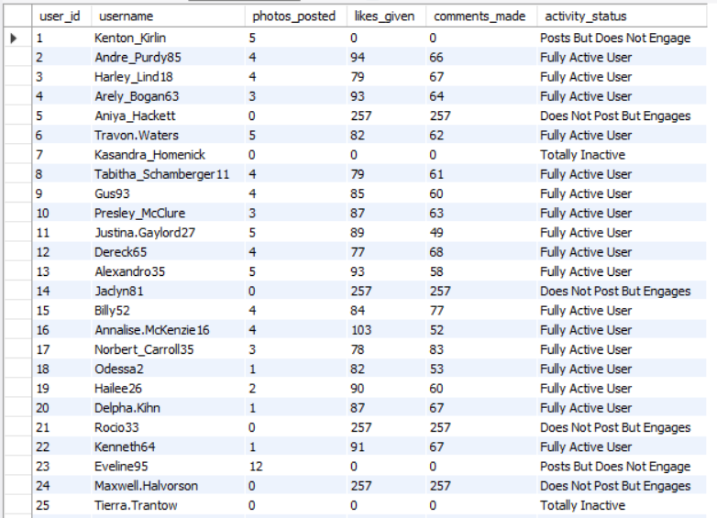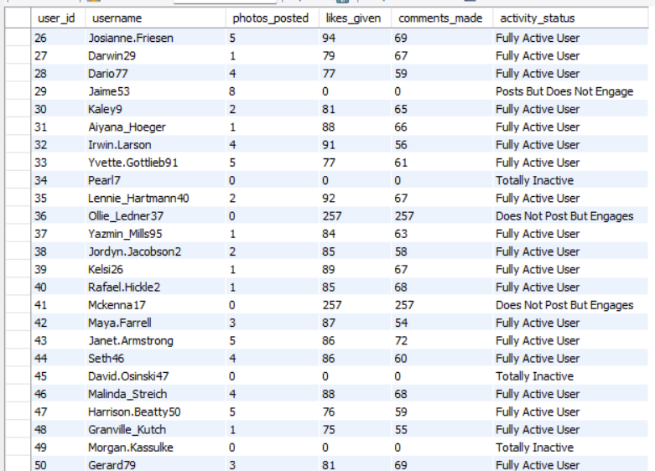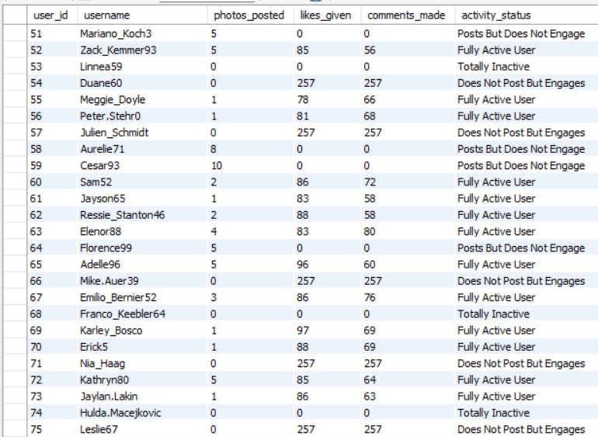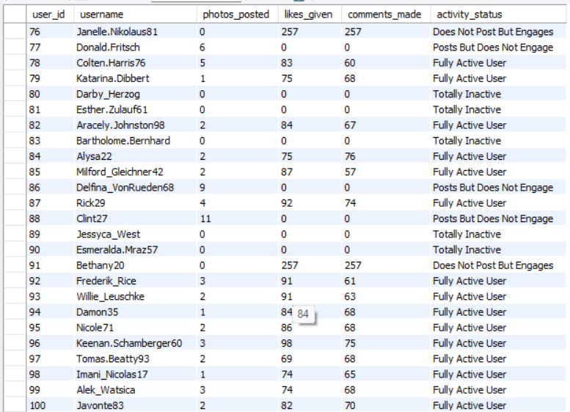

Q3 Which hashtags or content topics have the highest engagement rates? How can this information guide content strategy and ad campaigns?
ANSWER
This query analyzes engagement at the hashtag level by first creating two CTEs, Likes and Comments, which calculate the total number of likes and comments for each photo using photo_id.
The tags table is then joined with the photo_tags table to associate each hashtag with its related photos, and left joins are used to bring in the corresponding like and comment counts for each photo.
For every tag, the query computes the total number of posts, total likes, and total comments.
The engagement rate is calculated as the average combined number of likes and comments per post for each tag.
Finally, the results are sorted in descending order based on average engagement, and the top 10 hashtags are returned, helping identify the most engaging tags to support content strategy and advertising decisions.
This insight helps shape a content strategy by encouraging creators and marketers to use top-performing hashtags and create content around those themes. It also enables targeted ad campaigns by aligning product promotions with users’ current interests.
By analyzing historical performance data, we can identify "high-yield" topics and hashtags. Prioritizing these subjects ensures that content production resources are allocated toward themes with the highest probability of virality and user retention.
Insights from hashtag interactions should feed directly into the platform’s recommendation engine. Personalizing a user’s feed based on their "hashtag affinity" enhances the User Experience (UX) and increases daily active usage.

(WITH CTE_HASHTAG_ENGAGEMENT AS (
SELECT
t.id AS tag_id,
t.tag_name,
COUNT(DISTINCT pt.photo_id) AS total_photos,
COUNT(l.user_id) AS total_likes,
ROUND(COUNT(l.user_id) * 1.0 / COALESCE(COUNT(DISTINCT pt.photo_id), 0),2) AS avg_likes_per_photo
FROM tags t
JOIN photo_tags pt
ON t.id = pt.tag_id
LEFT JOIN likes l
ON pt.photo_id = l.photo_id
GROUP BY
t.id,
t.tag_name
)
SELECT
tag_id,
tag_name,
avg_likes_per_photo,
total_likes,
total_photos
FROM CTE_HASHTAG_ENGAGEMENT
ORDER BY avg_likes_per_photo DESC, total_photos DESC
LIMIT 10; )
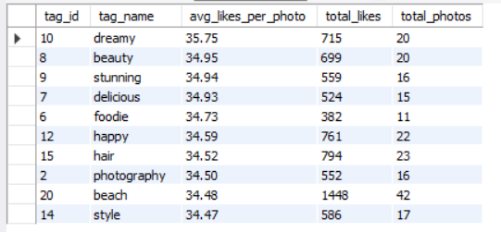

Q4 Are there any patterns or trends in user engagement based on demographics (age, location, gender) or posting times? How can these insights inform targeted marketing campaigns?
ANSWER

This query examines photo engagement over time by calculating posts, likes, and comments for different time periods. It first creates two CTEs, Total_Likes and Total_Comments, to count the total likes and comments for each photo. The main query joins this data with the photos table and extracts the hour of the day and day of the week from the photo creation time. The results are grouped by hour and day to identify peak engagement periods, and the average engagement is calculated by dividing the total likes and comments by the number of posts.

(WITH CTE_TOTAL_LIKES AS (
SELECT
photo_id,
COUNT(*) AS total_likes
FROM likes
GROUP BY photo_id
),

CTE_TOTAL_COMMENTS AS (
SELECT
photo_id,
COUNT(*) AS total_comments
FROM comments
GROUP BY photo_id
)

SELECT
DATE_FORMAT(p.created_dat, '%H') AS hour_of_day,
DAYNAME(p.created_dat) AS day_of_week,
COUNT(p.id) AS total_posts,
COALESCE(SUM(tl.total_likes), 0) AS total_likes,
COALESCE(SUM(tc.total_comments), 0) AS total_comments,
ROUND(
(
COALESCE(SUM(tl.total_likes), 0)
+ COALESCE(SUM(tc.total_comments), 0)
) / COUNT(p.id),
2
) AS average_engagement
FROM photos p
LEFT JOIN CTE_TOTAL_LIKES tl
ON p.id = tl.photo_id
LEFT JOIN CTE_TOTAL_COMMENTS tc
ON p.id = tc.photo_id
GROUP BY
DATE_FORMAT(p.created_dat, '%H'),
DAYNAME(p.created_dat)
ORDER BY average_engagement DESC;)
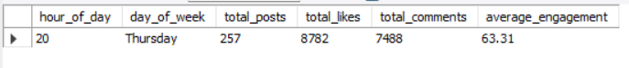
Q5 Based on follower counts and engagement rates, which users would be ideal candidates for influencer marketing campaigns? How would you approach and collaborate with these influencers?
ANSWER
This query identifies the top 10 users suitable for influencer marketing by analyzing follower counts and engagement rates. It first calculates the number of followers for each user in the CTE_FOLLOWERS and totals likes and comments per user in the CTE_POST_ENGAGEMENT and CTE_USER_ENGAGEMENT. These results are then combined with the users table, using COALESCE to handle missing values and computing an engagement rate based on likes and comments relative to follower count. Finally, users with at least one follower are filtered and ranked by engagement

(WITH CTE_FOLLOWERS AS (
SELECT
followee_id AS user_id,
COUNT(*) AS follower_count
FROM follows
GROUP BY followee_id
),
CTE_POST_ENGAGEMENT AS (
SELECT
p.user_id,
p.id AS photo_id,
COUNT(DISTINCT l.user_id) AS likes_received,
COUNT(DISTINCT c.id) AS comments_received
FROM photos p
LEFT JOIN likes l
ON p.id = l.photo_id
LEFT JOIN comments c
ON p.id = c.photo_id
GROUP BY p.user_id, p.id
),
CTE_USER_ENGAGEMENT AS (
SELECT
user_id,
COUNT(*) AS total_posts,
SUM(likes_received) AS total_likes,
SUM(comments_received) AS total_comments,
ROUND(
AVG(likes_received + comments_received), 2
) AS avg_engagement_per_post
FROM CTE_POST_ENGAGEMENT
GROUP BY user_id
),
CTE_INFLUENCER_SCORE AS (
SELECT
u.id AS user_id,
u.username,
COALESCE(f.follower_count, 0) AS follower_count,
COALESCE(e.total_posts, 0) AS total_posts,
COALESCE(e.total_likes, 0) AS total_likes,
COALESCE(e.total_comments, 0) AS total_comments,
COALESCE(e.avg_engagement_per_post, 0)
AS avg_engagement_per_post
FROM users u
LEFT JOIN CTE_FOLLOWERS f
ON u.id = f.user_id
LEFT JOIN CTE_USER_ENGAGEMENT e
ON u.id = e.user_id
)
SELECT
*,
DENSE_RANK() OVER (
ORDER BY follower_count DESC,
avg_engagement_per_post DESC
) AS influencer_rank
FROM CTE_INFLUENCER_SCORE
WHERE total_posts > 0
ORDER BY influencer_rank, user_id
LIMIT 10; )
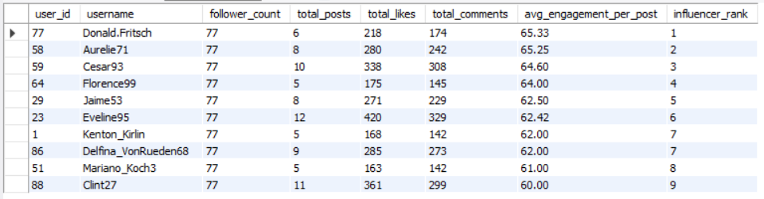
Q6 Based on user behavior and engagement data, how would you segment the user base for targeted marketing campaigns or personalized recommendations?
ANSWER
Based on user behaviour and engagement data, I would segment the user base in following way…
1. Highly Active Users
- Criteria: Users with at least 5 posts and 10 or more total interactions (likes + comments).
- Characteristics:
  - Frequently create and engage with content.
  - Contribute significantly to platform activity.
- Strategy:
  - Offer loyalty rewards and exclusive features.
  - Promote influencer or creator programs.
  - Prioritize their content in recommendation feeds.
2. Content Creators
- Criteria: Users who post content but rarely interact with others.
- Characteristics:
  - Focus on sharing content rather than engaging socially.
- Strategy:
  - Encourage community participation through engagement prompts.
  - Recommend similar creators to follow.
  - Provide analytics and content-performance insights.
3. Engaged Viewers
- Criteria: Users who frequently like or comment but do not create posts.
- Characteristics:
  - Consume and interact with content regularly.
  - Potential future content creators.
- Strategy:
  - Encourage first-time posting through campaigns or challenges.
  - Recommend trending content and creators.
  - Offer incentives for content creation.
4. Moderately Active Users
- Criteria: Users with occasional posting and engagement activity.
- Characteristics:
  - Participate sporadically across platform features.
- Strategy:
  - Send personalized recommendations based on interests.
  - Surface popular and relevant content to increase activity.
  - Use engagement reminders and notifications.
5. Inactive Users
- Criteria: No posts, likes, or comments.
- Characteristics:
  - Little or no interaction with the platform.
- Strategy:
  - Run re-engagement campaigns.
  - Send personalized content suggestions and email notifications.
  - Offer incentives such as promotions or onboarding tutorials.
The following query segments the data…

(WITH CTE_POSTS AS (
SELECT
user_id,
COUNT(*) AS total_posts
FROM photos
GROUP BY user_id
),
CTE_LIKES AS (
SELECT
user_id,
COUNT(*) AS likes_given
FROM likes
GROUP BY user_id
),
CTE_COMMENTS AS (
SELECT
user_id,
COUNT(*) AS comments_made
FROM comments
GROUP BY user_id
),
CTE_FOLLOWERS AS (
SELECT
followee_id AS user_id,
COUNT(*) AS follower_count
FROM follows
GROUP BY followee_id
),
CTE_USER_ACTIVITY AS (
SELECT
u.id AS user_id,
u.username,
COALESCE(p.total_posts, 0) AS total_posts,
COALESCE(l.likes_given, 0) AS likes_given,
COALESCE(c.comments_made, 0) AS comments_made,
COALESCE(f.follower_count, 0) AS follower_count
FROM users u
LEFT JOIN CTE_POSTS p
ON u.id = p.user_id
LEFT JOIN CTE_LIKES l
ON u.id = l.user_id
LEFT JOIN CTE_COMMENTS c
ON u.id = c.user_id
LEFT JOIN CTE_FOLLOWERS f
ON u.id = f.user_id
)
SELECT
user_id,
username,
total_posts,
likes_given,
comments_made,
follower_count,
CASE
WHEN total_posts = 0 AND likes_given = 0 AND comments_made = 0 THEN 'Inactive Users'
WHEN total_posts >= 5 AND likes_given + comments_made >= 10 THEN 'Highly Active Users'
WHEN total_posts > 0 AND likes_given + comments_made = 0 THEN 'Content Creators'
WHEN likes_given + comments_made > 0 AND total_posts = 0 THEN 'Engaged Viewers'
ELSE 'Moderately Active Users'
END AS user_segment
FROM CTE_USER_ACTIVITY
ORDER BY user_id; )
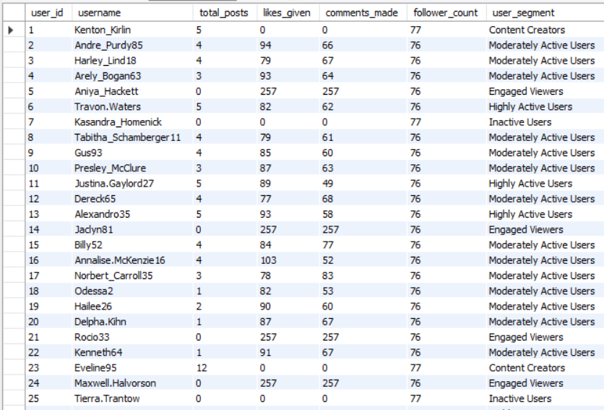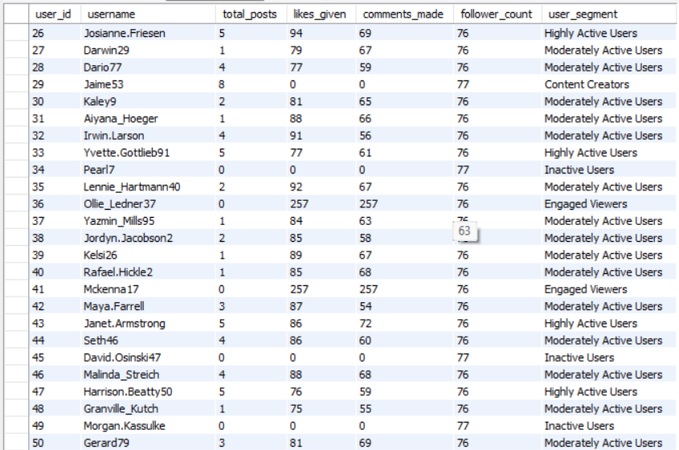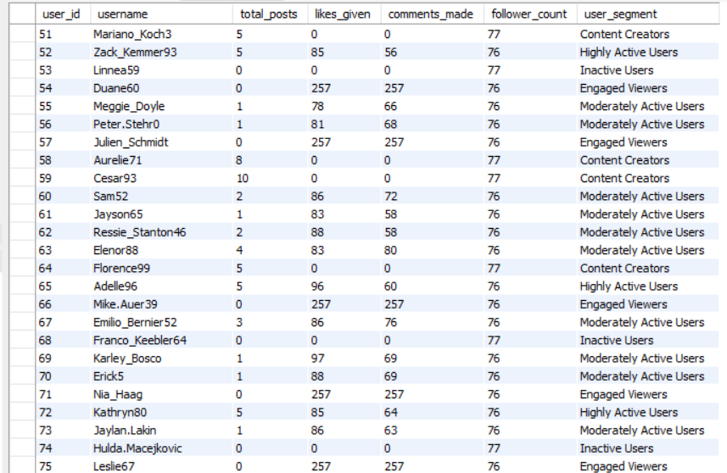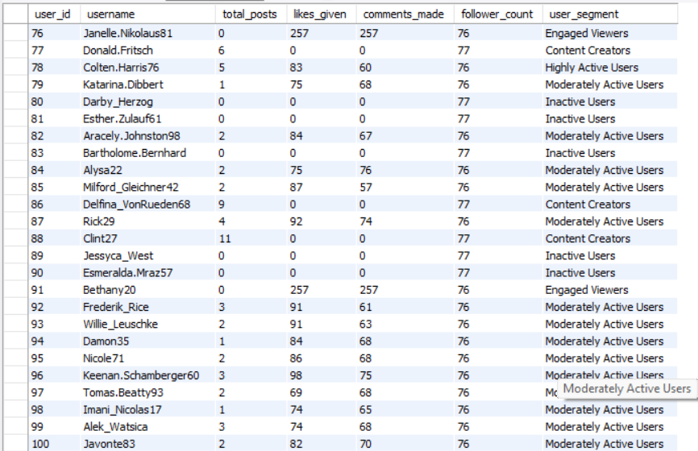
Q7 If data on ad campaigns (impressions, clicks, conversions) is available, how would you measure their effectiveness and optimize future campaigns?
ANSWER
To evaluate the effectiveness of ad campaigns, I would analyze key performance metrics such as Click-Through Rate (CTR), Conversion Rate, Cost Per Click (CPC), Cost Per Acquisition (CPA), and Return on Ad Spend (ROAS).
- CTR measures the percentage of users who click on an ad after seeing it and helps assess the effectiveness of the ad creative and targeting strategy.
- Conversion Rate indicates how successfully clicks are converted into desired actions such as purchases, sign-ups, or downloads.
- CPC and CPA help determine the cost efficiency of generating traffic and acquiring customers.
- ROAS measures the revenue generated for every dollar spent on advertising and is a key indicator of campaign profitability.
By comparing these metrics across different campaigns, audience segments, and content formats, we can identify high-performing ads and areas for improvement. Campaigns with strong CTR and conversion rates should receive additional budget, while underperforming campaigns may require changes to targeting, messaging, or creatives. A/B testing can also be used to evaluate different ad versions and optimize future campaigns.
Conclusion
Monitoring CTR, Conversion Rate, CPC, CPA, and ROAS provides a comprehensive view of campaign performance. These insights help marketers optimize budget allocation, improve targeting strategies, enhance ad creatives, and maximize overall return on investment.

Q8 How can you use user activity data to identify potential brand ambassadors or advocates who could help promote Instagram's initiatives or events?
ANSWER
Potential brand ambassadors can be identified by analyzing user activity, engagement levels, influence, and content consistency. Rather than focusing only on follower count, the goal is to identify highly engaged users who actively contribute to the platform and positively influence their communities.
Key Indicators for Identifying Brand Ambassadors
1. Engagement and Activity Level
- Users who consistently post content, like posts, and comment on others' content.
- Users with high engagement rates on their posts, indicating strong audience interaction.
- Users who regularly participate in platform trends, campaigns, or hashtag challenges.
2. Influence and Reach
- Users with a large and active follower base.
- Users whose content generates significant likes, comments, and shares.
- Users who are influential within specific niches such as fashion, fitness, travel, food, or photography.
3. Loyalty and Advocacy
- Long-term users who remain consistently active over time.
- Users who organically promote platform features, events, or campaigns without incentives.
- Users who frequently use branded hashtags or participate in official initiatives.
4. Content Quality and Brand Alignment
- Users who create high-quality and engaging content.
- Accounts whose content style aligns with the platform's values and campaign objectives.
- Users who maintain positive interactions and contribute to a healthy community environment.
Strategies for Ambassador Programs
Once potential ambassadors are identified, the platform can:
- Offer exclusive access to new features and beta programs.
- Invite them to participate in platform events and promotional campaigns.
- Provide recognition through ambassador badges or featured creator programs.
- Collaborate with them to create authentic, user-generated promotional content.
- Reward top advocates through incentives, partnerships, or creator support initiatives.
Conclusion
By analyzing posting activity, engagement metrics, follower networks, and content quality, organizations can identify users who have both influence and strong platform loyalty. These users can serve as effective brand ambassadors, helping increase awareness, drive engagement, and promote platform initiatives through authentic community-driven advocacy.

Q9 How would you approach this problem, if the objective and subjective questions weren't given?
ANSWER
If the objective and subjective questions were not provided, I would take a structured, data-driven approach to understand the dataset, uncover meaningful patterns, and generate actionable business insights.
1. Understand the Business Context
The first step would be identifying the platform's core objectives, such as increasing user engagement, improving retention, growing the creator ecosystem, and maximizing monetization opportunities. Understanding these goals helps ensure that the analysis focuses on metrics that create business value.
2. Explore the Data and Validate Quality
Before performing any analysis, I would review the database schema and relationships between tables such as users, photos, likes, comments, follows, and tags. I would also check for:
- Missing or null values
- Duplicate records
- Invalid relationships or orphaned records
- Inconsistent timestamps or data formats
This ensures the analysis is based on reliable data.
3. Perform Exploratory Data Analysis (EDA)
Next, I would calculate fundamental KPIs to understand user and content behavior:
- User activity levels (posts, likes, comments)
- Engagement metrics (likes, comments, engagement rate)
- Follower and following trends
- Content performance by tag or category
- Activity trends by day and hour
This helps identify patterns, anomalies, and areas worth deeper investigation.
4. Develop and Test Hypotheses
Based on initial observations, I would create business-focused hypotheses such as:
- Do users who post more frequently receive higher engagement?
- Which content categories generate the most interactions?
- Does posting time influence engagement?
- Are hashtags associated with increased reach and visibility?
SQL queries and statistical analysis would then be used to validate these assumptions.
5. Analyze User Segments and Content Trends
To gain deeper insights, I would segment users into groups such as:
- Power Users
- Content Creators
- Engaged Viewers
- Moderately Active Users
- Inactive Users
Similarly, I would analyze content categories and hashtags to identify trending topics, niche communities, and high-performing content types.
6. Apply Advanced Analysis
Using techniques such as CTEs, window functions, and multi-table joins, I would investigate:
- Influencer identification
- Brand ambassador potential
- Retention and churn behavior
- Engagement drivers
- Community and network dynamics
This transforms raw data into meaningful business intelligence.
7. Visualize Findings and Provide Recommendations
Finally, I would present the results using dashboards, charts, and reports to communicate insights effectively. Based on the findings, I would recommend strategies such as:
- Encouraging high-performing content categories
- Optimizing posting schedules
- Rewarding top contributors and creators
- Re-engaging inactive users
- Personalizing content recommendations
Conclusion
Without predefined questions, I would follow a systematic process consisting of data validation, exploratory analysis, hypothesis testing, user segmentation, trend analysis, and visualization. This approach enables the discovery of meaningful insights and supports data-driven decisions for improving user engagement, retention, content strategy, and overall platform growth.

Q10 Assuming there's a "User_Interactions" table tracking user engagements, how can you update the "Engagement_Type" column to change all instances of "Like" to "Heart" to align with Instagram's terminology?
ANSWER
To align the backend database terminology with the platform's user interface, all occurrences of "Like" in the Engagement_Type column can be updated to "Heart" using a simple SQL UPDATE statement.
(UPDATE User_Interactions
SET Engagement_Type = 'Heart'
WHERE Engagement_Type = 'Like'; )

- The UPDATE statement specifies the table where the modification will occur.
- The SET clause changes the value from 'Like' to 'Heart'.
- The WHERE clause ensures that only records with Engagement_Type = 'Like' are updated.
- Without the WHERE condition, all rows in the column would be changed, potentially leading to incorrect data.
Recommended Best Practices
Before executing the update in a production environment, it is advisable to:
- Verify the number of affected records:
SQL
SELECT COUNT(*)
FROM User_Interactions
WHERE Engagement_Type = 'Like';
- Use transactions to allow rollback if needed:
SQL
BEGIN;

UPDATE User_Interactions
SET Engagement_Type = 'Heart'
WHERE Engagement_Type = 'Like';

COMMIT;
- Ensure a recent backup exists before performing bulk updates.
Conclusion
This update ensures consistency between the application's branding and the database records by replacing all instances of "Like" with "Heart" while preserving the integrity of other engagement types.

