MYSQL
Assignment-2
Retrieve data using join with where clause

Sample table1: salesman
-salesman_id
-name -city
-commission Sample
table2: customer
-customer_id
-cust_name
-city
-grade
-salesman_id Sample
table3: orders
-ord_no
-purch_amt
-ord_date
-customer_id
-salesman_id

1. write a SQL query to find the salesperson and customer who reside in the same city. Return Salesman, cust_name and city
==>>
SELECT salesman.name AS "Salesman", customer.cust_name,customer.city
FROM salesman,customer WHERE salesman.city=customer.city;
OUTPUT:-
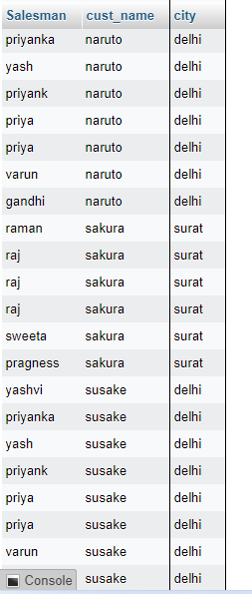

2. write a SQL query to find those orders where the order amount exists between 500 and 2000. Return ord_no, purch_amt, cust_name, city
==>>
SELECT c.ord_no,c.purch_amt, s.cust_name,s.city FROM orders c,customer s WHERE c.customer_id=s.customer_id AND c.purch_amt BETWEEN 500 AND 2000;
OUTPUT:-
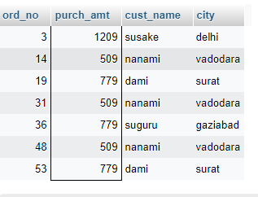

3. write a SQL query to find the salesperson(s) and the customer(s) he represents. Return Customer Name, city, Salesman, commission
==>>
SELECT c.cust_name AS "Customer Name", c.city, s.name AS "Salesman", s.commission FROM customer c INNER JOIN salesman s ON c.salesman_id=s.salesman_id;

OUTPUT:-
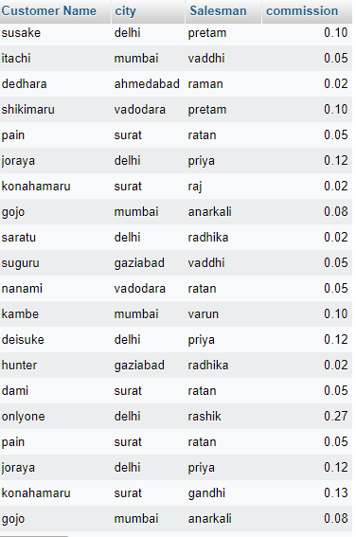

4. write a SQL query to find salespeople who received commissions of more than 12 percent from the company. Return Customer Name, customer city, Salesman, commission.
==>>
select c.cust_name as 'Customer Name', c.city as 'customer city', s.name as 'Salesman', s.commission FROM customer c,salesman s WHERE s.commission >0.12;
OUTPUT:-
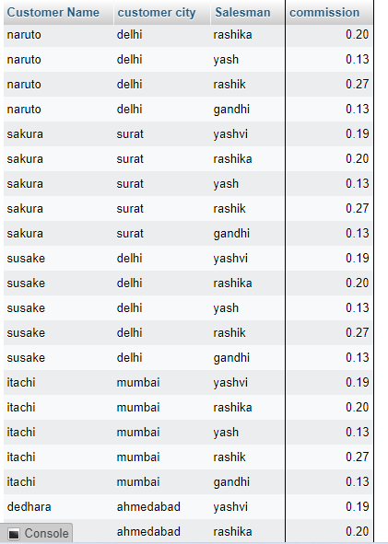

5. write a SQL query to locate those salespeople who do not live in the same city where their customers live and have received a commission of more than 12% from the company. Return Customer Name, customer city, Salesman, salesman city, commission.
==>>
SELECTc.cust_name AS "Customer Name",c.city, s.name AS "Salesman", s.city,s.commission FROM customer c INNER JOIN salesman s ON c.salesman_id=s.salesman_id WHERE s.commission>.12 AND c.city<>s.city;
OUTPUT:-
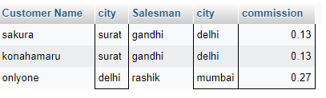

6. write a SQL query to find the details of an order. Return ord_no, ord_date, purch_amt, Customer Name, grade, Salesman, commission.
==>>
SELECTc.ord_no,c.ord_date,c.purch_amt, s.cust_name AS "Customer Name", s.grade, o.name AS "Salesman", o.commission FROM orders c INNER JOIN customer s ON c.customer_id=s.customer_id INNER JOIN salesman o ON c.salesman_id=o.salesman_id;
OUTPUT:-
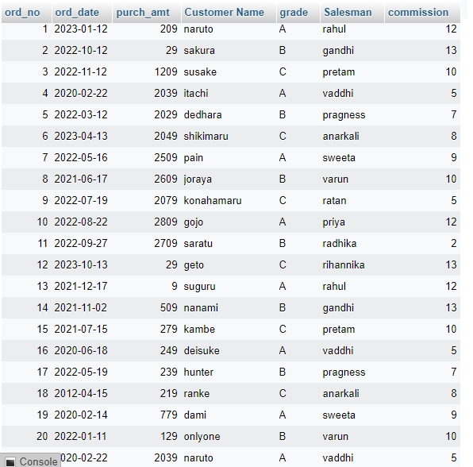

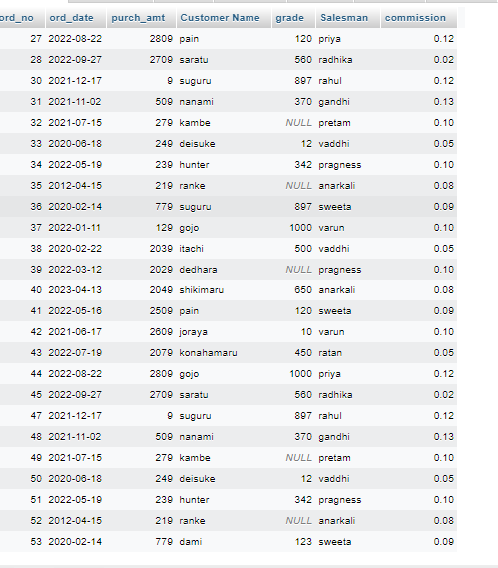

7. Write a SQL statement to join the tables salesman, customer and orders so that the same column of each table appears once and only the relational rows are returned.
==>> SELECT o.ord_no, o.ord_date, o.purch_amt,o.customer_id, o.salesman_id, c.cust_name, c.city, c.grade, s.name, s.city, s.commission FROM orders o join customer c on o.customer_id=c.customer_id JOIN salesman s ON o.salesman_id=s.salesman_id;
OUTPUT:-
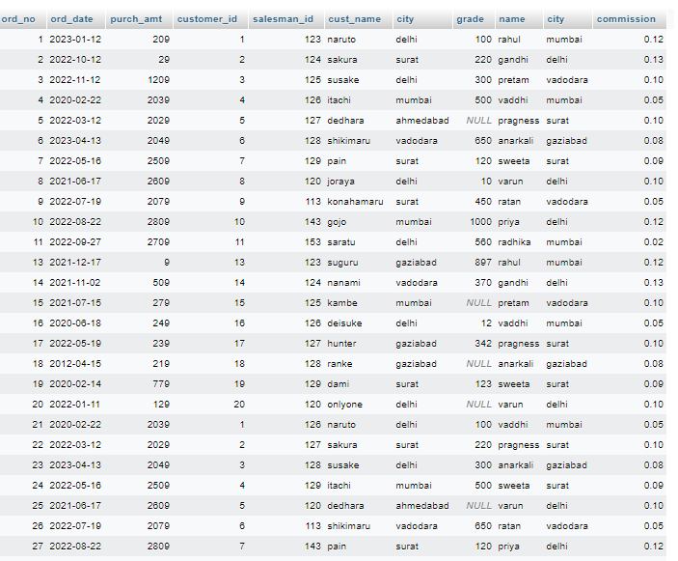

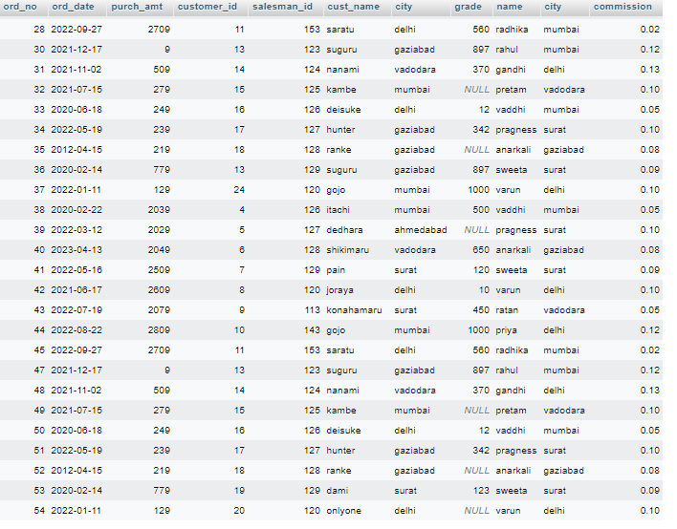

8. write a SQL query to display the customer name, customer city, grade, salesman, salesman city. The results should be sorted by ascending customer_id.
==>>
SELECT a.cust_name,a.city,a.grade, b.name AS "Salesman",b.city FROM customer a LEFT JOIN salesman b ON a.salesman_id=b.salesman_id order by a.customer_id;
OUTPUT:-
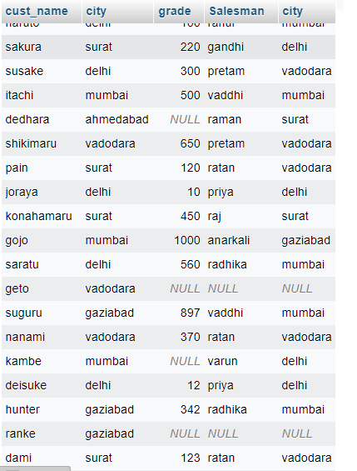

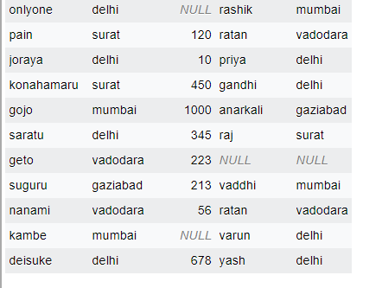

9.write a SQL query to find those customers with a grade less than 300. Return cust_name, customer city, grade, Salesman, salesmancity. The result should be ordered by ascending customer_id.
==>>
SELECT c.cust_name,c.city,c.grade, s.name AS "Salesman", s.city FROM customer c JOIN salesman c ON c.salesman_id=s.salesman_id WHERE c.grade<300;
OUTPUT:-
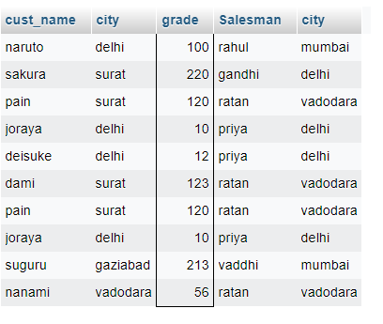

10. Write a SQL statement to make a report with customer name, city, order number, order date, and order amount in ascending order according to the order date to determine whether any of the existing customers have placed an order or not .
==>>
SELECT c.cust_name,c.city, s.ord_no, s.ord_date,s.purch_amt AS "Order Amount"
FROM customer c JOIN orders s ON c.customer_id=s.customer_id order by s.ord_date;
OUTPUT:-
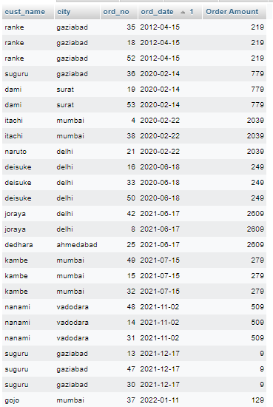

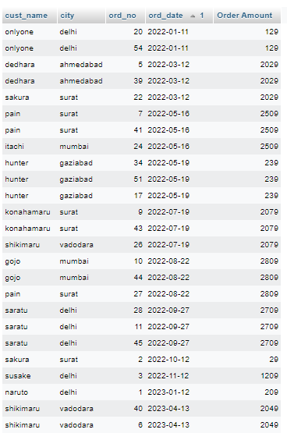

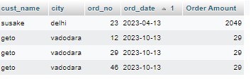

11. Write a SQL statement to generate a report with customer name, city, order number, order date, order amount, salesperson name, and commission to determine if any of the existing customers have not placed orders or if they have placed orders through their salesman or by themselves .
==>>
SELECT c.cust_name as 'customer name',c.city, s.ord_no, s.ord_date,s.purch_amt AS "Order Amount", o.name,o.commission
FROM customer c LEFT JOIN orders s ON c.customer_id=s.customer_id LEFT JOIN salesman o ON o.salesman_id=s.salesman_id;
OUTPUT:-
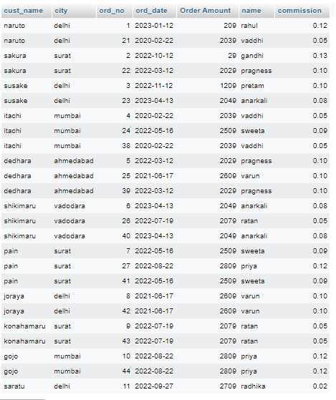

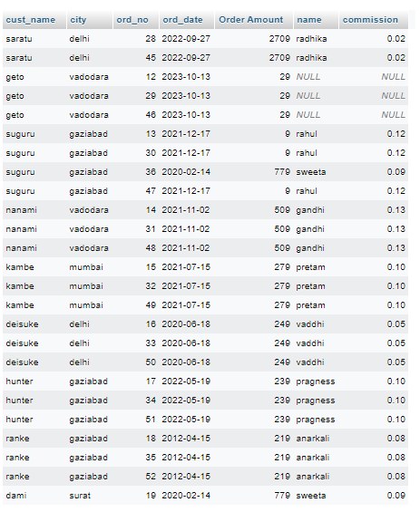

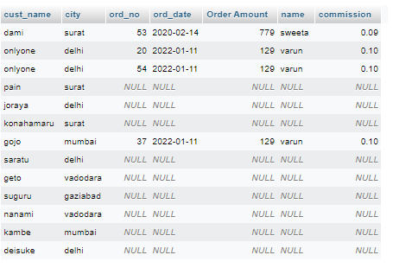

12. Write a SQL statement to generate a list in ascending order of salespersons who work either for one or more customers or have not yet joined any of the customers.
==>>
SELECT s.name as 'salepersons' FROM salesman s left JOIN customer c ON c.salesman_id=s.salesman_id ORDER BY s.name;
OUTPUT:-
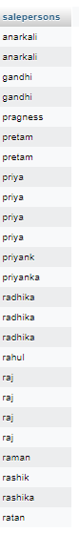

13. write a SQL query to list all salespersons along with customer name, city, grade, order number, date, and amount.
==>>
SELECT c.cust_name,c.city,c.grade, s.name AS "Salesman", O.ord_no, O.ord_date, O.purch_amt FROM salesman s INNER JOIN customer c ON s.salesman_id=c.salesman_id Inner JOIN orders o ON o.customer_id=c.customer_id;
OUTPUT:-

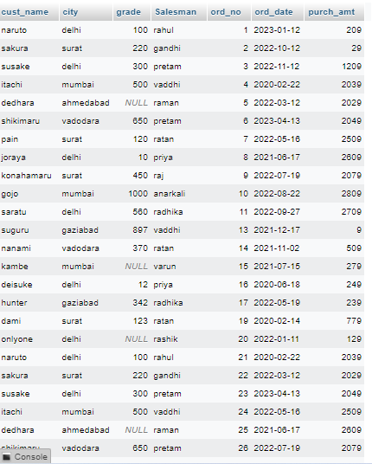

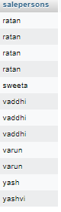

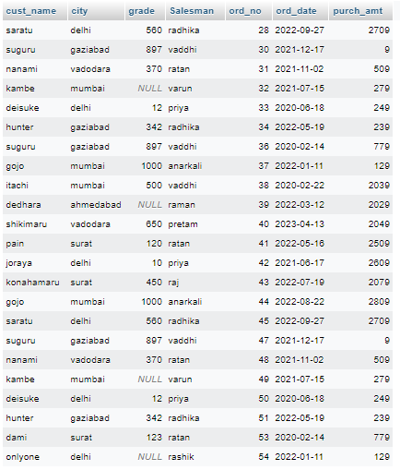

14. Write a SQL statement to make a list for the salesmen who either work for one or more customers or yet to join any of the customers. The customer may have placed, either one or more orders on or above order amount 2000 and must have a grade, or he may not have placed any order to the associated supplier.
==>>
SELECT s.salesman_id, s.name AS 'salesperson' FROM salesman s LEFT JOIN customer c ON s.salesman_id=c.salesman_id LEFT JOIN orders o ON c.customer_id=o.customer_id WHERE (o.purch_amt > 2000 AND grade IS NOT null)OR o.ord_no is null;
OUTPUT:-
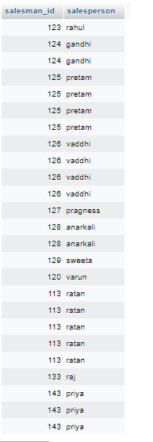

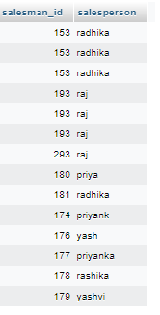

15. Write a SQL statement to generate a list of all the salesmen who either work for one or more customers or have yet to join any of them. The customer may have placed one or more orders at or above order amount 2000, and must have a grade, or he may not have placed any orders to the associated supplier.
==>>
SELECT s.salesman_id, s.name AS 'salesman' FROM salesman s LEFT JOIN customer c ON s.salesman_id=c.salesman_id LEFT JOIN orders o ON c.customer_id=o.customer_id WHERE (o.purch_amt > 2000 AND grade IS NOTnull)OR (o.ord_no is null);
OUTPUT:-
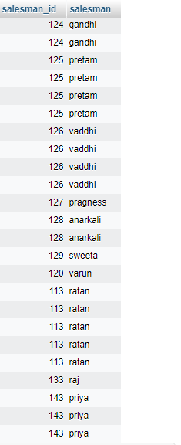

16. Write a SQL statement to generate a report with the customer name, city, order no. order date, purchase amount for only those customers on the list who must have a grade and placed one or more orders or which order(s) have been placed by the customer who neither is on the list nor has a grade.
==>>
SELECT c.cust_name AS 'customer name', c.city, o.ord_no as 'order no.', o.ord_date as 'order date', o.purch_amt AS 'purchase amount' FROM customer c JOIN orders o ON c.customer_id=o.customer_id WHERE (c.grade is not NULL and o.ord_no is null) or ( o.ord_no in ( SELECT oe.ord_no from orders oe WHERE oe.customer_id NOT IN (SELECT customer_id from customer)));
OUTPUT:-
NO DATA

17.Write a SQL query to combine each row of the salesman table with each row of the customer table.
==>>
SELECT * FROM `salesman` CROSS JOIN customer;
OUTPUT:-
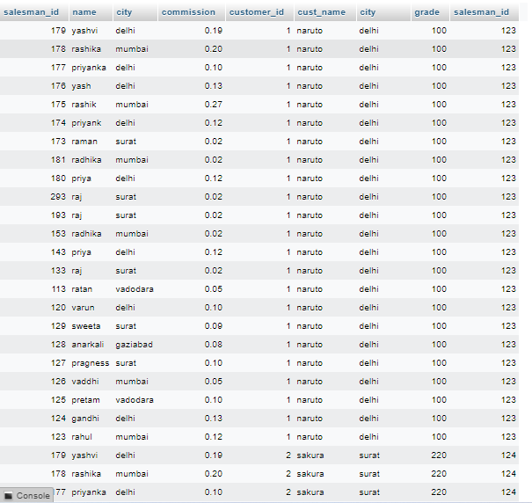

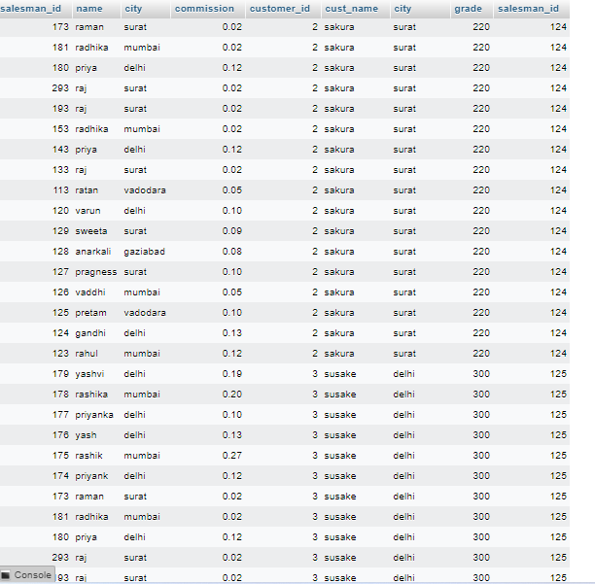

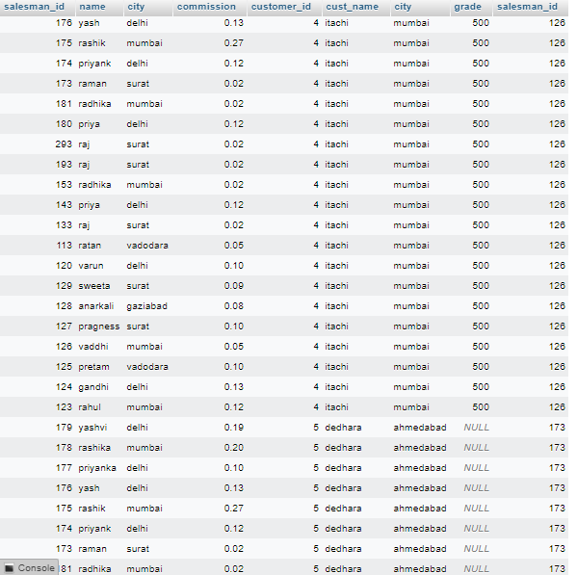

18. Write a SQL statement to create a Cartesian product between salesperson and customer, i.e. each salesperson will appear for all customers and vice versa for that salesperson who belongs to that city .
==>>
SELECT * FROM salesman s CROSS JOIN customer c WHERE s.city = c.city;
OUTPUT:-
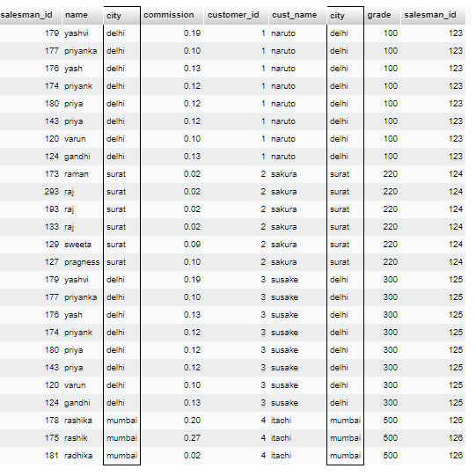

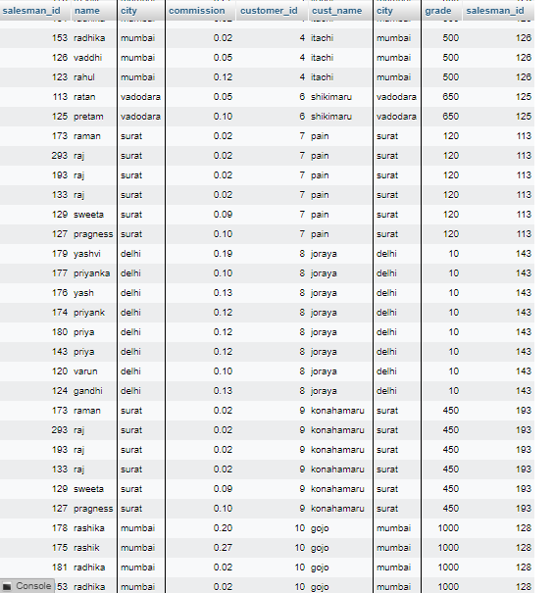

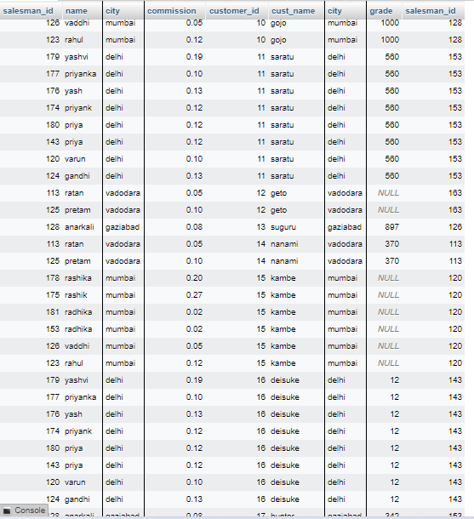

19. Write a SQL statement to create a Cartesian product between salesperson and customer, i.e. each salesperson will appear for every customer and vice versa for those salesmen who belong to a city and customers who require a grade .
==>>
SELECT*FROM salesman s CROSS JOIN customer c WHERE s.city IS NOT NULL AND c.grade IS NOT NULL;
OUTPUT:-
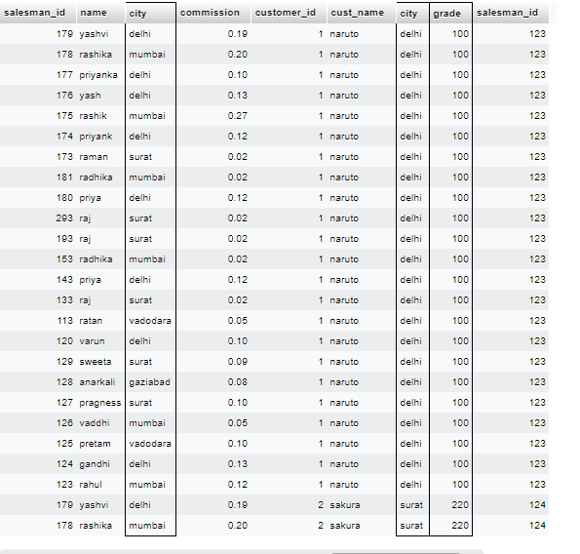

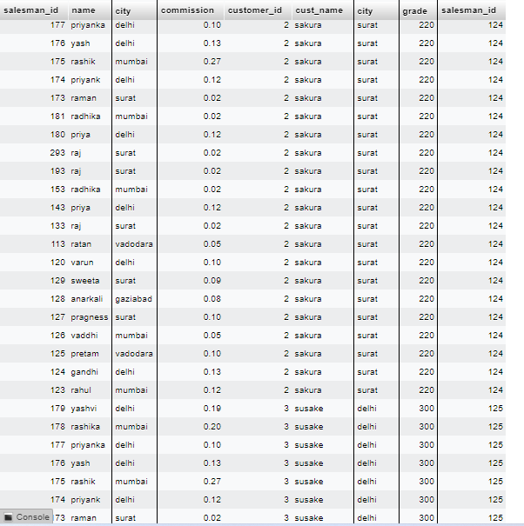

20. Write a SQL statement to make a Cartesian product between salesman and customer i.e. each salesman will appear for all customers and vice versa for those salesmen who must belong to a city which is not the same as his customer and the customers should have their own grade .
==>> SELECT * FROM salesman s CROSS JOIN customer c WHERE s.city IS NOT NULL AND c.grade IS NOT NULL AND s.city<>c.city;
OUTPUT:-
