MYSQL
Assignment-1
Simple SQL Query with a single table with where clause
Northwind database
Sample table :Products
-ProductID
-ProductName
-SupplierID
-CategoryID
-QuantityPerUnit
-UnitPrice
-UnitsInStock
-UnitsOnOrder
-ReorderLevel
-Discontinued

1. Write a query to get a Product list (id, name, unit price) where current products cost less than $20.
==>>
SELECT ProductID, ProductName, UnitPrice FROM products WHERE UnitPrice < 20;
OUTPUT:-

2. Write a query to get Product list (id, name, unit price) where products cost between $15 and $25.
==>>
SELECT ProductID, ProductName, UnitPrice FROM products WHERE UnitPrice BETWEEN 15 AND 20;

OUTPUT:-

3. Write a query to get Product list (name, unit price) of above average price.
==>>
SELECT ProductName, UnitPrice FROM products WHERE UnitPrice > (SELECT AVG(UnitPrice) FROM products);

OUTPUT:-

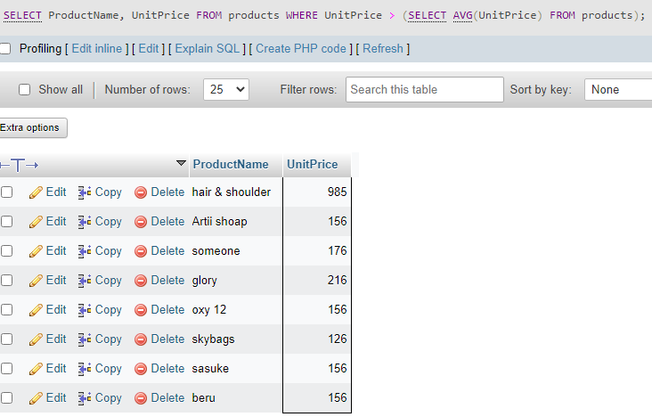

4. Write a query to get Product list (name, unit price) of ten most expensive products.
==>>
SELECT `ProductName`, `UnitPrice` FROM `Products` ORDER BY UnitPrice DESC LIMIT 10;
OUTPUT:-
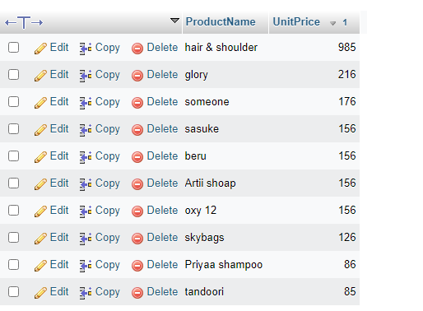

5.Write a query to count current and discontinued products.
==>>
SELECT Count(ProductName) FROM Products GROUP BY Discontinued;

OUTPUT:-
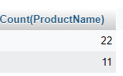

6.Write a query to get Product list (name, units on order , units in stock) of stock is less than the quantity on order.
==>>
SELECT ProductName, UnitsOnOrder , UnitsInStock FROM Products WHERE (((Discontinued)=0) AND ((UnitsInStock)<UnitsOnOrder));
OUTPUT:-
