MYSQL
Assignment-3
Retrieve data using Group By clause

Sample table1:Department
-dept_id
-dept_name
Sample table2: Employee
-emp_id
-dept_id
-mngr_id
-emp_name
-salary

1. write a SQL query to find Employees who have the biggest salary in their Department
==>
SELECT e.emp_id, e.emp_name, e.dept_id, e.salary from employee e INNER JOIN (SELECT k.dept_id, max(k.salary) as salary FROM employee k GROUP BY k.dept_id) et on e.dept_id=et.dept_id WHERE e.salary=et.salary;
OUTPUT:-
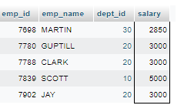

2. write a SQL query to find Departments that have less than 3 people in it.
==>
SELECT d.dept_id, d.dept_name FROM employee e JOIN department d on e.dept_id=d.dept_id GROUP by dept_id HAVING COUNT(emp_id) < 3;
OUTPUT:-
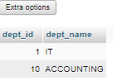

3. write a SQL query to find All Department along with the number of people there .
==>
SELECT d.dept_name, COUNT(emp_id) FROM employee e JOIN department d on e.dept_id=d.dept_id GROUP by e.dept_id;
OUTPUT:-
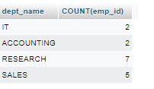

4. write a SQL query to find All Department along with the total salary there .
==>
SELECT d.dept_name,SUM(salary) FROM employee e JOIN department d on e.dept_id=d.dept_id GROUP BY e.dept_id;
OUTPUT:-
