MYSQL
Assignment-4
1.Brife Description on stored procedure.
=>
- A stored procedure is a prepared SQL code that you can save, so the code can be reused over and over again.
- So if you have an SQL query that you write over and over again, save it as a stored procedure, and then just call it to execute it.
- You can also pass parameters to a stored procedure, so that the stored procedure can act based on the parameter value(s) that is passed.

A procedure (often called a stored procedure) is a collection of pre-compiled SQL statements stored inside the database. It is a subroutine or a subprogram in the regular computing language. A procedure always contains a name, parameter lists, and SQL statements. We can invoke the procedures by using triggers, other procedures and applications such as Java, Python, PHP, etc. It was first introduced in MySQL version 5. Presently, it can be supported by almost all relational database systems.
If we consider the enterprise application, we always need to perform specific tasks such as database cleanup, processing payroll, and many more on the database regularly. Such tasks involve multiple SQL statements for executing each task. This process might easy if we group these tasks into a single task. We can fulfill this requirement in MySQL by creating a stored procedure in our database.
A procedure is called a recursive stored procedure when it calls itself. Most database systems support recursive stored procedures. But, it is not supported well in MySQL.

Stored Procedure Features
- Stored Procedure increases the performance of the applications. Once stored procedures are created, they are compiled and stored in the database.
- Stored procedure reduces the traffic between application and database server. Because the application has to send only the stored procedure's name and parameters instead of sending multiple SQL statements.
- Stored procedures are reusable and transparent to any applications.
- A procedure is always secure. The database administrator can grant permissions to applications that access stored procedures in the database without giving any permissions on the database tables.
How to call a stored procedure?
We can use the CALL statement to call a stored procedure. This statement returns the values to its caller through its parameters (IN, OUT, or INOUT). The following syntax is used to call the stored procedure in MySQL.

2.Explain ACID properties.
=>

1) Atomicity
The term atomicity defines that the data remains atomic. It means if any operation is performed on the data, either it should be performed or executed completely or should not be executed at all. It further means that the operation should not break in between or execute partially. In the case of executing operations on the transaction, the operation should be completely executed and not partially.
Example: If Remo has account A having $30 in his account from which he wishes to send $10 to Sheero's account, which is B. In account B, a sum of $ 100 is already present. When $10 will be transferred to account B, the sum will become $110. Now, there will be two operations that will take place. One is the amount of $10 that Remo wants to transfer will be debited from his account A, and the same amount will get credited to account B, i.e., into Sheero's account. Now, what happens - the first operation of debit executes successfully, but the credit operation, however, fails. Thus, in Remo's account A, the value becomes $20, and to that of Sheero's account, it remains $100 as it was previously present.
Thus, when the amount loses atomicity, then in the bank systems, this becomes a huge issue, and so the atomicity is the main focus in the bank systems.

2) Consistency
The word consistency means that the value should remain preserved always. In DBMS, the integrity of the data should be maintained, which means if a change in the database is made, it should remain preserved always. In the case of transactions, the integrity of the data is very essential so that the database remains consistent before and after the transaction. The data should always be correct.
Example:
In the above figure, there are three accounts, A, B, and C, where A is making a transaction T one by one to both B & C. There are two operations that take place, i.e., Debit and Credit. Account A firstly debits $50 to account B, and the amount in account A is read $300 by B before the transaction. After the successful transaction T, the available amount in B becomes $150. Now, A debits $20 to account C, and that time, the value read by C is $250 (that is correct as a debit of $50 has been successfully done to B). The debit and credit operation from account A to C has been done successfully. We can see that the transaction is done successfully, and the value is also read correctly. Thus, the data is consistent. In case the value read by B and C is $300, which means that data is inconsistent because when the debit operation executes, it will not be consistent.

3) Isolation
The term 'isolation' means separation. In DBMS, Isolation is the property of a database where no data should affect the other one and may occur concurrently. In short, the operation on one database should begin when the operation on the first database gets complete. It means if two operations are being performed on two different databases, they may not affect the value of one another. In the case of transactions, when two or more transactions occur simultaneously, the consistency should remain maintained. Any changes that occur in any particular transaction will not be seen by other transactions until the change is not committed in the memory.
Example: If two operations are concurrently running on two different accounts, then the value of both accounts should not get affected. The value should remain persistent. As you can see in the below diagram, account A is making T1 and T2 transactions to account B and C, but both are executing independently without affecting each other. It is known as Isolation.

4) Durability
Durability ensures the permanency of something. In DBMS, the term durability ensures that the data after the successful execution of the operation becomes permanent in the database. The durability of the data should be so perfect that even if the system fails or leads to a crash, the database still survives. However, if gets lost, it becomes the responsibility of the recovery manager for ensuring the durability of the database. For committing the values, the COMMIT command must be used every time we make changes.
Therefore, the ACID property of DBMS plays a vital role in maintaining the consistency and availability of data in the database.
Thus, it was a precise introduction of ACID properties in DBMS. We have discussed these properties in the transaction section also.

3.Explain offset in limit query with example.
=>

Introduction to SQL LIMIT clause
To limit the number of rows returned by a select statement, you use the LIMIT and OFFSET clauses.
In this syntax:
- The LIMIT row_count determines the number of rows (row_count) returned by the query.
- The OFFSET offset clause skips the offset rows before beginning to return the rows.
The OFFSET clause is optional. If you omit it, the query will return the row_count rows from the first row returned by the SELECT clause.
When you use the LIMIT clause, it is important to use an ORDER BY clause to ensure the order of rows in the result set.
Not all database systems support the LIMIT clause. Therefore, the LIMIT clause is available only in some database systems only such as MySQL, PostgreSQL, SQLite, Sybase SQL Anywhere, and HSQLDB. If you use SQL Server, you can use the SELECT TOP instead.
The following example uses the LIMIT clause to return the first 5 rows in the result set returned by the SELECT clause:
SELECT
employee_id, first_name, last_name
FROM
employees
ORDER BY first_name
LIMIT 5 OFFSET 3;
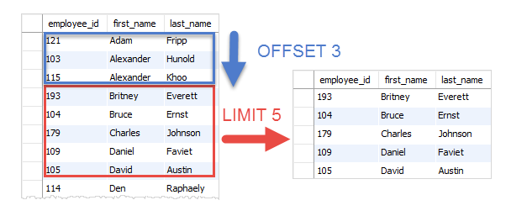

4.Left Join and Right Join with example.
=>

LEFT JOIN
This join returns all the rows of the table on the left side of the join and matches rows for the table on the right side of the join. For the rows for which there is no matching row on the right side, the result-set will contain null. LEFT JOIN is also known as LEFT OUTER JOIN.

Syntax:
SELECT table1.column1,table1.column2,table2.column1,....
FROM table1
LEFT JOIN table2
ON table1.matching_column = table2.matching_column;

table1: First table.
table2: Second table
matching_column: Column common to both the tables.

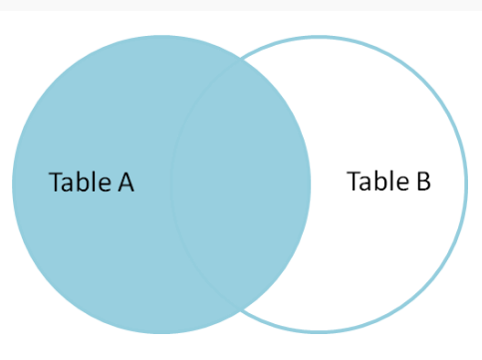

RIGHT JOIN
RIGHT JOIN is similar to LEFT JOIN. This join returns all the rows of the table on the right side of the join and matching rows for the table on the left side of the join. For the rows for which there is no matching row on the left side, the result-set will contain null. RIGHT JOIN is also known as RIGHT OUTER JOIN.

Syntax:
SELECT table1.column1,table1.column2,table2.column1,....
FROM table1
RIGHT JOIN table2
ON table1.matching_column = table2.matching_column;

table1: First table.
table2: Second table
matching_column: Column common to both the tables.

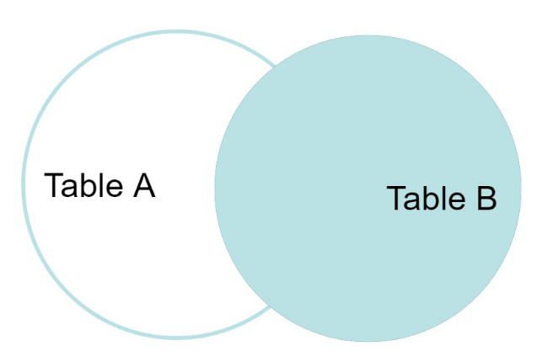

5. Explain Group by
=>
The GROUP BY Statement in SQL is used to arrange identical data into groups with the help of some functions. i.e if a particular column has same values in different rows then it will arrange these rows in a group. Important Points:
- GROUP BY clause is used with the SELECT statement.
- In the query, GROUP BY clause is placed after the WHERE clause.
- In the query, GROUP BY clause is placed before ORDER BY clause if used any.
- In the query , Group BY clause is placed before Having clause .
- Place condition in the having clause

syntax:
SELECT column1, function_name(column2)
FROM table_name
WHERE condition
GROUP BY column1, column2
ORDER BY column1, column2;

function_name: Name of the function used for example, SUM(), AVG().
table_name: Name of the table.
condition: Condition used.
6. Logical operators in mySQL.
=>
SQL logical operators are used to test for the truth of the condition. A logical operator like the Comparison operator returns a boolean value of TRUE, FALSE, or UNKNOWN.

Given below is the list of logical operators available in SQL.
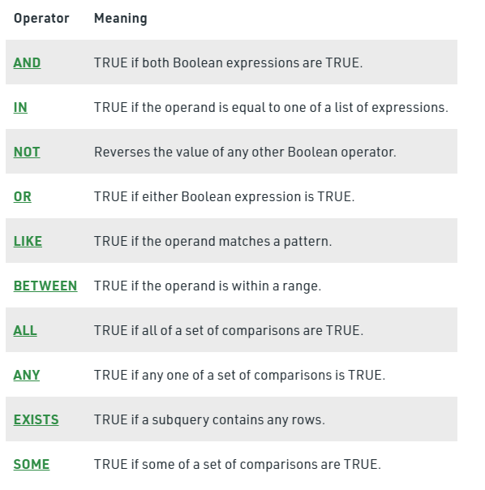

7.Data types in mySQL.
=>
1. Binary Datatypes :
There are four subtypes of this datatype which are given below :
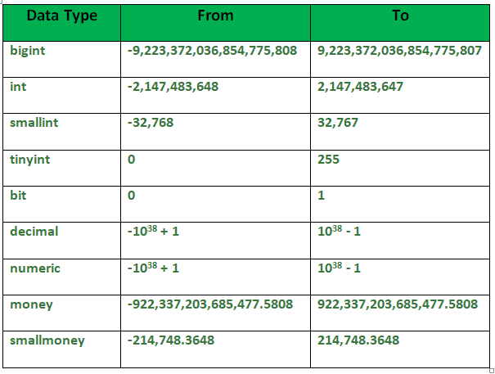
2. Exact Numeric Datatype :
There are nine subtypes which are given below in the table. The table contains the range of data in a particular type.
3. Approximate Numeric Datatype :
The subtypes of this datatype are given in the table with the range.
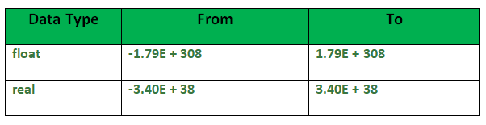

4. Character String Datatype :
The subtypes are given in below table –

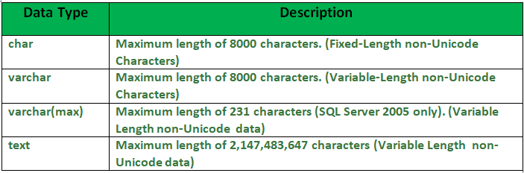
5. Unicode Character String Datatype :
The details are given in below table –

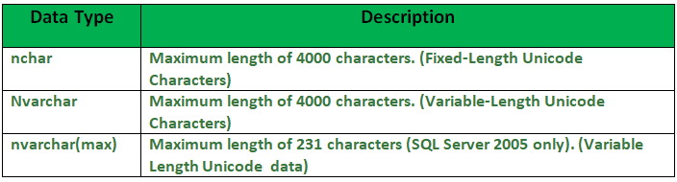

6. Date and Time Datatype :
The details are given in below table.
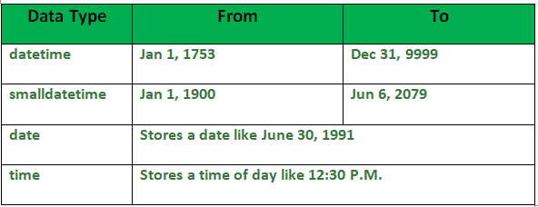
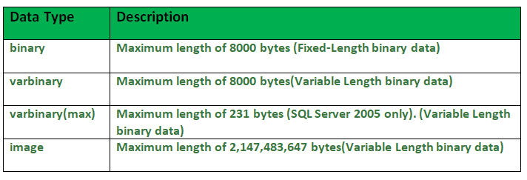

8.Float and double, Where to use them.
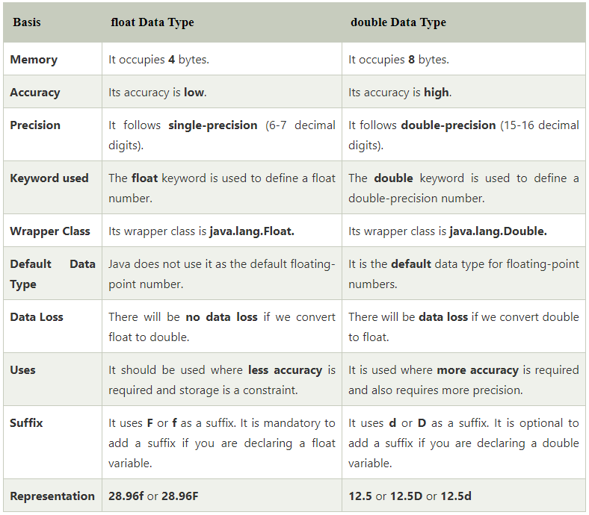
double is more precise than float. So, if a more precise and accurate result is required use double. Another reason to use double is that if the number is not fitting in the range offered by the float then use double. We should use float if we have memory constraint because it occupies half-space than double.

9.Functions in mySQL.
=>
Aggregate functions:
These functions are used to do operations from the values of the column and a single value is returned.
  - AVG()
  - COUNT()
  - FIRST()
  - LAST()
  - MAX()
  - MIN()
  - SUM()

Scalar functions:
These functions are based on user input, these too returns single value.
  - UCASE()
  - LCASE()
  - MID()
  - LEN()
  - ROUND()
  - NOW()
  - FORMAT()

AVG(): It returns the average value after calculating from values in a numeric column.
COUNT(): It is used to count the number of rows returned in a SELECT statement. It can’t be used in MS ACCESS.
FIRST(): The FIRST() function returns the first value of the selected column.

LAST(): The LAST() function returns the last value of the selected column. It can be used only in MS ACCESS.
MAX(): The MAX() function returns the maximum value of the selected column.
MIN(): The MIN() function returns the minimum value of the selected column.
SUM(): The SUM() function returns the sum of all the values of the selected column.
UCASE(): It converts the value of a field to uppercase.
LCASE(): It converts the value of a field to lowercase.
MID(): The MID() function extracts texts from the text field.
LEN(): The LEN() function returns the length of the value in a text field.
ROUND(): The ROUND() function is used to round a numeric field to the number of decimals specified.NOTE: Many database systems have adopted the IEEE 754 standard for arithmetic operations, which says that when any numeric .5 is rounded it results to the nearest even integer i.e, 5.5 and 6.5 both gets rounded off to 6.
NOW(): The NOW() function returns the current system date and time.
FORMAT(): The FORMAT() function is used to format how a field is to be displayed.

10. Having clause.
=>
In MySQL, the HAVING clause is used to apply a filter on the result of GROUP BY based on the specified condition. The conditions are Boolean type i.e. use of logical operators(AND, OR). This clause was included in SQL as the WHERE keyword failed when we use it with aggregate expressions. Having is a very generally used clause in SQL. Similar to WHERE it helps to apply conditions, but HAVING works with groups. If you wish to filter a group, the HAVING clause comes into action.
Some important points:
- Having clause is used to filter data according to the conditions provided.
- Having clause is generally used in reports of large data.
- Having clause is only used with the SELECT clause.
- The expression in the syntax can only have constants.
- In the query, ORDER BY is to be placed after the HAVING clause, if any.
- HAVING Clause implements in column operation.
- Having clause is generally used after GROUP BY.
The GROUP BY clause is used to arrange required data into groups.

11. Difference between innoDB and myisam:
=>
