**Industrial Internship Report on**

**”Smart City Traffic Patterns”**

**Prepared by**

**[Aniket Bhatia]**

|  |
| --- |
| *Executive Summary* |
| This report provides details of the Industrial Internship provided by upskill Campus and The IoT Academy in collaboration with Industrial Partner UniConverge Technologies Pvt Ltd (UCT).  This internship was focused on a project/problem statement provided by UCT. We had to finish the project including the report in 6 weeks’ time.  My project was about “Smart City Traffic Patterns” where we have to study about various traffic patterns related to a city, and how can we manage the traffic of the city better to transform it into a smart city.  This internship gave me a very good opportunity to get exposure to Industrial problems and design/implement solution for that. It was an overall great experience to have this internship. |

**TABLE OF CONTENTS**

1 Preface 3

2 Introduction 4

2.1 About UniConverge Technologies Pvt Ltd 4

2.2 About upskill Campus 8

2.3 Objective 9

2.4 Reference 9

2.5 Glossary 10

3 Problem Statement 11

4 Existing and Proposed solution 12

5 Proposed Design/ Model 13

6 Performance Test 14

6.2 Test Procedure 14

6.3 Performance Outcome 14

7 My learnings 15

8 Future work scope 16

# Preface

Over the course of six weeks, I embarked on a challenging and rewarding project that aimed to address a significant problem within a specific domain. The project was designed to demonstrate my abilities and skills in research, analysis, problem solving and project management.

This internship played a vital role in my career development as it helped me in:

1. Practical Application of Knowledge
2. Skill Development
3. Industry Exposure
4. Networking Opportunities
5. Resume Enhancement
6. Confidence Building

Smart City Traffic Pattern Project:

The project describes about the efficient management of traffic in a city.

The government wants to implement a robust traffic system for the city by being prepared for traffic peaks.

The dataset provided contains the traffic pattern of the four junctions of the city. Traffic pattern on holidays, as well as on various other occasions during the year, differ from normal working days.

I would like to thank USC&UCT for providing me this opportunity to upskill myself, and help me qualify for the better job opportunities.

I would also like to mention some of the goals which upskill helps the students to accomplish it.

1. Skill Enhancement and Training
2. Certification Program
3. Career Advancement
4. Flexible Learning Option

The program was planned in such a way that students can easily manage their workload and can manage their tasks very efficiently.

In the six weeks programme, we were supposed to

1. Explore about the problem statement
2. Learn More about machine learning and its algorithms
3. We had to attend the quizzes to ensure and validate our performance
4. Submit weekly reports to ensure regular progress is being made towards the project
5. Submit the final project code as well as the report

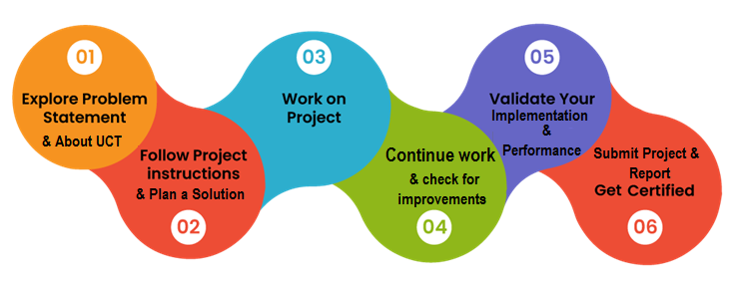

The six-week project was a fruitful experience that allowed me to showcase my abilities, creativity, and dedication. The successful completion of the project has not only contributed to the field but has also enhanced my overall skill set as a competent professional.

I would like to thank UCT, Upskill for providing me this opportunity and also my teachers, my colleagues who was there for me whenever I needed any kind of help or support.

I would like to take this opportunity to encourage my juniors to take this opportunity and be a part of the upskill and enhance yourself and experience this wonderful learning program.

# Introduction

## About UniConverge Technologies Pvt Ltd

A company established in 2013 and working in Digital Transformation domain and providing Industrial solutions with prime focus on sustainability and RoI.

For developing its products and solutions it is leveraging various**Cutting Edge Technologies e.g. Internet of Things (IoT), Cyber Security, Cloud computing (AWS, Azure), Machine Learning, Communication Technologies (4G/5G/LoRaWAN), Java Full Stack, Python, Front end**etc.

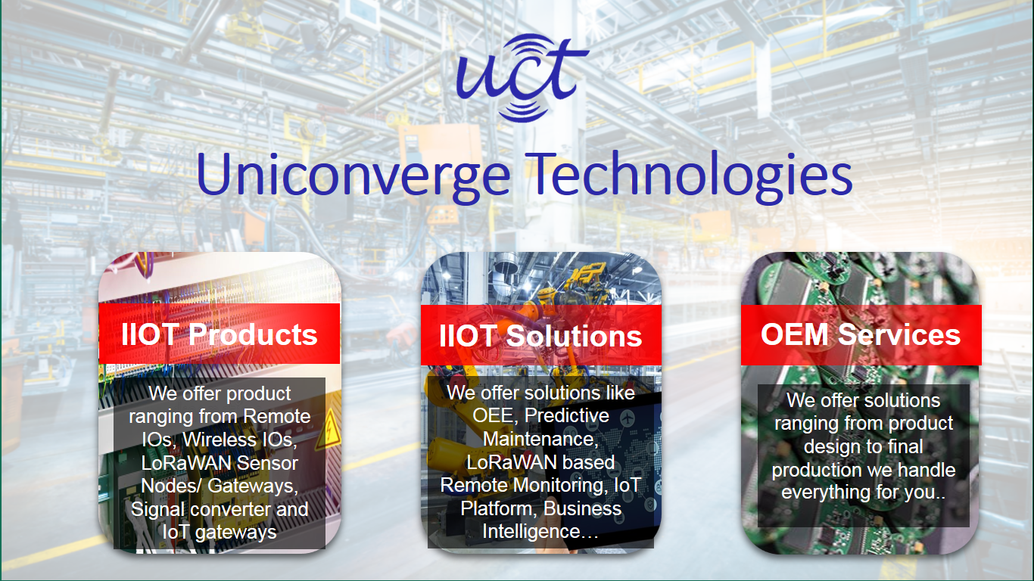

1. UCT IoT Platform **(****)**

**UCT Insight** is an IOT platform designed for quick deployment of IOT applications on the same time providing valuable “insight” for your process/business. It has been built in Java for backend and ReactJS for Front end. It has support for MySQL and various NoSql Databases.

* It enables device connectivity via industry standard IoT protocols - MQTT, CoAP, HTTP, Modbus TCP, OPC UA
* It supports both cloud and on-premises deployments.

It has features to  
• Build Your own dashboard  
• Analytics and Reporting  
• Alert and Notification  
• Integration with third party application(Power BI, SAP, ERP)  
• Rule Engine

 

1. **Smart Factory Platform (****)**

Factory watch is a platform for smart factory needs.

It provides Users/ Factory

* with a scalable solution for their Production and asset monitoring
* OEE and predictive maintenance solution scaling up to digital twin for your assets.
* to unleased the true potential of the data that their machines are generating and helps to identify the KPIs and also improve them.
* A modular architecture that allows users to choose the service that they what to start and then can scale to more complex solutions as per their demands.

Its unique SaaS model helps users to save time, cost and money.

 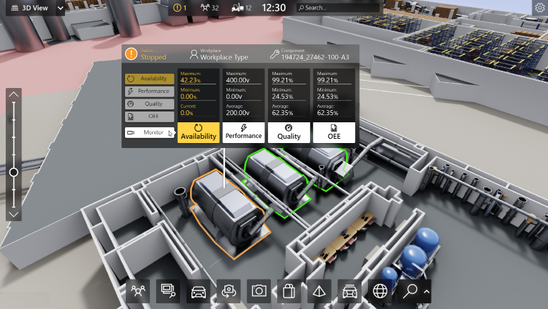

1. 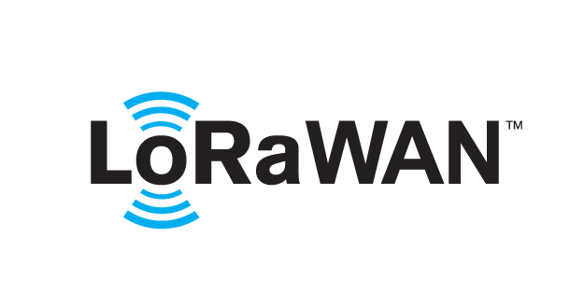 based Solution

UCT is one of the early adopters of LoRAWAN teschnology and providing solution in Agritech, Smart cities, Industrial Monitoring, Smart Street Light, Smart Water/ Gas/ Electricity metering solutions etc.

1. Predictive Maintenance

UCT is providing Industrial Machine health monitoring and Predictive maintenance solution leveraging Embedded system, Industrial IoT and Machine Learning Technologies by finding Remaining useful life time of various Machines used in production process.



## About upskill Campus (USC)

upskill Campus along with The IoT Academy and in association with Uniconverge technologies has facilitated the smooth execution of the complete internship process.

USC is a career development platform that delivers **personalized executive coaching** in a more affordable, scalable and measurable way.



Seeing need of upskilling in self paced manner along-with additional support services e.g. Internship, projects, interaction with Industry experts, Career growth Services

<https://www.upskillcampus.com/>

upSkill Campus aiming to upskill 1 million learners in next 5 year

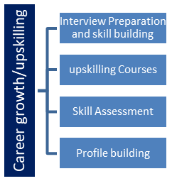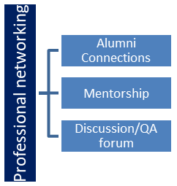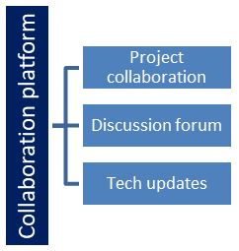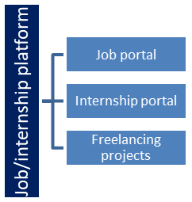

## The IoT Academy

The IoT academy is EdTech Division of UCT that is running long executive certification programs in collaboration with EICT Academy, IITK, IITR and IITG in multiple domains.

## Objectives of this Internship program

The objective for this internship program was to

 ☛ get practical experience of working in the industry.

 ☛ to solve real world problems.

 ☛ to have improved job prospects.

 ☛ to have Improved understanding of our field and its applications.

 ☛ to have Personal growth like better communication and problem solving.

## Reference

[1] <https://www.kaggle.com/utathya/smart-city-traffic-patterns>

## Glossary

|  |  |
| --- | --- |
| Terms | Acronym |
| Root Mean Square Error | RMSE |
| Support Vector Classifier | SVC |
| Random Forest | RF |
| Decision Tree | DT |
|  |  |

# Problem Statement

In the assigned problem statement

‘You are working with the government to transform your city into a smart city. The vision is to convert it into a digital and intelligent city to improve the efficiency of services for the citizens. One of the problems faced by the government is traffic. You are a data scientist working to manage the traffic of the city better and to provide input on infrastructure planning for the future.

The government wants to implement a robust traffic system for the city by being prepared for traffic peaks. They want to understand the traffic patterns of the four junctions of the city. Traffic patterns on holidays, as well as on various other occasions during the year, differ from normal working days. This is important to take into account for your forecasting.’

The main objective of the Smart City Traffic Pattern project is to design and implement an advanced traffic management system that optimizes traffic flow, reduces congestion, and enhances overall transportation efficiency within the city. The project aims to leverage cutting-edge technologies, data analytics, and real-time insights to make informed decisions and improve the commuting experience for residents and visitors alike.

# Existing and Proposed solution

The existing solutions that were provided were not tested on some of the algorithms only.

To ensure and get the best results the dataset should be tested with various algorithms and then comparision should be made regarding the results.

Different algorithms work differently for different datasets.

Some of the addition that were implemented was to study the dataset using various data visualization tools, using bar graphs, histograms which give inner insights of the data, what kind of data are we dealing with and how we could solve the problem, which columns are not going to affect the result and also how to overcome the null values problem.

## Code submission (Github link) : [Project - Link](https://github.com/aniketbhatia9/UpSkill-Campus/blob/80027e1e6562d5dc605c4c105210e7ae1f47a395/SmartCityTrafficPattern_AniketBhatia_USC_UCT.ipynb)

## Report submission (Github link) : Report-Link

# Proposed Design/ Model

The design flow of the Smart City Traffic Pattern solution outlines the sequential steps and interactions of various components to achieve efficient traffic management. Below is the proposed design flow:

1. **Data Collection**
2. **Data Integration and Preprocessing**
3. **Traffic Pattern Analysis**
4. **Traffic Flow Prediction**
5. **Intelligent Traffic Signal Control**
6. **Multi-Modal Integration and Routing**
7. **User Interface and Information Dissemination**
8. **Public Awareness and Engagement**
9. **Privacy & Security Measures**
10. **Scalability and Future Growth**
11. **Testing and Evaluation**
12. **Regulatory Compliance**
13. **Deployment and Implementation**
14. **Monitoring and Maintenance**

# Performance Test

The Root Mean Squared Error (RMSE) is one of the two main performance indicators for a regression model. It measures the average difference between values predicted by a model and the actual values. It provides an estimation of how well the model is able to predict the target value (accuracy).

RMSE score was calculated which was **5.93**

## Test Procedure

The model is first trained and then tested using the dataset provided to ensure the values predicted should match with the outcomes.

The test procedure for the Smart City Traffic Pattern Project is essential to ensure the system's functionality, accuracy, and reliability before its implementation in a real-world environment

1. Unit Testing
2. Integration Testing
3. Functional Testing
4. Performance Testing
5. Scalability Testing
6. User Interface Testing
7. Security Testing
8. Usability Testing
9. Regulatory Compliance Testing
10. Error Handling and Recovery Testing
11. User Acceptance Testing
12. Documentation Review

## Performance Outcome

Various algorithms were selected to compare the performance of those algorithms for the particular dataset.

The algorithms were random forest, decision tree classifier and SVM where all of them provided the same result, which means all were performing in the same manner.

XGBoost is also one of the algorithms which could have been used to measure the performance of the system.

# My learnings

Throughout this project, I have gained valuable learnings and experiences that will undoubtedly shape my future in several ways:

1. **Technical Skills**: Working on the Smart City Traffic Pattern Project has allowed me to develop and enhance various technical skills, such as data analysis, machine learning, predictive modeling, and programming. These skills will be highly sought-after in many industries, giving me a competitive edge in the job market.
2. **Real-World Application**: This project provided me with the opportunity to apply the knowledge gained during my academic studies to a real-world problem. Understanding how theoretical concepts translate into practical solutions is crucial for success in any profession.
3. **Project Management**: As a part of this project, I learned how to effectively manage timelines & set achievable goals, to ensure smooth progress. These project management skills will be invaluable in any future endeavors, whether in the workplace or personal projects.
4. **Data-Driven Decision Making**: I have learned the significance of data-driven decision making. Utilizing data analytics and insights to make informed choices not only improves project outcomes but can also be applied to problem-solving in various aspects of life.
5. **Adaptability and Problem-Solving**: Throughout the project, I encountered unexpected challenges that required adaptability and creative problem-solving. These experiences have strengthened my ability to approach problems with a proactive and flexible mindset.

# Future work scope

The future work scope in the project is vast and promising, as technology and data driven solutions continue to revolutionize urban transportation.

The area on which we could work for further development and improvement could be:

**Environmental Impact and Sustainability**

Expanding the project's focus to address environmental concerns, such as reducing emissions and promoting sustainable transportation. Implementing eco-friendly measures, such as encouraging electric vehicle adoption or promoting carpooling, can contribute to a greener and more sustainable smart city.

**Real-Time Data Integration**

Enhancing the project's capability to collect and integrate real-time data from various sources, including IoT sensors, mobile applications, and connected vehicles. This will enable more accurate and up-to-date traffic predictions and better adaptability to changing traffic conditions.