**Fluid Mechanics**

**Prof. Sumesh P. Thampi**

**Department of Chemical Engineering**

**Indian Institute of Technology, Madras**

**Lecture – 02**

**Fluid statics**

Now, let us talk about pressure. So, pressure is a special kind of stress, its also defined as force per unit area.

(Refer Slide Time: 00:25)

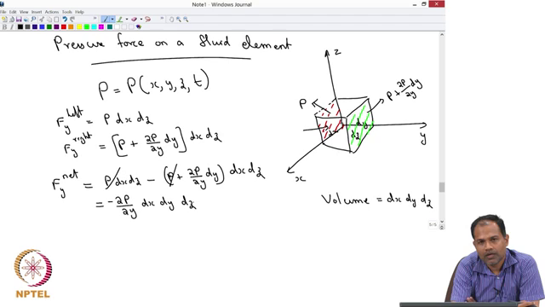

So, let us look at pressure force on a fluid element. Let us take a coordinate system. So, let us say this is x that is y and that is z and let us take a fluid element. So, this has got a length d x in x direction, d y in y direction and d z in z direction. So, that the volume of this fluid element:

$Volume=dx dy dz$

Now, let us say this fluid element is in a given fluid where there is a pressure distribution, so; that means, the pressure is changing from one point to another and let us say pressure is given as a function of x, y, z and t.

$P=P(x,y,z,t)$

So, pressure is changing at every point as well as in time ok, at any given point x, y, z and t you know what is the pressure and what you are going to do is you are going to now calculate what is the pressure exerted on each face of the fluid. So, let us say we are going to look at this face. So, the face that I have marked with red color and I want to calculate what is the force on that side. So, I know that on this side of this face, I can calculate the force because pressure is defined as force per unit area therefore, if I want to talk about a force which is acting in the y direction on the left side of the play on the left side of the cube is simply going to be. So, let us let me write left is simply going to be:

$F_{y}^{left}=Pdx dz$

So, that is the force that is going to be acting on this side of the element. Similarly, you can calculate what is the force on the other side. On this side this exactly opposite side of the red side that I have marked. Now, we do not know what is the pressure there, but we can let us say do a Taylor expansion and write down the pressure there.

So, let us say if the pressure here is given by P, then the pressure here can be written as:

$P+\frac{∂P }{∂y}dy$

So, that is a simplest approximation that you can do to represent pressure on that side. So, therefore, F y on the right side is given as:

$F_{y}^{right}=\left[P+\frac{∂P }{∂y}dy\right]dx dz$

And your interest is to calculate what is the net force acting in the y direction, which you will get if you subtract one from the other. So, if your interest is to calculate F y net which is the force acting in the y direction is given as :

$F_{y}^{net}=Pdx dz-\left[P+\frac{∂P }{∂y}dy\right]dx dz=-\frac{∂P }{∂y} dx dy dz$

So, that is the force that is arising in the y direction due to a pressure. We can continue, we can do the same thing in x direction as well as in z direction.

(Refer Slide Time: 05:55)

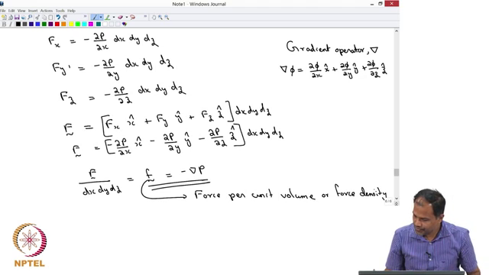

So, we can do the same exercise and then you find that:

$F_{x}=-\frac{∂P }{∂x} dx dy dz$

$F_{y}=-\frac{∂P }{∂y} dx dy dz$

$F_{z}=-\frac{∂P }{∂z} dx dy dz$

So, in the given coordinate system these are the forces that are generated, I want to write force as a vector. So, this is the component of force in x direction the second $F_{y}$ is the component of force in y direction and $F_{z}$ is the component of force in z direction.

So, I can write the net force:

$\vec{F}=F_{x}\hat{x}+F_{y}\hat{y}+F_{z}\hat{z}=\left[-\frac{∂P}{∂x}\hat{x}-\frac{∂P}{∂y}\hat{y}-\frac{∂P}{∂z}\hat{z}\right]dx dy dz=-∇P dx dy dz$

So, what is grad? Grad is nothing, but the gradient operator gradient operator that is the grad. So, that when grad is acting on some quantity that is nothing, but or we will use a different one let us say ∇ phi; that means:

$∇ϕ=\frac{∂ϕ}{∂x}\hat{x}+\frac{∂ϕ}{∂y}\hat{y}+\frac{∂ϕ}{∂z}\hat{z}$

So, that is the definition of the gradient operator. So, we get:

$\frac{ \vec{F}}{dx dy dz}=\vec{f}=-∇P$