**Chemical Reaction Engineering - II**

**Prof. Ganesh A Viswanathan**

**Department of Chemical Engineering**

**Indian Institute of Technology - Bombay**

**Module - 1**

**Lecture - 3**

**Catalyst Properties and Classification**

In the last lecture we defined what a catalyst is and what are the implications or utility of catalysts in various systems and how it may affect the yield and selectivity. In this lecture we will start by looking at some properties of the catalyst.

**(Refer Slide Time: 01:02)**

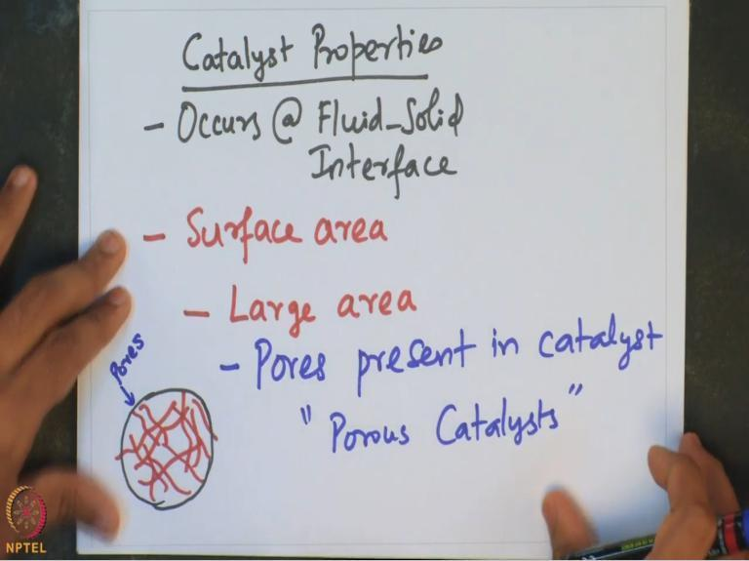

Catalytic reaction typically occurs at the fluid-solid interface. Therefore, clearly, the reaction would be a function of the surface area (or interfacial area) that is available for the reaction. Catalyst particles facilitate availability of large area for the reaction to happen.

The availability of large area is because of the pores present in the catalyst. Several pores may be present in the catalyst. These pores together actually offer availability of large area in which the reaction can occur. Such kind of catalysts is typically called as porous catalysts. Suppose we sketch a catalyst, let us assume that the catalyst is spherical in nature (see snapshot above).

There may be many pores that are actually present inside. Each of these pores will have fluid-surface present along the walls of the pores at which a chemical reaction can occur. These porous catalysts offer this unique advantage of providing large surface area for the reaction to

happen. Let us take a specific example and look at what is the ballpark surface area which may be available for the reaction to occur.

**(Refer Slide Time: 03:44)**

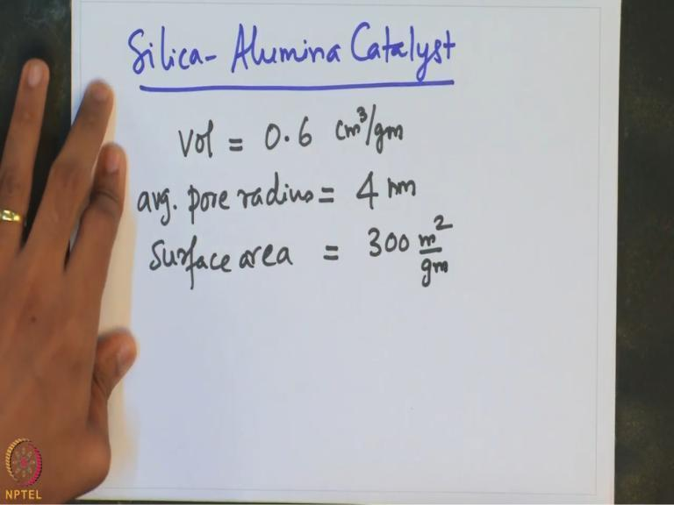

Let us take the example of Silica-Alumina catalyst. Typical volume of the catalyst is about 0.6 cm3 per gram of the catalyst. And the average pore radius is ~4 nm. The surface area available for the reaction is about 300 m2 per gram of the catalyst. Clearly, the kind of surface area available is actually phenomenal as one can see from this example.

These are the typical numbers applicable for most catalytic systems. The pore radius is very small. It is in nanometre range. Thus, in a catalyst of 3 mm diameter, the pores are about 4 nm through which fluid can go through. When the fluid goes through, the fluid-solid interface area is ~300 m2 per gram of the catalyst. Such catalysts having very high surface area because of these pores are typically referred to as the porous catalyst. There are several examples of these.