Aloha Interface  
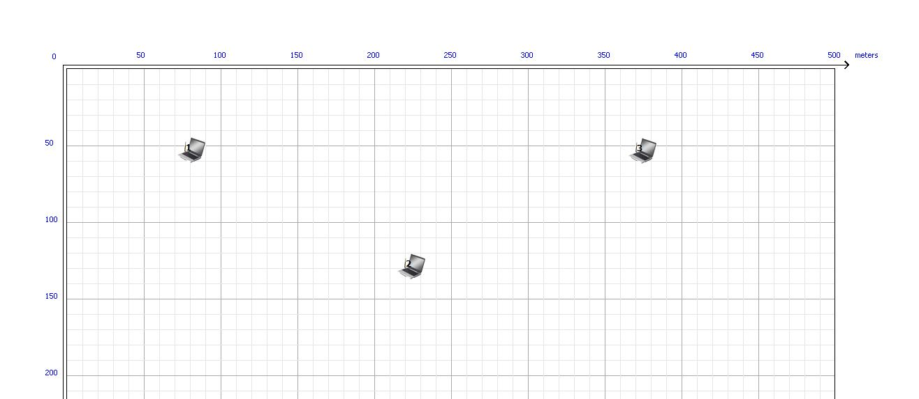

Data Configuration

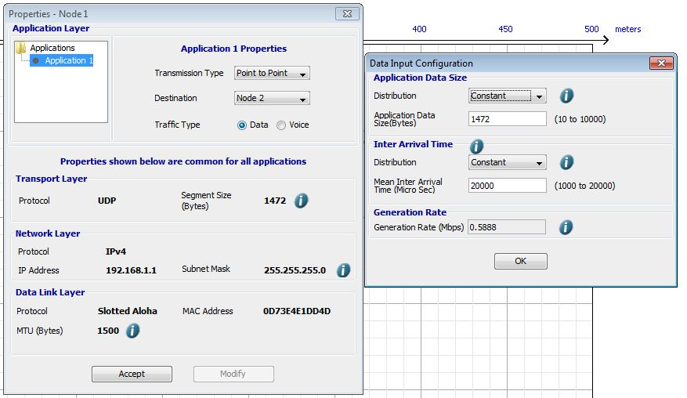

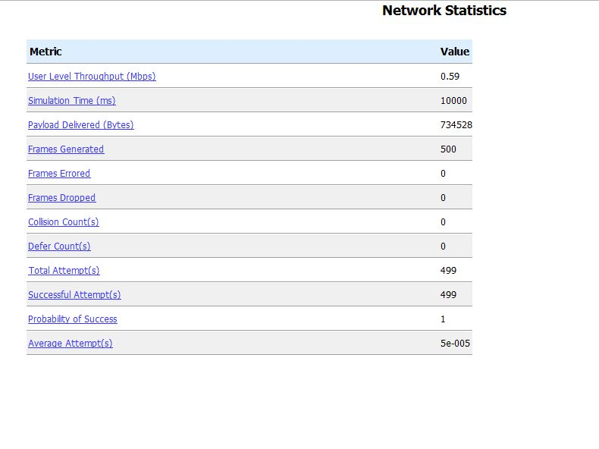

Only one machine is using transmission line out of Two





All three machines are using transmission line at same time

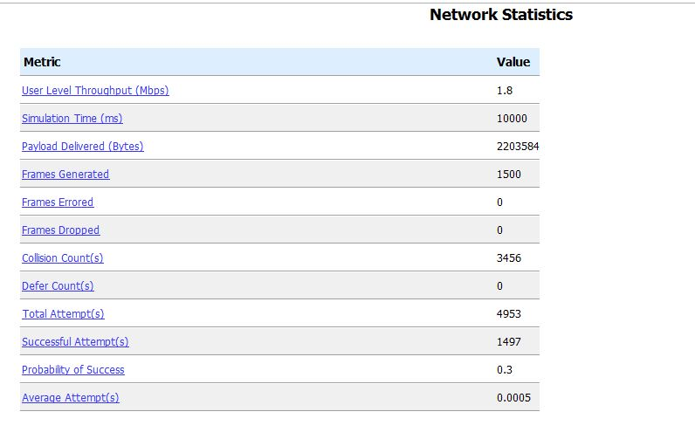



All Five machines are using transmission line at same time

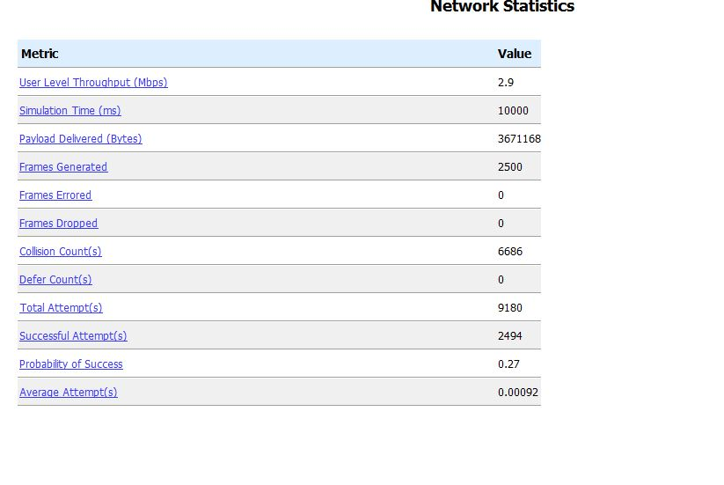

All Seven machines are using transmission line at same time

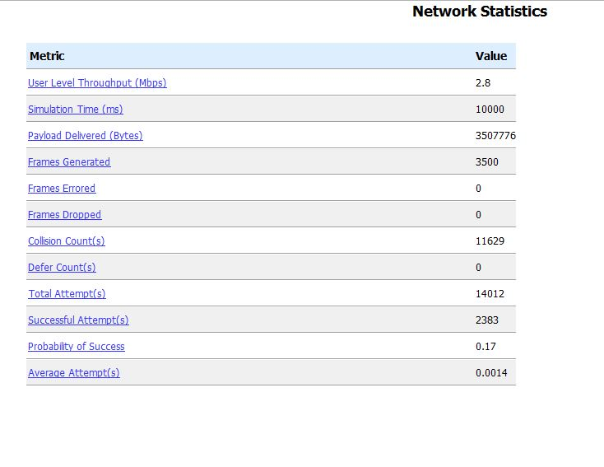



All eleven machines are using transmission line at same time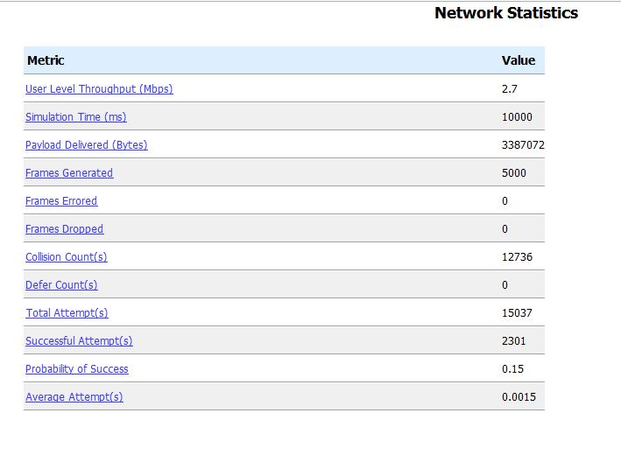



All nine machines are using transmission line at same time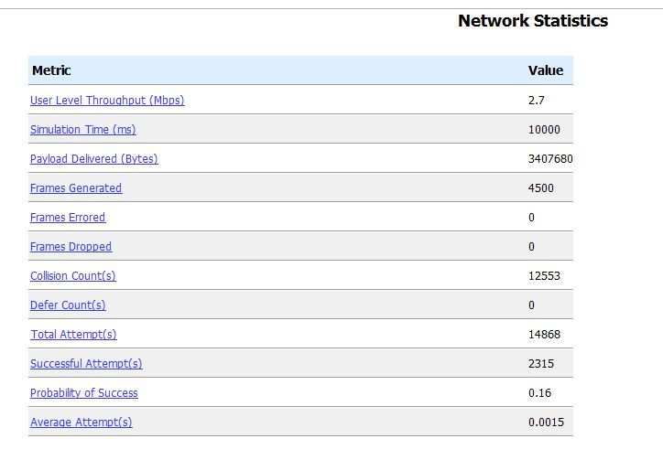



All 17 machines are using transmission line at same time

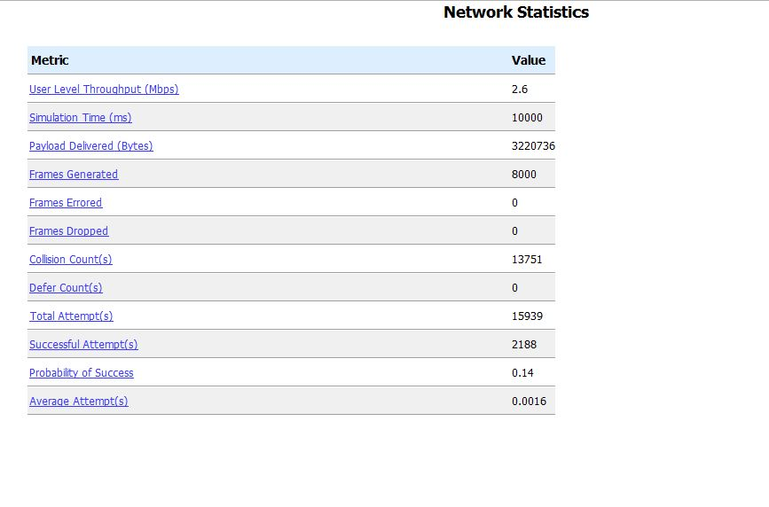

**Output Graph** ( Network Utilization vs Number of Machine )

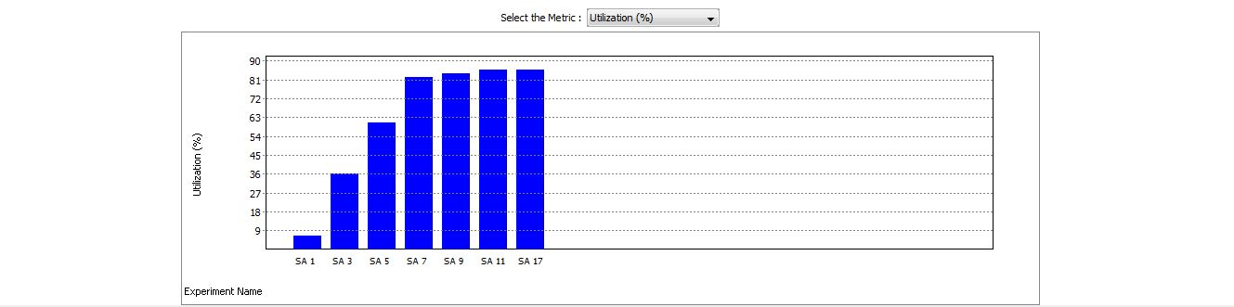

|  |  |  |  |  |  |  |  |  |  |  |  |  |  |  |  |  |  |  |  |  |  |  |  |  |  |  |  |  |  |  |  |  |  |  |  |  |  |  |  |  |  |  |  |  |  |  |  |  |  |  |  |  |  |  |  |  |  |  |  |  |  |  |  |  |  |  |  |  |  |  |  |  |  |  |  |  |  |  |  |  |  |  |  |  |  |  |  |  |  |  |
| --- | --- | --- | --- | --- | --- | --- | --- | --- | --- | --- | --- | --- | --- | --- | --- | --- | --- | --- | --- | --- | --- | --- | --- | --- | --- | --- | --- | --- | --- | --- | --- | --- | --- | --- | --- | --- | --- | --- | --- | --- | --- | --- | --- | --- | --- | --- | --- | --- | --- | --- | --- | --- | --- | --- | --- | --- | --- | --- | --- | --- | --- | --- | --- | --- | --- | --- | --- | --- | --- | --- | --- | --- | --- | --- | --- | --- | --- | --- | --- | --- | --- | --- | --- | --- | --- | --- | --- | --- | --- | --- |
| |  |  |  |  |  |  |  |  |  |  | | --- | --- | --- | --- | --- | --- | --- | --- | --- | --- | | Experiment Name | Utilization (%) | Effective Utilization (%) | Overhead (%) | Loss (%) | Unutilized (%) | Delay (ms) | Queuing Delay (ms) | Medium Access Time(ms) | Transmission Time (ms) | |  |  |  |  |  |  |  |  |  |  | | SA 1 | 6.092 | 5.876 | 0.216 | 0 | 93.908 | 1.857 | 0.626 | 0.01 | 1.221 | | SA 3 | 35.501 | 17.629 | 0.647 | 17.225 | 64.499 | 10.032 | 0.903 | 7.908 | 1.221 | | SA 5 | 60.259 | 29.369 | 1.077 | 29.812 | 39.741 | 18.598 | 5.164 | 12.212 | 1.221 | | SA 7 | 81.818 | 28.062 | 1.029 | 52.726 | 18.182 | 1578.731 | 1549.621 | 27.89 | 1.221 | | SA 9 | 83.527 | 27.261 | 1 | 55.266 | 16.473 | 2418.409 | 2379.841 | 37.347 | 1.221 | | SA 11 | 85.334 | 27.097 | 0.994 | 57.243 | 14.666 | 2671.107 | 2628.006 | 41.88 | 1.221 | | SA 17 | 85.529 | 25.766 | 0.945 | 58.818 | 14.471 | 3615.128 | 3542.69 | 71.217 | 1.221 | |

Experiment Statistics for Different Number of Transmission Nodes

Output Graph

