**Top 10 Process:**

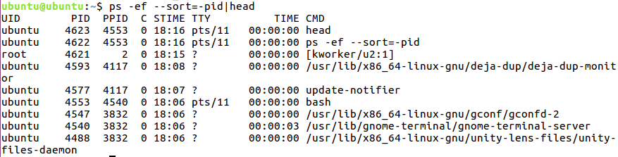

**Process with highest memory:**

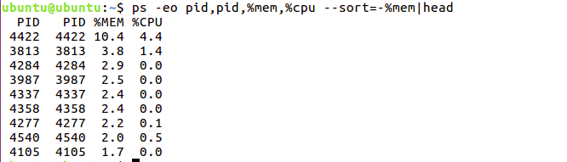

**Current logged user:**

