1. **Program:**

fileA=open('File_A.txt','w')

fileA.write('This is content of file A\nThis is to be copied on file B\n')

fileA.close()

fileA=open('File_A.txt','r')

val=fileA.read()

fileB=open('File_B.txt','w')

fileB.write(val)

fileB.close()

fileA.close()

fileB=open('File_B.txt','r').read()

print (fileB)

**output:**

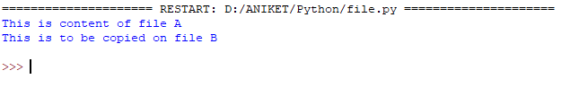

1. **Program:**

val="\nThis line is appended to end of the existing info."  
fileB=open('File_B.txt','a')  
fileB.write(val)  
fileB.close()  
fileB=open('File_B.txt','r').read()  
print(fileB)

**output:**

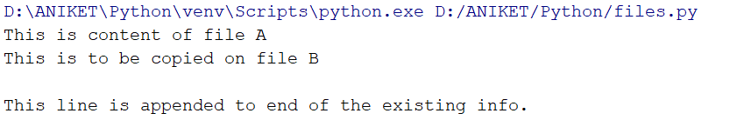

1. **Program:**

fileB=open('File_B.txt','r')  
a=fileB.readlines()  
wordcount=0  
charactercount=0  
for i in a:  
 words=i.split()  
 wordcount+=len(words)  
 for j in i:  
 character=j.split()  
 charactercount+=len(character)  
  
print("no of lines = %d" %len(a))  
print("no of words = %d" %wordcount)  
print("no of characters = %d" %charactercount)  
fileB.close()

**output:**

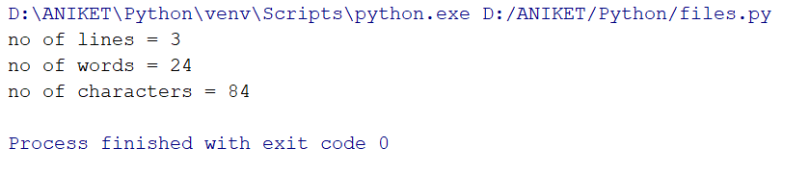

1. **program:**

import os  
def find(name="File_A.txt", path="D:\Aniket"):  
 for root, dirs, files in os.walk(path):  
 if name in files:  
 return os.path.join(root, name)  
  
p=find()  
print(p)

**output:**

