**Program:**

**Mainqueue:**

import mypackage.queue1 as q

q.print_queue()

q.insert(5)

q.insert(3)

q.insert(4)

q.insert(1)

q.insert(2)

q.print_queue()

q.delete()

q.print_queue()

**Module Queue1:**

x=[]

def delete():

global x

z=x[0]

del x[0]

return z

def insert(y):

global x

x.append(y)

def print_queue():

global x

print(x)

**output:**

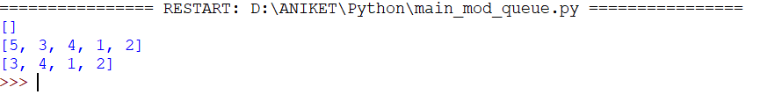

**Program:**

**Main_stack:**

import mypackage.stack as s

s.print_stack()

s.push(5)

s.push(4)

s.push(3)

s.push(2)

s.push(1)

s.push(7)

s.print_stack()

y=s.peep()

print(y)

s.pop()

s.print_stack()

**Module Stack:**

x=[]

def pop():

global x

z=x[0]

del x[0]

return z

def push(y):

global x

x.insert(0,y)

def peep():

global x

z=x[0]

return z

def print_stack():

global x

print(x)

**output:**

