**Setting up MySQL Workbench for the Project**

**Step 1:** Open MySQL workbench

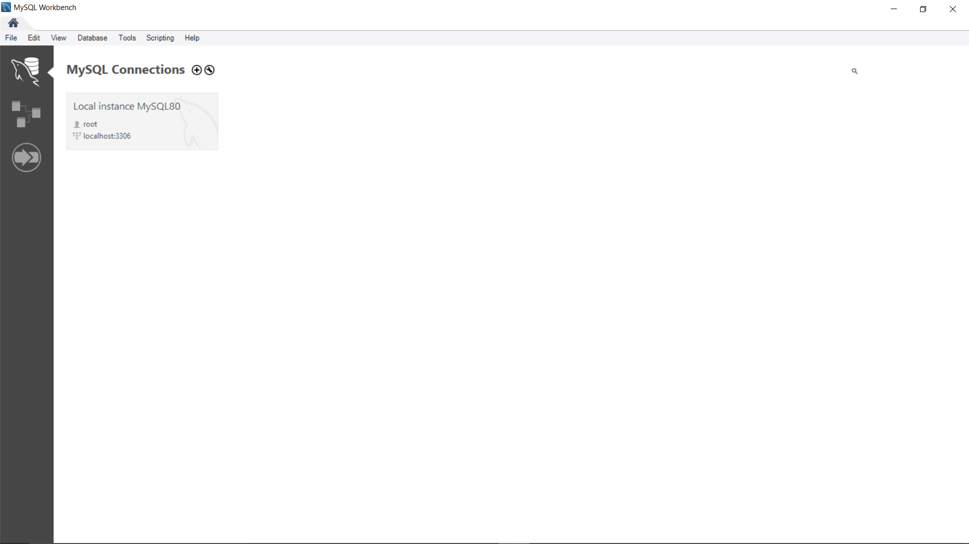

**Step 2:** Click on Database -> Connect to Database

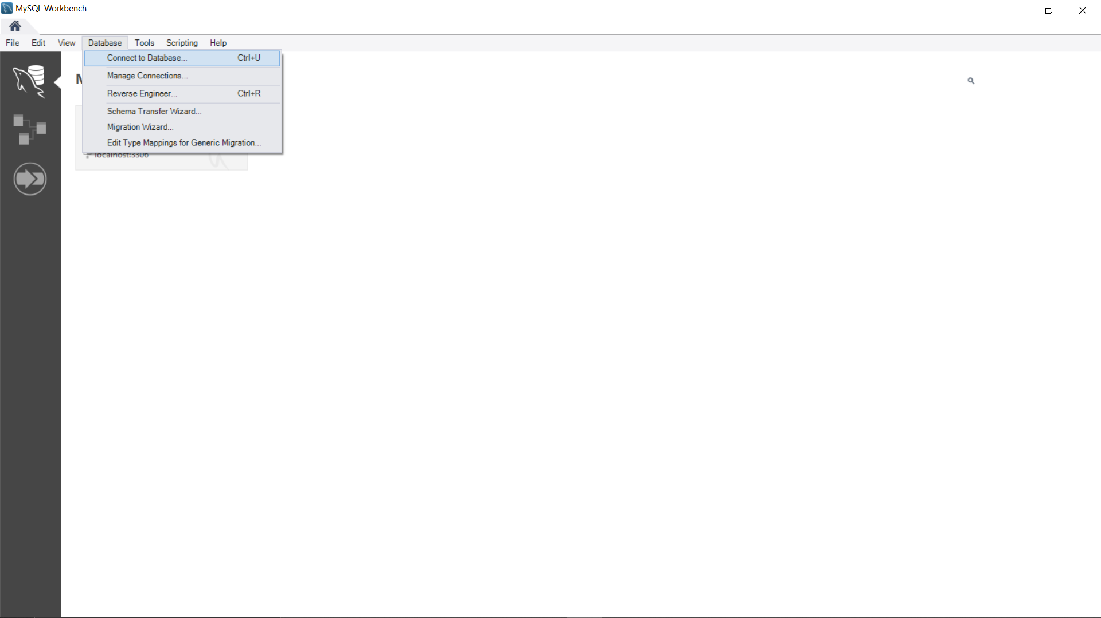

**Step 3:** Enter the Hostname, Port, Username, Default Schema and click on ‘Store in Vault...’ to enter the password

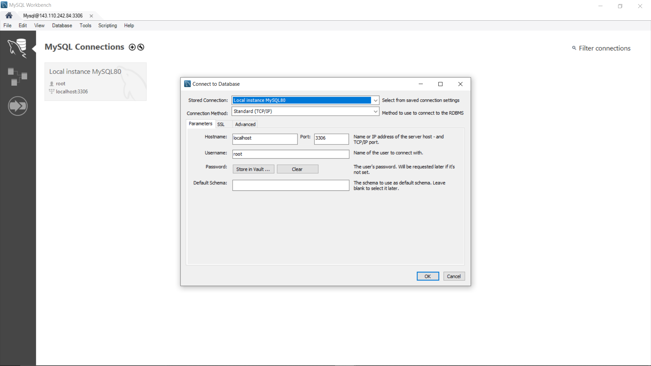

**Step 4:** Enter the password and click on ‘OK’.

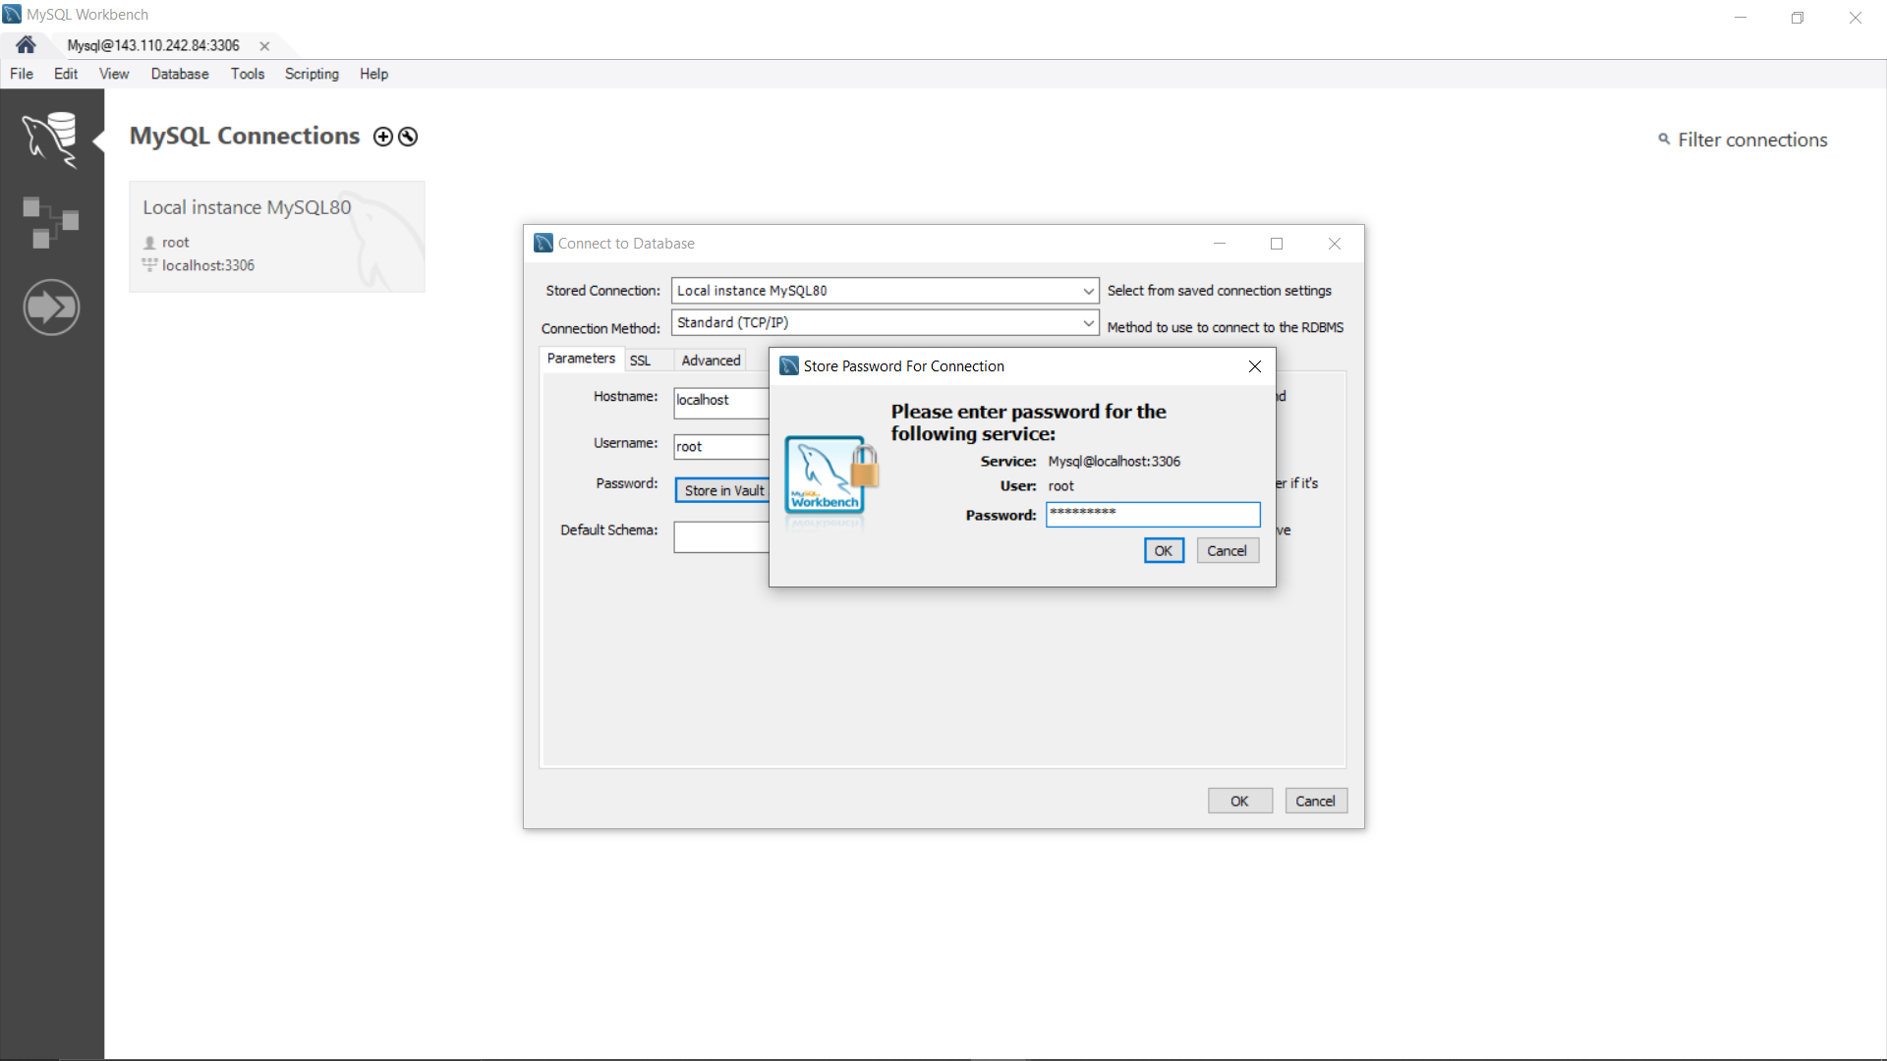

Let the Workbench load your database

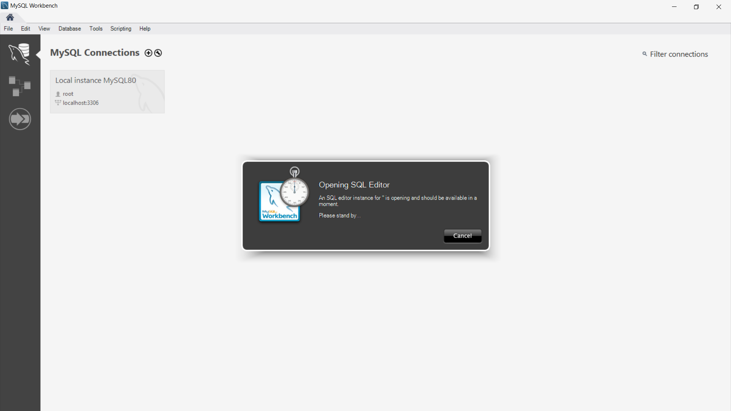

Database with tables can be observed at the left-hand side of the window

