**Getting started with Scrum**

Step-1 : Go to Projects, Click on create project.

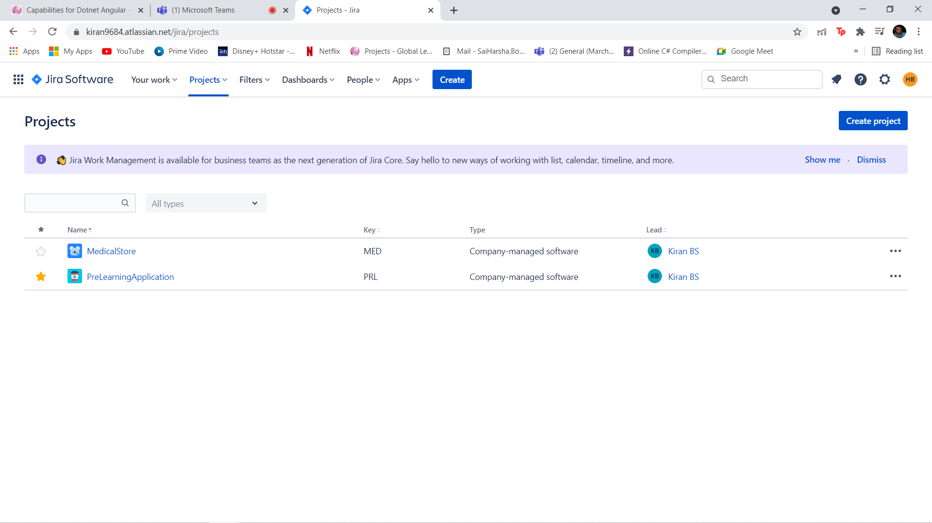

Step-2 : Choose the project type based on project requirement.

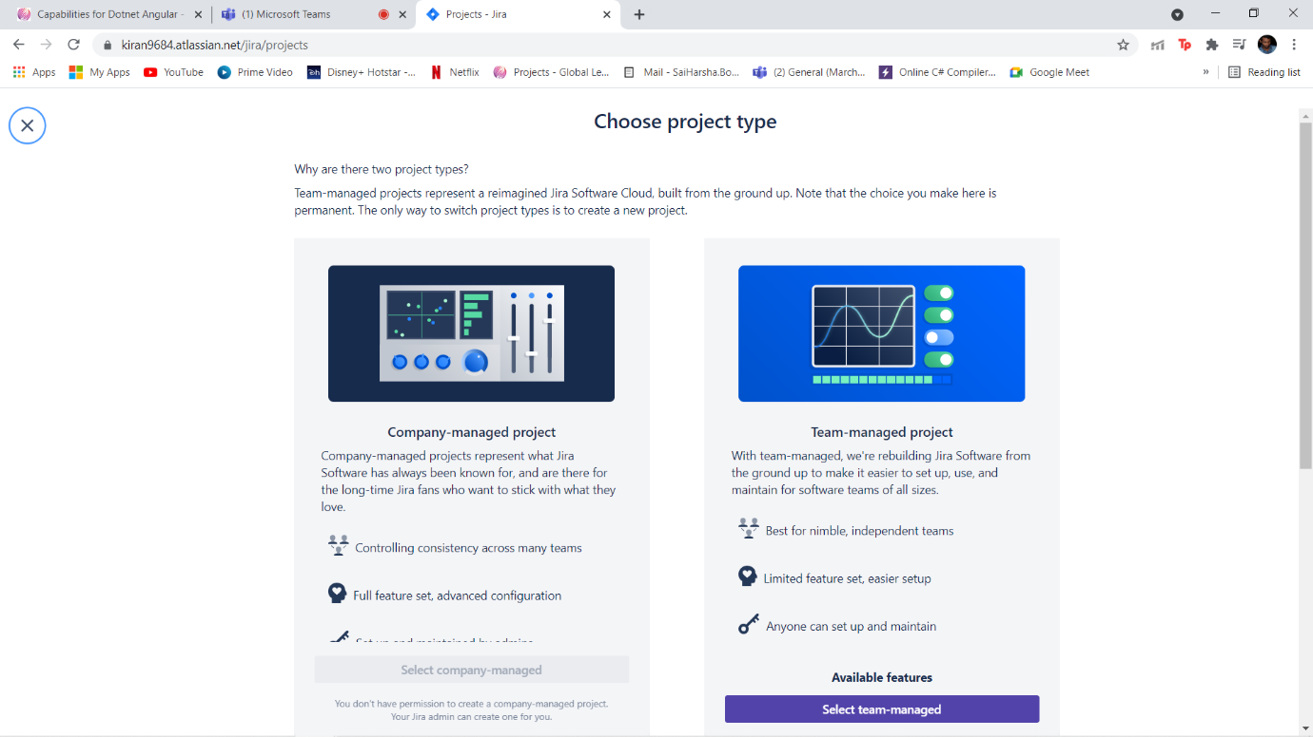

Step-3: Choose the appropriate template (Scrum).

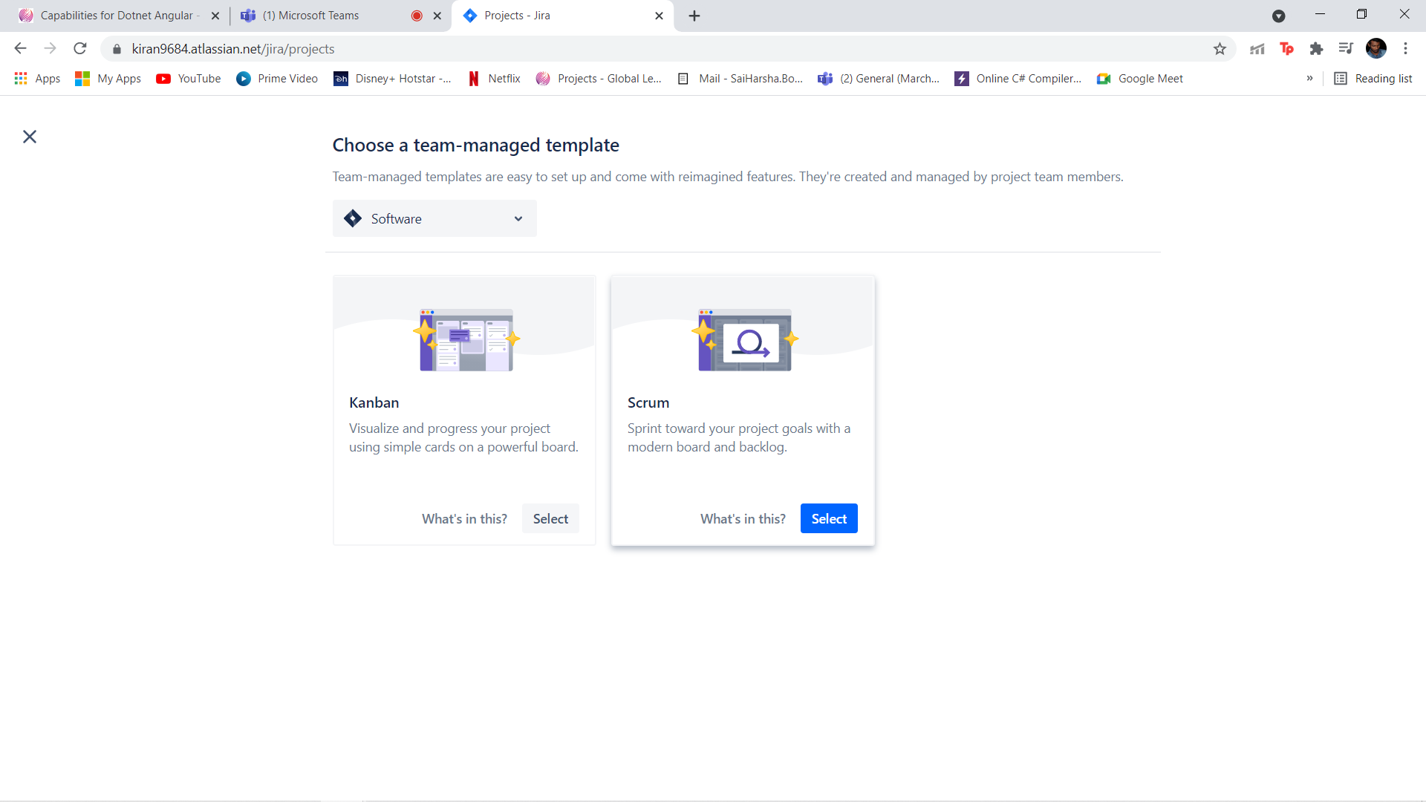

Step-4: Give your project name, Then click on create.

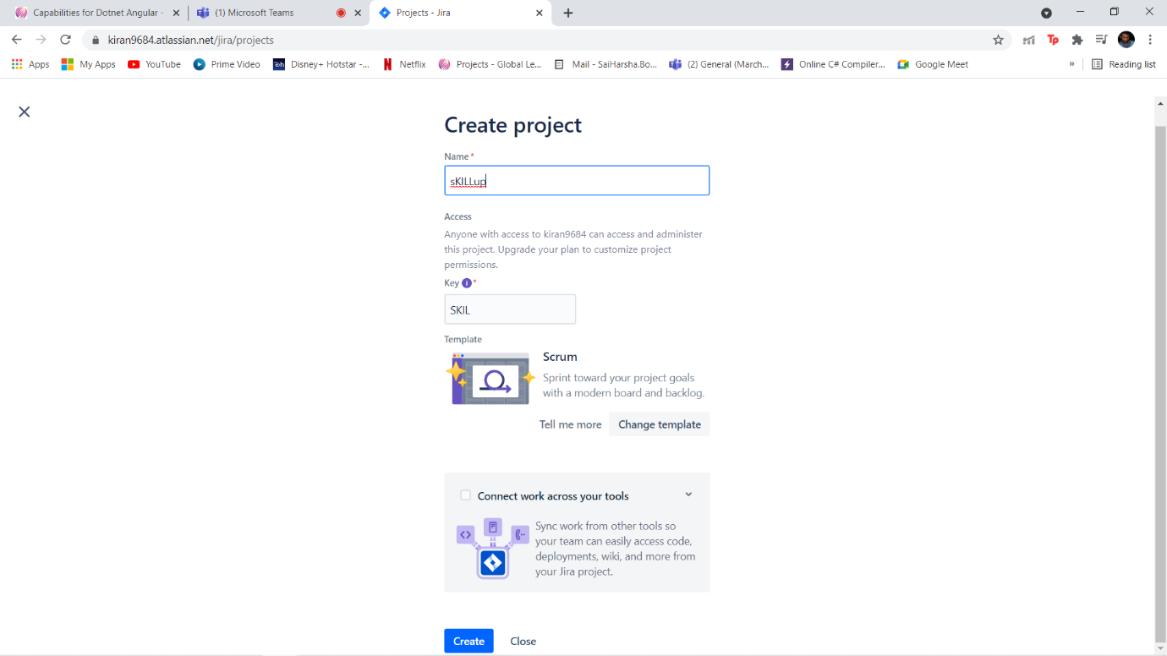

This will be the overview of the scrum project.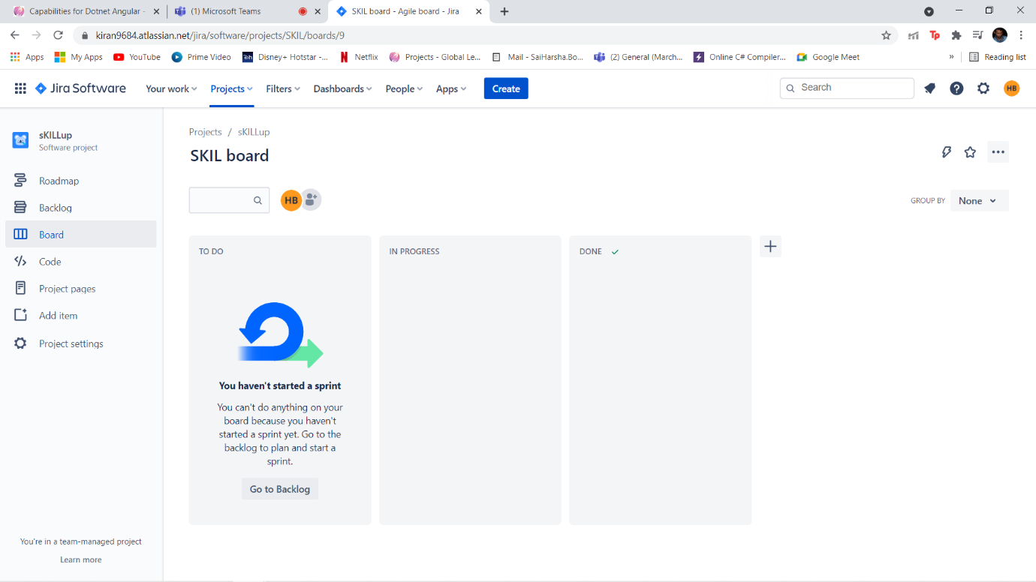

Step-5: Creating an epic

Click on Roadmap -> Create Epic -> Give a name and click on enter.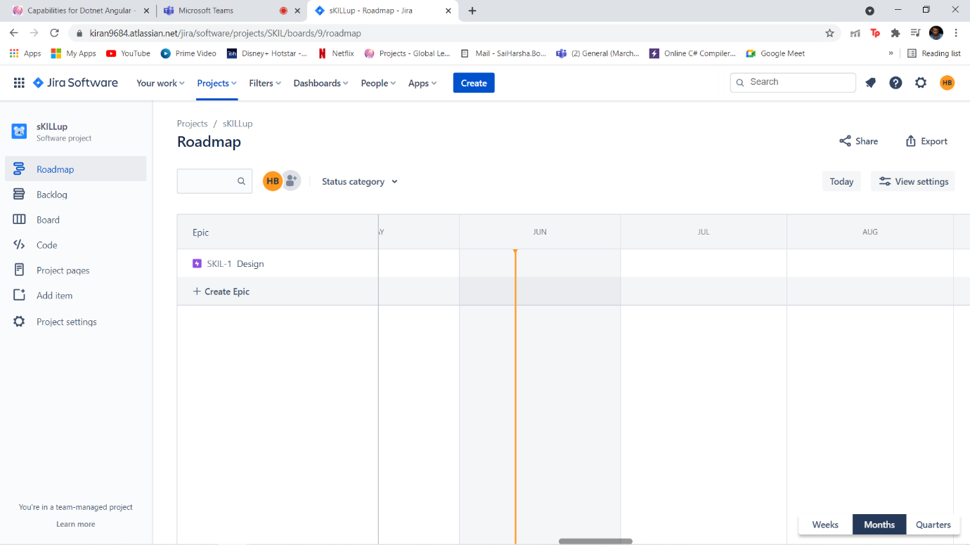

Step-6: Creating a User story and Sprint.

Goto Backlog -> Create Issue(Select Story Icon) ->Give a story name, description, add to epic. Now user story has been created. Next,

Click on create sprint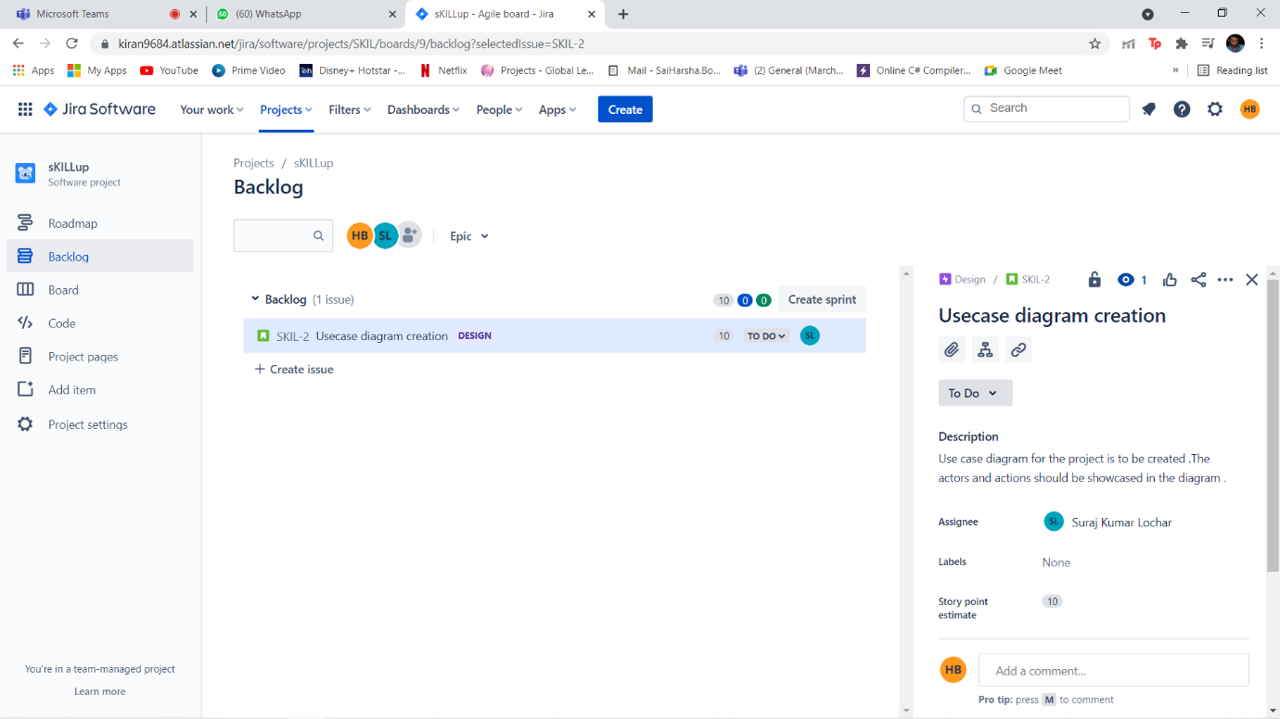

Step-7: Adding Stories to Sprint.

Drag and drop the stories from Backlog to Sprint.

Now click on Start Sprint .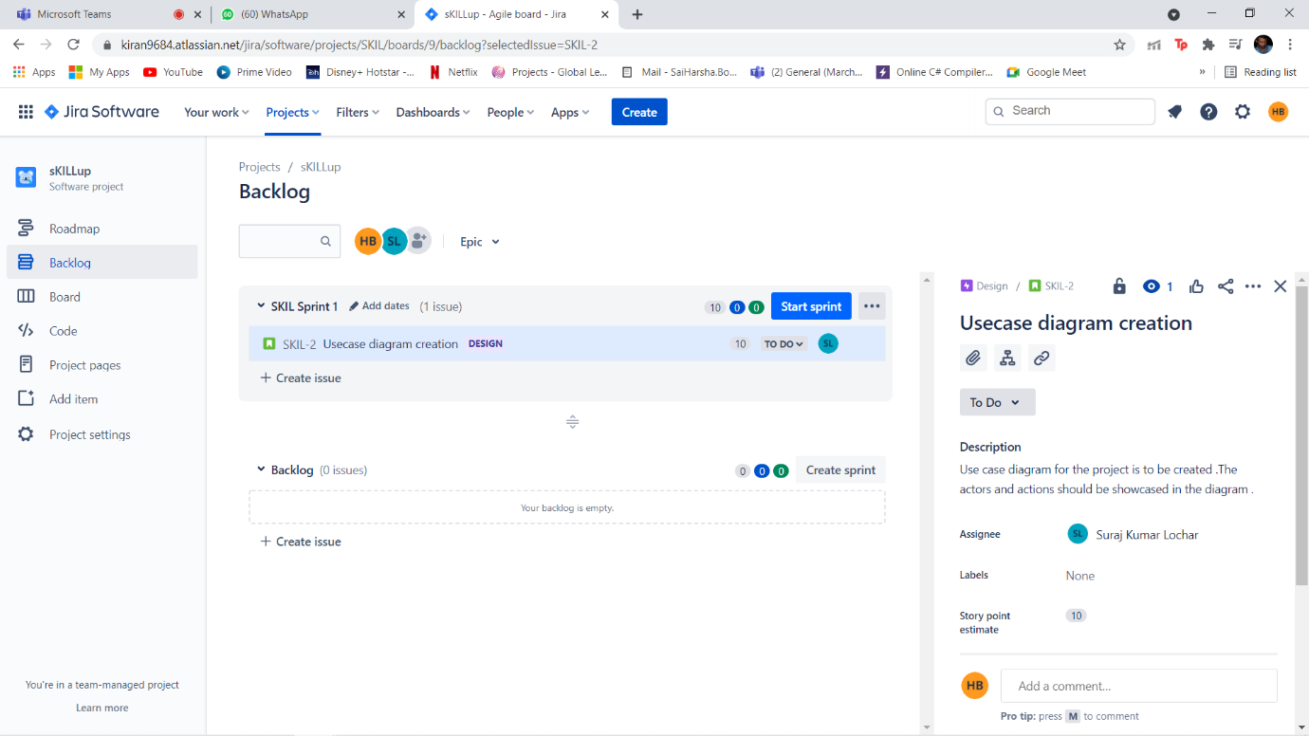

Step-8 : Now give the sprint start and end date along with sprint goal.

Now click on start.

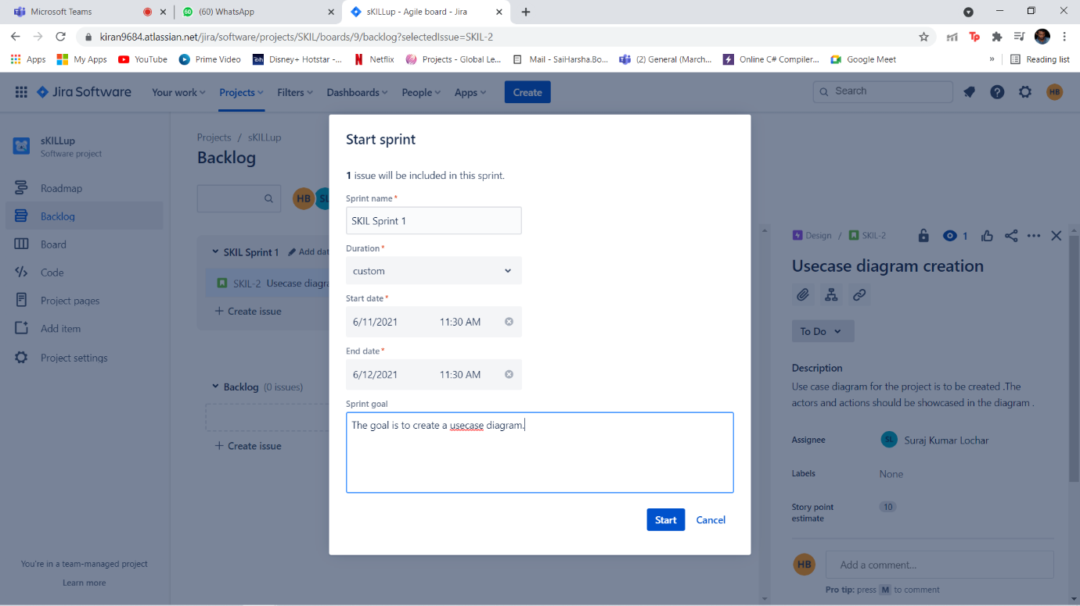

Overview when a sprint is started.

