**🌿 EcoWatts – Smart Home Energy Analyzer**

Submitted by: Aniket Dombale

Department of Technology, Savitribai Phule Pune University

Academic Year: 2025–26

# Hourly Energy Usage line chart

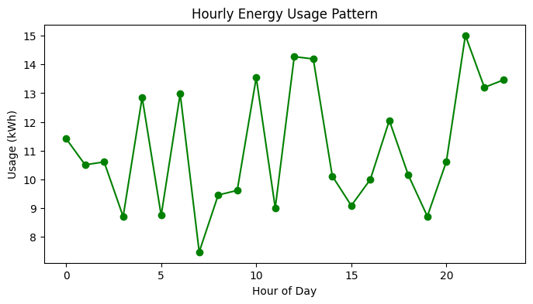

# Appliance Usage Pie Chart

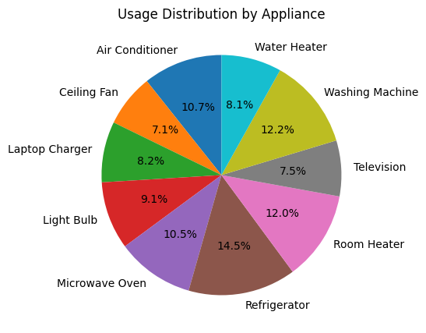

 # Room vs Hour Heatmap

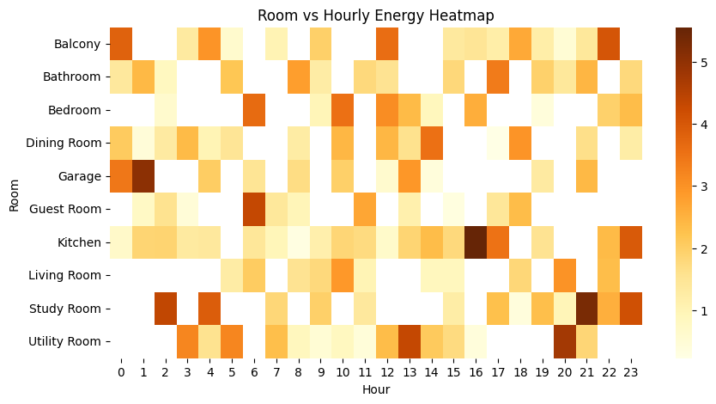

# Daily Usage Bar Chart

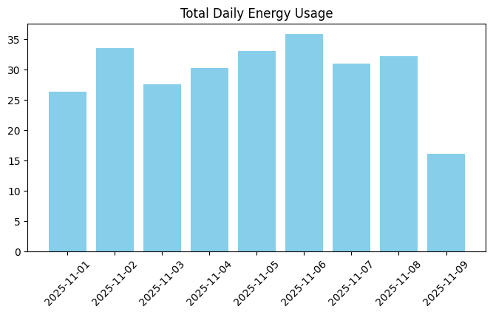

# Cost by Appliance

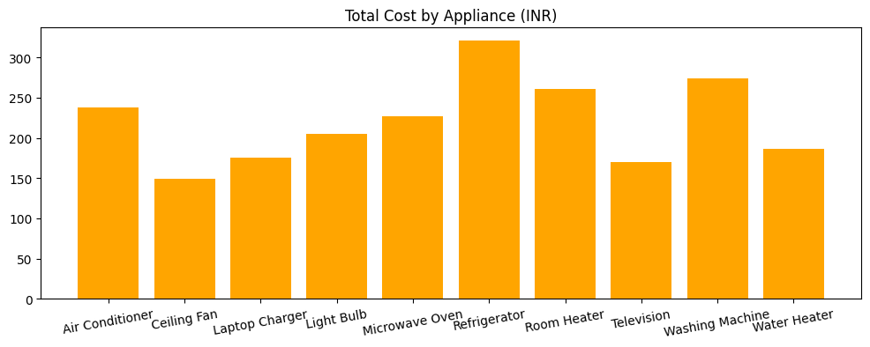

# Smart Tip Generator

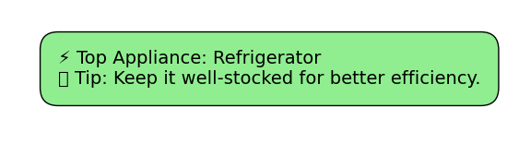

# Plot Forecast vs Actual

