COLLEGE MANAGEMENT SYSTEM

PROJECT BY – Mr. Aniket Rajanikant Patil

GUIDED BY - Mr. Sameer Warsolkar Sir.

***ABSTRACT***

This project is based on how colleges manage their system. CMS provides smooth administrative process to manage the student related information and their admission process along with other related stuffs like book library process.

**Aniket Rajanikant Patil**

<Ap.aniketpatil97@gmail.com>

Batch id : DS T – 326/11 to 1

College Management System

*Project for SQL Module*

*DESCRIPTION:*

Following database schema is designed to function as a backend storage database to manage College database.

The activities which are performed by college to maintain daily activities of students related information efficiently and easily. Some of the benefits of using this system are:

1. Updating Student details whenever there is new admission.
2. Maintaining usage of library by each and every student.
3. Its easy to find out which student belongs to which class and branch.
4. Keeping the record of whole college system within database is faster as compared to manual activities. RDBMS provides many ways to analyse available data.

Database name:

* College

This database contains 5 tables:

1. Student
2. Class
3. Branch
4. Books
5. Issues

How these tables/entities are related to each other is shown on next page through ER diagram,

i.e. Entity Relationship Diagram.

*ER-Diagram (Entity Relation – Diagram) for College Management System:*

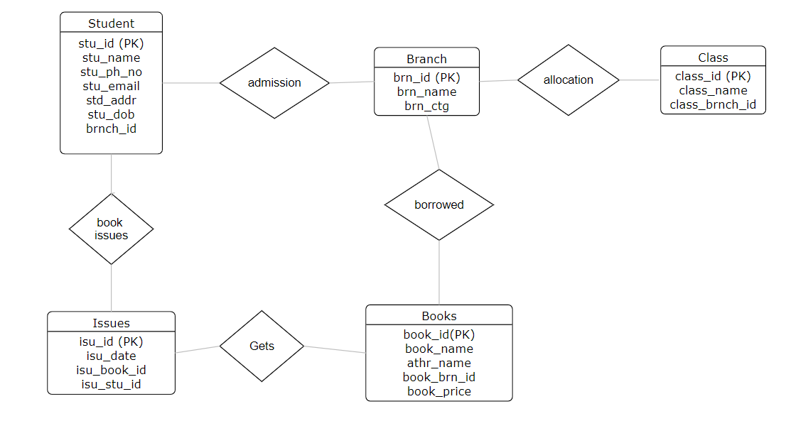

CREATING DATABASE:

Create database college;

Use college;

TABLE CREATION & INSERTION COMMANDS:

CREATE TABLE student(

stu_id INT PRIMARY KEY,

stu_name VARCHAR(30),

stu_ph_no INT ,

stu_email VARCHAR(30) ,

stu_addr VARCHAR(50),

stu_dob DATE,

brnch_id int

);

CREATE TABLE books (

book_id INT PRIMARY KEY ,

book_name VARCHAR(30),

athr_name VARCHAR(30),

book_brn_id INT,

book_price INT

);

CREATE TABLE branch (

brn_id INT PRIMARY KEY,

brn_name VARCHAR(20),

brn_ctg VARCHAR(20)

);

CREATE TABLE issues (

isu_id INT UNIQUE,

isu_date DATE ,

isu_book_id INT ,

isu_stu_id INT

);

CREATE TABLE class (

class_id int UNIQUE,

class_name varchar(20),

class_brnch_id int

);

***Inserting values in Student table:***

INSERT INTO student (`stu_id`,`stu_name`,`stu_ph_no`,`stu_email`,`std_addr`,`stu_dob`,`brnch_id`) VALUES (911,'Aniket Patil',7394658,'aniket6748@gmail.com','Thane Manpada','1994-09-03',1002);

INSERT INTO student (`stu_id`,`stu_name`,`stu_ph_no`,`stu_email`,`std_addr`,`stu_dob`,`brnch_id`) VALUES (912,'Adarsh Singh',5936827,'adarsh674@gmail.com','Thane Wadavali','1993-05-08',1002);

INSERT INTO student (`stu_id`,`stu_name`,`stu_ph_no`,`stu_email`,`std_addr`,`stu_dob`,`brnch_id`) VALUES (913,'Sanika Lokhande',9564836,'sanika3841@gmail.com','Mumbai Sakinaka','1998-07-13',1003);

INSERT INTO student (`stu_id`,`stu_name`,`stu_ph_no`,`stu_email`,`std_addr`,`stu_dob`,`brnch_id`) VALUES (914,'Aditi Chaugule',8375663,'aditi43@gmail.com','Bhiwandi Bhare','2000-05-07',1001);

INSERT INTO student (`stu_id`,`stu_name`,`stu_ph_no`,`stu_email`,`std_addr`,`stu_dob`,`brnch_id`) VALUES (915,'Vanita Kharat',6492657,'vanita45@gmail.com','Nashik Shirdi','1998-02-03',1002);

***Inserting values in Books table:***

INSERT INTO books (`book_id`,`book_name`,`athr_name`,`book_brn_id`,`book_price`) VALUES (11,'Basics Of Science','George.c',1001,455);

INSERT INTO books (`book_id`,`book_name`,`athr_name`,`book_brn_id`,`book_price`) VALUES (12,'Basics Of Maths','Hadhway Rome',1002,657);

INSERT INTO books (`book_id`,`book_name`,`athr_name`,`book_brn_id`,`book_price`) VALUES (13,'Algebra 101','Katty Holmes',1002,345);

INSERT INTO books (`book_id`,`book_name`,`athr_name`,`book_brn_id`,`book_price`) VALUES (14,'Stars And Moons','Marty & Josh',1001,999);

INSERT INTO books (`book_id`,`book_name`,`athr_name`,`book_brn_id`,`book_price`) VALUES (15,'C++ All In One','Jason.y',1003,867);

INSERT INTO books (`book_id`,`book_name`,`athr_name`,`book_brn_id`,`book_price`) VALUES (16,'Python For DS','Jose.Port',1003,567);

INSERT INTO books (`book_id`,`book_name`,`athr_name`,`book_brn_id`,`book_price`) VALUES (17,'Java OOPS','James Gosling',1002,450);

***Inserting values in Branch table:***

INSERT INTO branch (`brn_id`,`brn_name`,`brn_ctg`) VALUES (1001,'Finance','Commerce');

INSERT INTO branch (`brn_id`,`brn_name`,`brn_ctg`) VALUES (1002,'IT','Engineering');

INSERT INTO branch (`brn_id`,`brn_name`,`brn_ctg`) VALUES (1003,'Computer','Engineering');

***Inserting values in Issues table:***

INSERT INTO issues (`isu_id`,`isu_date`,`isu_book_id`,`isu_stu_id`) VALUES (5,'2021-09-26',11,919);

INSERT INTO issues (`isu_id`,`isu_date`,`isu_book_id`,`isu_stu_id`) VALUES (1,'2021-11-13',12,913);

INSERT INTO issues (`isu_id`,`isu_date`,`isu_book_id`,`isu_stu_id`) VALUES (2,'2021-12-04',16,917);

INSERT INTO issues (`isu_id`,`isu_date`,`isu_book_id`,`isu_stu_id`) VALUES (3,'2022-01-18',13,911);

INSERT INTO issues (`isu_id`,`isu_date`,`isu_book_id`,`isu_stu_id`) VALUES (4,'2022-01-02',15,915);

***Inserting values in Class table:***

INSERT INTO class (`class_id`,`class_name`,`class_brnch_id`) VALUES (100,'Class1',1001);

INSERT INTO class (`class_id`,`class_name`,`class_brnch_id`) VALUES (101,'Class2',1003);

INSERT INTO class (`class_id`,`class_name`,`class_brnch_id`) VALUES (102,'Class3',1002);

**SQL QUERIES:**

1. fetch all the students by descending order of the name.

* select * from student order by stu_name desc;

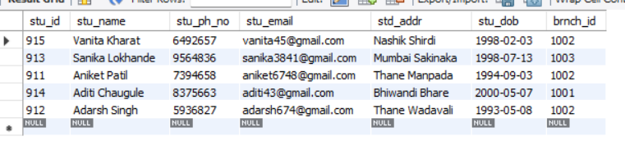

1. How many branches are present for engineering stream.

* select count(1) AS qty from branch where brn_ctg = 'Engineering';

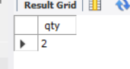

1. total price of all books in college.

* select sum(book_price) sum_book from books;

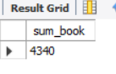

1. Write a query to get student details who stays in Thane

* select stu_id,stu_name,stu_ph_no,stu_email,std_addr,stu_dob from student where std_addr like 'Thane%';

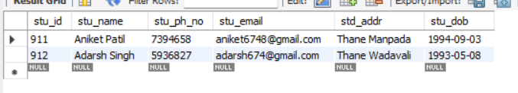

**SUB QUERIES:**

1. fetch name and email ID of a student who belongs to branch IT.

* select stu_name, stu_email from student where brnch_id = (select brn_id from branch where brn_name = 'IT');

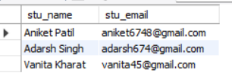

1. Write a query to get class name whoes branch category is 'Engineering'

* select class_name from class where class_brnch_id in (select brn_id from branch where brn_ctg = 'Engineering');

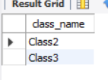

1. Write a query to get Students seating in 'Class 3'

* select * from student where brnch_id in

(select brn_id from branch where brn_id = (select class_brnch_id from class where class_name = 'Class3' ));

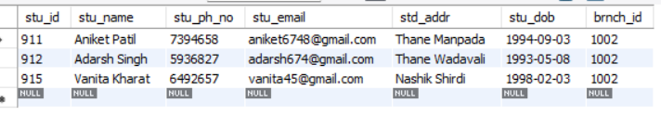

1. write a query to find the highest price of book

* select book_price , book_name from books

where book_price = (select max(book_price) highest_price from books);



**JOINS :**

1. fetch name, email ID and branch name of all students

* select s.stu_name,s.stu_email,b.brn_name from student s join branch b

on s.brnch_id = b.brn_id;

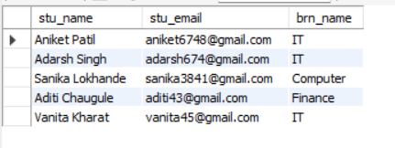

1. find out the student name, email id, book name and date of book issued who issued the book of "Basics Of Science"

* select s.stu_name,s.stu_email, b.book_name, i.isu_date

from student s join issues i on s.stu_id = i.isu_stu_id

join books b on i.isu_book_id = b.book_id

where b.book_name = 'Basics Of Maths';

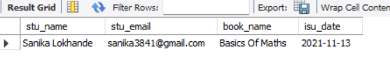

1. find out total books available for each branch

* select count(1), br.brn_name from branch br

join books b on b.book_brn_id = br.brn_id

group by br.brn_name;

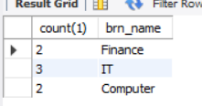

1. Name of books issued after year 2021

* select b.book_name,i.isu_date from books b

Join issues i on b.book_id = i.isu_book_id

where year(isu_date) > '2021';

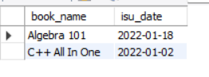

1. Find out the branch name which has more than 2 books also show the respective book count

* select count(1) as book_count, br.brn_name from branch br

join books b on b.book_brn_id = br.brn_id

group by br.brn_name

having book_count > 2;

