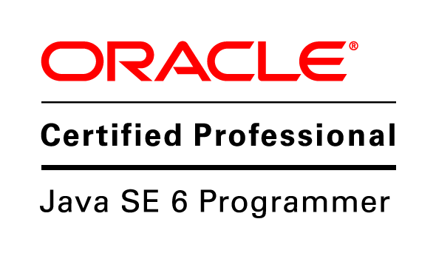
KATAKAM ANIKETHA Address:

1-9-312/5/2/1,Flat no.402
Krishna Nivas apts,
Vidyanagar,
Hyderabad- 500044
Email: aniketha112@gmail.com
Mobile: 9701234963
Career Objective:
To achieve high career growth in the field and be part of an organization where I can enhance my knowledge and skills and serve the organization to the best of my ability.

Educational Qualifications:

LEVEL OF EDUCATION | INSTITUTION | BOARD/UNIVERSITY | YEAR OF PASSING | AGGREGATE  (in %)
B.Tech (Branch- Information Technology) | Keshav Memorial Institute of Technology | Jawaharlal Nehru Technological University,Hyderabad | 2014  (anticipated) | 67%
Intermediate  (MPC) | Narayana Junior  College | Board of  Intermediate  Education, A.P. | 2010 | 89 %
School | Sri Aurobindo International School | Council for the Indian School Certificate Examinations(I.C.S.E) | 2008 | 68%

Computer Skills:

Programming Languages: C , C++, JAVA,Android.
Databases : MYSQL
Operating Systems : Windows, Linux (Ubuntu)
Web Designing : HTML, CSS, JS

Achievements:
- Participated in the 58th International Astronautical Congress.
- Undergone certified adventure youth camp in nainital for 8 days and got certified.
- Represented my school in many Inter-school Sports events.
- Awarded the “Most Promising Player” in a cricket tournament.

Academic project:

Project: EAMCET COUNSELLING ASSISTANT13
URL: https://play.google.com/store/apps/details?id=kmit.arr&hl=en

Description:
Engineering college selection made easy.This android application lets you know the Colleges you are eligible for based on your rank and category, in the entire state.Or, Instead if you would like to know about a particular college, Search by college to know the previous year's last admitted rank in that college in all categories.

Other Activities:
- Attended android workshop held in our college.
- Participated in Microsoft India app fest.
- Was a part of Microsoft imagine cup.
- Attended workshop on Computer networks in CMS.

Strengths:
- Enthusiastic in team work.
- Hard working
- Commitment to finish the work

Personal Profile:
D.O.B : 02-08-1993
Languages : English, Telugu and Hindi
Extra-Curricular Activities: Solving 2x2x2, 3x3x3 and 4x4x4 Rubik’s cube.
Hobbies : Playing Cricket, Basketball, Badminton, Volleyball.

Place: Hyderabad
Date:

KATAKAM ANIKETHA

