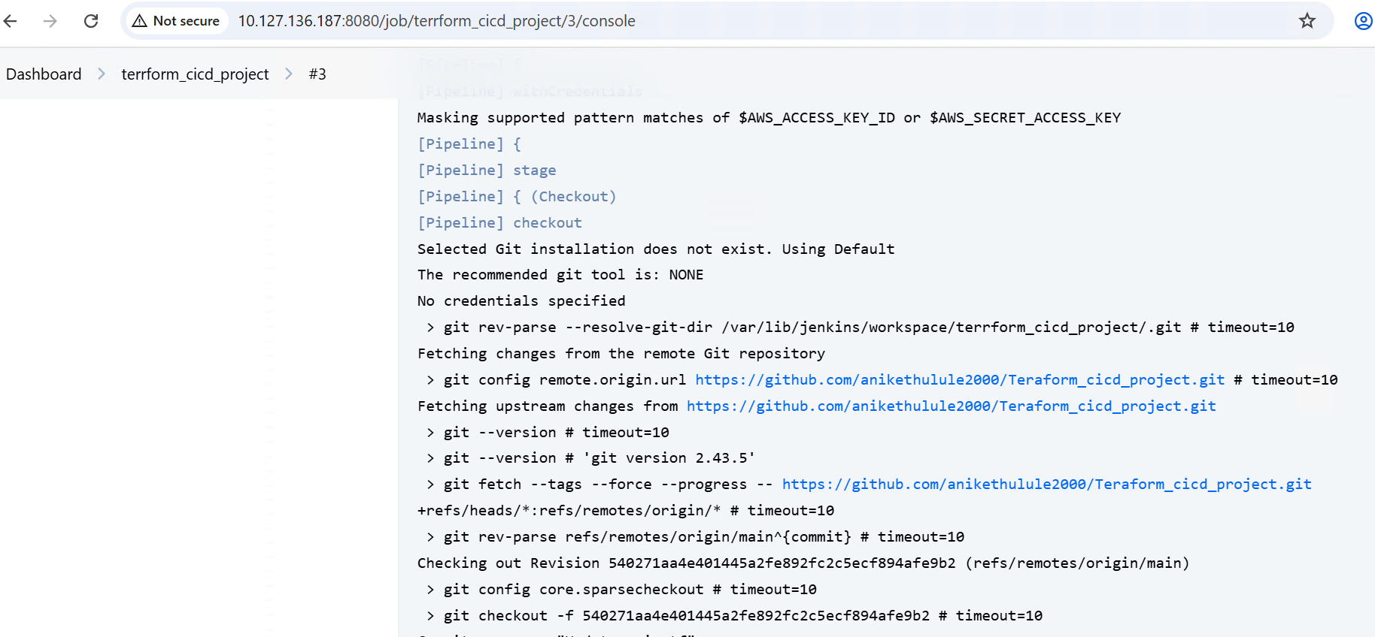

**Git checkout**

**Terraform init**

**Terraform validate and plan**

**Manual approval**

**Accepting to apply changes**

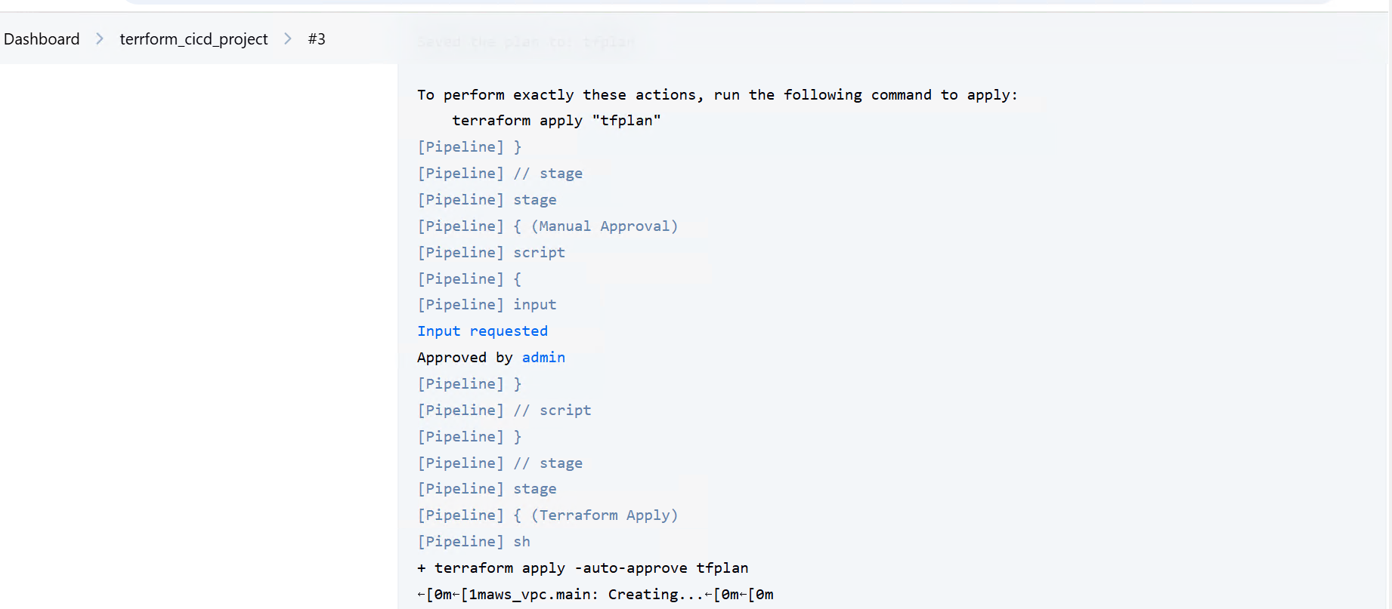

**Terraform applying**

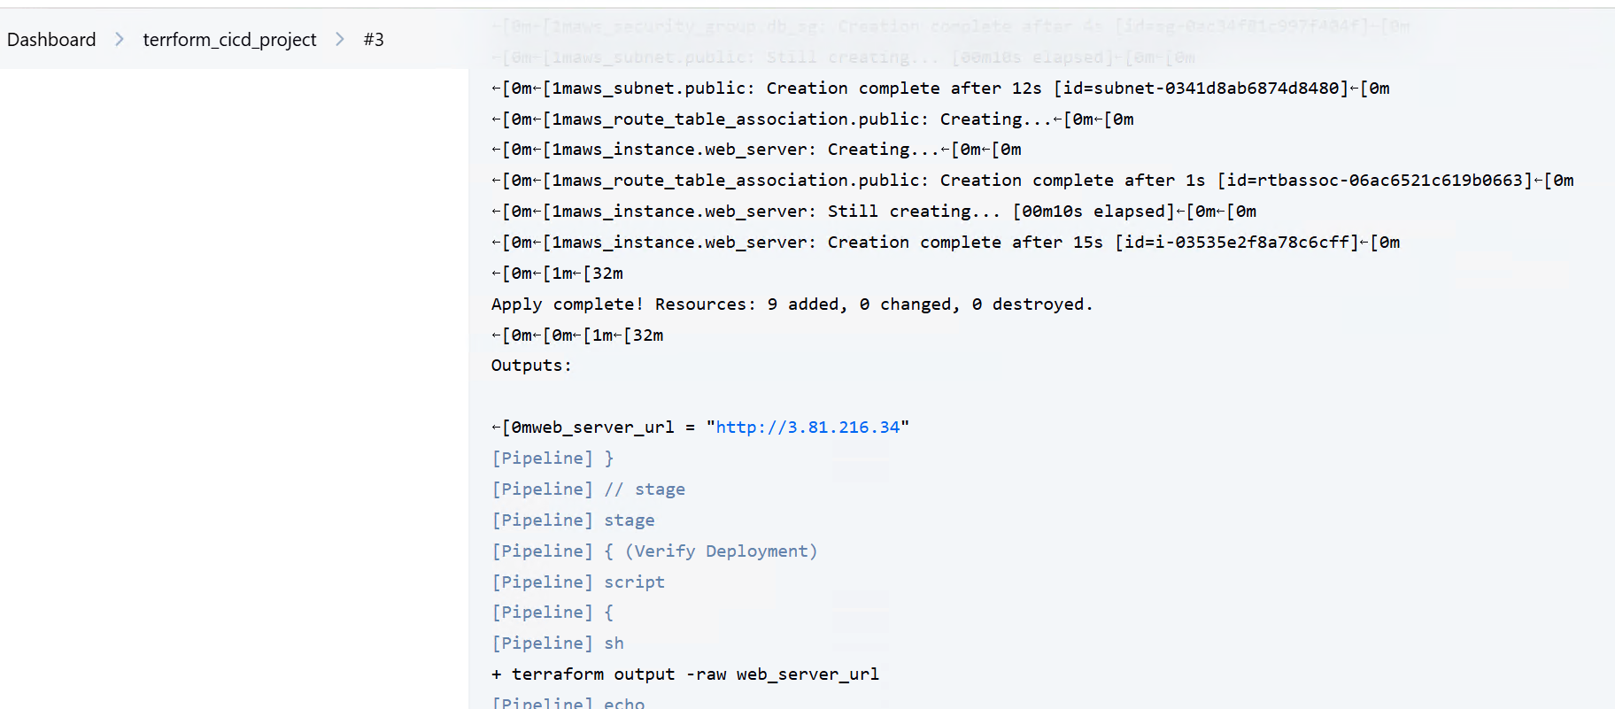

**Terraform output**

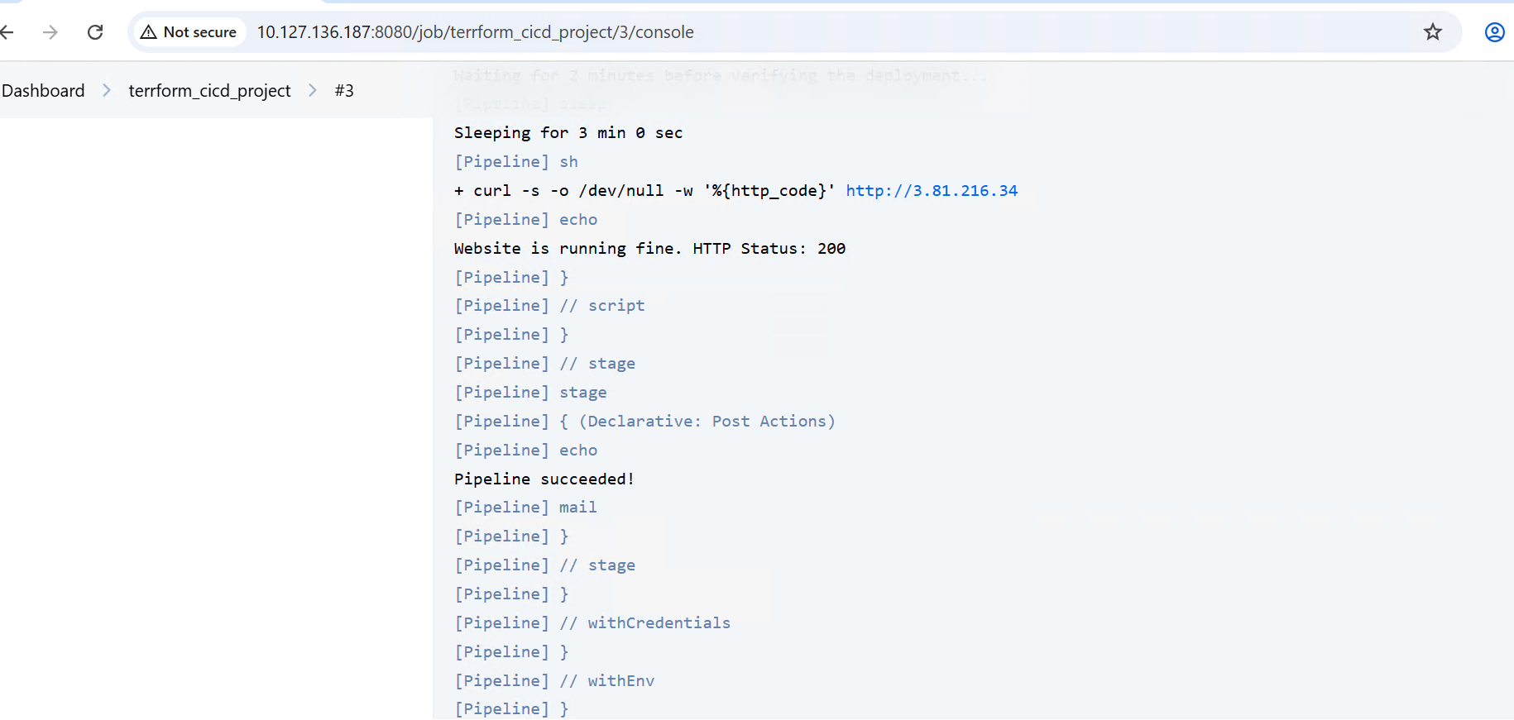

**Pipeline successful**

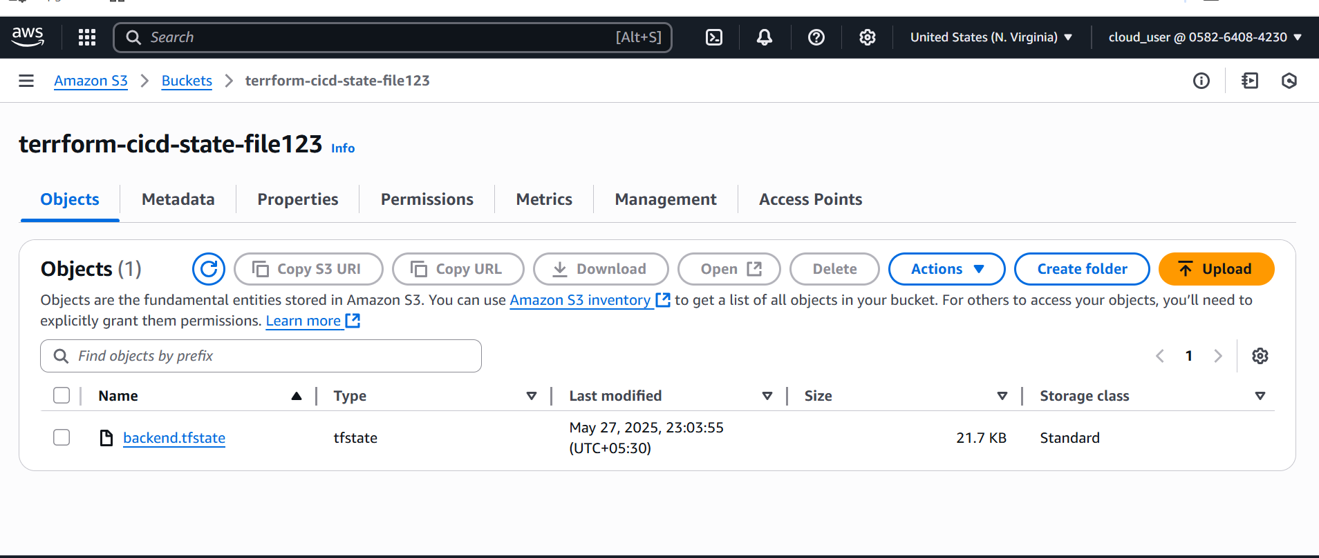

**S3 bucket state file added**

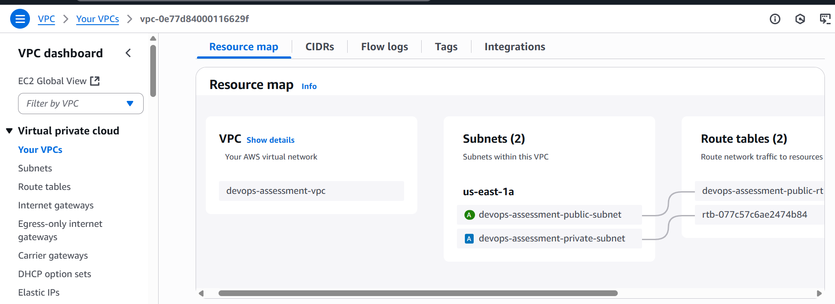

**VPC Created**

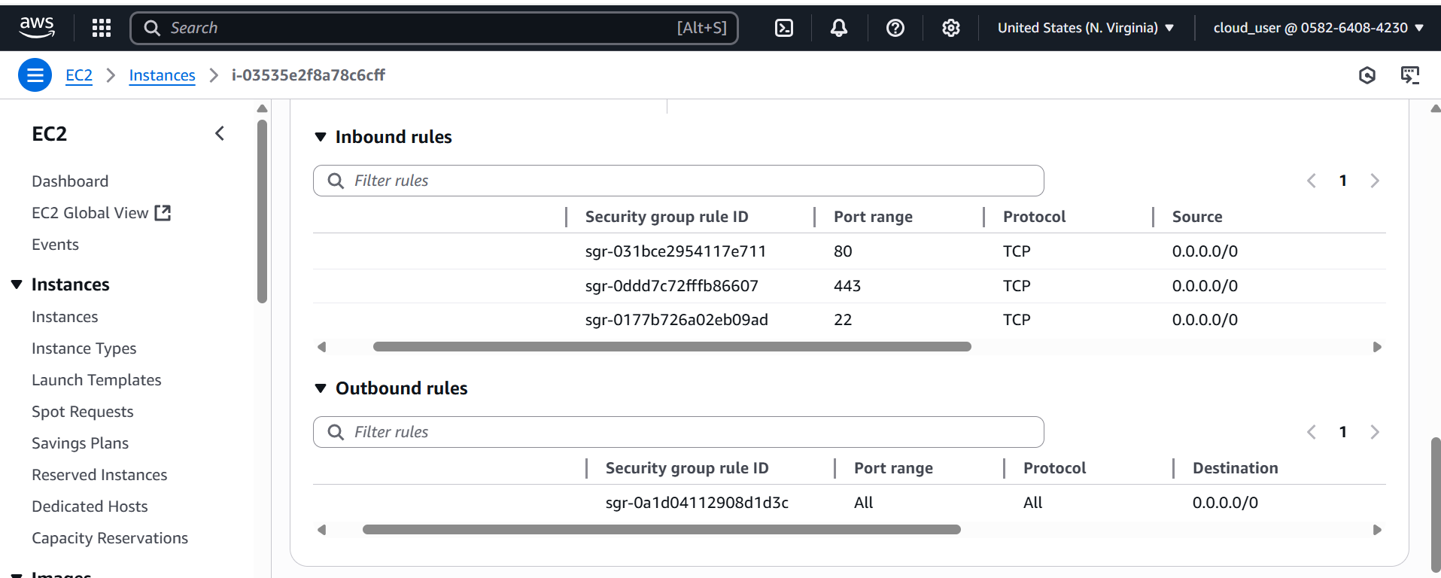

**Security groups added to ec2 instance**

**Accces website in chrome browser**

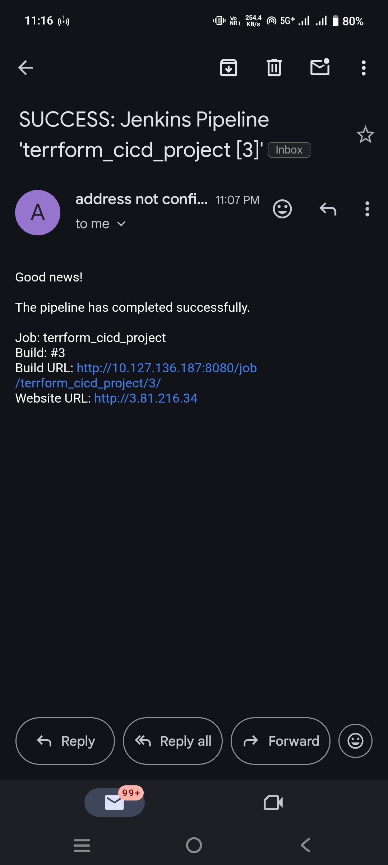

**Verification Mail**