**Board Game Checkers**

**Date: 1st November 2022**

**Team Quick Fix**

**Team Members:**  **Aman Kumar**

**Aniket Khajanchi**

**Milind Pal Singh Tanwar**

**Pritesh Kumar**

**Rayapati Tejasree**

**Requirement Analysis**

1. **Introduction**

Checkers, also known as draughts, is a board game that is one of the world's oldest. Checkers is played by two people competing against each other across a board of 64 light and dark squares, similar to a chessboard. The 24 disk-shaped playing pieces are of contrasting colors (whatever their colors, they are identified as black and white)

* 1. **Purpose and Intended Audience**

The sole purpose of this Checkers game is to make more people aware of this game, engage them, and help them with their logical and gaming skillsets. The intended audience we cater begins from age of 5 and anyone who knows the rules and has some logical thinking capability, they can play this.

* 1. **Objectives and success criteria of the project**The basic objectives of this project would be:

1. Two humans can play against each other.
2. Computer will decide the valid move according to the rules and the algorithm we code.
3. Computer detects and declare the winner based on the game algorithm.
4. **What makes it different?**
   1. **Current system**

There are various online based checkers game available out there. Most of them are two player games in which players can play a turn-based game but these applications do not have one or the other feature that enables players to select different modes (Easy, Intermediate) and variants of checkers.

* 1. **Proposed system**

This Application eliminates the limitations of existing systems by not only including a game between two players (multiplayer game) but also consisting of different modes like different grid layouts, playing on single computer as well as over the internet with other players, and more than one variant of the checker.

1. **Overview:**

In the project of checkers, the product perspective is to provide complete interface where user can play single player and multiplayer game in web-based Environment. GUI will be provided to facilitate this purpose.

1. **Functional Specifications**

The final product should include as a minimal the following:

* 1. **Checkers working**

1. Checkers is played by two players. Each player begins the game with 12 coloured tokens. (One set of pieces is white and the other red)
2. The board consists of 64 squares, alternating between 32 dark and 32 light squares.
3. Black moves first , then alternate moves.
4. Moves are allowed only on the dark squares, so pieces are always limited to forward moves (toward the opponent).
5. When a piece is captured, it is removed from the board.
6. If a player is able to make a capture, there is no option – the jump must be made. If more than one capture is available, the player is free to choose whichever he or she prefers.
7. When a piece reaches the furthest row from the player who controls that piece, it is crowned and becomes a king.
8. For more rule’s information, click on this link [English Draughts](https://en.wikipedia.org/wiki/English_draughts)
   1. **Appearance**
9. The basic colours for the board must be in the black and Adam white family.
10. The basic colours of the checker pieces must be white and red.
11. The colours of the board squares and the checker pieces must be distinguishable.
12. The basic checker pieces must resemble a round standard checker piece. When a checker piece is crowned King, you must change the look of the piece to clearly indicate it is a King. (Eg. draw a k or a crown in the middle of the token).
    1. **Basic Features**
13. The checker pieces will be able to be clicked/dragged by the mouse to and from squares.
14. If the player tries to makes an illegal move, we will alert the player, making cursor unavailable symbol with red or a beep prompt.
15. The checker piece will not to be able to be dragged to an unoccupiable space. Ex. A checker will not be able to be placed on a light-coloured space. Also, not be able to be placed between two squares. The checker will snap to the centre of the closest occupiable square when the mouse click is released.
16. Will be able to save the intermediate game and resume it or start over again according to need of user.
17. Providing users with different modes of game single player or multiplayer where in single player other player will be AI/Computer mode.
18. In Game, when clicked on the checker piece there will be a prediction of Valid moves and highlighting those boxes.
19. Implementing a beep or a sound indication at the player’s system whose ever turn it is.
20. In the end, if the opponent cannot move, or the opponent has no tokens left, the player wins.
21. **External Interface specification**
22. **User-Interface**: The software completely works in real time with the GUI by changing the token positions as the game continues and dynamically updating the points and status of the player whoever is active.   
      
    The User-Interface will look as follows:

**Rough Sketches:**

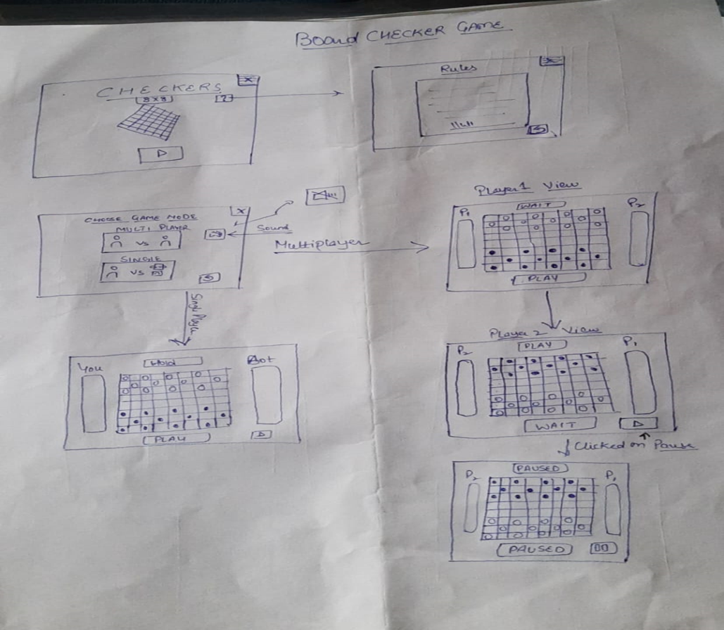

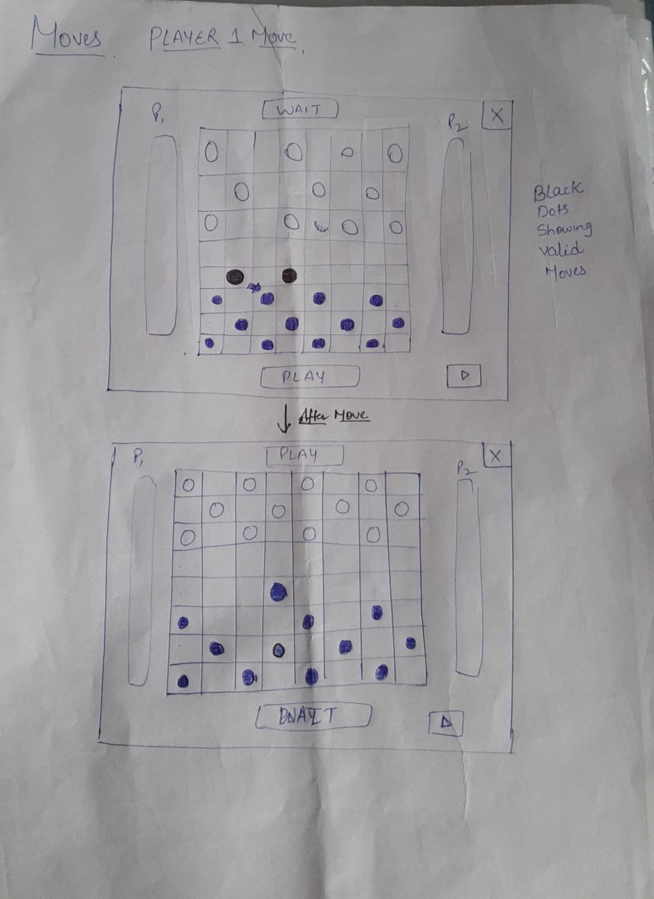

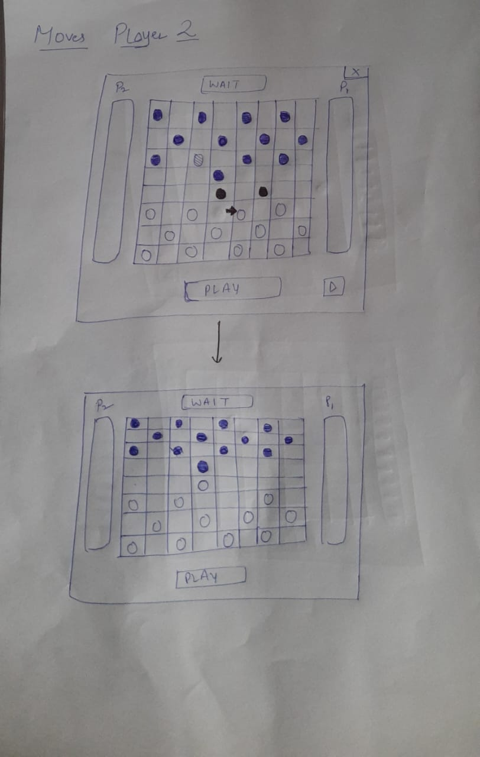

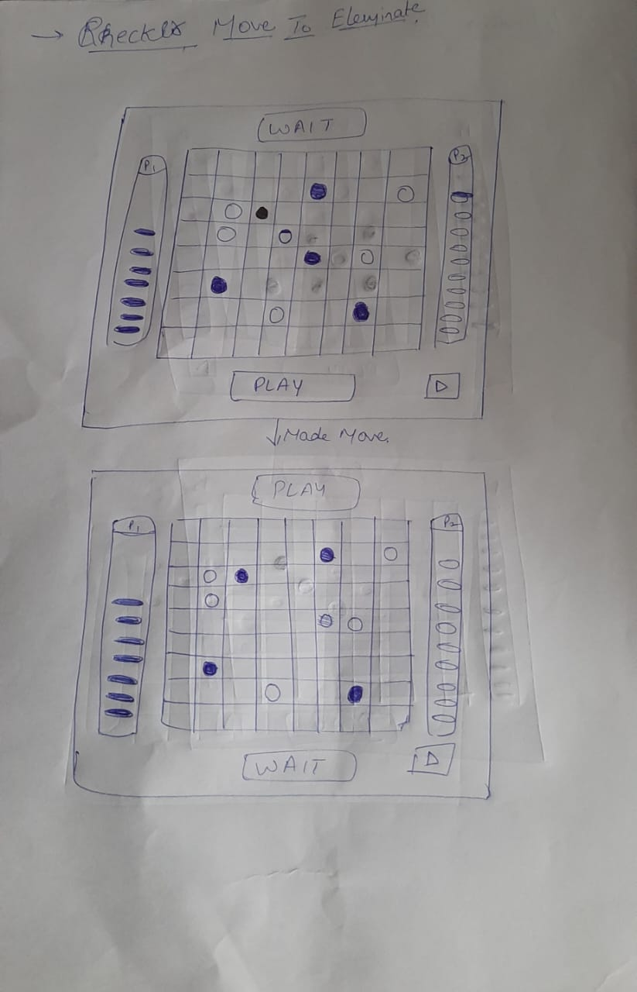

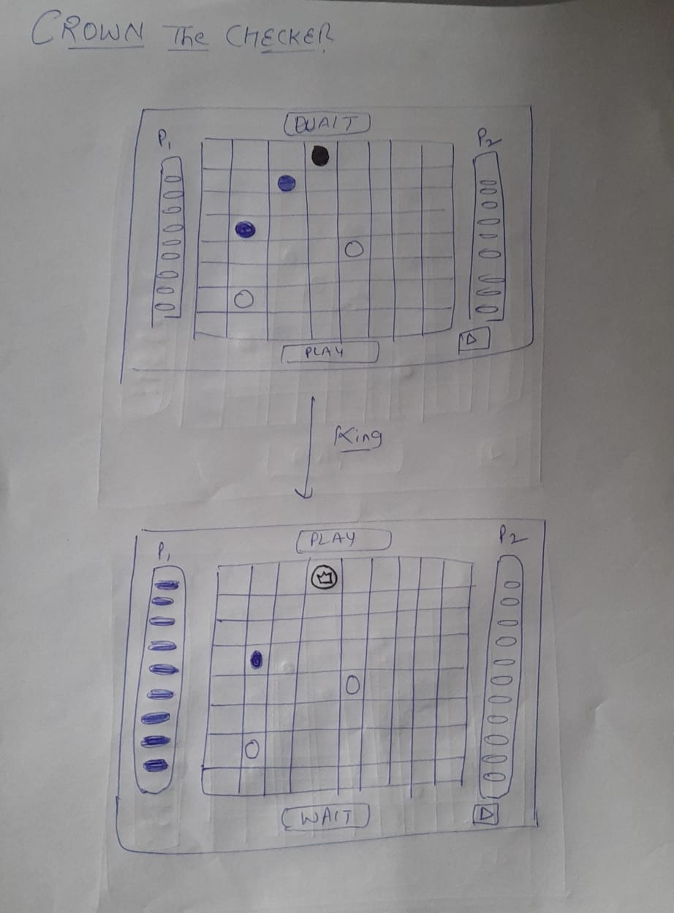

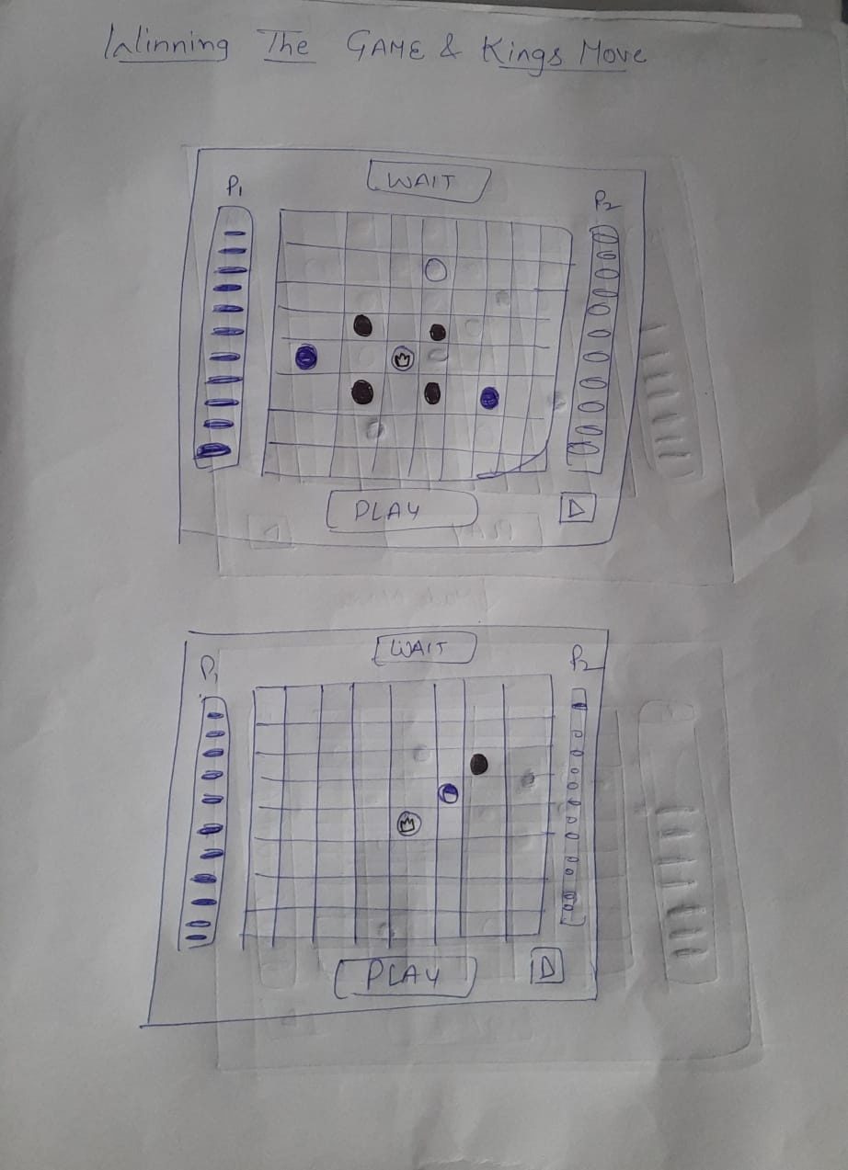

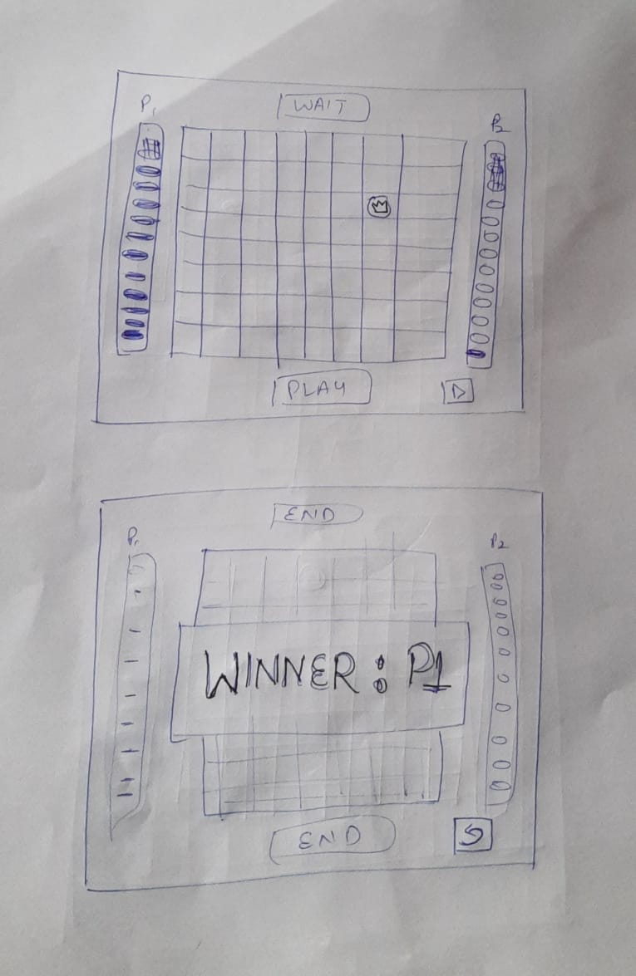

**UI Designs:**

Checker variants choosing mode page:  
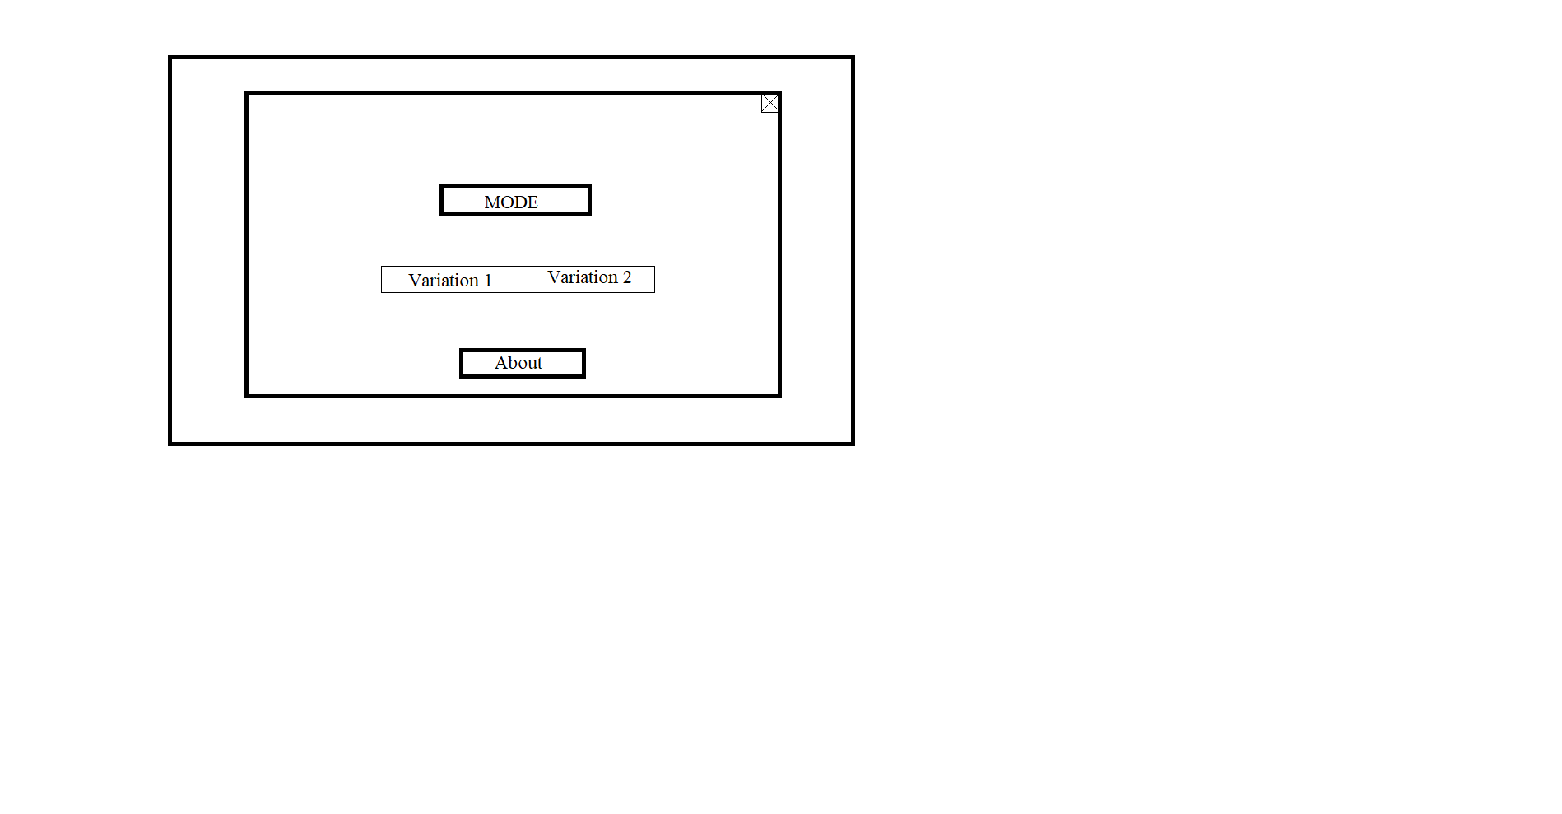

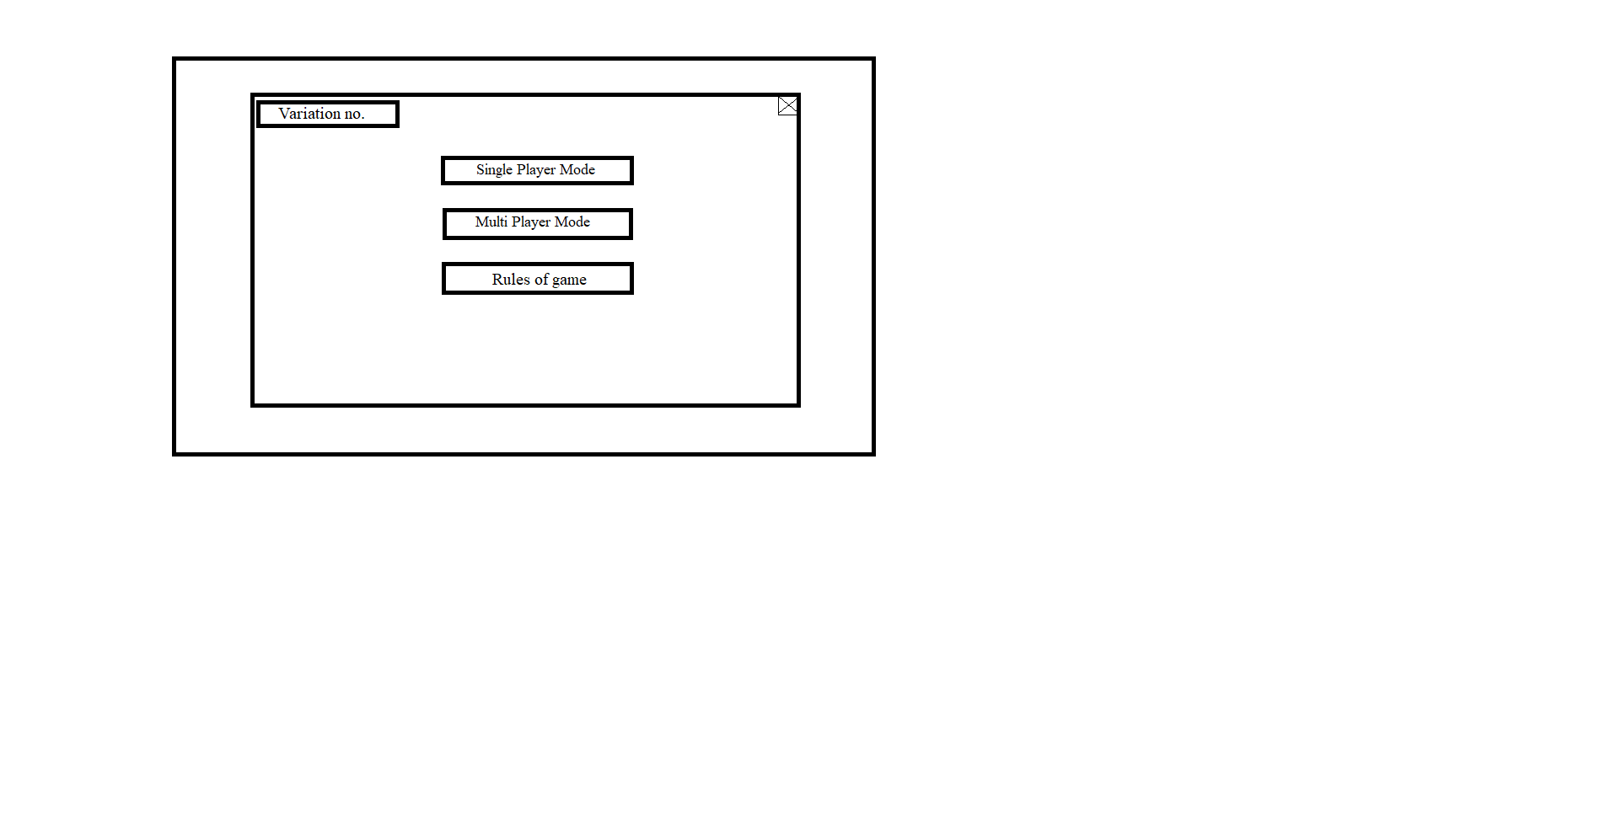Game choosing mode page: 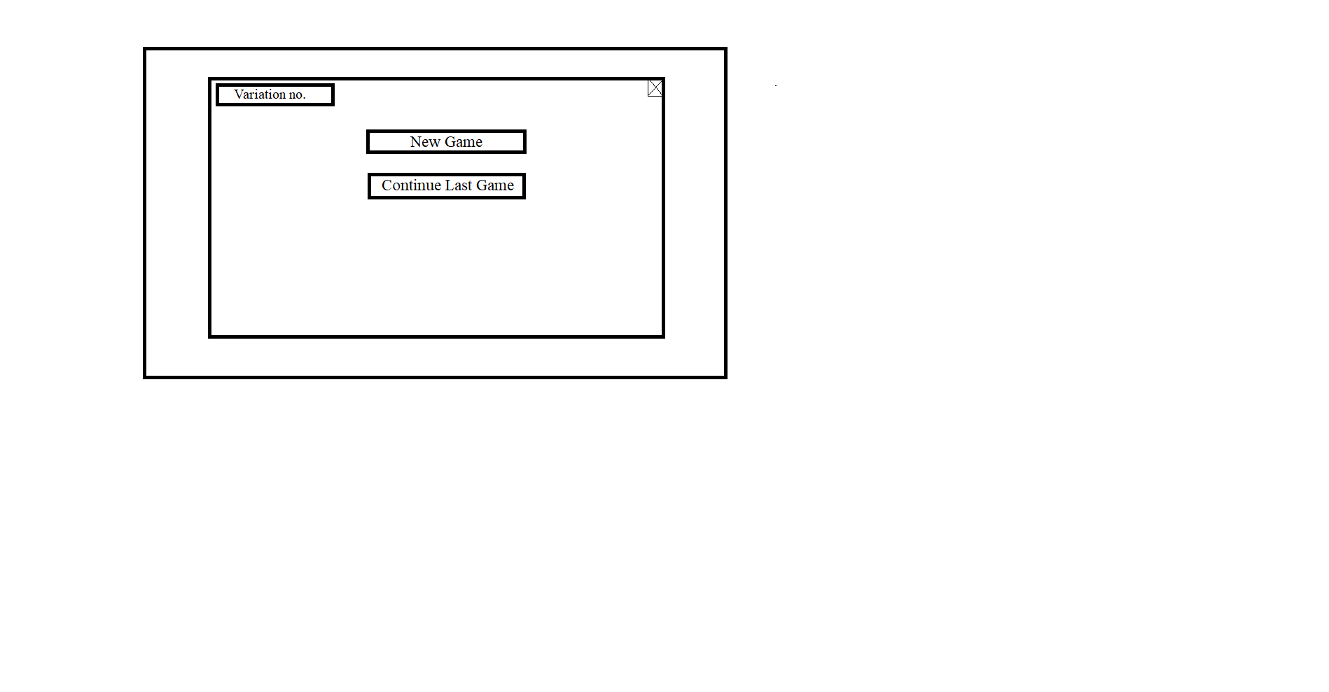

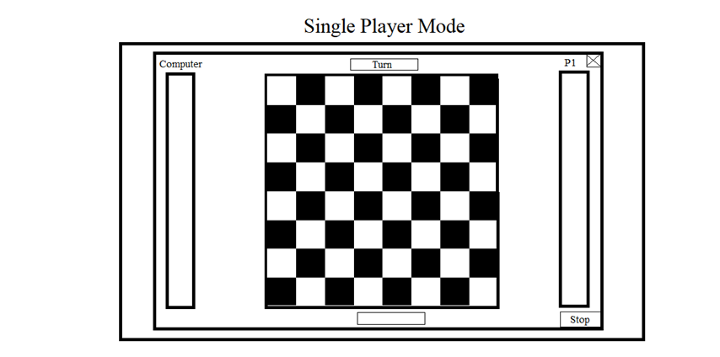Interface of single player mode:

Interface of Multi-player mode:

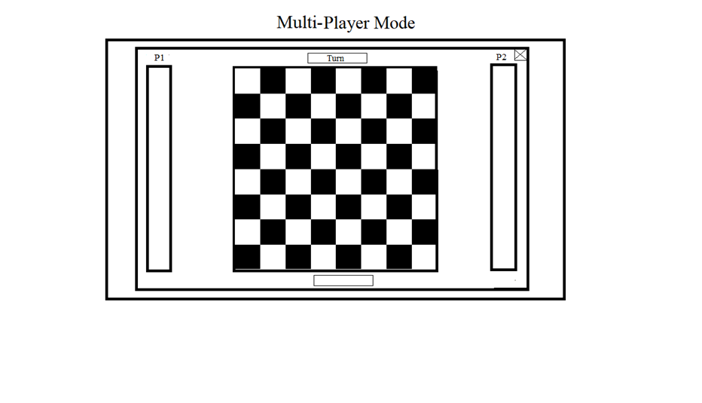

Invalid move and Jumping move feature:

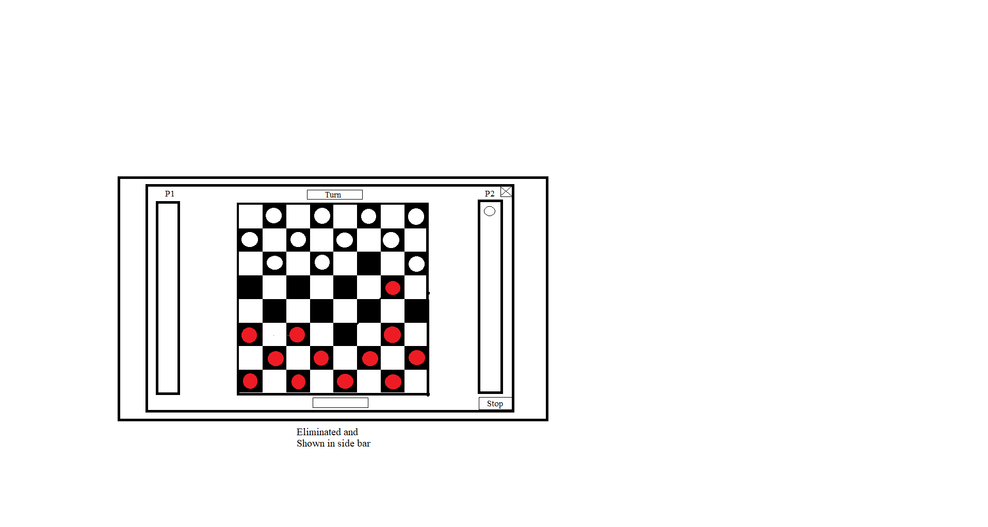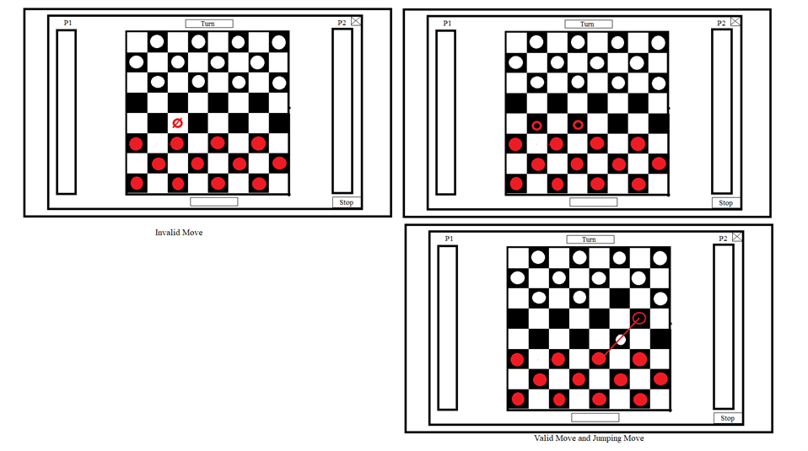

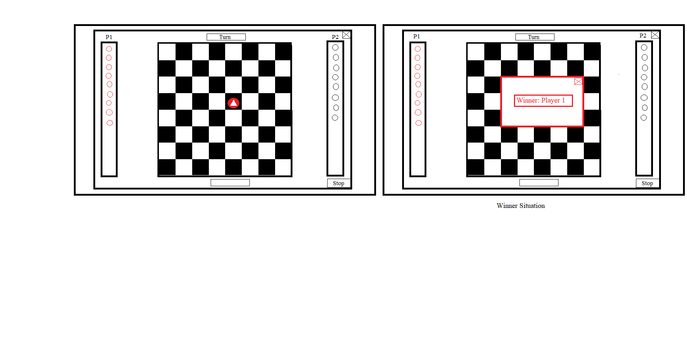

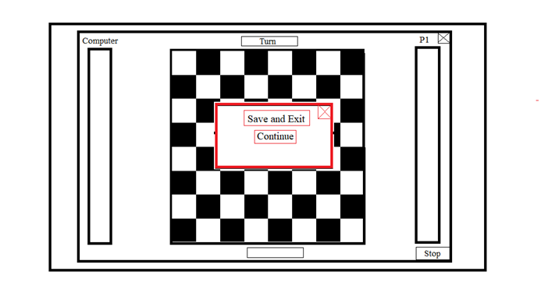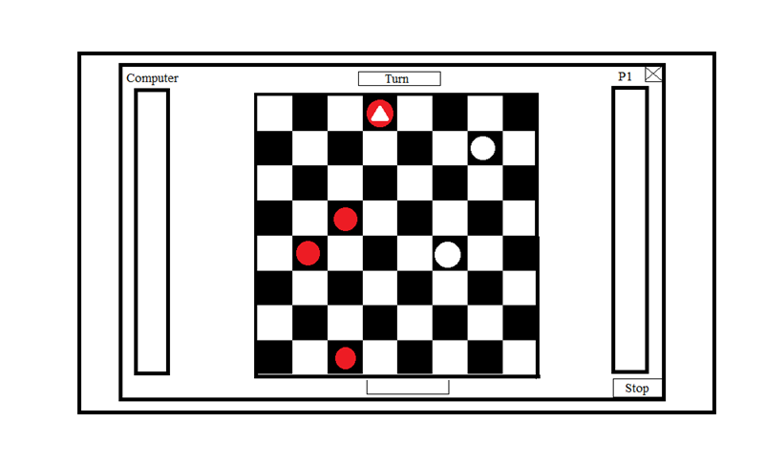

1. **Technical Specifications**
   1. **Hardware requirements**
2. RAM: greater than or equal to 2 GB
   1. **Performance:** The performance of this app depends on the internet speed and memory management.
3. **Possible Extensions:**
4. Implement Chat bot feature that enables players to engage themselves in the game socially.
5. Implement multiple variations of ‘Checkers’ as defined on the Wikipedia page.
6. Colour change for checkers available.
7. Multiple Game Options.