Aegis: Privacy-Preserving On-Device Combat Motion Intelligence
Snapdragon AI Lab Build & Present Challenge Submission | Detailed Technical Specification
Participant: Aniket Kapgate | Target Platform: Snapdragon X Elite / Plus HP PCs (Windows 11 on Arm)
Repository: https://github.com/aniketkapgate7-crypto/Aegis-Fight-Pattern-Analyzer | Evaluation Status: Verified MediaPipe CPU Baseline | QNN Optimization Planned

1. Executive Summary
Aegis is an edge-native, privacy-preserving motion intelligence system engineered for real-time human movement and threat pattern analysis on Snapdragon-powered HP PCs. The system transforms live optical camera feeds into normalized 2D skeletal landmarks, evaluates multi-frame kinematic trajectories over a temporal sliding window, and identifies strikes, defensive guards, rapid approach, and fall patterns. Crucially, Aegis processes video entirely in local memory without transmitting imagery to cloud servers, stores no biometric templates, and does not perform facial recognition. Aegis does not perform face recognition, face identification, facial embeddings or biometric identity tracking. One coarse nose keypoint is used only for pose geometry. By uniting zero-cloud on-device inference with explainable kinematic evidence, Aegis provides transparent decision-support telemetry for sports coaching, supervised athletic safety, and edge AI research.
2. Problem Statement
Contemporary physical safety monitoring and athletic combat analysis rely almost universally on two flawed paradigms:
- Reactive Post-Event Review: Traditional video surveillance and coaching reviews occur post-incident, failing to alert supervisors during the unfolding event.
- Cloud Latency & Network Fragility: Offloading video streams to cloud analytics introduces substantial transmission latency (200-800+ ms), consumes critical network bandwidth, and fails when Internet connectivity drops.
- Severe Biometric & Privacy Exposure: Transmitting unencrypted visual feeds of athletes or public spaces to remote datacenters creates catastrophic risks of biometric data theft, facial surveillance abuses, and non-consensual tracking.
- Opaque Black-Box Classifications: End-to-end deep video classifiers output opaque probability vectors without explaining which joint, limb velocity, or physical movement triggered the classification.
3. Proposed Solution
Aegis addresses these core vulnerabilities through a four-pillar edge architecture:
- 100% On-Device Processing: Ingests camera streams into volatile RAM, calculates joint coordinates, and immediately overwrites frame buffers. No video is uploaded to cloud endpoints.
- Biometric Anonymity: Completely abstracts human subjects into 9 skeletal joint coordinates (nose, shoulders, wrists, hips, ankles), stripping clothing, ethnicity, and identity. Aegis does not perform face recognition, face identification, facial embeddings or biometric identity tracking. One coarse nose keypoint is used only for pose geometry.
- Explainable Temporal Logic: Evaluates physical kinematics (limb reach multiples, angular velocities, torso ratios) over a 12-frame sliding window, producing human-verifiable evidence strings.
- AEGIS CORE Telemetry: Renders a high-contrast 960x540 heads-up display with live FPS, inference latency, threat gauges, and optional deduplicated local incident logging.

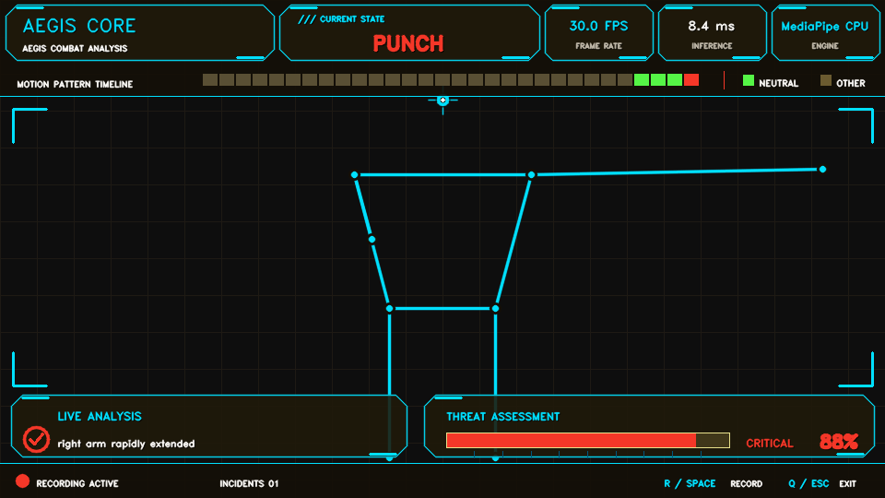
Figure 1: AEGIS CORE live heads-up display operating at 960x540 with synthetic martial arts pose telemetry.
4. Target Users and Use Cases
- Athletic & Combat Sports Coaching: Quantitative velocity, extension reach, and guard recovery metrics for boxing, karate, and mixed martial arts training without bulky wearable sensors.
- Supervised Facility Safety: Real-time awareness for facility supervisors monitoring wrestling mats, gymnastics arenas, and athletic centers to detect sudden falls or physical distress.
- Edge AI & NPU Research: Demonstrating how Qualcomm Snapdragon Hexagon NPUs can offload computer vision pipelines on battery-constrained laptops without sacrificing privacy.
5. System Architecture & Technical Implementation
Aegis is constructed from decoupled, modular subsystems ensuring clean testability, zero global state, and straightforward hardware acceleration migration:
- Frame Ingestion & Preprocessing: Ingests live webcam feeds or pre-recorded clips via OpenCV, downsampling to 960x540 for optimal balance between landmark resolution and display latency.
- Pose Estimation Engine (MediaPipe CPU): Extracts 9 primary joint landmarks with individual visibility confidence gating (>0.40) to prevent erroneous tracking under limb occlusion.
- Temporal Feature Window: Maintains a deque of recent poses (12 frames) to calculate velocity, body scale expansion, and positional differentials.
- Kinematic Pattern Engine: Evaluates joint geometry against validated biomechanical thresholds with strict priority hierarchy (Fall > Punch > Kick > Approach > Guard > Neutral).
- Threat Fusion Engine: Aggregates confidence and threat weights into a unified [0.0, 1.0] scale, mapped to LOW, ELEVATED, HIGH, and CRITICAL danger states.
- AEGIS CORE UI & Incident Tracker: Renders custom anti-aliased HUD panels, threat gauges, and timelines. Manages local JSONL incident logging with state-driven threat re-arming.
6. Pattern-Detection Methodology
The pattern recognition engine evaluates six distinct movement classes deterministically:
Pattern | Kinematic Criteria | Threat | Sample Rationale
Neutral | Upright torso, limbs in equilibrium | 0.05 | No risk-pattern threshold crossed
Guard | Wrists within 1.30x shoulder width of nose | 0.30 | Both hands raised near face
Punch-like Extension | Arm reach > 1.45x shoulder width, speed > 0.90/s | 0.88 | Right arm rapidly extended (reach 1.65x)
Kick-like Extension | Ankle reach > 1.35x, speed > 0.65/s, elevated | 0.90 | Right leg extended, ankle elevated
Rapid Approach | Torso scale growth > 6% over 3 frames, rate > 0.80/s | 0.72 | Body scale increased rapidly (+12.4%)
Fall-like Posture | Torso horizontal/vertical ratio > 1.25, compact | 0.90 | Torso horizontal ratio 1.84, vertical span low

7. Explainability & Human-in-the-Loop Telemetry
A critical limitation of deep learning in safety-critical domains is the 'black box' problem. Aegis ensures complete interpretability: every incident record and HUD alert includes human-readable telemetry explaining exactly why the alert triggered (e.g., 'right arm reach 1.62x shoulder width, extension speed 1.15/s'). Aegis is strictly designed as an operator decision-support tool; autonomous physical locking, punitive actions, or automated enforcement are prohibited.
8. Privacy & Responsible-Use Safeguards
- Zero Cloud Upload: Video is processed in volatile memory. No raw video frames are saved to disk or transmitted across network interfaces.
- Biometric Anonymity: Aegis does not perform face recognition, face identification, facial embeddings or biometric identity tracking. One coarse nose keypoint is used only for pose geometry.
- Opt-In Local Logging: Logging occurs only when an operator explicitly toggles recording (R or Space). Log files reside locally in artifacts/.
- No Intent Inference: Aegis detects physical motions, not criminal intent or moral guilt. Human verification is strictly required.
9. Current Verified Evidence & Technical Truthfulness
In strict accordance with competition rules, all claims in Aegis reflect verified, reproducible execution:
- Functional Live Pipeline: Fully operational video capture, landmark ingestion, and 960x540 display rendering.
- Automated Test Suite: 17 deterministic unit tests passing in pytest (covering neutral, strikes, guard, falls, approach, jitter rejection, boundaries, deduplication, and provider reporting).
- Truthful Provider Reporting: MediaPipe CPU is the only currently verified active pose provider. Supplying AEGIS_MODEL_PATH does not connect model outputs to pose estimation; runtime diagnostics only verify provider availability. Genuine QNN pose execution requires an ONNX/QNN pose-estimator adapter that preprocesses frames, calls session.run(), converts outputs to normalized PoseFrame landmarks, and replaces MediaPipePoseEstimator.
- Deduplication Verification: Re-arming mechanism validated; prevents duplicate incident records during continuous high-threat motions.
10. Snapdragon Optimization Plan & Qualcomm AI Hub (Planned)
Aegis features a modular runtime interface designed for transition to Qualcomm Hexagon NPUs on Snapdragon-powered HP PCs. Supplying AEGIS_MODEL_PATH does not connect model outputs to pose estimation; runtime diagnostics only verify provider availability. MediaPipe CPU is the only currently verified active pose provider. The planned optimization pathway includes:
- 1. Model Selection (Planned): Select a lightweight pose estimation network (YOLOv8n-pose or RTMPose) from the Qualcomm AI Hub catalog.
- 2. Model Compilation (Planned): Quantize (INT8) and compile the model specifically targeting the Snapdragon X Elite / Plus Hexagon NPU using the Qualcomm AI Hub compilation API.
- 3. NPU Execution (Planned): Implement an ONNX/QNN pose-estimator adapter that preprocesses frames, calls session.run(), converts outputs to normalized PoseFrame landmarks, and replaces MediaPipePoseEstimator via ONNX Runtime QNNExecutionProvider (QnnHtp.dll).
- 4. Verification Protocol (Planned): Execute scripts/benchmark.py on an identical 1080p clip to measure end-to-end FPS, p95 latency, and power savings.
11. Accessibility & Key Innovations
- Accessible HUD: High-contrast color palette, readable text shadows, combined geometric icons, numeric readouts, and clear text status labels.
- Inclusive Controls: Full keyboard control (R/Space for recording, Q/Esc for exit) and deterministic synthetic mode (--demo / --export-preview).
- Key Innovations: Temporal biomechanical analysis rather than single-frame classification; transparent evidence generation; truthful on-device runtime abstraction.
12. Limitations & Future Roadmap
- Known Limitations: Extreme camera angles (steep overhead) and severe visual occlusion degrade 2D coordinate accuracy, triggering safe neutral fallback.
- Future Roadmap: QNN Hexagon NPU pose integration, multi-person tracking support, and battery-efficiency benchmarking on Snapdragon X Elite HP laptops.

