Maximum Likelihood Estimator

2024-04-23

#MLE  
library(tidyverse)

## Warning: package 'tidyverse' was built under R version 4.3.3

## Warning: package 'ggplot2' was built under R version 4.3.2

## Warning: package 'tibble' was built under R version 4.3.2

## Warning: package 'tidyr' was built under R version 4.3.2

## Warning: package 'readr' was built under R version 4.3.3

## Warning: package 'purrr' was built under R version 4.3.2

## Warning: package 'dplyr' was built under R version 4.3.2

## Warning: package 'stringr' was built under R version 4.3.2

## Warning: package 'forcats' was built under R version 4.3.3

## Warning: package 'lubridate' was built under R version 4.3.2

## ── Attaching core tidyverse packages ──────────────────────── tidyverse 2.0.0 ──  
## ✔ dplyr 1.1.4 ✔ readr 2.1.5  
## ✔ forcats 1.0.0 ✔ stringr 1.5.1  
## ✔ ggplot2 3.4.4 ✔ tibble 3.2.1  
## ✔ lubridate 1.9.3 ✔ tidyr 1.3.0  
## ✔ purrr 1.0.2   
## ── Conflicts ────────────────────────────────────────── tidyverse_conflicts() ──  
## ✖ dplyr::filter() masks stats::filter()  
## ✖ dplyr::lag() masks stats::lag()  
## ℹ Use the conflicted package (<http://conflicted.r-lib.org/>) to force all conflicts to become errors

library(EnvStats)

## Warning: package 'EnvStats' was built under R version 4.3.3

##   
## Attaching package: 'EnvStats'  
##   
## The following objects are masked from 'package:stats':  
##   
## predict, predict.lm

library(dplyr)  
  
set.seed(33)  
#Binomial Distribution  
heads= rbinom(1,100,0.5); heads #Generate no. of heads

## [1] 55

ebinom(heads,size = 100, method = "mle")

##   
## Results of Distribution Parameter Estimation  
## --------------------------------------------  
##   
## Assumed Distribution: Binomial  
##   
## Estimated Parameter(s): size = 100.00  
## prob = 0.55  
##   
## Estimation Method: mle/mme/mvue for 'prob'  
##   
## Data: heads  
##   
## Sample Size: 100

#poisson distribution  
set.seed(33)  
N = 100  
data_pois = rpois(n = N, lambda = 5);data_pois

## [1] 5 4 5 8 7 5 4 4 1 2 6 3 3 4 7 7 7 4 3 8 5 2 5 4 10  
## [26] 7 5 4 6 3 5 7 5 4 6 3 5 8 4 8 4 3 5 4 7 7 6 3 5 8  
## [51] 5 5 6 6 10 4 1 1 3 2 9 7 5 8 4 9 7 8 4 4 8 4 4 5 5  
## [76] 8 5 2 3 4 3 6 4 4 8 2 6 4 7 5 7 4 5 1 3 3 9 2 4 3

df_poisson = data.frame(data_pois);df_poisson

## data_pois  
## 1 5  
## 2 4  
## 3 5  
## 4 8  
## 5 7  
## 6 5  
## 7 4  
## 8 4  
## 9 1  
## 10 2  
## 11 6  
## 12 3  
## 13 3  
## 14 4  
## 15 7  
## 16 7  
## 17 7  
## 18 4  
## 19 3  
## 20 8  
## 21 5  
## 22 2  
## 23 5  
## 24 4  
## 25 10  
## 26 7  
## 27 5  
## 28 4  
## 29 6  
## 30 3  
## 31 5  
## 32 7  
## 33 5  
## 34 4  
## 35 6  
## 36 3  
## 37 5  
## 38 8  
## 39 4  
## 40 8  
## 41 4  
## 42 3  
## 43 5  
## 44 4  
## 45 7  
## 46 7  
## 47 6  
## 48 3  
## 49 5  
## 50 8  
## 51 5  
## 52 5  
## 53 6  
## 54 6  
## 55 10  
## 56 4  
## 57 1  
## 58 1  
## 59 3  
## 60 2  
## 61 9  
## 62 7  
## 63 5  
## 64 8  
## 65 4  
## 66 9  
## 67 7  
## 68 8  
## 69 4  
## 70 4  
## 71 8  
## 72 4  
## 73 4  
## 74 5  
## 75 5  
## 76 8  
## 77 5  
## 78 2  
## 79 3  
## 80 4  
## 81 3  
## 82 6  
## 83 4  
## 84 4  
## 85 8  
## 86 2  
## 87 6  
## 88 4  
## 89 7  
## 90 5  
## 91 7  
## 92 4  
## 93 5  
## 94 1  
## 95 3  
## 96 3  
## 97 9  
## 98 2  
## 99 4  
## 100 3

library(ggplot2)  
  
# Assuming df_poisson is your data frame  
df_poisson %>%  
 ggplot(aes(x = data_pois)) +  
 geom_histogram(bins = 20, fill = "steelblue2", color = "black") +   
 labs(title = "Poisson Distribution",  
 subtitle = "lambda = 5", x = "data", y = "count") +  
 theme_bw()

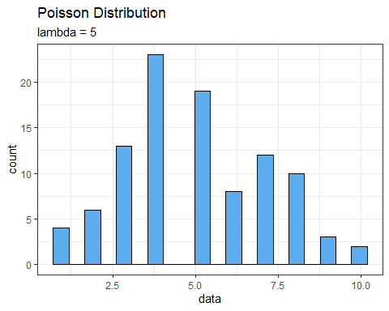

epois(data_pois, method = "mle")

##   
## Results of Distribution Parameter Estimation  
## --------------------------------------------  
##   
## Assumed Distribution: Poisson  
##   
## Estimated Parameter(s): lambda = 5.01  
##   
## Estimation Method: mle/mme/mvue  
##   
## Data: data_pois  
##   
## Sample Size: 100

#Normal Distribution  
set.seed(1001)  
N = 100  
x = rnorm(N, mean = 3, sd = 2)  
x

## [1] 7.37729619 2.64490533 2.62944944 -2.01307243 1.88537733 2.71288109  
## [7] 5.18300340 1.75411253 1.18507923 -0.18742658 3.60528903 6.26878486  
## [13] 1.75630690 3.93432219 5.83853168 3.22053041 6.73925847 0.93949832  
## [19] 0.31673114 4.10879669 2.87585836 3.19320327 6.12590113 4.65646398  
## [25] 4.08012879 1.81011141 -0.80168182 3.38701642 1.83639941 -0.09042167  
## [31] 3.95762467 3.45868324 2.72414705 7.82147805 -0.84558927 6.32588477  
## [37] 7.24271793 2.62323881 -1.24422629 3.55319391 1.74893516 4.09219791  
## [43] 3.31139808 1.59226744 2.92421693 4.41032717 -0.44820554 3.44275845  
## [49] 3.95110280 9.77094291 0.97937533 -0.60944355 -0.24075802 4.82236372  
## [55] 3.52247284 4.16118883 0.91735737 5.32012563 7.29470710 1.70717701  
## [61] 1.13813817 4.57069827 2.06789284 2.34379844 4.83065661 6.37873479  
## [67] 6.34617822 4.59893667 5.73343941 1.27183186 0.13451638 2.11741674  
## [73] 1.83984841 -0.94284961 6.12912791 1.38160427 4.39336857 0.65575408  
## [79] 1.85255187 3.32998899 3.50400924 3.28920818 2.95427895 1.85861012  
## [85] 1.90420631 4.47689200 1.25175261 4.90473380 0.91111430 0.71309013  
## [91] 3.57556844 1.24380271 0.86782642 4.96231161 0.23702580 4.90181607  
## [97] 0.38663556 3.42671709 4.57177487 4.45719266

mean(x)

## [1] 2.998305

sd(x)

## [1] 2.288979

data.frame(x = x) %>%  
 ggplot(aes(x = x)) +  
 geom_histogram(bins = 30, fill = "skyblue4", color = "black") +   
 labs(title = "Normal Distribution") +  
 theme_bw(base_size = 16)+  
 xlab("Data")

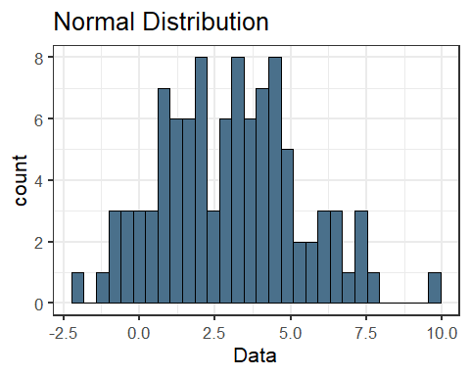

enorm(x, method = "mle")

##   
## Results of Distribution Parameter Estimation  
## --------------------------------------------  
##   
## Assumed Distribution: Normal  
##   
## Estimated Parameter(s): mean = 2.998305  
## sd = 2.277506  
##   
## Estimation Method: mle/mme  
##   
## Data: x  
##   
## Sample Size: 100