MDS

2024-01-24

#To do dimensionality reduction using Multidimensional Scaling  
  
#proximity matrix  
P = rbind(c(0,93,82,133),c(93,0,52,60), c(82,52,0,111),c(133,60,111,0))   
n = dim(P)[1]; n

## [1] 4

P = P*P  
  
ones_mat = matrix(1,n,1); ones_mat

## [,1]  
## [1,] 1  
## [2,] 1  
## [3,] 1  
## [4,] 1

one_onet = ones_mat %*% t(ones_mat); one_onet

## [,1] [,2] [,3] [,4]  
## [1,] 1 1 1 1  
## [2,] 1 1 1 1  
## [3,] 1 1 1 1  
## [4,] 1 1 1 1

Iden = diag(1,n,n); Iden

## [,1] [,2] [,3] [,4]  
## [1,] 1 0 0 0  
## [2,] 0 1 0 0  
## [3,] 0 0 1 0  
## [4,] 0 0 0 1

J = Iden - (1/n)*one_onet; J

## [,1] [,2] [,3] [,4]  
## [1,] 0.75 -0.25 -0.25 -0.25  
## [2,] -0.25 0.75 -0.25 -0.25  
## [3,] -0.25 -0.25 0.75 -0.25  
## [4,] -0.25 -0.25 -0.25 0.75

B = (-0.5)* J %*% P %*% J; B

## [,1] [,2] [,3] [,4]  
## [1,] 5035.0625 -1553.0625 258.9375 -3740.938  
## [2,] -1553.0625 507.8125 5.3125 1039.938  
## [3,] 258.9375 5.3125 2206.8125 -2471.062  
## [4,] -3740.9375 1039.9375 -2471.0625 5172.062

eig = eigen(B); eig

## eigen() decomposition  
## $values  
## [1] 9.724168e+03 3.160986e+03 3.659656e+01 8.170566e-13  
##   
## $vectors  
## [,1] [,2] [,3] [,4]  
## [1,] 0.6371597 0.5864982 0.006882366 -0.5  
## [2,] -0.1866207 -0.2139168 -0.818176212 -0.5  
## [3,] 0.2531171 -0.7063152 0.432493393 -0.5  
## [4,] -0.7036561 0.3337338 0.378800454 -0.5

s_vals = sqrt(eig$values); s_vals

## [1] 9.861119e+01 5.622265e+01 6.049509e+00 9.039118e-07

lam = diag(s_vals); lam

## [,1] [,2] [,3] [,4]  
## [1,] 98.61119 0.00000 0.000000 0.000000e+00  
## [2,] 0.00000 56.22265 0.000000 0.000000e+00  
## [3,] 0.00000 0.00000 6.049509 0.000000e+00  
## [4,] 0.00000 0.00000 0.000000 9.039118e-07

Em = cbind(eig$vectors); Em

## [,1] [,2] [,3] [,4]  
## [1,] 0.6371597 0.5864982 0.006882366 -0.5  
## [2,] -0.1866207 -0.2139168 -0.818176212 -0.5  
## [3,] 0.2531171 -0.7063152 0.432493393 -0.5  
## [4,] -0.7036561 0.3337338 0.378800454 -0.5

proj = Em %*% lam; proj

## [,1] [,2] [,3] [,4]  
## [1,] 62.83108 32.97448 0.04163493 -4.519559e-07  
## [2,] -18.40289 -12.02697 -4.94956435 -4.519559e-07  
## [3,] 24.96018 -39.71091 2.61637266 -4.519559e-07  
## [4,] -69.38837 18.76340 2.29155675 -4.519559e-07

plot(proj[,1], proj[,2], lwd = 3, col = "red",  
 xlab = "feature_1", ylab = "feature_2",  
 main = "Multidimensional Scaling Map")

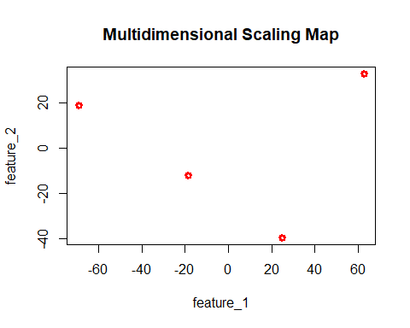

x = proj[,1]  
y = proj[,2]  
plot(x,y, pch = 19, xlim = range(x)+c(0,10),col = "magenta4",  
 ylim = range(y)+c(0,20), main = "MDS Map")  
  
cities = c("cph", "aar", "ode", "aal")  
text(x,y, pos = 4, labels = cities)  
abline(v = 0, h = 0)

