Myntra Men's Jeans
Data Analysis Report
End-to-End Data Analytics Project
Pricing · Brand Performance · Customer Engagement
July 2026

Executive Summary
This report presents a comprehensive analysis of Myntra's men's jeans product catalog, covering 31,527 cleaned product listings across 371 brands. The analysis examines pricing strategies, discount patterns, customer ratings, and brand engagement to generate actionable business recommendations for Myntra's merchandising, marketing, and partnership teams.
Key findings indicate that the mid-price segment (₹1,001–2,000) drives the majority of customer engagement, brands such as HIGHLANDER and HARDSODA deliver the strongest overall business performance, and value-for-money leaders like MarvelQ and AngelFab combine competitive pricing with strong customer satisfaction.

1. Introduction
Myntra is one of India's leading fashion e-commerce platforms, offering a wide range of apparel across price segments. Understanding how products are priced, discounted, and rated by customers is essential for optimizing inventory, promotional campaigns, and brand partnerships.
This project follows a structured analytics pipeline: data loading, quality assessment, cleaning, exploratory data analysis (EDA), and advanced business insights. The objective is to transform raw product listing data into data-driven recommendations that support Myntra's business strategy.

2. Dataset Description
The dataset was obtained through web scraping of Myntra's men's jeans product listings. It contains seven attributes per product record.
Column | Type | Description
brand_name | Categorical | Brand of the product
pants_description | Categorical | Product title / description
price | Numerical | Selling price in INR
MRP | Numerical | Maximum retail price in INR
discount_percent | Numerical | Discount as decimal (0–1)
ratings | Numerical | Average customer rating (1–5)
number_of_ratings | Numerical | Total number of ratings

Original dataset: 52,120 records. After cleaning: 31,527 records across 371 unique brands.

3. Data Cleaning Summary
The following data quality issues were identified and addressed:
- Missing values: None found — no imputation required.
- Duplicate rows: 17,047 exact duplicates removed (52,120 → 35,073).
- Invalid discounts: 3,546 records with discount >100% removed (35,073 → 31,527).
- Data types: All numerical columns validated; discount stored as decimal (0–1).

4. EDA Highlights
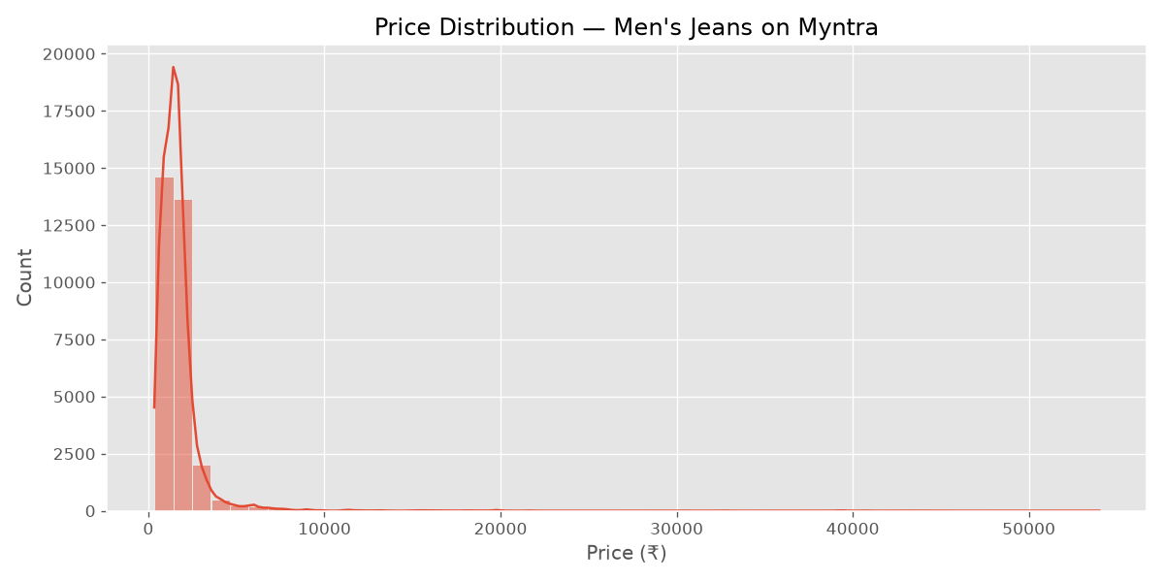
Figure 1: Price distribution of men's jeans on Myntra
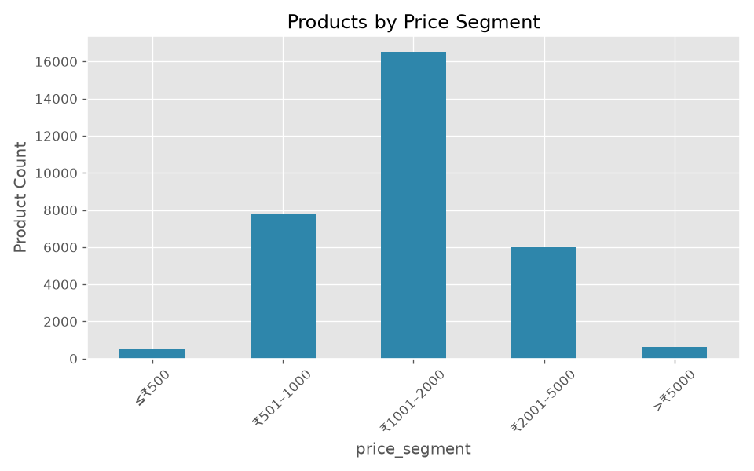
Figure 2: Product count by price segment
- Average selling price is ₹1,697 with a median of ₹1,484 — indicating a right-skewed distribution.
- 50% of products are priced between ₹899 and ₹1,829 (affordable to mid-range segment).
- Premium products (up to ₹54,000) exist but represent a small portion of the catalog.
- Average customer rating is 3.98/5, with most products rated between 3.8 and 4.2.
- Roadster, HIGHLANDER, and United Colors of Benetton lead in total customer engagement.
- Premium products receive slightly higher ratings but lower overall engagement volume.

5. Business Insights

5.1 Best Value for Money
Top brands: MarvelQ, AngelFab, Metronaut, SZN, HARDSODA. These brands achieve a balanced combination of affordability, promotional offers, and customer satisfaction rather than relying on a single factor.
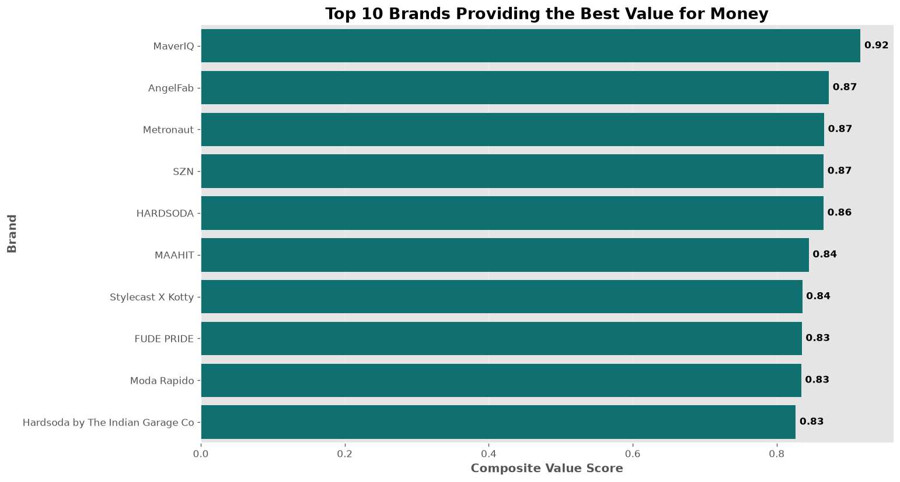

5.2 Customer Engagement
HIGHLANDER leads in engagement efficiency (ratings per product). Roadster dominates total engagement due to its large catalog. Evaluating both metrics provides a comprehensive view of brand performance.
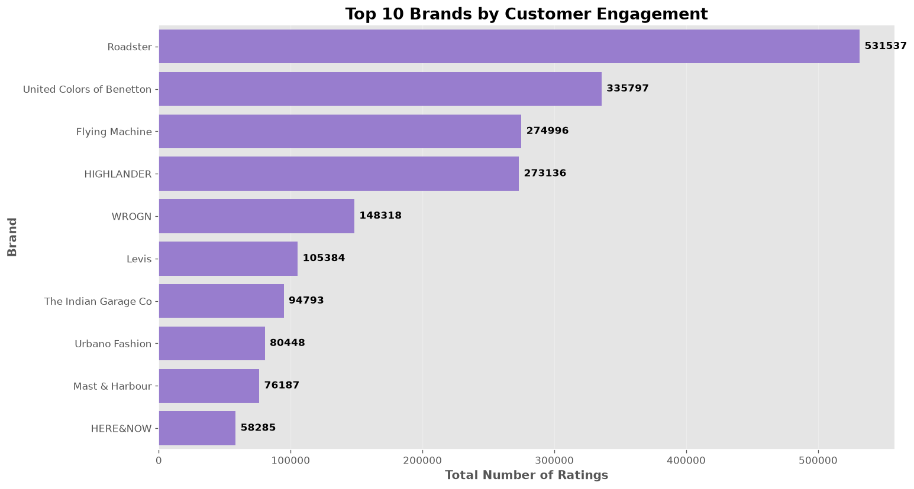

5.3 Promotional Discounts
Some brands consistently rely on high average discounts. A small number of products receive 100% discounts, which may represent promotional anomalies. Discounts should be applied strategically to maintain profitability.

5.4 Price Segment Performance
The mid-price segment (₹1,001–2,000) offers the largest product selection with strong engagement. Premium products achieve higher ratings but lower engagement, suggesting a smaller but satisfied customer base.
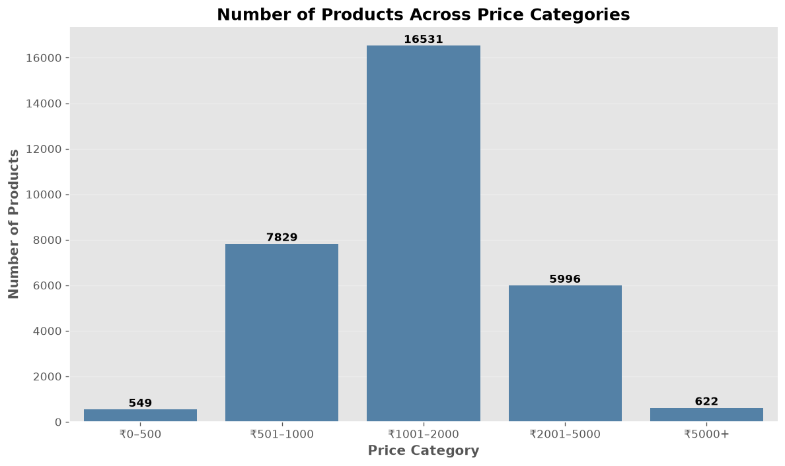

5.5 Brand Prioritization
Top priority brands by Business Performance Score: HIGHLANDER, HARDSODA, Sztori, THE BEETEL HOUSE. These brands combine competitive pricing, positive ratings, effective promotions, and strong engagement.
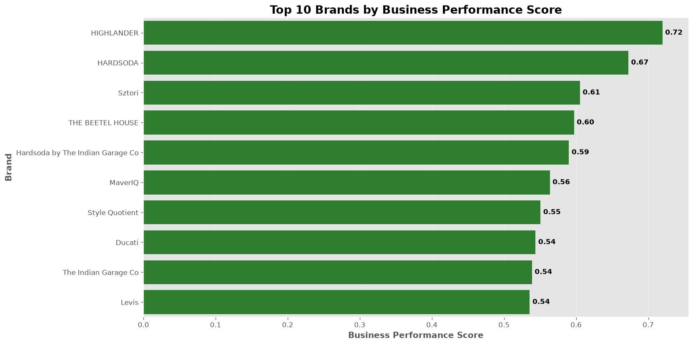

6. Overall Conclusions
The analysis reveals that Myntra's men's jeans catalog is concentrated in the mid-price segment, where customer engagement is highest. Brand success depends on a balanced combination of pricing, discounts, ratings, and engagement — not any single metric alone.
Composite scoring models (Value Score and Business Performance Score) provide a more holistic evaluation than individual metrics, enabling Myntra to identify high-performing brands and optimize merchandising decisions.

7. Recommendations
- Prioritize HIGHLANDER, HARDSODA, and Sztori for featured collections and marketing campaigns.
- Use value-for-money leaders (MarvelQ, AngelFab, Metronaut) as benchmarks for pricing strategy.
- Strengthen the mid-price portfolio (₹1,001–2,000) as the core revenue driver.
- Market premium products through exclusivity campaigns rather than discount-focused promotions.
- Monitor brands with consistently high discounts to ensure promotional profitability.
- Promote HIGHLANDER and Urbano Fashion for engagement efficiency despite smaller catalogs.
- Build an interactive dashboard for ongoing monitoring of brand and pricing metrics.

