

|  |  |  |  |  |
| --- | --- | --- | --- | --- |
| University of Cincinnati, Clifton Ave, 45220 |  | p. 5135508008 |  | project@picturepal.com  www.picturepal.com |

Picture Pal

A catalogue for memories!!!

Table of Contents

1. Project Plan1

Project Charter2

Project Scope3

Staffing3

Staffing3

Infrastructure3

Team Collaboration Plan4

1. Work Breakdown Structure and Schedule5

Work Breakdown6

Gantt Chart7

Planning and Analysis Phase8

Design and Implementation8

1. Feasibility Analysis9

Economic Feasibility10

Cost to Benefit Analysis11

Organizational Feasibility12

Technical Feasibility12

1. System Requirements13

Functional Requirements14

Non Functional Requirements14

Benchmarking15

Questionnaire Result16

1. System Diagrams and Models17

Use Case Diagram18

Activity Diagram19

Use Case Description20

Class Diagram21

Sequence Diagram22

Communication Diagram23

Behavioral Diagram24

**PROJECT PLAN**

# Project Charter

**Picture Pal:**

Image analytics can build a cloud which can determine what a photograph or a picture contains. Using this functionality, we will build an application synced with analytics cloud which will automatically categorize all the captured photographs and organize them. Picture retrieval would also be semantic based. This project targets the problem individuals and organizations are facing to organize and share multiple photographs they deal at once. We are capitalizing on the opportunity of providing individuals with image analytics to search through a pool of photographs through multiple tag strategy, and auto sharing of these photographs with other customers using same application  
 **Goals**

* To create a mobile application and a web service for storing photographs on cloud with high security
* To use image analytics for tagging multiple objects in a photograph that a photograph relates to
* To enable auto sharing of photographs with another application user

**Project Milestones**   
Make Beta version of the application live by 25-May-2017.  
 **Primary audience**   
All smartphone users and laptop/ tablet users  
  
**Constraints, Assumptions, Risks and Dependencies**

|  |  |
| --- | --- |
| Assumptions | Image Learning will take less time |
|  | The speed of Internet is very high for image to be uploaded and downloaded from cloud |
|  | The images stored in Cloud services are highly secured |
|  | Images will be tagged exhaustively covering all possible objects captured in photograph |
|  | Text analytics to work seamlessly while searching images |

**Approval Signatures**

|  |  |  |  |  |  |  |
| --- | --- | --- | --- | --- | --- | --- |
|  |  |  |  |  |  |  |
| Abhay Chile, Project Manager |  | Udval Panchlothia, Solution Architect |  | Ruchi Garg,  System Analyst |  | Aniket Mahurkar, Data Analyst |

# Project Scope

**Customer’s View**

* A mobile and web application, leveraging analytics cloud, to help upload photographs on cloud and to retrieve them with writing a faint memory of what the photograph contains
* Users will not have to worry about organizing photographs in specific albums
* A mobile application that provides features to enable following functionalities
  + Automatic uploading: If enabled then photographs from mobile device will be uploaded on cloud automatically whenever user is in Wi-Fi zone. If disabled, user will have to manually upload photographs on cloud. Option will be given in gallery to select which photographs to be put on cloud.
  + Auto delete: With this functionality enabled, photographs will be automatically deleted from local device when uploaded on cloud
  + Automatic tagging: When enabled, users with picture pal application can tag other users in their photographs so that photographs in which other users are tagged will be shared with them
  + Tagging: Any photographs when opened in application, user can add manual tags to the photograph. Same will be later uploaded on cloud for further automatic tagging.
  + Image Search: Write the description of the image in the search box, and image with maximum number of overlapping tags containing text description will be displayed
  + Sharing: Link will be created for the album or individual photographs that can be shared with non-picture pal users.
  + Download: Users can download pictures from application to local device, whenever required.
* A web application will be created with all above functionalities so that users can transfer photos from a laptop or other equivalent devices.
* Users can create manual albums on cloud, if they still want to put few selected photos in a particular photograph

# Staffing

We will hire a team of wed developers and mobile application developers to develop web based application and mobile application. A team of image analytics will be employed for maintaining image analytics machine learning. Planning and designing will be done internally.

# Infrastructure

We will purchase a cloud storage that can be scalable in future. Vendors will be evaluated for the same. Security of data and cost will be at forefront while evaluating the vendors.

# Team Collaboration Plan

**Members:**

|  |  |
| --- | --- |
| 1. Abhay Chile   Apt 35, 222 Senator Place,  Cincinnati, Ohio – 45220  +1-513-888-4344 | 1. Udhval   Apt 65, 222 Senator Place,  Cincinnati, Ohio – 45220  +1-513-888-3247 |
| 1. Aniket Mahurkar   Apt 25, 222 Senator Place,  Cincinnati, Ohio – 45220  +1-513-550-8008 | 1. Ruchi Garg   Apt 7, 505 Ludlow Avenue  Cincinnati, Ohio - 45220  +1-469-991-7545 |

**Location for Discussion:**

Every Wednesday 3.00pm to 5.00pm at Tangeman University Center

**Weekly Review:**

Every Saturday 3.00pm to 5.00pm at Tangeman University Center

**Document Sharing:**

1. We have created a shared location for document.

https://1drv.ms/f/s!AvzW_bqiDcY-gad27USIzBddr1VMjg

1. Documents are also shared over following email address by updating version numbers.
2. [chileai@mail.uc.edu](mailto:chileai@mail.uc.edu)
3. [panchlup@mail.uc.edu](mailto:panchlup@mail.uc.edu)
4. [gargri@mail.uc.edu](mailto:gargri@mail.uc.edu)
5. [mhurkav@mail.uc.edu](mailto:mhurkav@mail.uc.edu)

**Role Assignment:**

Project Manager: Abhay Chile

Solution Architect: Udval Panchlothia

Data Analyst: Aniket Mahurkar

System Analyst: Ruchi Garg

**WORK BREAKDOWN STRUCTURE AND SCHEDULE**

# Work Breakdown Structure

|  |  |  |  |  |
| --- | --- | --- | --- | --- |
| WBS Number | Task name / Title | Planned start date | Planned end date | Duration (weeks) |
| 1 | **Picture Pal** | 07/10/16 | 25/05/17 | 32.96 |
| 1.1 | **Planning** | 07/10/16 | 22/11/16 | 7 |
| 1.1.1 | Team Collaboration | 07/10/16 | 18/10/16 | 2 |
| 1.1.2 | Project Charter | 18/10/16 | 24/10/16 | 1.0 |
| 1.1.3 | Project Scope | 24/10/16 | 31/10/16 | 1.0 |
| 1.1.4 | Project Sponsorship | 31/10/16 | 07/11/16 | 1.0 |
| 1.1.5 | Feasibility Analysis | 07/11/16 | 22/11/16 | 2 |
| 1.2 | **Analysis** | 22/11/16 | 12/01/17 | 7 |
| 1.2.1 | Conduct Questionnaire | 22/11/16 | 30/11/16 | 1 |
| 1.2.2 | Conduct Interview | 30/11/16 | 14/12/16 | 2 |
| 1.2.3 | Review Software Specification/Budget | 14/12/16 | 21/12/16 | 1 |
| 1.2.4 | Preliminary Software Specification | 21/12/16 | 29/12/16 | 1 |
| 1.2.5 | Gather Required Information | 29/12/16 | 12/01/17 | 2 |
| 1.3 | **Design** | 12/01/17 | 16/03/17 | 9 |
| 1.3.1 | Review Hardware and Software Infrastructure | 12/01/17 | 19/01/17 | 1 |
| 1.3.2 | Review Network Infrastructure | 19/01/17 | 26/01/17 | 1 |
| 1.3.3 | User Interface Design | 26/01/17 | 09/02/17 | 2 |
| 1.3.4 | Picture Segregation Functionality | 09/02/17 | 02/03/17 | 3 |
| 1.3.5 | Database Setup and Connectivity | 02/03/17 | 16/03/17 | 2 |
| 1.4 | **Implementation** | 16/03/17 | 25/05/17 | 10 |
| 1.4.1 | Develop Application Testing Plan | 16/03/17 | 23/03/17 | 1 |
| 1.4.2 | Test Software Prototype IOS | 23/03/17 | 06/04/17 | 2 |
| 1.4.3 | Gather Feedback | 06/04/17 | 10/04/17 | 0.5 |
| 1.4.4 | Incorporate Feedback for IOS Prototype Release | 10/04/17 | 13/04/17 | 0.5 |
| 1.4.5 | Test Software Prototype Android | 13/04/17 | 27/04/17 | 2 |
| 1.4.6 | Gather Feedback | 27/04/17 | 01/05/17 | 0.5 |
| 1.4.7 | Incorporate Feedback for Android Release | 01/05/17 | 04/05/17 | 0.5 |
| 1.4.8 | Test Software Prototype Windows | 04/05/17 | 18/05/17 | 2 |
| 1.4.9 | Gather Feedback | 18/05/17 | 22/05/17 | 0.5 |
| 1.4.10 | Incorporate Feedback for Windows Release | 22/05/17 | 25/05/17 | 0.5 |

# Gantt Chart

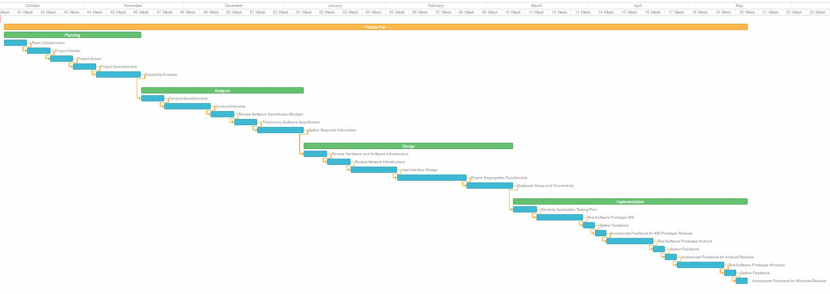

# Planning and Analysis Phase through Gantt Chart

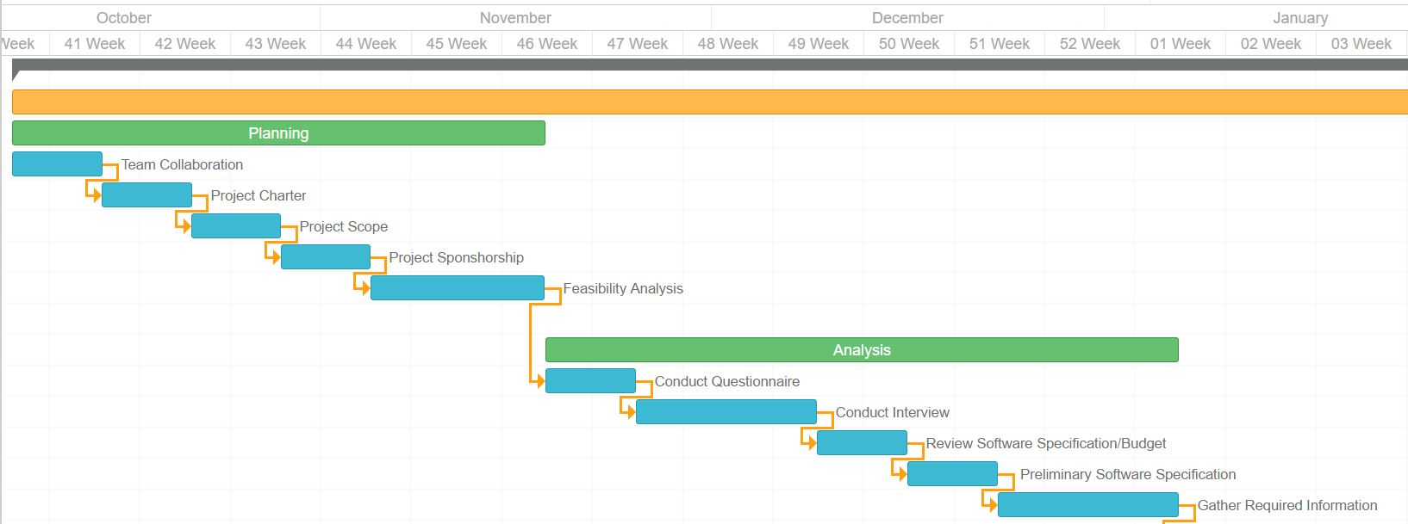

# Design and Implementation through Gantt Chart

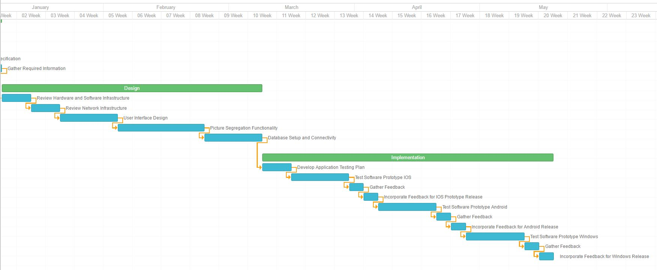

**FEASIBILITY ANALYSIS**

# Economic Feasibility:

* **Tangible Benefits:**
  + Innovation:   
    The unique analytics system which will be the core driving force of this application will be completely dependent on the machine learning. With free of cost feature it will be expected that a lot of data will be captured by the system. In today’s day and age where in more than 1.5 million photographs are shared in a single day the scope of gathering data is very high. In machine learning systems the higher the amount of data higher would be the accuracy of them system. The core intellectual property of our systems machine learning core will be the driving force and the unique selling point
  + Market Reach:   
    With the rich user interface and easy to use application boasting of attractive features a sizeable market is forecasted. With so many app users delivery of highly personalized targeted ads would be possible. With user data also available personalized can be further optimized and targeted. With such model, high advertisement revenues can be expected.
* **Intangible Benefits:** 
  + The machine learning core, once powerful, can be utilized to provide services to business to help streamline their businesses with image recognition capabilities in house
  + The business as a whole can also be sold to other bigger companies in the same space as the application user base would be considerably large in the coming years

|  |  |  |  |  |  |  |
| --- | --- | --- | --- | --- | --- | --- |
|  | **2016** | **2017** | **2018** | **2019** | **2020** | **Total** |
| **Revenue from Advertisements** | 100000 | 132000 | 144000 | 169000 | 249000 |  |
| **Expected Customer Base** | 25000 | 300000 | 500000 | 700000 | 900000 |
| **TOTAL BENEFITS:** | 100000 | 132000 | 144000 | 169000 | 249000 | 794000 |
| **Servers** | 20000 | 40000 | 50000 | 60000 | 70000 |  |
| **Software licenses** | 0 | 10000 | 10000 | 0 | 0 |
| **Server software** | 10000 | 10000 | 10000 | 10000 | 10000 |
| **Development labor** | 40000 | 15000 | 0 | 0 | 0 |
| **TOTAL DEVELOPMENT COSTS:** | 70000 | 75000 | 70000 | 70000 | 80000 |
| **Hardware** | 10000 | 15000 | 3000 | 1500 | 500 |
| **Software** | 5000 | 4000 | 3000 | 2000 | 1000 |
| **Operational labor** | 30000 | 30000 | 30000 | 30000 | 30000 |
| **TOTAL OPERATIONAL COSTS:** | 45000 | 49000 | 36000 | 33500 | 31500 |
| **TOTAL COSTS:** | 150000 | 158000 | 139000 | 135500 | 142500 | 725000 |
| **YEARLY NPV:** | -50000 | -26000 | 5000 | 33500 | 106500 | 69000 |
| **CUMULATIVE NPV:** | -50000 | -76000 | -71000 | -37500 | 69000 |  |
| **RETURN ON INVESTMENT:** | 9.52% | | | | |  |
|  |  | | | | |  |

# Cost to Benefit Analysis

# Organizational Feasibility:

* We will be capitalizing on the technical background of the founder team. All four of us have expertise in different domains essential to any software endeavor like Business Analysis, Database Management, Analytics and programming. Hence the initial product development cost will reduce drastically.
* The recent boom in social media domain validates the consumer as well as business need for an idea like picture pal

# Technical Feasibility:

* Image recognition is now a very popular field of study. A lot of open source tools and frameworks have been made available in the market and can be implemented for commercial use.
* With billions of mobile devices in use right now, a light weight iOS and Android specific application will be easy to ship out and deliver to the customers
* Cloud servers and cloud storage is very affordable now(As low as 3 cents per GB per month) and hence can be utilized for the implementation
* The cloud also offer flexibility to instantaneously scale up in case of increasing market demand

**SYSTEM REQUIREMENTS**

# Functional Requirements:

* The system will access camera on user device for the purpose of clicking photographs
* The systems will access storage for retrieving stored photographs
* The system will upload photographs from use device to cloud
* Remote Service(Cloud) will run analytics on photographs and tag them by the different metrics such as faces, objects, colour, background etc
* The system will allow user to associate tags like Home, Family, Friend, Vacation etc to the photograph
* The cloud will be sorting photographs on the basis of the tags attached to the photographs
* Cloud will allow non-photograph owner users to access photograph on the basis of sharing settings
* System will allow exporting of photographs in various file formats
* System will allow email messaging of photographs
* System will restrict number of photographs per user to a limited predefined number

# Non Functional Requirements:

* **Operational**
  + The User App will be available on Android and iOS platform
  + The User App will be Free of Cost to the User
  + Application will be interfaced with Remote Service(Cloud)
  + Remote Service will be completely built using open source software
* **Performance**
  + The Application should be light weight; no more than 20 Mega Byte on the installer file
  + The Application should compress the photographs on the device to 30% of the original size before upload
  + Syncing of User App with remote service should not take more than 4 minutes per 20 photographs
* **Security**
  + User data should be scrambled such that only the system would know whose data it is and data should not be accessible by unauthorized users including software administrators
  + User data should be stored in a highly encrypted environment
  + User App authentication will be a two step verification process including phone number and Password

# Benchmarking

|  |  |  |
| --- | --- | --- |
| **Competitor Name** | **Competitors USP** | **How Picture Pal gives an advantage** |
| Google Photos | * Very powerful analytics core * Market share in other products | * Google Photos hasn’t been marketed at all. People aren’t generally aware of functionality * It doesn’t offer auto sharing or export features * It doesn’t have albums by the fly, multiple album stacking feature |
| iOS Photo Application | * Embedded as inbuilt app * Has developed powerful algorithms for face recognition | * Competitor has no revenue model and isn’t marketed as a stand alone app * Doesn’t feed an analytics core and hence isn’t evolving with time |
| Snapchat | * Very large user base * High level of image manipulation know-how | * Storage of photographs isn’t Snapchat’s focus at all, neither is sharing or album formation * Image tagging facility provided by Picture Pal is unexplored area for Snapchat |

# Questionnaire result:

Through the use of online survey, our team collected data from varied users that shared their current problems with selecting and sharing photographs.

Team collected responses were consistent smart phone users actively involved in clicking photographs and sharing it with friends and families.

Participants were asked a variety of questions varying from frequency of clicking and sharing photographs along with time taken for the same. From the data we made several conclusions:

* On an average 50 photos are added to gallery daily
* These photos from mobile gallery are transferred to laptop or hard drive most frequently once in four months.
* User is dealing with 7200 photographs at a time. From this pool h tries to select and share photographs
* Average of 10% photographs from this pool is shared
* On a average an customer wastes 23-24 hour in one month to do this activity of searching selecting and sharing these photographs.
* Customers are not happy with current photo sharing applications like Whatsapp.

**SYSTEM DIAGRAMS AND MODELS**

# Use case Diagram

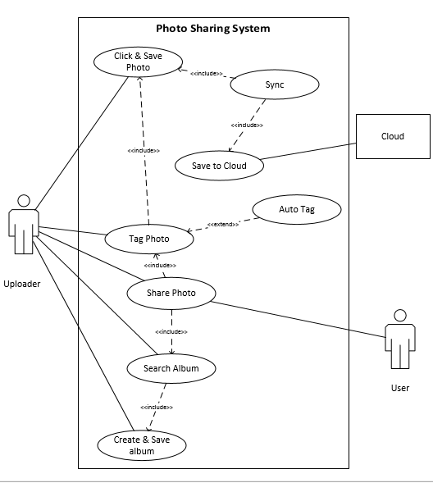

# Activity Diagram



# Use Case Descriptions

|  |  |  |
| --- | --- | --- |
| **Use Case Name:** Click and Save photo | **ID:** 1 | **Importance Level:** High |
| **Primary Actor:** Uploader | **Use Case Type:** Detail, Essential |  |
| **Stakeholder and Interest:** | Uploader wants to click photo and save it | |
| **Brief Description:** | This use case describes how an app user can click and save photo | |
| **Trigger:** | When Uploader finds an object to capture | |
| **Relationships:** |  |  |
|  | **Association:** | Uploader |
|  | **Include:** |  |
| **Normal Flow of Events:** | 1.The Uploaderr captures a photo with phone | |
|  | 2. Photo will be save on phone | |

|  |  |  |
| --- | --- | --- |
| **Use Case Name:** Sync | **ID:** 2 | **Importance Level:** High |
| **Primary Actor:** Phone, Cloud | **Use Case Type:** Overview, Essential |  |
| **Stakeholder and Interest:** |  | |
| **Brief Description:** | This use case describes that as soon as photo is uploaded to cloud, it releases phone memory | |
| **Trigger:** | Wifi Connection | |
| **Relationships:** |  |  |
|  | **Association:** |  |
|  | **Include:** | Click and save photo, Save to cloud |
| **Normal Flow of Events:** | 1.The photo is uploaded to cloud | |
|  | 2. Gets deleted from phone memory | |

|  |  |  |
| --- | --- | --- |
| **Use Case Name:** Tag photo | **ID:** 4 | **Importance Level:** Medium |
| **Primary Actor:** Uploader | **Use Case Type:** Overview, Real |  |
| **Stakeholder and Interest:** | Uploader | |
| **Brief Description:** | Uploader wants to tag photo manually into multiple category | |
| **Trigger:** | User wants to identify people with different group names | |
| **Relationships:** |  |  |
|  | **Association:** | Uploader |
|  | **Include:** | Click and save photo |
|  | **Extends:** | Auto tag |
| **Normal Flow of Events:** | 1. User groups objects in different categories | |
|  | 2. User does multiple tagging | |
|  | 3. For tagging user has to first click and save photo | |
|  | 4. User will tag auto tagged photo | |

|  |  |  |
| --- | --- | --- |
| **Use Case Name:** Share Photo | **ID:** 6 | **Importance Level:** High |
| **Primary Actor:** Uploader, User | **Use Case Type:** Detail, Essential |  |
| **Stakeholder and Interest:** | Uploader wants to share photo; User wants to receive it | |
| **Brief Description:** | It allows photos to be shared | |
| **Trigger:** | When user decides to share a photo | |
|  | Photo is uploaded to cloud | |
| **Relationships:** |  |  |
|  | **Association:** | Uploader, User |
|  | **Include:** | Tag photo and search album |
| **Normal Flow of Events:** | 1. Uploader search for an album to share | |
|  | 2. Before sharing tagging is done | |
|  | 3. If uploader doesn not find an album then he creates and saves one album | |
|  | 4. Photo is shared automatically with the people who are present in the photo | |

# Class Diagram

**Class diagram for photo sharing**

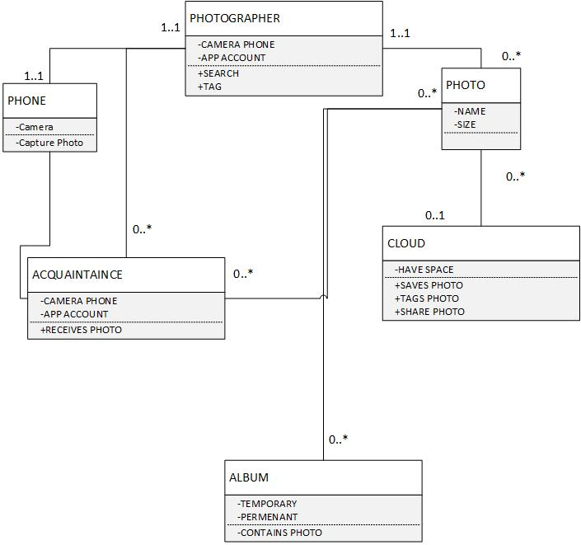

# Sequence Diagram:

1. **Sequence diagram for uploading photo use case**



1. **Sequence diagram for sharing album with non app user**



# Communication Diagram:

1. **System Communication Diagram**

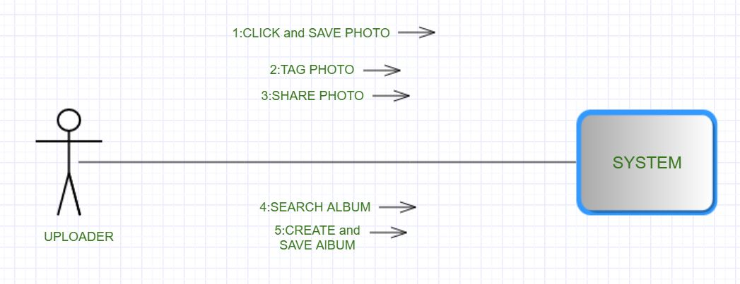

1. **Share Communication Diagram:**

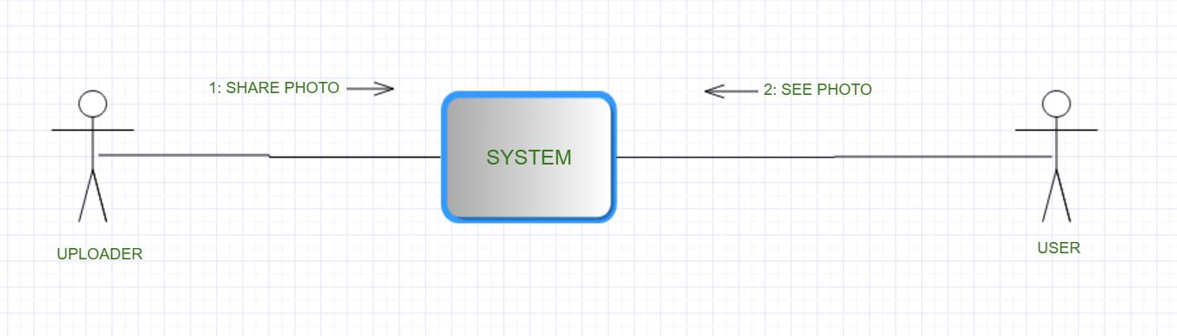

# Behavioral Diagram

