DSSS

clc;

close all;

clear all;

b=round(rand(1,20));

pattern=[];

for k=1:20

if b(1,k)==0

sig=zeros(1,6);

else

sig=ones(1,6);

end

pattern=[pattern sig];

end

subplot(3,1,1);

plot(pattern);

axis([-1 130 -.5 1.5]);

title('\bf\it Original Bit Sequence');

% Generating the pseudo random bit pattern for spreading

spread_sig=round(rand(1,120));

subplot(3,1,2);

plot(spread_sig);

axis([-1 130 -.5 1.5]);

title('\bf\it Pseudorandom Bit Sequence');

% XORing the pattern with the spread signal

hopped_sig=xor(pattern,spread_sig);

% Modulating the hopped signal

dsss_sig=[];

t=[0:100];

fc=50

c1=cos(2*pi*fc*t);

c2=cos(2*pi*fc*t+pi);

for k=1:120

if hopped_sig(1,k)==0

dsss_sig=[dsss_sig c1];

else

dsss_sig=[dsss_sig c2];

end

end

subplot(3,1,3);

plot([1:12120],dsss_sig);

axis([-1 12220 -1.5 1.5]);

title('\bf\it DSSS Signal');

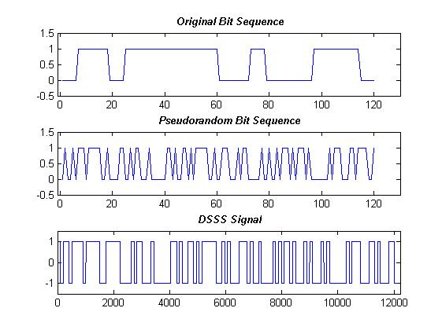

Clustering

clear all;

clc;

i=input('enter value of i:');

j=input('enter value of j:');

R=input('enter value of radius of cell');

cityarea=input('enter city area');

N=i^2+i*j+j^2;

areacell= 2.5981*R^2;

totalcells=round(cityarea/areacell)

ch_bw=60*10^3; % channel bandwidth given

spectr=40*10^6; % spectrumsize given

totch=round(spectr/ch_bw); % Total channels

k=round(totch/N)

M=round(totalcells/N)

c=M*k*N

plexp=4; %path loss exponent

s_i=(((3*N)^0.5)^plexp)/6 % i0 =6 total number of co-channels

s_idb=10*log10(s_i);

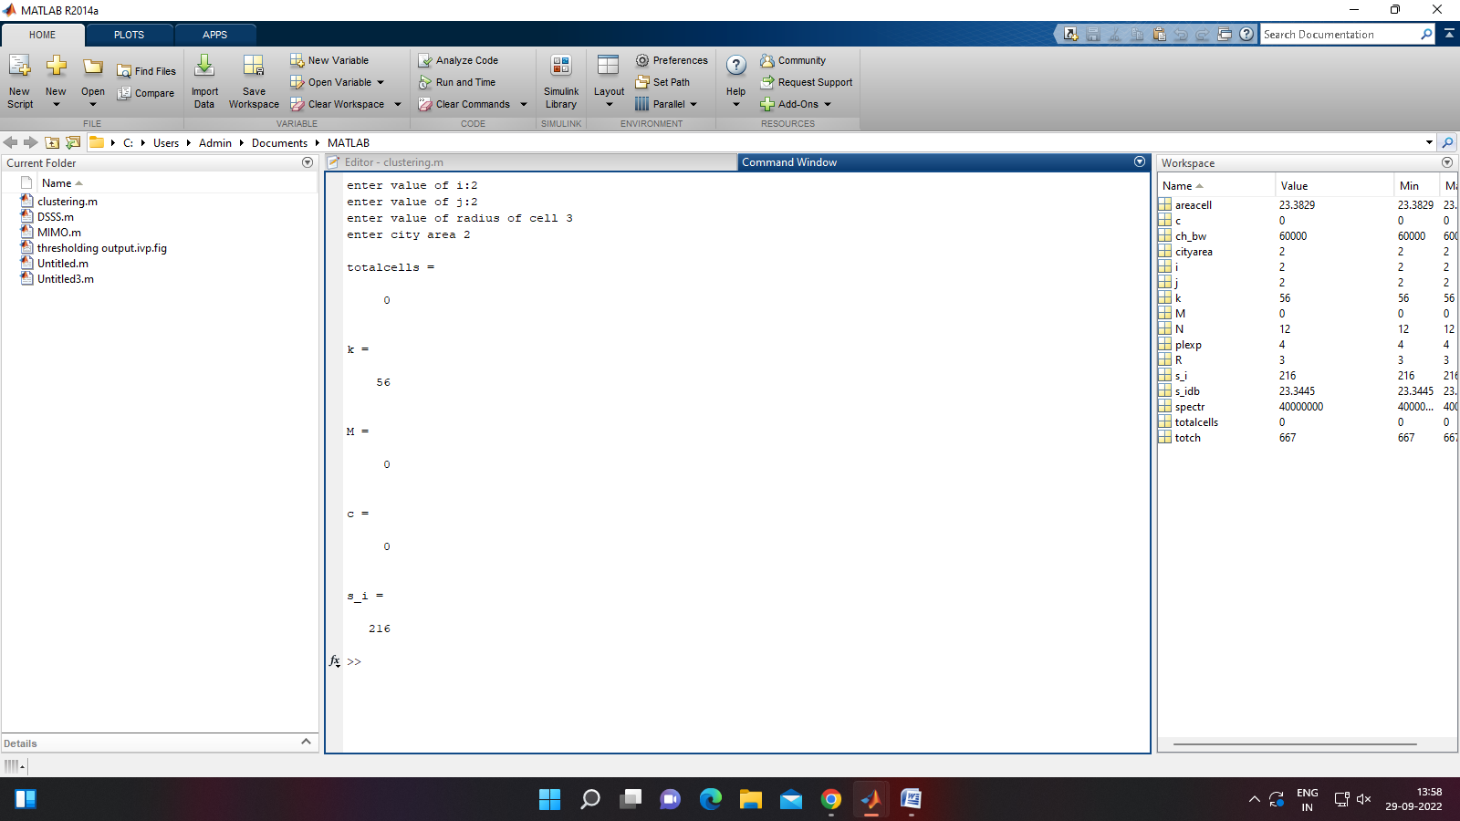

MIMO

clear all

clc

%Shannon capacity

snr=0;

for i = 1:10

snr = snr +2;

c=(log(1+10^(snr/10)))/log(2);

x(i)=snr;

y(i)=c;

end

figure

plot(x,y,'-','LineWidth',1.5)

hold on

% capacity of MIMO Link with NR=2, NT=2

NR=2;

rand('state',456321)

snr=0;

for i=1:10;

snr=snr+2;

for j=1:10000;

c(j)=(NR*log(1+(10^(snr/10))*abs(normrnd(0,1)))/log(2));

end

yy(i)=mean(c);

xx(i)=snr;

end

plot(xx,yy,':','LineWidth',1.5)

% capacity of MIMO Link with NR=3, NT=3

NR=3;

rand('state',456321)

snr=0;

for i=1:10;

snr=snr+2;

for j=1:10000;

c(j)=(NR*log(1+(10^(snr/10))*abs(normrnd(0,1)))/log(2));

end

yy(i)=mean(c);

xx(i)=snr;

end

plot(xx,yy,'-.','LineWidth',1.5)

% capacity of MIMO Link with NR=4, NT=4

NR=4;

rand('state',456321)

snr=0;

for i=1:10;

snr=snr+2;

for j=1:10000;

c(j)=(NR*log(1+(10^(snr/10))*abs(normrnd(0,1)))/log(2));

end

yy(i)=mean(c);

xx(i)=snr;

end

plot(xx,yy,'--','LineWidth',1.5)

xlabel('SNR(dB)')

ylabel('Capacity (bit/s/Hz)')

grid on

legend('Shannon Capacity','MIMO, NT=NR=2','MIMO, NT=NR=3','MIMO, NT=NR=4',2)

title('MIMO Capacity')

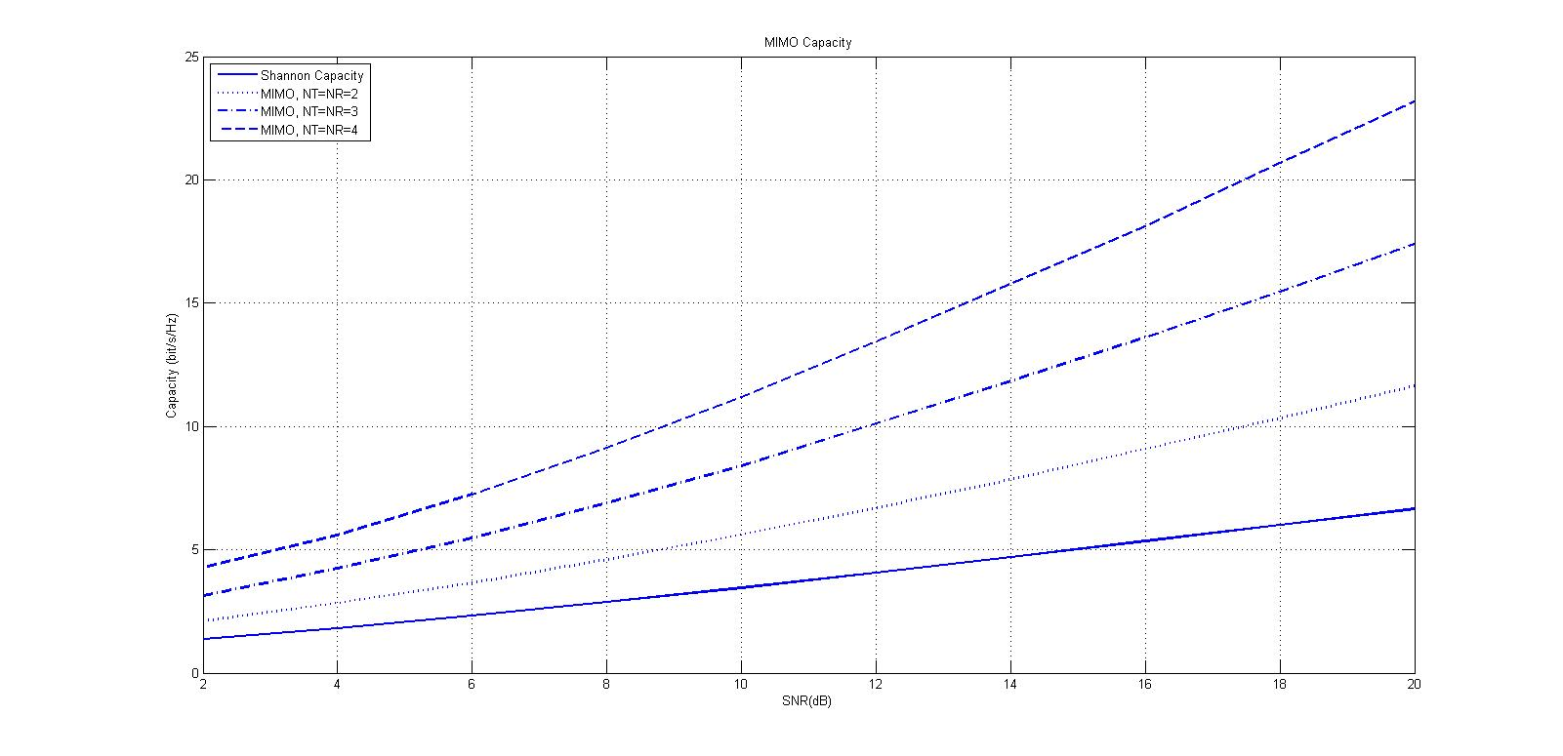

%----Rayleigh_PDF-----------------------------------------

%----------Input Section----------------

N=1000000; %Number of samples to generate

variance = 0.2; % Variance of underlying Gaussian random variables

%---------------------------------------

%Independent Gaussian random variables with zero mean and unit variance

x = randn(1, N);

y = randn(1, N);

%Rayleigh fading envelope with the desired variance

r = sqrt(variance*(x.^2 + y.^2));

%Define bin steps and range for histogram plotting

step = 0.1; range = 0:step:3;

%Get histogram values and approximate it to get the pdf curve

h = hist(r, range);

approxPDF = h/(step*sum(h)); %Simulated PDF from the x and y samples

%Theoritical PDF from the Rayleigh Fading equation

theoretical = (range/variance).*exp(-range.^2/(2*variance));

plot(range, approxPDF,'b*', range, theoretical,'r');

title('Simulated and Theoretical Rayleigh PDF for variance = 0.5')

legend('Simulated PDF','Theoretical PDF')

xlabel('r --->');

ylabel('P(r)---> ');

grid;

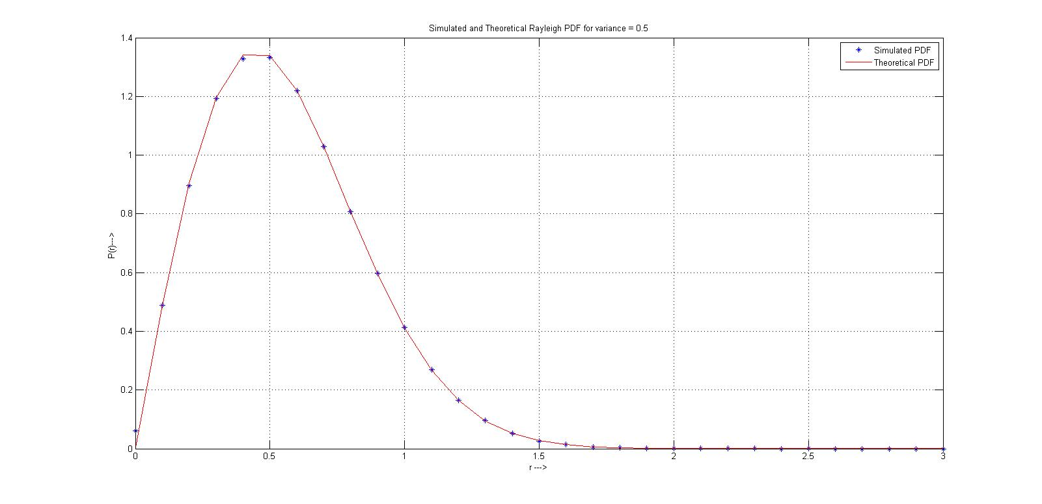

CDMA

clc

clear all

Ad=input('Enter A data : ');

Bd=input('Enter B data : ');

Ak=input('Enter key for A : ');

Bk=input('Enter key for B : ');

if (Ad == 0)

Ad=-1;

end

if (Bd == 0)

Bd=-1;

end

m=length(Ak);

n=length(Bk);

for i=1:m

if (Ak(i) == 0)

Ak(i)=-1;

end

end

for i=1:n

if (Bk(i) == 0)

Bk(i)=-1;

end

end

As=Ad*Ak;

Bs=Bd*Bk;

Cs=As+Bs

a=Cs.*Ak

b=Cs.*Bk

m=length(a);

n=length(b);

k=0;

for i=1:m

k=k+a(i);

end

k

c=0;

for i=1:n

c=c+b(i);

end

c

if (k > c)

disp('Since k > c connect Tx A to Rx a')

else

disp('Since k < c connect Tx B to Rx b')

end

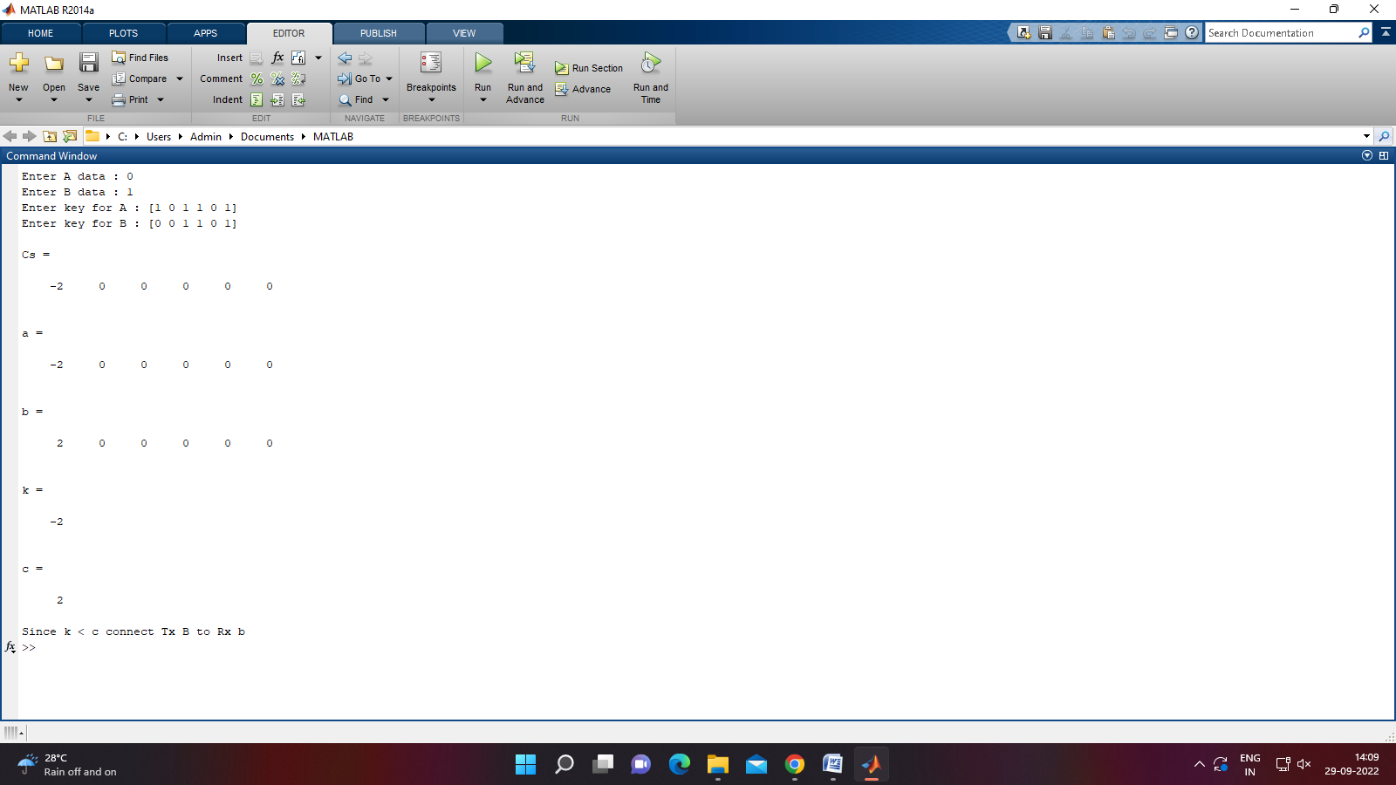

COGNITIVE RADIO

clc;

clear all;

close all;

u = 1;

snr_avgdB =0;

snr_avg = power(10,snr_avgdB/10);

Base= 0.01:0.02:1;

Pf =Base.^2;

for i=1:length(Pf)

%Threshold

Th(i) = gaminv(1-Pf(i),u,1)*2;

pd(i) = marcumq(sqrt(snr_avg*2*u),sqrt(Th(i)),u);

end

plot(Pf,pd,'->r','Linewidth',2)

holdon

snr_avgdB =3;

snr_avg = power(10,snr_avgdB/10);

for i=1:length(Pf)

%Threshold

Th1(i) = gaminv(1-Pf(i),u,1)*2;

pd1(i) = marcumq(sqrt(snr_avg*2*u),sqrt(Th1(i)),u);

end

plot(Pf,pd1,'-ob','Linewidth',2)

holdon

snr_avgdB =8;

snr_avg = power(10,snr_avgdB/10);

for i=1:length(Pf)

%Threshold

Th2(i) = gaminv(1-Pf(i),u,1)*2;

pd2(i) = marcumq(sqrt(snr_avg*2*u),sqrt(Th2(i)),u);

end

plot(Pf,pd2,'-*k','Linewidth',2)

holdon

xlabel('Probability of False alarm (Pf)');

ylabel('Probability of detection (Pd)');

legend ('SNR=0db','SNR=3db','SNR=8db');

grid on;

