|  |
| --- |
|  |
|  |
|  |
|  |
|  |
|  |
|  |
|  |
|  |

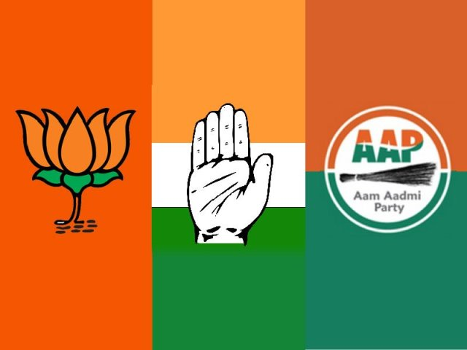

EXPLORATORY DATA ANALYSIS AND PREDICTIVE ANALYSIS: 2020 DELHI LEGISLATIVE ASSEMBLY ELECTIONS (GREATER KAILASH)

06/08/2019

ANIKET. N. GAIKWAD

**INTRODUCTION**

The report aims to analyze political data from different elections held in Delhi in past few years and predict the results of the **GREATER KAILASH** constituency in the upcoming **DELHI LEGISLATIVE ASSEMBLY ELECTIONS** in 2020.

**MORE ABOUT DELHI:**

Delhi is a capital territory consisting of a mixed population of voters from different castes and religions which makes it difficult for the government to execute its development plans and maintain peaceful environment. Delhi is divided into 70 Legislative constituencies and 11 Parliamentary constituencies.

The report consists of detailed analysis of various legislative as well as parliamentary elections in the past 11 years. It consists of:

* 2008 VIDHAN SABHA ELECTIONS
* 2013 VIDHAN SABHA ELECTIONS
* 2014 LOK SABHA ELECTIONS
* 2015 VIDHAN SABHA ELECTIONS

The analysis includes analyzing and finding various trends such as strong polling booths for a particular party, vote share of different parties, details about the candidates contesting the election and univariate as well as bivariate analysis with the of data visualization of many other factors which may affect the result of the Greater Kailash constituency in the upcoming Delhi legislative assembly elections in 2020.

**DATA SOURCE AND COLLECTION**

The analytics report is created with reference to data collected from the website owned by the **ELECTION COMMISSION OF INDIA(ECI).** Following links were used to extract and collect data:

* **GENERAL DETAILS:**
* <https://eci.gov.in>
* <https://en.wikipedia.org/wiki/Greater_Kailash_(Delhi_Assembly_constituency)>
* ​**FORM 20:**

<https://eci.gov.in/statistical-report/link-to-form-20/>

* **CANDIDATE DATA (2013):**

<http://myneta.info/delhi2013/index.php?action=show_candidates&constituency_id=69>

* **CANDIDATE DATA (2015):**

<http://myneta.info/delhi2015/index.php?action=show_candidates&constituency_id=21>

**DATA EXTRACTION**

* Most of the data used in the analysis was present in the .pdf format on site such as eci.gov.in and myneta.info.
* This data was converted to excel sheets with the help of python libraries available such as pdfminer, tabula, regex etc.

**INFORMATION ABOUT GREATER KAILASH**

**Greater Kailash** (often referred to as **GK**) is a residential area in [South Delhi](https://en.wikipedia.org/wiki/South_Delhi), comprising several neighborhoods and multiple markets. It is one of the poshest neighborhoods of Delhi and is home to some of the most affluent families of Delhi. It is divided into two zones, namely Parts 1 and 2, located around a section of the Outer Ring Road. It is sought after both in commercial and residential category. In 2009 Greater Kailash was rated as the safest place in Delhi by [The Times of India](https://en.wikipedia.org/wiki/The_Times_of_India), after 2008 serial blast took place in GK - 1, M-Block market.

**GREATER KAILASH 1:**

Greater Kailash 1 (GK-I) was developed in the 1960s by [DLF Limited](https://en.wikipedia.org/wiki/DLF_Limited) when Delhi Government allowed private developers to build colonies, and is today one of the most affluent neighborhoods in the city, home to well-known politicians, business personality and people associated with Bollywood industry. GK 1 markets in M and N Block are some of the most popular markets among Delhiites and tourists because of its wide range of shopping, restaurants, bars etc. Home to a wide range of international and national retail stores, such as Giovanni, Next, Puma, Nike, Adidas, Lacoste, United Colors of Benetton, Carlton and several restaurants and coffee houses such as Starbucks, Dunkin Donuts, Cafe Coffee Day, Bohemia etc. Office of ASSOCHAM was there in Zamrudpur Community Centre till May 2013.

**EXPANSION: GREATER KAILASH 2**

Greater Kailash-II is one of the posh areas in South Delhi. The development of Greater Kailash-I was followed by the expansion of Greater Kailash Part II, which has easier accessibility to the Outer Ring Road of New Delhi. M-Block, GK II is a popular market, with many restaurants, coffee shops, sanitary shops and beauty salons. It is one of the largest hubs for sanitary ware in Northern India. Recently the market has experienced heavy foot fall due to several posh restaurants, salons and banks. The area has benefited with a lot of restaurants such as Whistling Duck, Fig and Maple, Chunghwa, Diva, Carnatic Cafe, Yeti, PDA and many more, bakeries such as Red Moon, Defence Bakery, Birdy's, Nik's and coffee houses such as [Costa Coffee](https://en.wikipedia.org/wiki/Costa_Coffee), Barista, [Chocolateria San Churro](https://en.wikipedia.org/w/index.php?title=Chocolateria_San_Churro&action=edit&redlink=1), Cafe Turtle etc.

**EDUCATIONAL INSTITUTIONS PRESENT IN GREATER KAILASH:**

* [Balvantray Mehta Vidya Bhawan Anguridevi Shersingh Memorial Academy](https://en.wikipedia.org/wiki/Balvantray_Mehta_Vidya_Bhawan_ASMA)
* [Don Bosco School](https://en.wikipedia.org/wiki/Don_Bosco_School_(Alaknanda,_New_Delhi))
* [Summer Fields School](https://en.wikipedia.org/wiki/Summer_Fields_School,_New_Delhi)
* [K R Mangalam](https://en.wikipedia.org/wiki/K_R_Mangalam_World_School)
* [Bluebells School](https://en.wikipedia.org/wiki/Bluebells_School_International)
* [Paul George Global School](https://en.wikipedia.org/w/index.php?title=Paul_George_Global_School&action=edit&redlink=1)
* [Mount Litera World Pre School-ZEE LEARN LTD C-215 GK1 9711130153](https://en.wikipedia.org/w/index.php?title=Mount_Litera_World_Pre_School-ZEE_LEARN_LTD_C-215_GK1_9711130153&action=edit&redlink=1)

**HOSPITALS PRESENT IN GREATER KAILASH:**

* Apollo Spectra Hospital
* Fortis La Femme Hospital
* Sukhda Hospital
* Phoenix Hospital
* Premier Skin Hospital
* Bharti Eye Hospital
* Spectra Eye Hospital

**DISTANCE OF GREATER KAILASH FROM DIFFERENT PLACES**:

* The [Domestic Airport](https://en.wikipedia.org/wiki/Delhi_airport#Terminal_1_(Domestic)) is 17 km from Greater Kailash.
* The [International Airport](https://en.wikipedia.org/wiki/Delhi_airport) (IGI) is 22 km from Greater Kailash.
* The Nizamuddin Railway station is approximately 9 km from Greater Kailash
* The New Delhi Railway Station is approximately 15 – 16 km from Greater Kailash

**DATA ANALYSIS**

**DELHI LEGISLATIVE ASSEMBLY ELECTIONS (2008)**

**(GREATER KAILASH)**

**PRE-ELECTION SITUATION (2003-2008)**

* The 2003 elections for the Delhi Vidhan Sabha formed its 7th Assembly. After this election, **Sheila Dikshit** of the INC continued to be the Chief Minister of Delhi.
* 70 MLAs were elected, representing 70 Assembly constituencies. Sheila Dikshit won from the Gole Market constituency.
* **Greater Kailash** was not formed yet (Eventually formed in 2008). The voters belonging to Greater Kailash, were a part of South Delhi.

**VOTE PERCENTAGE OF DIFFERENT PARTIES IN GREATER KAILASH CONSTITUENCY (2008)**

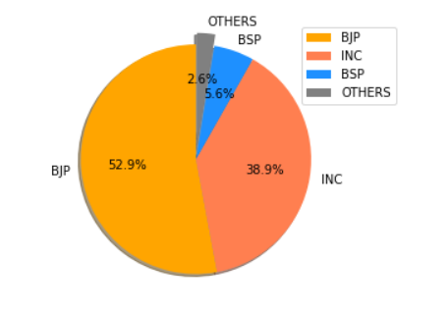

* Bharatiya Janata Party (BJP) won securing 53% of the total vote share.
* Indian National Congress (INC) secured second position with 39% of total votes.
* BJP replaced INC to take over Greater Kailash after 10 years.

**NO. OF VOTES WON BY DIFFERENT PARTIES AT GREATER KAILASH (2008)**

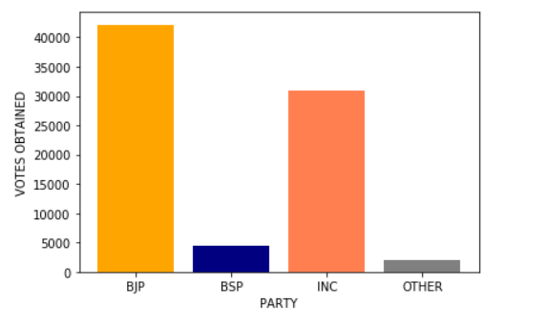

* Greater Kailash had 79,703 registered voters.
* BJP secured 42,197 votes and won.
* INC followed with 30,979 votes.

**OUTCOME OF THE ANALYSIS**

* The 2008 election resulted into power switch where the defending party, Indian National Congress (INC) was defeated by Bharatiya Janata Party (BJP) by 11,218 votes.
* **ONE OF THE PROBABLE REASONS FOR THE DEFEAT**:
* 2008 Serial blasts which took place in GK - 1, M-Block market.

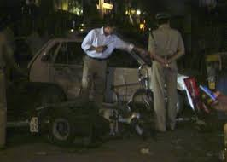

IMAGE FROM THE SERIAL BLAST IN 2008

* BJP accused INC for failing to provide security and maintaining peaceful environment in the area.
* The accusation mentioned above caused BJP to take advantage and secure Greater Kailash.

**DELHI LEGISLATIVE ASSEMBLY ELECTIONS (2013)**

**(GREATER KAILASH)**

**PRE-ELECTION SITUATION (2009-2013)**

BJP were in-charge of the Greater Kailash and implemented some public projects such as progressing the metro station construction work and improving the bus connectivity etc.

**CASE STUDY: 2011 ANTI-CORRUPTION MOVEMENT**

The **Indian anti-corruption movement**, commencing in 2011, was a series of demonstrations and protests across India intended to establish strong legislation and enforcement against perceived endemic political corruption. The movement was named among the "Top 10 News Stories of 2011" by *Time* magazine.

The movement gained momentum from 5 April 2011, when anti-corruption activist Anna Hazare began a hunger strike at the Jantar Mantar in New Delhi. The chief legislative aim of the movement was to alleviate corruption in the Indian government through introduction of the Jan Lok pal Bill. Another aim, spearheaded by Ramdev, was the repatriation of black money from Swiss and other foreign banks.

Grievances of mass protesters focussed on legal and political issues, including political corruption, kleptocracy, and other forms of corruption. The movement was primarily one of non-violent civil resistance, featuring demonstrations, marches, acts of civil disobedience, hunger strikes, and rallies, as well as the use of social media to organise, communicate, and raise awareness. The protests were non-partisan and most protesters were hostile to attempts made by political parties to use them to strengthen their own political agendas.

Hazare declared that the protest movement would recommence and a mark of protest he sat on hunger strike on 25 March 2012 for one day. A month later, Hazare sat a token one-day fast focussed on remembrance of whistle-blowers such as Narendra Kumar and Satyendra Dubey who had died as a result of their support for the anti-corruption cause. On 3 June, Hazare undertook another one-day fast at Jantar Mantar, where he was joined by Ramdev, a yoga guru.

**FASTING AT JANTAR MANTAR**

Jantar Mantar was the scene of an "indefinite" fast that began on 25 July and involved various members of Team Anna, although Hazare was not involved until four days later. The focus on this occasion was a protest against the government's refusal of an inquiry against the prime minister and 14 cabinet ministers, whom they had accused of corruption. The fast ended on 3 August. Three days later, Hazare announced that since the government seemed to be unready to enact the Jan Lokpal Bill, he and his fellow activists had decided to end their fast, to discontinue talks with the government and to cease any protests under the Team Anna name.

**FORMATION OF AAM AADMI PARTY IN 2012**

Anna Hazare and Kiran Bedi reformed Team Anna, while Kejriwal and some others split from the erstwhile apolitical movement with the intention of forming what was to become the Aam Aadmi Party.

After failing to press government to pass The Lokpal Bill, 2011, the Team Anna split on issue of formation of political party. Anna Hazare and some others did not want to enter mainstream politics while Arvind Kejriwal led India Against Corruption opined to join politics. Arvind Kejriwal and others finally formed the new **Aam Aadmi Party (AAP),** on **26 November 2012.**

**ANALYSIS**

**PERCENTAGE OF VOTERS IN GREATER KAILASH (2013)**

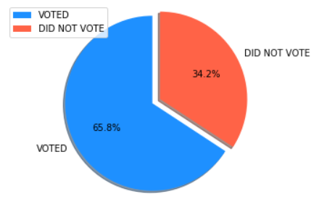

* Total number of registered voters in 2013: **1,43,773**
* Total number of people who voted: **94,581**
* Total number of people who didn’t vote: **49,192**

**NUMBER OF POLLING BOOTHS WON BY DIFFERENT PARTIES IN GREATER KAILASH (2013)**

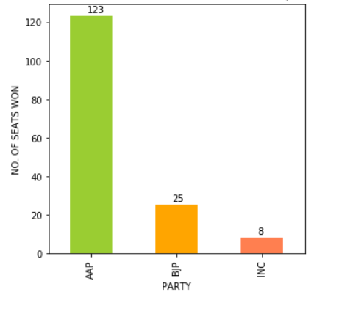

* Greater Kailash seemed to be a one-sided affair as **Aam Aadmi Party (AAP)** won **123** out of 156 polling booths in the constituency.
* **Bharatiya Janata Party (BJP)** on the other hand, under-performed, securing only **25** polling stations.
* The **Indian National Congress (INC)** were reduced to a minimal performance of all time in Greater Kailash winning just **8** polling station.

**NUMBER OF VOTES WON BY DIFFERENT PARTIES VIA EVM IN GREATER KAILASH (2013)**

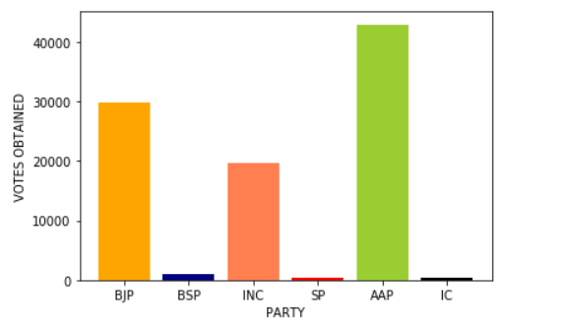

* **AAP** won **42,924** votes and won in Greater Kailash.
* **BJP** secured the second position, winning **29,897** votes.
* **INC** were able to win **19,641** votes only.

**NUMBER OF VOTES WON THROUGH BALLOT PAPER VOTING IN GREATER KAILASH (2013)**

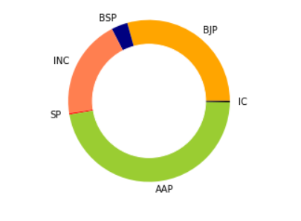

* AAP secured 173 votes from the ballot paper voting.
* BJP secured 108 votes and finish second here too.
* INC finish last out of the three major parties, winning only 73 votes only.

**PERCENTAGE OF VOTES WON BY DIFFERENT PARTIES IN GREATER KAILASH (2013)**

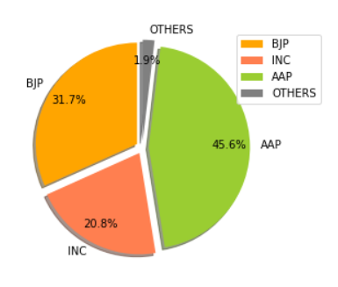

**TABLE REPRESENTING THE RESULT IN TABULAR FORM**

|  |  |
| --- | --- |
| PARTY | PERCENTAGE OF VOTES WON |
| BJP | **31.7** |
| INC | **20.8** |
| AAP | **45.6** |
| OTHERS | **1.9** |

**OUTCOME OF THE ANALYSIS**

* The 2013 Delhi legislative elections in Greater Kailash experienced changes in the election results.
* The newcomers, the Aam Aadmi Party won the election by securing 45.6% of the total vote share in their first ever election campaign.
* On the other hand, BJP were not able to defend and felt to the AAP formed after the strong anti-corruption movement in 2012.
* INC continued with the gradual decrease in their vote share, winning only 21% of the total vote share.
* **PROBABLE REASON FOR BJP’S DEFEAT**:

ANTI-CORRUPTION MOVEMENT (2011-2013)

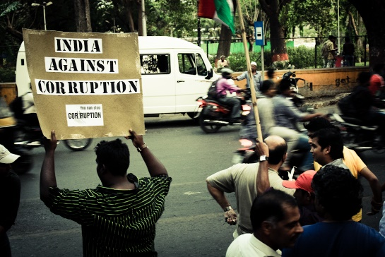

* The anti-corruption movement led to change in people’s mind set and caused great harm to the reputation and performance of some established parties such BJP, INC, BSP etc.
* The movement greatly contributed to the formation of Aam Aadmi Party in 2012.
* Rallies, protests involved in the campaign were mostly organized in Delhi.
* This gave AAP an upper hand in the Delhi Elections as they followed the same ideology of an anti-corrupt government.

**INDIAN GENERAL ELECTIONS**

**2014**

**DELHI (GREATER KAILASH)**

**PRE-ELECTION SITUATION (2009-2014)**

AAP were in control at the legislative level after forming alliance with INC.BJP’s attempts to win Greater Kailash and other places, failed with the success of anti-corruption movement and the establishment of AAP in 2012.

**CASE STUDY: THE ‘NAMO’ EFFECT (2014)**

It was the Lok Sabha elections this time and at the same point of time, Narendra Modi, the chief minister of Gujarat was selected as BJP’s candidate for the prime minister position.

Rallies and campaigns were organized all over the country by BJP, making people change their thinking process by publicizing ideas such as ‘anti-congress India’ etc.

People started believing in the new ideologies brought in by BJP and the increasing support for BJP swept almost every part of the country often called as ‘The Namo Effect’.

**ANALYSIS**

**VOTE PERCENTAGE OF DIFFERENT PARTIES IN GREATER KAILASH IN 2014**

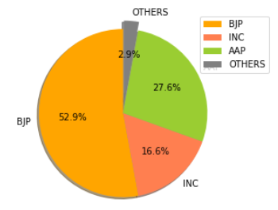

* BJP’s effective planning and executions of their strategies reflected a positive impact on the general election results.
* In Greater Kailash, **BJP** won **53%** of the total vote share.
* As Greater Kailash was one of the most populated area in South Delhi District, BJP eventually won the South Delhi District Seat also.
* The effect of AAP was still prominent, they performed well in Greater Kailash with their first general election campaign.

**NUMBER OF VOTES WON BY DIFFERENT PARTIES IN GREATER KAILASH (2014)**

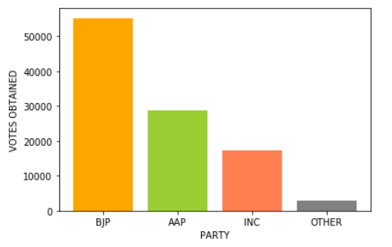

* Total number of registered electors in Greater Kailash in 2014: **1,04,339**
* **BJP** secured **55,200** votes and took the lead in the South Delhi District seat.
* **AAP** on the other hand, were able to win **28,829** votes in Greater Kailash.
* **INC** continued their gradual fall in the vote share in the area, winning **17,312** votes only.

**OUTCOME OF THE ANALYSIS**

* BJP won the most no. of votes in Greater Kailash and eventually went on to win the South Delhi Constituency Seat.
* **REASON FOR THE WIN**
* The Namo Effect (as Explained before)

**DELHI LEGISLATIVE ASSEMBLY ELECTION**

**2015**

**GREATER KAILASH**

**PRE-ELECTION SITUATION (2013-2015)**

BJP were in control of Greater Kailash, South Delhi and the whole country. AAP on the other hand, were struggling at the legislative level. After forming an alliance with INC to form the government in 2013, now conflicts started to increase, and many other issues made the condition worse.

**NON-ACCEPTANCE OF JAN LOKPAL BILL (2014)**

AAP's leader Arvind Kejriwal, who defeated the incumbent chief minister Sheila Dikshit, became the 7th chief minister of Delhi. However, on 14 February 2014 (after 49 days of rule), **Arvind Kejriwal resigned from his post citing the reason as his government's inability to table the Jan Lokpal Bill in Delhi Assembly for discussion, due to stiff opposition from other political parties in the house.**

**Delhi remained thereafter under President's Rule for about a year**. On 4 November 2014, the Lieutenant Governor of Delhi Najeeb Jung recommended the Union Cabinet for the dissolution of Delhi assembly and conduct fresh elections. On 12 January 2015, the Election Commission of India announced that state assembly elections would be held on 7 February 2015 with results being announced on 10 February 2015.

**ANALYSIS**

**PERCENATGE OF VOTERS IN GREATER KAILASH IN 2015**

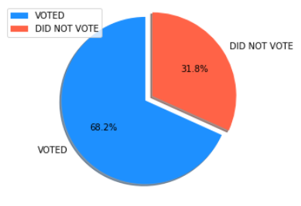

* Total number of registered electors**: 1,58,346**
* Total number of electors who voted in 2015: **1,08,037**
* Total number of non-voters in 2015: **50,309**
* Greater Kailash registered a gradual increase in the percentage of voters from **65.8%** in **2013** to **68.2%** in **2015**.

**USAGE OF NOTA (2013-2015)**

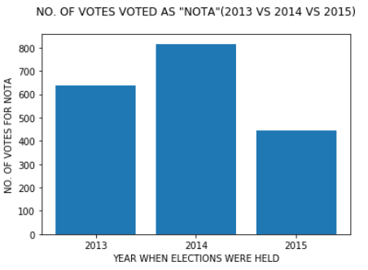

* The **NOTA** option was used by **636** voters in **2013**.
* The count went on to increase to **816** voters in **2014**.
* It was by used by **443** voters in **2015**.

**NUMBER OF VOTES WON BY DIFFERENT PARTIES IN 2015**

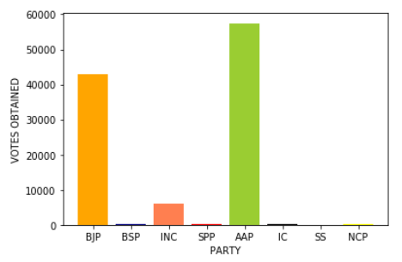

* **AAP** won the seat, securing **57,430** votes.
* **BJP** finished second, securing **42,902** votes.
* **INC** continued their poor performance winning just **6,072** votes.

**NUMBER OF VOTES WON BY DIFFERENT PARTIES THROUGH BALLOT PAPER IN 2015**

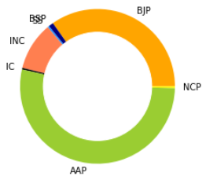

* Total number of votes through ballot paper: **299**
* **AAP** won **159** votes through ballot paper.
* **BJP** secured **104** votes through the ballot paper.
* **INC** were able to win **30** votes only.

**NUMBER OF POLLING BOOTHS WON BY DIFFERENT PARTIES IN 2015**

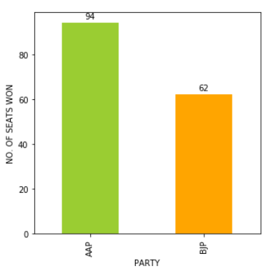

* **AAP** won the seat by winning **94** polling booths out of the total **156** polling booths.
* **BJP** won the remaining **62** polling booths.

**PERCENTAGE OF VOTES SECURED BY DIFFERENT PARTIES IN 2015**

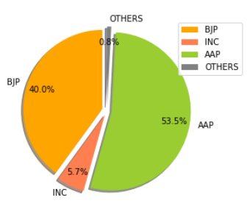

**TABULAR FORM**:

|  |  |
| --- | --- |
| PARTY | VOTE PERCENTAGE |
| BJP | **40%** |
| AAP | **53.5%** |
| INC | **5.7%** |
| OTHERS | **0.8%** |

**OUTCOME OF THE ANALYSIS**

* **AAP** won the Greater Kailash for the **second time consecutively**.
* **BJP** finished second, securing **40%** of the total vote share.
* INC struggled and experienced a decrease in the vote share from 21% in 2013 to just 5.7% in 2015.
* **PROBABLE REASON FOR AAP’S WIN:**
* **AAP’S MANIFESTO:**

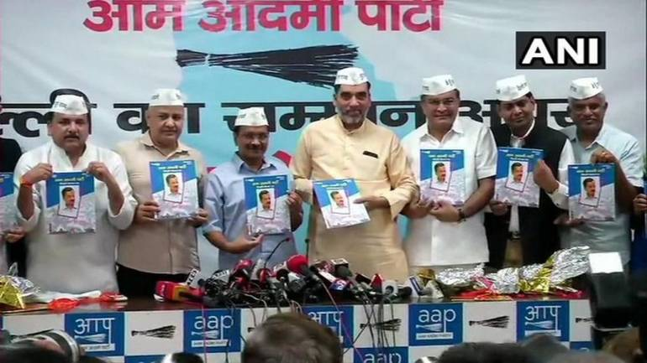

* AAP released its manifesto on 31 January 2015.
* Resolved to legislate the Delhi Jan Lokpal Bill after coming to power.
* Will keep its promise of reducing electricity bills by half.
* Put Delhi's own power station at the pithead and comprehensively solve Delhi's electricity problem in long run.
* Facilitate a phased shift to renewable and alternate sources of energy like Solar Energy.
* Provide Water as a Right. It will provide access to clean drinking water to all of Delhi at an affordable price.

**PERFORMANCE ANALYSIS**

**BHARATIYA JANATA PARTY**

**GREATER KAILASH**

**FINANCIAL DETAILS OF THE CANDIDATES**

**2013: AJAY KUMAR MALHOTRA**

**MOVABLE ASSETS**

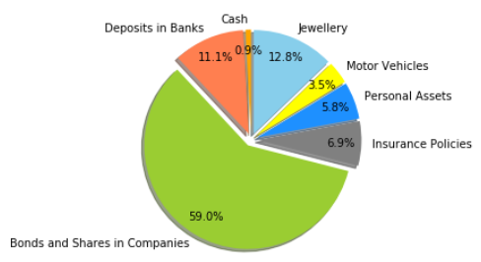

**AMOUNT OF VARIOUS MOVABLE ASSETS**

|  |  |
| --- | --- |
| ASSET | AMOUNT IN RUPEES |
| CASH | **3,51,000** |
| JEWELLERY | **52,27,000** |
| MOTOR VEHICLE | **14,31,000** |
| PERSONAL ASSETS | **22,50,000** |
| INSURANCE POLICIES | **28,28,018‬** |
| BONDS AND SHARES IN COMPANIES | **2,41,28,880** |
| DEPOSITS IN BANKS | **45,32,000** |

**IMMOVABLE ASSETS**

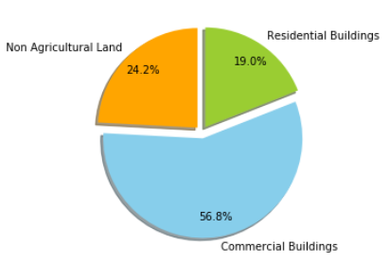

**AMOUNT OF IMMOVABLE ASSETS**

|  |  |
| --- | --- |
| ASSET | AMOUNT IN RUPEES |
| NON-AGRICULTURAL LAND | **1,52,60,000** |
| COMMERCIAL BUILDINGS | **3,59,00,000** |
| RESIDENTIAL BULDINGS | **1,20,00,000** |

**2015: RAKESH KUMAR GULLAIYA**

**MOVABLE ASSETS**

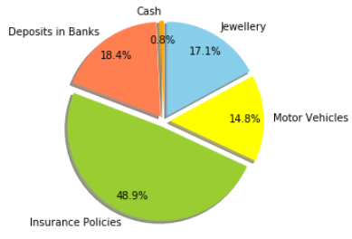

**AMOUNT OF VARIOUS MOVABLE ASSETS**

|  |  |
| --- | --- |
| ASSET | AMOUNT IN RUPEES |
| CASH | **97,500** |
| JEWELLERY | **21,95,000** |
| MOTOR VEHICLE | **19,05,253** |
| PERSONAL ASSETS | **Nil** |
| INSURANCE POLICIES | **62,70,000** |
| BONDS AND SHARES IN COMPANIES | **Nil** |
| DEPOSITS IN BANKS | **23,65,291** |

**IMMOVABLE ASSETS**

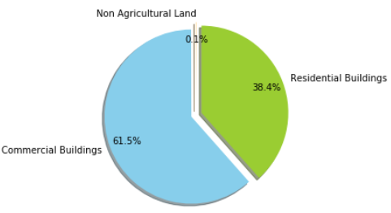

**AMOUNT OF IMMOVABLE ASSETS**

|  |  |
| --- | --- |
| ASSET | AMOUNT IN RUPEES |
| NON-AGRICULTURAL LAND | **10,000** |
| COMMERCIAL BUILDINGS | **1,20,00,000** |
| RESIDENTIAL BULDINGS | **75,00,000** |

**COMPARISON OF NUMBER OF VOTES WON WITH RESPECT TO THE POLLING BOOTHS**

**2013**

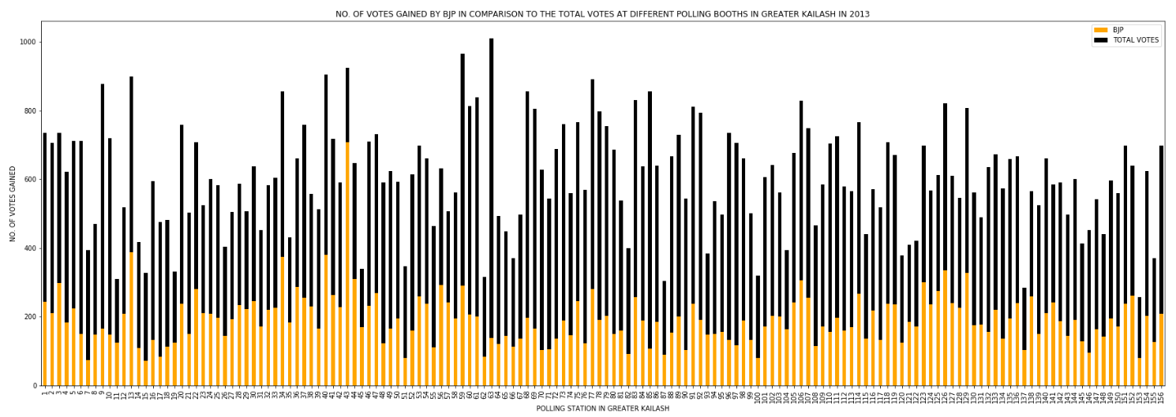

**2014**

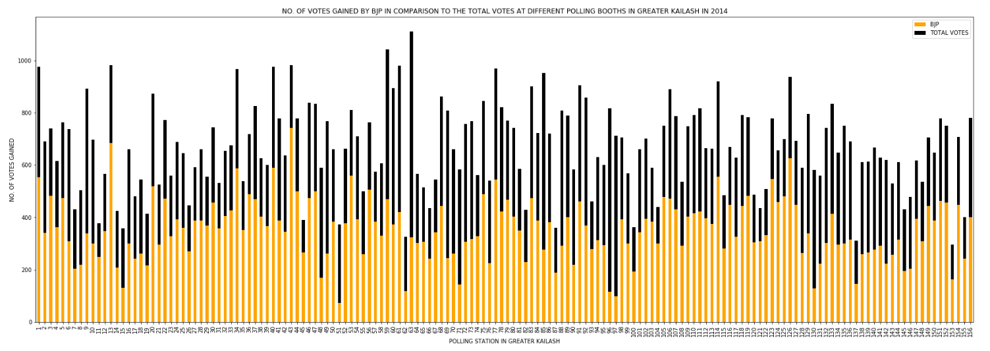

**2015**

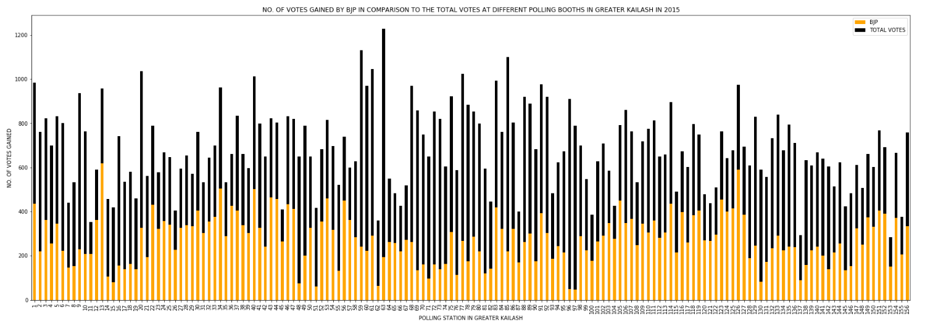

## **NUMBER OF POLLING STATIONS WHERE BJP SECURED 50% OR MORE VOTES**

|  |  |
| --- | --- |
| YEAR | >50% |
| 2013 | **2** |
| 2014 | **105** |
| 2015 | **54** |

## **POLLING STATIONS WHERE BJP SECURED LESS THAN 33% OF VOTES**

|  |  |
| --- | --- |
| YEAR | <33% |
| 2013 | **93** |
| 2014 | **9** |
| 2015 | **53** |

## **IMPROVEMENT IN BJP'S VOTE SHARE IN GREATER KAILASH (2013 VS 2015)**

|  |  |
| --- | --- |
| PERFORMANCE | IMPROVEMENT IN RESULTS FROM 2013 TO 2015 |
| IMPROVED RESULTS | **132** |
| UNIMPROVED RESULTS | **24** |

# **CHANGE IN THE VOTE SHARE OF BJP IN THE PAST FOUR ELECTIONS**

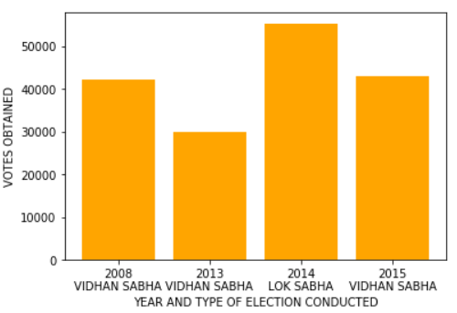

**OUTCOME OF THE ANALYSIS**

* BJP’s performance in the legislative assembly elections has **slightly increased from 2013 to 2015.**
* BJP had an upper hand in the Lok Sabha elections in Greater Kailash in 2014.
* We can conclude that BJP were **stronger** when it came to **Lok Sabha Elections**, but **struggled at the legislative assembly level** after the formation of Aam Aadmi Party in 2012.

**PERFORMANCE ANALYSIS**

**AAM AADMI PARTY**

**GREATER KAILASH**

**FINANCIAL DETAILS OF THE CANDIDATES**

**2013: SAURABH BHARADWAJ**

**MOVABLE ASSETS**

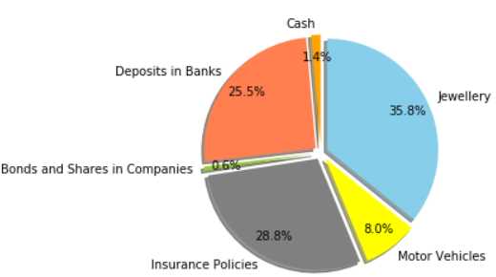

**AMOUNT OF VARIOUS MOVABLE ASSETS**

|  |  |
| --- | --- |
| ASSET | AMOUNT IN RUPEES |
| CASH | **50,000** |
| JEWELLERY | **13,04,500** |
| MOTOR VEHICLE | **2,90,000** |
| PERSONAL ASSETS | **Nil** |
| INSURANCE POLICIES | **10,50,826** |
| BONDS AND SHARES IN COMPANIES | **20,227** |
| DEPOSITS IN BANKS | **9,28,789** |

**IMMOVABLE ASSETS**

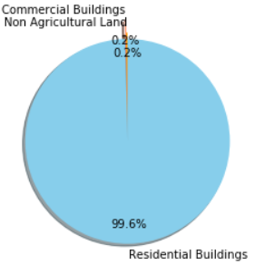

|  |  |
| --- | --- |
| ASSET | AMOUNT IN RUPEES |
| NON-AGRICULTURAL LAND | **10,000** |
| COMMERCIAL BUILDINGS | **10,000** |
| RESIDENTIAL BULDINGS | **50,00,000** |

**2015: SAURABH BHARADWAJ**

**MOVABLE ASSETS**

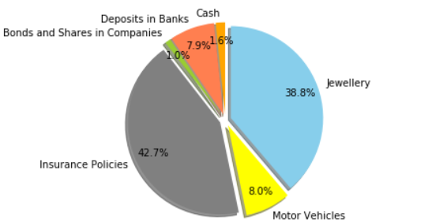

**AMOUNT OF VARIOUS MOVABLE ASSETS**

|  |  |
| --- | --- |
| ASSET | AMOUNT IN RUPEES |
| CASH | **48,000** |
| JEWELLERY | **11,36,740** |
| MOTOR VEHICLE | **2,33,000** |
| PERSONAL ASSETS | **Nil** |
| INSURANCE POLICIES | **12,51,580** |
| BONDS AND SHARES IN COMPANIES | **29,690** |
| DEPOSITS IN BANKS | **2,30,139** |

**IMMOVABLE ASSETS**

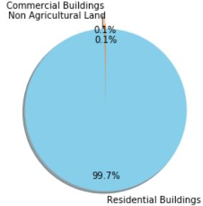

**AMOUNT OF IMMOVABLE ASSETS**

|  |  |
| --- | --- |
| ASSET | AMOUNT IN RUPEES |
| NON-AGRICULTURAL LAND | **10,000** |
| COMMERCIAL BUILDINGS | **10,000** |
| RESIDENTIAL BULDINGS | **70,00,000** |

**COMPARISON OF NUMBER OF VOTES WON WITH RESPECT TO THE POLLING BOOTHS**

**2013**

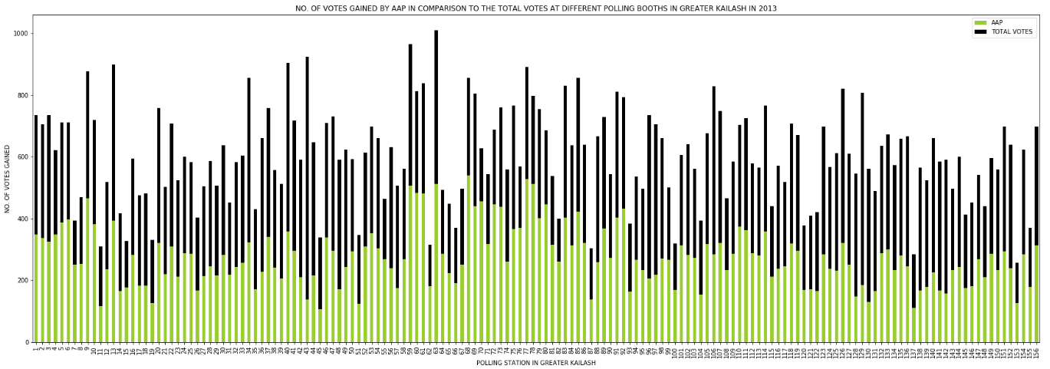

**2014**

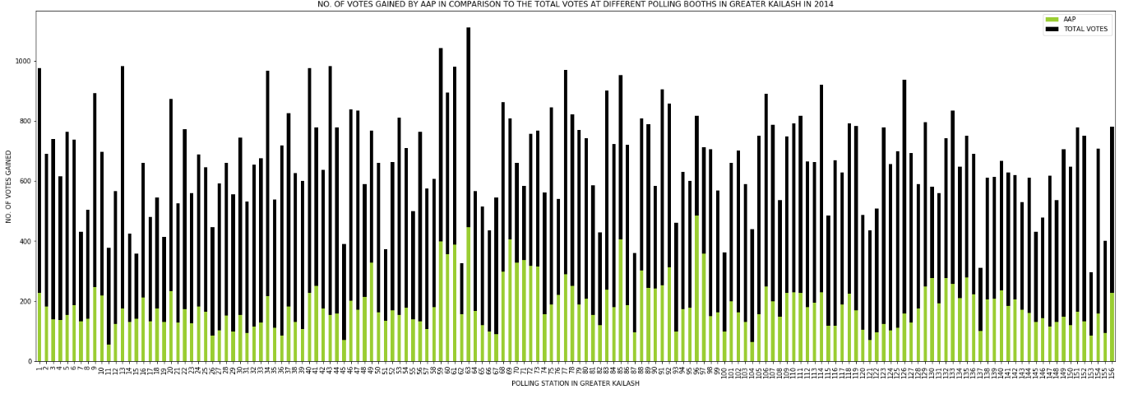

**2015**

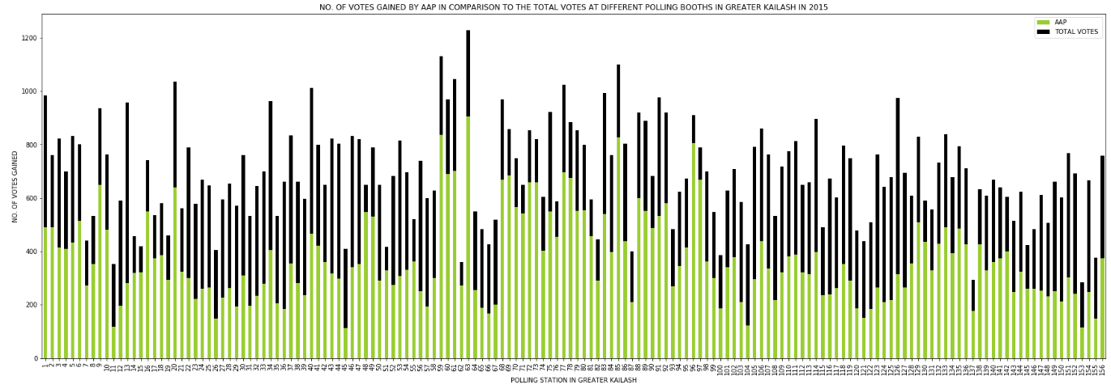

## **NUMBER OF POLLING STATIONS WHERE AAP SECURED 50% OR MORE VOTES**

|  |  |
| --- | --- |
| YEAR | >50% |
| 2013 | **40** |
| 2014 | **4** |
| 2015 | **81** |

## **POLLING STATIONS WHERE AAP SECURED LESS THAN 33% OF VOTES**

|  |  |
| --- | --- |
| YEAR | <33% |
| 2013 | **11** |
| 2014 | **126** |
| 2015 | **53** |

## **IMPROVEMENT IN AAP’S VOTE SHARE IN GREATER KAILASH (2013 VS 2015)**

|  |  |
| --- | --- |
| PERFORMANCE | IMPROVEMENT IN RESULTS FROM 2013 TO 2015 |
| IMPROVED RESULTS | **122** |
| UNIMPROVED RESULTS | **34** |

# **CHANGE IN THE VOTE SHARE OF AAP IN THE PAST FOUR ELECTIONS**

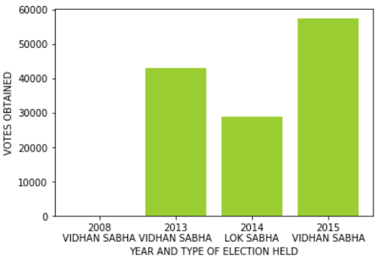

**OUTCOME OF THE ANALYSIS**

* After their formation in 2012, AAP made a huge impact at the legislative level in Delhi.
* While contesting their first ever election in 2013, **AAP** finished **second** behind BJP and eventually forming the government with the help of support from INC.
* In Greater Kailash, **AAP have successfully won the seat** in both **2013** as well as **2015** elections.
* **AAP** eventually **struggled in the Lok Sabha elections** in 2014.

**PERFORMANCE ANALYSIS**

**INDIAN NATIONAL CONGRESS PARTY**

**GREATER KAILASH**

**FINANCIAL DETAILS OF THE CANDIDATES**

**2013: VIRENDER KASANA**

**MOVABLE ASSETS**

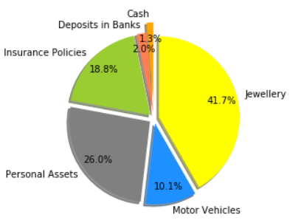

**AMOUNT OF VARIOUS MOVABLE ASSETS**

|  |  |
| --- | --- |
| ASSET | AMOUNT IN RUPEES |
| CASH | **1,43,000** |
| JEWELLERY | **45,30,000** |
| MOTOR VEHICLE | **11,00,884** |
| PERSONAL ASSETS | **9,46,000** |
| INSURANCE POLICIES | **20,44,000** |
| BONDS AND SHARES IN COMPANIES | **Nil** |
| DEPOSITS IN BANKS | **2,12,979** |

**IMMOVABLE ASSETS**

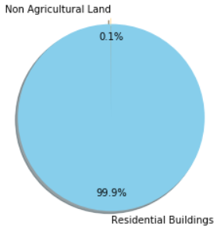

|  |  |
| --- | --- |
| ASSET | AMOUNT IN RUPEES |
| NON-AGRICULTURAL LAND | **10,000** |
| COMMERCIAL BUILDINGS | **10,000** |
| RESIDENTIAL BULDINGS | **50,00,000** |

**2015: SHARMISTHA MUKHERJEE**

**MOVABLE ASSETS**

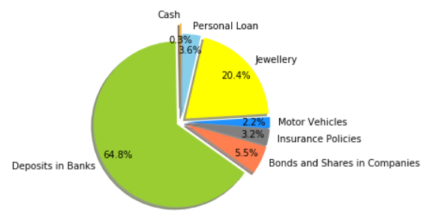

**AMOUNT OF VARIOUS MOVABLE ASSETS**

|  |  |
| --- | --- |
| ASSET | AMOUNT IN RUPEES |
| CASH | **46,720** |
| JEWELLERY | **36,75,675** |
| MOTOR VEHICLE | **3,92,000** |
| PERSONAL ASSETS | **6,49,037** |
| INSURANCE POLICIES | **5,67,687** |
| BONDS AND SHARES IN COMPANIES | **9,91,456** |
| DEPOSITS IN BANKS | **1,16,57,026** |

**IMMOVABLE ASSETS**

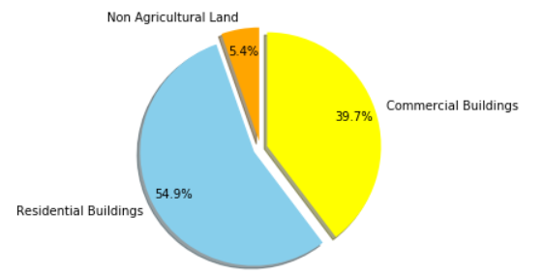

**AMOUNT OF IMMOVABLE ASSETS**

|  |  |
| --- | --- |
| ASSET | AMOUNT IN RUPEES |
| NON-AGRICULTURAL LAND | **6,00,000** |
| COMMERCIAL BUILDINGS | **44,32,000** |
| RESIDENTIAL BULDINGS | **61,32,000** |

**COMPARISON OF NUMBER OF VOTES WON WITH RESPECT TO THE POLLING BOOTHS**

**2013**

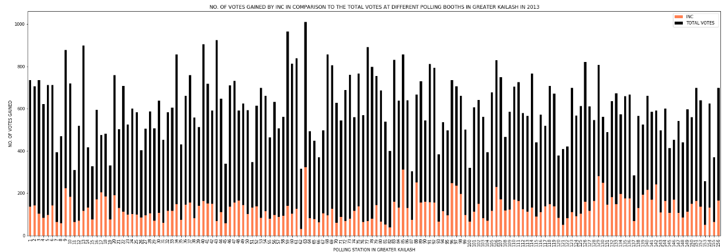

**2014**

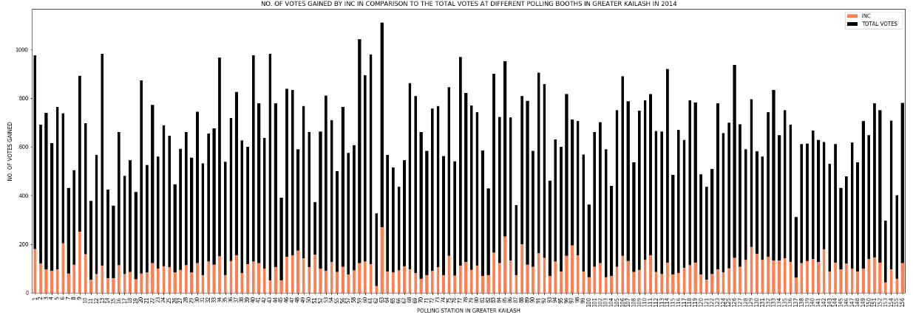

**2015**

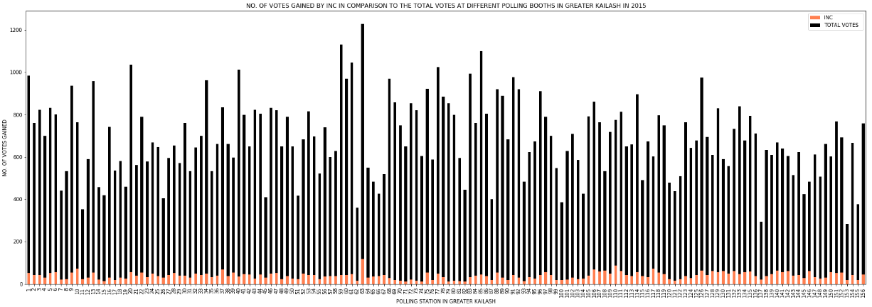

## **NUMBER OF POLLING STATIONS WHERE INC SECURED 50% OR MORE VOTES**

|  |  |
| --- | --- |
| YEAR | >50% |
| 2013 | **0** |
| 2014 | **0** |
| 2015 | **0** |

## **POLLING STATIONS WHERE INC SECURED LESS THAN 33% OF VOTES**

|  |  |
| --- | --- |
| YEAR | <33% |
| 2013 | **156** |
| 2014 | **155** |
| 2015 | **8** |

## **IMPROVEMENT IN INC’S VOTE SHARE IN GREATER KAILASH (2013 VS 2015)**

|  |  |
| --- | --- |
| PERFORMANCE | IMPROVEMENT IN RESULTS FROM 2013 TO 2015 |
| IMPROVED RESULTS | **0** |
| UNIMPROVED RESULTS | **156** |

**CHANGE IN THE VOTE SHARE OF INC IN THE PAST FOUR ELECTIONS**

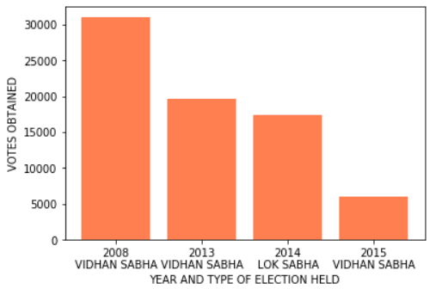

**OUTCOME OF THE ANALYSIS**

* **INC** has experienced a **steep fall** in their performance during 2013 to 2015.
* As shown in the bar plot above, **INC has recorded a decline of 81%** in their vote share from 2008 to 2015.
* After having just **8 polling stations votes less than 33%**, INC still lost the election with not a single polling booth victory at Greater Kailash in 2015.
* INC hasn’t improved at **any of the polling station** from 2013 to 2015 at Greater Kailash.

**PREDICTIVE ANALYSIS**

**DELHI LEGISLATIVE ASSEMBLY ELECTIONS**

**2020**

**GREATER KAILASH**

**PRE-ELECTION SITUATION (2015-2020)**

AAP are in control at the legislative level in Greater Kailash. BJP on the other hand have the control over Greater Kailash as well as South Delhi District at the parliamentary level.

**THINGS WHICH MAY AFFECT ON THE ELECTION RESULTS AT GREATER KAILASH IN 2020**

**BHARATIYA JANATA PARTY**

* **DESPERATION IN THE PARTY**

Not only winning the Greater Kailash constituency is the aim, the saffron party wants to win the upcoming election badly, and for this, the BJP has set a target to win 60 out of total 70 constituencies in Delhi Vidhan Sabha election.

* **CONTESTING A FACE-LESS ELECTION**

In Delhi, the BJP will contest elections without any chief minister face. Delhi BJP spokesperson Ashok Goel said, "We [BJP] have got the votes from all the section of societies in the 2019 Lok Sabha elections. People will support the BJP for the achievement of the Narendra Modi government and the failure of the AAP at Greater Kailash.

* **PARTY WORKERS OPINION SURVEY**

The BJP is going to conducted a survey in June 2019.Through this survey, the BJP understood the party workers' point of view on the issues and planned two more such surveys, and the last survey will be conducted in November 2019.

**AAM AADMI PARTY**

* **GATHERING PUBLIC OPINIONS**

Since April 2019, Aam Aadmi Party (AAP) MLAs have been holding meetings across their constituencies in order to reach out to the public, get feedback and make a list of projects that need to be completed before the 2020 Delhi Assembly polls.

* **EXPECTATION OF THE PEOPLE IN GREATER KAILASH**

In his constituency, residents asked for a foot-over bridge as the Bus Rapid Transit corridor from Moolchand to Ambedkar Nagar had been dismantled, making the road too wide and too busy for pedestrians to cross.

* **EFFECT OF ‘IGNORANCE’ ON THE UPCOMING RESULTS**

AAP did an excellent work in their tenure but such things as alliance with congress, ignoring your party members voice fade the faith of people in you.

* **WORK DONE BY AAP WILL CERTAINLY HELP IN 2020**

Many efforts like Happiness Curriculum and construction of new classrooms in government schools have received accolades globally. The primary healthcare centres offering free consultations, tests and medicines also received praise from Gro Harlem Brunt land, the former director general of World Health Organisation. Considered to be one of the flagship schemes of the AAP government, 189 of the promised clinics have been set up in Delhi

* **AAP seek to shift focus to THEIR welfare-driven policies**

By reducing the power tariff substantially in Delhi just a few months before the Assembly elections, Chief Minister Arvind Kejriwal has shown that he is not willing to lose his grip over the ‘Development and Welfare’ narrative but is determined to derive the maximum political mileage out of it.

**INDIAN NATIONAL CONGRESS PARTY**

* **RECENT IMPROVEMENT IN THE LOK SABHA ELECTION RESULTS MAY HELP**

With five of its seven candidates finishing second in the Capital in the Lok Sabha polls, Delhi Congress, senses resurgence. The party -- fighting a prestige battle in the city it ruled for 15 years until 2015 - had been finishing third in election after election since Kejriwal took over as Chief Minister.

* **SHEILA DIKSHIT: A HUGE LOSS TO THE PARTY**

The Indian National Congress will face some serious problems after the unfortunate death of Mrs. Sheila Dikshit on 20th July 2019. Now a big question arises for INC that who will lead the Delhi Election Campaign in 2020?

**PREDICTION**

Predictive Analysis for the election results at Greater Kailash was performed with help of election data of the following elections:

* 2008 Vidhan Sabha Elections
* 2013 Vidhan Sabha Elections
* 2015 Vidhan Sabha Elections

Tools used for predictions:

* Python Programming Language
* Jupyter Notebook

Python Modules used for the data as well as predictive analysis:

* NumPy
* Pandas
* Matplotlib
* Seaborn
* Sci-kit learn
* OS

Machine Learning Algorithm used for prediction:

* **K- NEAREST NEIGHBOR CLASSIFIER ALGORITHM**

K-Nearest Neighbors is one of the most basic yet essential classification algorithms in Machine Learning. It belongs to the supervised learning domain and finds intense application in pattern recognition, data mining and intrusion detection.

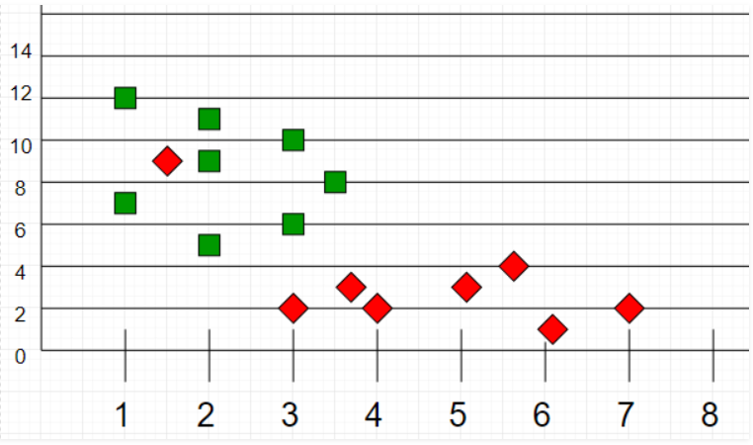

**PREDICTED ELECTION RESULTS AT GREATER KAILASH IN 2020**

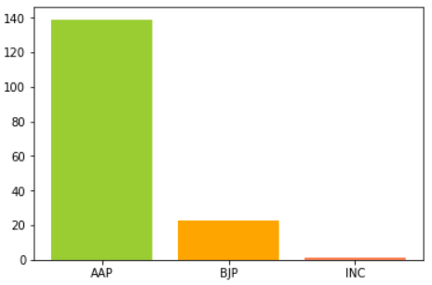

|  |  |
| --- | --- |
| PREDICTED RESULTS | POLLING STATIONS |
| TOTAL POLLING STATIONS IN 2020 | **163** |
| IN FAVOUR OF BJP | **23** |
| IN FAVOUR OF AAP | **139** |
| IN FAVOUR OF INC | **1** |

* According to the predicted results in 2020, AAP will be successful to retain their hold on Greater Kailash.

**PROBABLE WINNING PERCENTAGE OF DIFFERENT PARTIES AT GREATER KAILASH IN 2020**

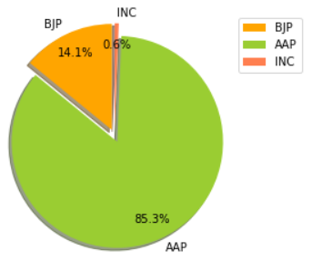

|  |  |
| --- | --- |
| PARTY | PERCENTAGE |
| BJP | **14.1** |
| AAP | **85.3** |
| INC | **0.6** |

**CONCLUSION**

* **Changes in strategies and execution plans for different parties at the state legislative level, eventually won’t affect the election results at Greater Kailash in 2020.**
* **AAP will be able to secure Greater Kailash successfully in 2020 Delhi Legislative Elections.**

**APPENDIX**

* **COMPUTER CODE FOR EXPLORATORY DATA AS WELL AS PREDICTIVE ANALYSIS**

<https://github.com/aniketng21/Political-Analytics-Delhi-2020/blob/master/POLITICALANALYTICS.ipynb>

* **BIBLOGRAPHY**
* <https://eci.gov.in>
* <https://en.wikipedia.org/wiki/Greater_Kailash_(Delhi_Assembly_constituency)>
* <https://eci.gov.in/statistical-report/link-to-form-20/>
* <http://myneta.info/delhi2013/index.php?action=show_candidates&constituency_id=69>
* <http://myneta.info/delhi2015/index.php?action=show_candidates&constituency_id=21>
* <http://www.elections.in/delhi/assembly-constituencies/greater-kailash.html>
* <http://www.elections.in/delhi/assembly-constituencies/2015-election-results.html>
* <https://python-graph-gallery.com/matplotlib/>
* <https://www.firstpost.com/india/with-power-tariff-cuts-months-before-delhi-polls-arvind-kejriwal-seeks-to-shift-focus-to-his-welfare-driven-policies-7104731.html>
* <https://www.indiatoday.in/mail-today/story/early-polls-in-delhi-parties-change-gears-1545198-2019-06-09>
* <https://www.quora.com/Who-will-be-going-to-win-the-2020-Delhi-assembly-elections>
* <https://www.hindustantimes.com/delhi-news/3-years-of-aap-govt-bypolls-on-20-seats-to-test-kejriwal-popularity-in-delhi/story-3PDo7Ws4iG6T09yH7dyuxL.html>

**THANK YOU**