**Project Name: Eco-Cart**

**Project Member:**

**Aniket Pachore *220343120067***

***Yash Patil*  *220343120118***

***Mayur Patil* *220343120057***

***Bharat Sonar*  *220343120023***

**Abstract:**

The e-commerce products -to-consumer aspect (eco-friendly ) is the most effective use of the World Wide Web. The primary goal of an e-commerce site is to make a eco friendly products to reach all the customers and step to go green .

This project deals with developing an e-commerce website for eco friendly product Management. It provides the user with a different category of eco friendly products such as category available such as [Needle Work](http://localhost:3000/Payment), kitchen wares, wooden products ,home décor ,handicraft . The system is implemented using a 4-tier approach, with a backend database, a middle tier of Spring Boot, and web browser (react) as the front end client.

In order to develop an e-commerce website, a number of Technologies must be studied and understood. These include multi-tiered architecture, server and client side scripting techniques, implementation technologies such as Spring MVC, programming language (such as Core Java, Advance Java), relational databases (such as MySQL).

This is a project with the objective to develop a basic website where a consumer is provided with a eco-friendly products through application Where the user will be given the power to know about his complaint status and would be able to review it. Thus, resulting in a better communication and trust between the general public and government body.

**Implementation Technologies:**

1. **Spring Framework:**

Spring Framework is a Java platform that provides comprehensive infrastructure support for developing Java applications. Spring handles the infrastructure so you can focus on your application.

Spring enables you to build applications from “plain old Java objects” (POJOs) and to apply enterprise services non-invasively to POJOs. This capability applies to the Java SE programming model and to full and partial Java EE.

**1.1 Features of Spring Framework:**

**1. Lightweight**

Spring is modular lightweight framework which allows you to selectively use any of its modules on the top of Spring Core.

**2. Inversion of Control (IOC)**

This is another top feature of Spring framework where application dependencies are satisfied by the framework itself. Framework creates the object in runtime and satisfies application dependencies.

**3. Container**

Spring provides their own container for managing the bean lifecycle.

**4. MVC Framework**

Spring MVC Framework is used for developing MVC based web applications.

**1.2 Advantages of Spring Framework:**

**1. Solving difficulties of Enterprise application development**

Spring is solving the difficulties of development of complex applications, it provides Spring Core, Spring IoC and Spring AOP for integrating various components of business applications.

**2. Support Enterprise application development through POJOs**

Spring supports development of Enterprise application development using the POJO classes which removes the need of importing heavy Enterprise container during development. This makes application testing much easier.

**3. Easy integration other frameworks**

Spring designed to be used with all other frameworks of Java, you can use ORM, Struts, Hibernate and other frameworks of Java together. Spring framework do not impose any restriction on the frameworks to be used together.

**4. Application Testing**

Spring Container can be used to develop and run test cases outside enterprise container which makes testing much easier.

**5. Modularity**

Spring framework is modular framework and it comes with many modules such as Spring MVC, Spring ORM, Spring JDBC, Spring Transactions etc. which can used as per application requirement in modular fashion.

**6. Spring Transaction Management**

Spring Transaction Management interface is very flexible it can configure to use local transactions in small application which can be scaled to JTA for global transactions.

* 1. **The spring JPA**

Spring Data JPA, part of the larger Spring Data family, makes it easy to easily implement JPA based repositories. This module deals with enhanced support for JPA based data access layers. It makes it easier to build Spring-powered applications that use data access technologies.

Implementing a data access layer of an application has been cumbersome for quite a while. Too much boilerplate code has to be written to execute simple queries as well as perform pagination, and auditing. Spring Data JPA aims to significantly improve the implementation of data access layers by reducing the effort to the amount that’s actually needed. As a developer you write your repository interfaces, including custom finder methods, and Spring will provide the implementation automatically.

## **Features**

* Sophisticated support to build repositories based on Spring and JPA
* Support for [Querydsl](http://www.querydsl.com/) predicates and thus type-safe JPA queries
* Transparent auditing of domain class
* Pagination support, dynamic query execution, ability to integrate custom data access code
* Validation of @Query annotated queries at bootstrap time
* Support for XML based entity mapping
* JavaConfig based repository configuration by introducing @EnableJpaRepositories.

**1.3 Spring boot**

Spring Boot makes it easy to create stand-alone, production-grade Spring based Applications that you can "just run".

We take an opinionated view of the Spring platform and third-party libraries so you can get started with minimum fuss. Most Spring Boot applications need minimal Spring configuration.

If you’re looking for information about a specific version, or instructions about how to upgrade from an earlier release, check out [the project release notes section](https://github.com/spring-projects/spring-boot/wiki#release-notes) on our wiki.

## **Features**

* Create stand-alone Spring applications
* Embed Tomcat, Jetty or Undertow directly (no need to deploy WAR files)
* Provide opinionated 'starter' dependencies to simplify your build configuration
* Automatically configure Spring and 3rd party libraries whenever possible
* Provide production-ready features such as metrics, health checks, and externalized configuration
* Absolutely no code generation and no requirement for XML configuration
  1. **React (frontend)**

React is a declarative, efficient, and flexible JavaScript library for building user interfaces. It lets you compose complex UIs from small and isolated pieces of code called “components”.

React has a few different kinds of components, but we’ll start with React.Component subclasses

Currently, ReactJS gaining quick popularity as the best JavaScript framework among web developers. It is playing an essential role in the front-end ecosystem. The important features of ReactJS are as following.

* JSX
* Components
* One-way Data Binding
* Virtual DOM
* Simplicity
* Performance

## **Features**

* JSX is a JavaScript syntactic extension. ...
* const name = 'Simplilearn'; ...
* The Virtual DOM is React's lightweight version of the Real DOM. ...
* Fig: DOM of a Webpage. ...
* React goes beyond just being a UI framework; it contains many extensions that cover the entire application architecture. ...
* Fig: One-way data binding.

**2.1** **MySQL**

MySQL, the most popular Open Source SQL database management system, is developed, distributed, and supported by Oracle Corporation.

**Features of MySQL:**

* **MySQL is a database management system.**

A database is a structured collection of data. It may be anything from a simple shopping list to a picture gallery or the vast amounts of information in a corporate network. To add, access, and process data stored in a computer database, you need a database management system such as MySQL Server. Since computers are very good at handling large amounts of data, database management systems play a central role in computing, as standalone utilities, or as parts of other applications.

* **MySQL databases are relational.**

A relational database stores data in separate tables rather than putting all the data in one big storeroom. The database structures are organized into physical files optimized for speed. The logical model, with objects such as databases, tables, views, rows, and columns, offers a flexible programming environment.

* **MySQL software is Open Source.**

Open Source means that it is possible for anyone to use and modify the software. Anybody can download the MySQL software from the Internet and use it without paying anything.

* **The MySQL Database Server is very fast, reliable, scalable, and easy to use.**

MySQL Server was originally developed to handle large databases much faster than existing solutions and has been successfully used in highly demanding production environments for several years. Although under constant development, MySQL Server today offers a rich and useful set of functions. Its connectivity, speed, and security make MySQL Server highly suited for accessing databases on the Internet.

* **MySQL Server works in client/server or embedded systems.**

The MySQL Database Software is a client/server system that consists of a multithreaded SQL server that supports different back ends, several different client programs and libraries, administrative tools, and a wide range of application programming interfaces (APIs).

**2.Hardware and Software Requirements (Minimum):**

**Hardware:**

1. Intel i3 processor 3rd generation or later / AMD Ryzen 200 2nd generation or later

2. 2 GB ddr3 ram.

3. Windows 7 Home edition or later.

4. 200 GB Sata HDD Space

5. Data Connection 200 kbps

**Software:**

1. Eclipse 4.7 Oxygen
2. MySQL 5.7 with Workbench 8.0
3. Google Chrome version 79.0
4. Apache Tomcat Server 8.5
5. Maven Dependencies

**3. E R Diagram**

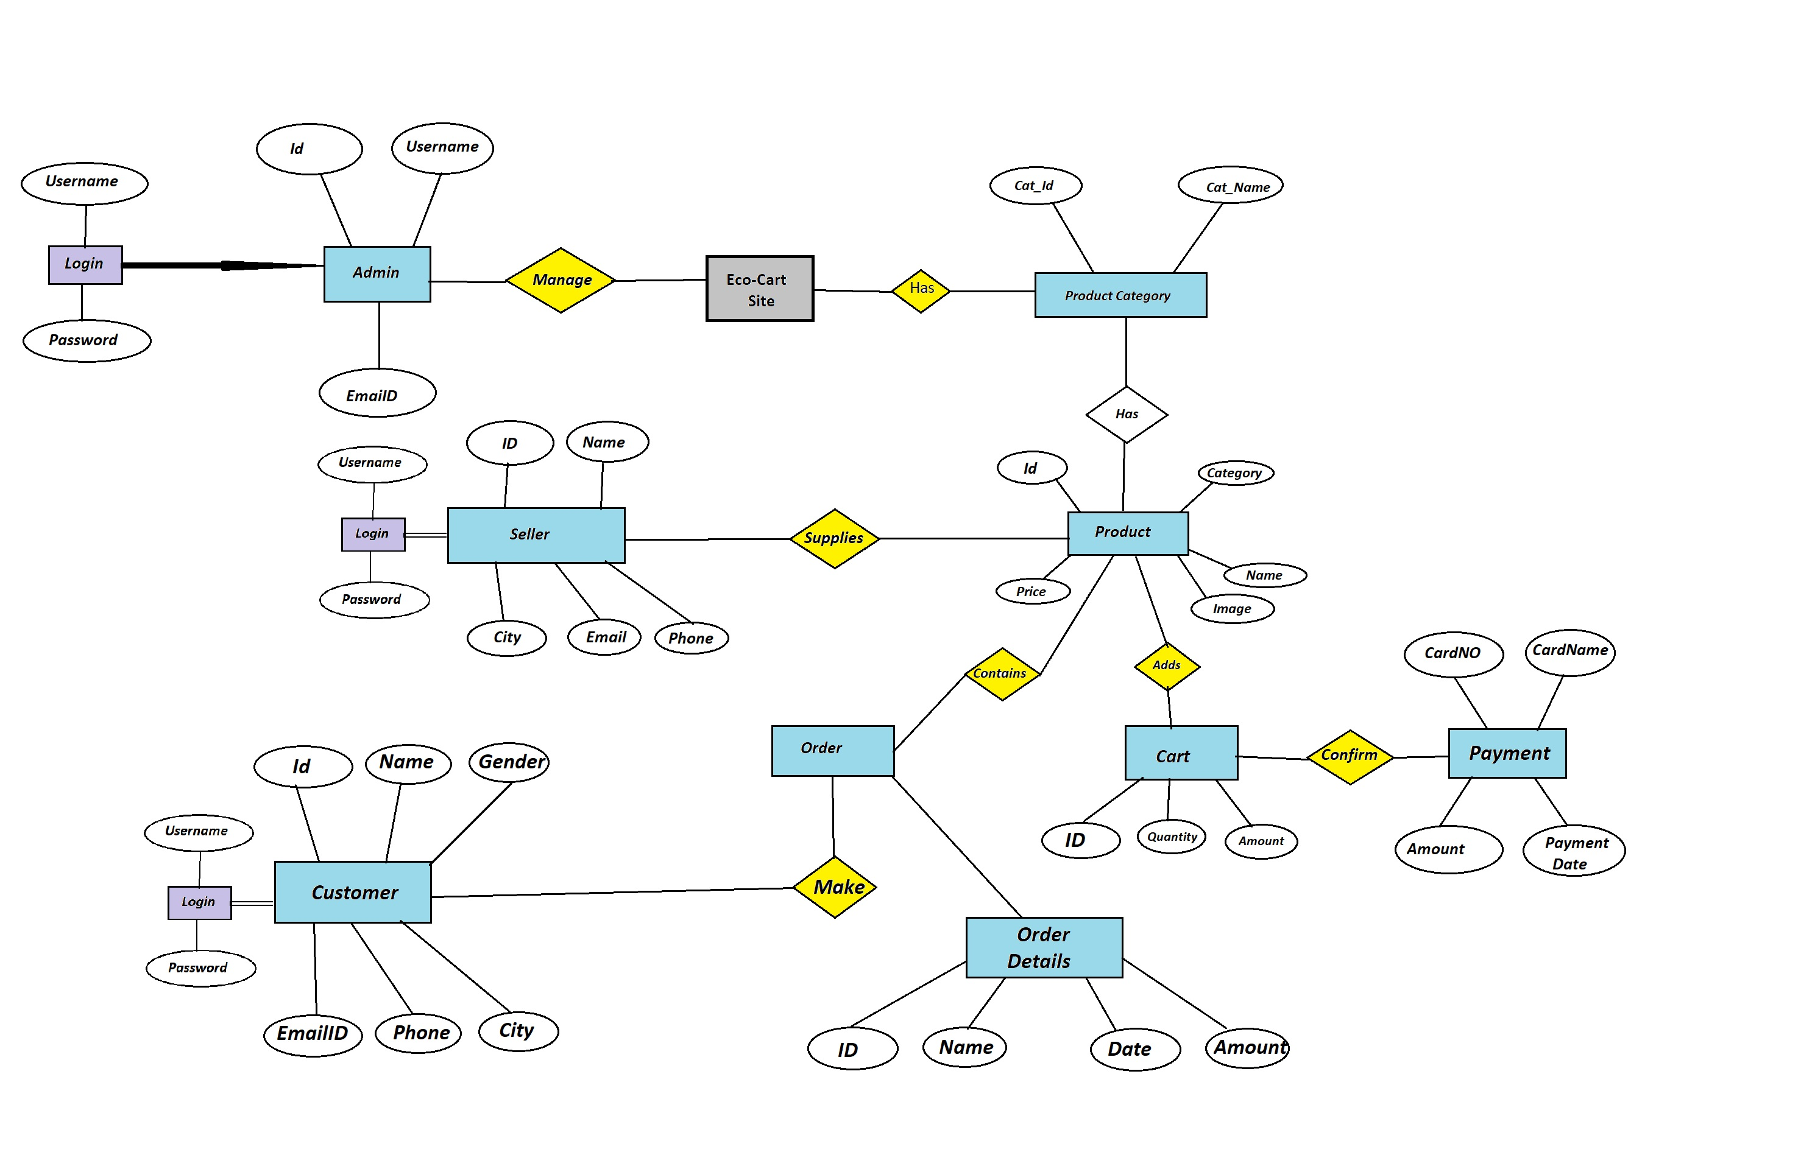

Figure 2: ER Diagram

1. **Table Structures:**

**1.Table name:Consumer**

**Column name Type**

ConsumerId int (11) NO PRI auto_increment

Name varchar(20) YES

Password varchar(20) YES

EmailId varchar(40) YES

ContactNo varchar(20) YES

City varchar(20) YES

Address_String varchar(20) YES

Pincode varchar(20) YES

**2.Table name:Admin**

**Column name Type**

Admin_Id int (11) NO PRI auto_increment

Admin_Name varchar(50) YES

Admin_Password varchar(10) YES

Admin_Email varchar(30) YES

Complain_Category varchar(50) YES

**3.Table name:products**

**Column name Type**

ProductsId int (11) NO PRI auto_increment

ProductsId int (11) YES MUL

ProductsName varchar(40) YES

ProductsCategory varchar(100) YES

ProductsHeading varchar(100) YES

Description varchar(200) YES

Image varchar(50) YES

Seller_id int YES

**4.Table name:cart**

**Column name Type**

StatusId int (11) NO PRI auto_increment

ProductsId int (11) YES MUL

Status varchar(100) YES

**5.Table name:Seller**

**Column name Type**

Seller_Id int (11) NO PRI auto_increment

Seller_Name varchar(50) YES

Seller_Password varchar(10) YES

Seller_Email varchar(30) YES

Seller_Photo varchar(255) YES

1. **UML Diagrams:**

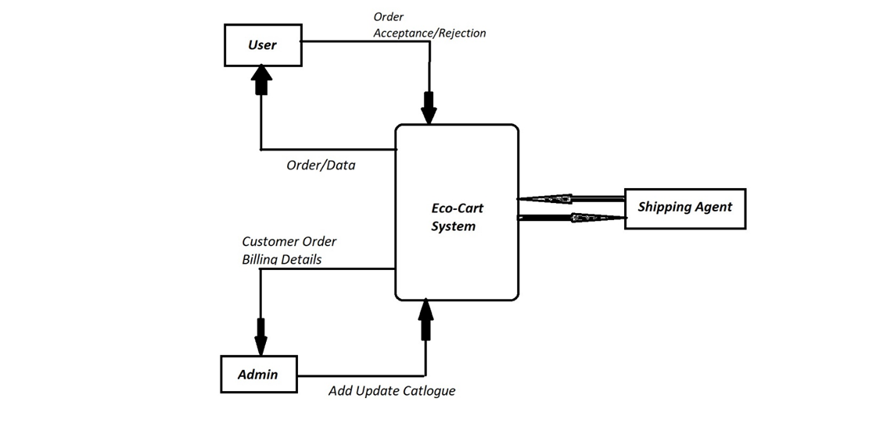

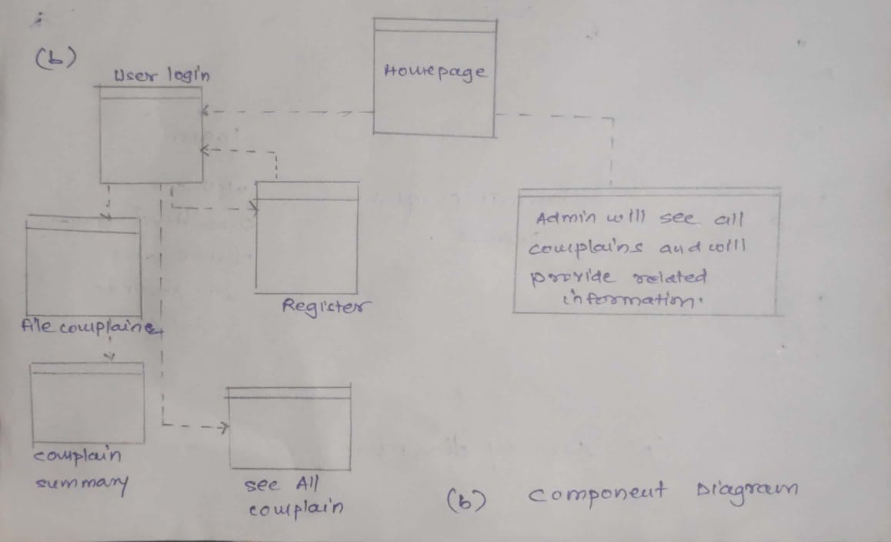

1. **End to End Flow of Application:**

**User:**

* 1. User will login to the website or will have to register on ecommerce website
  2. After registration User will login and Dashboard page will be displayed to him which will display the various e commerce products and its status if any.
  3. From that page can User can click on the ‘**products’** button and reach the products details form page.
  4. In the cart the products and products details will display the User has to pick a category among the **5** pre defined categories and brief about the products with image of the object or place.
  5. A ‘**summary of products and payment ’** will be displayed on the Website showing all the details of the products in cart
  6. User will only be able to see his order and products after the the category chosen.

**Admin:**

1. Admin will login as Admin from the ‘**Admin login**’ page and will be able to see his share of products filed by the Users of a particular area.
2. Admin can Review the products and after adding it Admin will ‘**Receive’** the products .
3. It is the job of Admin to assign appropriate task and product description or service of product to resolve the matter at the hand as soon as possible to avoid disturbance on website .
4. After conforming about the product , Admin will check the status of the product as ‘**buy ’**and head over to the next stage of payment method .

**Modules:**

1. Future Scope of Project

* Products with natural and chemical free ingredients.
* Products having eco-friendly packaging.
* Products can be recycled and reusable i.e. reusable, refillable containers etc.
* Efficient products which save energy, water, gasoline and money.
* Eco-Friendly materials for your home will benefit your health, comfort, environment and finances.

**Thank You!**