1. In an HTML page display a text “You have clicked the button 0 times.” and a button   
   with a text “Click”. As many times the button is clicked the count value on the text   
   should update.

Ans:-

<!DOCTYPE html>

<html lang="en">

<head>

<meta charset="UTF-8" />

<meta name="viewport" content="width=device-width, initial-scale=1.0" />

<title>21BCSE30 | Aniket Patra</title>

<link rel="stylesheet" href="./Bootstrap5/bootstrap.min.css">

</head>

<body>

<center>

<div class="mt-5">

<h1>You have clicked the button <span id="count">0</span> times</h1>

<button id="click" class="btn btn-primary">Click</button>

</div>

</center>

</body>

<script src="./Bootstrap5/bootstrap.bundle.min.js"></script>

<script>

document.getElementById('click').addEventListener('click',()=>{

let countDiv = document.getElementById("count");

let count = parseInt(countDiv.innerText);

countDiv.innerText = count + 1;

});

</script>

</html>

**Output:-**

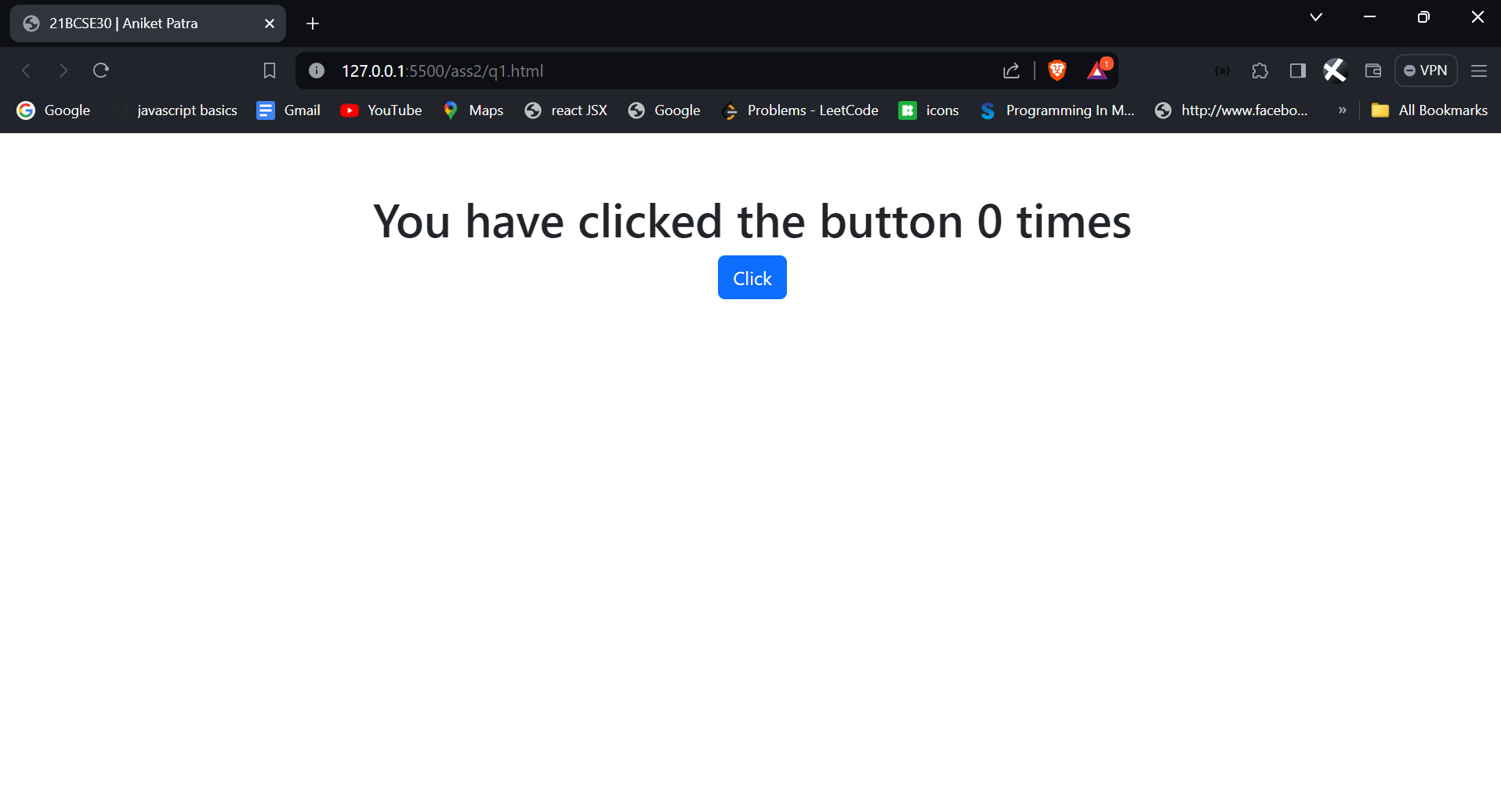

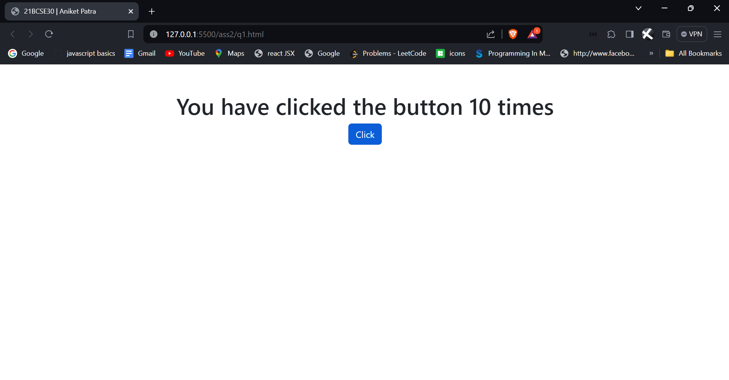

1. Create an array of 10 student objects. Each student object has a roll, name, mobile,   
   and email. Display all student data in an HTML table. Style the table using CSS.

Ans:-

<!DOCTYPE html>

<html lang="en">

<head>

<meta charset="UTF-8">

<meta name="viewport" content="width=device-width, initial-scale=1.0">

<title>21BCSE30 | Aniket Patra</title>

<link rel="stylesheet" href="./Bootstrap5/bootstrap.min.css">

<style>

table,th,tr,td{

border: 1px solid black;

text-align: center;

margin-top: 5%;

}

tr:nth-child(even){

background-color: aquamarine;

}

tr:nth-child(odd){

background-color: burlywood;

}

th{

color: blueviolet;

text-decoration: underline;

}

</style>

</head>

<body>

<div id="students"></div>

<script src="./Bootstrap5/bootstrap.bundle.min.js"></script>

<script>

var students = [

{roll:6,name:'Aniket Patra',mobile:8260374471,email:'aniketpatra96@gmail.com'},

{roll:5,name:'Akash Kumar',mobile:9860077371,email:"akashkumarrjn@gmail.com"},

{roll:1,name:'Rohit Sharma',mobile:9860077370,email:"rohitsharmaa_123@yahoo.com"},

{roll:7,name:'Vishal Jain', mobile: 9999999999, email:"vishaljain123@gmail.com"},

{roll:8,name:'Rakesh Roshan',mobile:9437890341,email:'rakesh.roshan5@gmail.com'},

{roll:9,name:'Depeeka Kakkar',mobile:9437123202,email:'depeeka.kakkar46@yahoo.com'},

{roll:2,name:'Dinesh Pathak',mobile:7978613543,email:'pathak.dinesh12@gmail.com'},

{roll:3,name:'Anmol Partha Behera',mobile:9091278562,email:'behera.anmol22@gmail.com'},

{roll:11,name:'Ashutosh Panda',mobile:7982678115,email:'ashutosh.panda45@gmail.com'},

{roll:13,name:'Suvendu Sahoo',mobile:4546712367,email:'sahoo.suvendu67@yahoo.com'}

];

window.onload = ()=>{

const table = document.createElement('table');

const headRow = document.createElement('tr');

['Roll No','Name','Mobile Number','Email ID'].forEach((item) => {

let th = document.createElement('th');

th.appendChild(document.createTextNode(item));

headRow.appendChild(th);

});

table.appendChild(headRow);

students.forEach((obj)=>{

let row = document.createElement('tr');

row.className = 'table-danger';

Object.values(obj).forEach((item)=> {

let td = document.createElement('td');

td.appendChild(document.createTextNode(item));

row.appendChild(td);

})

table.appendChild(row);

});

table.classList='mt-5 table table-bordered table-hover';

table.style='width:50%;margin:auto;';

document.getElementById("students").appendChild(table);

}

</script>

</body>

</html>

**Output:-**

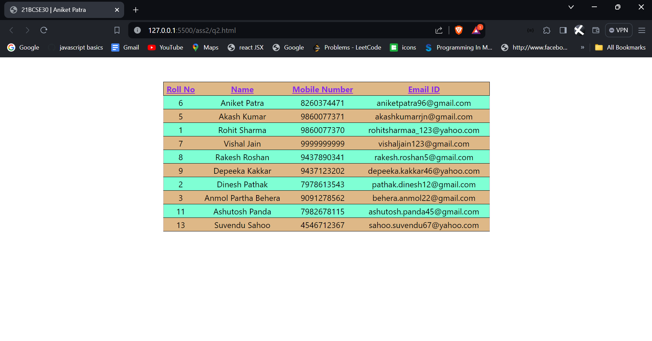

1. Create a form to add TODOs with 3 fields – task, date, and time. Each time a task is   
   added it should be displayed on the same HTML page along with the existing tasks.   
   Style the TODOs with CSS.

Ans:-

<!DOCTYPE html>

<html lang="en">

<head>

<meta charset="UTF-8" />

<meta name="viewport" content="width=device-width, initial-scale=1.0" />

<title>21BCSE30 | Aniket Patra</title>

<link rel="stylesheet" href="./Bootstrap5/bootstrap.min.css" />

<style>

.space {

margin-left: 1%;

}

.form {

width: 50%;

}

@media screen and (max-width: 768px) {

.d-flex {

display: block !important; /* or any other styles you want to apply */

}

.todo {

width: 50% !important;

}

.space {

margin-top: 1%;

}

}

</style>

</head>

<body>

<center>

<form class="form">

<div class="container mt-4 bg-light p-4 rounded shadow-sm">

<h1 class="fs-1 fw-bold lh-1">Add Todo</h1>

<hr />

<div class="d-flex">

<label for="task" class="form-label visually-hidden">Task</label>

<input

id="task"

type="text"

class="form-control space"

placeholder="What needs to be done?"

required

/>

<label for="date" class="form-label visually-hidden">Date</label>

<input

id="date"

type="date"

class="form-control space"

placeholder="Which date the task needs to be done?"

required

/>

<label for="time" class="form-label visually-hidden">Time</label>

<input

id="time"

type="time"

class="form-control space"

placeholder="What time the task needs to be done?"

required

/>

</div>

<button

type="submit"

class="btn btn-outline-success mt-3"

onclick="addTodo()"

>

Save Todo

</button>

</div>

</form>

</center>

<center>

<div class="row todo">

<div

id="list"

class="col-md-6 offset-md-3 col-xs-12 container mt-4 bg-white p-4 rounded shadow-sm"

>

<h3 class="text-start fs-4 text-muted">My Todos:</h3>

<ul id="todolist" class="list-group list-group-flush">

<!-- List will be populated here -->

</ul>

</div>

</div>

</center>

<script src="./Bootstrap5/bootstrap.bundle.min.js"></script>

<script>

document

.getElementsByClassName("form")[0]

.addEventListener("submit", function (event) {

event.preventDefault();

this.reset();

});

</script>

<script>

const base_url = "https://aniketpatra.pythonanywhere.com";

function addTodo() {

let task = document.querySelector("#task").value;

let date = document.querySelector("#date").valueAsNumber;

let time = document.querySelector("#time").value;

if (task === "" || date == null || time == "")

return alert("Please fill all fields");

const list = document.getElementById("todolist");

list.innerHTML += `

<li class="list-group-item d-flex justify-content-between align-items-start">

<div class="ms-2 me-auto">

<div class="fw-bold"><span class="fw-normal">Title :</span> ${task}</div>

Due Date : ${new Date(date).toLocaleString()}<br>

Time : ${time}

</div>

</li>`;

}

</script>

</body>

</html>

**Output:-**

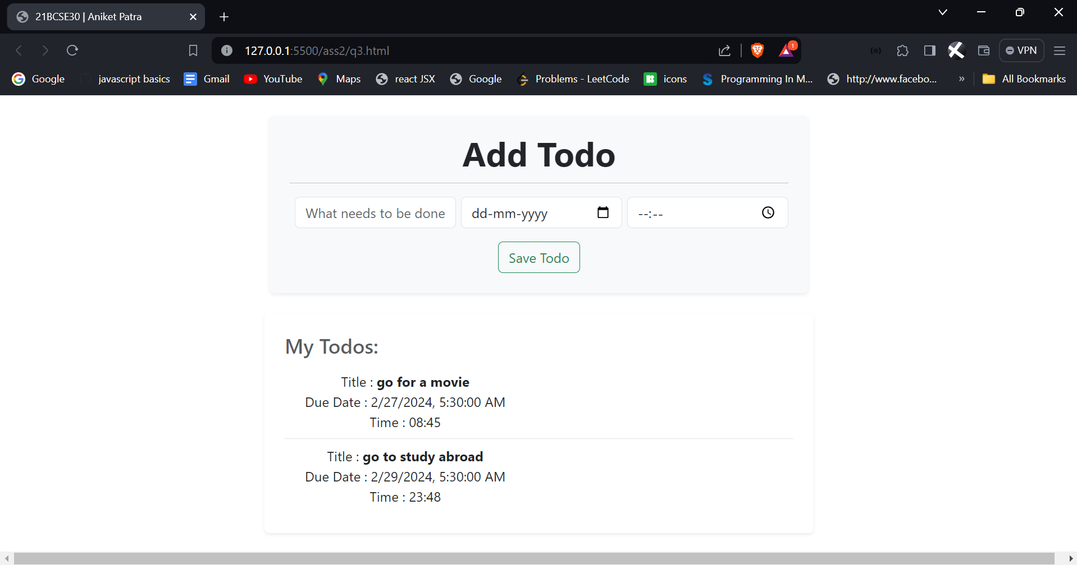

1. Design an HTML page to accept the working experience of an employee having fields   
   – Organization, Designation, and Duration. Create a button with the text “Add More”.   
   Each time the button is clicked one more row should be added with all three fields.   
   Create a submit button and once clicked log the data in console, provided in the form   
   in the array of objects format, with each object representing a row of data.

Ans:-

<!DOCTYPE html>

<html lang="en">

<head>

<meta charset="UTF-8" />

<meta name="viewport" content="width=device-width, initial-scale=1.0" />

<title>21BCSE30 | Aniket Patra</title>

<link rel="stylesheet" href="./Bootstrap5/bootstrap.min.css" />

</head>

<body>

<center>

<div class="container mt-4 bg-light p-4 rounded border shadow-sm">

<h1>Working Experience of Employee</h1>

<form class="form">

<div id="experienceFields">

<div class="experienceRow">

<div class="row mb-3">

<label for="organization" class="col-sm-2 col-form-label"

>Name of Organization</label

>

<div class="col-sm-10">

<input

type="text"

name="organization[]"

class="form-control"

id="organization"

placeholder="Enter the Organization"

/>

</div>

</div>

<div class="row mb-3">

<label for="designation" class="col-sm-2 col-form-label"

>Designation of Employee</label

>

<div class="col-sm-10">

<input

type="text"

name="designation[]"

class="form-control"

id="designation"

placeholder="Enter the Designation of the Employee"

/>

</div>

</div>

<div class="row mb-3">

<label for="duration" class="col-sm-2 col-form-label"

>Duration of Service</label

>

<div class="col-sm-10">

<input

type="text"

name="duration[]"

class="form-control"

id="duration"

placeholder="Enter the Duration of Service of the Employee"

/>

</div>

</div>

</div>

</div>

<button

type="button"

onclick="addExperience()"

class="btn btn-primary"

>

Add More

</button>

<button type="submit" onclick="submitForm()" class="btn btn-success">

Submit

</button>

</form>

</div>

</center>

<script src="./Bootstrap5/bootstrap.bundle.min.js"></script>

<script>

function addExperience() {

var experienceFields = document.getElementById("experienceFields");

var newExperienceRow = document.createElement("div");

newExperienceRow.className = "row mb-3 experienceRow";

var labels = [

"Name of Organization",

"Designation of Employee",

"Duration of Service",

];

var nameLabels = ["organization", "designation", "duration"];

for (var i = 0; i < labels.length; i++) {

var labelContainer = document.createElement("label");

labelContainer.className = "col-sm-2 col-form-label";

labelContainer.textContent = labels[i];

newExperienceRow.appendChild(labelContainer);

var inputContainer = document.createElement("div");

inputContainer.className = "col-sm-10";

var input = document.createElement("input");

input.type = "text";

input.name = nameLabels[i].toLowerCase().replace(/\s/g, "_") + "[]";

console.log(input.name);

input.className = "form-control";

input.placeholder = "Enter the " + labels[i];

inputContainer.appendChild(input);

newExperienceRow.appendChild(inputContainer);

}

experienceFields.appendChild(newExperienceRow);

}

function submitForm() {

var formData = [];

var experienceRows = document.querySelectorAll(".experienceRow");

experienceRows.forEach(function (row) {

var organization = row.querySelector(

'input[name="organization[]"]'

)?.value;

var designation = row.querySelector(

'input[name="designation[]"]'

)?.value;

var duration = row.querySelector('input[name="duration[]"]')?.value;

if (organization && designation && duration) {

// Check for values before creating object

var experienceObject = {

Organization: organization,

Designation: designation,

Duration: duration,

};

formData.push(experienceObject);

} else {

alert("gone wrong");

}

});

console.log(formData);

document

.getElementsByClassName("form")[0]

.addEventListener("submit", function (event) {

event.preventDefault();

this.reset();

});

}

</script>

</body>

</html>

**Output:-**

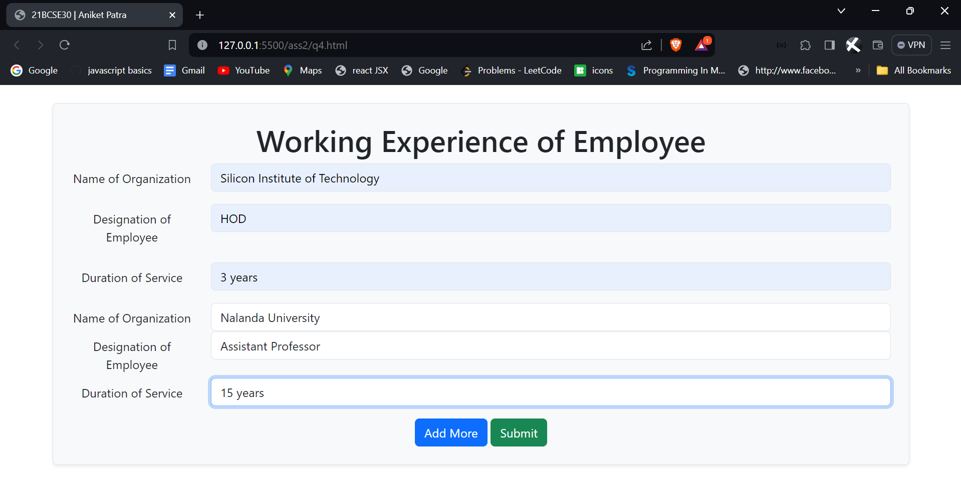

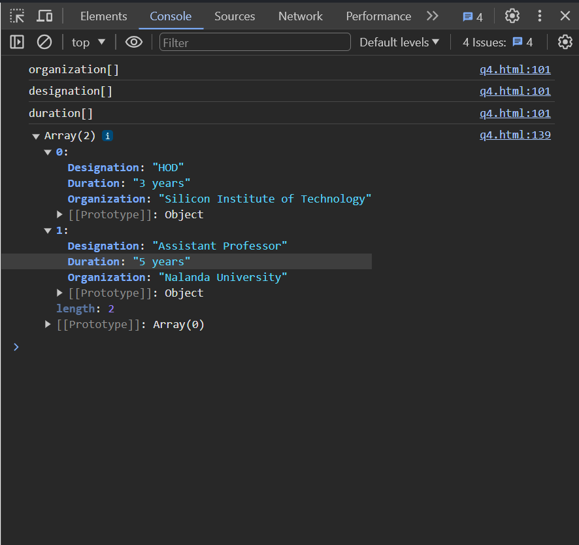

1. Create an JS array of color names. In HTML create a div with fixed height and width.   
   Also, create buttons based on array elements. If any button is clicked, the background   
   color of the div should change to the corresponding color.

Ans:-

<!DOCTYPE html>

<html lang="en">

<head>

<meta charset="UTF-8" />

<meta name="viewport" content="width=device-width, initial-scale=1.0" />

<title>21BCSE30 | Aniket Patra</title>

<style>

#container {

display: flex;

justify-content: center;

align-items: center;

width: 200px;

height: 200px;

margin-bottom: 1%;

margin-top: 3%;

}

</style>

<link rel="stylesheet" href="./Bootstrap5/bootstrap.min.css">

</head>

<body>

<center><div id="container"></div></center>

<div id="buttons"></div>

<script src="./Bootstrap5/bootstrap.bundle.min.js"></script>

<script>

const colorNames = [

"Red",

"Green",

"Blue",

"Yellow",

"Orange",

"Purple",

"Pink",

"Brown",

"Gray",

"Black",

"White",

"Cyan",

"Magenta",

"Turquoise",

"Lime",

"Indigo",

"Maroon",

"Olive",

"Teal",

"Navy",

"Lavender",

"Coral",

"Gold",

"Silver",

"Chocolate",

"Plum",

"Sienna",

"Crimson",

"Chartreuse",

"Ivory",

"Khaki",

"Aqua",

"Bisque",

"Violet",

];

const colorbtn = document.getElementById('buttons');

const colordiv = document.getElementById('container');

colorNames.forEach((color) => {

let button = document.createElement('button');

button.style = 'margin-right:6px;margin-bottom:3px;';

button.textContent = color;

button.className = `${color} btn btn-info`;

colorbtn.append(button);

button.addEventListener('click', () => {

colordiv.style = `background-color:${color}`;

});

});

</script>

</body>

</html>

**Output:-**

