**1. Create a module in Node.JS containing a function to reverse a number. Use ES6 default export to export the function from the module. Import the module in a separate file and test the reverse function.**

**Ans-**

Main.js

//21BCSE30 | ANIKET PATRA

import reverseNumber from "./reverseNumber.js";

const number = 12345;

console.log(`Original number: ${number}`);

const reversed = reverseNumber(number);

console.log(`Reversed number: ${reversed}`);

reverseNumber.js

//21BCSE30 | ANIKET PATRA

const reverseNumber = (number) => {

const reversedNumber = parseFloat(

number.toString().split("").reverse().join("")

);

return reversedNumber * Math.sign(number);

};

export default reverseNumber;

**Output:-**

PS C:\Users\DCA2023\Desktop\6th sem\Emerging Tech Lab\Assignment-5\ass-5> node "c:\Users\DCA2023\Desktop\6th sem\Emerging Tech Lab\Assignment-5\ass-5\tempCodeRunnerFile.js"

Original number: 12345

Reversed number: 54321

**2. Create a module in Node.js that contains several functions for different arithmetic operations like addition, subtraction, multiplication, and division. Use ES6 export to export all the functions from the module and use them in a separate file.**

**Ans-**

Main.js

//21BCSE30 | ANIKET PATRA

import { add, subtract, multiply, divide } from "./arithmeticOperations.js";

const a = 10;

const b = 5;

console.log(`Addition: ${a} + ${b} = ${add(a, b)}`);

console.log(`Subtraction: ${a} - ${b} = ${subtract(a, b)}`);

console.log(`Multiplication: ${a} * ${b} = ${multiply(a, b)}`);

try {

console.log(`Division: ${a} / ${b} = ${divide(a, b)}`);

} catch (error) {

console.error(error.message);

}

arithmeticOperations.js

//21BCSE30 | ANIKET PATRA

export const add = (a, b) => a + b;

export const subtract = (a, b) => a - b;

export const multiply = (a, b) => a * b;

export const divide = (a, b) => {

if (b === 0) {

throw new Error("Division by zero is not allowed");

}

return a / b;

};

**Output:-**

PS C:\Users\DCA2023\Desktop\6th sem\Emerging Tech Lab\Assignment-5\ass-5> node Main.js

Addition: 10 + 5 = 15

Subtraction: 10 - 5 = 5

Multiplication: 10 * 5 = 50

Division: 10 / 5 = 2

**3. Write a JavaScript class containing several functions to perform file read, write, append, and delete operations. Use a constructor to set the file path. Use ES6 export to export the class and use it in a separate file to demonstrate the file operations.**

**Ans-**

Main.js

//21BCSE30 | ANIKET PATRA

import FileOperations from './fileOperations.js';

const filePath = 'testFile.txt';

const fileOps = new FileOperations(filePath);

fileOps.readFile()

.then(data => {

console.log('File content:');

console.log(data);

})

.catch(err => console.error('Error reading file:', err));

const contentToWrite = 'Hello, world!\n';

fileOps.writeFile(contentToWrite)

.then(result => console.log(result))

.catch(err => console.error('Error writing to file:', err));

const contentToAppend = 'This is appended content.\n';

fileOps.appendFile(contentToAppend)

.then(result => console.log(result))

.catch(err => console.error('Error appending to file:', err));

fileOps.deleteFile()

.then(result => console.log(result))

.catch(err => console.error('Error deleting file:', err));

fileOperations.js

//21BCSE30 | ANIKET PATRA

import fs from "fs";

class FileOperations {

constructor(filePath) {

this.filePath = filePath;

}

readFile() {

return new Promise((resolve, reject) => {

fs.readFile(this.filePath, "utf8", (err, data) => {

if (err) {

reject(err);

} else {

resolve(data);

}

});

});

}

writeFile(content) {

return new Promise((resolve, reject) => {

fs.writeFile(this.filePath, content, "utf8", (err) => {

if (err) {

reject(err);

} else {

resolve("File written successfully");

}

});

});

}

appendFile(content) {

return new Promise((resolve, reject) => {

fs.appendFile(this.filePath, content, "utf8", (err) => {

if (err) {

reject(err);

} else {

resolve("Content appended successfully");

}

});

});

}

deleteFile() {

return new Promise((resolve, reject) => {

fs.unlink(this.filePath, (err) => {

if (err) {

reject(err);

} else {

resolve("File deleted successfully");

}

});

});

}

}

export default FileOperations;

**Output:-**

PS C:\Users\DCA2023\Desktop\6th sem\Emerging Tech Lab\Assignment-5\ass-5> node Main.js

File deleted successfully

File written successfully

Content appended successfully

File content:

Hello, world!

This is appended content.

**4. Create a simple Node.js server that serves static HTML files. The server should be able to handle requests for different HTML files using routing and serve them accordingly.**

**Ans-**

Server.js

//21BCSE30 | ANIKET PATRA

const http = require('http');

const fs = require('fs');

const path = require('path');

const htmlDirectory = path.join(__dirname, 'html_files');

const server = http.createServer((req, res) => {

const url = req.url === '/' ? '/index.html' : req.url;

const filePath = path.join(htmlDirectory, url);

fs.access(filePath, fs.constants.F_OK, (err) => {

if (err) {

res.writeHead(404, { 'Content-Type': 'text/plain' });

res.end('404 Not Found');

} else {

fs.readFile(filePath, (err, data) => {

if (err) {

res.writeHead(500, { 'Content-Type': 'text/plain' });

res.end('500 Internal Server Error');

} else {

const contentType = getContentType(filePath);

res.writeHead(200, { 'Content-Type': contentType });

res.end(data);

}

});

}

});

});

function getContentType(filePath) {

const extname = path.extname(filePath);

switch (extname) {

case '.html':

return 'text/html';

case '.css':

return 'text/css';

case '.js':

return 'text/javascript';

default:

return 'text/plain';

}

}

// Define the port to listen on

const port = 3000;

// Start the server

server.listen(port, () => {

console.log(`Server is running on http://localhost:${port}`);

});

Index.html

<!DOCTYPE html>

<html lang="en">

<head>

<meta charset="UTF-8">

<meta name="viewport" content="width=device-width, initial-scale=1.0">

<title>21BCSE30 | ANIKET PATRA</title>

</head>

<body>

<h1>Welcome</h1>

</body>

</html>

Aboutus.html

<!DOCTYPE html>

<html lang="en">

<head>

<meta charset="UTF-8">

<meta name="viewport" content="width=device-width, initial-scale=1.0">

<title>21BCSE30 | ANIKET PATRA</title>

</head>

<body>

<h1>About Us Page</h1>

</body>

</html>

**Output:-**

PS C:\Users\DCA2023\Desktop\6th sem\Emerging Tech Lab\Assignment-5\ass-5> node "c:\Users\DCA2023\Desktop\6th sem\Emerging Tech Lab\Assignment-5\ass-5\Q4\q4.js"

Server is running on <http://localhost:3000>

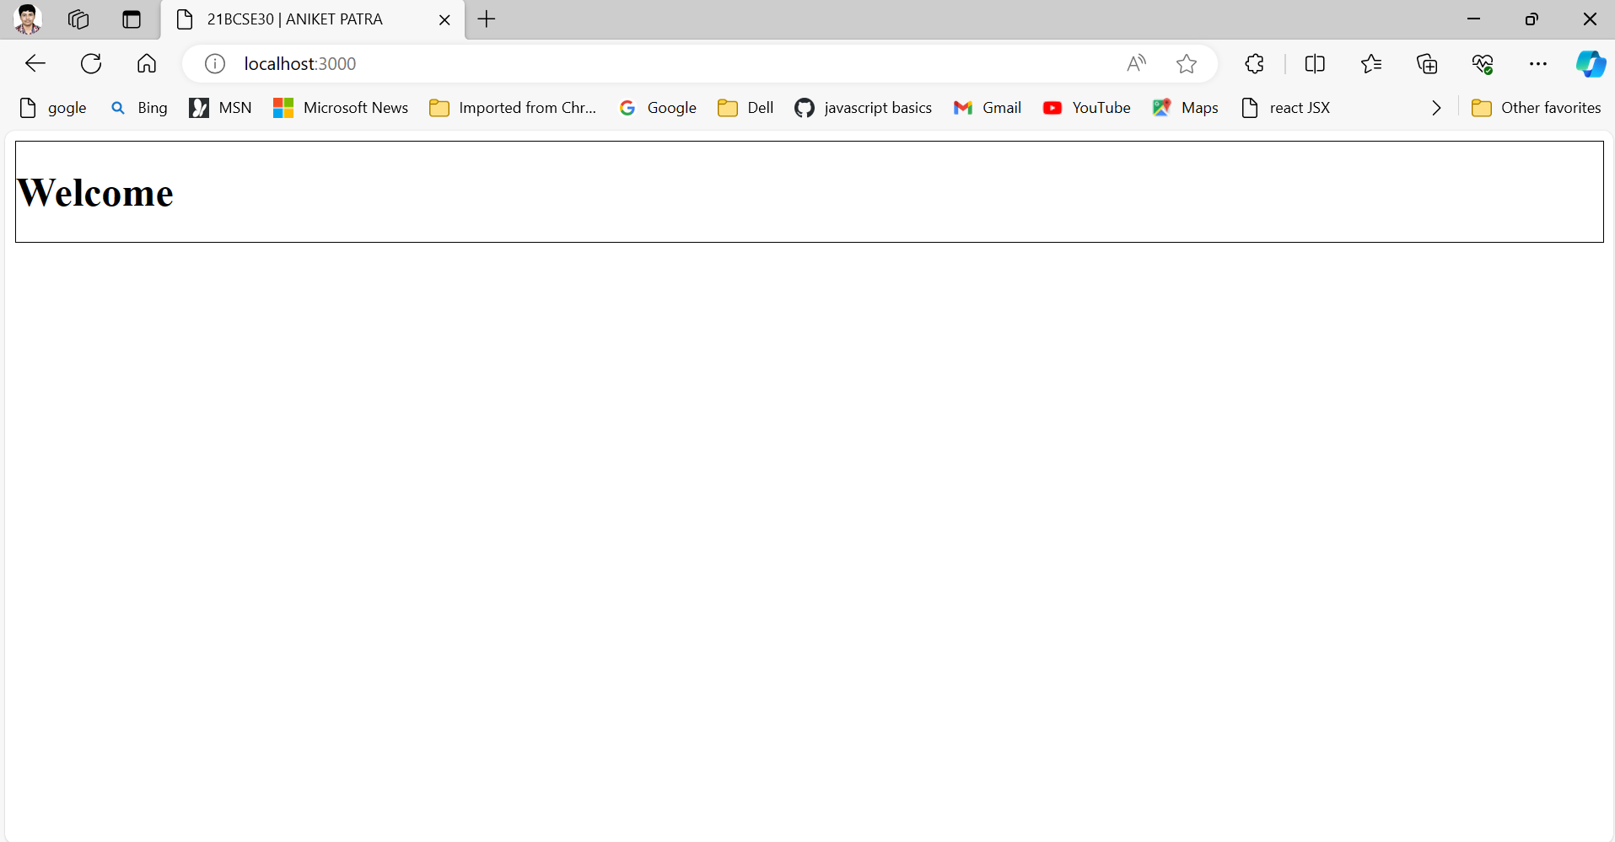

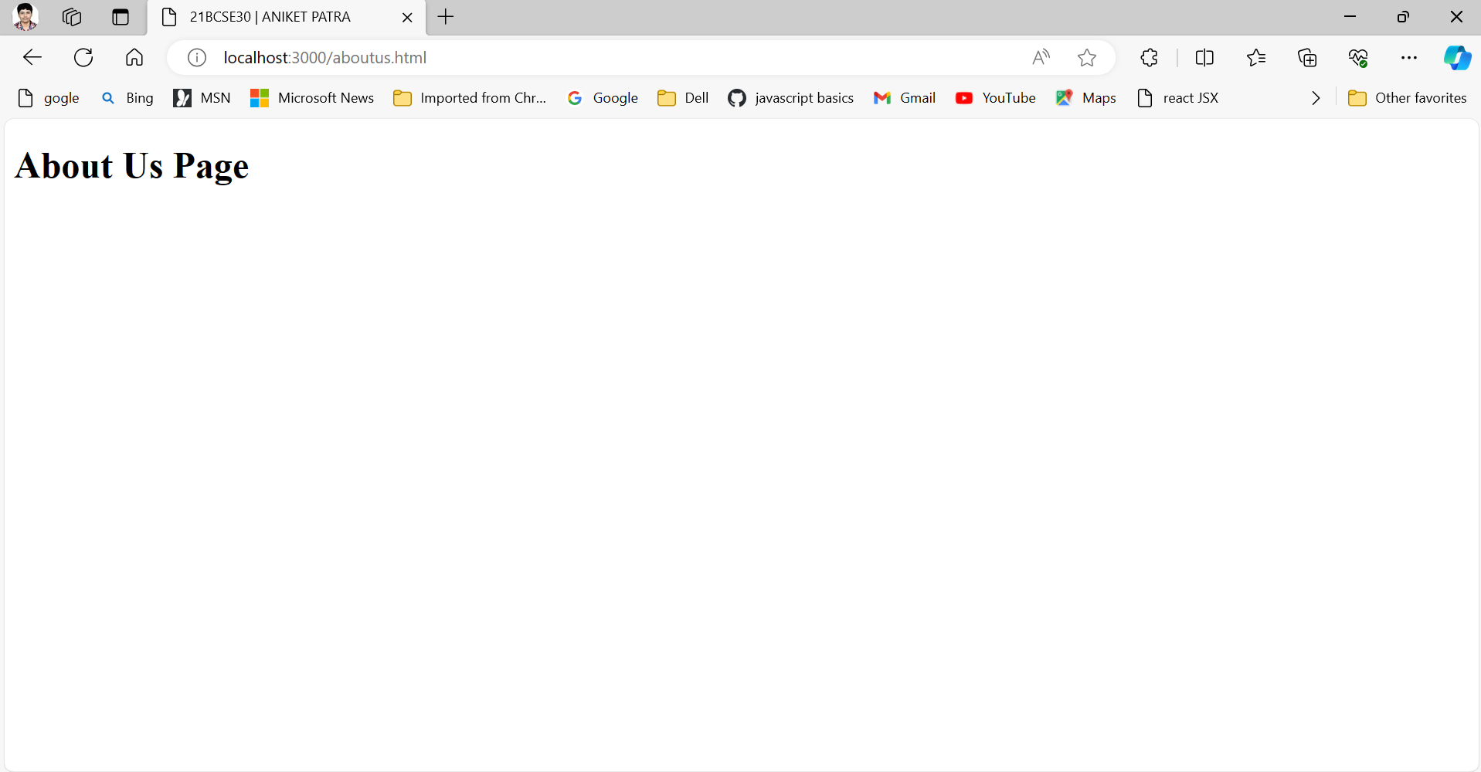

**5. Create a basic Express.js application with multiple routes that render different HTML pages. Use the express module and serve static files such as CSS and images.**

**Ans-**

Main.js

//21BCSE30 | ANIKET PATRA

const express = require("express");

const path = require("path");

const app = express();

app.use(express.static(path.join(__dirname, "public")));

// Define routes

app.get("/", (req, res) => {

res.sendFile(path.join(__dirname, "views", "index.html"));

});

app.get("/about", (req, res) => {

res.sendFile(path.join(__dirname, "views", "about.html"));

});

app.get("/contact", (req, res) => {

res.sendFile(path.join(__dirname, "views", "contact.html"));

});

// Start the server

const PORT = process.env.PORT || 3000;

app.listen(PORT, () => {

console.log(`Server is running on http://localhost:${PORT}`);

});

Index.html

<!DOCTYPE html>

<html lang="en">

<head>

<meta charset="UTF-8" />

<meta name="viewport" content="width=device-width, initial-scale=1.0" />

<link rel="stylesheet" href="./css/style.css" />

<title>21BCSE30 | ANIKET PATRA</title>

</head>

<body>

<div id="title">

<img id="logo" src="./images/logo.png" alt="error" />

<h1>Silicon University</h1>

</div>

<div id="body">

Silicon Institute of Technology, Bhubaneswar has been upgraded to Silicon

University. Silicon has a NAAC Grade A accreditation. Three of our

undergraduate programs, CSE, ECE, and EEE, are NBA accredited. We are

placed in the Band 151-300 in the Innovation Category, in NIRF Rankings

2023. Silicon was ranked 161 in Engineering in NIRF Rankings 2022.

</div>

</body>

</html>

Contact.html

<!DOCTYPE html>

<html lang="en">

<head>

<meta charset="UTF-8" />

<meta name="viewport" content="width=device-width, initial-scale=1.0" />

<link rel="stylesheet" href="./css/style.css" />

<title>21BCSE30 | ANIKET PATRA</title>

</head>

<body>

<div id="title">

<img id="logo" src="./images/logo.png" alt="error" />

<h1>Silicon University</h1>

</div>

<div id="body">

<h2>Contact Us At the below Address</h2>

<p>

Silicon Institute of Technology, Silicon Hills, Patia Bhubaneswar –

751024 Odisha, India

</p>

</div>

<img id="silicon-block" src="./images/silicon.jpg" alt="" srcset="" />

</body>

</html>

About.html

<!DOCTYPE html>

<html lang="en">

<head>

<meta charset="UTF-8" />

<meta name="viewport" content="width=device-width, initial-scale=1.0" />

<link rel="stylesheet" href="./css/style.css" />

<title>21BCSE30 | ANIKET PATRA</title>

</head>

<body>

<div id="title">

<img id="logo" src="./images/logo.png" alt="error" />

<h1>Silicon University</h1>

</div>

<div id="body">

<p>

Silicon University (formerly known as Silicon Institute of Technology,

Bhubaneswar) combines a commitment to providing the best engineering

education with supporting India’s development in science and technology

through rigorous academic programs, promoting fundamental and applied

research, and fostering innovation and entrepreneurship. Founded in 2001

in the eastern state of Odisha, India, SiliconTech, the engineering

institute of Silicon University, is known for its community of reputed

and dedicated faculty, bright and talented students, and effective

administration and support staff.

</p>

</div>

<center>

<img id="silicon-block" src="./images/sil.jpg" alt="">

</center>

</body>

</html>

Style.css

h1{

color: red;

}

#logo{

width: 25%;

height: 25%;

}

#silicon-block{

width: 40%;

height: 40%;

}

#title{

display: flex;

justify-content: space-between;

}

#body{

margin-top: 3%;

}

**Output:-**

PS C:\Users\DCA2023\Desktop\6th sem\Emerging Tech Lab\Assignment-5\ass-5> node "c:\Users\DCA2023\Desktop\6th sem\Emerging Tech Lab\Assignment-5\ass-5\Q5\q5.js"

Server is running on <http://localhost:3000>

**HomePage**



**Contact Us Page**



**About Us Page**

