# **Decimal Number System**

Base = 10

1 – 9

1000 - 1 = 10^3

100 - 2 = 10^2

10 - 3 = 10^1

1 - 4 = 10^0

1234 = 1*1000 + 2*100 + 3*10 + 4*1

1234 = 1*10^3 + 2*10^2 + 3*10^1 + 4*10^0

**Binary Number System**

Base = 2

32 = 2^5

16 = 2^4

8 = 2^3

4 = 2^2

2 = 2^1

1 = 2^0

45 = 1*32 + 0*16 + 1*8 + 1*4 + 0*2 + 1*1

45 = 1*2^5 + 0*2^4 + 1*2^3 + 1*2^2 + 0*2^1 + 1*2^0

# **Decimal to Binary**

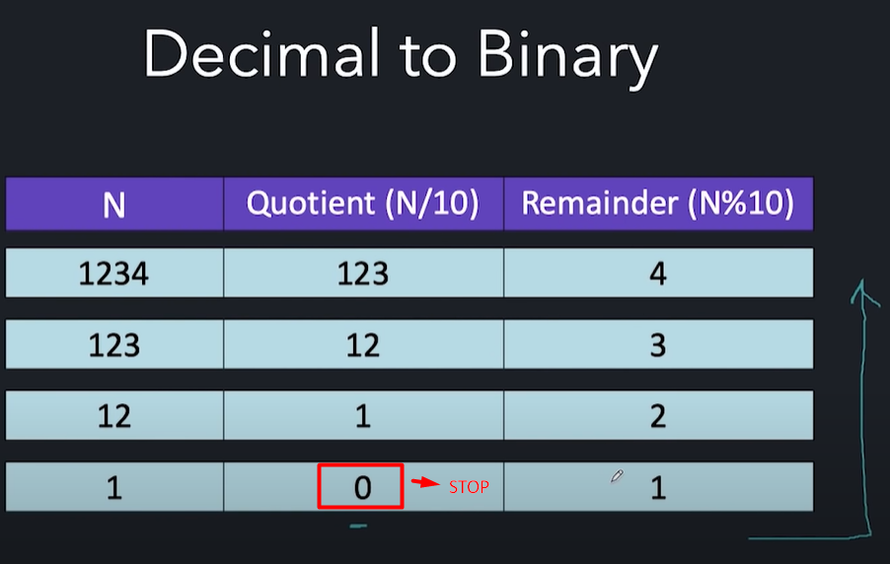

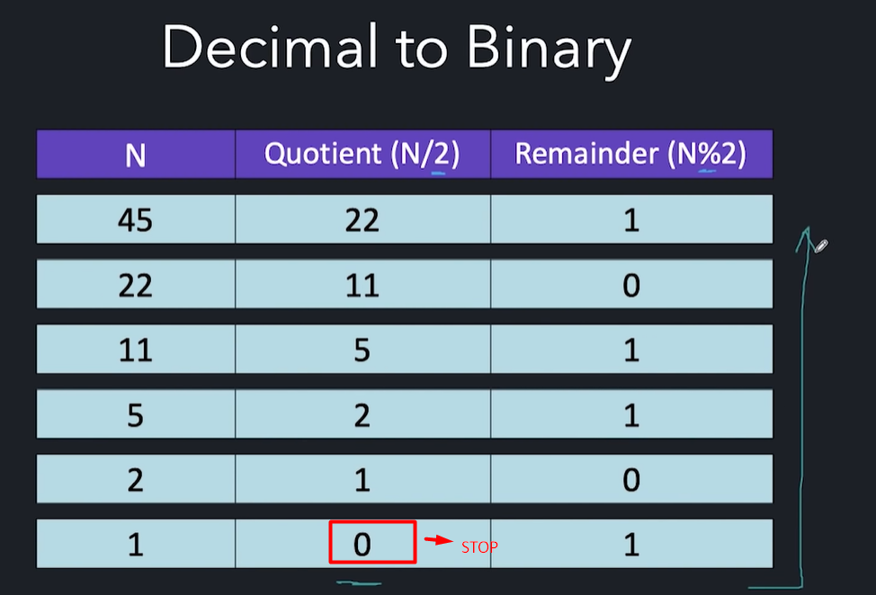

# **Binary to Decimal**

