Project Management Portal

The Project Management Portal is a in-house web application to manage the Project and its related information. It will help organizations to manage small projects and show the progress and reports of the projects using Grid views and using Graphs.

1. Employee View - Card View

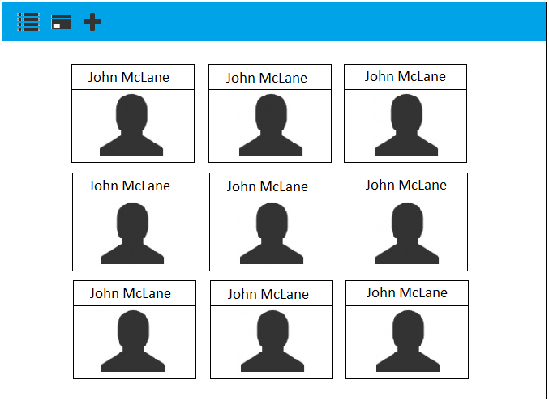

1. Employee View - List View

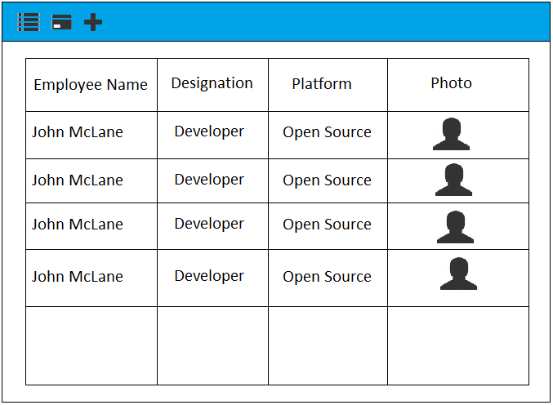

1. Projects View - Card View

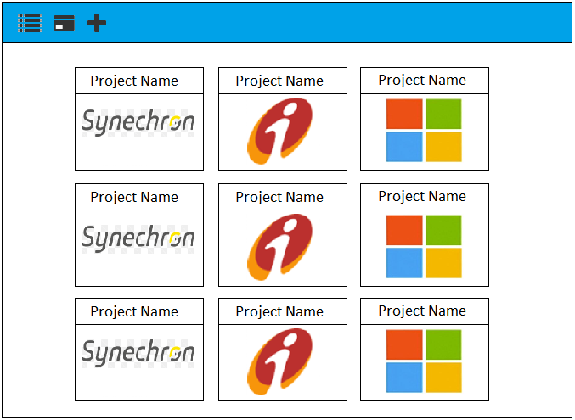

1. Task View - List View

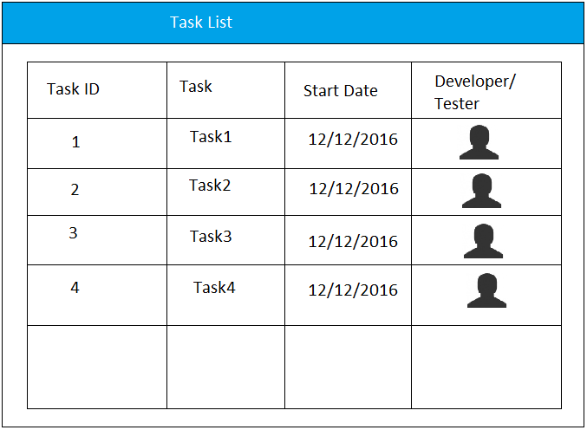

CRUD Operations for PMP

1. Projects -
   1. New Project Form
   2. List of projects
   3. Project Details
2. User Stories
   1. New User Stories
   2. List of User Stories
   3. Details of User Stories
3. Employees -
   1. New Employee Form
   2. Update Employee Form
   3. List of Employees
   4. Details of Employee
4. Tasks -
   1. New Task Form
   2. Tasks List
   3. Task Details
   4. Update Bug Form
5. Bugs -
   1. List of Bugs
   2. Details of Bug
   3. New Bug Form
   4. Update Bug Form
6. Dashboard -
   1. Should display Project Specific information like Tasks, Bugs in a Chart format using High charts (Or Charts API of your choice)
7. Authentication -
   1. To see the details, you must be an authenticated user
   2. You should be able to see the details of the project to which you have been assigned
   3. You should be able to filter the details of the dashboard using Start Date and End Date of Project Tasks and Bugs