System Requirements Statement (SRS) –

VaccAlert

Doc. Ref. :

Version : 0.4

Status : Drafted

Created by :

Date : 25-June-2024

1. Introduction 3

2. Functional Requirements 4

2.1 Parent Module 5

2.2 Hospital Module 9

2.3 Admin Module 12

2.4 Use Case Diagram 15

THIS DOCUMENT CONTAINS 17 NUMBERED PAGES

# Introduction

This document explains the system requirements and scope for developing VaccAlert System.

VaccAlert System is a system design especially for child vaccination.

VaccAlert System could divide the three main parts, Parent part, Hospital part, Admin part.

This document specifically details the system requirements for the Account part of all the three parts.

# 

# Functional Requirements

The Account part of VaccAlert System has three modules which are divided into 20 processes described as below.

|  |  |  |
| --- | --- | --- |
| **No** | **BRS requirement ID** | **Description** |
| **2.1** | **Parent Module** | |
| **2.1.1** | **F1** | **Account Creation Process** |
| **2.1.2** | **F2** | **Login Process** |
| **2.1.3** | **F3** | **Forgot Password Process** |
| **2.1.4** | **F4** | **Change Password Process** |
| **2.1.5** | **F5** | **Update Account Process** |
| **2.1.6** | **F6** | **View Schedule** |
| **2.1.7** | **F7** | **Book Vaccine Appointment** |
| **2.1.8** | **F8** | **Cancel Booking** |
| **2.2** | **Hospital Module** | |
| **2.2.1** | **F9** | **Account Creation Process** |
| **2.2.2** | **F10** | **Login Process** |
| **2.2.3** | **F11** | **Forgot Password Process** |
| **2.2.4** | **F12** | **Change Password Process** |
| **2.2.5** | **F13** | **View Vaccination Appointment List** |
| **2.2.6** | **F14** | **View Vaccine Stock** |
| **2.3 Admin Module** | | |
| **2.3.1** | **F15** | **Login Process** |
| **2.3.2** | **F16** | **Verify Hospital** |
| **2.3.3** | **F17** | **View Users** |
| **2.3.4** | **F18** | **View Hospitals** |
| **2.3.5** | **F19** | **Add Vaccine** |
| **2.3.6** | **F20** | **Remove Vaccine** |

# Parent Module

The parent user of the VaccAlert System can perform the following functions:

1. View available vaccines.
2. Book appointments for vaccines.
3. Cancel vaccine bookings.
   * 1. **Account Creation Process**

* VaccAlert System requires users to create an account before using its features. Therefore, VaccAlert System should provide a sign-up function that allows parents to become users of the system.
* When a parent signs up for an account, the system requires the following information:

1. **Login information**

The updatable items as described below.

1. First Name
2. Last Name
3. E-mail address

**Note:** All items are required, but updates are optional.

* + UserName
* The UserName should be unique. If the UserName correspond with not case-sensitive to other which is previously registered, the UserName should not be registered as an account.
  + Password
* The Password has constrains which makes the Password consists of more than or equal 8 and less than or equal 16 characteristics including characters described as below.

1. Numeric figure (at least one)
2. Capital alphabet (A-Z)(at least one)
3. Small alphabet (a-z)(at least one)
4. Special character (#, $, %, &, etc.) (at least one)

* The Password is masked by dummy characters. The re-entering Password is demanded.
  + Email
* The email address must follow standard format rules:

1. It must contain exactly one '@' symbol
2. There must be at least one character before the '@' symbol.
3. There must be a valid domain name after the '@' symbol (e.g., gmail.com).
4. **The Security Question information**

The Security Question information is needed when parent lost their Password. This information consists of two items described as below.

1. Selected Question
2. Answer

**Note:** All items are required, but updates are optional.

* + - Some questions which are difficult to answer for anyone else are prepared in advance.
      * + E.g. which color do you like most?
    - A question should be selected from options by the parent, and the Answer is registered by the Parent.
* Login information should be entered on one screen, and then parent information and Security Question information should be entered on another screen.
  + 1. **Login Process**
* VaccAlert System always compels user authentication before using itself except when a new account is successfully created.
* The user authentication demands UserName and Password. The UserName and the Password should be checked in three ways.
  + First, The UserName and the Password should be existed and correct.
* If The UserName and the Password are not equal to what the user has registered, the user authentication cannot be provided.
  + Second, the User Type linked to the UserName should be present in "parent".
* When the User Type is "Parent", then user can be placed on “Parent Home”.
  + Finally, UserName should be available.
* The Administrator can decide whether the UserName is available or suspended – Refer to the SRS of the Admin part.
* If parent is rejected, user authentication is not provided for system user.
* Only when the three checks are successfully completed, parent can be placed on respected page.
* **The “Parent Home Features”:**

1. A trigger to logout
2. A trigger to update Profile
3. A trigger to Search Vaccines
4. A trigger to Book Vaccine
5. A trigger to View Booking List
   * 1. **Forgot Password Process**

* When system user lost their Password, the recovery method should be provided by VaccAlert system.
* The recovery method is described as below.
  + First, system user enters their Username for VaccAlert System.
  + Next, VaccAlert System demands the Answer which has been registered since when the Account was created.
  + Only when the Answer is correct, parent get the new function to enter new password and set the password.
* If the Answer is not correct, otherwise, the correct Answer is demanded for user again.
  + In that case, Of course, parent couldn’t get the new password.
    1. **Change Password Process**
* When parent wants to change their Password, the measure should be provided by VaccAlert System.
* Therefore, VaccAlert System should provide the function which is available after getting the parent authentication.
* The function demands the current password and the new password.
* Of course, the new password should consist of more than or equal 8 and less than or equal 16 characteristics including at least a numeric figure, a capital alphabet, a small alphabet, and a special character.
* The current password and the new password are masked by using dummy characters.
* The new password is demanded to enter twice to avoid a typing error.
* Only when the current password is correct, parent could change their Password.
* When the current password is changed into new password, VaccAlert System compels user authentication again.
  + 1. **Update Account Process**
* VaccAlert System should provide the function which makes the account updated for parent.
* The information parent could update is described below.

1. Child information
2. User Information
3. **The Child information**

The updatable items as described below.

1. First Name
2. Middle Name
3. Last Name
4. Mother Name
5. Date Of Birth
6. Address
7. Mobile Number
8. Blood Group
9. Weight
10. Gender

**Note:** All items are required, but updates are optional.

1. **The User information**

The updatable items as described below.

1. User Name
2. E-mail address

**Note:** All items are required, but updates are optional.

* + 1. **View Schedule**
* Parents can view the upcoming vaccine schedule for their children through the VaccAlert System.
* The parent logs into its account and navigates to the view upcoming vaccine schedule feature.
* The system retrieves and displays the upcoming vaccine schedule for each child, including vaccine names, due dates, and any additional instructions or notes.
  + 1. **Book Vaccine Appointment**
* The User can view Available vaccine and User can book for that vaccine

1. First Name
2. Last Name
3. Email

* Above data automatic generated by system using user information

1. Booking date
2. Time slot
3. Vaccine name
4. Hospital name
   * 1. **Cancel Booking**

* When a parent wants to cancel a vaccination booking, the feature should be provided by the VaccAlert System.
* The function requires the parent to select the specific booking they wish to cancel.
* A confirmation pop-up will appear, asking the parent to confirm the cancellation.

# Hospital Module

* + 1. **Account Creation Process**
* VaccAlert System requires hospitals to create an account before using its features. Therefore, VaccAlert System should provide a sign-up function that allows hospitals to become users of the system.
* When a hospital signs up for an account, the system requires the following information:

1. **Login information**

The updatable items as described below:

1. Hospital Name
2. Contact Email Address
3. Hospital Address
4. Contact Number
5. Registration Number (provided by the healthcare authority)
6. Type of hospital(e.g., General, Specialized, Clinic)

**Note:** All items are required, but updates are optional.

* + UserName
* The Username should be unique. If the Username correspond with not case-sensitive to other which is previously registered, the Username should not be registered as an account.
  + Password
* The Password has constrains which makes the Password consists of more than or equal 8 and less than or equal 16 characteristics including characters described as below.

1. Numeric figure (at least one)
2. Capital alphabet (A-Z)(at least one)
3. Small alphabet (a-z)(at least one)
4. Special character (#, $, %, &, etc.) (at least one)

* The Password is masked by dummy characters. The re-entering Password is demanded.
  + Email
* The email address must follow standard format rules:

1. It must contain exactly one '@' symbol
2. There must be at least one character before the '@' symbol.
3. There must be a valid domain name after the '@' symbol (e.g., gmail.com).
4. **The Security Question information**

The Security Question information is needed when hospital loses their Password. This information consists of two items described as below.

1. Selected Question
2. Answer

**Note:** All items are required, but updates are optional.

* + - Some questions which are difficult to answer for anyone else are prepared in advance.
      * + E.g. which color do you like most?
    - A question should be selected from options by the hospital, and the answer is registered by the hospital.
* Login information should be entered on one screen, and then hospital information and Security Question information should be entered on another screen.
  + 1. **Login Process**

1. The user authentication demands Username and Password. The Username and the Password should be checked in three ways.
   1. First, The Username and the Password should be existed and correct.

* If the Username and the Password are not equal to what the user has registered, the user authentication cannot be provided.
  1. Second, the User Type linked to the UserName should be present in "Hospital".
* When the User Type is "Hospital", then user can be placed on “Hospital Home”.
  1. Finally, UserName should be available.
* The Administrator can decide whether the UserName is available or suspended.
* If hospital is rejected, user authentication is not provided for system user.

1. Only when the three checks are successfully completed, Hospital can be placed on respected page.

* **The “Hospital Home” features:**

1. A trigger to logout
2. A trigger to view vaccination appointment list
3. A trigger to View Vaccine stock
   * 1. **Forgot Password Process**

* When system user lost their Password, the recovery method should be provided by VaccAlert system.
* The recovery method is described as below.
  + First, system user enters their Username for VaccAlert System.
  + Next, VaccAlert System demands the Answer which has been registered since when the Account was created.
  + Only when the Answer is correct, hospital get the new function to enter new password and set the password.
* If the Answer is not correct, otherwise, the correct Answer is demanded for user again.
  + In that case, Of course, hospital couldn’t get the new password.
    1. **Change Password Process**
* When hospital wants to change their Password, the measure should be provided by VaccAlert System.
* Therefore, VaccAlert System should provide the function which is available after getting the hospital authentication.
* The function demands the current password and the new password.
* Of course, the new password should consist of more than or equal 8 and less than or equal 16 characteristics including at least a numeric figure, a capital alphabet, a small alphabet, and a special character.
* The current password and the new password are masked by using dummy characters.
* The new password is demanded to enter twice to avoid a typing error.
* Only when the current password is correct, hospital could change their Password.
* When the current password is changed into new password, VaccAlert System compels user authentication again.
  + 1. **View Vaccination Appointment list**
* Hospitals can view the list of all vaccination appointments scheduled.
* The VaccAlert System should provide a function for hospital staff to access the appointment list.
* The list should include details such as appointment date and time, patient's name, type of vaccination, and status of the appointment.
* This feature helps hospital staff to manage and prepare for upcoming vaccinations efficiently.
  + 1. **View Vaccine stock**
* VaccAlert system also provides a facility for hospital that can view the current vaccine stock.
* This feature helps hospital staff manage their vaccine inventory, ensuring they have the necessary supplies for upcoming appointments.

# Admin Module

* The Admin Module of the Vaccination Alert System is made to help with administrative tasks.
* This document describes what the Admin Module should do and what features it should have.
  + 1. **Login Process**
* VaccAlert System always requires users to log in before using it, except when they are creating a new account.
* The user authentication demands UserID and Password. The UserID and the Password should be checked in three ways.
  + First, The UserID and the Password should be existed and correct.
* If The UserID and the Password are not equal to what the admin has registered, the Admin authentication cannot be provided.
  + Second, the User Type linked to the UserID should be "Admin".
* When the User Type is "Admin", user can be placed on “Admin Home”.
  + Finally, UserID should be available.
* The Administrator has the authority to determine if a UserID is available or suspended.
* If user is rejected, user authentication is not provided for system user.
* The Admin account should remain active for the duration decided by the Administrator.
* Only when the three checks are successfully completed, Admin can be placed on respected page.
* **The “Admin Home” features:**

1. Trigger to logout
2. Trigger to Verify Hospital
3. Trigger to View Users
4. Trigger to View Hospitals
5. Trigger to Add Vaccine
6. Trigger to Remove Vaccine
   * 1. **Verify Hospital**

* Admins can verify hospital accounts during their registration process through the VaccAlert System.
* The admin logs into the account and navigates to the verify hospitals feature.
* The system displays a list of hospitals awaiting verification, including their submitted details (e.g., Hospital Name, Address and Registration Number).
* The admin reviews the information and approves or rejects the verification request.
* The system updates the hospital’s status based on the admin’s decision.
  + 1. **View Users**.
* Admins can view all registered users through the VaccAlert System.
* The admin logs into the account and navigates to the view users feature.
* The system retrieves and displays a list of all registered users, including details such as Username, User Type.
  + 1. **View Hospitals**
* Admins can view all registered hospitals through the VaccAlert System.
* The admin logs into the account and navigates to the view hospitals feature.
* The system retrieves and displays a list of all hospitals, including details such as Hospital Name, Address, and Verification Status.
  + 1. **Add Vaccine**
* Admins can add new vaccines to the system inventory through the VaccAlert System.
* The admin logs into the account and navigates to the add vaccine feature.
* The admin enters the details of the new vaccine.
* Following details are required to add the vaccine.

1. Vaccine Name
2. Description
3. Dose
4. Max Age
5. Route
6. Site
7. When to give

* The admin confirms the addition of the new vaccine.
* The system updates the vaccine inventory and confirms the addition.
  + 1. **Remove Vaccine**
* Admins can remove vaccines from the system inventory through the VaccAlert System.
* The admin logs into the account and navigates to the remove vaccine feature.
* The system displays a list of current vaccines.
* The admin selects the vaccine to remove from the list.
* The admin confirms the removal of the selected vaccine.
* The system updates the vaccine inventory and confirms the removal.

# Use Case Diagrams

* + 1. **Parent**

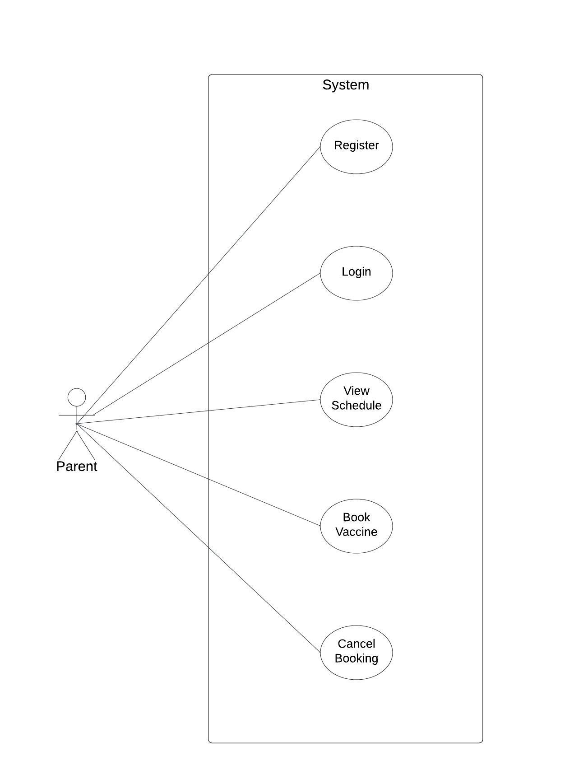

*Fig 1. Use case diagram for parent*

1. In Parent use case diagram Parent is the Actor.
2. Parent can handle following use cases:
3. Register
4. Login
5. View Schedule
6. Book Vaccine
7. Cancel Booking
   * 1. **Hospital:**

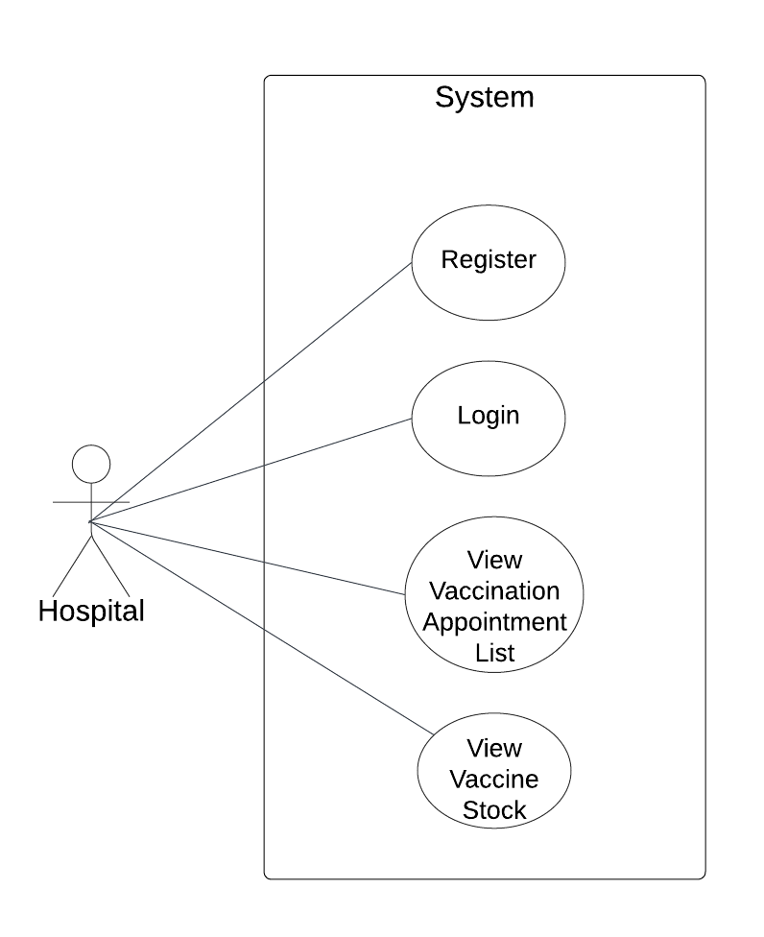

*Fig 2. Use case diagram for hospital*

1. In Hospital use case diagram Hospital is the Actor.
2. Hospital can handle following use cases:

a. Register

b. Login

c. View Vaccination Appointment List

d. View Vaccine Stock

* + 1. **Admin**

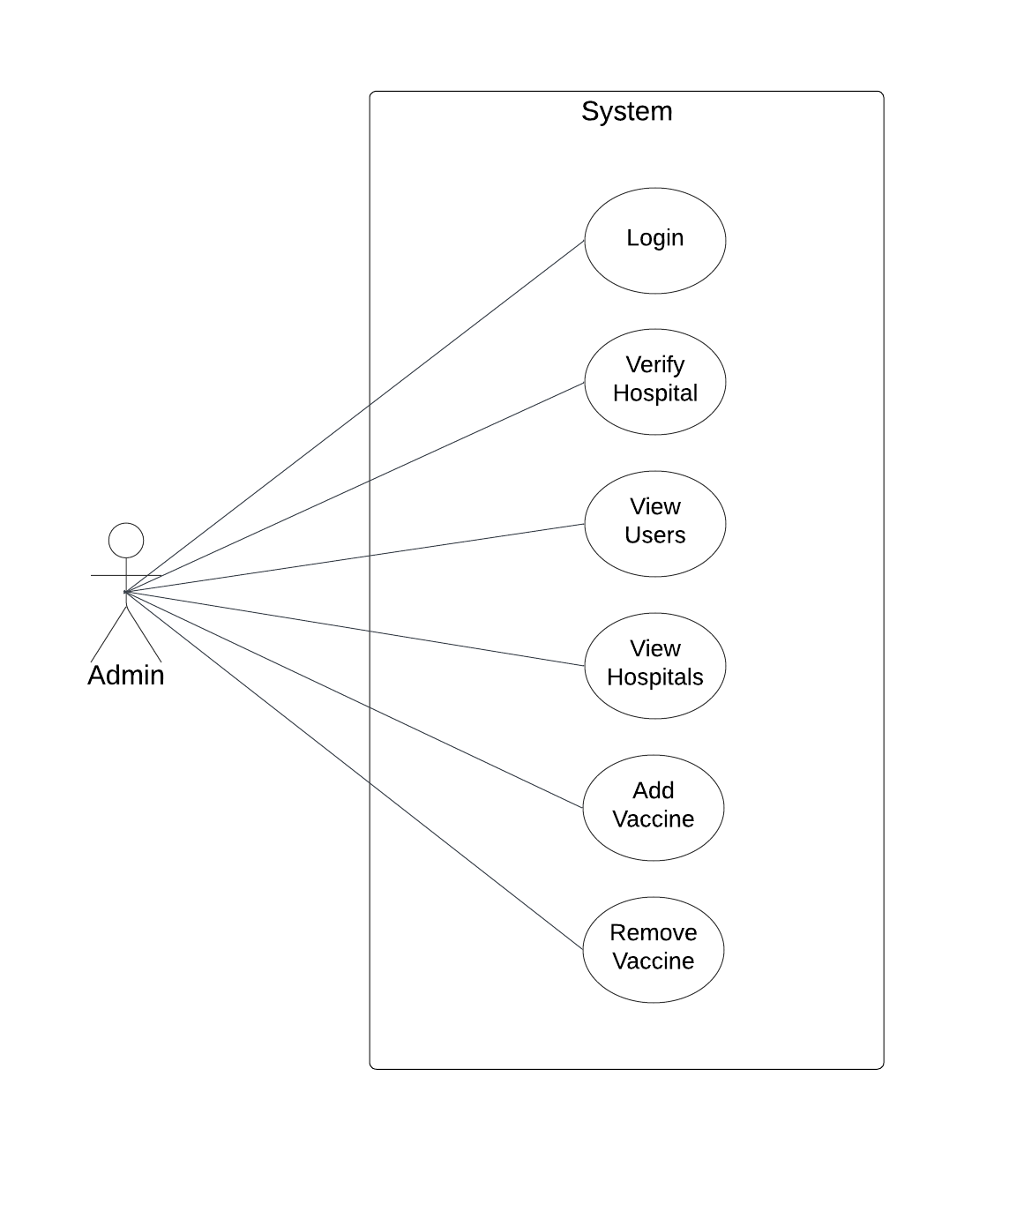

*Fig. Use case diagram for admin*

1. In Admin use case diagram Admin is the Actor.
2. Admin can handle following use cases:
3. Login
4. Verify Hospital
5. View Users
6. View Hospitals
7. Add Vaccine
8. Remove Vaccine