

Aniket Dixit

DPSG International | ghazibad

Library Management System

Class XII, 2024 – INFORMATICS PRACTICES PRACTICAL FILE

Submited to - rajeev sir

Certificate

This is to certify that Master Aniket Dixit studying in the DPSGI Ghaziabad of standard XII has completed the Informatics Practices (Python) Project. Aniket has developed a Python-based Library Management System (LMS) project under the guidance of Rajeev Sir during the academic year 2023-24

____________________

INTERNAL EXAMINER

____________________

EXTERNAL EXAMINER

____________________

PRINCIPAL

Contents

**Project Repo Structure** 3

**IDE View of the LMS Codebase** 4

**Python Files of the LMS Codebase** 4

**LMS Solution Input/Output Details** 10

**Table/ Backend Data Structure** 12

**Bibliography** 12

# **Project Repo Structure**

The following GitHub repo snapshot provides a bird-eye view of the LMS project.

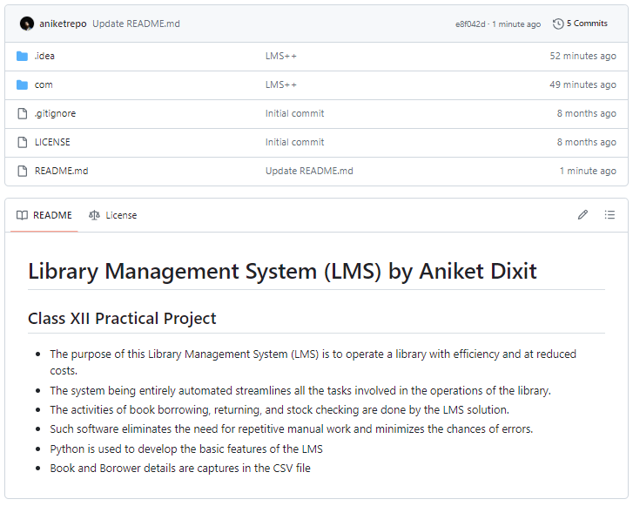

The following codebase is available at my GitHub repo: <https://github.com/aniketrepo/python-feature-set>

# **IDE View of the LMS Codebase**

The following PyCharm IDE snapshot provides a bird-eye view of the LMS codebase.

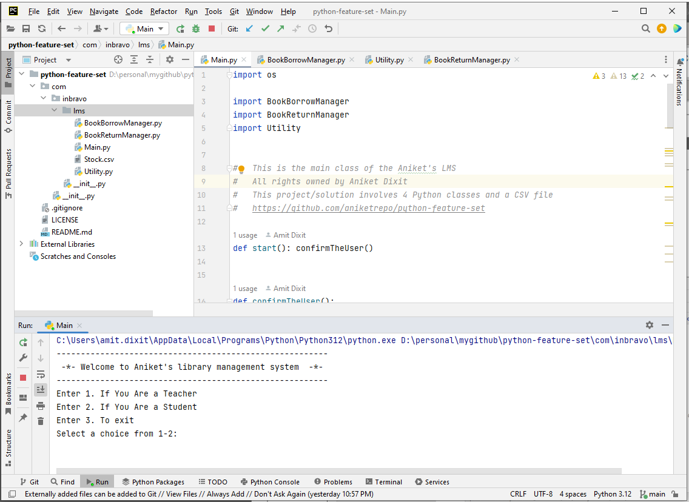

# **Python Files of the LMS Codebase**

There are 4 Python files developed within the LMS codebase.

|  |
| --- |
| * File: Main.py * GitHub Link: [lms/com/inbravo/lms/Main.py at main · aniketrepo/lms (github.com)](https://github.com/aniketrepo/lms/blob/main/com/inbravo/lms/Main.py) |
|  |

|  |
| --- |
| * File: BookBorrowManager.py * GitHub Link: [python-feature-set/com/inbravo/lms/BookBorrowManager.py at main · aniketrepo/python-feature-set (github.com)](https://github.com/aniketrepo/python-feature-set/blob/main/com/inbravo/lms/BookBorrowManager.py) |
|  |

|  |
| --- |
| File: BookReturnManager.py  GitHub Link: [python-feature-set/com/inbravo/lms/BookReturnManager.py at main · aniketrepo/python-feature-set (github.com)](https://github.com/aniketrepo/python-feature-set/blob/main/com/inbravo/lms/BookReturnManager.py) |
|  |

|  |
| --- |
| * File: Utility.py * GitHub Link: [python-feature-set/com/inbravo/lms/Utility.py at main · aniketrepo/python-feature-set (github.com)](https://github.com/aniketrepo/python-feature-set/blob/main/com/inbravo/lms/Utility.py) |
|  |

# **LMS Solution Input/Output Details**

LMS solution is developed in Python language. I have used some of the online available references to understand the control flow and developed a similar Python class structure and functions.

|  |  |
| --- | --- |
| Feature | Description |
| Confirm the user Type | Main.py is the entry class. The following text is printed when you execute it: |
| Show the Library Usage Options (Book Borrow/ Return/ Listing) | The user must confirm its type before performing any LMS features. After the confirmation by entering Either 1 OR 2, it shows the following text: |
| Library Usage Options (Book Borrow) | If the user enters option 2. It asks for the User's Details (First and Last Name). Then it provides some book options to choose from |
| Library Usage Options (Book Return) | If the user enters option 3. It asks for the User's Name (First Name). Then it provides the details of the borrowed book and performs the book return option |
| Library Usage Options (Book Listing) | If the user enters option 1. It asks for the User's Name (First Name). Then it provides the details of the borrowed book and performs the book return option |

# **Table/ Backend Data Structure**

The following table structure is used to store the Book Titles

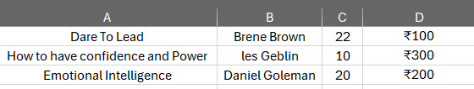

The following table structure is used to store the Book Borrower Details:

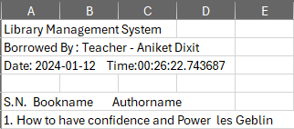

# **Bibliography**

To develop this LMS project following references are used:

* GitHub Python project references: <https://github.com/search?q=library+management+system+python&type=repositories>
* Google.com
* Informatics Practices by Preeti Arora