

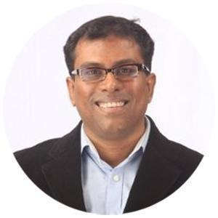

**Nipun Sharma**

CEO,  
Flipkart  
  
None



**Personal Data:**

|  |  |  |
| --- | --- | --- |
| Date Of Birth | : | not given |
| Nationality | : | not given |
| Location | : | NA |
| Languages | : | not given |

**Educational Data:**

|  |  |  |
| --- | --- | --- |
| 1997 | : | Jamnalal Bajaj Institute of Management Studies, Mumbai Masters in Management Studies (Marketing) |
| 1992 | : | Narsee Monjee College of Commerce, Mumbai Bachelor of Commerce (Financial Accounting) |



***Company Profile:*** *CEO,Flipkart*

***Key Responsibilities:***

* Deepen the strategic moat for Flipkart by enabling highest quality services for the products sold on the platform.
* Scale up B2B externalisation business and become market leader.
* Launch B2C business with defined category wise market leadership goals.
* Manage cross functional teams towards common delivery. These include Operations, Customer Service, Business Development, Tech (Product + Engineering), HR, Finance, Design, Procurement, Analytics & IT.
* Manage overall national business with complete P&L and investment responsibilities

***Key Achievements:***

* Launched several new services. Huge improvement in NPS. Winner of the last two Flipkart Group CEO Customer Excellence Award. Won the prestigious 2023 Aegis Graham Bell Award in the Innovation in Managed Services category. This award is supported by Ministry of Electronics & Information Technology, NITI Aayog & Skill India. Also rated as India's Most Trusted Consumer Durables Service Solutions Provider for three years in a row.
* B2B externalisation revenue has grown 2X in last 24 months. Set to grow 2X in next 12 months. Achieved market leadership.
* Launched Flipkart Home Services. Delivered service to 55K customers with a FK app star rating of 4.2
* Revamped business strategy & became the first Flipkart group company to achieve EBITDA break even.  
    
    
  Summary of Professional Experience Prior to Current Stint





|  |  |  |
| --- | --- | --- |
| Location Preference | : | not given |
| CTC* | : | not given |
| Contact Details | : | nipunshrm@yahoo.co.in, +91 9839315000 |
| 2019 | : | **London Business School**  Leading for Results Program A Leadership Development Program focused on  • Strengthening market positions & accelerating growths  • Excelling in execution and creating a winning culture |
| 1992-1994 | : | **Indo-German Training Centre, Mumbai**  Diploma in Business Administration  • Sponsored by Bayer (India) Ltd, with 2/3rds of training being on the job.  • Course under the aegis of Indo-German Chamber of Commerce. • Training content developed by Deutscher Industrie – und Handelsta (Association of German Chambers of Industry & Commerce). |

