KARNATAK LAW SOCIETY’S

GOGTE INSTITUTE OF TECHNOLOGY

UDYAMBAG, BELGAUM-590008

(An Autonomous Institution under Visvesvaraya Technological University, Belgaum)

##### (APPROVED BY AICTE, NEW DELHI)



*Course Activity Report*

**Certificate Generation And Emailing**

*Submitted in the partial fulfillment for the academic requirement of* ***6th Semester B.E. in***

**Robotic Process Automation – 18CS645**

***Submitted by***

|  |  |
| --- | --- |
| **NAME** | **USN** |
| Akshay Deshpande | 2GI19CS016 |
| Aniket Saha | 2GI19CS189 |
| Ashutosh Joshi | 2GI19CS191 |
| Sachin Mutalikdesai | 2GI19CS122 |

under the guidance of

**Prof. Vidyadheesh J. Pandurangi**

Assistant Professor

Dept. of Computer Science and Engineering

**2021 - 2022**

#### **KARNATAK LAW SOCIETY’S**

**GOGTE INSTITUTE OF TECHNOLOGY**

#### Udyambag Belagavi -590008 Karnataka, India.

##### Department of Computer Science and Engineering



Certificate

This is to certify that the Course Activity titled **“Certificate generation and emailing”** carried out by students Akshay Deshpande , Aniket Saha , Ashutosh Joshi, Sachin Mutalikdesai bearing **USNs: 2GI19CS016, 2GI19CS189, 2GI19CS191, 2GI19CS122** is submitted in partial fulfilment of the requirements for 6th semester B.E. in **Robotic Process Automation** (18CS645), COMPUTER SCIENCE AND ENGINEERING ,Visvesvaraya Technological University, Belagavi. It is certified that all corrections/ suggestions indicated have been incorporated in the report. The course project report has been approved as it satisfies the academic requirements prescribed for the said degree.

Signature of the Faculty Member Signature of the HoD Date: 04-07-2022

# Declaration

Team B5 the undersigned solemnly declare that the project - Report for Certificate generation and emailing is based on our own work carried out during the course of our study under the supervision of Prof. Vidyadheesh J. Pandurangi. The statements made and the conclusions drawn are the outcome of our research and work.

# Acknowledgement

This is to acknowledge all those without whom this project would not have been reality. Firstly, I would wish to thank our Computer Science Prof. Vidyadheesh J. Pandurangi who gave his immense support, dedicated his time towards it and made us understand how to make this project. Without his guidance, the project would not have been complete.

A project is a bridge between theoretical and practical learning and with this thinking we as team worked on the project and made it successful due to timely support and efforts of all who helped us.

Once again, we would like to express my gratitude towards our **Prof. Vidyadheesh J. Pandurangi** for his kind co-operation and encouragement which help us in completion of this project.

Contents

Declaration 3

Acknowledgement 3

Abstract 5

Introduction to RPA & UiPath 5

Problem Statement 6

Scenario 6

Packages & Activities 6

Read Range Activity 6

For each Row Activity 6

Assign Activity 7

BalaReva Package 7

Get Password Activity 8

Properties 8

Send SMTP Mail Message Activity 8

Properties 8

Workflow Design – Flowchart 10

Workflow Design – Read Range Activity 11

Workflow Design – PowerPoint Application Scope 11

Workflow Design – Export To PDF 12

Workflow Design – SMTP Mail Message 12

Excel Sheet 13

Certificate Template 13

Output 14

Output folder (containing all generated certificates) 14

An example email containing the certificate 14

Conclusion 15

Reference 15

• UiPath Documentation 15

• UiPathTutorials 15

# Abstract

We know RPA is best suited for automating tasks and processes that are rule-driven and repetitive in nature. One such task is the process of generating certificates and mailing them. Consider a scenario, where a task of generating participation certificates for participants participating in an event is to be automated. Certificates are generated based on a template available as a PowerPoint slide. Once the certificates are generated, the individual certificates need to be mailed to the individual participants too. All details of the students can be found in an excel sheet containing the name and the email of the participants.

# Introduction to RPA & UiPath

**RPA** is defined as an art of using software robots to interact with Software-as-a-Service applications and IT systems to automate the rule-based manual jobs associated with repetitive and transactional processes. The robot mimics the interactions of an employee with a system's user interface. The RPA services provide data security, enhanced business efficiency and effectiveness across various business applications without modifying available system and infrastructure. Robotic Process Automation can be termed as the breed of technology in the industries like Machine Learning, Automation Engineering and Artificial Intelligence. It can be considered as the low-risk process of performing business tasks in an automated manner than using the most valuable human resources on tasks that are repeated over the time. Further, RPA is for the non-technical businesspersons who are looking for the technology that do things for them rather than doing by themselves.

**UiPath** is a robotic process automation tool for large-scale end-to-end automation. For an accelerated business change, it provides solutions for businesses to automate routine office activities. It uses a variety of methods to transform tedious tasks into automated processes. It provides an open-source platform that promotes collaboration and automation of repetitive tasks. It is used in various fields such as banking, healthcare, finance, and many more.

# Problem Statement

Certificate Generation and emailing is about building a workflow in UiPath studio to automate the repetitive task of generating participation certificates for participants participating in an event.

# Scenario

1.We have details of participants (name and email ID) stored in an excel sheet.

2. A certificate template is available in the form of a PowerPoint slide.

3. The excel sheet is read using the Read Range activity and stored in a variable of type DataTable.

4. Loop through the DataTable and extract the name of each participant.

5. Use the name and write it to the certificate template using the TextShapeEdit activity.

6. Export the slide as PDF using the Export To PDF activity and store it in a folder where all the certificates are supposed to be stored.

7. Loop through the DataTable and extract the name and email of the participant.

8. Find the generated certificate of the participant and send it as an attachment to the participants email ID using the Send SMTP mail message activity

# Packages & Activities

## Read Range Activity

Read range activity is used to read a table from an Excel file from a user-defined location. There are two types of Read Range activity: Read Range workbook is able to read any tabular information from an excel file. As evident from the image, a workbook path must be supplied.

Read Range by opening Excel requires the software to be installed and used under the Excel Scope activity. The range of cells to be read from can also be selected from this activity, for example, A1:A2.

## For each Row Activity

The For Each Row loop works by iterating through a [DataTable](https://rpayourway.com/what-is-a-datatable), row by row, and executing whatever actions are placed within the body of the loop.

For example, you could use a For Each Row loop on a data table of new students to check whether they have enrolled in classes or not. The For Each Row loop will not stop until all rows within the given DataTable have been processed.

In UiPath, the For Each Row loop can be achieved using the **For Each Row**activity. The For Each Row activity can be used in both a sequence and a flowchart and works only with DataTables. Let’s take a look at the For Each Row Activity:

* **DataTable** – Contains the DataTable you wish to loop through.
* **Row Name** – This is a local variable name for the row you are currently processing. It is called a local variable as the scope is within the body of the loop only and the value is replaced every time a new row is selected from the DataTable. Even though the default name is “row”, this name can be changed to anything and is not shown in the Variables Panel.
* **Body** – Contains the actions and activities you’re looking to repeat.
* **Index** – The zero-based index (i.e. starts at zero) of the current element in the collection. This can be useful for logging purposes for determining the progress of the loop.

## Assign Activity

#### The[**Assign**](https://activities.uipath.com/docs/assign) activity is an important activity that is going to be used quite often, as it enables you to assign a value to a variable.

You can use an **Assign** activity to increment the value of a variable in a loop, sum up the value of two or more variables and assign the result to another variable (see the example in the [Generic Value Variables](https://docs.uipath.com/studio/docs/genericvalue-variables)), assign values to an array (see [Array Variables](https://docs.uipath.com/studio/docs/array-variables)) and so on.

## BalaReva Package

This package offers hundreds of automation activities that simplify processes in MS Excel.

Nowadays, MS Excel is being used by more than 80% of businesses and millions of users across the globe. Its most common use cases include but are not limited to business analysis, people management, office administration, strategic analysis, and others.

BalaReva - Excel Automation for Enterprises is designed to automate the wide spectrum of your Excel tasks whether at work or for personal use. It offers more than 100 activities that cover the most common Excel processes to speed up your projects.

Moreover, BalaReva - Excel Automation for Enterprises has been refactored and is now based on the UiPath Activity Creator Plugin which helps prevent potential compatibility issues with UiPath Studio. Also, it’s supported by the vendor and successfully passed all Marketplace security checks, thus getting a Gold Certified badge.

The BalaReva pacakges used in this Project are

* **BalaReva.EasyPowerPoint.Activities**: This package contains various PowerPoint activities that will help automate your work.The activity we used is Text ShapeEdit inside PowerPoint application scope activity.It edits the text shape inside the slide of the PowerPoint. This package's activity is to allow a quick read for the text from slides and execute the macros in a simple way.
* **BalaReva.PowerPoint.Activites**: This package contains various PowerPoint activities that will help automate your work. The Package is for PowerPoint Insert Slide Delete SlideInsert Picture to the Slide Export to PDF Create New PowerPoint. The activity we used is Export to PDF.

## Get Password Activity

This activity encrypts a password by associating it with the current user. Only workflows running under the current user context can decrypt the password.

### Properties

* **Private**  - If selected, the values of variables and arguments are no longer logged at Verbose level.
* **Password** - The password to be encrypted.
* **Result** - The password to be encrypted.

## Send SMTP Mail Message Activity

This activity sends an email message by using the SMTP protocol.

### Properties

**Logon**

* **Email** - The email account used to send the message.
* **Password** - The password of the email account used to send the message.
* **SecurePassword** - The password of the email account used, as a secure string.

**Host**

* **Server** - The email server host that is to be used.
* **Port** - The port that the email message is to be sent through.

**Sender**

* **Name** - The display name of the sender.
* **From** - The email address of the sender.

**Options**

* **Ignore CRL** - Specifies whether to ignore the Certificate Revocation List validation when connecting. This field only accepts Boolean values and variables. If left empty, the default False value is used.
* **IsBodyHtml** - Specifies whether the body of the message is written in HTML format.
* **ReplyTo** - The email address to be used when replying.
* **SecureConnection** - Specifies the SSL and/or TLS encryption to be used for the connection.

**Receiver**

* **To** - The main recipients of the email message.
* **Cc** - The secondary recipients of the email message.
* **Bcc** - The hidden recipients of the email message.

**Email**

* **Subject** - The subject of the email message.
* **Body** - The body of the email message.

**Common**

* **DisplayName** - The display name of the activity.
* **TimeoutMS** - Specifies the amount of time (in milliseconds) to wait for the activity to run before an error is thrown. The default value is 30000 milliseconds (30 seconds).

**Attachments**

* **Files** - The attachments to be added to the email message.

**Forward**

* **MailMessage** - The message to be forwarded. This field only supports MailMessage objects.

**Misc**

* **Private** - If selected, the values of variables and arguments are no longer logged at Verbose level.

# Workflow Design – Flowchart

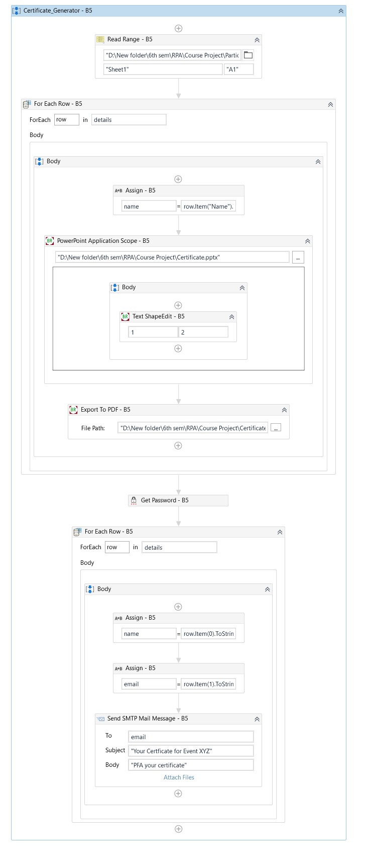

Fig. Design Workflow of the process

## Workflow Design – Read Range Activity

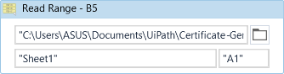

Fig. Read Range Activity

## Workflow Design – PowerPoint Application Scope

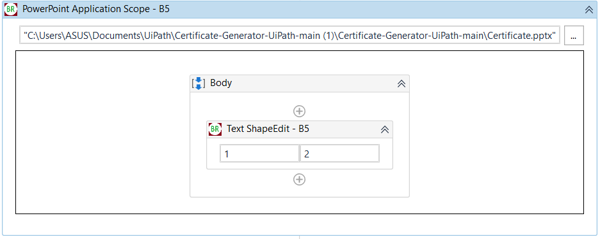

Fig. PowerPoint Application Scope

## Workflow Design – Export To PDF

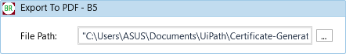

Fig. Export To Pdf

## Workflow Design – SMTP Mail Message

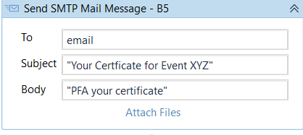

Fig. SMTP Mail Message Process

## Excel Sheet

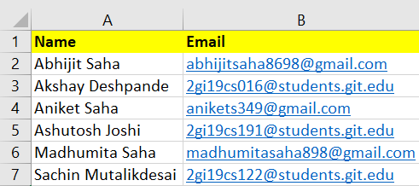

## Certificate Template

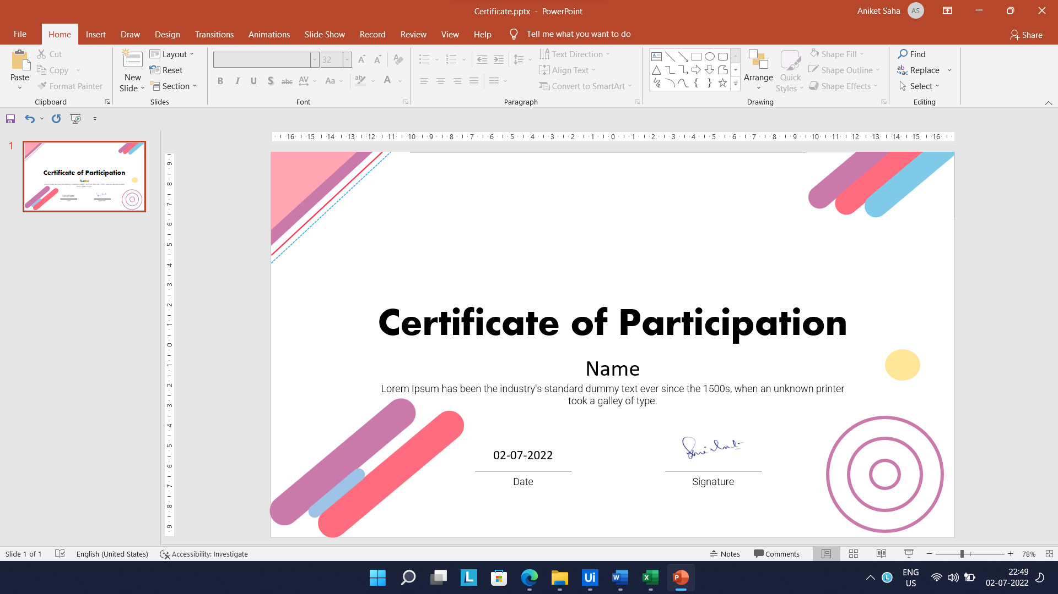

# Output

## Output folder (containing all generated certificates)

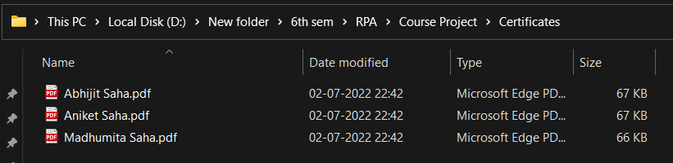

## An example email containing the certificate

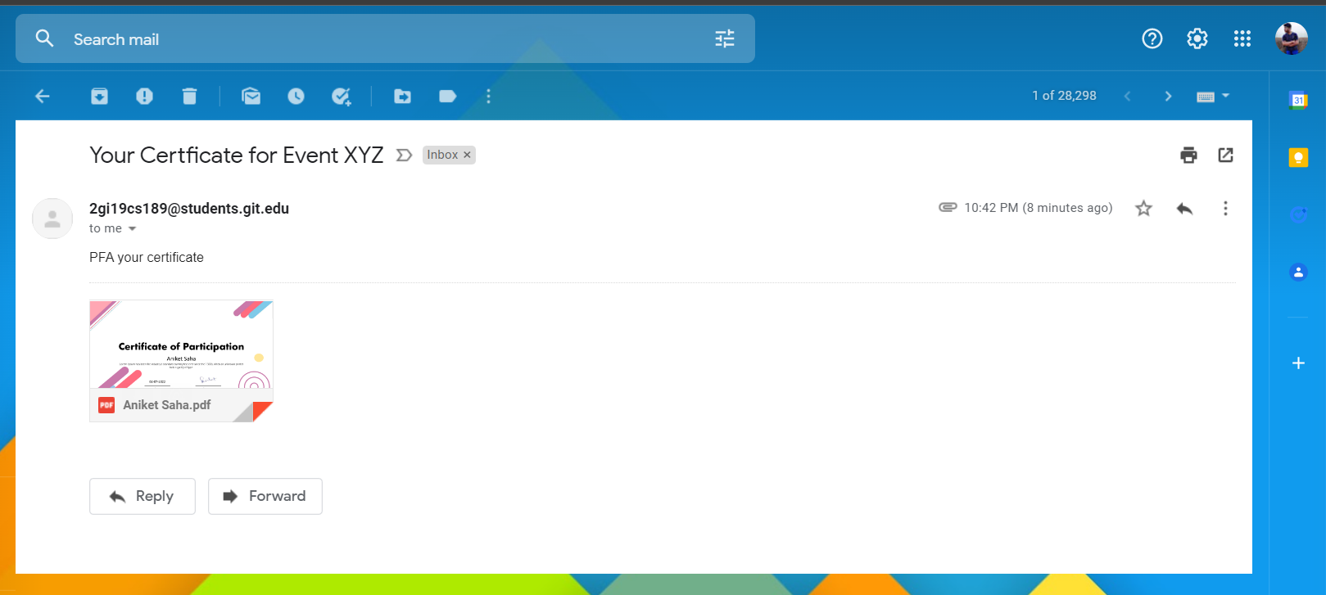

# Conclusion

Robotic Process Automation (RPA) is a new wave of the future technologies. Robotic Process Automation is one of the most advanced technologies in the area of computer science, electronics and communication, mechanical engineering and information technology. It is an emerging form of Business Process Automation technology based on software robots (bots) and artificial intelligence workers. RPA is an automation technology based on software tool that mimics human behavior for repetitive tasks.

In this project we successfully built a software robot which helps in generating certificates and emailing them to respective recipients using UiPath studio.

# Reference

# [UiPath Documentation](https://docs.uipath.com/)

# [UiPathTutorials](https://docs.uipath.com/studio/docs/tutorials)