**KARNATAK LAW SOCIETY’S**

**GOGTE INSTITUTE OF TECHNOLOGY**

UDYAMBAG, BELAGAVI-590008

(An Autonomous Institution under Visvesvaraya Technological University, Belgaum)

**(APPROVED BY AICTE, NEW DELHI)**



*Course Activity Report on*

“**Library Management System”**

*submitted in the partial fulfillment for the academic requirement of*

*5th Semester B.E.*

*in*

***Software Design and Modeling Laboratory (18CSL58)***

*Submitted by:*

|  |  |
| --- | --- |
| Aniket Saha | 2GI19CS189 |
| Ashutosh Joshi | 2GI19CS191 |
| K. Rahul | 2GI19CS190 |
| Mohit Saboji | 2GI19CS073 |

under the guidance of:

**Prof. Arundhati Nelli**

Department of Computer Science and Engineering , KLS GIT,Belagavi

**KARNATAK LAW SOCIETY’S**

**GOGTE INSTITUTE OF TECHNOLOGY**

UDYAMBAG, BELGAUM-590008

(An Autonomous Institution under Visvesvaraya Technological University, Belgaum)

**(APPROVED BY AICTE, NEW DELHI)**

**Department of Computer Science and Engineering**

**Certificate**

This is to certify that the Course Project work titled **“Library Management System”** carried out by **Aniket Saha, Ashutosh Joshi, Mohit Saboji, K. Rahul** bearing USNs: **2GI19CS189, 2GI19CS191, 2GI19CS072, 2GI19CS190** is submitted in partial fulfilment of the requirements for 5th semester B.E. in **Computer Science and Engineering**, as per the project requirement for the academic year 2021-22 under the guidance of **Prof. Arundhati Nelli, KLS GIT, Belagavi**. It is certified that all corrections/ suggestions indicated have been incorporated in the report. The course project report has been approved as it satisfies the academic requirements prescribed for the said degree.

Signature of Project Guide:

Date:

Prof. Arundhati Nelli,

Department of Computer Science and Engineering,

KLS Gogte Institute of Technology, Belagavi.

Name of the Examiners Signature of the Examiners

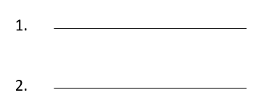 

**TABLE OF CONTENTS**

PROBLEM STATEMENT 1

THEORY 1

PURPOSE 2

ADVANTAGES 2

DISADVANTAGES 2

PERFORMANCE REQUIREMENTS 3

SPEED AND LATENCY REQUIREMENTS 3

PRECISION AND ACCURACY REQUIREMENTS 3

CAPACITY REQUIREMENTS 3

DEPENDABILITY REQUIREMENTS 3

RELIABILITY REQUIREMENTS 3

MAINTAINABILITY AND SUPPORTABILITY REQUIREMENTS 3

MAINTENANCE REQUIREMENTS 3

SUPPORTABILITY REQUIREMENTS 3

SECURITY REQUIREMENTS 3

ACCESS REQUIREMENTS 3

USABILITY REQUIREMENTS 4

EASE OF USE REQUIREMENTS 4

UNDERSTANDABILITY AND POLITENESS REQUIREMENTS 4

ACCESSIBILITY REQUIREMENTS 4

FUNCTIONAL AND NON-FUNCTIONAL REQUIREMENTS 5

FUNCTIONAL REQUIREMENTS 5

NON- FUNCTIONAL REQUIREMENTS: 7

USE CASE DIAGRAM 8

USE CASE DESCRIPTION 9

REGISTRATION 9

LOGIN 10

MANAGE USER DETAILS 11

ADD RECORD 12

SEARCH FOR A BOOK 13

ISSUE A BOOK 14

RETURN A BOOK 15

RENEW A BOOK 16

UPDATE BOOK DETAILS 17

DELETE A BOOK 18

SEQUENCE DIAGRAM 19

VIEW/EDIT BOOK DETAILS 20

ADD MEMBER 21

EDIT STUDENT RECORD 22

ADD BOOK RECORD 23

ACTIVITY DIAGRAM 24

ISSUE/ RETURN A BOOK 25

LOGIN 26

SIGN UP 27

ADD A BOOK 28

CLASS DIAGRAM 29

ER DIAGRAM 30

# PROBLEM STATEMENT

To develop an application using Java to accomplish all library functions which were originally performed by the librarians. The application also has an associated relational database that stores all relevant information about the actors of the system and the books of the library.

# THEORY

Library computerization is the process of adequately utilizing computer hardware cum software's and its varying facilities such as networking cables, software packages etc. in accomplishing library functions which were originally performed manually by the librarians.

Now we are in the age of automation. In this age we feel the importance of automation in all steps of daily jobs. We are trying to develop an automation system which will provide lots of facilities. The total automation system divided into many modules. Here our part is

“Computerization of library activities and book transactions”. This is a small part of total automation system but computerization of library activities will provide an environment which facilitates the user, easy to access the library information.

Computerization of libraries has provided libraries with cheaper means of purchasing information resources for their libraries. This is so as other methods where the libraries have to apply the use of manual means in selecting and acquiring its resources is more costly and involves more human efforts. Thus, libraries now acquire information resources through the World Wide Web and Internet, this has made it more affordable for libraries to procure more current information resources such as journals, magazines which are very costly when procured in physical format. Computerizing the library functions and services encompasses the initial:

* Planning processes
* Selection of hardware and software
* Acquisition of selected hardware and software
* Training of library personnel on the use
* Maintenance of these novel system
* Networking of computer terminals (inter linking of computers)
* Retrospective conversion of the library collections i.e., printed materials and artifacts records by means of computer software into machine readable options.

# PURPOSE

The library management system is a software to manage manual functions of a library. The application provides a full-fledged software that implements all functionalities of a library. The system aims to provide an environment to maintain the details of books and library members i.e., students and the librarian. The software helps to manage the entire library operations from maintaining book records to issue a book. In addition, it allows streamlined management of fine details of books such as author name, edition, and many other important details. So, it is easier to search for books and find the right materials for students and the librarian. The librarian performs tasks such as adding books and managing the users. The users perform activities such as issuing a book, searching for a book, extending the date of return, and returning a book.

The electronic management via the software is essential to track information like issue date, due date, who has borrowed any material, etc. The system is developed and designed with an aim to facilitate efficient management to the schools to manage a modern library with accurate data management.

# ADVANTAGES

The library management system offers ease to perform day to day library operations electronically. this practice being many advantages like;

* Simple and easy to operate
* Mobile access, anytime, anywhere
* Search, add, update, and view library materials online
* Helps to manage library functions constructively
* Saves time and reduces overheads
* Reduce library’s operating cost
* Remove manual processes to issue books and maintain records

# DISADVANTAGES

The advantage of library management software outweigh the disadvantages. But there are few disadvantages associated with the system.

* Online stored data is prone to cyber hacks.
* Complications
* Risk of computer virus
* Since the system stocks data on the computer’s hard drive, this raises the risk of data loss.

# PERFORMANCE REQUIREMENTS

## SPEED AND LATENCY REQUIREMENTS

* Data would be inserted in MySQL database within few seconds
* Query would respond on time and bring the results within few seconds
* UI should load within no time

## PRECISION AND ACCURACY REQUIREMENTS

* After successful login, legitimate details have to be shown
* All the data should store accurate and valid information to the database
* Only registered users can update their information

## CAPACITY REQUIREMENTS

* There is no user limit

# DEPENDABILITY REQUIREMENTS

## RELIABILITY REQUIREMENTS

* The user should register as a new user and update database with given information
* Only accurate information can give access of the system
* Every user can update their own information
* The system should perform activities immediately upon user response

# MAINTAINABILITY AND SUPPORTABILITY REQUIREMENTS

## MAINTENANCE REQUIREMENTS

* Modify the system when the application environment changes
* Fix bugs within the system
* Fix accidental data mistakes by the user

## SUPPORTABILITY REQUIREMENTS

* Provide user guidance
* For better user experience, provide customer support

# SECURITY REQUIREMENTS

## ACCESS REQUIREMENTS

* Only registered users can login to the system
* Only the librarian can manage the user and book details

# USABILITY REQUIREMENTS

## EASE OF USE REQUIREMENTS

* System user interface should be extremely user friendly
* New user should not face much difficulties
* Profile maintenance and documentation support is not complex

## UNDERSTANDABILITY AND POLITENESS REQUIREMENTS

* All kinds of users should understand the system with great ease
* Data of users is kept confidential and is highly prioritized

## ACCESSIBILITY REQUIREMENTS

* The system should be accessible from all devices.
* There is minimal downtime
* The system responds quickly to user actions with less delay

# FUNCTIONAL AND NON-FUNCTIONAL REQUIREMENTS

## FUNCTIONAL REQUIREMENTS

A **Functional Requirement** (FR) is a description of the service that the software must offer. It describes a software system or its component. They describe the functionality of a system – how a system should react to particular set of inputs and what should be the corresponding output.

1. Requirement 1

* Description: Login
* Input: Credentials such as username and password
* Output: Login successful

1. Requirement 2

* Description: Logout
* Input: Click event on logout button
* Output: Logout successful

1. Requirement 3

* Description: Adding new user
* Input: User details
* Output: Registration successful

1. Requirement 4

* Description: Search for a book
* Input: Book name
* Output: Search results, either found or not found

1. Requirement 5

* Description: Issue a book
* Input: Book details and user account details
* Output: Appropriate message, either success or failure

1. Requirement 6

* Description: Add a new book (only for the admin)
* Input: Book details
* Output: New book added successfully

1. Requirement 7

* Description: Search for a book
* Input: Book name
* Output: Search results, either found or not found

1. Requirement 8

* Description: Return a book
* Input: Book details and user account details
* Output: Return successful

## NON- FUNCTIONAL REQUIREMENTS:

**Non-functional Requirements** (NFRs) define system attributes such as security, reliability, performance, maintainability, scalability, and usability. They serve as constraints or restrictions on the design of the system across the different backlogs.

1. Availability
   * The system must be available 24 hours a day
   * Database backup and recovery plan should be proper in order to avoid any unexpected downtime of application.
2. Security requirements

* User authentication and validation of members using their unique member ID
* Proper accountability which includes not allowing a member to see other member’s account
* System will be connected to secured database

1. Performance requirement
   * The information is refreshed depending upon whether some updates have occurred or not in the application
   * The system shall respond to the member a short time of the request submittal
   * The system shall be allowed to take more time when doing large processing jobs.
2. Hardware Requirements

* Processor: Minimum 1 GHz or more
* Minimum 256MB of RAM
* Minimum 1GB of free hard drive space

1. Software Requirements

* Java SE 11 or higher
* Apache NetBeans IDE 12.5
* MySQL server
* Operating System: Windows XP and higher

# USE CASE DIAGRAM

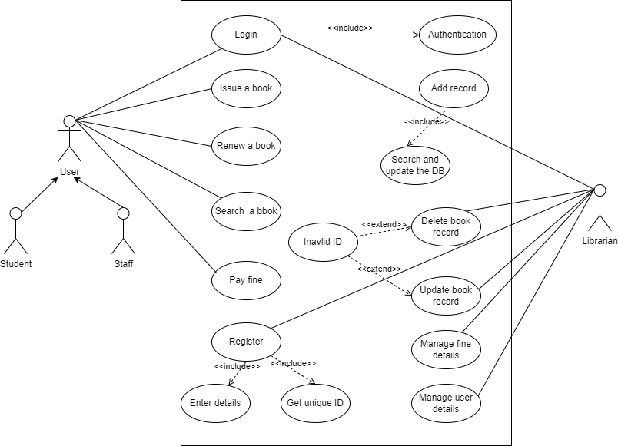

# USE CASE DESCRIPTION

## REGISTRATION

|  |  |
| --- | --- |
| Use Case Name | Registration |
| Scenario | User registration to the system |
| Brief Description | User should register providing all details with username and password |
| Actors | Student, Staff, Librarian |
| Pre-condition | All details are valid |
| Post-condition | User details added to the database |
| Flow of events | |  |  | | --- | --- | | User | System | | * Must provide all details * Username and password are valid * All required fields are filled | * Confirm valid username * Confirm unique username | |
| Exception  Condition | Username already exists  Credentials are not valid |

## LOGIN

|  |  |
| --- | --- |
| Use Case Name | Login |
| Scenario | User login to the system |
| Brief Description | User should login with valid username and password |
| Actors | Student, Staff, Librarian |
| Pre-condition | The user with the username already exists or is registered |
| Post-condition | After successful login, the user has access to the system |
| Flow of events | |  |  | | --- | --- | | User | System | | * Username and password are valid | * Confirm valid username * Confirm unique username * Give access of the system to the user | |
| Exception  Condition | Username does not exist  Username and/ or password do not match |

## MANAGE USER DETAILS

|  |  |
| --- | --- |
| Use Case Name | Manage user details |
| Scenario | Librarian can check borrowed books and the corresponding details |
| Brief Description | Librarian can access user account details that has borrowed a book and can impose fine if applicable |
| Actors | Librarian |
| Pre-condition | Librarian is already registered |
| Post-condition | The books that are currently borrowed, and their details is visible to the librarian |
| Flow of events | |  |  | | --- | --- | | Librarian | System | | * Login to the system * Check currently borrowed books * Check corresponding user details * Update fine details | * Authenticate librarian * Give access of the system * Show books that have been borrowed * Show corresponding user details | |
| Exception  Condition | Username does not exist  Username and/ or password do not match |

## ADD RECORD

|  |  |
| --- | --- |
| Use Case Name | Add record |
| Scenario | Librarian adds new books |
| Brief Description | Librarian can add new books into the database and its details |
| Actors | Librarian |
| Pre-condition | The book with the same name does not already exist in the database |
| Post-condition | The new book is successfully added into the database |
| Flow of events | |  |  | | --- | --- | | Librarian | System | | * Login to the system * Add a new book * Enter book details | * Authenticate librarian * Give access of the system to the user * Add a record of the newly added book to the database | |
| Exception  Condition | Username does not exist  Book with the same name and details already exist in the database |

## SEARCH FOR A BOOK

|  |  |
| --- | --- |
| Use Case Name | Search for a book |
| Scenario | User (student, staff) can search a book by its name, author name, edition |
| Brief Description | A user can search for a book by providing appropriate details such as book name or author name. If the book exists, the book information is displayed |
| Actors | User (student, Staff) |
| Pre-condition | The book with the same name already exists in the database |
| Post-condition | The book information is displayed to the user |
| Flow of events | |  |  | | --- | --- | | User | System | | * Login to the system * Search for a book * Select keyword * Enter book details | * Authenticate user * Give access of the system to the user * Search for the book by the specified keyword in the database * Display book information | |
| Exception  Condition | Book does not exist |

## ISSUE A BOOK

|  |  |
| --- | --- |
| Use Case Name | Issue a book |
| Scenario | User (student, staff) can issue a book |
| Brief Description | User can issue a book for himself and may choose to return it or renew it on or before the specified date from the issue data |
| Actors | User (student, Staff) |
| Pre-condition | The book exists in the database and sufficient copies of the book are available for issue |
| Post-condition | The book is issued to the user, user account details and book details get updated and date of return is computed |
| Flow of events | |  |  | | --- | --- | | User | System | | * Login to the system * Search for a book * Request for issue | * Authenticate user * Give access of the system to the user * Search for the book in the database * Check if book can be issued * Update user, book details * Compute return date | |
| Exception  Condition | Book does not exist  No copies of the book are available for issue |

## RETURN A BOOK

|  |  |
| --- | --- |
| Use Case Name | Return a book |
| Scenario | User (student, staff) can return a book already issued to them |
| Brief Description | User can return a book already issued to them. If the user has crossed the date of return, then the user is subjected to additional fine |
| Actors | User (student, Staff) |
| Pre-condition | The user has borrowed the book |
| Post-condition | The date of return is checked for the computed date, and if there is any difference the user is prompted to pay the fine |
| Flow of events | |  |  | | --- | --- | | User | System | | * Login to the system * Request for return * Select books among the borrowed books * Pay fine if prompted | * Authenticate user * Give access of the system to the user * Check for an entry in the borrowed books table * Compute fine details * Update user, book details | |
| Exception  Condition | User not valid  Selected book not borrowed |

## RENEW A BOOK

|  |  |
| --- | --- |
| Use Case Name | Renew a book |
| Scenario | User (student, staff) can renew a book |
| Brief Description | User can choose to renew a book and extend the date of return only for one time. |
| Actors | User (student, Staff) |
| Pre-condition | The user has borrowed the book and has not applied for renewal earlier |
| Post-condition | The date of return is extended and changes are made in the tables |
| Flow of events | |  |  | | --- | --- | | User | System | | * Login to the system * Request for renewal * Select book | * Authenticate user * Give access of the system to the user * Check if user has borrowed the book * Check for earlier renewal requests * Update user, book details * Compute the new return date | |
| Exception  Condition | User not valid  The selected book is not borrowed  The selected book has already been renewed |

## UPDATE BOOK DETAILS

|  |  |
| --- | --- |
| Use Case Name | Update book details |
| Scenario | Librarian can update book details |
| Brief Description | Librarian can update book details such as name, author name, edition, number of copies, etc. |
| Actors | Librarian |
| Pre-condition | The book already exists in the database |
| Post-condition | Appropriate changes are made in the books table |
| Flow of events | |  |  | | --- | --- | | Librarian | System | | * Login to the system * Search for a book * Update details | * Authenticate user * Give access of the system to the user * Search for the book in the database * Update details | |
| Exception  Condition | User not valid  Book does not exist |

## DELETE A BOOK

|  |  |
| --- | --- |
| Use Case Name | Delete a book |
| Scenario | Librarian can delete a book from the books table of the database |
| Brief Description | Librarian can delete a book if it no longer needs to be kept in the library for obvious reasons |
| Actors | Librarian |
| Pre-condition | The book already exists in the database |
| Post-condition | The selected book is removed from the books table of the database |
| Flow of events | |  |  | | --- | --- | | Librarian | System | | * Login to the system * Search for a book * Delete book | * Authenticate user * Give access of the system to the user * Search for the book in the database * Remove the record of the selected book * Update book table | |
| Exception  Condition | User not valid  Book does not exist |

# SEQUENCE DIAGRAM

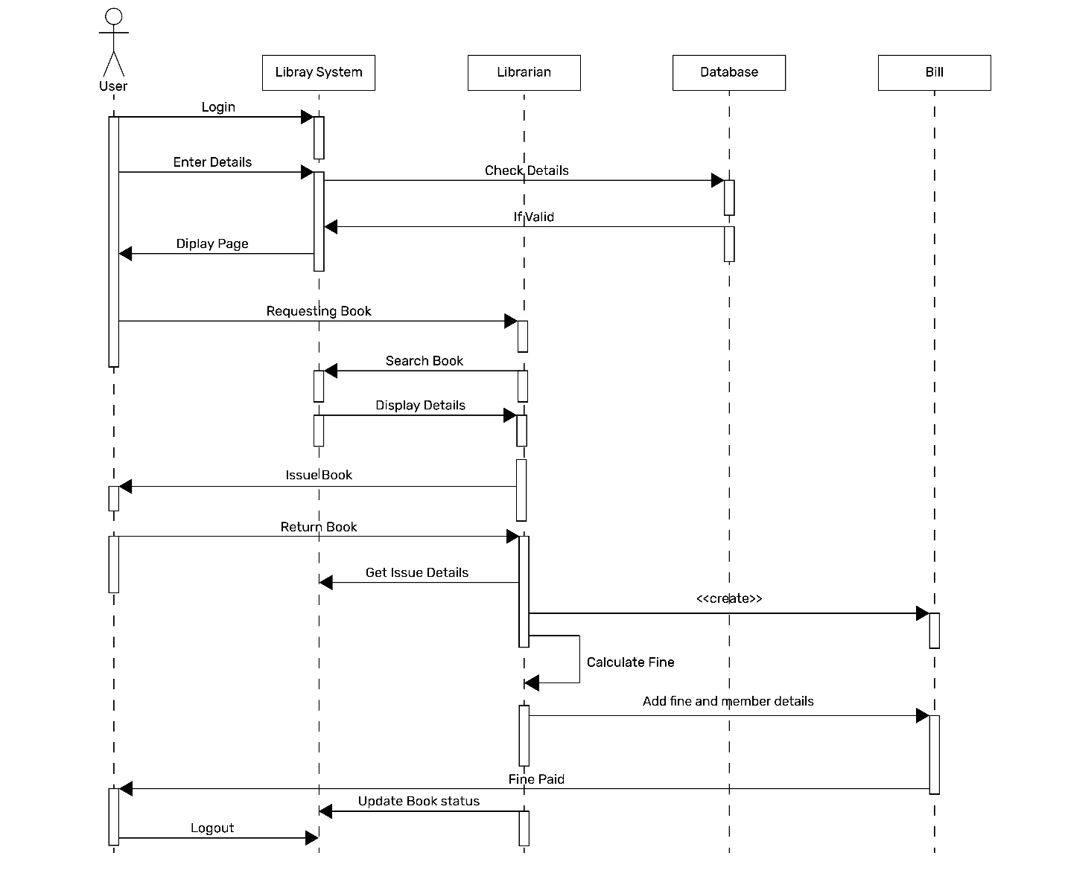

**:Library System**

**:Library**

**:Database**

**:Bill**

## VIEW/EDIT BOOK DETAILS

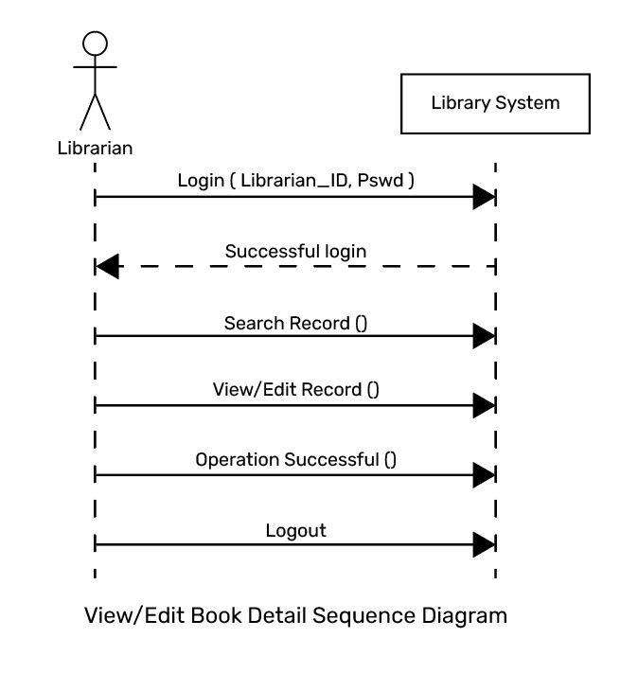

**:Library System**

## ADD MEMBER

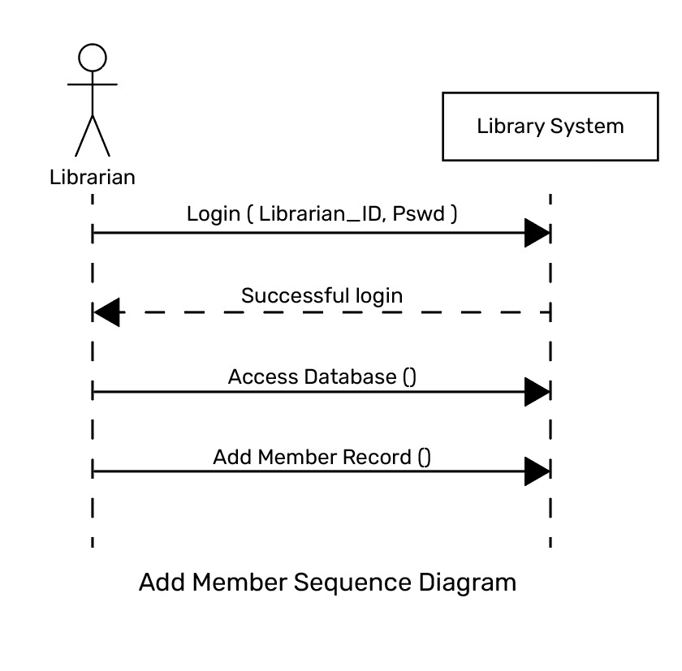

**:Library System**

## EDIT STUDENT RECORD

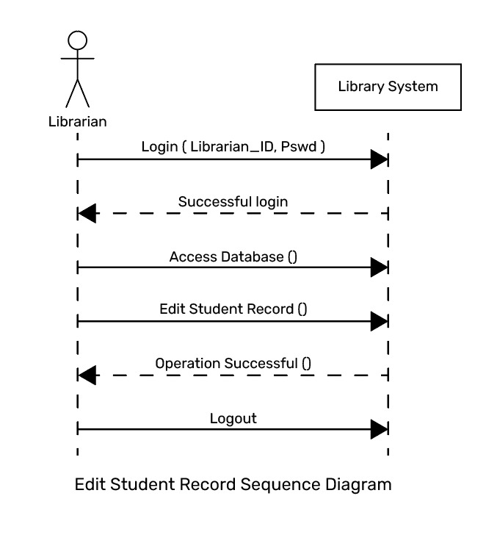

**:Library System**

## ADD BOOK RECORD

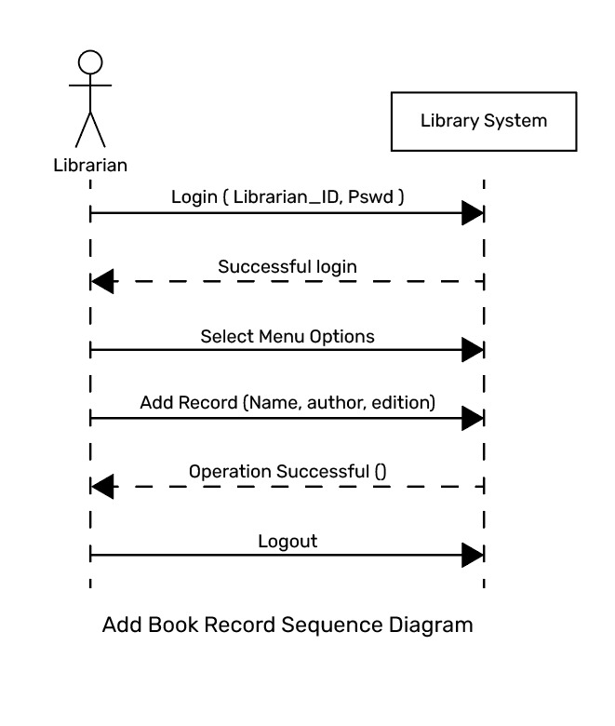

**:Library System**

**:Library System**

**:Library System**

# ACTIVITY DIAGRAM

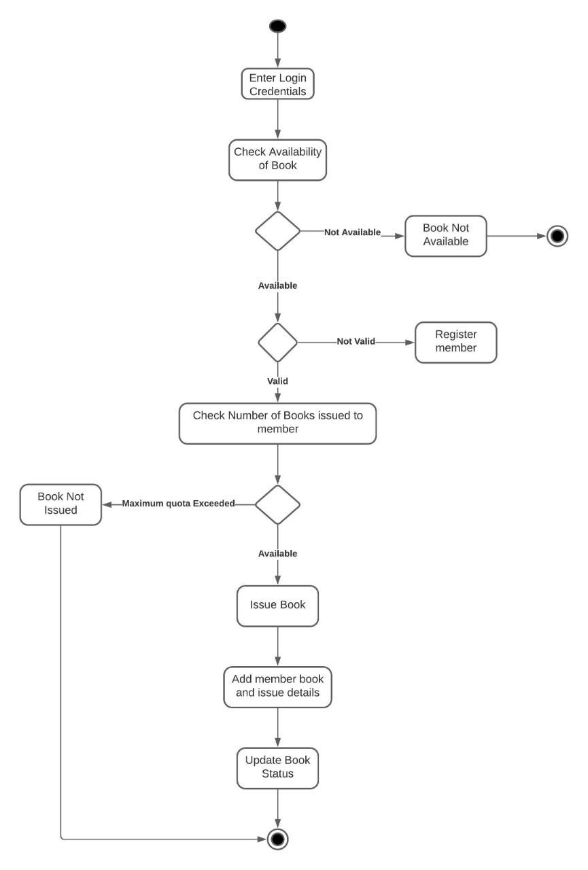

## ISSUE/ RETURN A BOOK

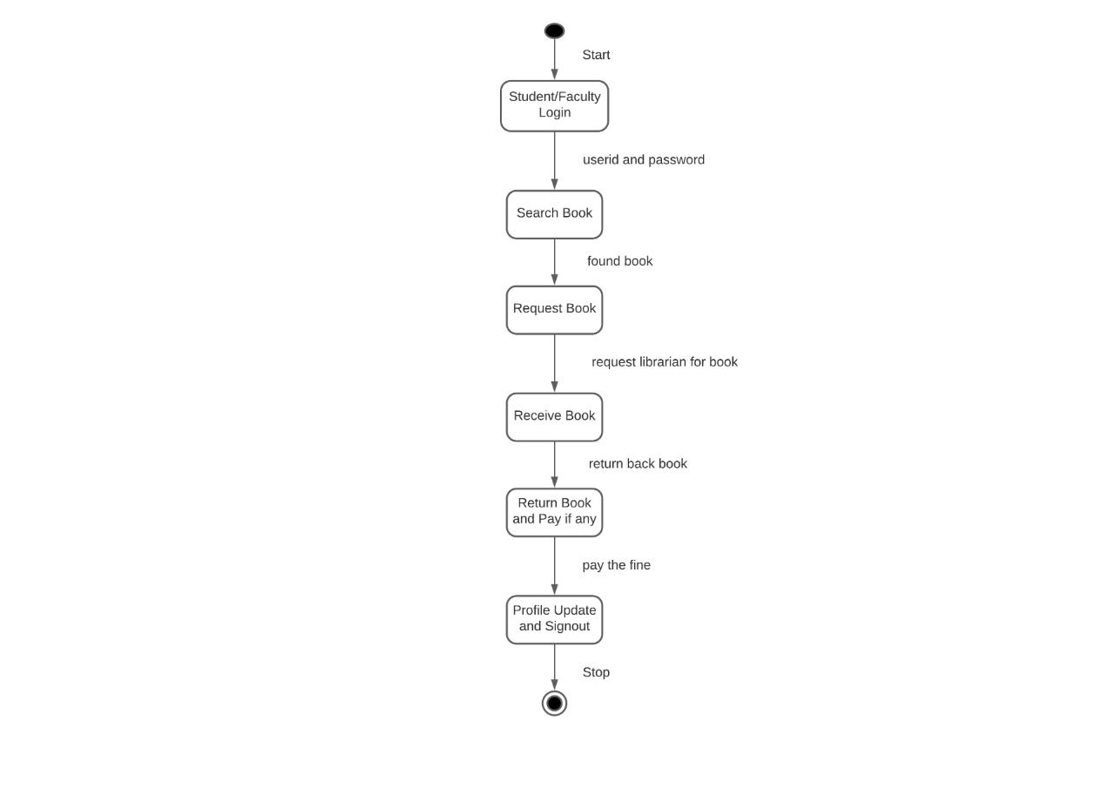

## LOGIN

## SIGN UP

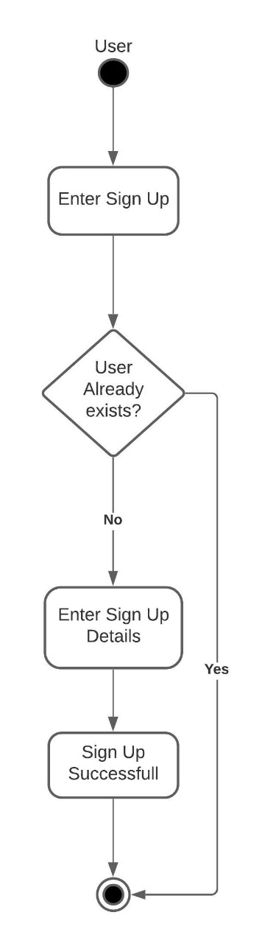

## ADD A BOOK

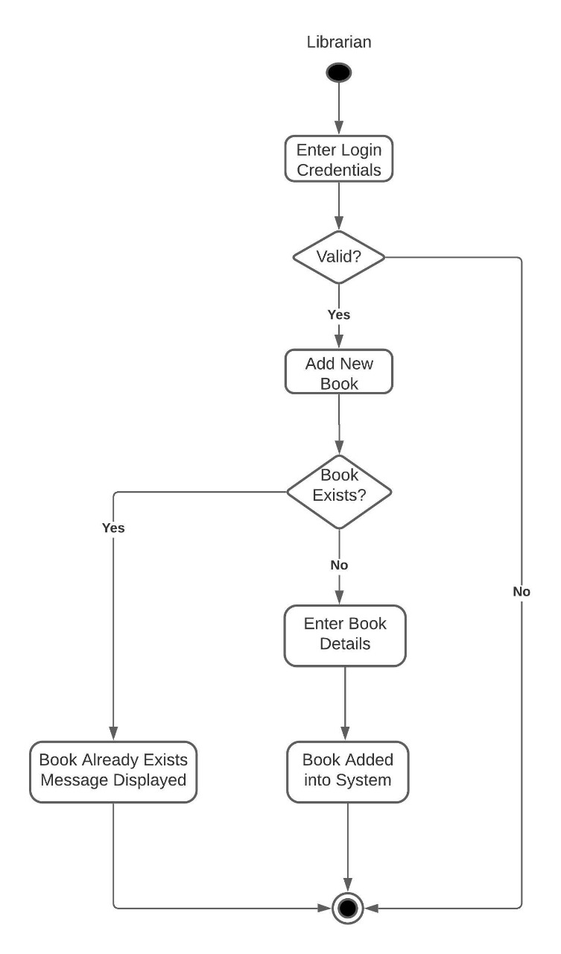

# CLASS DIAGRAM

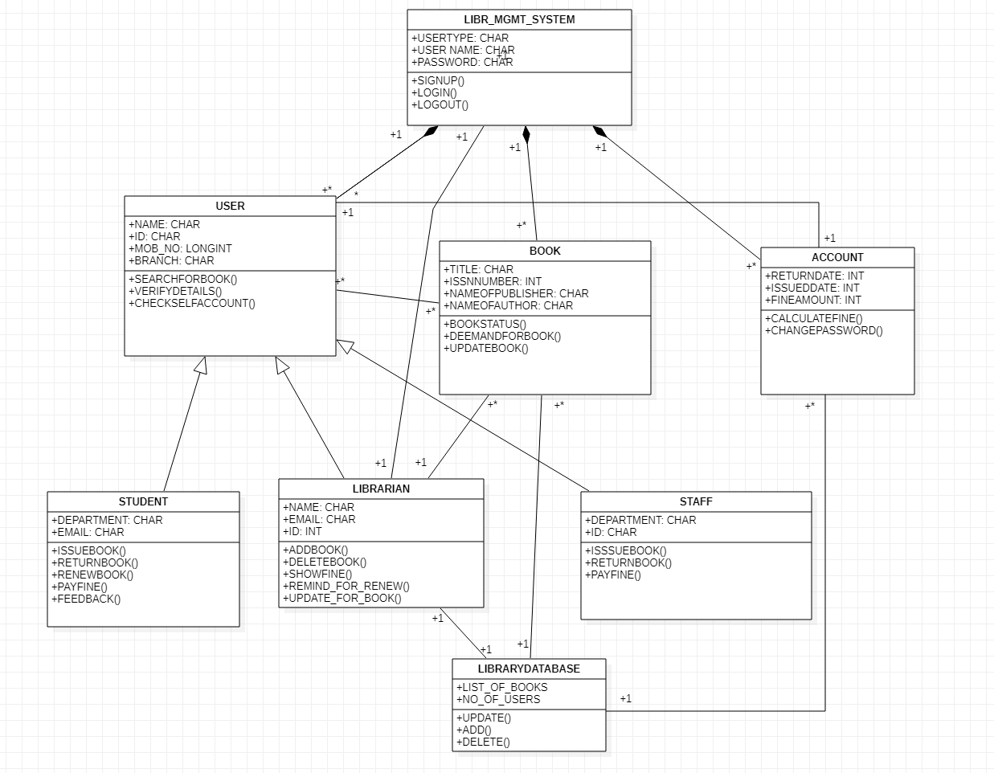

# ER DIAGRAM

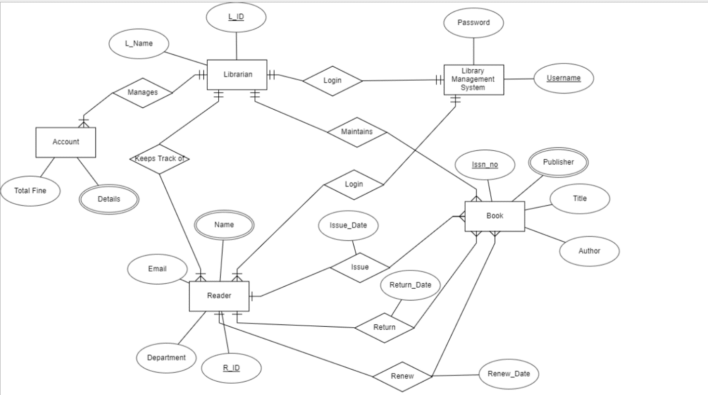

# SCREENSHOTS

