FINAL REPORT

Team Name: Last Byte

Team Members:
- Aniket Sahu 25BAI11514 – Model Training
- Mohd.Wasil Azmi 25BCE11172– Designer
- Gulshan Nijammudin Shaikh Mansuri 25BCE11141– Model Training

- Disha Dashore25BAI10444 – Documentation
This project presents an AI-powered Adventure Mapping prototype that analyzes terrain images and highlights safe walking paths, rocky regions, and vegetation density to assist hikers and off-road explorers.
At its core, the system uses semantic segmentation to classify each pixel of an input image into six terrain categories, enabling real-time scene understanding through a simple web-based interface.
Our method places a strong emphasis on learning objectives, reproducibility, and usefulness.
System Architecture (Frontend + ML)
The system follows a simple end-to-end pipeline:
User uploads terrain image
↓
Web Frontend Interface
↓
U-Net Segmentation Model
↓
Color-coded Terrain Map
↓
User receives navigation insights
The frontend allows users to upload images and visualize segmentation results, while the backend performs preprocessing, inference, and mask generation.
Dataset Overview
The dataset includes:
Training images and masks
Masks and pictures for validation
Six semantic classes are included in each mask. To make the original labels compatible with the model output, they were remapped to a continuous range [0–5].

Preprocessing Data
We used the following fundamental preprocessing procedures to get the data ready for training:
512 × 512 resized images

Original Label | Remapped label
0 | 0
1 | 1
2 | 2
3 | 3
27 | 4
39 | 50
Normalized pixel values to [0, 1]
Masks resized through the use of nearest neighbor interpolation
Masks in the LongTensor format
Additionally, we used lightweight augmentation
50% chance of a random horizontal flip
These actions maintained the pipeline's simplicity while enhancing generalization.
These preprocessing steps ensure consistent input for both model training and real-time frontend inference.

Architecture of Models
For semantic segmentation, we employed a specially designed U-Net architecture. Because it strikes as a good balance between simplicity and performance, U-Net was selected. The model can learn both fine spatial details and global context thanks to its encoder–decoder structure, and skip connections aid in preserving significant features during upsampling.
Summary of Architecture
Encoder: Convolution, ReLU, and max pooling in three downsampling blocks
Bottleneck: Representation of deep features
Transposed convolutions with skip connections as a decoder
Six class channels are produced by the final layer's 1x1 convolution.

The trained model is integrated into a lightweight frontend interface, enabling users to analyze terrain images interactively.

Frontend Interface
A simple web-based frontend was developed to simulate a real-life Adventure Mapping application.
Features include:
- Image upload by user
- One-click terrain analysis
- Side-by-side visualization of original image and segmented output
- Color-coded regions indicating:
  - Safe walking paths
  - Rocky zones
  - Vegetation areas
  - Rough terrain
This interface demonstrates how the segmentation model can be deployed in practical navigation scenarios.

Training Setup
- Input size: 512px × 512px
- Loss Function: Cross Entropy + 0.5 × Dice Loss
- Optimizer: Adam
- Epochs: 40
- Batch size: 1
- Number of classes :6
Training was performed using the provided scripts. Logs and checkpoints were saved in the runs directory.
Due to limited hackathon time, training was kept short and focused on producing a working baseline model.

Evaluation Metric
Model performance was evaluated using Mean Intersection over Union (mIoU).
mIoU measures how well predicted segmentation masks overlap with ground truth labels across all classes. This metric provides a more reliable assessment than pixel accuracy for segmentation tasks.

Results
Findings

Using user-uploaded images, the system successfully creates pixel-level terrain maps.
Segmented outputs make it obvious which areas are dangerous and which are accessible.

Because of the short hackathon duration, functional deployment took precedence over comprehensive performance optimization.

Among the visual outputs are:

original picture of the terrain
Regions of terrain with color mapping
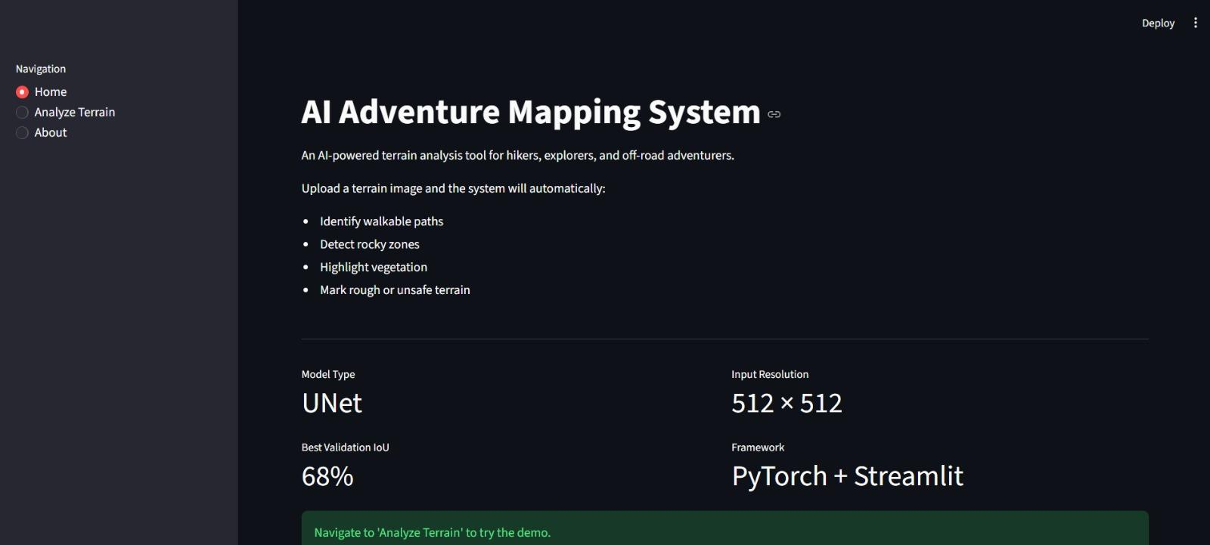
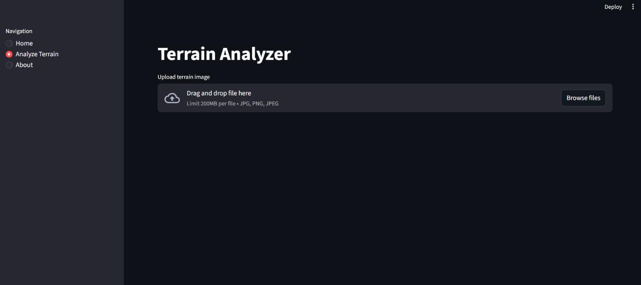
HOW THE PROJECT WORKS: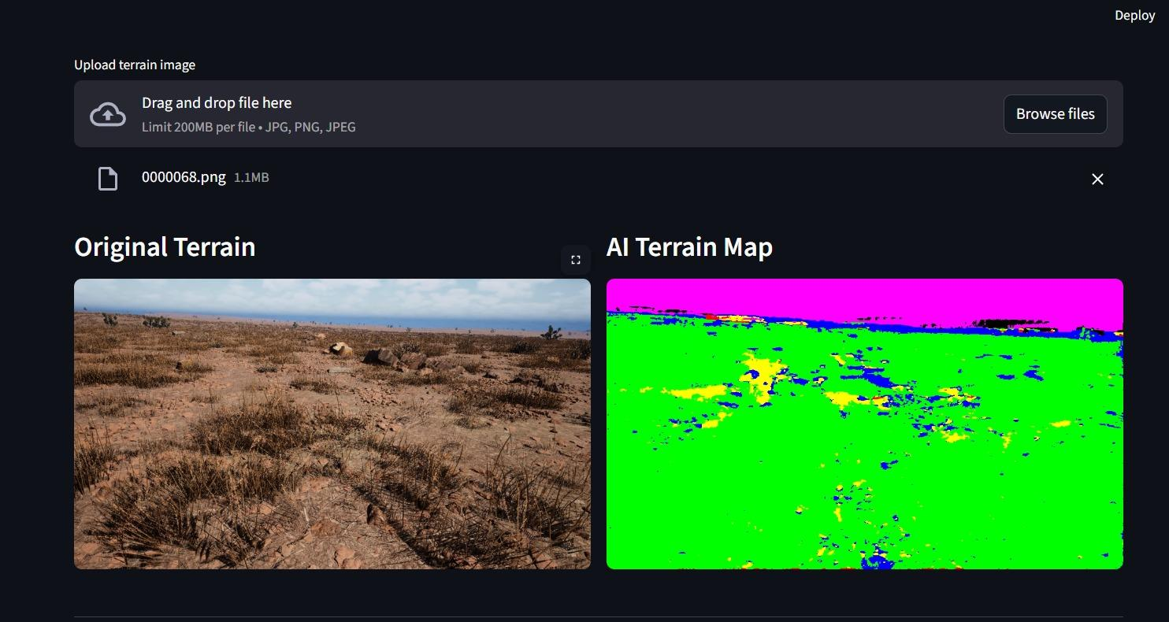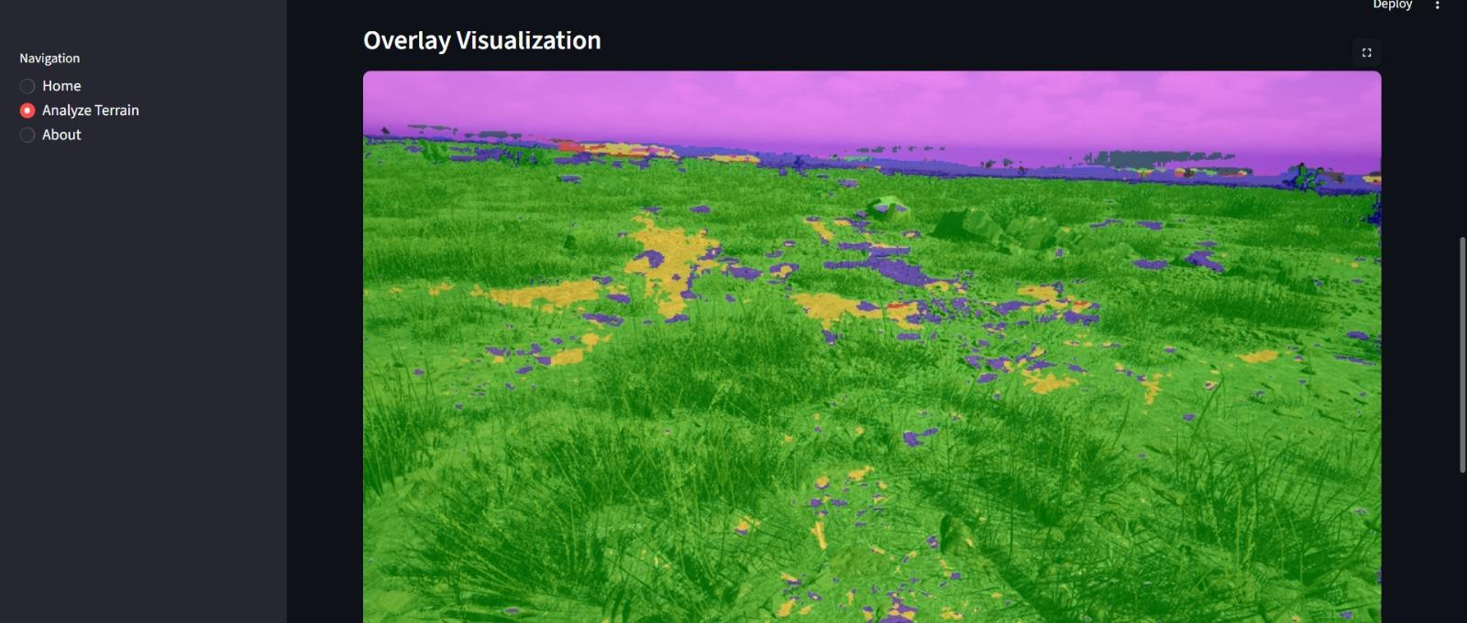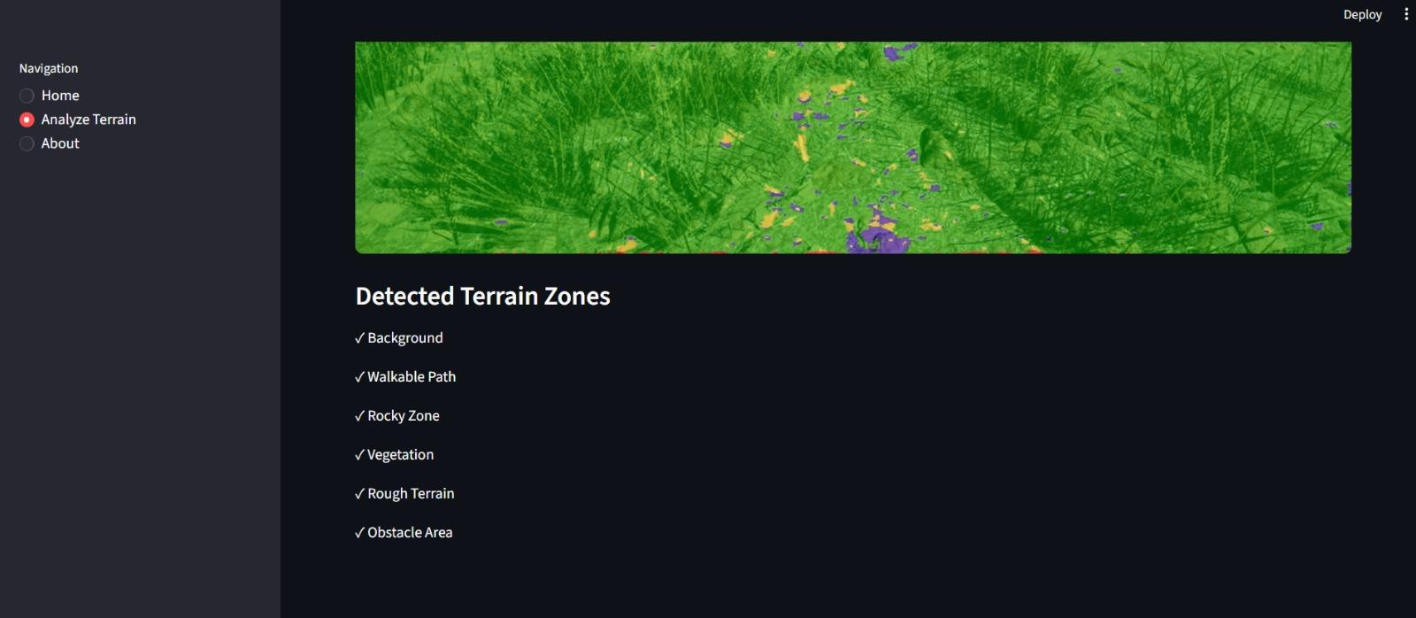

GRAPHS:
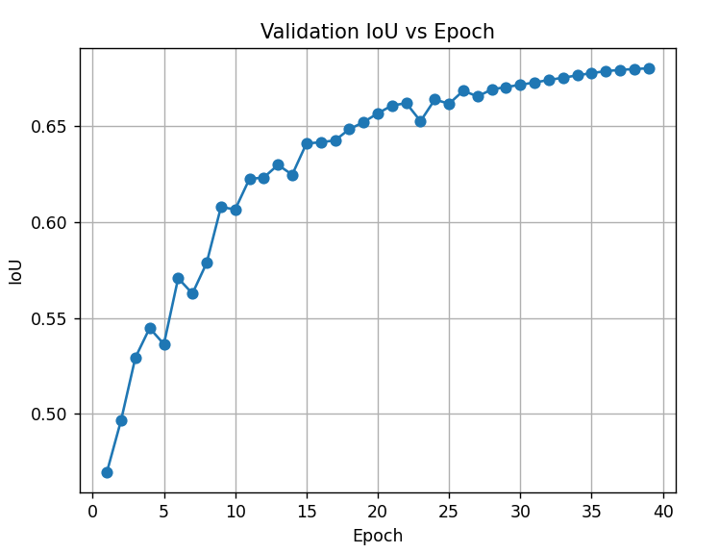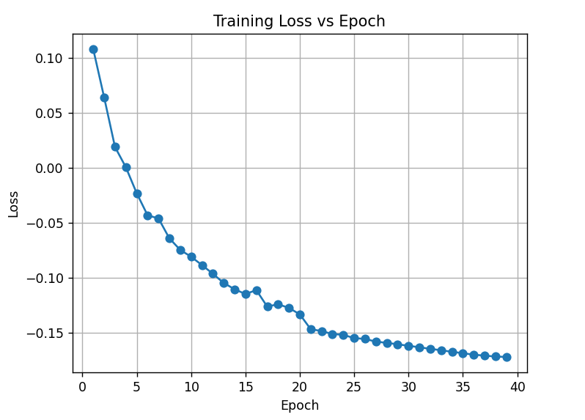

Confusion Matrix:
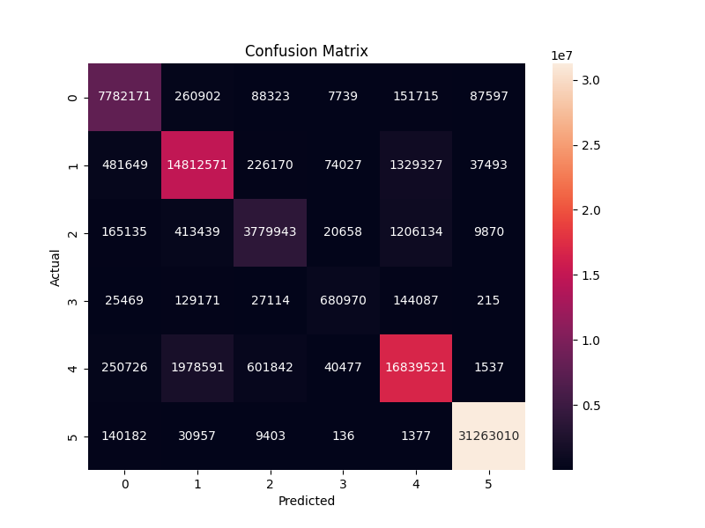

Real Life implementation

Adventure Mapping Apps

Apps for hikers or campers could:

highlight safe walking paths

mark rocky zones

show vegetation density

based on camera input.

In a nutshell:
In this project, we developed an AI-powered Adventure Mapping prototype that enables terrain understanding through semantic segmentation. Using synthetic desert images provided by Duality AI and generated through their simulation platform Falcon, we trained a U-Net-based model to classify terrain at pixel level.
The trained model was integrated with a simple frontend interface, allowing users to upload images and receive segmented terrain maps highlighting safe paths and hazardous regions. This demonstrates a complete end-to-end pipeline from data preprocessing to real-world application deployment.

Challenges and Observations
Tech Complication
We initially started off with Deeplabv3 but that did not suit of model was slow and created unwanted leisure then, we shifted to custom U-net architecture
Class Confusion
Some visually similar classes were occasionally misclassified, especially in shadowed or low-contrast regions.
Consistently Inconsistent
IoU (intersection over union) kept deflecting and showed irregular variations, stabilizing the same was a task.

Future Work
Given additional time, we would:
- Improve frontend UI for mobile usage
- Add GPS-based mapping support
- Train on larger datasets
- Optimize inference speed for real-time deployment
- Integrate live drone or camera feeds

