**LAB 8**

Aniket sambher

Section A

Reg No.190905466

Roll no. 58

Q1. Write a C program for 4 digit BCD up/down counters on seven segment using a switch and timer with a delay of 1-second between each count.

#include<LPC17xx.h> #include<stdio.h>

unsigned int seg_select[4] = {0<<23, 1<<23, 2<<23, 3<<23}; int dig1=0x00, dig2=0x00, dig3=0x00, dig4=0x00;

unsigned int seg_count=0x00, temp1=0x00;

unsigned char arr_dec[10]={0x3F,0x06,0x5B,0x4F,0x66,0x6D,0x7D,0x07,0x7F,0x6F}; unsigned long int i=0;

unsigned int k; void delay(void); void display(void); int main(void){

SystemInit(); SystemCoreClockUpdate();

LPC_PINCON->PINSEL0 &= 0xFF0000FF;//output LPC_PINCON->PINSEL3 &= 0xFFC03FFF;//bit LPC_PINCON->PINSEL4 &=0xFCFFFFFF;//switch LPC_GPIO0->FIODIR |= 0x00000FF0;//output LPC_GPIO1->FIODIR |= 0x07800000;//bit LPC_GPIO2->FIODIR &= 0xFFFFEFFF;//switch

while(1){

k = LPC_GPIO2->FIOPIN >> 12; //We read input from 2.12 k &= 0x00000001;

//delay(); display(); seg_count +=1

if(seg_count == 0x04){

seg_count = 0x00; if(k==1){

dig1+=1;

if(dig1 == 0x0A){

dig1=0; dig2+=1;

if(dig2 == 0x0A){

dig2=0; dig3+=1;

if(dig3 == 0x0A){

dig3=0; dig4+=1;

if(dig4 == 0x0A){

dig4=0;

}//end of dig4

}//end of dig3

}//end of dig2

}//end of dig1

}

else{

dig1-=1; // if digit is at initial value of 0, this will change to 9 if(dig1 == -1){

dig1=0x9; dig2-=1; if(dig2 == -1){

dig2=0x9; dig3-=1; if(dig3 == -1){

dig3=0x9; dig4-=1; if(dig4 == -1){

dig4=0x9;

}//end of dig4

}//end of dig3

}//end of dig2

}//end of dig1

}//end of else

}//end of segcount

}//end of while

}//end of main void display(void){

LPC_GPIO1->FIOPIN = seg_select[seg_count]; if(seg_count == 0x00){//for segment U8

temp1=dig1;

}

else if(seg_count == 0x01){//for segment U9 temp1=dig2;

}

else if(seg_count == 0x02){//for segment U10 temp1=dig3;

}

else if(seg_count == 0x03){//for segment U11 temp1=dig4;

}

LPC_GPIO0->FIOPIN = arr_dec[temp1]<<4;//Taking Data Lines for 7-Seg for(i=0;i<10;i++);

}

void delay(void){

unsigned int i; for(i=0;i<10000;i++);

}

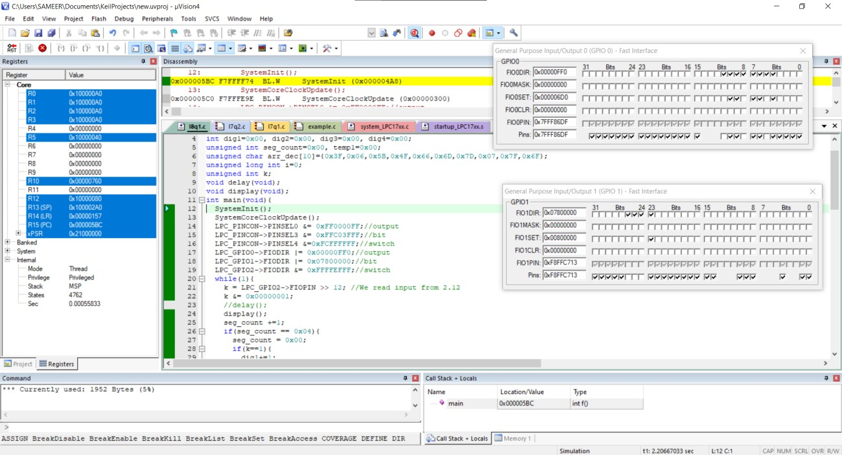

Q2. Write a program for 4 digit Hexadecimal up/down counters on seven segment using a switch and timer with a delay of 1-second between each count.

#include<LPC17xx.h> #include<stdio.h>

unsigned int seg_select[4] = {0<<23, 1<<23, 2<<23, 3<<23}; int dig1=0x00, dig2=0x00, dig3=0x00, dig4=0x00;

unsigned int seg_count=0x00, temp1=0x00; unsigned char

arr_dec[16]={0x3F,0x06,0x5B,0x4F,0x66,0x6D,0x7D,0x07,0x7F,0x6F,0x5F,0x7C,0x58,0x5E,0x7B,0x71};

unsigned long int i=0; unsigned int k;

void delay(void);

void display(void); int main(void){

SystemInit(); SystemCoreClockUpdate();

LPC_PINCON->PINSEL0 &= 0xFF0000FF;//output LPC_PINCON->PINSEL3 &= 0xFFC03FFF;//bit LPC_PINCON->PINSEL4 &=0xFCFFFFFF;//switch LPC_GPIO0->FIODIR |= 0x00000FF0;//output LPC_GPIO1->FIODIR |= 0x07800000;//bit LPC_GPIO2->FIODIR &= 0xFFFFEFFF;//switch

while(1){

k = LPC_GPIO2->FIOPIN >> 12; //We read input from 2.12 k &= 0x00000001;

//delay(); display(); seg_count +=1;

if(seg_count == 0x04){

seg_count = 0x00; if(k==1){

dig1+=1;

if(dig1 == 0x10){

dig1=0; dig2+=1;

if(dig2 == 0x10){

dig2=0; dig3+=1;

if(dig3 == 0x0A){

dig3=0; dig4+=1;

if(dig4 == 0x10){

dig4=0;

}//end of dig4

}//end of dig3

}//end of dig2

}//end of dig1

}

else{

dig1-=1; // if digit is at initial value of 0, this will change to F if(dig1 == -1){

dig1=0xF; dig2-=1; if(dig2 == -1){

dig2=0xF; dig3-=1; if(dig3 == -1){

dig3=0xF; dig4-=1; if(dig4 == -1){

dig4=0xF;

}//end of dig4

}//end of dig3

}//end of dig2

}//end of dig1

}//end of else

}//end of segcount

}//end of while

}//end of main void display(void){

LPC_GPIO1->FIOPIN = seg_select[seg_count]; if(seg_count == 0x00){//for segment U8

temp1=dig1;

}

else if(seg_count == 0x01){//for segment U9 temp1=dig2;

}

else if(seg_count == 0x02){//for segment U10 temp1=dig3;

}

else if(seg_count == 0x03){//for segment U11 temp1=dig4;

}

LPC_GPIO0->FIOPIN = arr_dec[temp1]<<4;//Taking Data Lines for 7-Seg for(i=0;i<10;i++);

}

void delay(void){

unsigned int i; for(i=0;i<10000;i++);

}

