**Lab end sem**

Aniket sambher

Reg no-190905466

Section -A

Roll no -58

**Creating table and inserting values**

create table Part(

PartNo integer,

PartName varchar(2),

VehicleType varchar(2),

UnitPrice integer,

SalesPrice integer,

primary key(PartNo),

check (VehicleType in ('V1','V2','V3','V4','V5')),

check (UnitPrice > 0),

check (SalesPrice >0)

);

insert into Part values(1,'P1','V1',10,12);

insert into Part values(2,'P2','V2',100,110);

insert into Part values(3,'P3','V1',150,175);

insert into Part values(4,'P4','V3',200,250);

insert into Part values(5,'P5','V2',75,90);

create table Service(

ServiceNo integer ,

PartNo integer,

ServiceDate date,

CustomerNo varchar(3),

Qty integer,

CONSTRAINT pk PRIMARY KEY (ServiceNo, PartNo));

alter table Service add constraint abc foreign key(PartNo) references Part(PartNo);

insert into Service values(1,1,'01-Jan-17','C1',5);

insert into Service values(1,3,'01-Jan-17','C1',4);

insert into Service values(2,3,'05-Feb-18','C2',10);

insert into Service values(3,1,'15-May-18','C3',9);

insert into Service values(4,1,'03-Jun-19','C1',5);

**QUERIES**

1. select PartName from Part where PartNo not in(select PartNo from Service);

1. select customerNo from service group by customerNo having count(*)=(select max(count(*)) from service group by customerNo );

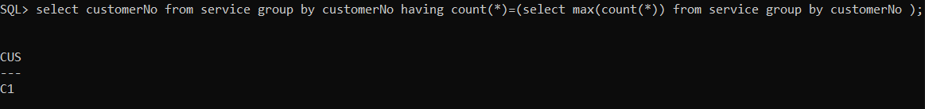

1. select distinct(customerNo) from service l where not exists((select partName from part where vehicletype='V1')MINUS(select PartName from (part natural join service) where customerNo=l.customerNo ))

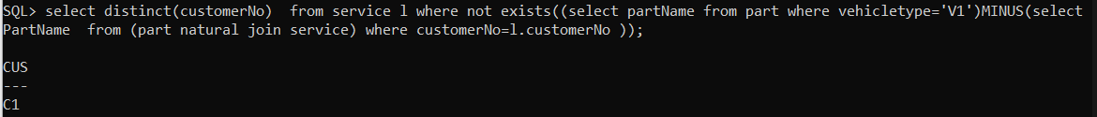

**PL SQL**

//set the server output to on

declare

Invalid_PartNumber Exception;

cursor c1 is select * from Part natural join Service;

cursor c2 is select * from Part;

pno Service.PartNo%TYPE;

profit Part.SalesPrice%TYPE := 0;

countPart number :=0;

begin

pno:=&partNo;

for q in c2

loop

if q.PartNo = pno then

countPart:=countPart+1;

end if;

end loop;

if countPart = 0 then

raise Invalid_PartNumber;

end if;

for p in c1

loop

if p.PartNo = pno then

profit := profit + (p.SalesPrice - p.UnitPrice) * p.Qty;

end if;

end loop;

dbms_output.put_line('Total Profit for part:'||profit);

Exception

when Invalid_PartNumber then

dbms_output.put_line('Invalid part number');

when others then

dbms_output.put_line('Error');

end;

/

**FOR exception**

