iSmartRAG — Project Approach Note
Smart Study Assistant with RAG Chatbot
20th July 2026

1. Overview
iSmartRAG is a web application that lets students build a personal knowledge base from their own study material — PDFs, Word documents, PowerPoint slides, and websites — and then chat with it using a RAG (Retrieval-Augmented Generation) powered chatbot. Every answer is grounded in the student's own uploaded content, with source citations showing exactly where the answer came from.

In addition to chat, students can generate MCQ quizzes from their material and get graded explanations — making it an active study tool, not just a search engine.

2. Problem Statement
Students studying from multiple sources — textbooks, lecture slides, handwritten notes, reference websites — have no unified way to query across all of them. Existing tools like ChatGPT answer from general training data, not from the student's specific syllabus. iSmartRAG solves this by building a personal, private vector knowledge base per user that the chatbot queries exclusively.

3. Core Features

Feature | Description
Document Ingestion | Upload PDFs, DOCX, PPT → chunk → embed → store in ChromaDB
Website Ingestion | Paste any URL → scrape → chunk → embed → same pipeline as docs
RAG Chatbot | Multi-turn chat strictly grounded in your uploaded docs + scraped pages
Source Citations | Every answer shows which chunk, page, or URL it came from
Quiz Generator | Auto-generate MCQs from any topic in your ingested material
Answer Evaluator | User answers quiz → LLM grades and explains mistakes
Multi-User | Each user has their own isolated doc + web collection

4. System Architecture
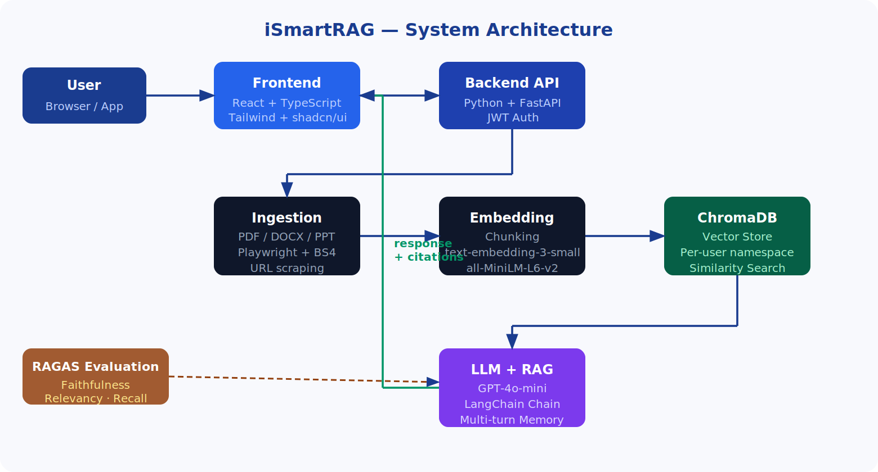

4.1 Document Ingestion Flow
- User uploads PDF / DOCX / PPT via the frontend
- Backend parses and extracts clean text
- Text is split into overlapping chunks (e.g. 500 tokens, 50 overlap)
- Each chunk is embedded using OpenAI text-embedding-3-small
- Embeddings stored in ChromaDB under the user's namespace

4.2 Website Ingestion Flow
- User pastes a URL in the frontend
- Playwright opens the page (handles JS-rendered content)
- BeautifulSoup extracts clean text (strips nav, footer, ads)
- Recursive crawler follows internal links up to depth 2 / max 20 pages
- Each scraped page goes through the same chunker → embedder → ChromaDB pipeline
- Source metadata stored as URL + page title per chunk

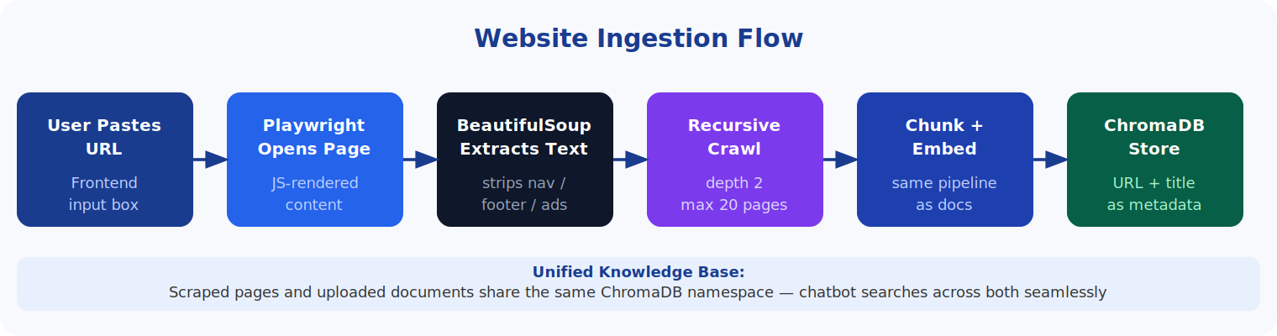

4.3 RAG Chatbot Flow
- User sends a message in the chat interface
- Query is embedded and matched against ChromaDB (top-k similarity search)
- Retrieved chunks + last N conversation turns stuffed into the prompt
- GPT-4o-mini generates a grounded answer
- Response returned to UI with citation chips (filename or URL source)
- If no relevant chunk is found, the bot says so — no hallucination

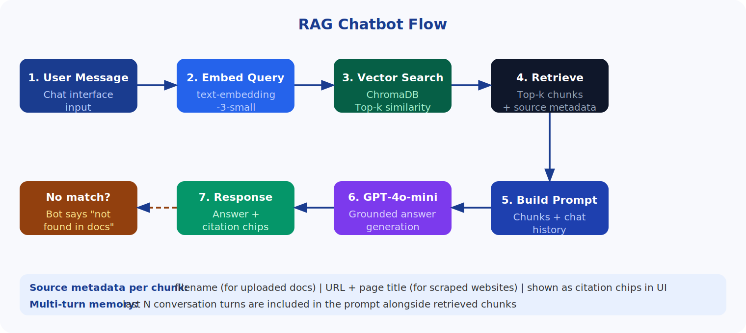

5. Technology Stack

Layer | Technology
Backend | Python + FastAPI
Scraping | Playwright + BeautifulSoup (recursive, depth-limited)
Vector DB | ChromaDB
Embeddings | text-embedding-3-small (OpenAI) or all-MiniLM-L6-v2 (free)
LLM | GPT-4o-mini
Frontend | React + TypeScript + Tailwind + shadcn/ui
Auth | JWT
Containers | Docker + docker-compose
Cloud | Oracle Cloud Always Free (ARM VM — 4 CPU, 24 GB RAM)
Reverse Proxy | Nginx + Let's Encrypt SSL
CI/CD | GitHub Actions → GHCR → SSH deploy to Oracle VM
Evaluation | RAGAS (faithfulness, relevancy, context recall)

6. Deployment Architecture
The application will be fully containerized using Docker and deployed on Oracle Cloud Always Free infrastructure (ARM VM — 4 CPU, 24 GB RAM, completely free). This gives us a real production deployment with a public domain and SSL.

6.1 Container Setup
- Container 1 — FastAPI backend
- Container 2 — React frontend served via Nginx
- Container 3 — ChromaDB
- docker-compose manages all three locally and on the VM

6.2 CI/CD Pipeline (GitHub Actions)
- Trigger: push to main branch
- Step 1 — Lint (flake8 for Python, eslint for React)
- Step 2 — Unit tests (pytest)
- Step 3 — Docker build for backend and frontend images
- Step 4 — Push images to GitHub Container Registry (GHCR)
- Step 5 — SSH into Oracle VM, pull new images, docker-compose up
- Result: every push to main auto-deploys to production

6.3 Networking
- Nginx reverse proxy routes traffic to the right container
- Let's Encrypt SSL for HTTPS (free, auto-renewing)
- Single public IP, Nginx handles /api → FastAPI and / → React

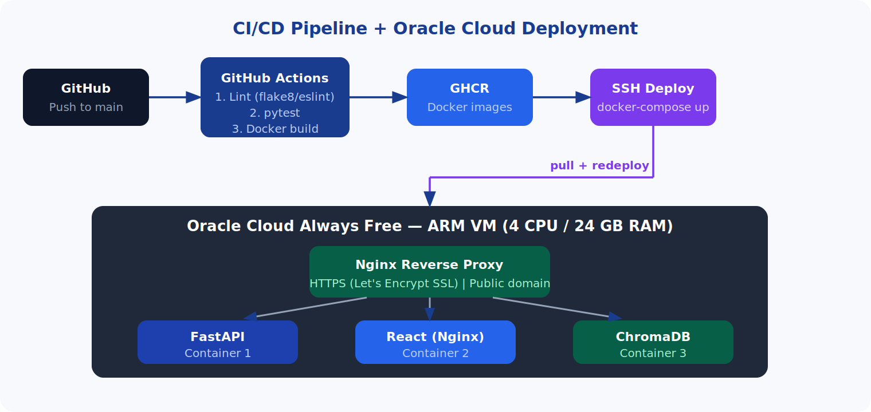

7. What Makes This Stand Out
- Dual ingestion — documents and live websites in one unified knowledge base
- Production deployment — real domain, HTTPS, cloud VM — not just localhost
- CI/CD — automated deploys; most college projects have never touched this
- Per-user isolated vector spaces — proper multi-tenancy, not a shared DB
- RAGAS evaluation — quantified RAG quality metrics (faithfulness, relevancy, context recall)
- Multi-turn memory — chatbot remembers context from earlier in the session

8. Proposed Timeline

Month | Milestone
Month 1 | Architecture finalized, Docker setup locally, basic ingestion + ChromaDB working
Month 2 | RAG chatbot end-to-end, website scraper integrated, unified pipeline
Month 3 | Frontend complete — file upload, URL input, chat UI, quiz mode
Month 4 | Auth, CI/CD pipeline, Oracle Cloud deployment, Nginx + SSL
Month 5 | RAGAS evaluation, bug fixes, documentation, report writing
Month 6 | Presentation prep, demo video, paper draft if targeting conference

9. Research Foundation — Base Papers
This project is grounded in published research across three intersecting areas: RAG for education, web scraping for RAG knowledge bases, and multi-document question answering. The papers below serve as our academic foundation and can be cited in the project synopsis and report.

9.1 Foundational RAG Paper
Lewis et al. (2020) — Retrieval-Augmented Generation for Knowledge-Intensive NLP Tasks The original paper that introduced RAG. Establishes the core architecture of combining a retriever with a generator — the backbone of our entire system. Link: https://arxiv.org/abs/2005.11401

9.2 RAG for Education
Maryamah et al. (2024) — Chatbots in Academia: A RAG Approach for Improved Efficient Information Access Published at KST 2024 (IEEE). Directly covers RAG-based academic chatbots — the closest published paper to our core use case. Link: https://ieeexplore.ieee.org/document/10499868
Survey Paper (2025) — Towards Efficient Educational Chatbots: Benchmarking RAG Frameworks arXiv 2025. Benchmarks RAG frameworks specifically for educational chatbots and uses RAGAS as the evaluation standard — directly validates our evaluation approach. Link: https://arxiv.org/abs/2503.00781
Survey Paper (2025) — Retrieval-Augmented Generation (RAG) Chatbots for Education: A Survey of Applications Comprehensive survey of RAG chatbot applications in education, covering hallucination reduction and domain-specific grounding — directly justifies why RAG over plain LLMs. Link: https://www.researchgate.net/publication/390700272

9.3 Web Scraping + RAG
Research Paper (2025) — RAG Based Implementation for Smart Web Scraping using Crawl4AI Covers combining BeautifulSoup-based web scraping with chunking, vectorization, and semantic search for RAG — directly mirrors our website ingestion pipeline. Link: https://www.researchgate.net/publication/393916689
Benita et al. (2024) — Implementation of RAG in Chatbot Systems for Enhanced Real-Time Customer Support IEEE ICACRS 2024. Covers RAG systems built on scraped website content — validates our dual ingestion (documents + URLs) architecture. Link: https://ieeexplore.ieee.org/document/10895375

9.4 Multi-Document QA
Research Paper (2026) — Enhanced RAG Framework for Intelligent Multi-Document Question Answering Directly maps to our multi-source ingestion — PDFs, DOCX, PPT, and websites all feeding one unified vector knowledge base for QA. Link: https://rsisinternational.org/journals/ijrsi/view/enhanced-retrieval-augmented-generation-framework-for-intelligent-multi-document-question-answering

9.5 RAG Evaluation (RAGAS)
Es et al. (2024) — RAGAS: Automated Evaluation of Retrieval Augmented Generation EACL 2024. The paper behind the RAGAS library we will use to evaluate our system on faithfulness, answer relevancy, and context recall. Link: https://arxiv.org/abs/2309.15217

Our novelty claim: none of the above papers combine all three aspects — educational RAG chatbot + website ingestion + quiz generation + RAGAS evaluation + CI/CD cloud deployment — into one unified student-facing system. That combination is our original contribution.

10. Next Steps for the Team
- Review this note and confirm agreement on scope and stack
- Divide modules among team members based on interest and strengths
- Set up shared GitHub repository with branch protection rules
- Get API keys — OpenAI (or decide on free embedding alternative)
- First meeting: finalize architecture diagram and start Month 1 tasks

