Project Documentation: CI/CD Pipeline Using Jenkins and Terraform on AWS

1. Project Overview
This project demonstrates how to automate the provisioning of AWS infrastructure using Jenkins and Terraform in a CI/CD pipeline.
The goal is to integrate Infrastructure as Code (IaC) into a continuous delivery workflow, allowing infrastructure to be created, validated, and managed automatically from a Jenkins pipeline using Terraform and AWS services.
Key Components:
- Jenkins → Automation server for CI/CD.
- Terraform → Infrastructure as Code tool for AWS resource provisioning.
- AWS → Cloud provider hosting the infrastructure (EC2, VPC, Subnet, S3).
- S3 Bucket → Used as Terraform backend for remote state management.
- GitHub → Version control system for storing Terraform and Jenkins files.

2. Architecture Diagram

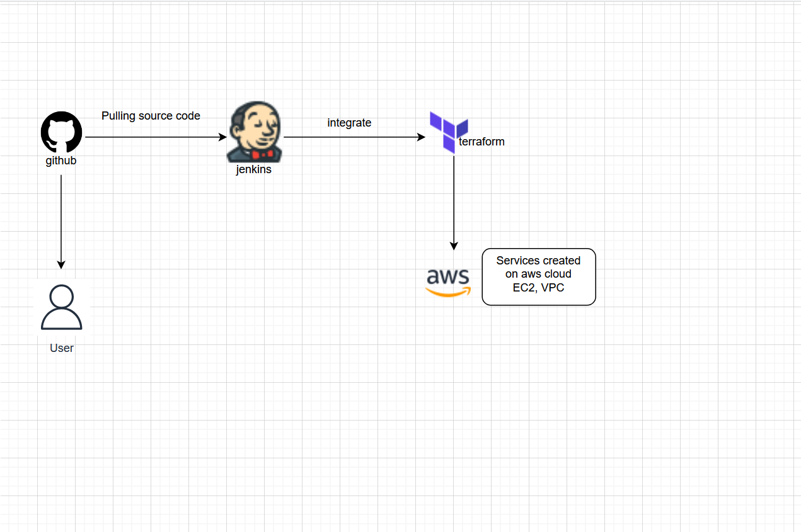

3. Prerequisites
Before starting the setup, ensure the following requirements are met:
- AWS Account
- IAM User with permissions:
  - AdministratorAccess
  - AmazonS3FullAccess
- S3 Bucket (for Terraform state file) → infra-terraform-state-aniket-2025
- EC2 Instance (Ubuntu 22.04) for Jenkins and Terraform
- Key Pair → account-a (used by Terraform for SSH access)
- Public GitHub Repository → jenkins-terraform-aws-cicd
4. Environment Setup

Jenkins Installation on EC2
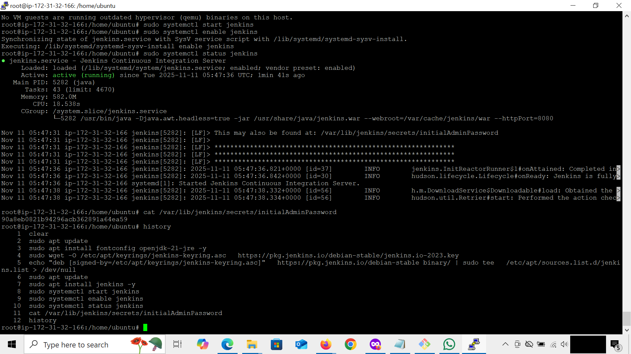

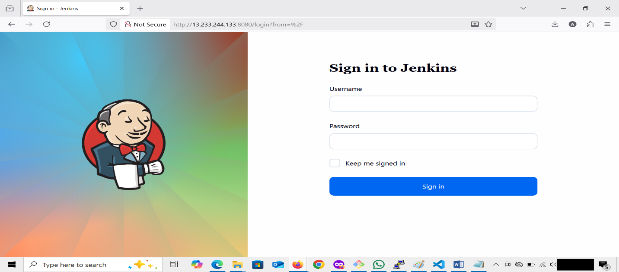

Terraform Installation on Jenkins EC2
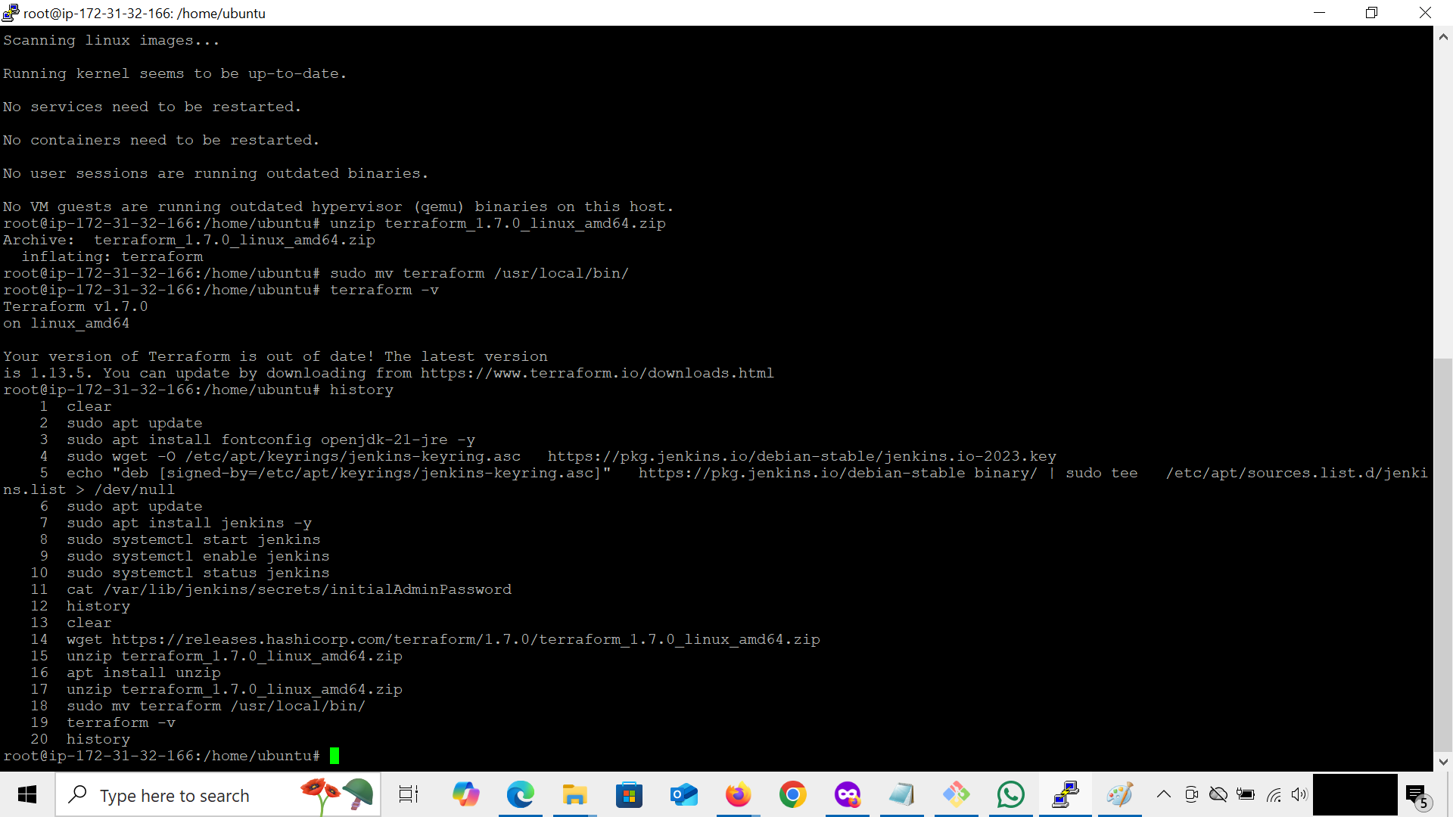

AWS CLI Installation
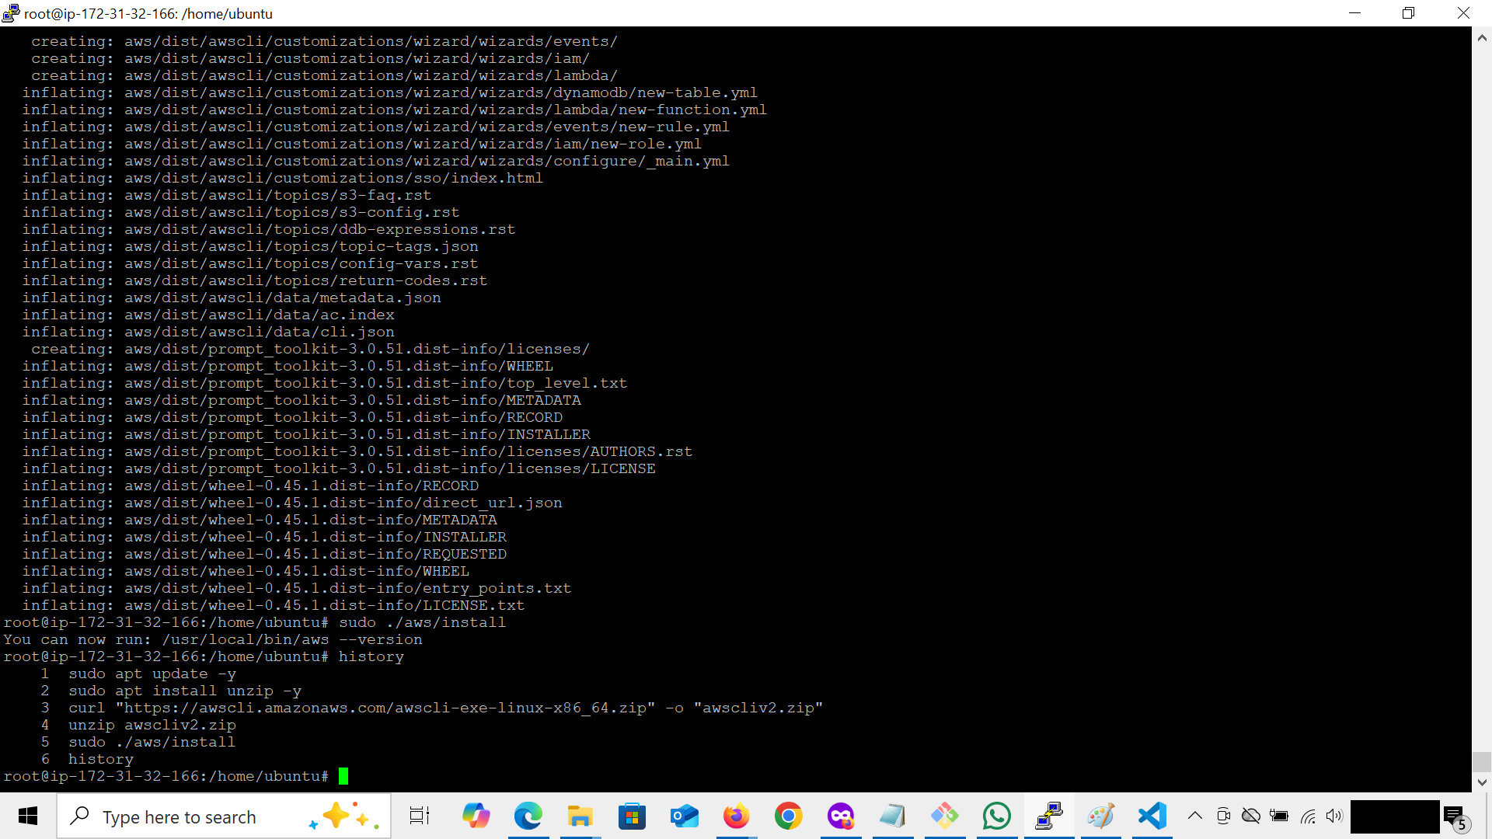

5. AWS Configuration

IAM User and Permissions
Created a dedicated IAM user jenkins-terraform-user with these policies:
- AdministratorAccess
- AmazonS3FullAccess
Used for Jenkins → Terraform AWS authentication.

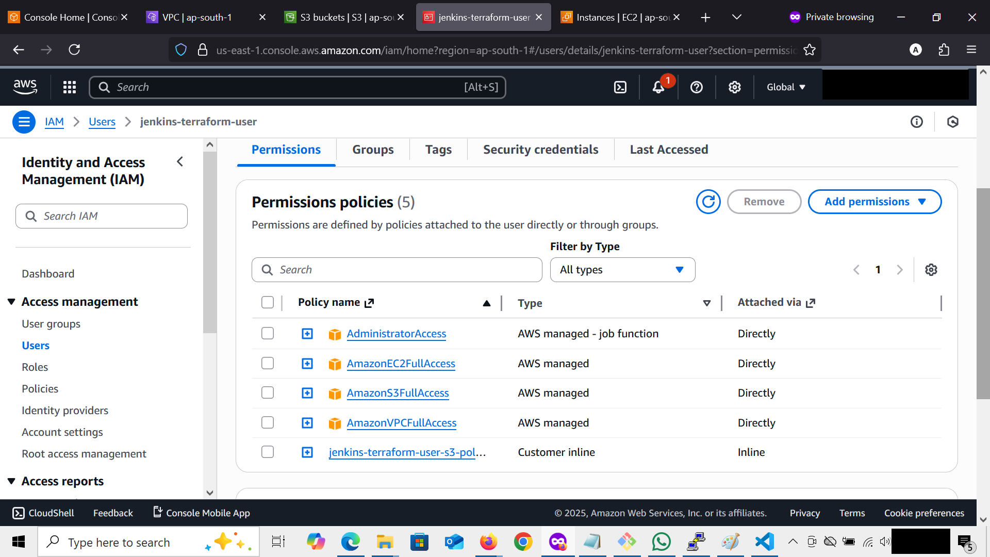

S3 Bucket for Terraform State

What is a Terraform State File?
When Terraform creates or updates infrastructure, it keeps track of all deployed resources in a state file named terraform.tfstate.
This file acts as a single source of truth for Terraform, it records details about every AWS resource created (like EC2 IDs, subnet IDs, VPC IDs, etc.), allowing Terraform to understand the current infrastructure state and make only necessary changes in the future.
Without this file, Terraform would have no idea what’s already deployed, leading to duplicated or mismatched resources.

Why Use a Remote Backend (S3)?
By default, Terraform stores its state file locally (on the Jenkins server).
However, this is not ideal for collaborative or CI/CD environments.
That’s why we use an AWS S3 bucket as a remote backend to

S3 bucket name: infra-terraform-state-aniket-2025
Region: ap-south-1
Used to store Terraform state files remotely for consistency and collaboration.
S3 bucket view in AWS Console
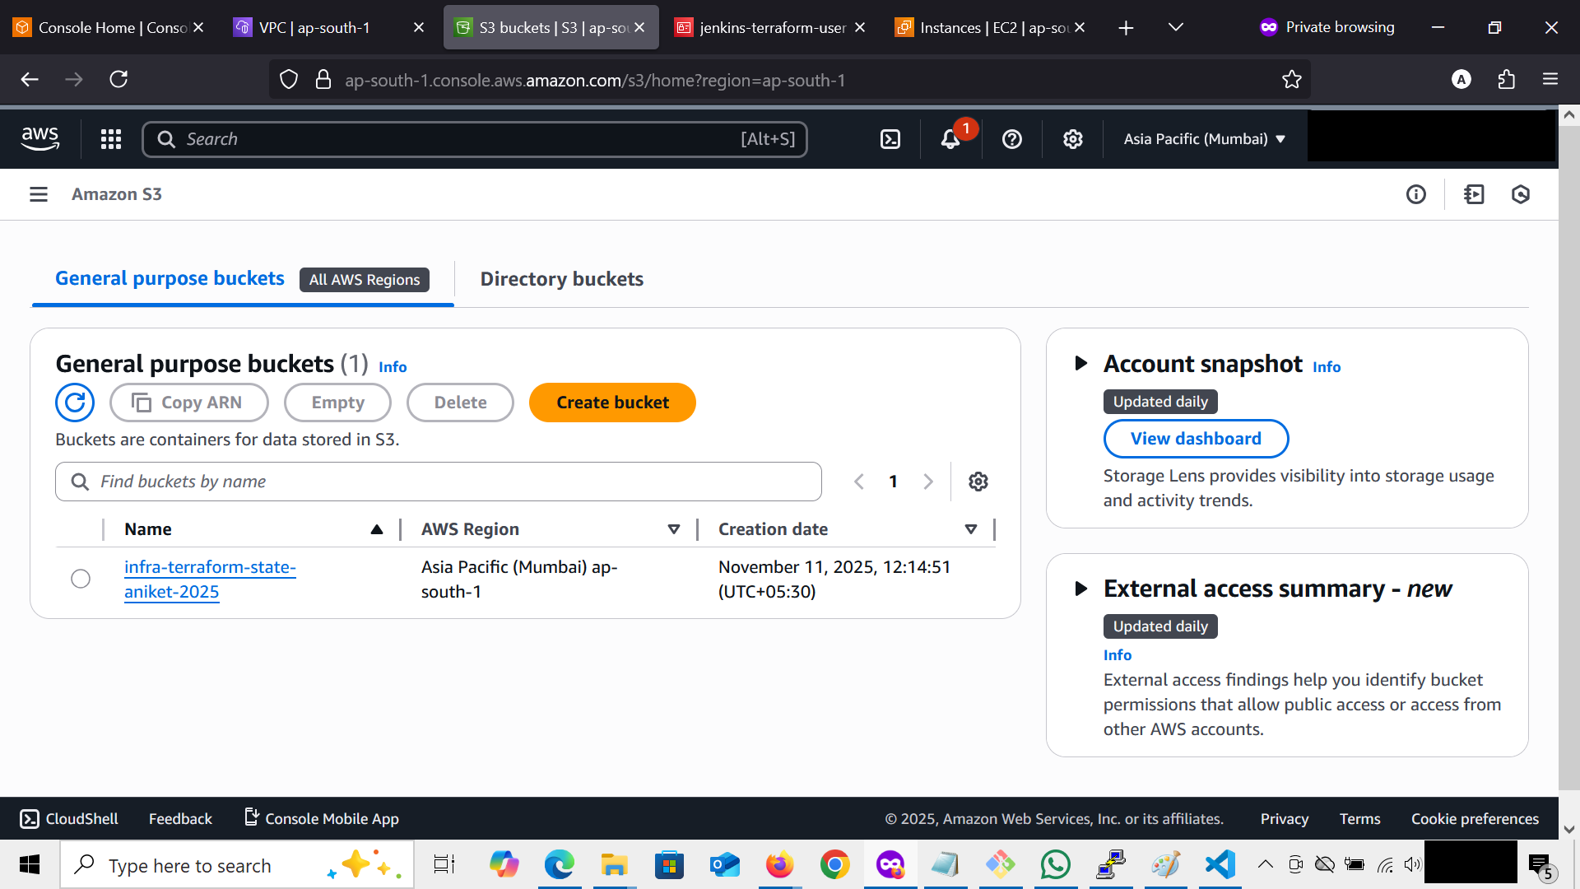

6. Jenkins Configuration

Required Jenkins Plugins
Installed via Manage Jenkins → Manage Plugins → Available:
- AWS Credentials Plugin
- Git Plugin
- Pipeline Plugin
- Terraform Plugin (optional)

Jenkins Credentials
Stored AWS keys securely:
- Go to Manage Jenkins → Manage Credentials
- Add New:
  - Kind: AWS Credentials
  - ID: AWS_ACCESS_KEY_ID
  - Access Key / Secret Key: from IAM user
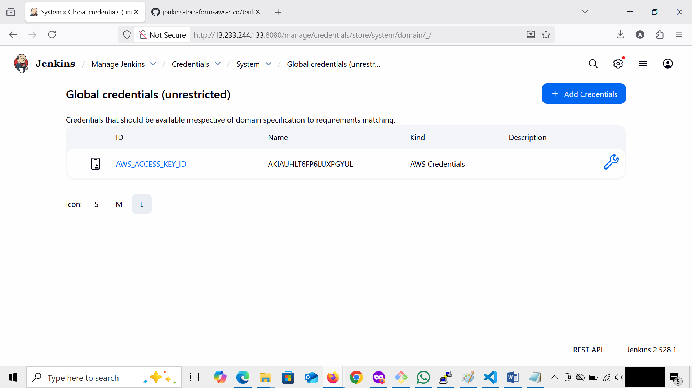

Jenkins Pipeline Configuration
- Go to Jenkins → New Item → Pipeline
- Set:
  - Definition: Pipeline script from SCM
  - SCM: Git
  - Repository URL: https://github.com/anikettalwekar/jenkins-terraform-aws-cicd.git
  - Branch: main
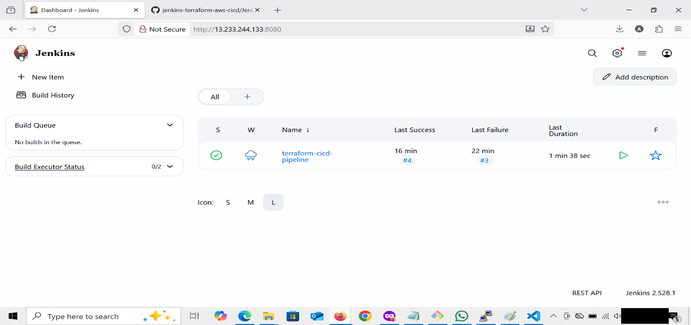

7. Terraform Configuration Files (Stored in GitHub)
- main.tf: Defines AWS VPC, Subnet, Security Group, and EC2 instance.
- variables.tf: Defines variable for key_name = "account-a".
- outputs.tf: Outputs instance details (ID, public IP, VPC ID).
- provider.tf: Configures AWS provider region and backend (S3).
File | Purpose
main.tf | Core infrastructure (VPC, subnet, EC2, SG)
variables.tf | Dynamic input parameters (key_name, region, etc.)
outputs.tf | Returns useful resource details
provider.tf | Connects Terraform to AWS region and backend

8. Jenkinsfile Explanation
Jenkinsfile defines all pipeline stages:
This provides automated, repeatable infrastructure delivery.
Stage | Purpose
Checkout Code | Pulls latest Terraform files from GitHub
Verify AWS Credentials | Validates IAM access using AWS CLI
Terraform Init | Initializes backend and providers
Terraform Validate | Checks syntax and configuration
Terraform Plan | Previews resource creation
Terraform Apply | Provisions AWS resources
Terraform Destroy (Optional) | Removes infrastructure
Jenkins console (pipeline start)
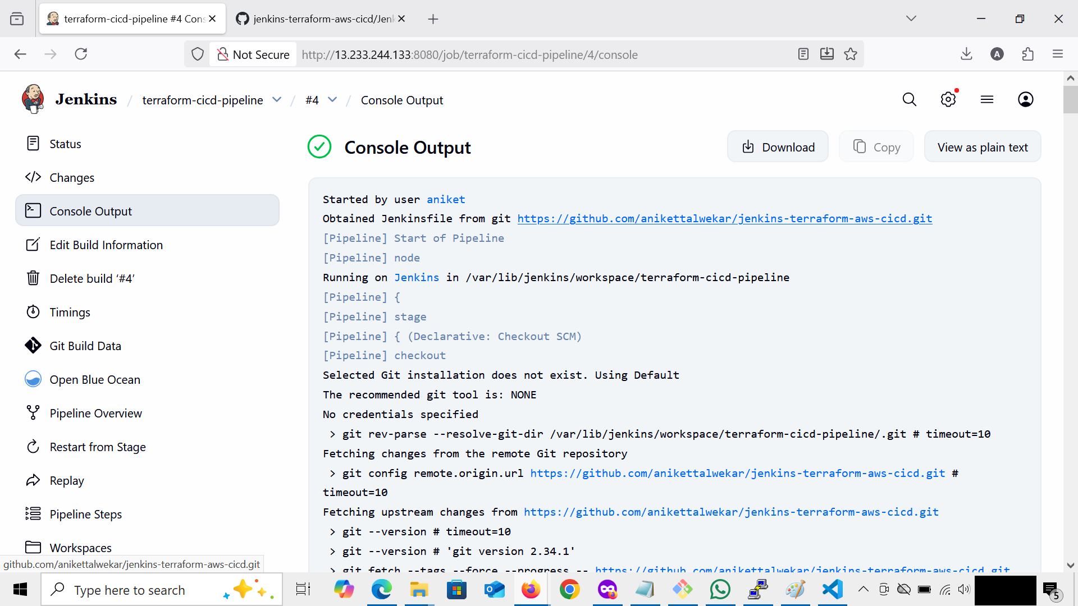

Jenkins console (pipeline end)
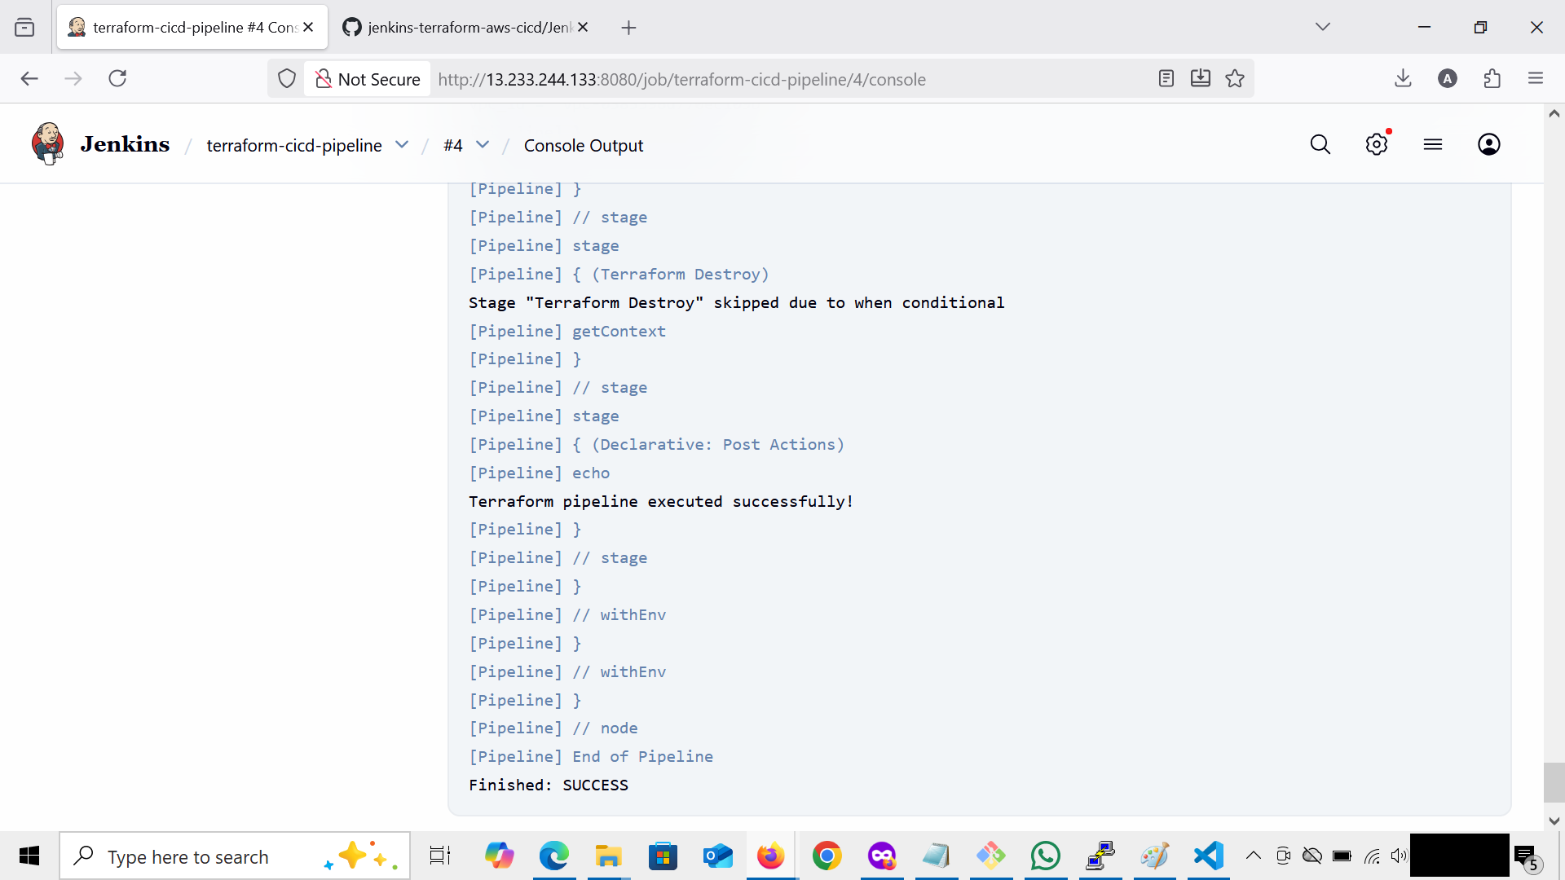
9. AWS Infrastructure Verification
After the successful Jenkins pipeline execution, Terraform automatically provisioned AWS resources as defined in the Terraform configuration files (main.tf, variables.tf, and provider.tf).

Resources Created by Terraform

Resource Type | Name | Description
VPC | infra-project-vpc | Custom Virtual Private Cloud created to host network resources
Subnet | infra-project-subnet | Public subnet within the VPC for EC2 instance deployment
Security Group | infra-project-sg | Allows inbound SSH (22) and HTTP (8080) traffic
EC2 Instance | infra-project-ec2 | EC2 instance automatically created by Terraform through Jenkins pipeline

EC2

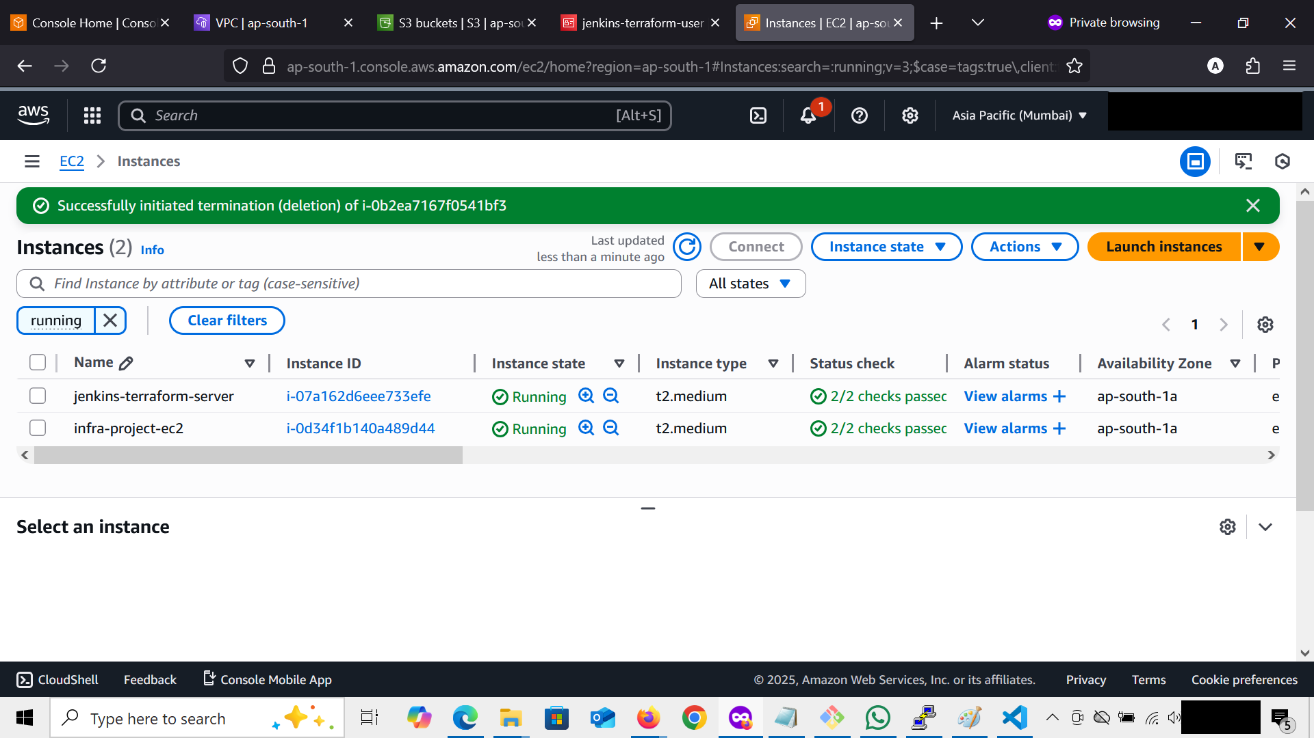
VPC
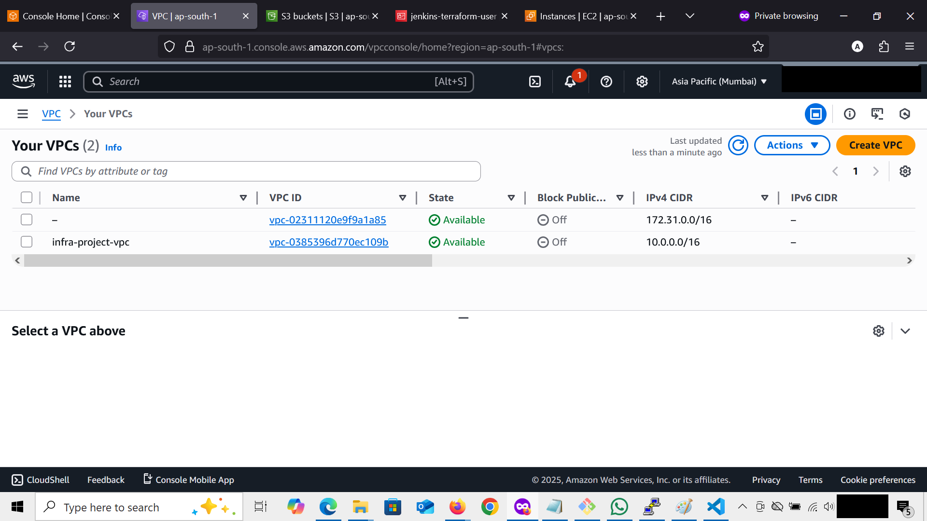

Subnet
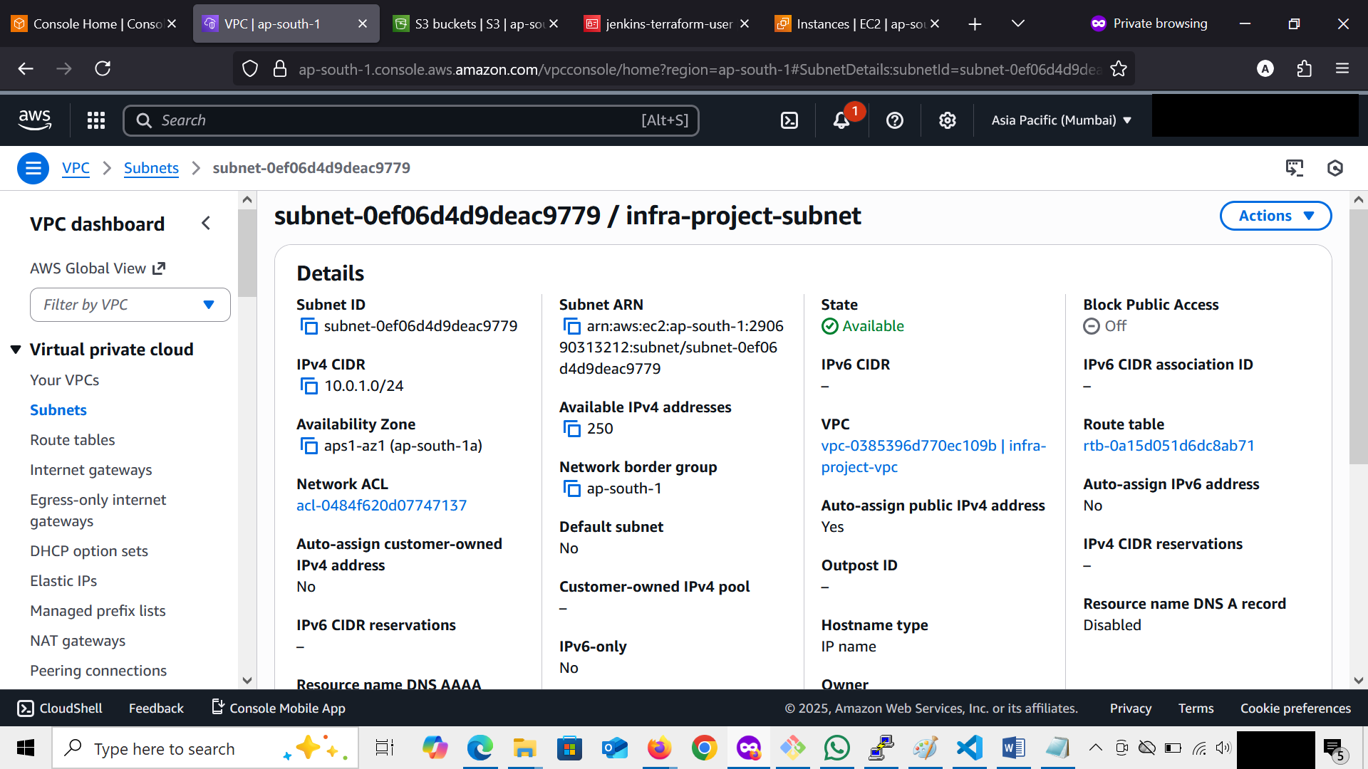

Security Group
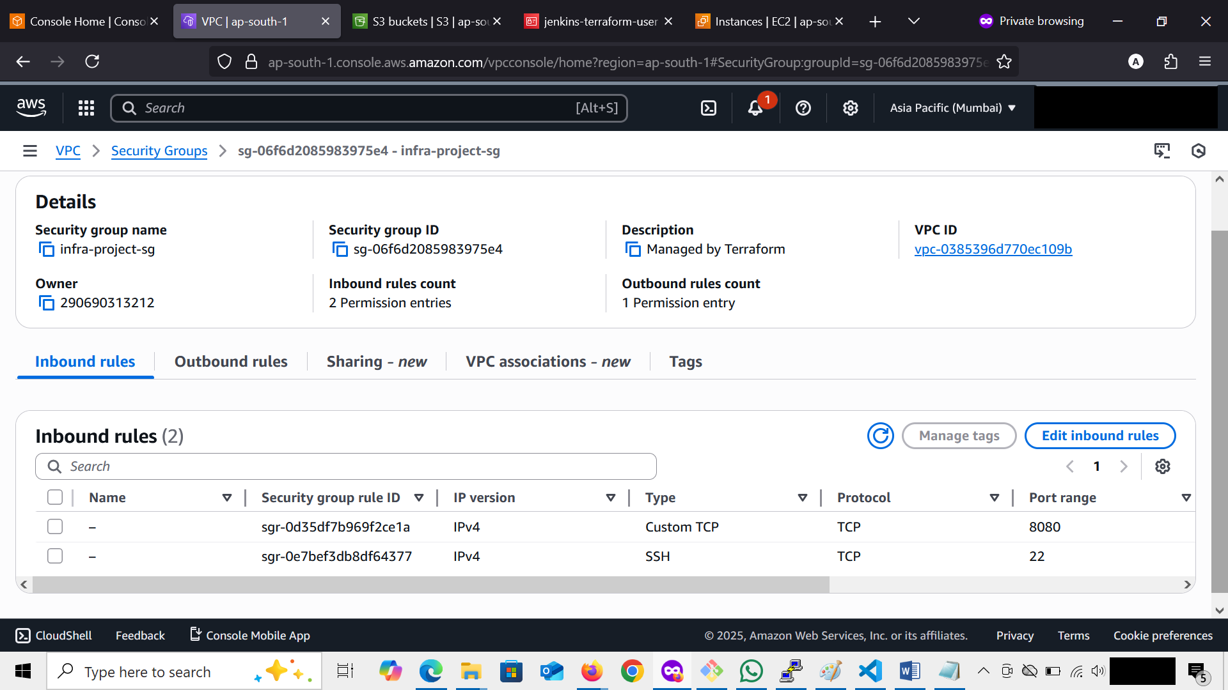

S3 Bucket: infra-terraform-state-aniket-2025
Key: terraform/state.tfstate
Region: ap-south-1
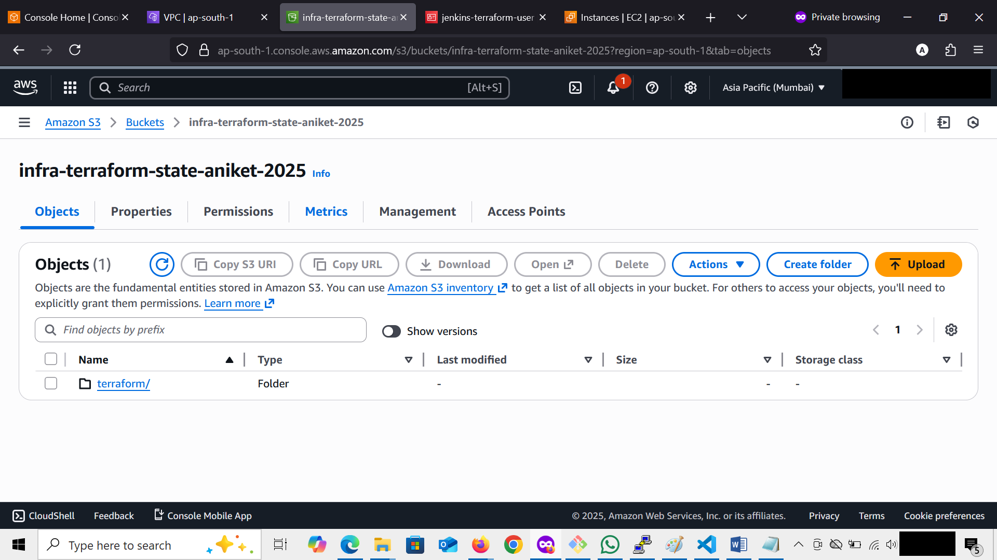
his ensures consistent state even if the Jenkins instance is recreated.

10. CI/CD Execution Workflow
- Developer pushes Terraform code to GitHub.
- Jenkins pipeline is triggered.
- Jenkins clones repo → verifies AWS creds → initializes Terraform.
- Terraform provisions EC2, VPC, subnet, and SG on AWS.
- Jenkins shows the build result and stores logs.
- State file is uploaded to S3.
- Destroy can be triggered for cleanup.

11. Destroy Infrastructure
Terraform destroy stage (optional) removes all created resources automatically:
terraform destroy -auto-approve

12. Conclusion
This project demonstrates a complete CI/CD workflow integrating Jenkins, Terraform, GitHub, and AWS.
The system automates infrastructure deployment and management using Infrastructure as Code (IaC).

Key Achievements:
- Jenkins automates Terraform workflows.
- Infrastructure is stored, versioned, and auditable.
- Remote state management with S3 ensures team consistency.
- Scalable foundation for multi-environment (Dev/Stage/Prod) CI/CD pipelines.

