**CAMPUS EVENTS AND ACTIVITES**



**CALENDAR SUBMISSION**

|  |  |  |
| --- | --- | --- |
| Project Title: Campus Events | **Report** |  |
| Submission Date: [30-11-23] |  |
| Submitted by: |  |
| **NAME** | **Reg.no** | **ROLL.NO** |
| I. Jayant Singh Rathore | 12318747 | 67 |
| II. Aniket Verma | 12319353 | 68 |
| III. Kunal Tudu | 12319746 | 71 |

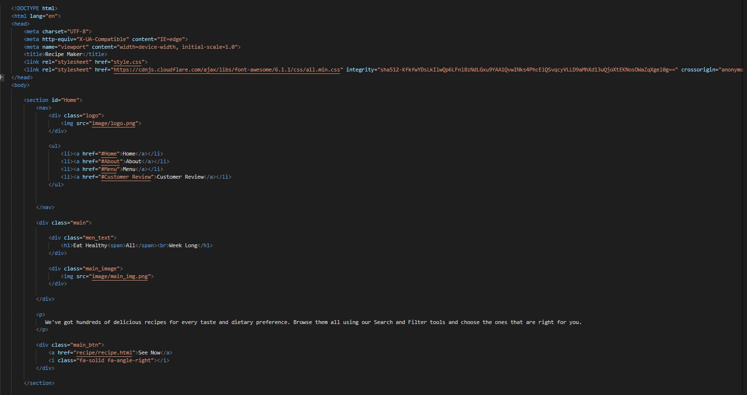FRONT PAGE CODE =



INTRODUCTION :

Welcome to our dynamic Campus Events and Activities Calendar, your gateway to the pulse of our vibrant university life! This one-page introduction serves as your passport to a kaleidoscope of experiences awaiting you on campus. Dive into a rich tapestry of academic lectures, engaging workshops, cultural celebrations, and thrilling sports events that define the rhythm of our university community.

As you explore this meticulously curated calendar, envision a journey of intellectual curiosity, social connection, and personal growth. Join us in embracing the myriad opportunities that shape the essence of our campus life – where every day unfolds as a chapter in a captivating narrative of learning, collaboration, and unforgettable moments. Step into the heartbeat of our community; your adventure begins here!



# Features and Functionality :

The Recipe Meal Planner And Grocery List Generator offers the following key features:

1. Enjoy the recipes of various Meals: A detailed recipe and the ingredients used for the making the Meal

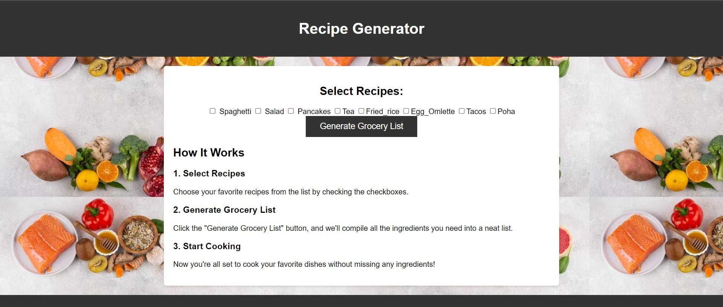

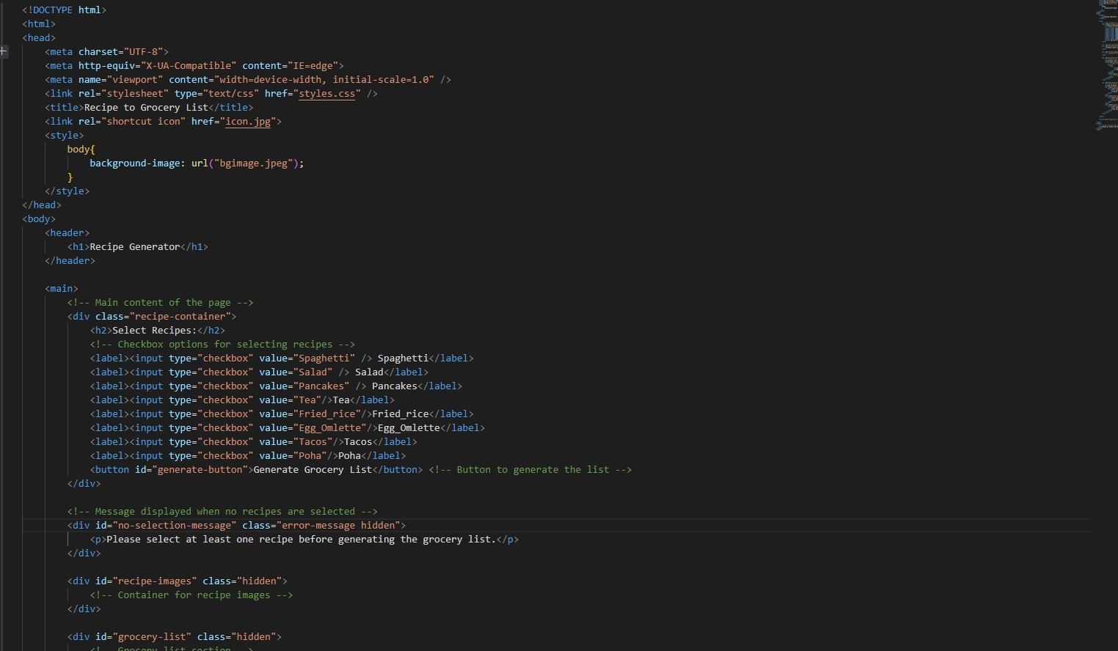

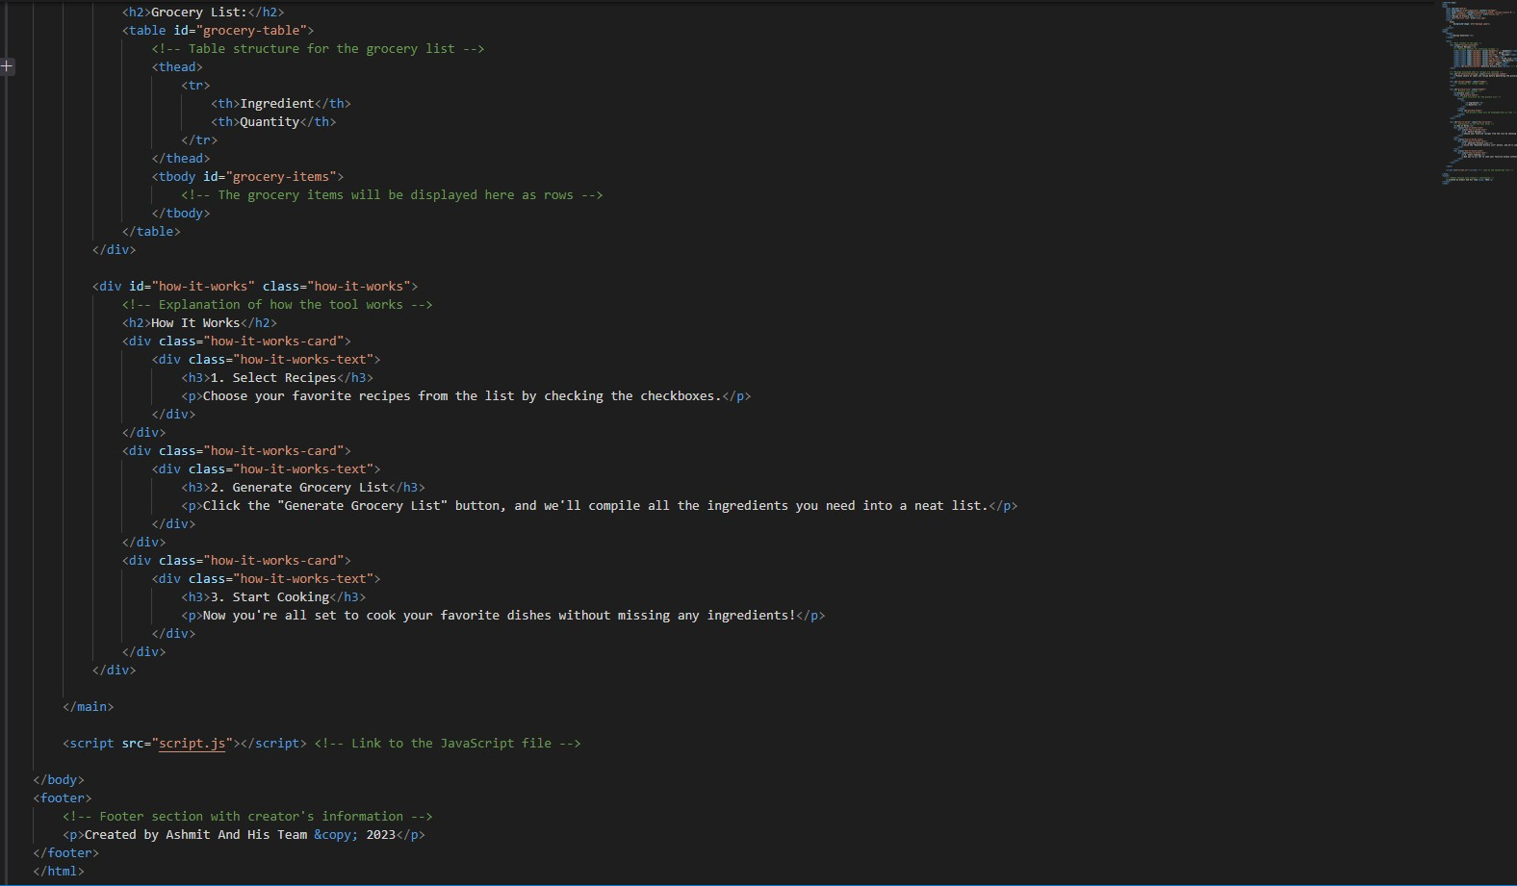

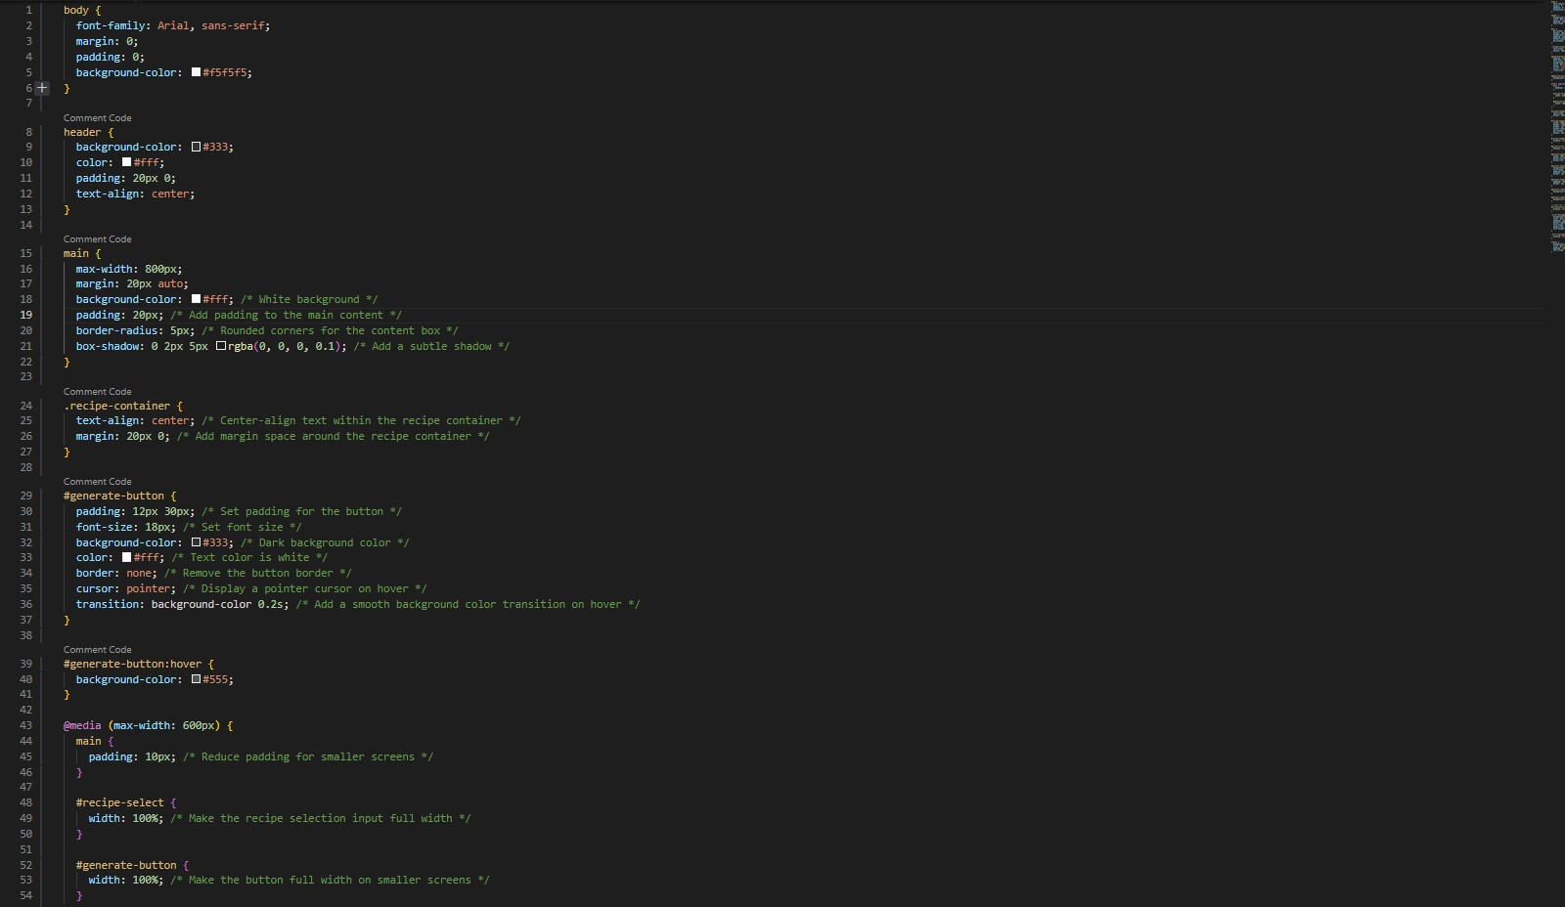

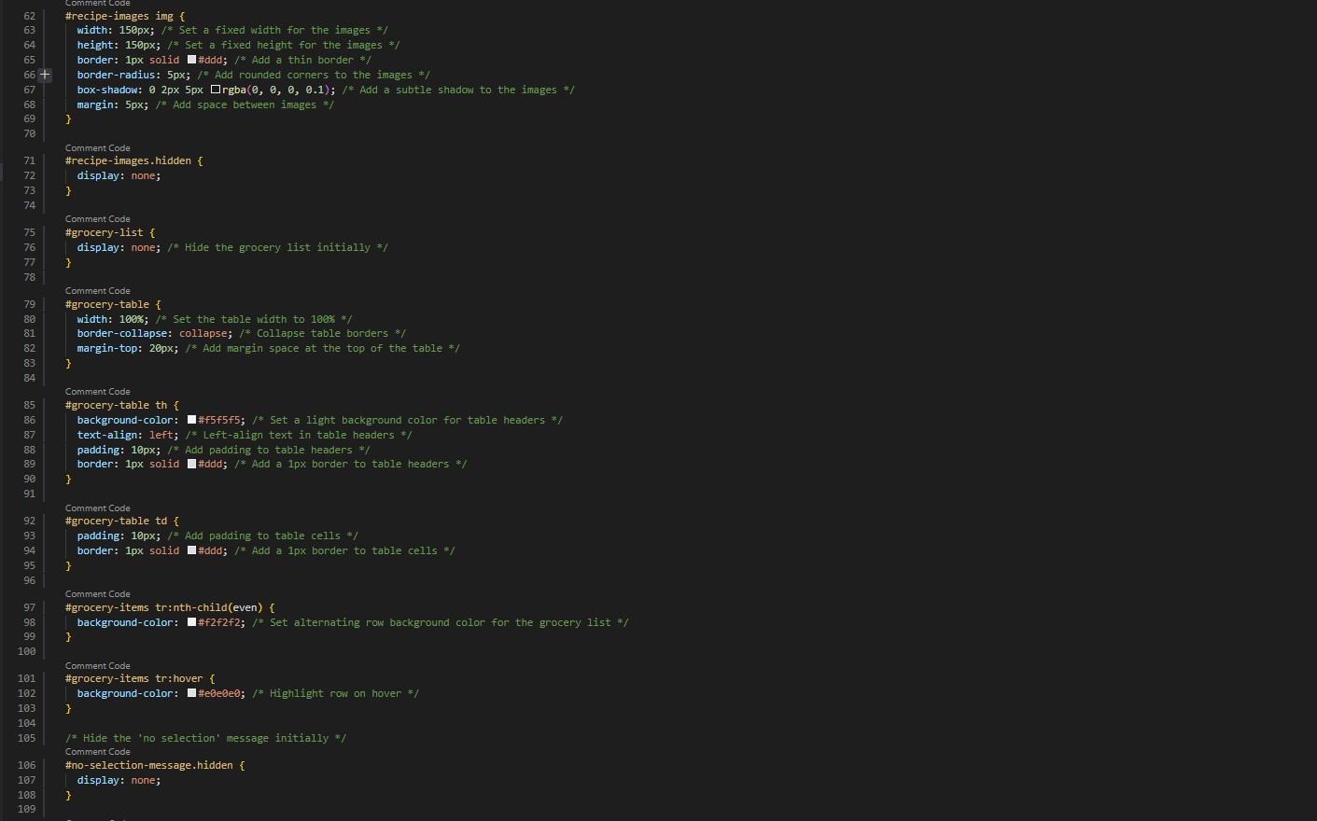

1. 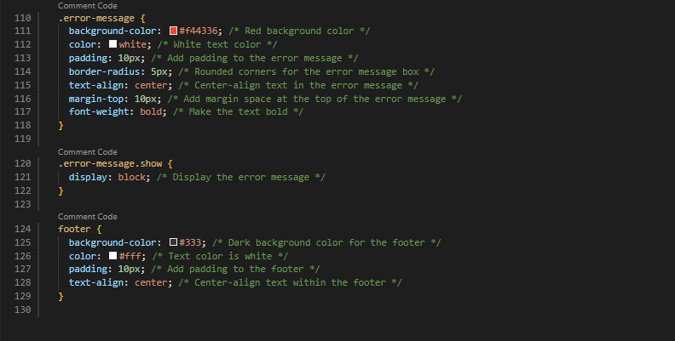About us:



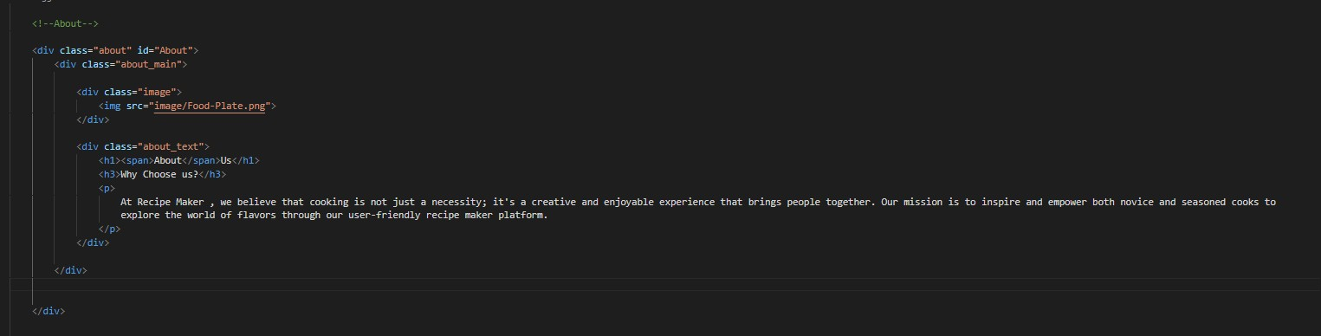

# User Interface:

The user interface is user-friendly and intuitive, designed to provide a seamless experience for users and is very helpfull for the people for generating their grocery list.

# Customer Review:

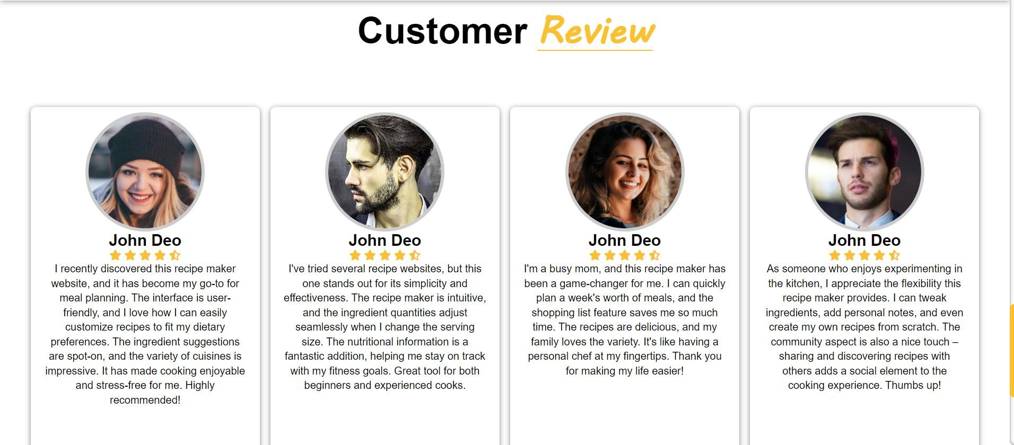

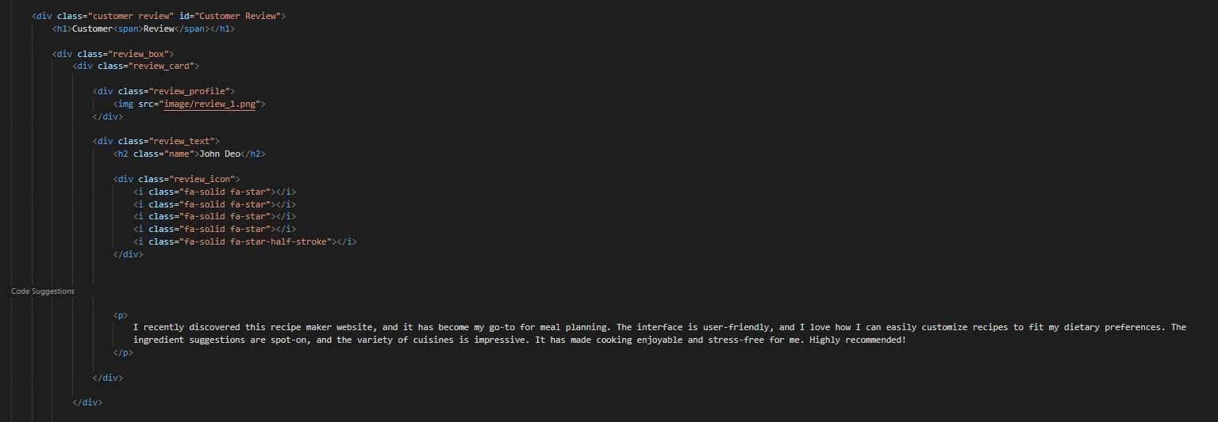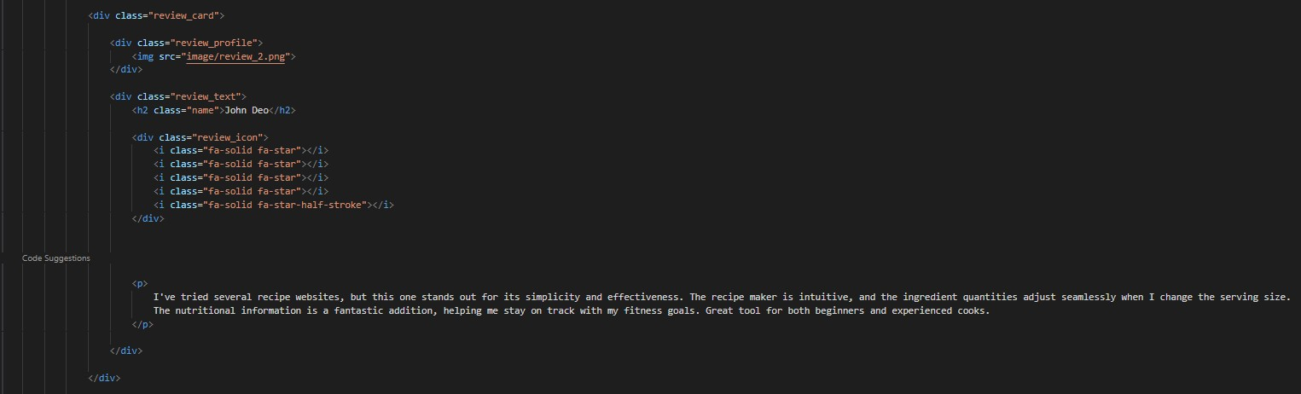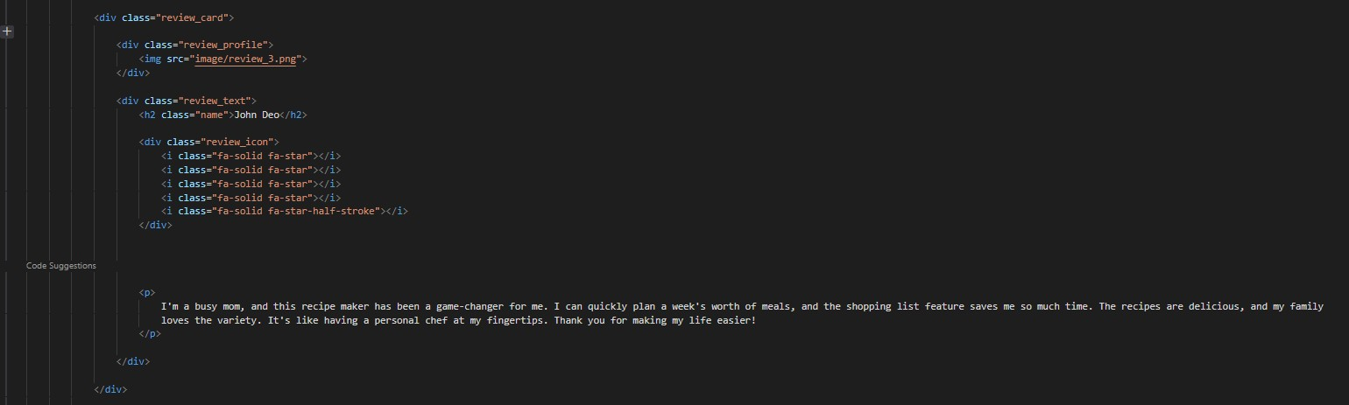

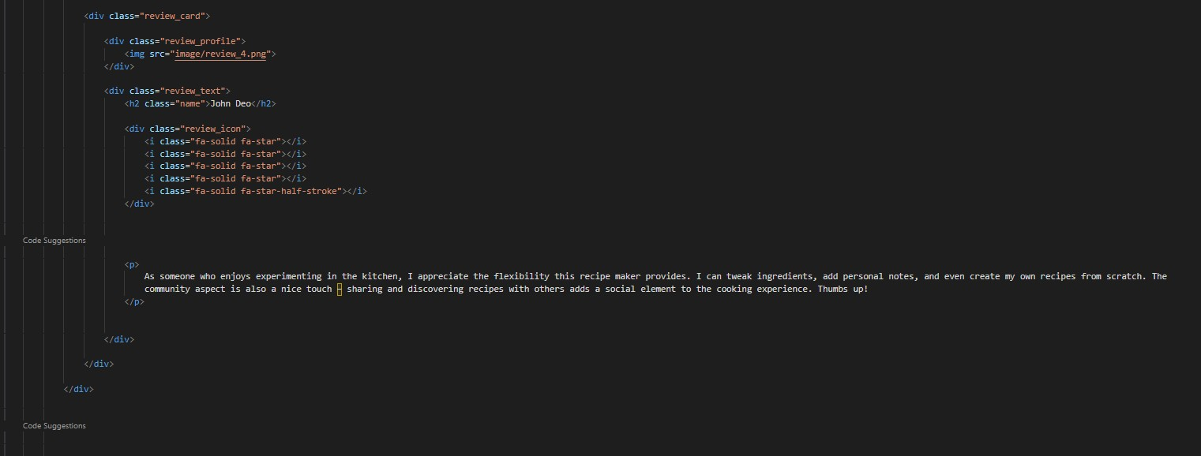

Menu:

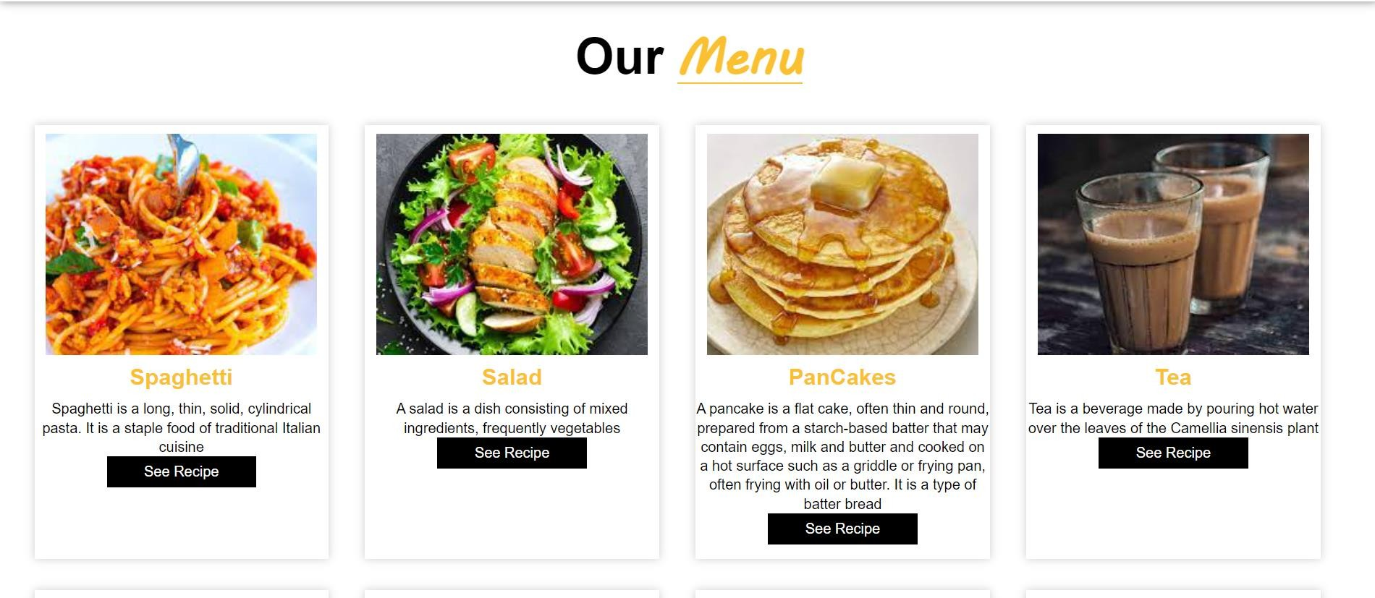

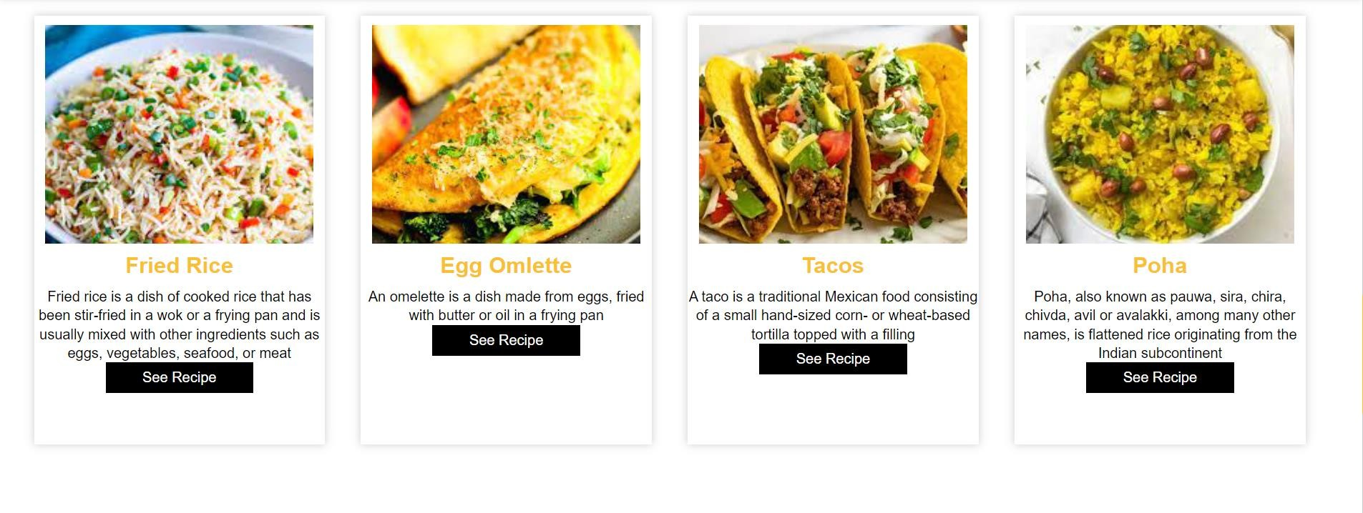

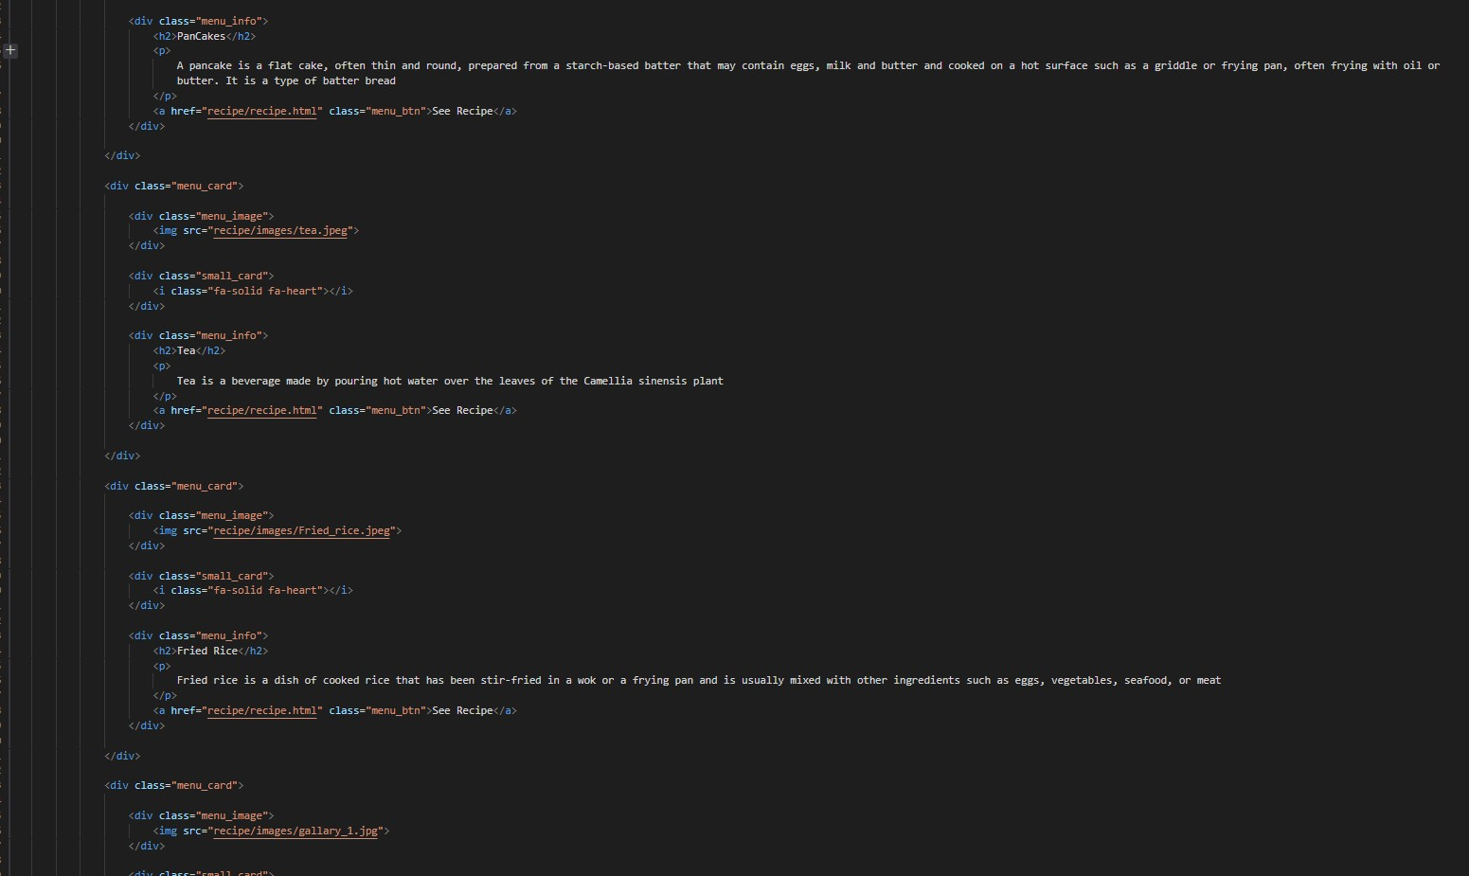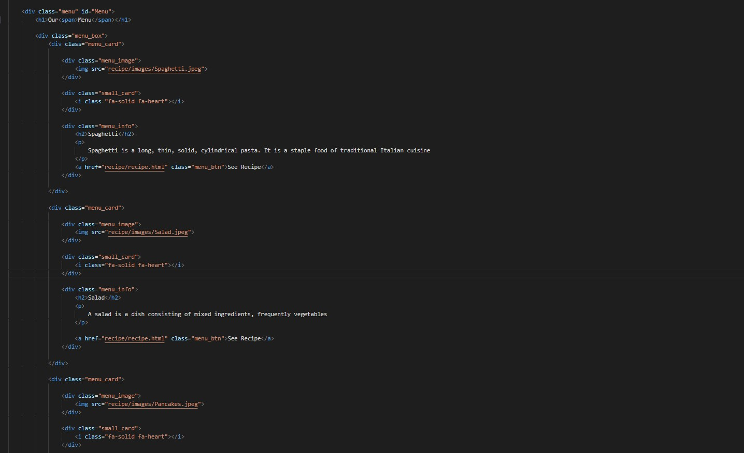

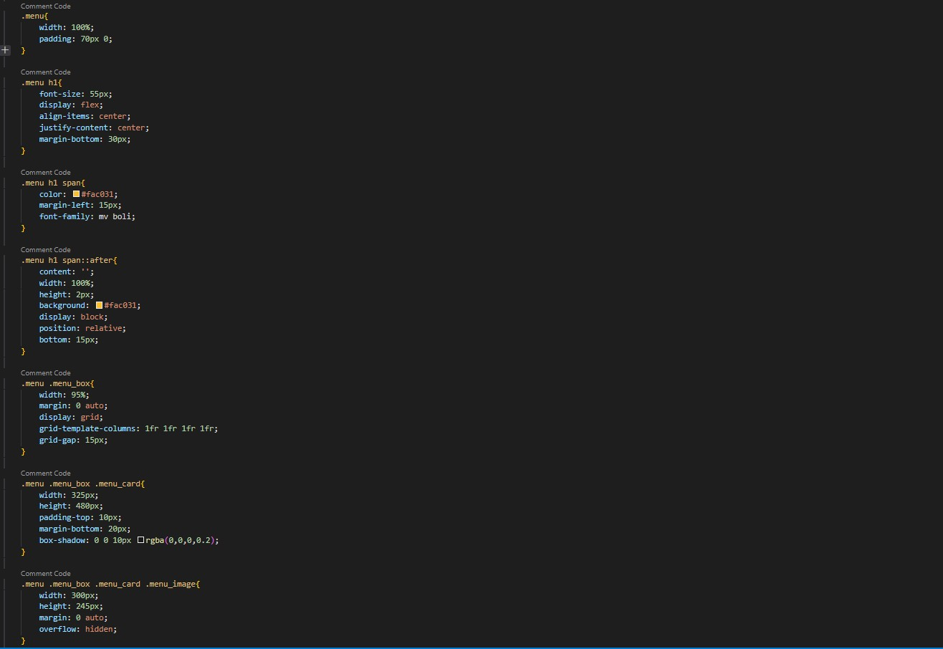

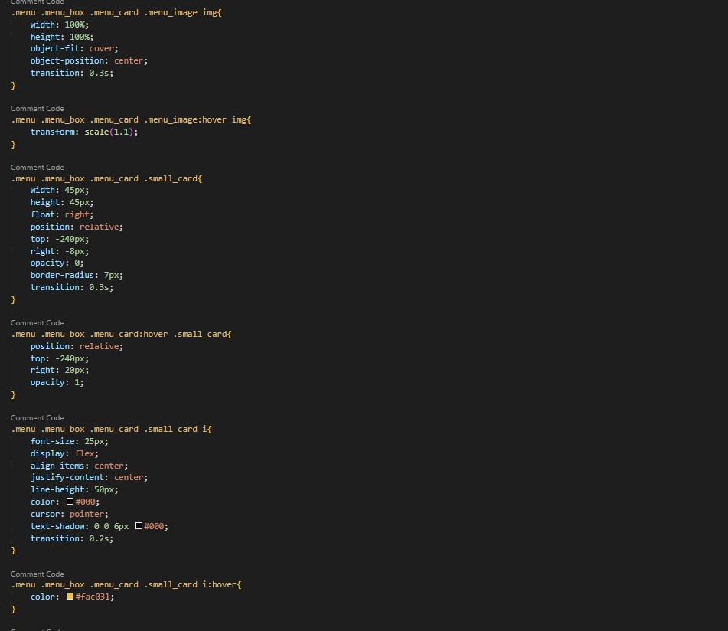

# Recipe Generator:

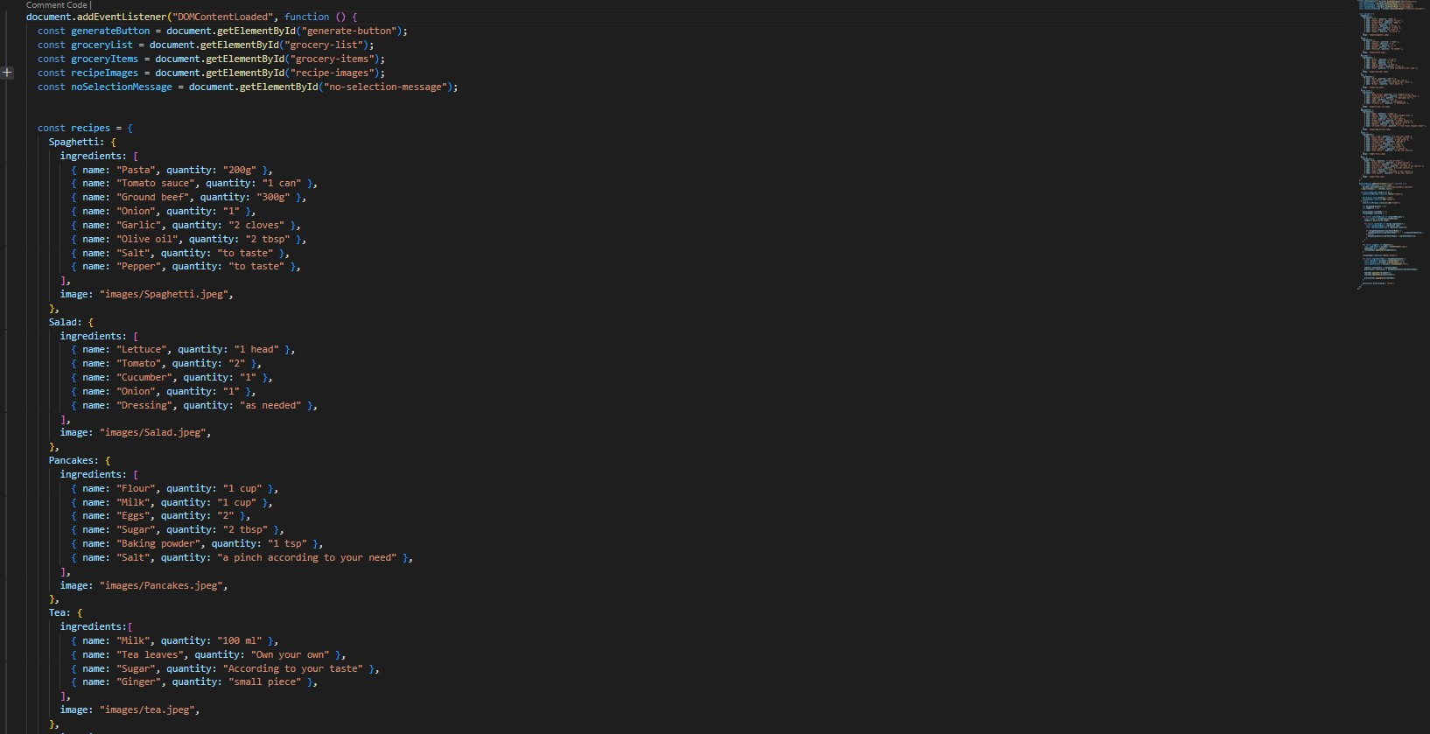

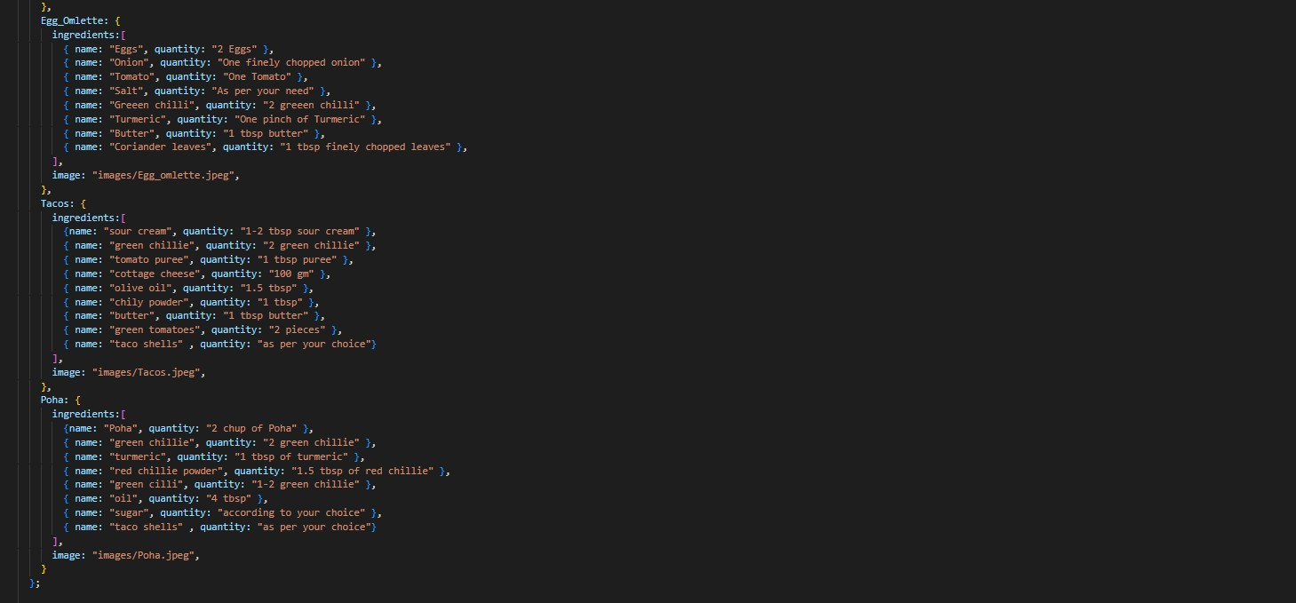

Contacts:



