Ecosystem Description

## Ecosystem Env1_sdm1, Mesic warm coastal lichenfields

Env1_sdm1, Mesic warm coastal lichenfields. Primarily occurs on flat, rocky coastlines or low outcrops, which have frequent cloud cover and may receive thick seasonal snow cover. Exposure to meltwaters is higher than other ecosystem types in the group. The dominant biota include several lichen species. Includes areas suitable for penguin colonies (Gentoo, Chinstrap), except where adjacent to ice shelves.

### Photos (if available)

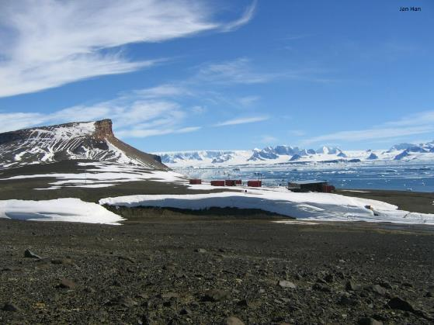

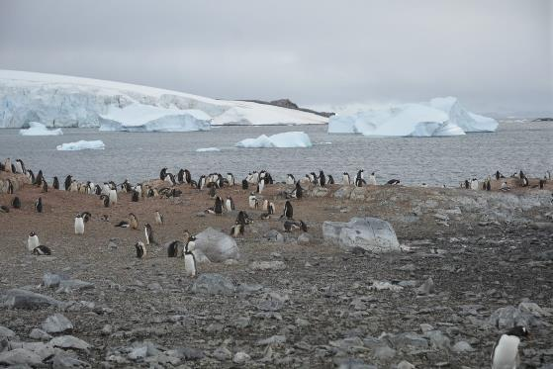

### Distribution

Maps - Full map

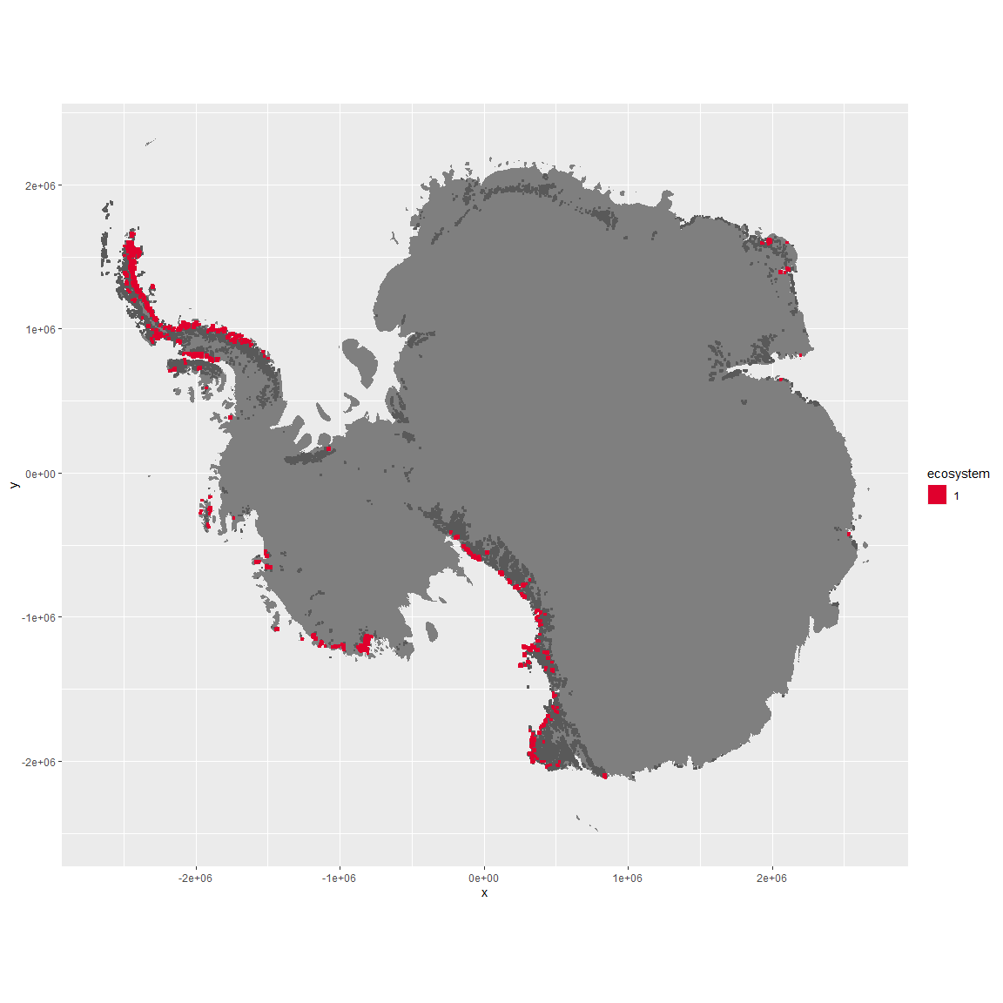

Regional maps

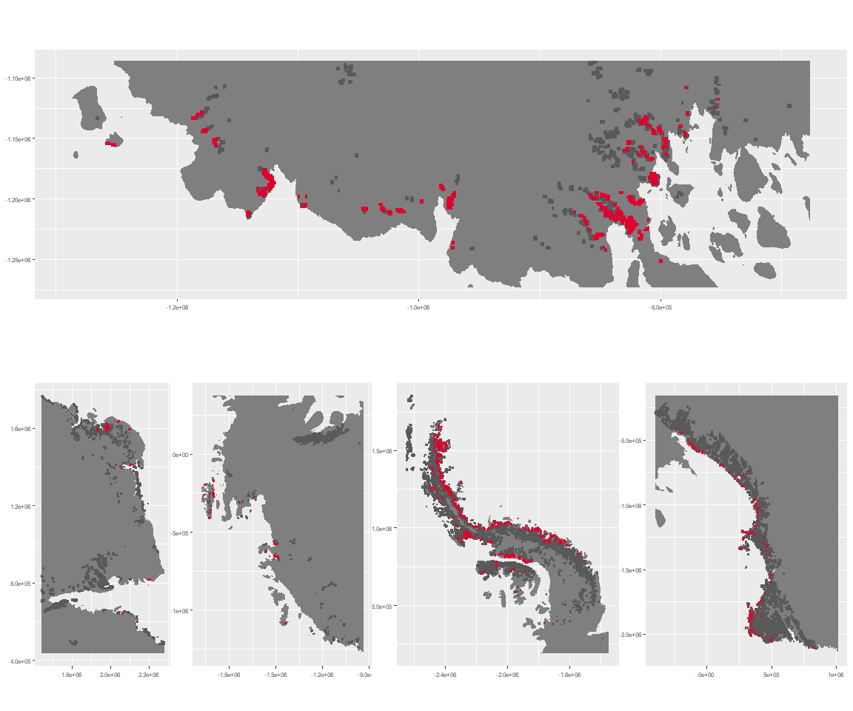

### Environment

The unit env1_sdm1 is part of the environmental supergroup env1.

This supergroup is, on average, substantially higher in sumtemp, temp, modT_0315 and melt than continental antarctica. It is substantially lower in slope, rugos and elev than the rest of the continent.

The elevation of unit env1_sdm1 ranges from 0 to 1793 metres above sea level, but 90% of its pixels fall above 51 and below 900 metres. Its average elevation is 437 metres.

The unit is higher in cloud, temp, sumtemp, DDminus5 and precip and lower in no variables than the rest of its environmental supergroup.

#### Distinctiveness of the unit from its group and the rest of Antarctica

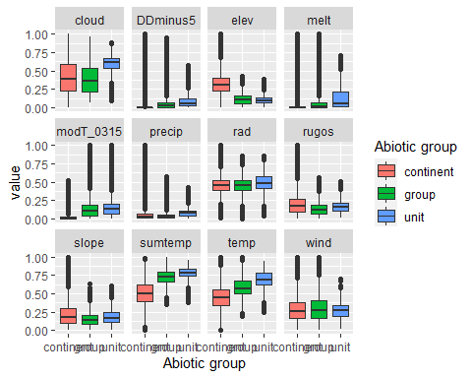

### Biota

Most widespread species in the unit (found in most pixels)

The top most widespread species in ecosystem env1_sdm1

| scientific | Functional_group | phylum | polar specialist? | count | relative_pct |
| --- | --- | --- | --- | --- | --- |
| Usnea sphacelata | Ascomycota_Lecanoromycetes_Lecanorales_Parmeliaceae__ | Ascomycota | TRUE | 25 | 4.5372 |
| Umbilicaria decussata | Ascomycota_Lecanoromycetes_Umbilicariales_Umbilicariaceae__ | Ascomycota | FALSE | 20 | 3.6298 |
| Pseudephebe minuscula | Ascomycota_Lecanoromycetes_Lecanorales_Parmeliaceae__ | Ascomycota | FALSE | 19 | 3.4483 |
| Pleopsidium chlorophanum | Ascomycota_Lecanoromycetes_Acarosporales_Acarosporaceae__ | Ascomycota | FALSE | 13 | 2.3593 |
| Physcia caesia | Ascomycota_Lecanoromycetes_Teloschistales_Physciaceae__ | Ascomycota | FALSE | 12 | 2.1779 |
| Xanthoria elegans | Ascomycota_Lecanoromycetes_Teloschistales_Teloschistaceae__ | Ascomycota | FALSE | 12 | 2.1779 |
| Buellia frigida | Ascomycota_Lecanoromycetes_Teloschistales_Physciaceae__ | Ascomycota | TRUE | 10 | 1.8149 |
| Rhizoplaca melanophthalma | Ascomycota_Lecanoromycetes_Lecanorales_Lecanoraceae__ | Ascomycota | FALSE | 10 | 1.8149 |
| Schistidium antarctici | Bryophyta_Bryopsida_Grimmiales___ | Bryophyta | TRUE | 10 | 1.8149 |
| Bryum pseudotriquetrum | Bryophyta_Bryopsida_Bryales___ | Bryophyta | FALSE | 8 | 1.4519 |
| Pygoscelis adeliae | Chordata_Aves_Sphenisciformes_Spheniscidae_Pygoscelis_adeliae | Chordata | FALSE | 8 | 1.4519 |
| Usnea antarctica | Ascomycota_Lecanoromycetes_Lecanorales_Parmeliaceae__ | Ascomycota | FALSE | 8 | 1.4519 |

This supergroup is, on average, substantially higher in suitability for Rotifers, Springtails_slim, Nematodes, mosses_Pottiales, mites_Trombidiformes, lichens_Physcid_(shadow), lichens_Teloschistid, lichens_Candelarid, mites_Sarcoptiformes, algae_Green, mosses_Dicranales, lichens_Lecanorid, lichens_Parmelid, lichens_Rhizocarpid, mites_Mesostigmata, lichens_Acarosporacid, lichens_Stereocaulid, Algae, mosses_Bryales, penguins_Gentoo, mosses_Hypnales_(feather), penguins_Chinstrap, mosses_Polytrichales, lichens_Cladonid and lichens,_Bacidiacid functional groups than continental antarctica. It is substantially lower in suitability for no variables than the rest of the continent.

Unit env1_sdm1 is higher in suitability for penguins_Gentoo, penguins_Chinstrap, mosses_Polytrichales, lichens_Cladonid and lichens,*Bacidiacid and lower in suitability for lichens_Teloschistid, Nematodes, lichens_Physcid*(shadow), lichens_Candelarid, lichens_Acarosporacid, mites_Trombidiformes, Algae and algae_Green than the rest of its environmental supergroup.

Distinctiveness of the unit from the environmental group and the rest of Antarctica

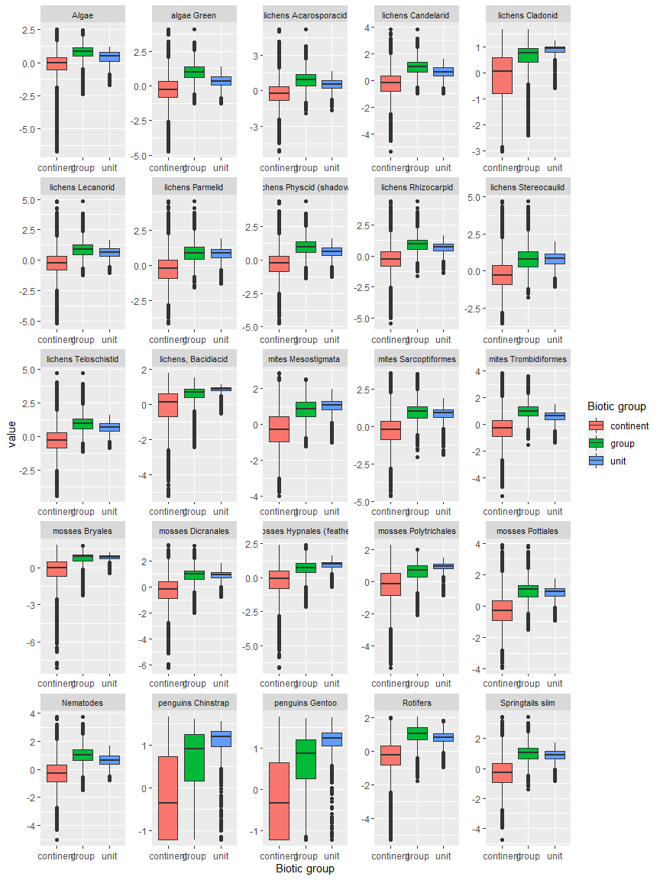

Ecosystem Description

## Ecosystem Env1_sdm2, Dry coastal lichen fields

Env1_sdm2, Dry coastal lichen fields. Primarily occurs on flat, rocky terrain or low outcrops on cold, dry and windy coastlines, commonly (but not exclusively) adjacent to ice shelves. Characteristic biota includes several tardigrade, rotifer and arthopods taxa recorded primarily from this unit. Nutrient fluxes potentially influenced by Emperor penguin colonies on adjacent ice sheets.

### Photos (if available)

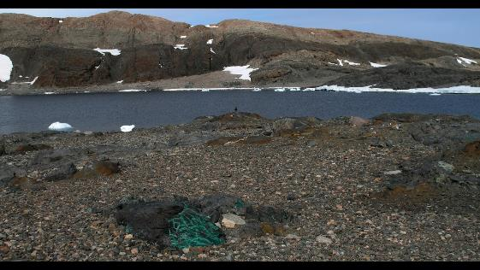

Ecosystem photo

### Distribution

Maps - Full map

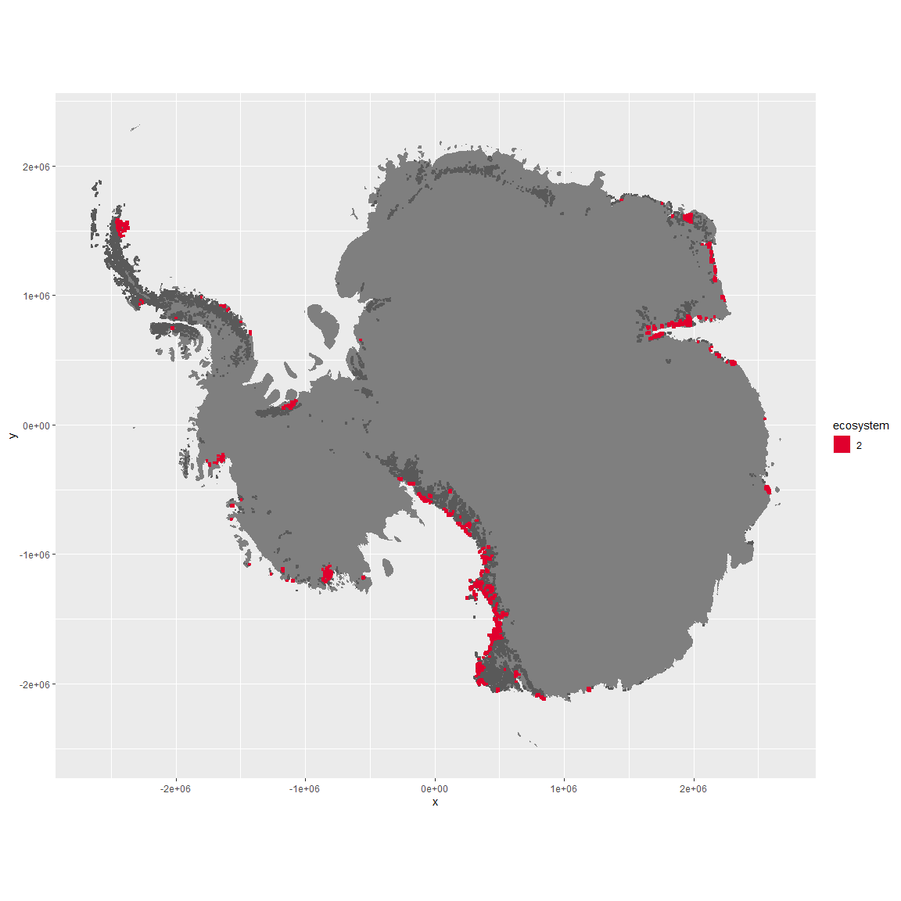

Regional maps

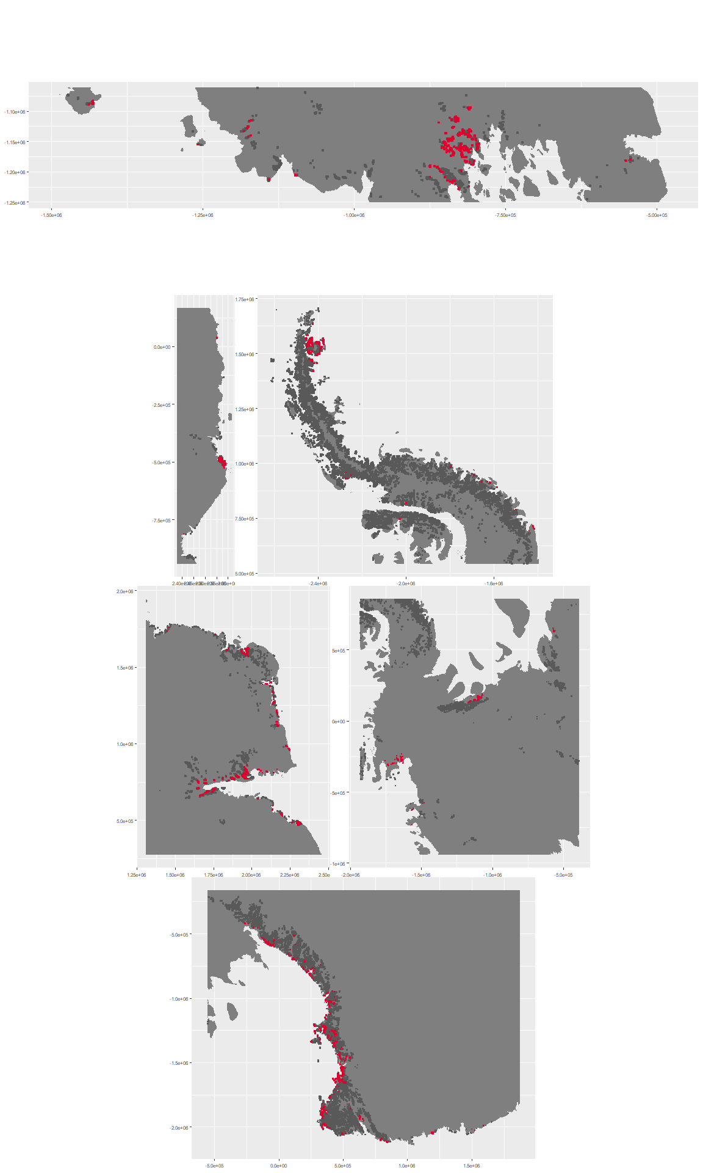

### Environment

The unit env1_sdm2 is part of the environmental supergroup env1.

This supergroup is, on average, substantially higher in sumtemp, temp, modT_0315 and melt than continental antarctica. It is substantially lower in slope, rugos and elev than the rest of the continent.

The elevation of unit env1_sdm2 ranges from 0 to 1939 metres above sea level, but 90% of its pixels fall above 4 and below 949 metres. Its average elevation is 361 metres.

The unit is higher in wind and lower in temp, cloud and melt than the rest of its environmental supergroup.

#### Distinctiveness of the unit from its group and the rest of Antarctica

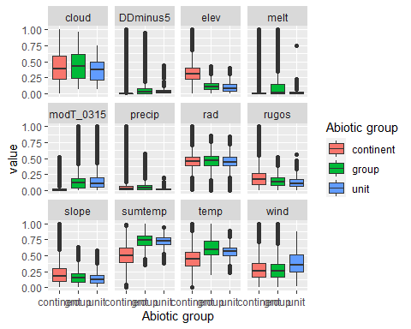

### Biota

Most widespread species in the unit (found in most pixels)

The top most widespread species in ecosystem env1_sdm2

| scientific | Functional_group | phylum | polar specialist? | count | relative_pct |
| --- | --- | --- | --- | --- | --- |
| Bryum pseudotriquetrum | Bryophyta_Bryopsida_Bryales___ | Bryophyta | FALSE | 78 | 2.7445 |
| Buellia frigida | Ascomycota_Lecanoromycetes_Teloschistales_Physciaceae__ | Ascomycota | TRUE | 72 | 2.5334 |
| Xanthoria elegans | Ascomycota_Lecanoromycetes_Teloschistales_Teloschistaceae__ | Ascomycota | FALSE | 61 | 2.1464 |
| Lecanora expectans | Ascomycota_Lecanoromycetes_Lecanorales_Lecanoraceae__ | Ascomycota | TRUE | 52 | 1.8297 |
| Umbilicaria aprina | Ascomycota_Lecanoromycetes_Umbilicariales_Umbilicariaceae__ | Ascomycota | FALSE | 52 | 1.8297 |
| Umbilicaria decussata | Ascomycota_Lecanoromycetes_Umbilicariales_Umbilicariaceae__ | Ascomycota | FALSE | 52 | 1.8297 |
| Acarospora gwynnii | Ascomycota_Lecanoromycetes_Acarosporales_Acarosporaceae__ | Ascomycota | TRUE | 50 | 1.7593 |
| Rhizoplaca melanophthalma | Ascomycota_Lecanoromycetes_Lecanorales_Lecanoraceae__ | Ascomycota | FALSE | 50 | 1.7593 |
| Candelariella flava | Ascomycota_Lecanoromycetes_Candelariales_Candelariaceae__ | Ascomycota | TRUE | 49 | 1.7241 |
| Caloplaca citrina | Ascomycota_Lecanoromycetes_Teloschistales_Teloschistaceae__ | Ascomycota | TRUE | 46 | 1.6186 |

This supergroup is, on average, substantially higher in suitability for Rotifers, Springtails_slim, Nematodes, mosses_Pottiales, mites_Trombidiformes, lichens_Physcid_(shadow), lichens_Teloschistid, lichens_Candelarid, mites_Sarcoptiformes, algae_Green, mosses_Dicranales, lichens_Lecanorid, lichens_Parmelid, lichens_Rhizocarpid, mites_Mesostigmata, lichens_Acarosporacid, lichens_Stereocaulid, Algae, mosses_Bryales, penguins_Gentoo, mosses_Hypnales_(feather), penguins_Chinstrap, mosses_Polytrichales, lichens_Cladonid and lichens,_Bacidiacid functional groups than continental Antarctica. It is substantially lower in suitability for no variables than the rest of the continent.

Unit env1_sdm2 is higher in suitability for lichens_Acarosporacid, Algae, Rotifers, lichens_Physcid_(shadow), lichens_Lecanorid, lichens_Candelarid and lichens_Teloschistid and lower in suitability for no variables than the rest of its environmental supergroup.

Distinctiveness of the unit from the environmental group and the rest of Antarctica

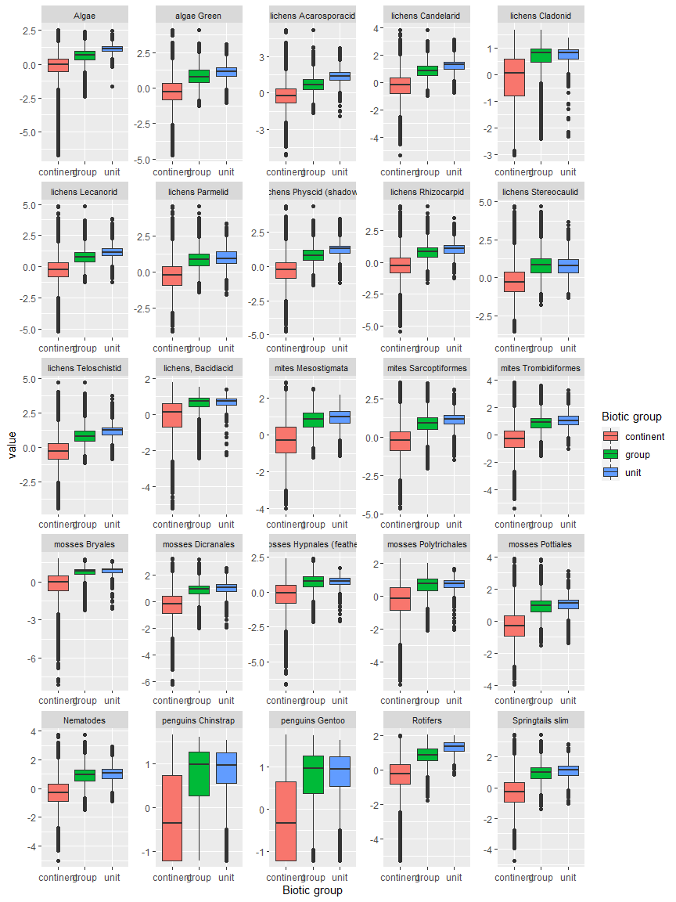

Ecosystem Description

## Ecosystem Env1_sdm3 Mesic coastal lowlands

Env1_sdm3 Mesic coastal lowlands. Rocky lowlands in warm, cloudy mesic areas support a biota dominated mainly by lichens, mosses and seabirds. Colonies of penguins on the lower slopes and nesting seabirds influence moss beds upslope enriched by nutrients via updrafts. Grasses occur occasionally within this system at low elevations on the Antarctic Peninsula and associated islands, but not in other areas. The microbiota is likely to exhibit strong regional variation within this unit around the continent.

### Photos (if available)

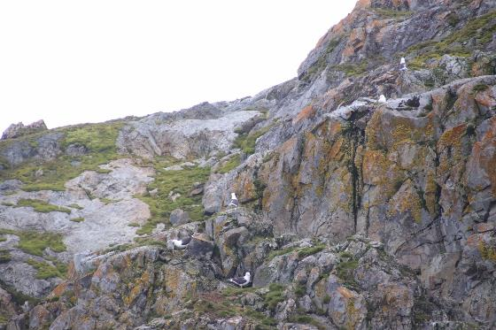

Ecosystem photo

### Distribution

Maps - Full map

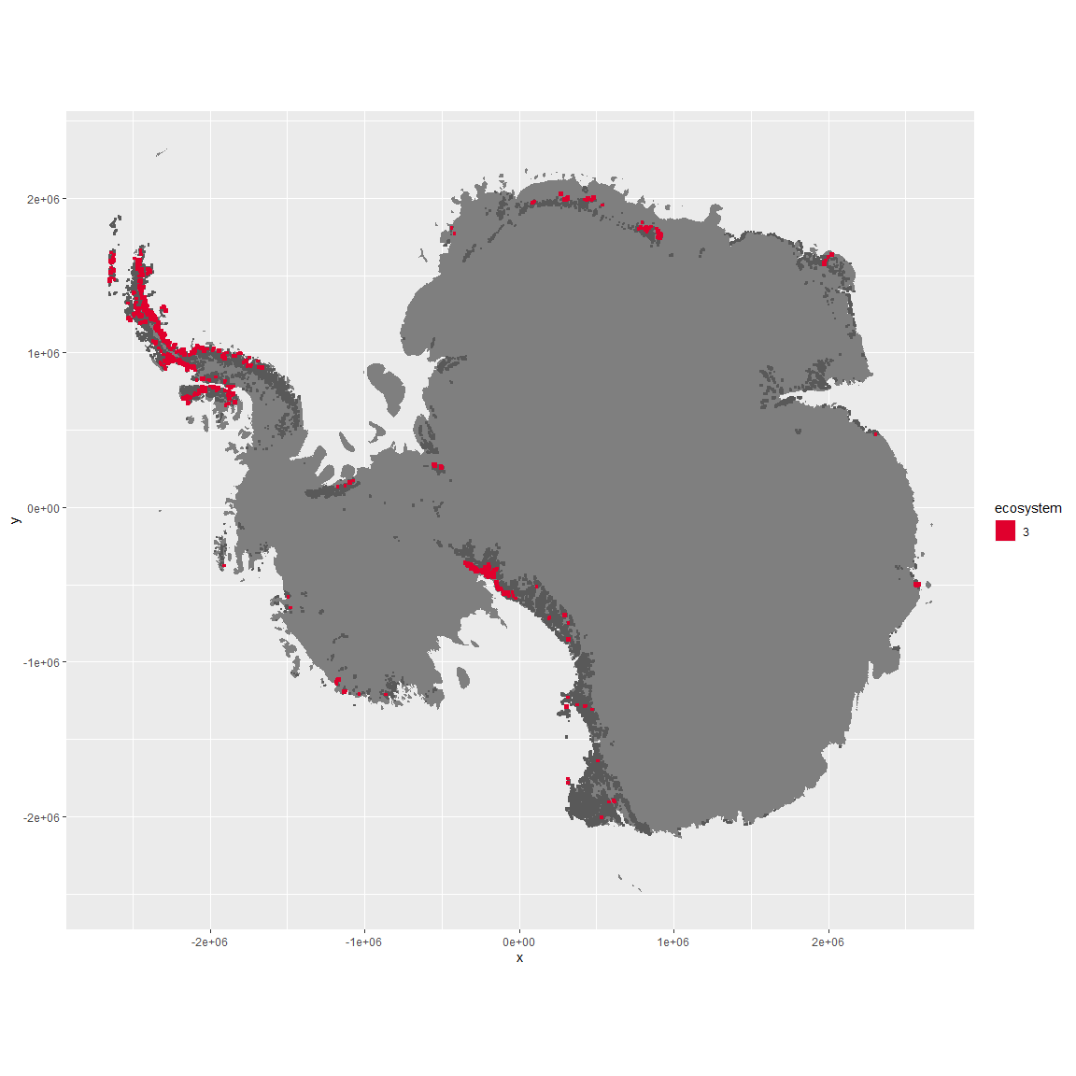

Regional maps

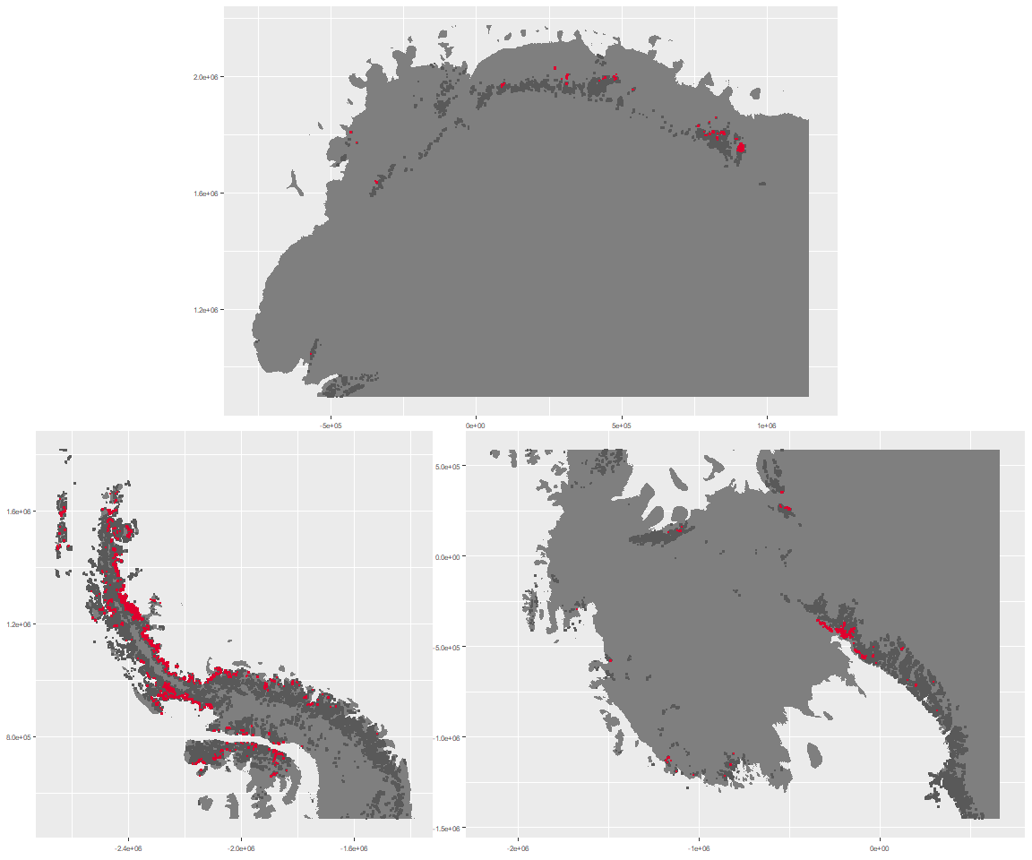

### Environment

The unit env1_sdm3 is part of the environmental supergroup env1.

This supergroup is, on average, substantially higher in sumtemp, temp, modT_0315 and melt than continental antarctica. It is substantially lower in slope, rugos and elev than the rest of the continent.

The elevation of unit env1_sdm3 ranges from 0 to 1984 metres above sea level, but 90% of its pixels fall above 18 and below 1107 metres. Its average elevation is 466 metres.

The unit is higher in cloud, melt, temp, wind, DDminus5, precip and sumtemp and lower in no variables than the rest of its environmental supergroup.

#### Distinctiveness of the unit from its group and the rest of Antarctica

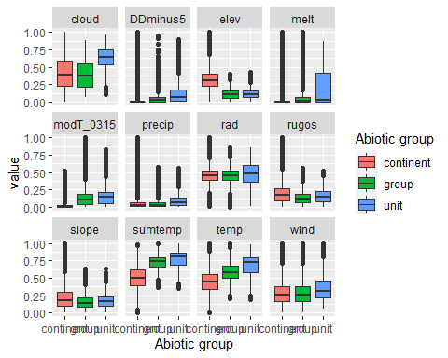

### Biota

Most widespread species in the unit (found in most pixels)

The top most widespread species in ecosystem env1_sdm3

| scientific | Functional_group | phylum | polar specialist? | count | relative_pct |
| --- | --- | --- | --- | --- | --- |
| Polytrichastrum alpinum | Bryophyta_Bryopsida_Polytrichales___ | Bryophyta | FALSE | 21 | 1.1925 |
| Syntrichia princeps | Bryophyta_Bryopsida_Pottiales___ | Bryophyta | FALSE | 21 | 1.1925 |
| Ceratodon purpureus | Bryophyta_Bryopsida_Dicranales___ | Bryophyta | FALSE | 20 | 1.1357 |
| Andreaea gainii | Bryophyta_Andreaeopsida_Andreaeales___ | Bryophyta | TRUE | 19 | 1.0789 |
| Cryptopygus antarcticus | Arthropoda_Entognatha_Entomobryomorpha___ | Arthropoda | TRUE | 19 | 1.0789 |
| Sanionia uncinata | Bryophyta_Bryopsida_Hypnales___ | Bryophyta | FALSE | 19 | 1.0789 |
| Pohlia nutans | Bryophyta_Bryopsida_Bryales___ | Bryophyta | FALSE | 18 | 1.0221 |
| Pygoscelis adeliae | Chordata_Aves_Sphenisciformes_Spheniscidae_Pygoscelis_adeliae | Chordata | FALSE | 18 | 1.0221 |
| Umbilicaria decussata | Ascomycota_Lecanoromycetes_Umbilicariales_Umbilicariaceae__ | Ascomycota | FALSE | 16 | 0.9086 |
| Usnea antarctica | Ascomycota_Lecanoromycetes_Lecanorales_Parmeliaceae__ | Ascomycota | FALSE | 16 | 0.9086 |

This supergroup is, on average, substantially higher in suitability for Rotifers, Springtails_slim, Nematodes, mosses_Pottiales, mites_Trombidiformes, lichens_Physcid_(shadow), lichens_Teloschistid, lichens_Candelarid, mites_Sarcoptiformes, algae_Green, mosses_Dicranales, lichens_Lecanorid, lichens_Parmelid, lichens_Rhizocarpid, mites_Mesostigmata, lichens_Acarosporacid, lichens_Stereocaulid, Algae, mosses_Bryales, penguins_Gentoo, mosses_Hypnales_(feather), penguins_Chinstrap, mosses_Polytrichales, lichens_Cladonid and lichens,_Bacidiacid functional groups than continental Antarctica. It is substantially lower in suitability for no variables than the rest of the continent.

Unit env1_sdm3 is higher in suitability for lichens_Parmelid, lichens_Stereocaulid, lichens_Rhizocarpid, mites_Sarcoptiformes, mites_Mesostigmata and mosses_Polytrichales and lower in suitability for Rotifers than the rest of its environmental supergroup.

Distinctiveness of the unit from the environmental group and the rest of Antarctica

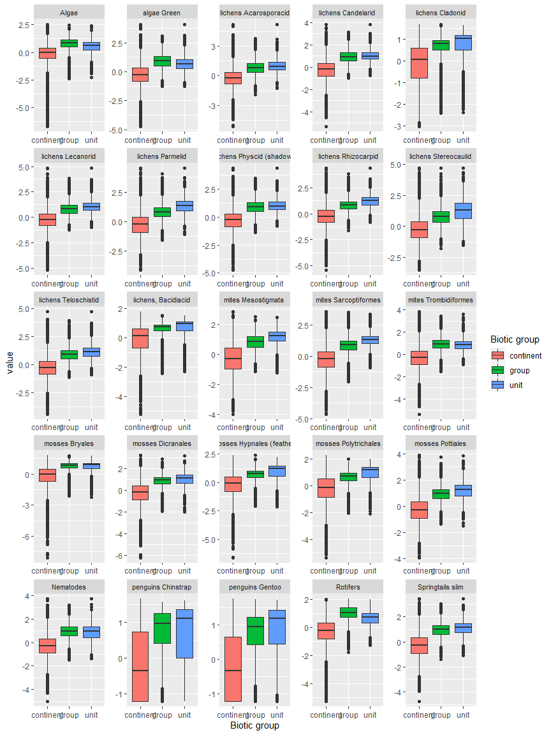

Ecosystem Description

## Ecosystem Env1_sdm4 Xeric valley floors

Env1_sdm4 Xeric valley floors. Flat or rolling valley bottoms typically carved by antecedent glaciers and surrounded by valley sides and high peaks. The valleys may extend many kilometres inland and are relatively sheltered from the wind and extremely dry, but often contains lakes maintained by meltwater streams. Some incidence of this unit also seen between the edge of existing glaciers and steep mountain slopes. These systems are colder than the rest of the lowlands, but still warmer than the continental average. The vegetation is sparse due to extremely dry conditions, which are largely unsuitable for mosses, and instead characterised by algae, Stereocaulid lichens with nematodes and trombidiformid mites, rotifers and springtails.

### Photos (if available)

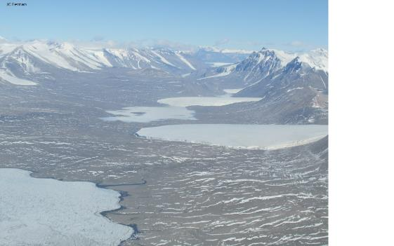

Ecosystem photo

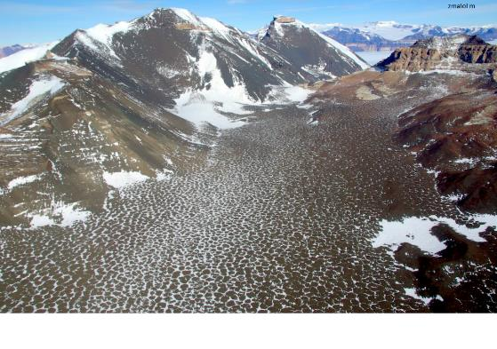

Ecosystem photo

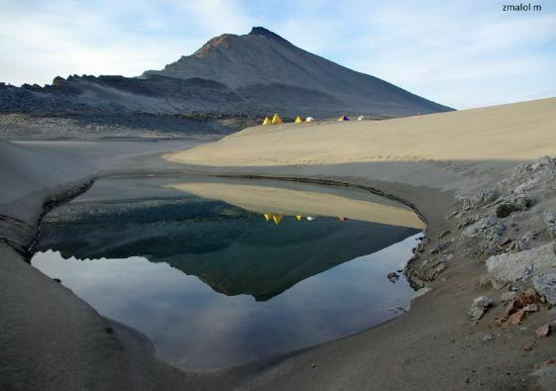

Ecosystem photo

### Distribution

Maps - Full map

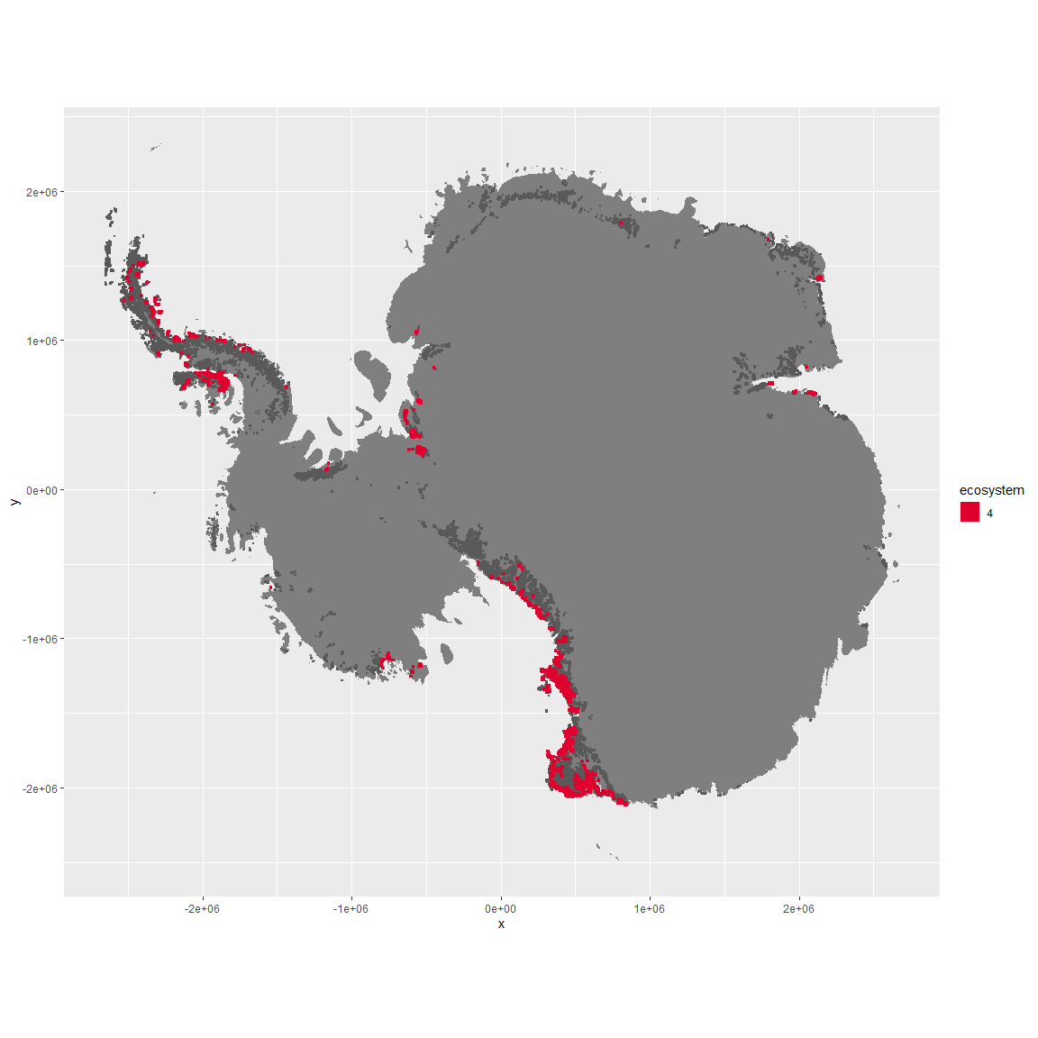

Regional maps

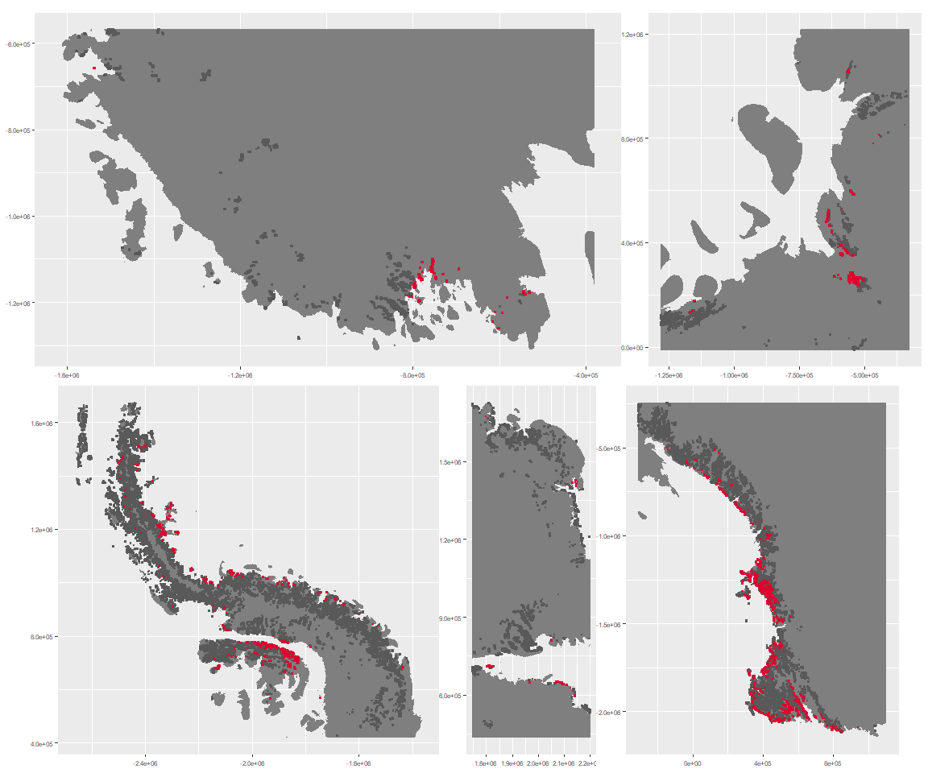

### Environment

The unit env1_sdm4 is part of the environmental supergroup env1.

This supergroup is, on average, substantially higher in sumtemp, temp, modT_0315 and melt than continental antarctica. It is substantially lower in slope, rugos and elev than the rest of the continent.

The elevation of unit env1_sdm4 ranges from 0 to 1903 metres above sea level, but 90% of its pixels fall above 53 and below 1016 metres. Its average elevation is 496 metres.

The unit is higher in no variables and lower in DDminus5, temp, cloud and wind than the rest of its environmental supergroup.

#### Distinctiveness of the unit from its group and the rest of Antarctica

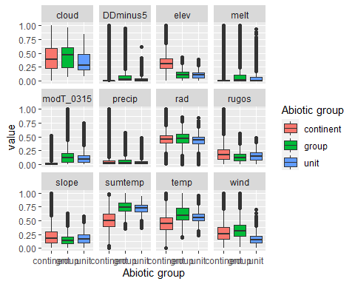

### Biota

Most widespread species in the unit (found in most pixels)

The top most widespread species in ecosystem env1_sdm4

| scientific | Functional_group | phylum | polar specialist? | count | relative_pct |
| --- | --- | --- | --- | --- | --- |
| Gomphiocephalus hodgsoni | Arthropoda_Entognatha_Poduromorpha___ | Arthropoda | TRUE | 50 | 3.2362 |
| Usnea sphacelata | Ascomycota_Lecanoromycetes_Lecanorales_Parmeliaceae__ | Ascomycota | TRUE | 38 | 2.4595 |
| Scottnema lindsayae | Nematoda_____ | Nematoda | TRUE | 37 | 2.3948 |
| Stereotydeus mollis | Arthropoda_Arachnida_Trombidiformes___ | Arthropoda | TRUE | 33 | 2.1359 |
| Eudorylaimus antarcticus | Nematoda_____ | Nematoda | TRUE | 27 | 1.7476 |
| Buellia frigida | Ascomycota_Lecanoromycetes_Teloschistales_Physciaceae__ | Ascomycota | TRUE | 26 | 1.6828 |
| Xanthoria elegans | Ascomycota_Lecanoromycetes_Teloschistales_Teloschistaceae__ | Ascomycota | FALSE | 24 | 1.5534 |
| Pseudephebe minuscula | Ascomycota_Lecanoromycetes_Lecanorales_Parmeliaceae__ | Ascomycota | FALSE | 23 | 1.4887 |
| Umbilicaria decussata | Ascomycota_Lecanoromycetes_Umbilicariales_Umbilicariaceae__ | Ascomycota | FALSE | 23 | 1.4887 |
| Bryum pseudotriquetrum | Bryophyta_Bryopsida_Bryales___ | Bryophyta | FALSE | 21 | 1.3592 |

This supergroup is, on average, substantially higher in suitability for Rotifers, Springtails_slim, Nematodes, mosses_Pottiales, mites_Trombidiformes, lichens_Physcid_(shadow), lichens_Teloschistid, lichens_Candelarid, mites_Sarcoptiformes, algae_Green, mosses_Dicranales, lichens_Lecanorid, lichens_Parmelid, lichens_Rhizocarpid, mites_Mesostigmata, lichens_Acarosporacid, lichens_Stereocaulid, Algae, mosses_Bryales, penguins_Gentoo, mosses_Hypnales_(feather), penguins_Chinstrap, mosses_Polytrichales, lichens_Cladonid and lichens,_Bacidiacid functional groups than continental Antarctica. It is substantially lower in suitability for no variables than the rest of the continent.

Unit env1_sdm4 is higher in suitability for Nematodes and mites_Trombidiformes and lower in suitability for mosses_Polytrichales than the rest of its environmental supergroup.

Distinctiveness of the unit from the environmental group and the rest of Antarctica

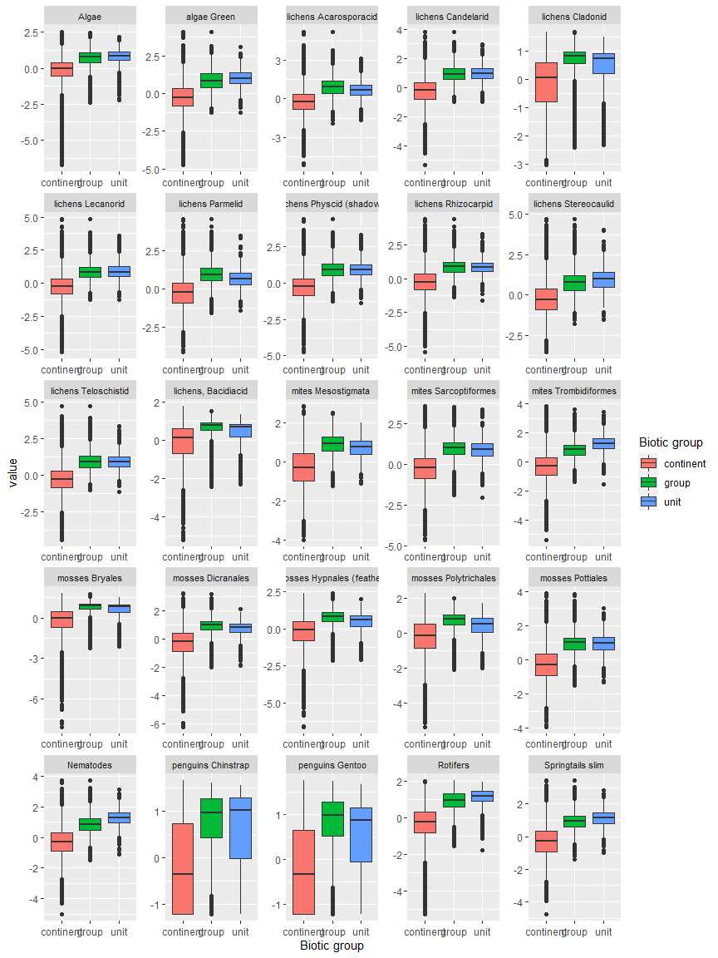

Ecosystem Description

## Ecosystem Env1_sdm5 Subcoastal mossy rises

Env1_sdm5 Subcoastal mossy rises [cf. terraces/ridges]. These moss-dominated ecosystems occupy low-relief rocky outcrops, usually in the subcoastal hinterlands, extending to higher elevations than other coastal ice-free terrestrial ecosystems, although some are quite close to the coastline. Conditions are sufficiently warm and sunny to promote moss growth, but somewhat cooler and windier than other coastal systems in Group 1. Several processes are likely to enhance habitat suitability for mosses by promoting nutrient enrichment. Many occurrences co-incide with abandoned penguin colonies that were active earlier in the Holocene when sea levels were higher than at present. Toxic nitrogen levels associated with active colonies have since been leached, while residual levels of N and other nutrients promote moss growth. Alternatively, more elevated sites receive nutirent influxes from nesting seabirds or aerosol inputs via updrafts from extant penguin colonies below. While mosses are conspicuous features of these systems, lichens and some nematodes are also widespread, and several cyanobacteria species are characteristic of occurrences in different regions of the continent.

### Photos (if available)

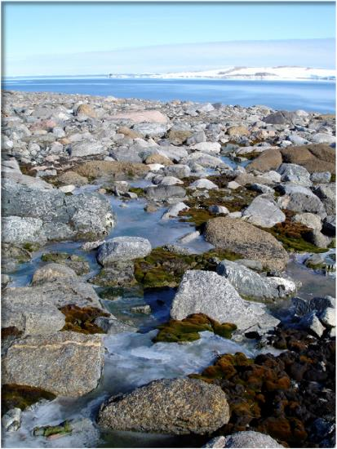

Ecosystem photo

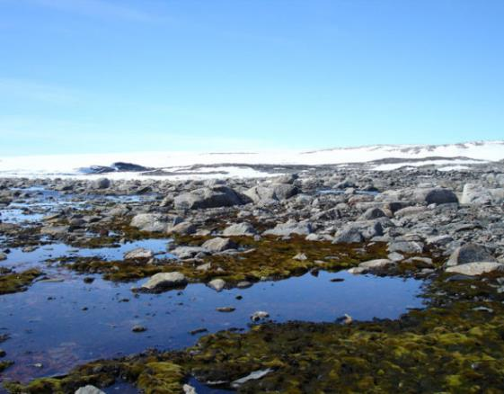

Ecosystem photo

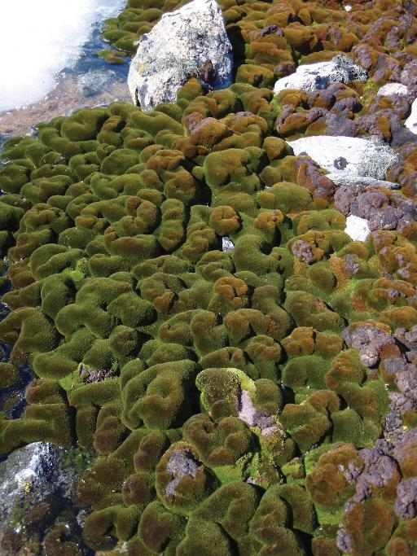

Ecosystem photo

### Distribution

Maps - Full map

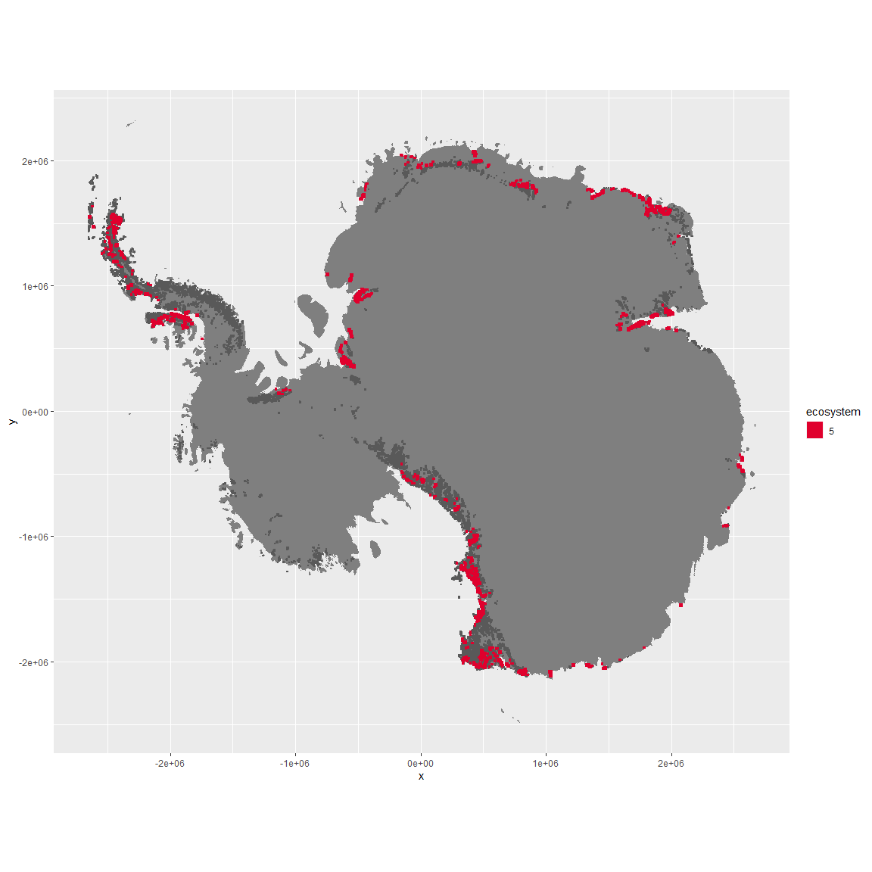

Regional maps

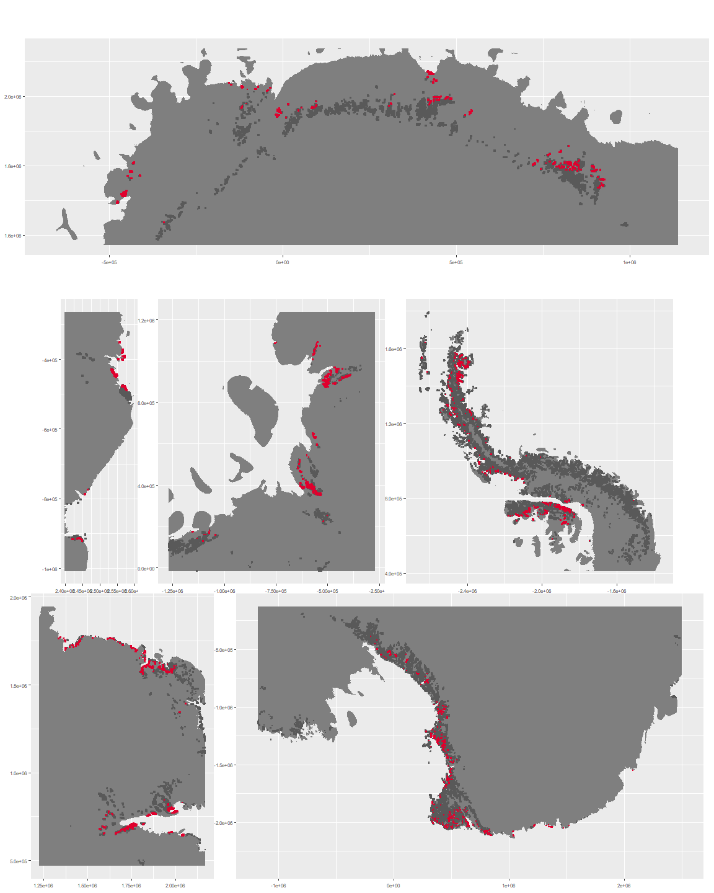

### Environment

The unit env1_sdm5 is part of the environmental supergroup env1.

This supergroup is, on average, substantially higher in sumtemp, temp, modT_0315 and melt than continental antarctica. It is substantially lower in slope, rugos and elev than the rest of the continent.

The elevation of unit env1_sdm5 ranges from 0 to 1836 metres above sea level, but 90% of its pixels fall above 20 and below 1364 metres. Its average elevation is 616 metres.

The unit is higher in wind and lower in sumtemp and cloud than the rest of its environmental supergroup.

#### Distinctiveness of the unit from its group and the rest of Antarctica

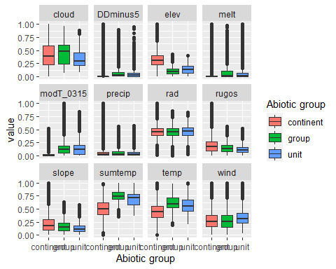

### Biota

Most widespread species in the unit (found in most pixels)

The top most widespread species in ecosystem env1_sdm5

| scientific | Functional_group | phylum | polar specialist? | count | relative_pct |
| --- | --- | --- | --- | --- | --- |
| Ceratodon purpureus | Bryophyta_Bryopsida_Dicranales___ | Bryophyta | FALSE | 55 | 2.5253 |
| Bryum pseudotriquetrum | Bryophyta_Bryopsida_Bryales___ | Bryophyta | FALSE | 47 | 2.1579 |
| Usnea sphacelata | Ascomycota_Lecanoromycetes_Lecanorales_Parmeliaceae__ | Ascomycota | TRUE | 39 | 1.7906 |
| Umbilicaria decussata | Ascomycota_Lecanoromycetes_Umbilicariales_Umbilicariaceae__ | Ascomycota | FALSE | 36 | 1.6529 |
| Pseudephebe minuscula | Ascomycota_Lecanoromycetes_Lecanorales_Parmeliaceae__ | Ascomycota | FALSE | 32 | 1.4692 |
| Xanthoria elegans | Ascomycota_Lecanoromycetes_Teloschistales_Teloschistaceae__ | Ascomycota | FALSE | 31 | 1.4233 |
| Buellia frigida | Ascomycota_Lecanoromycetes_Teloschistales_Physciaceae__ | Ascomycota | TRUE | 27 | 1.2397 |
| Usnea antarctica | Ascomycota_Lecanoromycetes_Lecanorales_Parmeliaceae__ | Ascomycota | FALSE | 24 | 1.1019 |
| Bryum argenteum | Bryophyta_Bryopsida_Bryales___ | Bryophyta | FALSE | 23 | 1.0560 |
| Pottia heimii | Bryophyta_Bryopsida_Pottiales___ | Bryophyta | FALSE | 23 | 1.0560 |

This supergroup is, on average, substantially higher in suitability for Rotifers, Springtails_slim, Nematodes, mosses_Pottiales, mites_Trombidiformes, lichens_Physcid_(shadow), lichens_Teloschistid, lichens_Candelarid, mites_Sarcoptiformes, algae_Green, mosses_Dicranales, lichens_Lecanorid, lichens_Parmelid, lichens_Rhizocarpid, mites_Mesostigmata, lichens_Acarosporacid, lichens_Stereocaulid, Algae, mosses_Bryales, penguins_Gentoo, mosses_Hypnales_(feather), penguins_Chinstrap, mosses_Polytrichales, lichens_Cladonid and lichens,_Bacidiacid functional groups than continental Antarctica. It is substantially lower in suitability for no variables than the rest of the continent.

Unit env1_sdm5 is higher in suitability for no variables and lower in suitability for penguins_Gentoo, penguins_Chinstrap, Springtails_slim, mites_Sarcoptiformes, lichens_Lecanorid, mites_Mesostigmata and lichens_Stereocaulid than the rest of its environmental supergroup.

Distinctiveness of the unit from the environmental group and the rest of Antarctica

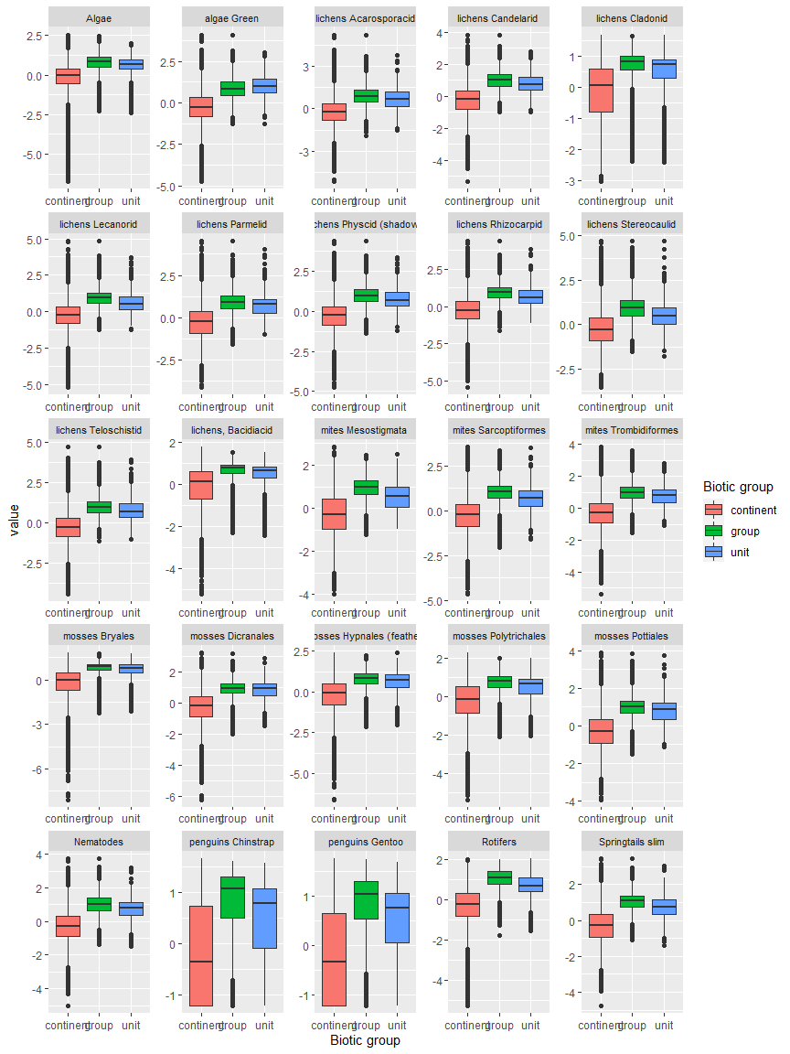

Ecosystem Description

## Ecosystem Env2_sdm1 Meltwater-fed low coastal mountains

Env2_sdm1 Meltwater-fed low coastal mountains. Occurs mainly in the rugged areas of Alexander and Adelaide Islands and on the coastal peninsula with some outliers elsewhere. Maritime influence makes these systems warmer and wetter than others within the Env2 group, and they also have greater relief and higher exposure to meltwater at lower elevations. Sampled biota includes mainly common lichen and moss species, but this system also has unusually high suitability for mosses of Hypnales and Polytrichales, lichens of Bacidiaceae and Cladoniaceae, and adjacent to the coast, penguins.

### Photos (if available)

### Distribution

Maps - Full map

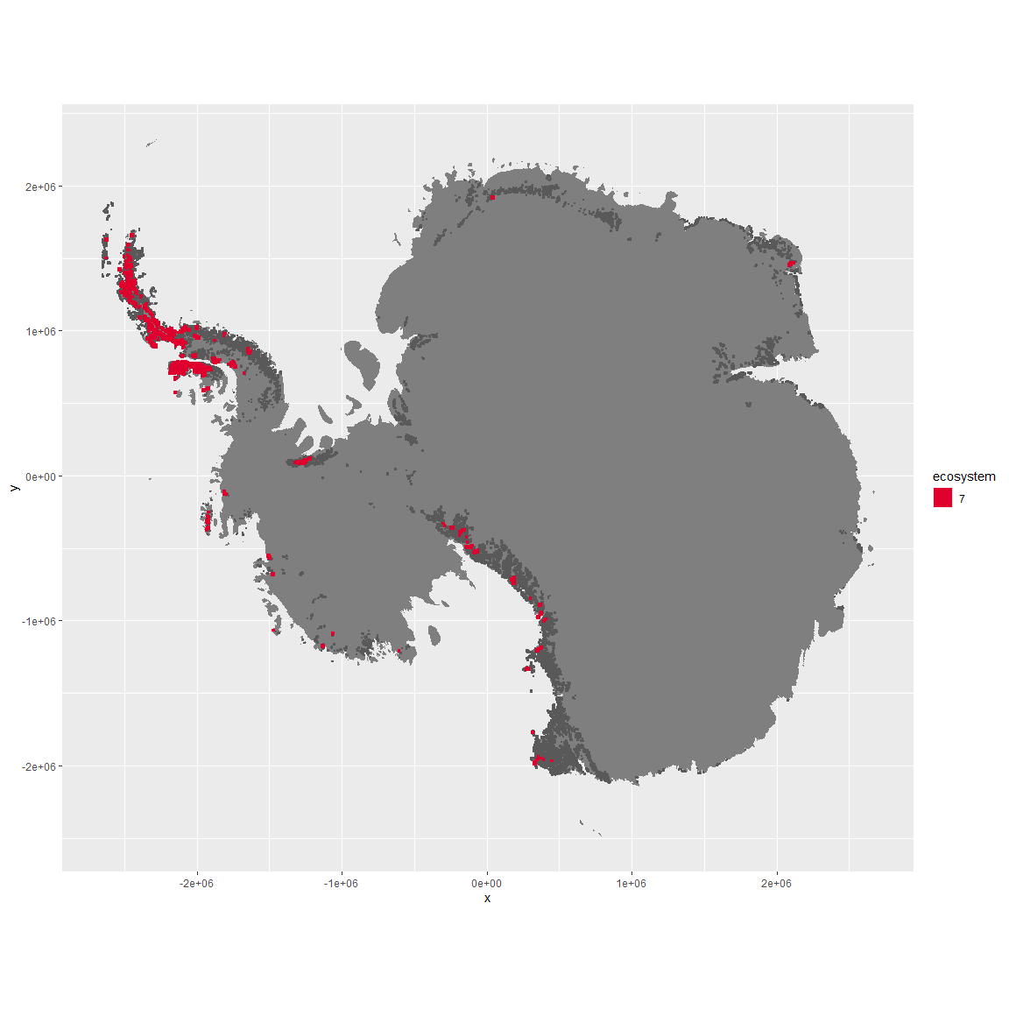

Regional maps

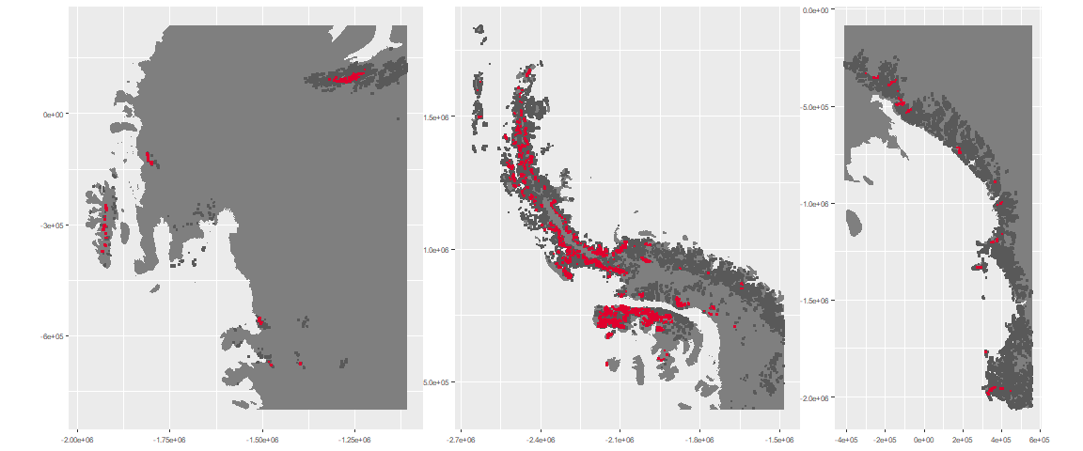

### Environment

The unit env2_sdm1 is part of the environmental supergroup env2.

This supergroup is, on average, substantially higher in cloud, precip, temp and sumtemp than continental antarctica. It is substantially lower in no variables than the rest of the continent.

The elevation of unit env2_sdm1 ranges from 0 to 4955 metres above sea level, but 90% of its pixels fall above 391 and below 2726 metres. Its average elevation is 1164 metres.

The unit is higher in melt, temp, sumtemp, cloud, precip, slope, rugos and modT_0315 and lower in elev and wind than the rest of its environmental supergroup.

#### Distinctiveness of the unit from its group and the rest of Antarctica

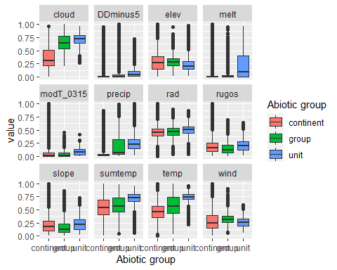

### Biota

Most widespread species in the unit (found in most pixels)

The top most widespread species in ecosystem env2_sdm1

| scientific | Functional_group | phylum | polar specialist? | count | relative_pct |
| --- | --- | --- | --- | --- | --- |
| Usnea sphacelata | Ascomycota_Lecanoromycetes_Lecanorales_Parmeliaceae__ | Ascomycota | TRUE | 19 | 2.9688 |
| Umbilicaria decussata | Ascomycota_Lecanoromycetes_Umbilicariales_Umbilicariaceae__ | Ascomycota | FALSE | 12 | 1.8750 |
| Pseudephebe minuscula | Ascomycota_Lecanoromycetes_Lecanorales_Parmeliaceae__ | Ascomycota | FALSE | 11 | 1.7188 |
| Pohlia cruda | Bryophyta_Bryopsida_Bryales___ | Bryophyta | FALSE | 10 | 1.5625 |
| Schistidium antarctici | Bryophyta_Bryopsida_Grimmiales___ | Bryophyta | TRUE | 9 | 1.4062 |
| Umbilicaria antarctica | Ascomycota_Lecanoromycetes_Umbilicariales_Umbilicariaceae__ | Ascomycota | TRUE | 9 | 1.4062 |
| Bryum pseudotriquetrum | Bryophyta_Bryopsida_Bryales___ | Bryophyta | FALSE | 8 | 1.2500 |
| Syntrichia princeps | Bryophyta_Bryopsida_Pottiales___ | Bryophyta | FALSE | 8 | 1.2500 |
| Usnea antarctica | Ascomycota_Lecanoromycetes_Lecanorales_Parmeliaceae__ | Ascomycota | FALSE | 8 | 1.2500 |
| Bartramia patens | Bryophyta_Bryopsida_Bryales___ | Bryophyta | FALSE | 7 | 1.0938 |
| Cephaloziella varians | Marchantiophyta_____ | Marchantiophyta | FALSE | 7 | 1.0938 |
| Ceratodon purpureus | Bryophyta_Bryopsida_Dicranales___ | Bryophyta | FALSE | 7 | 1.0938 |
| Grimmia reflexidens | Bryophyta_Bryopsida_Grimmiales___ | Bryophyta | FALSE | 7 | 1.0938 |
| Pleopsidium chlorophanum | Ascomycota_Lecanoromycetes_Acarosporales_Acarosporaceae__ | Ascomycota | FALSE | 7 | 1.0938 |
| Pohlia nutans | Bryophyta_Bryopsida_Bryales___ | Bryophyta | FALSE | 7 | 1.0938 |
| Sanionia uncinata | Bryophyta_Bryopsida_Hypnales___ | Bryophyta | FALSE | 7 | 1.0938 |
| Usnea aurantiaco-atra | Ascomycota_Lecanoromycetes_Lecanorales_Parmeliaceae__ | Ascomycota | FALSE | 7 | 1.0938 |
| Xanthoria elegans | Ascomycota_Lecanoromycetes_Teloschistales_Teloschistaceae__ | Ascomycota | FALSE | 7 | 1.0938 |

This supergroup is, on average, substantially higher in suitability for no variables functional groups than continental Antarctica. It is substantially lower in suitability for mites_Trombidiformes, Nematodes, lichens_Acarosporacid, lichens_Teloschistid, lichens_Candelarid, lichens_Lecanorid, lichens_Physcid_(shadow), algae_Green, Rotifers and Algae than the rest of the continent.

Unit env2_sdm1 is higher in suitability for penguins_Chinstrap, lichens_Cladonid, penguins_Gentoo, mosses_Hypnales_(feather), lichens,_Bacidiacid, mosses_Polytrichales, mosses_Bryales, mosses_Dicranales and mosses_Pottiales and lower in suitability for lichens_Lecanorid, lichens_Acarosporacid, lichens_Candelarid and Algae than the rest of its environmental supergroup.

Distinctiveness of the unit from the environmental group and the rest of Antarctica

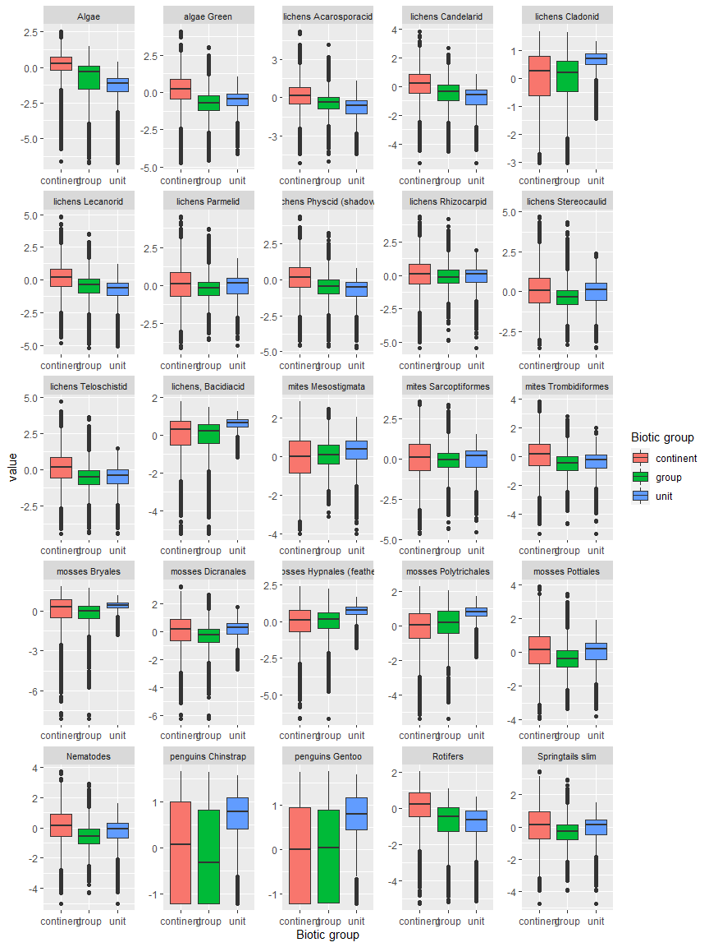

Ecosystem Description

## Ecosystem Env2_sdm2 Cool dry hill slopes

Env2_sdm2 Cool dry hill slopes. Occurs mainly in the south Antarctic peninsula, Ellsworth mountains, and western end of the Transantarctic mountains. On the south peninsula, it occurs in association with Env5 (may be quite similar to some Env5 units). Most arid and cold unit in Env2, receiving relatively low snowfall. Unit is higher elevation than its group but not rugged, colder and drier than rest of the subgroup (melt, precip, and temp variables low). In some cases, temp and moisture variables drop below continental average. Sampled biota appear to be mainly mosses, but suitability is lower than continental average for most functional groups, particularly Ochrophytes, Nematodes, and penguins.

### Photos (if available)

### Distribution

Maps - Full map

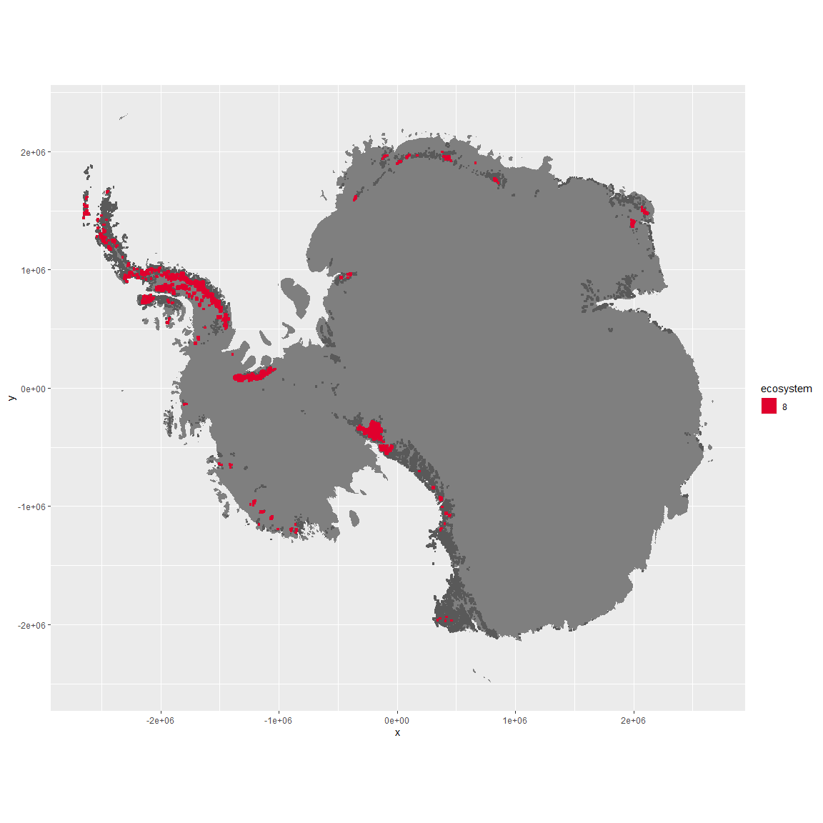

Regional maps

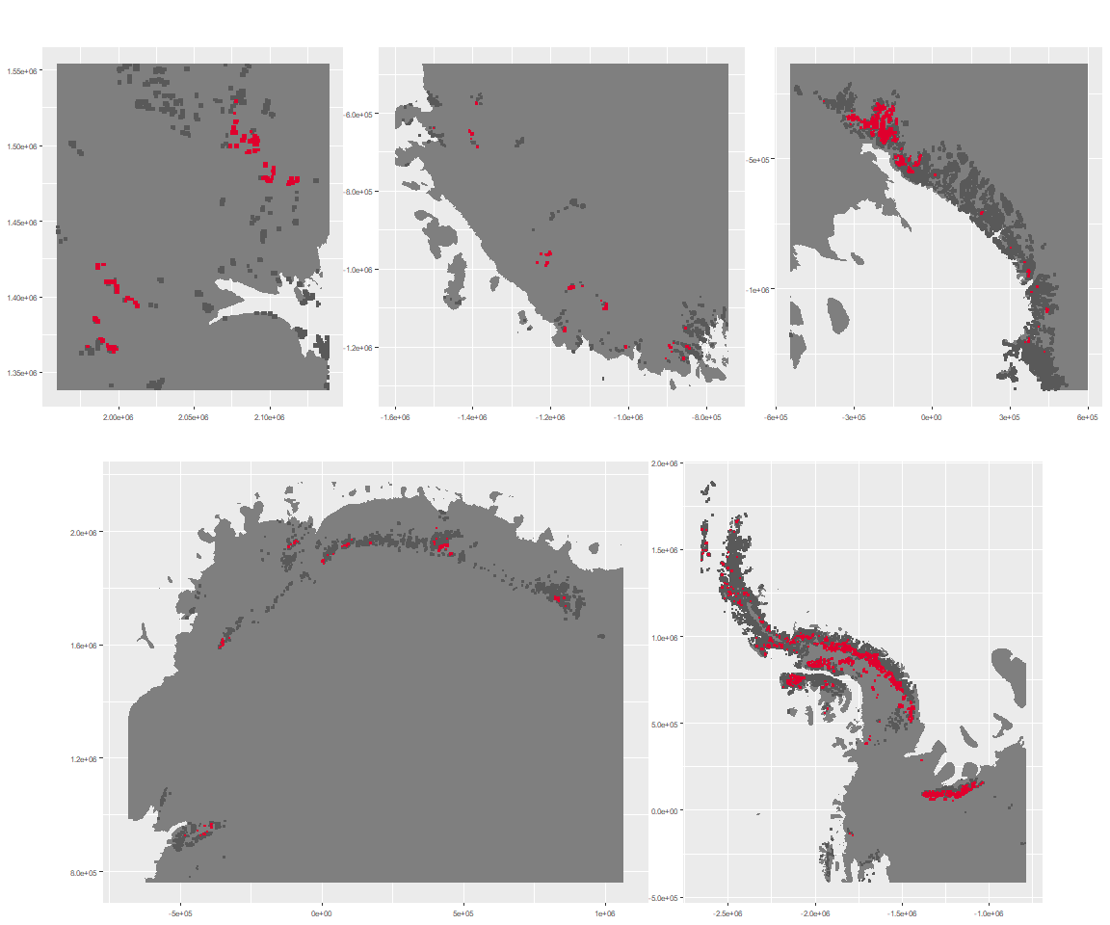

### Environment

The unit env2_sdm2 is part of the environmental supergroup env2.

This supergroup is, on average, substantially higher in cloud, precip, temp and sumtemp than continental antarctica. It is substantially lower in no variables than the rest of the continent.

The elevation of unit env2_sdm2 ranges from 0 to 3974 metres above sea level, but 90% of its pixels fall above 623 and below 2321 metres. Its average elevation is 1468 metres.

The unit is higher in elev and lower in modT_0315, DDminus5, rad, melt, rugos, slope, cloud, sumtemp, temp and precip than the rest of its environmental supergroup.

#### Distinctiveness of the unit from its group and the rest of Antarctica

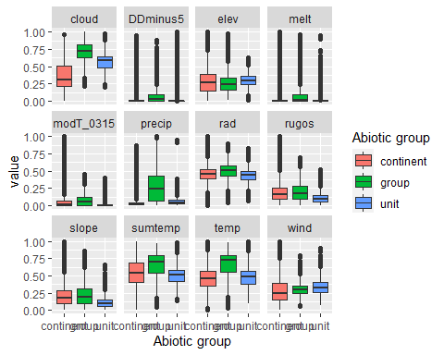

### Biota

Most widespread species in the unit (found in most pixels)

The top most widespread species in ecosystem env2_sdm2

| scientific | Functional_group | phylum | polar specialist? | count | relative_pct |
| --- | --- | --- | --- | --- | --- |
| Syntrichia princeps | Bryophyta_Bryopsida_Pottiales___ | Bryophyta | FALSE | 10 | 1.9342 |
| Bryum pseudotriquetrum | Bryophyta_Bryopsida_Bryales___ | Bryophyta | FALSE | 9 | 1.7408 |
| Ceratodon purpureus | Bryophyta_Bryopsida_Dicranales___ | Bryophyta | FALSE | 8 | 1.5474 |
| Polytrichastrum alpinum | Bryophyta_Bryopsida_Polytrichales___ | Bryophyta | FALSE | 8 | 1.5474 |
| Schistidium antarctici | Bryophyta_Bryopsida_Grimmiales___ | Bryophyta | TRUE | 8 | 1.5474 |
| Usnea sphacelata | Ascomycota_Lecanoromycetes_Lecanorales_Parmeliaceae__ | Ascomycota | TRUE | 8 | 1.5474 |
| Andreaea gainii | Bryophyta_Andreaeopsida_Andreaeales___ | Bryophyta | TRUE | 7 | 1.3540 |
| Lecidea cf. cancriformis | Ascomycota_Lecanoromycetes_Lecanorales_Lecideaceae__ | Ascomycota | TRUE | 7 | 1.3540 |
| Pohlia nutans | Bryophyta_Bryopsida_Bryales___ | Bryophyta | FALSE | 7 | 1.3540 |
| Sanionia uncinata | Bryophyta_Bryopsida_Hypnales___ | Bryophyta | FALSE | 7 | 1.3540 |

This supergroup is, on average, substantially higher in suitability for no variables functional groups than continental Antarctica. It is substantially lower in suitability for mites_Trombidiformes, Nematodes, lichens_Acarosporacid, lichens_Teloschistid, lichens_Candelarid, lichens_Lecanorid, lichens_Physcid_(shadow), algae_Green, Rotifers and Algae than the rest of the continent.

Unit env2_sdm2 is higher in suitability for Algae, Rotifers, lichens_Lecanorid, lichens_Physcid_(shadow), lichens_Acarosporacid, lichens_Candelarid and lichens_Teloschistid and lower in suitability for mites_Mesostigmata, lichens_Cladonid, mosses_Hypnales_(feather), mosses_Polytrichales, penguins_Gentoo and penguins_Chinstrap than the rest of its environmental supergroup.

Distinctiveness of the unit from the environmental group and the rest of Antarctica

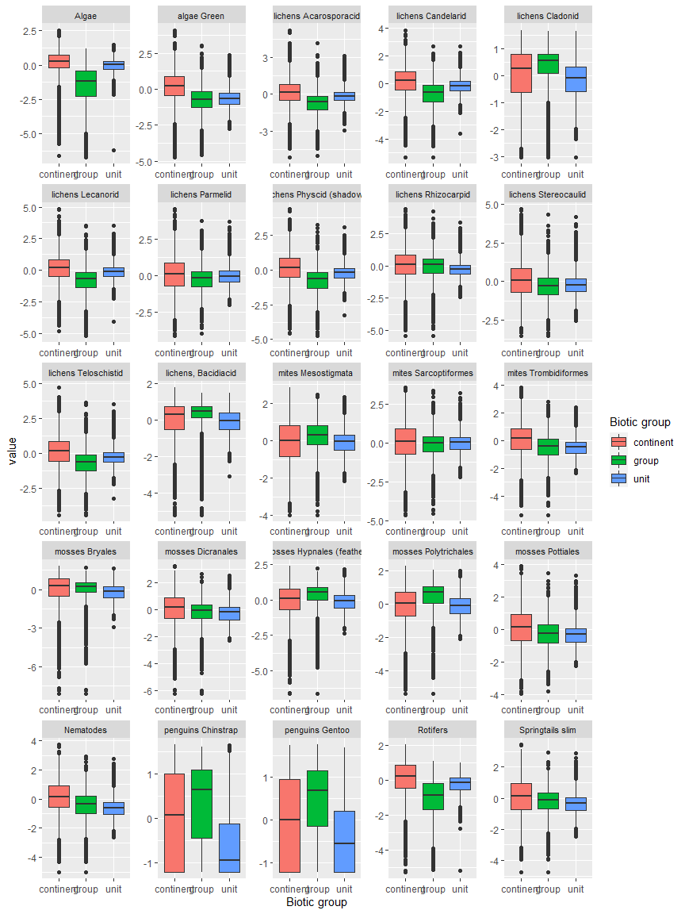

Ecosystem Description

## Ecosystem Env2_sdm3 Rugged sparsely vegetated slopes

Env2_sdm3 Rugged sparsely vegetated slopes. These systems occur mainly on the west side of the northern Antarctic peninsula with outliers in Marie Byrd land and the Transanarctic Mountains. Maritime influence makes conditions warm with high precipitation like unit 2.1, but they are in windier locations, span a greater climatic range, have a longer growing season (degree-days above -5°C) and there is much less meltwater. The biota is characterised by lichens, mosses and mites, but these systems appear to be unsuitable for rotifers and ochrophytes.

### Photos (if available)

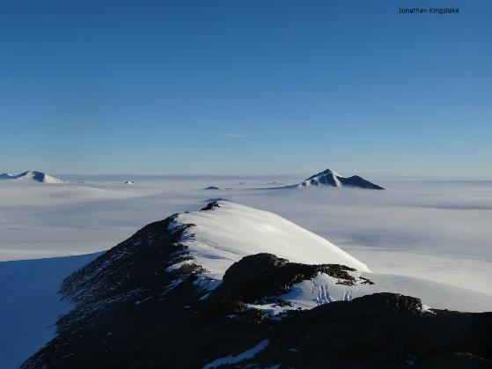

Ecosystem photo

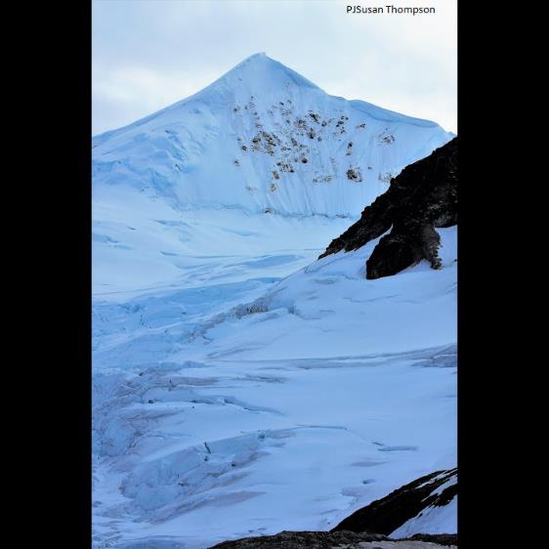

Ecosystem photo

### Distribution

Maps - Full map

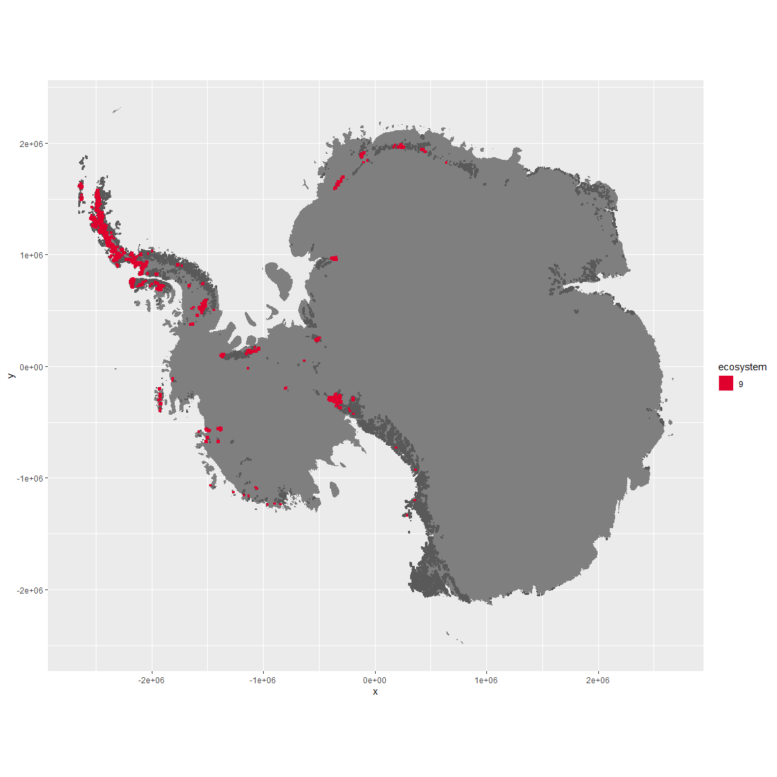

Regional maps

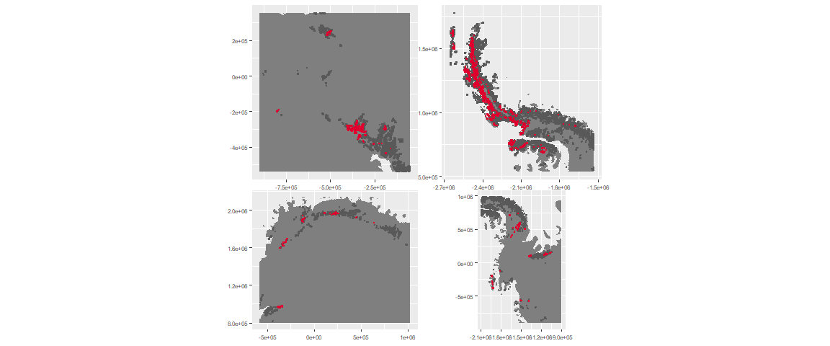

### Environment

The unit env2_sdm3 is part of the environmental supergroup env2.

This supergroup is, on average, substantially higher in cloud, precip, temp and sumtemp than continental antarctica. It is substantially lower in no variables than the rest of the continent.

The elevation of unit env2_sdm3 ranges from 0 to 3302 metres above sea level, but 90% of its pixels fall above 223 and below 1858 metres. Its average elevation is 964 metres.

The unit is higher in precip, sumtemp, temp, DDminus5, slope, cloud, rugos and modT_0315 and lower in elev than the rest of its environmental supergroup.

#### Distinctiveness of the unit from its group and the rest of Antarctica

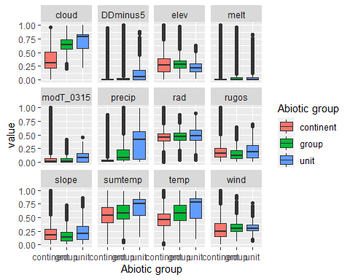

### Biota

Most widespread species in the unit (found in most pixels)

The top most widespread species in ecosystem env2_sdm3

| scientific | Functional_group | phylum | polar specialist? | count | relative_pct |
| --- | --- | --- | --- | --- | --- |
| Andreaea regularis | Bryophyta_Andreaeopsida_Andreaeales___ | Bryophyta | TRUE | 18 | 2.5140 |
| Polytrichastrum alpinum | Bryophyta_Bryopsida_Polytrichales___ | Bryophyta | FALSE | 16 | 2.2346 |
| Sanionia uncinata | Bryophyta_Bryopsida_Hypnales___ | Bryophyta | FALSE | 15 | 2.0950 |
| Syntrichia princeps | Bryophyta_Bryopsida_Pottiales___ | Bryophyta | FALSE | 14 | 1.9553 |
| Pseudephebe minuscula | Ascomycota_Lecanoromycetes_Lecanorales_Parmeliaceae__ | Ascomycota | FALSE | 13 | 1.8156 |
| Deschampsia antarctica | Tracheophyta_____ | Tracheophyta | FALSE | 12 | 1.6760 |
| Bryum pseudotriquetrum | Bryophyta_Bryopsida_Bryales___ | Bryophyta | FALSE | 11 | 1.5363 |
| Pohlia cruda | Bryophyta_Bryopsida_Bryales___ | Bryophyta | FALSE | 11 | 1.5363 |
| Bartramia patens | Bryophyta_Bryopsida_Bryales___ | Bryophyta | FALSE | 10 | 1.3966 |
| Colobanthus quitensis | Tracheophyta_____ | Tracheophyta | FALSE | 10 | 1.3966 |
| Distichium capillaceum | Bryophyta_Bryopsida_Dicranales___ | Bryophyta | FALSE | 10 | 1.3966 |
| Schistidium antarctici | Bryophyta_Bryopsida_Grimmiales___ | Bryophyta | TRUE | 10 | 1.3966 |
| Usnea antarctica | Ascomycota_Lecanoromycetes_Lecanorales_Parmeliaceae__ | Ascomycota | FALSE | 10 | 1.3966 |
| Usnea aurantiaco-atra | Ascomycota_Lecanoromycetes_Lecanorales_Parmeliaceae__ | Ascomycota | FALSE | 10 | 1.3966 |
| Usnea sphacelata | Ascomycota_Lecanoromycetes_Lecanorales_Parmeliaceae__ | Ascomycota | TRUE | 10 | 1.3966 |

This supergroup is, on average, substantially higher in suitability for no variables functional groups than continental Antarctica. It is substantially lower in suitability for mites_Trombidiformes, Nematodes, lichens_Acarosporacid, lichens_Teloschistid, lichens_Candelarid, lichens_Lecanorid, lichens_Physcid_(shadow), algae_Green, Rotifers and Algae than the rest of the continent.

Unit env2_sdm3 is higher in suitability for lichens_Rhizocarpid, mites_Trombidiformes, Nematodes, penguins_Chinstrap, mites_Mesostigmata, algae_Green, Springtails_slim, penguins_Gentoo and mites_Sarcoptiformes and lower in suitability for Rotifers and Algae than the rest of its environmental supergroup.

Distinctiveness of the unit from the environmental group and the rest of Antarctica

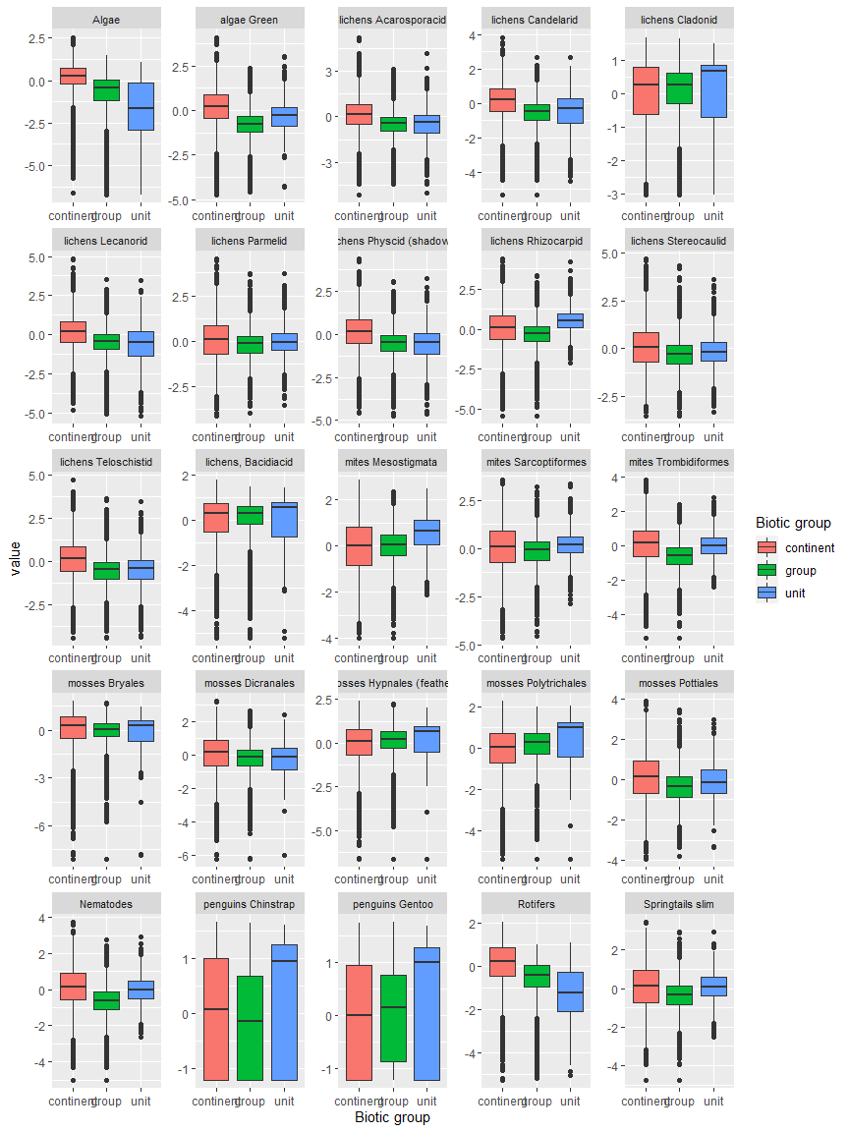

Ecosystem Description

## Ecosystem Env2_sdm4

Env2_sdm4. Occurs mainly along the highest peaks set back from the coast on the peninsula. Similar to 2.2 but receive a lot more snowfall, and consequently avalanches may be more frequent. Cladonid and Bacidiacid lichens are present but conditions are largely unsuitable for most other groups.

### Photos (if available)

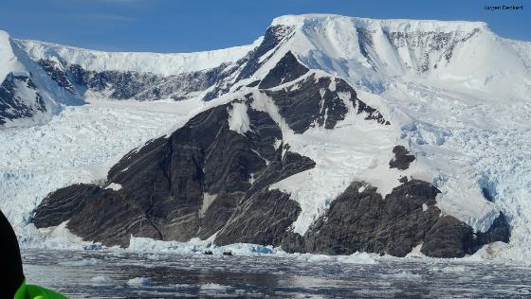

Ecosystem photo

### Distribution

Maps - Full map

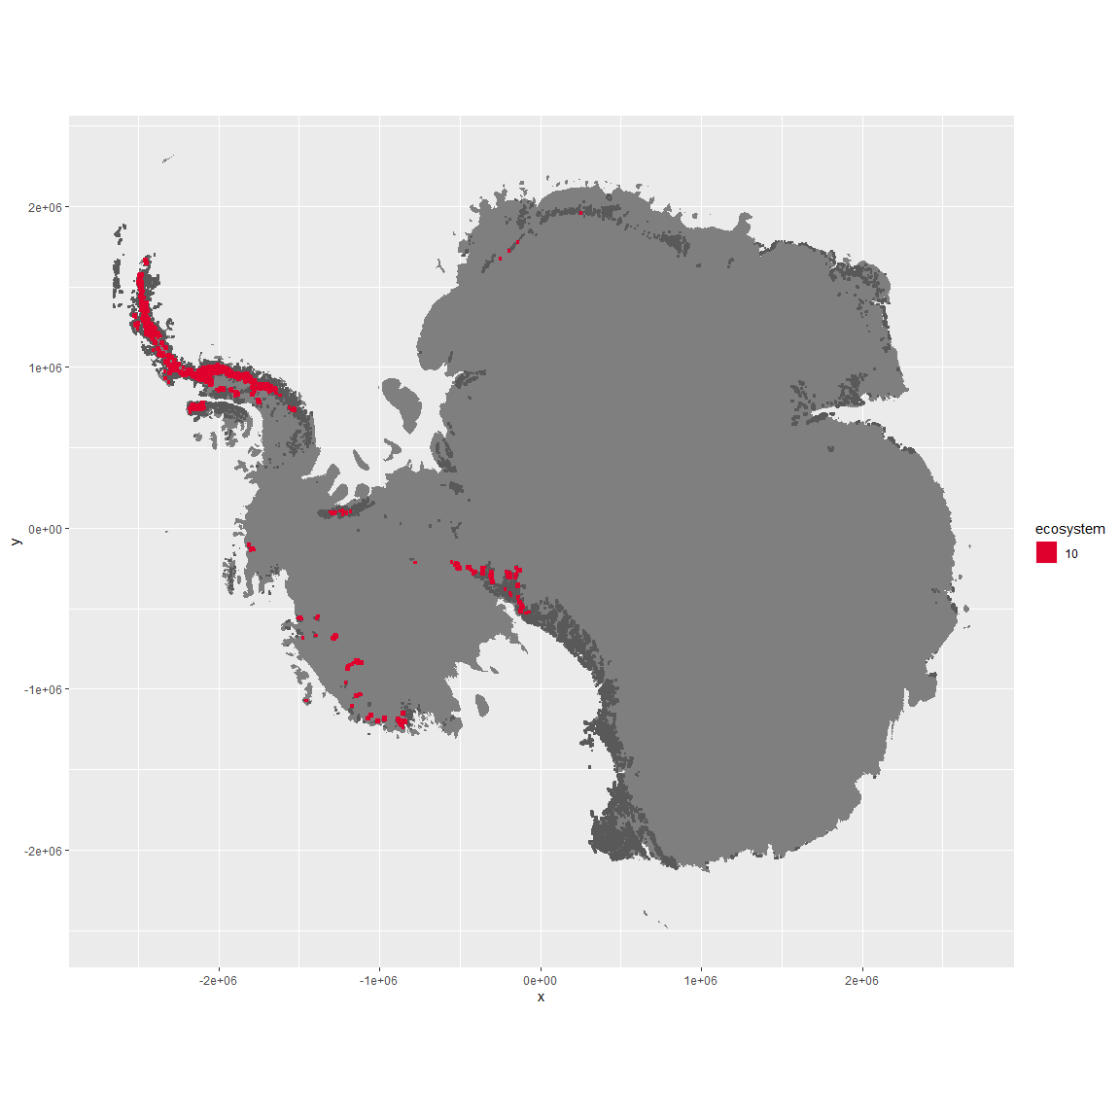

Regional maps

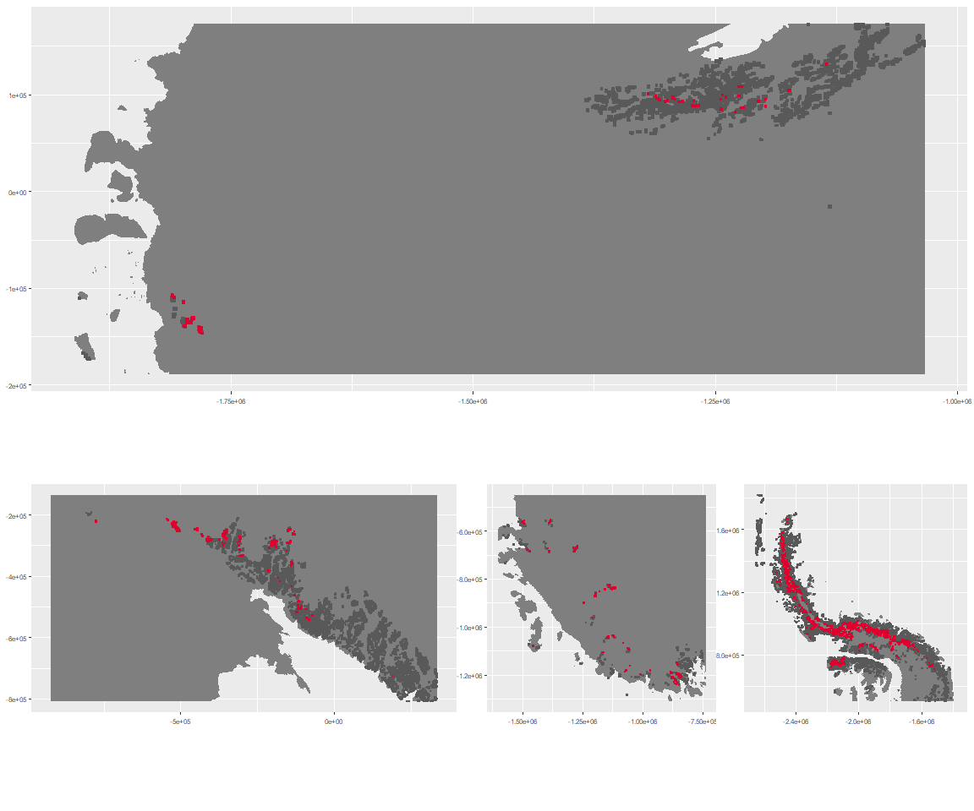

### Environment

The unit env2_sdm4 is part of the environmental supergroup env2.

This supergroup is, on average, substantially higher in cloud, precip, temp and sumtemp than continental antarctica. It is substantially lower in no variables than the rest of the continent.

The elevation of unit env2_sdm4 ranges from 0 to 4511 metres above sea level, but 90% of its pixels fall above 699 and below 2661 metres. Its average elevation is 1516 metres.

The unit is higher in elev and cloud and lower in melt than the rest of its environmental supergroup.

#### Distinctiveness of the unit from its group and the rest of Antarctica

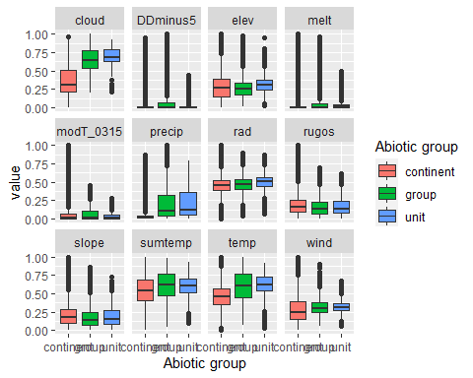

### Biota

Most widespread species in the unit (found in most pixels)

The top most widespread species in ecosystem env2_sdm4

| scientific | Functional_group | phylum | polar specialist? | count | relative_pct |
| --- | --- | --- | --- | --- | --- |
| Pseudephebe minuscula | Ascomycota_Lecanoromycetes_Lecanorales_Parmeliaceae__ | Ascomycota | FALSE | 18 | 15.3846 |
| Usnea sphacelata | Ascomycota_Lecanoromycetes_Lecanorales_Parmeliaceae__ | Ascomycota | TRUE | 12 | 10.2564 |
| Lecidea cf. cancriformis | Ascomycota_Lecanoromycetes_Lecanorales_Lecideaceae__ | Ascomycota | TRUE | 11 | 9.4017 |
| Pleopsidium chlorophanum | Ascomycota_Lecanoromycetes_Acarosporales_Acarosporaceae__ | Ascomycota | FALSE | 6 | 5.1282 |
| Carbonea vorticosa | Ascomycota_Lecanoromycetes_Lecanorales_Lecanoraceae__ | Ascomycota | FALSE | 5 | 4.2735 |
| Umbilicaria decussata | Ascomycota_Lecanoromycetes_Umbilicariales_Umbilicariaceae__ | Ascomycota | FALSE | 5 | 4.2735 |
| Ceratodon purpureus | Bryophyta_Bryopsida_Dicranales___ | Bryophyta | FALSE | 4 | 3.4188 |
| Lecidea cancriformis | Ascomycota_Lecanoromycetes_Lecanorales_Lecideaceae__ | Ascomycota | TRUE | 4 | 3.4188 |
| Acarospora gwynnii | Ascomycota_Lecanoromycetes_Acarosporales_Acarosporaceae__ | Ascomycota | TRUE | 3 | 2.5641 |
| Rhizoplaca melanophthalma | Ascomycota_Lecanoromycetes_Lecanorales_Lecanoraceae__ | Ascomycota | FALSE | 3 | 2.5641 |

This supergroup is, on average, substantially higher in suitability for no variables functional groups than continental Antarctica. It is substantially lower in suitability for mites_Trombidiformes, Nematodes, lichens_Acarosporacid, lichens_Teloschistid, lichens_Candelarid, lichens_Lecanorid, lichens_Physcid_(shadow), algae_Green, Rotifers and Algae than the rest of the continent.

Unit env2_sdm4 is higher in suitability for no variables and lower in suitability for mites_Mesostigmata, mosses_Polytrichales, mosses_Hypnales_(feather), Algae, mosses_Bryales, mosses_Dicranales, lichens_Acarosporacid, Springtails_slim, mites_Sarcoptiformes, lichens_Lecanorid, lichens_Candelarid, lichens_Parmelid, lichens_Rhizocarpid, lichens_Stereocaulid, lichens_Physcid_(shadow), mosses_Pottiales, lichens_Teloschistid, Nematodes, mites_Trombidiformes and algae_Green than the rest of its environmental supergroup.

Distinctiveness of the unit from the environmental group and the rest of Antarctica

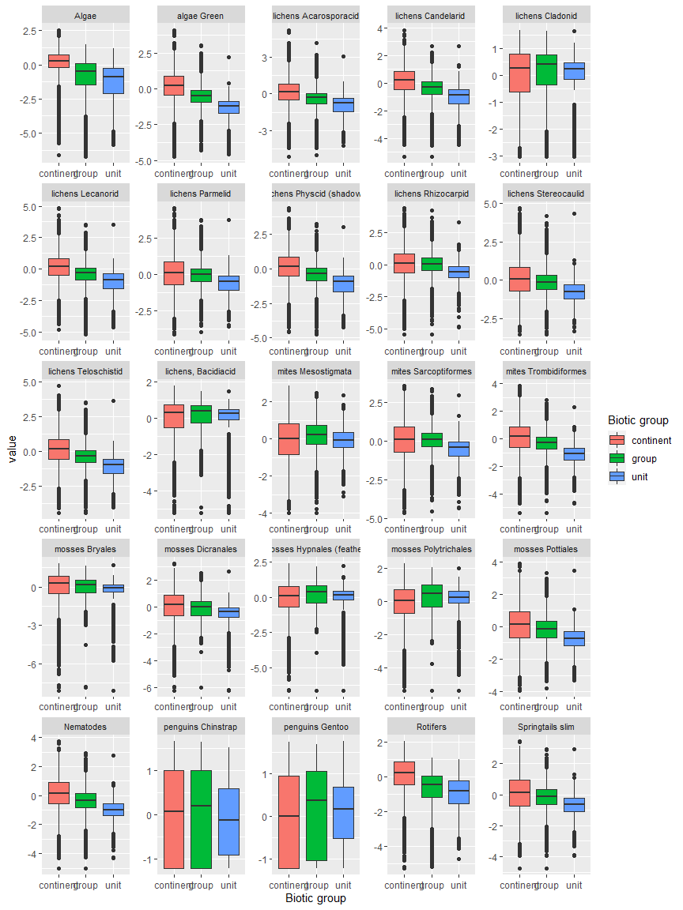

Ecosystem Description

## Ecosystem Env3_sdm1

Env3_sdm1. Occurs mainly in the Transantarctic mountains, Victoria Land and Dronning Maud land. Unit has especially low cloud and highest wind in the group. Main sampled biota appears to be arthopods (springtails and mites) but Chlorophyta, Nematodes, and lichens are also represented. Suitability appears especially low for many mosses, penguins, and some lichens (Cladoniaceae and Bacidiaceae).

### Photos (if available)

### Distribution

Maps - Full map

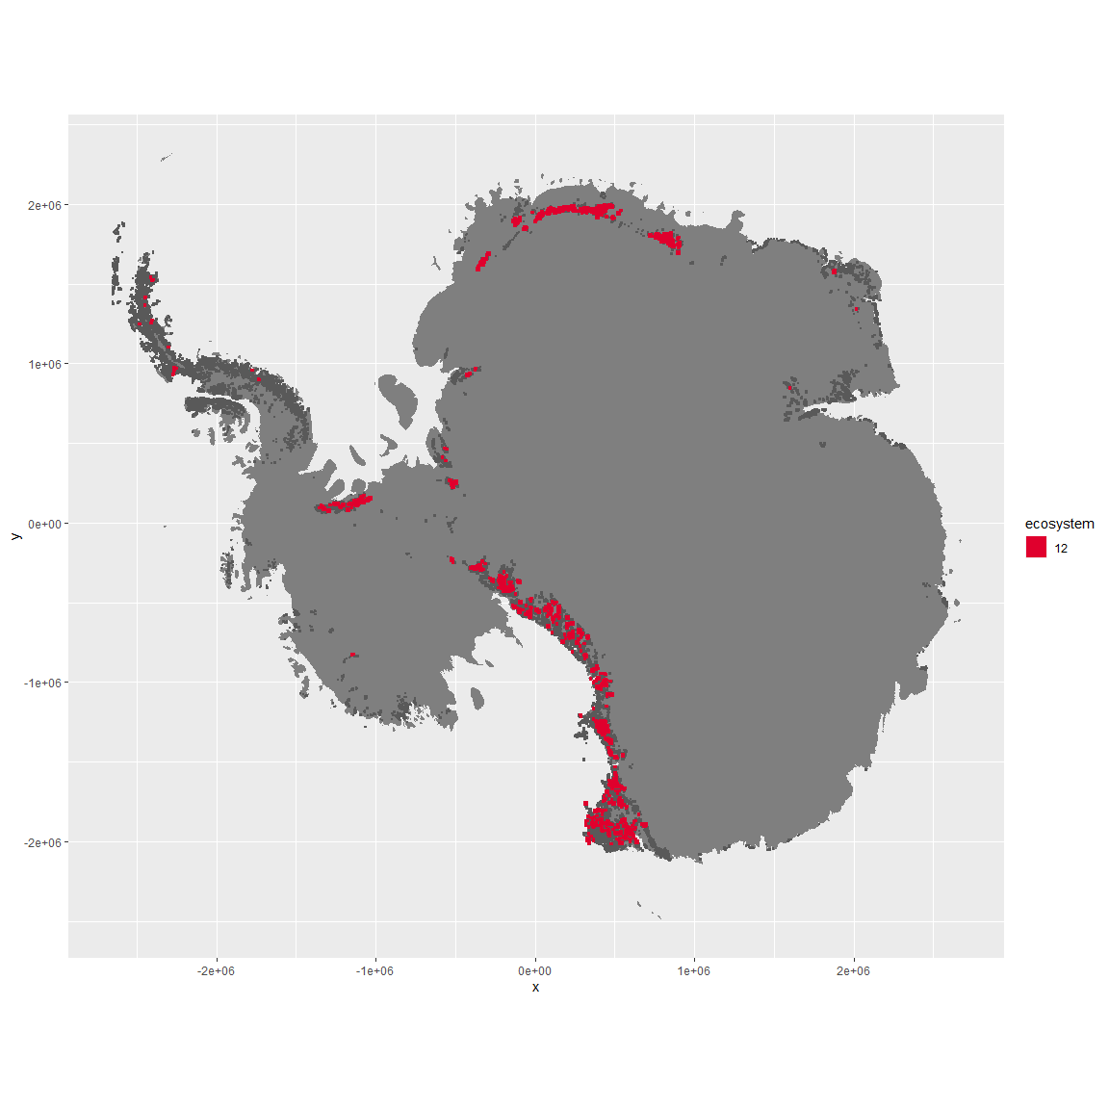

Regional maps

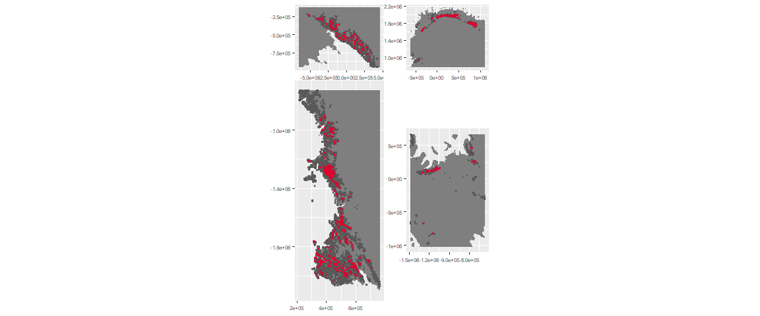

### Environment

The unit env3_sdm1 is part of the environmental supergroup env3.

This supergroup is, on average, substantially higher in slope, rugos and elev than continental antarctica. It is substantially lower in cloud, sumtemp and temp than the rest of the continent.

The elevation of unit env3_sdm1 ranges from 0 to 3679 metres above sea level, but 90% of its pixels fall above 775 and below 2536 metres. Its average elevation is 1696 metres.

The unit is higher in wind and lower in cloud than the rest of its environmental supergroup.

#### Distinctiveness of the unit from its group and the rest of Antarctica

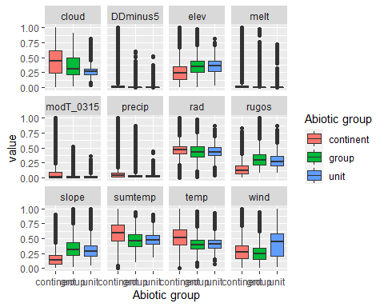

### Biota

Most widespread species in the unit (found in most pixels)

The top most widespread species in ecosystem env3_sdm1

| scientific | Functional_group | phylum | polar specialist? | count | relative_pct |
| --- | --- | --- | --- | --- | --- |
| Gomphiocephalus hodgsoni | Arthropoda_Entognatha_Poduromorpha___ | Arthropoda | TRUE | 6 | 5.3097 |
| Stereotydeus mollis | Arthropoda_Arachnida_Trombidiformes___ | Arthropoda | TRUE | 5 | 4.4248 |
| Xanthoria elegans | Ascomycota_Lecanoromycetes_Teloschistales_Teloschistaceae__ | Ascomycota | FALSE | 4 | 3.5398 |
| Lecidea cancriformis | Ascomycota_Lecanoromycetes_Lecanorales_Lecideaceae__ | Ascomycota | TRUE | 3 | 2.6549 |
| Plectus frigophilus | Nematoda_____ | Nematoda | TRUE | 3 | 2.6549 |
| Prasiola crispa | Chlorophyta_____ | Chlorophyta | FALSE | 3 | 2.6549 |
| Candelariella hallettensis | Ascomycota_Lecanoromycetes_Candelariales_Candelariaceae__ | Ascomycota | TRUE | 2 | 1.7699 |
| Carbonea vorticosa | Ascomycota_Lecanoromycetes_Lecanorales_Lecanoraceae__ | Ascomycota | FALSE | 2 | 1.7699 |
| Cryptopygus sverdrupi | Arthropoda_Entognatha_Entomobryomorpha___ | Arthropoda | TRUE | 2 | 1.7699 |
| Eudorylaimus antarcticus | Nematoda_____ | Nematoda | TRUE | 2 | 1.7699 |
| Eupodes angardi | Arthropoda_Arachnida_Trombidiformes___ | Arthropoda | TRUE | 2 | 1.7699 |
| Lecanora fuscobrunnea | Ascomycota_Lecanoromycetes_Lecanorales_Lecanoraceae__ | Ascomycota | TRUE | 2 | 1.7699 |
| Pseudephebe minuscula | Ascomycota_Lecanoromycetes_Lecanorales_Parmeliaceae__ | Ascomycota | FALSE | 2 | 1.7699 |
| Pygoscelis adeliae | Chordata_Aves_Sphenisciformes_Spheniscidae_Pygoscelis_adeliae | Chordata | FALSE | 2 | 1.7699 |
| Tydeus erebus | Arthropoda_Arachnida_Trombidiformes___ | Arthropoda | TRUE | 2 | 1.7699 |
| Umbilicaria aprina | Ascomycota_Lecanoromycetes_Umbilicariales_Umbilicariaceae__ | Ascomycota | FALSE | 2 | 1.7699 |
| Umbilicaria decussata | Ascomycota_Lecanoromycetes_Umbilicariales_Umbilicariaceae__ | Ascomycota | FALSE | 2 | 1.7699 |
| Xanthoria sp. | Ascomycota_Lecanoromycetes_Teloschistales_Teloschistaceae__ | Ascomycota | TRUE | 2 | 1.7699 |

This supergroup is, on average, substantially higher in suitability for no variables functional groups than continental Antarctica. It is substantially lower in suitability for Springtails_slim, lichens_Cladonid, mosses_Hypnales_(feather), penguins_Chinstrap, mosses_Polytrichales, mites_Sarcoptiformes, mites_Mesostigmata and penguins_Gentoo than the rest of the continent.

Unit env3_sdm1 is higher in suitability for lichens_Acarosporacid, lichens_Parmelid, lichens_Candelarid, algae_Green, lichens_Rhizocarpid, lichens_Teloschistid, lichens_Lecanorid, lichens_Physcid_(shadow), mites_Sarcoptiformes, Algae, mites_Trombidiformes, mosses_Pottiales and lichens_Stereocaulid and lower in suitability for mosses_Polytrichales, mosses_Bryales, penguins_Gentoo, penguins_Chinstrap, lichens,_Bacidiacid and lichens_Cladonid than the rest of its environmental supergroup.

Distinctiveness of the unit from the environmental group and the rest of Antarctica

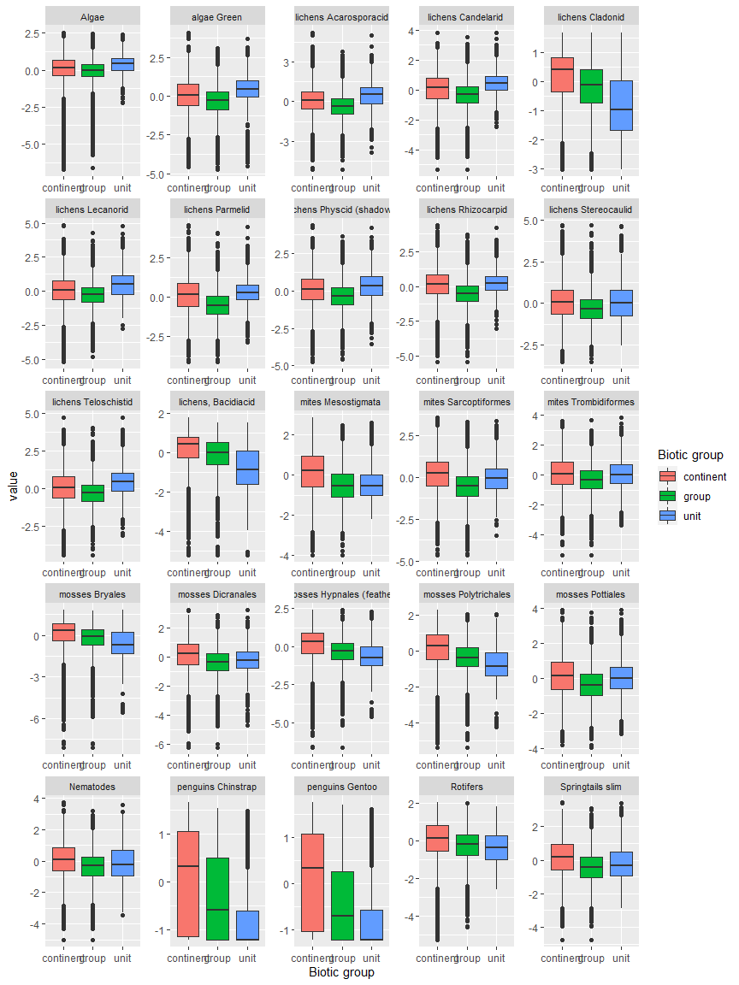

Ecosystem Description

## Ecosystem Env3_sdm2 Steep coastal wind-shaded cliffs and mountainsides

Env3_sdm2 Steep coastal wind-shaded cliffs and mountainsides. Occurs mainly along the Eastern coast of the peninsula and throughout the Transantarctic mountains and Victoria Land. Lowest wind and warmest temps in the group, relatively moist (cloud and precip). Unit is lower than group average but still above continental average in elevation, but higher than both in rugosity and slope. Biota are mainly lichens with some nematodes sampled.

### Photos (if available)

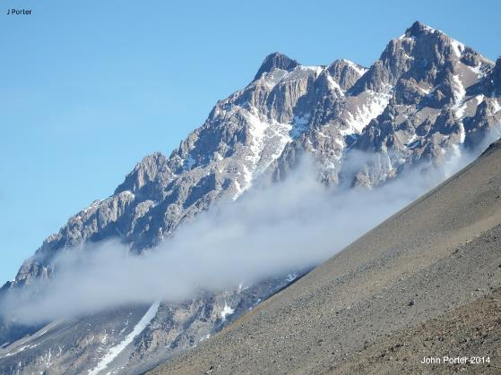

Ecosystem photo

### Distribution

Maps - Full map

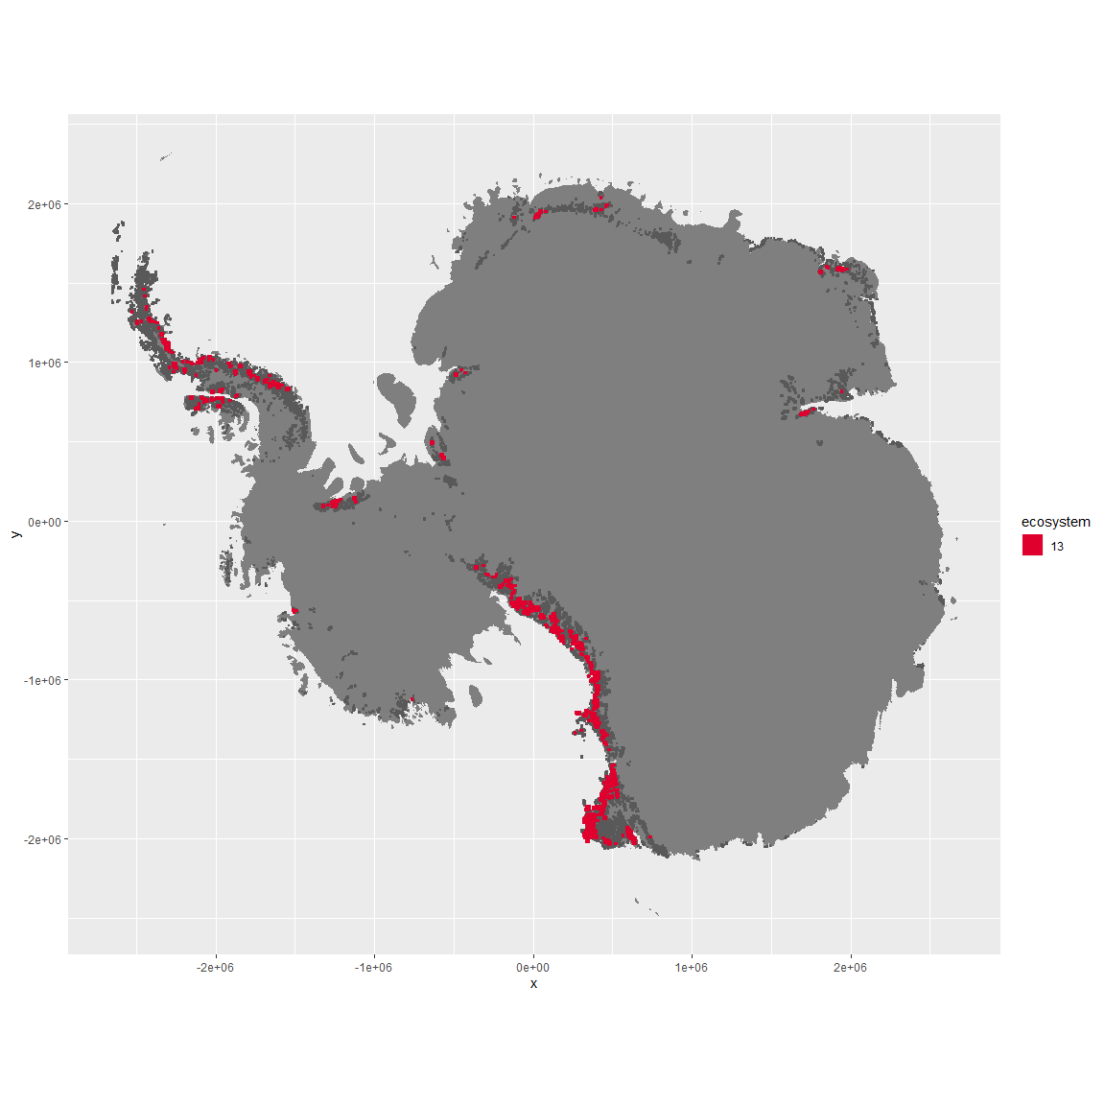

Regional maps

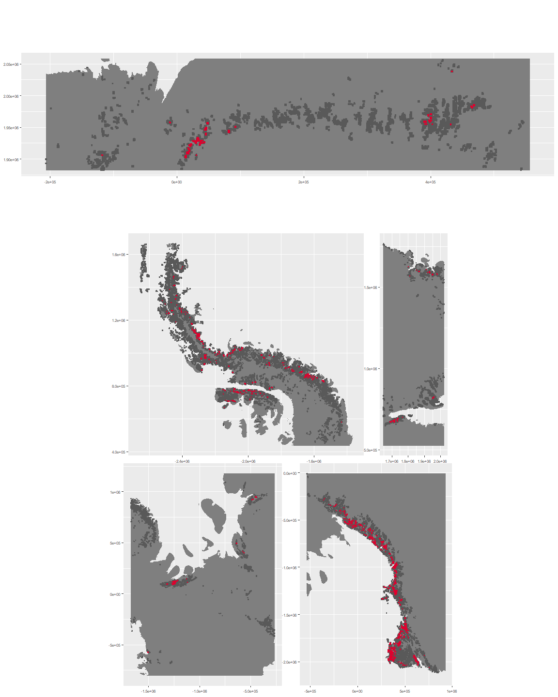

### Environment

The unit env3_sdm2 is part of the environmental supergroup env3.

This supergroup is, on average, substantially higher in slope, rugos and elev than continental antarctica. It is substantially lower in cloud, sumtemp and temp than the rest of the continent.

The elevation of unit env3_sdm2 ranges from 0 to 4815 metres above sea level, but 90% of its pixels fall above 567 and below 2908 metres. Its average elevation is 1582 metres.

The unit is higher in temp, slope, cloud, rugos, sumtemp, rad and melt and lower in wind than the rest of its environmental supergroup.

#### Distinctiveness of the unit from its group and the rest of Antarctica

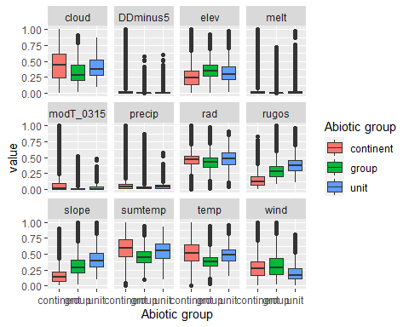

### Biota

Most widespread species in the unit (found in most pixels)

The top most widespread species in ecosystem env3_sdm2

| scientific | Functional_group | phylum | polar specialist? | count | relative_pct |
| --- | --- | --- | --- | --- | --- |
| Pleopsidium chlorophanum | Ascomycota_Lecanoromycetes_Acarosporales_Acarosporaceae__ | Ascomycota | FALSE | 7 | 4.2683 |
| Umbilicaria decussata | Ascomycota_Lecanoromycetes_Umbilicariales_Umbilicariaceae__ | Ascomycota | FALSE | 5 | 3.0488 |
| Usnea sphacelata | Ascomycota_Lecanoromycetes_Lecanorales_Parmeliaceae__ | Ascomycota | TRUE | 5 | 3.0488 |
| Acarospora gwynnii | Ascomycota_Lecanoromycetes_Acarosporales_Acarosporaceae__ | Ascomycota | TRUE | 4 | 2.4390 |
| Buellia frigida | Ascomycota_Lecanoromycetes_Teloschistales_Physciaceae__ | Ascomycota | TRUE | 4 | 2.4390 |
| Lecanora physciella | Ascomycota_Lecanoromycetes_Lecanorales_Lecanoraceae__ | Ascomycota | FALSE | 3 | 1.8293 |
| Pohlia nutans | Bryophyta_Bryopsida_Bryales___ | Bryophyta | FALSE | 3 | 1.8293 |
| Pseudephebe minuscula | Ascomycota_Lecanoromycetes_Lecanorales_Parmeliaceae__ | Ascomycota | FALSE | 3 | 1.8293 |
| Rhizoplaca melanophthalma | Ascomycota_Lecanoromycetes_Lecanorales_Lecanoraceae__ | Ascomycota | FALSE | 3 | 1.8293 |
| Xanthoria elegans | Ascomycota_Lecanoromycetes_Teloschistales_Teloschistaceae__ | Ascomycota | FALSE | 3 | 1.8293 |

This supergroup is, on average, substantially higher in suitability for no variables functional groups than continental Antarctica. It is substantially lower in suitability for Springtails_slim, lichens_Cladonid, mosses_Hypnales_(feather), penguins_Chinstrap, mosses_Polytrichales, mites_Sarcoptiformes, mites_Mesostigmata and penguins_Gentoo than the rest of the continent.

Unit env3_sdm2 is higher in suitability for penguins_Chinstrap, lichens,*Bacidiacid, lichens_Cladonid, penguins_Gentoo, mosses_Bryales, mosses_Hypnales*(feather), mosses_Polytrichales and mosses_Dicranales and lower in suitability for lichens_Rhizocarpid and lichens_Candelarid than the rest of its environmental supergroup.

Distinctiveness of the unit from the environmental group and the rest of Antarctica

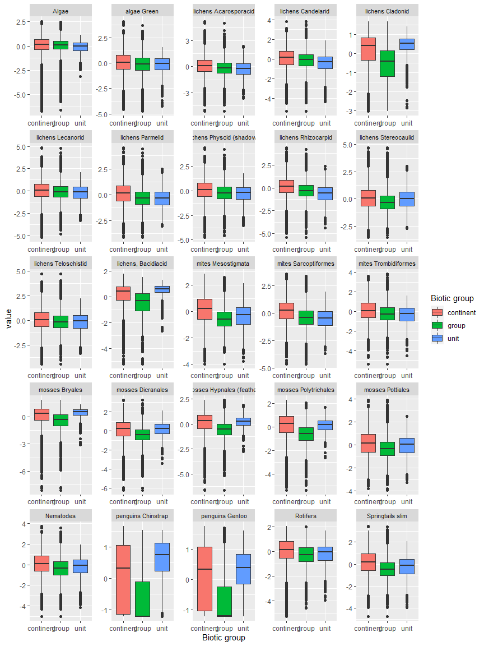

Ecosystem Description

## Ecosystem Env3_sdm3

Env3_sdm3. Occurs mainly in the Transantarctic mountains, Victoria land, and the Prince Charles mountains. May be both coastal and inland. Does not deviate much from group averages except that it’s less cloudy, maybe a tad less rugged than the group average. Most sampled biota are nematodes, but lichens and Entognatha (Arthropods) are also represented. Suitability is low for most functional groups, but Suitability for Ochrophyta and Rotifera is above the continental average, and suitability for Chlorophyta and Nematoda are above the group average. Unit is particularly unsuitable for penguins.

### Photos (if available)

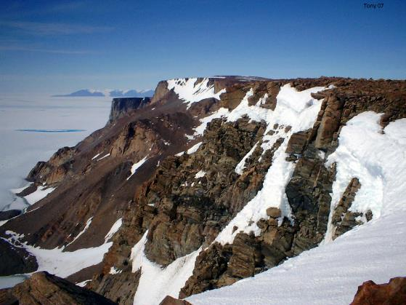

Ecosystem photo

### Distribution

Maps - Full map

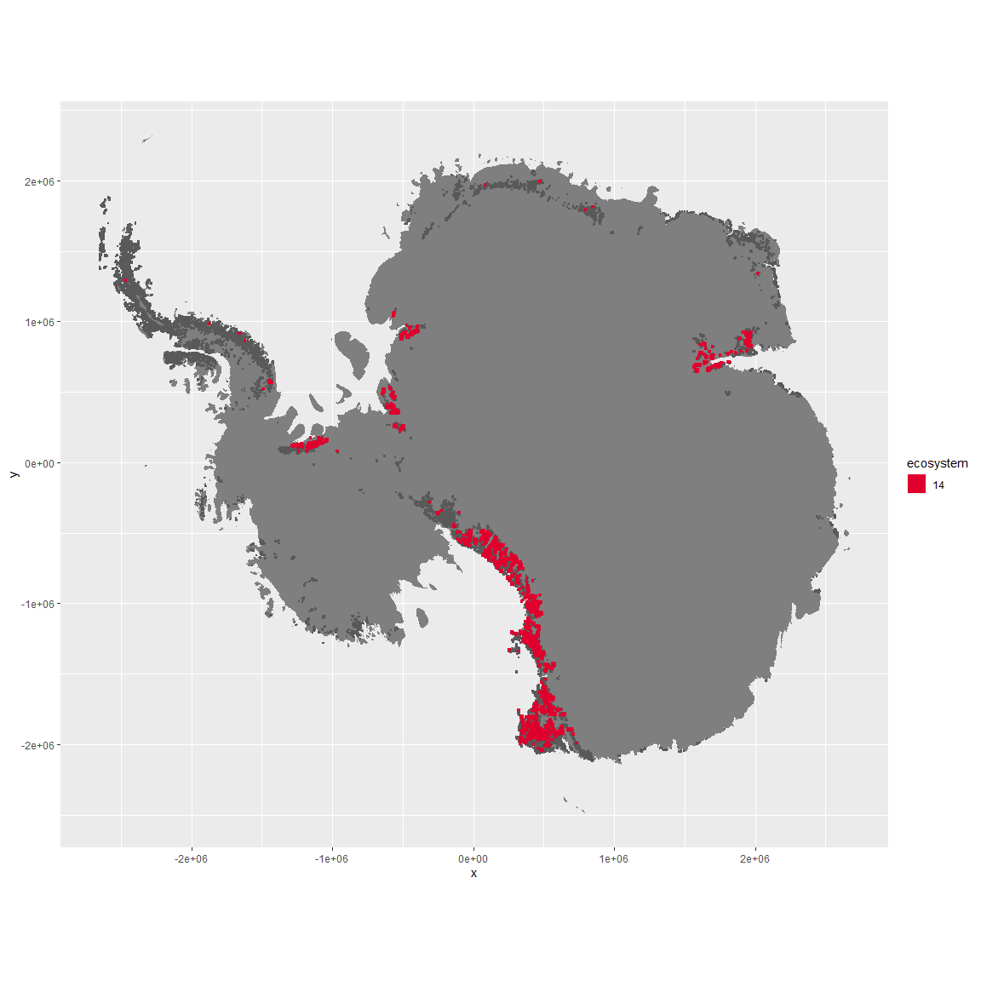

Regional maps

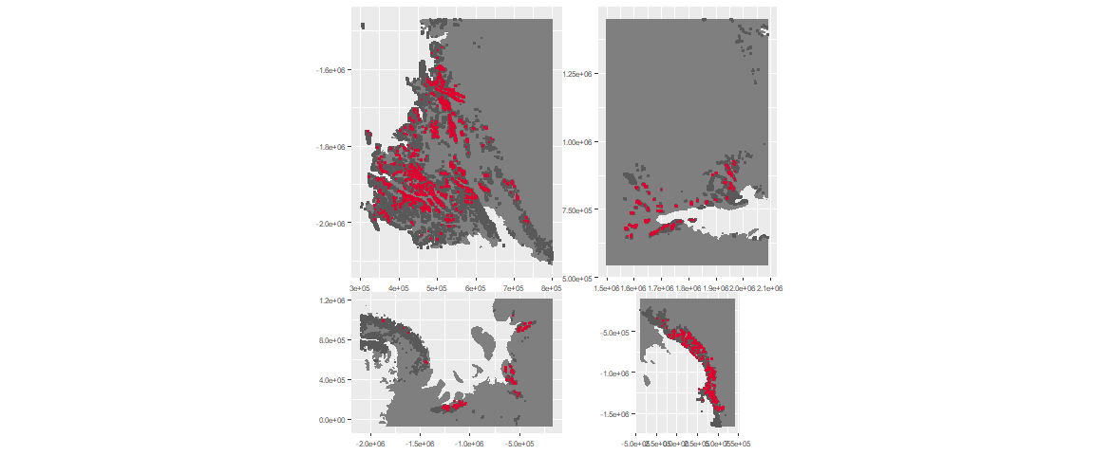

### Environment

The unit env3_sdm3 is part of the environmental supergroup env3.

This supergroup is, on average, substantially higher in slope, rugos and elev than continental antarctica. It is substantially lower in cloud, sumtemp and temp than the rest of the continent.

The elevation of unit env3_sdm3 ranges from 0 to 4143 metres above sea level, but 90% of its pixels fall above 579 and below 2554 metres. Its average elevation is 1532 metres.

The unit is higher in no variables and lower in wind, elev, temp, rugos, slope and cloud than the rest of its environmental supergroup.

#### Distinctiveness of the unit from its group and the rest of Antarctica

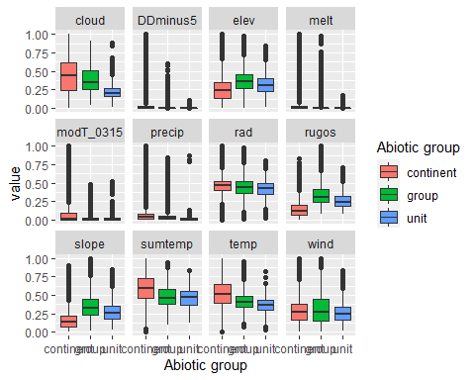

### Biota

Most widespread species in the unit (found in most pixels)

The top most widespread species in ecosystem env3_sdm3

| scientific | Functional_group | phylum | polar specialist? | count | relative_pct |
| --- | --- | --- | --- | --- | --- |
| Scottnema lindsayae | Nematoda_____ | Nematoda | TRUE | 10 | 9.6154 |
| Eudorylaimus antarcticus | Nematoda_____ | Nematoda | TRUE | 6 | 5.7692 |
| Acarospora gwynnii | Ascomycota_Lecanoromycetes_Acarosporales_Acarosporaceae__ | Ascomycota | TRUE | 4 | 3.8462 |
| Buellia pallida | Ascomycota_Lecanoromycetes_Teloschistales_Physciaceae__ | Ascomycota | TRUE | 3 | 2.8846 |
| Gomphiocephalus hodgsoni | Arthropoda_Entognatha_Poduromorpha___ | Arthropoda | TRUE | 3 | 2.8846 |
| Biscoia sudpolaris | Arthropoda_Entognatha_Poduromorpha___ | Arthropoda | TRUE | 2 | 1.9231 |
| Carbonea capsulata | Ascomycota_Lecanoromycetes_Lecanorales_Lecanoraceae__ | Ascomycota | TRUE | 2 | 1.9231 |
| Geomonhystera antarcticola | Nematoda_____ | Nematoda | TRUE | 2 | 1.9231 |
| Lecanora expectans | Ascomycota_Lecanoromycetes_Lecanorales_Lecanoraceae__ | Ascomycota | TRUE | 2 | 1.9231 |
| Lecanora fuscobrunnea | Ascomycota_Lecanoromycetes_Lecanorales_Lecanoraceae__ | Ascomycota | TRUE | 2 | 1.9231 |
| Lecidea cancriformis | Ascomycota_Lecanoromycetes_Lecanorales_Lecideaceae__ | Ascomycota | TRUE | 2 | 1.9231 |
| Nanorchestes antarcticus | Arthropoda_Arachnida_Sarcoptiformes___ | Arthropoda | TRUE | 2 | 1.9231 |
| Plectus murrayi | Nematoda_____ | Nematoda | TRUE | 2 | 1.9231 |
| Pleopsidium chlorophanum | Ascomycota_Lecanoromycetes_Acarosporales_Acarosporaceae__ | Ascomycota | FALSE | 2 | 1.9231 |
| Rhizoplaca melanophthalma | Ascomycota_Lecanoromycetes_Lecanorales_Lecanoraceae__ | Ascomycota | FALSE | 2 | 1.9231 |
| Xanthoria elegans | Ascomycota_Lecanoromycetes_Teloschistales_Teloschistaceae__ | Ascomycota | FALSE | 2 | 1.9231 |

This supergroup is, on average, substantially higher in suitability for no variables functional groups than continental Antarctica. It is substantially lower in suitability for Springtails_slim, lichens_Cladonid, mosses_Hypnales_(feather), penguins_Chinstrap, mosses_Polytrichales, mites_Sarcoptiformes, mites_Mesostigmata and penguins_Gentoo than the rest of the continent.

Unit env3_sdm3 is higher in suitability for Rotifers and Nematodes and lower in suitability for lichens_Parmelid than the rest of its environmental supergroup.

Distinctiveness of the unit from the environmental group and the rest of Antarctica

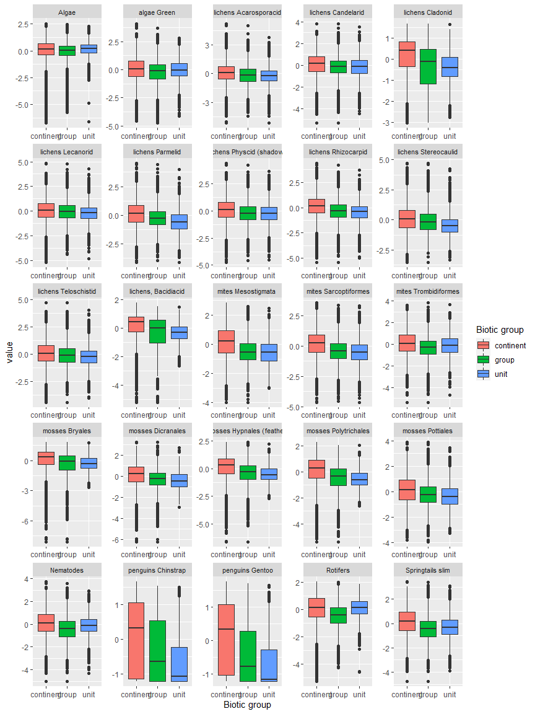

Ecosystem Description

## Ecosystem Env3_sdm4 Steep coastal wind-exposed cliffs and mountainsides

Env3_sdm4 Steep coastal wind-exposed cliffs and mountainsides. Occurs mainly in the North peninsula and western Transantarctic mountains. Cloudier and a bit more rugged than rest of unit and than the continental average. Sampled biota is a mix of nematodes, lichens, mosses, and Arthropods. Suitability is lower than the continental average for all functional groups, but is apparently highest for Ochrophytes and perhaps some lichen groups.

### Photos (if available)

### Distribution

Maps - Full map

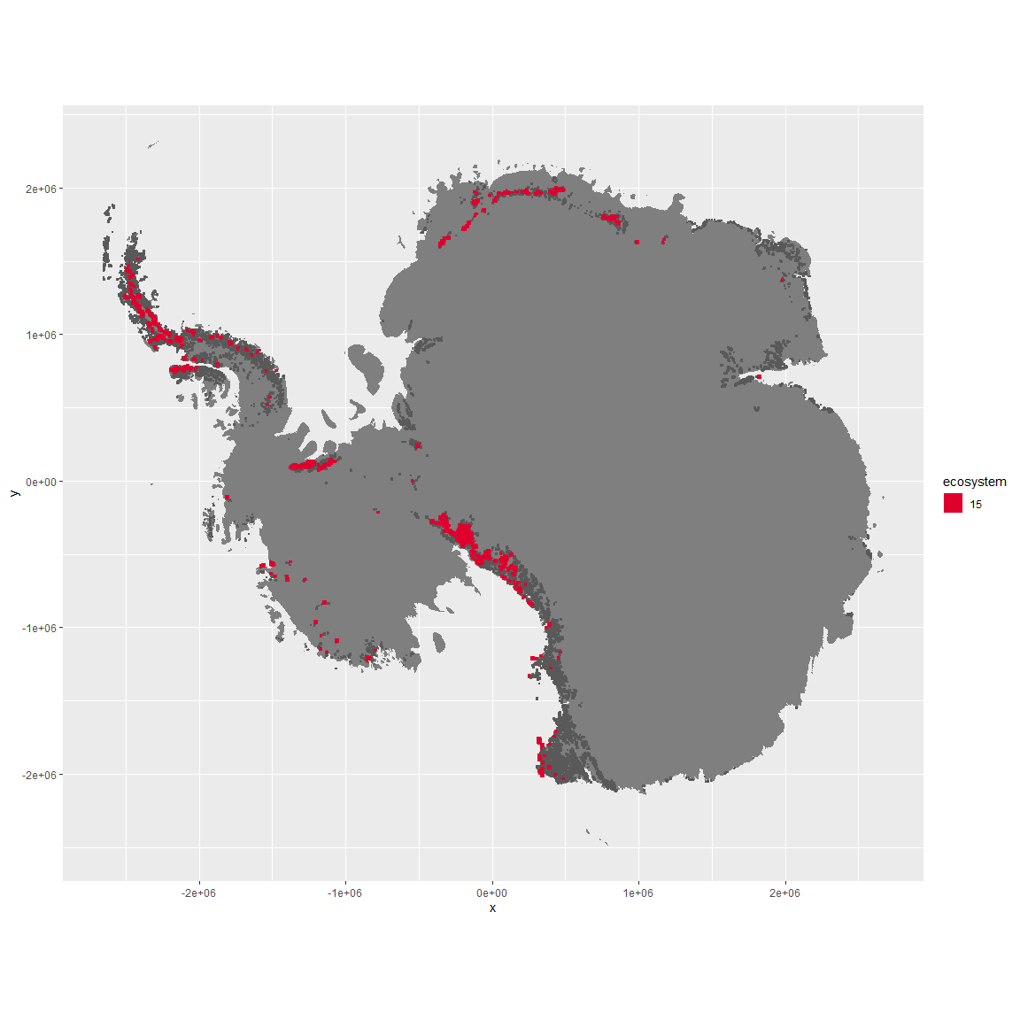

Regional maps

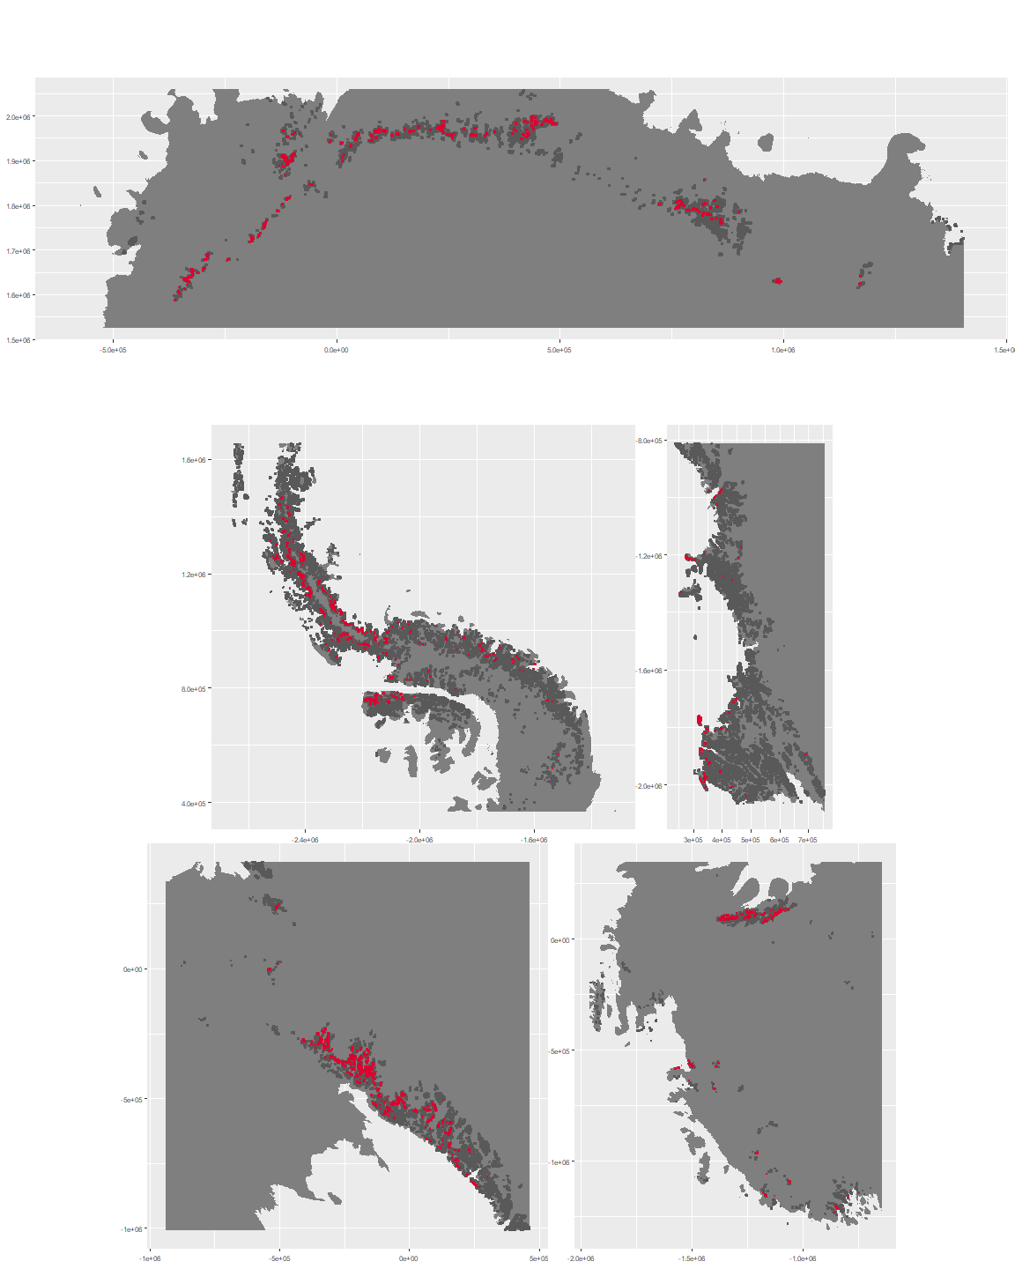

### Environment

The unit env3_sdm4 is part of the environmental supergroup env3.

This supergroup is, on average, substantially higher in slope, rugos and elev than continental antarctica. It is substantially lower in cloud, sumtemp and temp than the rest of the continent.

The elevation of unit env3_sdm4 ranges from 0 to 4966 metres above sea level, but 90% of its pixels fall above 227 and below 2923 metres. Its average elevation is 1613 metres.

The unit is higher in cloud, precip, slope, rugos, temp and wind and lower in no variables than the rest of its environmental supergroup.

#### Distinctiveness of the unit from its group and the rest of Antarctica

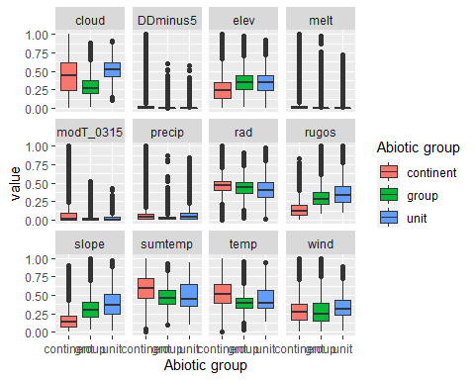

### Biota

Most widespread species in the unit (found in most pixels)

The top most widespread species in ecosystem env3_sdm4

| scientific | Functional_group | phylum | polar specialist? | count | relative_pct |
| --- | --- | --- | --- | --- | --- |
| Pohlia cruda | Bryophyta_Bryopsida_Bryales___ | Bryophyta | FALSE | 3 | 4.8387 |
| Pseudephebe minuscula | Ascomycota_Lecanoromycetes_Lecanorales_Parmeliaceae__ | Ascomycota | FALSE | 3 | 4.8387 |
| Pygoscelis adeliae | Chordata_Aves_Sphenisciformes_Spheniscidae_Pygoscelis_adeliae | Chordata | FALSE | 3 | 4.8387 |
| Acarospora gwynnii | Ascomycota_Lecanoromycetes_Acarosporales_Acarosporaceae__ | Ascomycota | TRUE | 2 | 3.2258 |
| Lecidea cancriformis | Ascomycota_Lecanoromycetes_Lecanorales_Lecideaceae__ | Ascomycota | TRUE | 2 | 3.2258 |
| Lecidea cf. cancriformis | Ascomycota_Lecanoromycetes_Lecanorales_Lecideaceae__ | Ascomycota | TRUE | 2 | 3.2258 |
| Nanorchestes antarcticus | Arthropoda_Arachnida_Sarcoptiformes___ | Arthropoda | TRUE | 2 | 3.2258 |
| Plectus murrayi | Nematoda_____ | Nematoda | TRUE | 2 | 3.2258 |
| Usnea sphacelata | Ascomycota_Lecanoromycetes_Lecanorales_Parmeliaceae__ | Ascomycota | TRUE | 2 | 3.2258 |
| Arthrorhaphis citrinella | Ascomycota_Lecanoromycetes_Not assigned_Arthrorhaphidaceae__ | Ascomycota | FALSE | 1 | 1.6129 |
| Brachythecium austro-salebrosum | Bryophyta_Bryopsida_Hypnales___ | Bryophyta | TRUE | 1 | 1.6129 |
| Brachythecium subpilosum | Bryophyta_Bryopsida_Hypnales___ | Bryophyta | FALSE | 1 | 1.6129 |
| Buellia darbishirei | Ascomycota_Lecanoromycetes_Teloschistales_Physciaceae__ | Ascomycota | TRUE | 1 | 1.6129 |
| Buellia frigida | Ascomycota_Lecanoromycetes_Teloschistales_Physciaceae__ | Ascomycota | TRUE | 1 | 1.6129 |
| Caloplaca isidioclada | Ascomycota_Lecanoromycetes_Teloschistales_Teloschistaceae__ | Ascomycota | FALSE | 1 | 1.6129 |
| Candelaria murrayi | Ascomycota_Lecanoromycetes_Candelariales_Candelariaceae__ | Ascomycota | TRUE | 1 | 1.6129 |
| Candelariella flava | Ascomycota_Lecanoromycetes_Candelariales_Candelariaceae__ | Ascomycota | TRUE | 1 | 1.6129 |
| Ceratodon purpureus | Bryophyta_Bryopsida_Dicranales___ | Bryophyta | FALSE | 1 | 1.6129 |
| Cladonia galindezii | Ascomycota_Lecanoromycetes_Lecanorales_Cladoniaceae__ | Ascomycota | TRUE | 1 | 1.6129 |
| Coccorhagidia gressitti | Arthropoda_Arachnida_Trombidiformes___ | Arthropoda | TRUE | 1 | 1.6129 |
| Colobanthus quitensis | Tracheophyta_____ | Tracheophyta | FALSE | 1 | 1.6129 |
| Deschampsia antarctica | Tracheophyta_____ | Tracheophyta | FALSE | 1 | 1.6129 |
| Desmococcus sp. | Chlorophyta_____ | Chlorophyta | TRUE | 1 | 1.6129 |
| Eudorylaimus antarcticus | Nematoda_____ | Nematoda | TRUE | 1 | 1.6129 |
| Gloeocapsa sp. | Cyanobacteria_____ | Cyanobacteria | TRUE | 1 | 1.6129 |
| Gomphiocephalus hodgsoni | Arthropoda_Entognatha_Poduromorpha___ | Arthropoda | TRUE | 1 | 1.6129 |
| Grimmia lawiana | Bryophyta_Bryopsida_Grimmiales___ | Bryophyta | TRUE | 1 | 1.6129 |
| Grimmia reflexidens | Bryophyta_Bryopsida_Grimmiales___ | Bryophyta | FALSE | 1 | 1.6129 |
| Isotoma klovstadi | Arthropoda_Entognatha_Entomobryomorpha___ | Arthropoda | TRUE | 1 | 1.6129 |
| Lecanora cf. orosthea | Ascomycota_Lecanoromycetes_Lecanorales_Lecanoraceae__ | Ascomycota | TRUE | 1 | 1.6129 |
| Lecanora expectans | Ascomycota_Lecanoromycetes_Lecanorales_Lecanoraceae__ | Ascomycota | TRUE | 1 | 1.6129 |
| Lecanora fuscobrunnea | Ascomycota_Lecanoromycetes_Lecanorales_Lecanoraceae__ | Ascomycota | TRUE | 1 | 1.6129 |
| Luticola sp. | Ochrophyta_____ | Ochrophyta | TRUE | 1 | 1.6129 |
| Pannaria hookeri | Ascomycota_Lecanoromycetes_Peltigerales_Pannariaceae__ | Ascomycota | FALSE | 1 | 1.6129 |
| Placopsis contortuplicata | Ascomycota_Lecanoromycetes_Baeomycetales_Trapeliaceae__ | Ascomycota | TRUE | 1 | 1.6129 |
| Pleopsidium chlorophanum | Ascomycota_Lecanoromycetes_Acarosporales_Acarosporaceae__ | Ascomycota | FALSE | 1 | 1.6129 |
| Polytrichastrum alpinum | Bryophyta_Bryopsida_Polytrichales___ | Bryophyta | FALSE | 1 | 1.6129 |
| Polytrichum juniperinum | Bryophyta_Bryopsida_Polytrichales___ | Bryophyta | FALSE | 1 | 1.6129 |
| Polytrichum piliferum | Bryophyta_Bryopsida_Polytrichales___ | Bryophyta | FALSE | 1 | 1.6129 |
| Rhizocarpon adarense | Ascomycota_Lecanoromycetes_Not assigned_Rhizocarpaceae__ | Ascomycota | TRUE | 1 | 1.6129 |
| Rhizocarpon sp. | Ascomycota_Lecanoromycetes_Not assigned_Rhizocarpaceae__ | Ascomycota | TRUE | 1 | 1.6129 |
| Sanionia uncinata | Bryophyta_Bryopsida_Hypnales___ | Bryophyta | FALSE | 1 | 1.6129 |
| Stereocaulon antarcticum | Ascomycota_Lecanoromycetes_Lecanorales_Stereocaulaceae__ | Ascomycota | TRUE | 1 | 1.6129 |
| Stereotydeus mollis | Arthropoda_Arachnida_Trombidiformes___ | Arthropoda | TRUE | 1 | 1.6129 |
| Stichococcus bacillaris | Chlorophyta_____ | Chlorophyta | FALSE | 1 | 1.6129 |
| Syntrichia princeps | Bryophyta_Bryopsida_Pottiales___ | Bryophyta | FALSE | 1 | 1.6129 |
| Tephromela atra | Ascomycota_Lecanoromycetes_Lecanorales_Mycoblastaceae__ | Ascomycota | FALSE | 1 | 1.6129 |
| Umbilicaria aprina | Ascomycota_Lecanoromycetes_Umbilicariales_Umbilicariaceae__ | Ascomycota | FALSE | 1 | 1.6129 |
| Warnstorfia sarmentosa | Bryophyta_Bryopsida_Hypnales___ | Bryophyta | FALSE | 1 | 1.6129 |
| Xanthoria elegans | Ascomycota_Lecanoromycetes_Teloschistales_Teloschistaceae__ | Ascomycota | FALSE | 1 | 1.6129 |

This supergroup is, on average, substantially higher in suitability for no variables functional groups than continental Antarctica. It is substantially lower in suitability for Springtails_slim, lichens_Cladonid, mosses_Hypnales_(feather), penguins_Chinstrap, mosses_Polytrichales, mites_Sarcoptiformes, mites_Mesostigmata and penguins_Gentoo than the rest of the continent.

Unit env3_sdm4 is higher in suitability for mites_Mesostigmata and lower in suitability for Rotifers, lichens_Physcid_(shadow), Nematodes, lichens_Acarosporacid, Algae and algae_Green than the rest of its environmental supergroup.

Distinctiveness of the unit from the environmental group and the rest of Antarctica

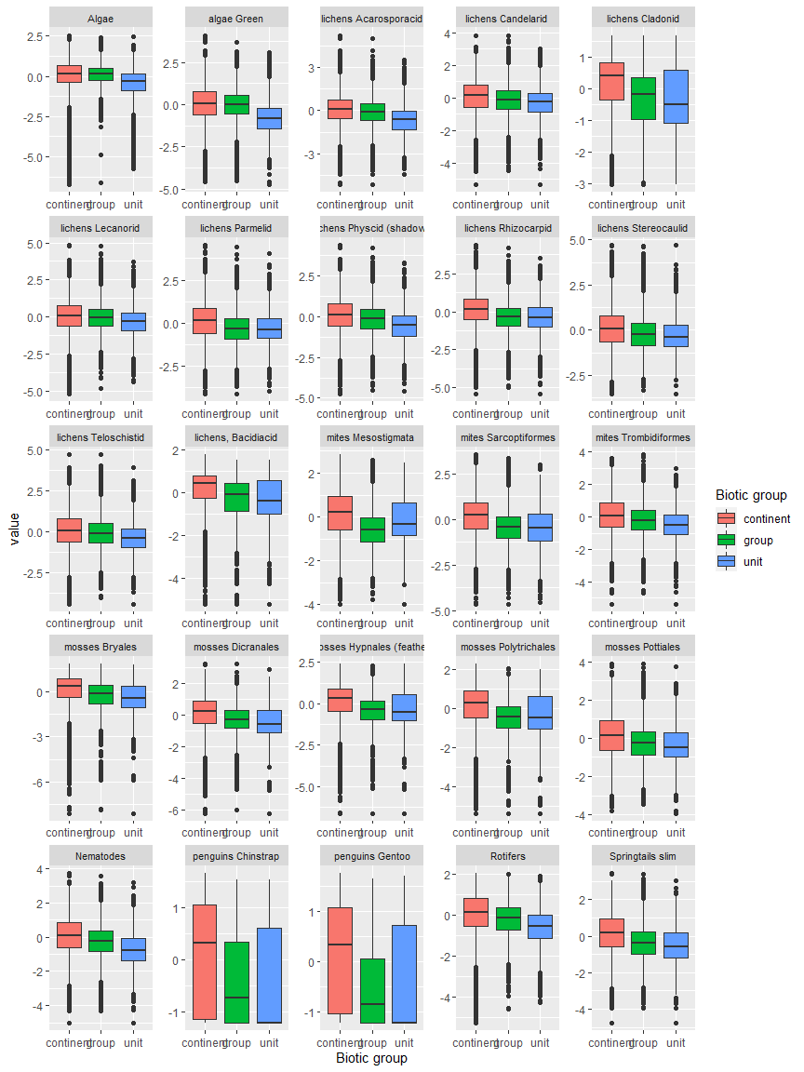

Ecosystem Description

## Ecosystem Env3_sdm5 Inland high mountains

Env3_sdm5 Inland high mountains. Occurs mainly in the Transantarctic mountains and Victoria land. This unit is an extreme example, higher and colder than the unit average. Unit does not occur near the coast. Biota is sparse but consists mainly of lichens, but suitability is below the continental average for all functional groups. The highest suitability is apparently for Ochrophyta.

### Photos (if available)

### Distribution

Maps - Full map

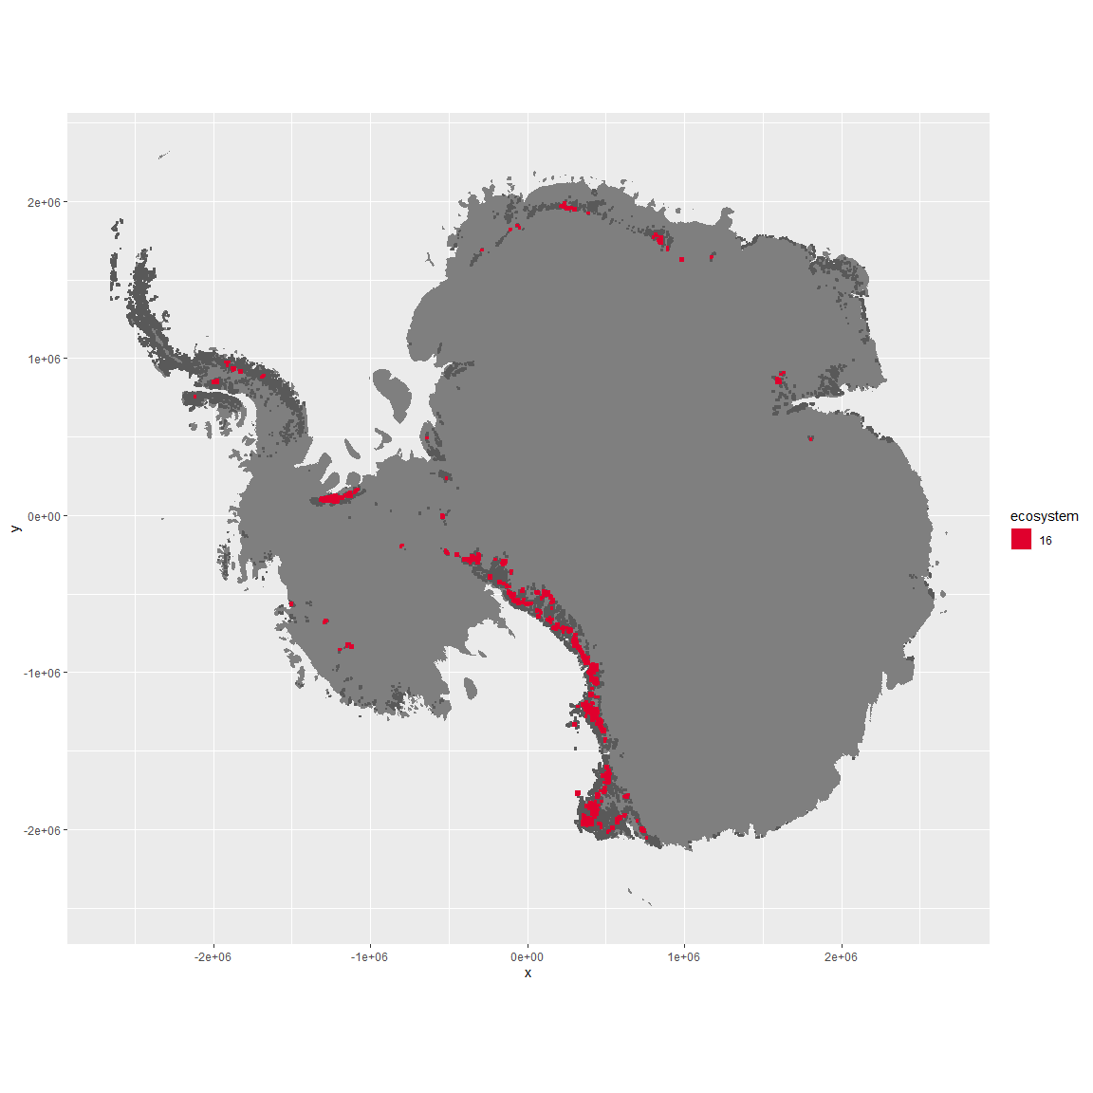

Regional maps

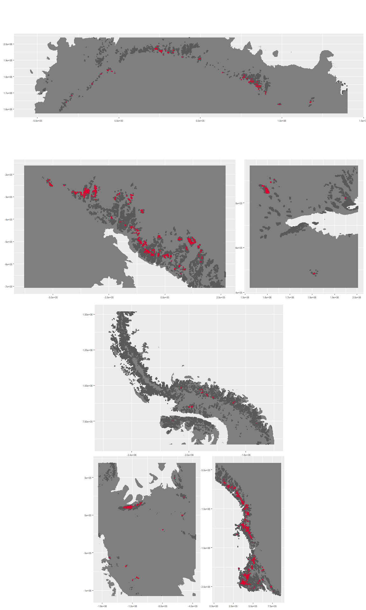

### Environment

The unit env3_sdm5 is part of the environmental supergroup env3.

This supergroup is, on average, substantially higher in slope, rugos and elev than continental antarctica. It is substantially lower in cloud, sumtemp and temp than the rest of the continent.

The elevation of unit env3_sdm5 ranges from 93 to 4365 metres above sea level, but 90% of its pixels fall above 1324 and below 2943 metres. Its average elevation is 2064 metres.

The unit is higher in elev and lower in wind, temp and sumtemp than the rest of its environmental supergroup.

#### Distinctiveness of the unit from its group and the rest of Antarctica

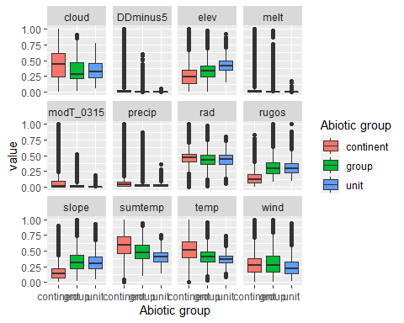

### Biota

Most widespread species in the unit (found in most pixels)

The top most widespread species in ecosystem env3_sdm5

| scientific | Functional_group | phylum | polar specialist? | count | relative_pct |
| --- | --- | --- | --- | --- | --- |
| Carbonea capsulata | Ascomycota_Lecanoromycetes_Lecanorales_Lecanoraceae__ | Ascomycota | TRUE | 3 | 5.2632 |
| Candelariella flava | Ascomycota_Lecanoromycetes_Candelariales_Candelariaceae__ | Ascomycota | TRUE | 2 | 3.5088 |
| Carbonea vorticosa | Ascomycota_Lecanoromycetes_Lecanorales_Lecanoraceae__ | Ascomycota | FALSE | 2 | 3.5088 |
| Hemichloris antarctica | Chlorophyta_____ | Chlorophyta | FALSE | 2 | 3.5088 |
| Heterococcus endolithicus | Ochrophyta_____ | Ochrophyta | TRUE | 2 | 3.5088 |
| Lecanora fuscobrunnea | Ascomycota_Lecanoromycetes_Lecanorales_Lecanoraceae__ | Ascomycota | TRUE | 2 | 3.5088 |
| Neocryptopygus nivicolus | Arthropoda_Entognatha_Entomobryomorpha___ | Arthropoda | TRUE | 2 | 3.5088 |
| Scottnema lindsayae | Nematoda_____ | Nematoda | TRUE | 2 | 3.5088 |
| Xanthoria elegans | Ascomycota_Lecanoromycetes_Teloschistales_Teloschistaceae__ | Ascomycota | FALSE | 2 | 3.5088 |
| Acarospora gwynnii | Ascomycota_Lecanoromycetes_Acarosporales_Acarosporaceae__ | Ascomycota | TRUE | 1 | 1.7544 |
| Achnanthes sp. | Ochrophyta_____ | Ochrophyta | TRUE | 1 | 1.7544 |
| Antarcticinella monoculata | Arthropoda_Entognatha_Entomobryomorpha___ | Arthropoda | TRUE | 1 | 1.7544 |
| Aulacoseira sp. | Ochrophyta_____ | Ochrophyta | TRUE | 1 | 1.7544 |
| Blastenia cf. bastini | Ascomycota_Lecanoromycetes_Teloschistales_Teloschistaceae__ | Ascomycota | TRUE | 1 | 1.7544 |
| Buellia bastinii | Ascomycota_Lecanoromycetes_Teloschistales_Physciaceae__ | Ascomycota | TRUE | 1 | 1.7544 |
| Buellia evanescens | Ascomycota_Lecanoromycetes_Teloschistales_Physciaceae__ | Ascomycota | TRUE | 1 | 1.7544 |
| Buellia grisea | Ascomycota_Lecanoromycetes_Teloschistales_Physciaceae__ | Ascomycota | FALSE | 1 | 1.7544 |
| Buellia pallida | Ascomycota_Lecanoromycetes_Teloschistales_Physciaceae__ | Ascomycota | TRUE | 1 | 1.7544 |
| Caloneis tenuis | Ochrophyta_____ | Ochrophyta | FALSE | 1 | 1.7544 |
| Campylopus pyriformis | Bryophyta_Bryopsida_Dicranales___ | Bryophyta | FALSE | 1 | 1.7544 |
| Coccomyxa gloeobotrydiformis | Chlorophyta_____ | Chlorophyta | TRUE | 1 | 1.7544 |
| Cyclotella ocellata | Ochrophyta_____ | Ochrophyta | FALSE | 1 | 1.7544 |
| Elliptochloris reniformis | Chlorophyta_____ | Chlorophyta | TRUE | 1 | 1.7544 |
| Eudorylaimus antarcticus | Nematoda_____ | Nematoda | TRUE | 1 | 1.7544 |
| Fragilaria berolinensis | Ochrophyta_____ | Ochrophyta | TRUE | 1 | 1.7544 |
| Fragilaria sp. | Ochrophyta_____ | Ochrophyta | TRUE | 1 | 1.7544 |
| Gloeocapsa magma | Cyanobacteria_____ | Cyanobacteria | FALSE | 1 | 1.7544 |
| Gomphiocephalus hodgsoni | Arthropoda_Entognatha_Poduromorpha___ | Arthropoda | TRUE | 1 | 1.7544 |
| Graesiella emersonii | Chlorophyta_____ | Chlorophyta | FALSE | 1 | 1.7544 |
| Hassallia bouteillei | Cyanobacteria_____ | Cyanobacteria | TRUE | 1 | 1.7544 |
| Lecidea cancriformis | Ascomycota_Lecanoromycetes_Lecanorales_Lecideaceae__ | Ascomycota | TRUE | 1 | 1.7544 |
| Lecidea cf. cancriformis | Ascomycota_Lecanoromycetes_Lecanorales_Lecideaceae__ | Ascomycota | TRUE | 1 | 1.7544 |
| Lecidea coreyi | Ascomycota_Lecanoromycetes_Lecanorales_Lecideaceae__ | Ascomycota | TRUE | 1 | 1.7544 |
| Mastigocladus laminosus | Cyanobacteria_____ | Cyanobacteria | FALSE | 1 | 1.7544 |
| Parmelia griseola | Ascomycota_Lecanoromycetes_Lecanorales_Parmeliaceae__ | Ascomycota | TRUE | 1 | 1.7544 |
| Pinnularia maior | Ochrophyta_____ | Ochrophyta | FALSE | 1 | 1.7544 |
| Pseudephebe minuscula | Ascomycota_Lecanoromycetes_Lecanorales_Parmeliaceae__ | Ascomycota | FALSE | 1 | 1.7544 |
| Pseudococcomyxa simplex | Chlorophyta_____ | Chlorophyta | TRUE | 1 | 1.7544 |
| Rhizocarpon geographicum | Ascomycota_Lecanoromycetes_Not assigned_Rhizocarpaceae__ | Ascomycota | FALSE | 1 | 1.7544 |
| Rhizoplaca melanophthalma | Ascomycota_Lecanoromycetes_Lecanorales_Lecanoraceae__ | Ascomycota | FALSE | 1 | 1.7544 |
| Stereotydeus mollis | Arthropoda_Arachnida_Trombidiformes___ | Arthropoda | TRUE | 1 | 1.7544 |
| Stigonema ocellatum | Cyanobacteria_____ | Cyanobacteria | FALSE | 1 | 1.7544 |
| Trebouxia sp. | Chlorophyta_____ | Chlorophyta | TRUE | 1 | 1.7544 |
| Umbilicaria aprina | Ascomycota_Lecanoromycetes_Umbilicariales_Umbilicariaceae__ | Ascomycota | FALSE | 1 | 1.7544 |
| Umbilicaria cf. krascheninnikovii | Ascomycota_Lecanoromycetes_Umbilicariales_Umbilicariaceae__ | Ascomycota | TRUE | 1 | 1.7544 |
| Umbilicaria decussata | Ascomycota_Lecanoromycetes_Umbilicariales_Umbilicariaceae__ | Ascomycota | FALSE | 1 | 1.7544 |
| Usnea sphacelata | Ascomycota_Lecanoromycetes_Lecanorales_Parmeliaceae__ | Ascomycota | TRUE | 1 | 1.7544 |

This supergroup is, on average, substantially higher in suitability for no variables functional groups than continental Antarctica. It is substantially lower in suitability for Springtails_slim, lichens_Cladonid, mosses_Hypnales_(feather), penguins_Chinstrap, mosses_Polytrichales, mites_Sarcoptiformes, mites_Mesostigmata and penguins_Gentoo than the rest of the continent.

Unit env3_sdm5 is higher in suitability for no variables and lower in suitability for mosses_Polytrichales, mites_Sarcoptiformes, lichens_Physcid_(shadow), mosses_Bryales, mosses_Hypnales_(feather), lichens_Teloschistid, Rotifers, Nematodes, lichens_Rhizocarpid, mites_Trombidiformes, Springtails_slim, lichens_Parmelid, lichens_Candelarid, algae_Green, mites_Mesostigmata, mosses_Pottiales and mosses_Dicranales than the rest of its environmental supergroup.

Distinctiveness of the unit from the environmental group and the rest of Antarctica

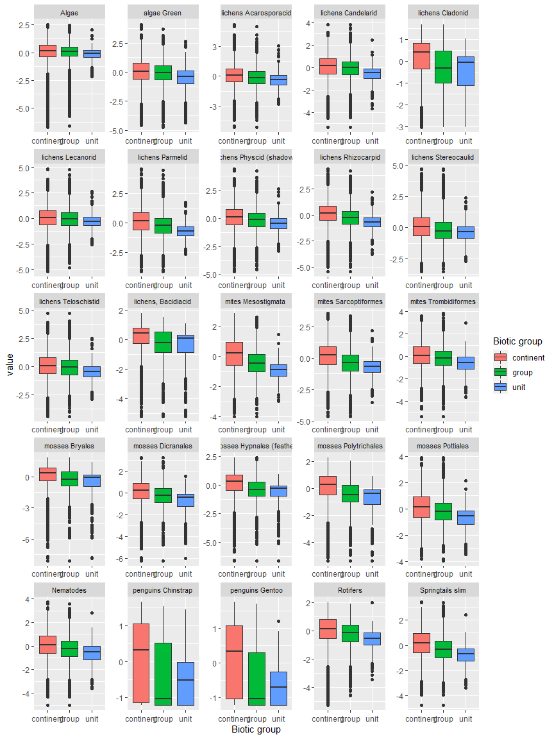

Ecosystem Description

## Ecosystem Env4_sdm1, Windy overcast plateaus

Env4_sdm1, Windy overcast plateaus. Occurs mainly on the eastern coast of the northern peninsula, Dronning Maud land, Enderby land, and in the Prince Charles mountains. This unit is especially windy and high in radiation (North-facing slopes?). Sampled fauna is scarce but consists of lichens, a few mosses and the occasional tardigrade. Suitability is below continental average for all functional groups in Env 4 but this unit nonetheless has higher than continental average suitability for Candelariaceae, Rhizocarpaceae, Acarosporaceae and to a lesser extent Permeliaceae lichens.

### Photos (if available)

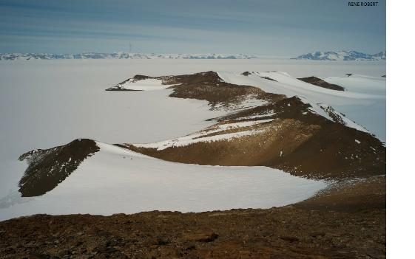

Ecosystem photo

### Distribution

Maps - Full map

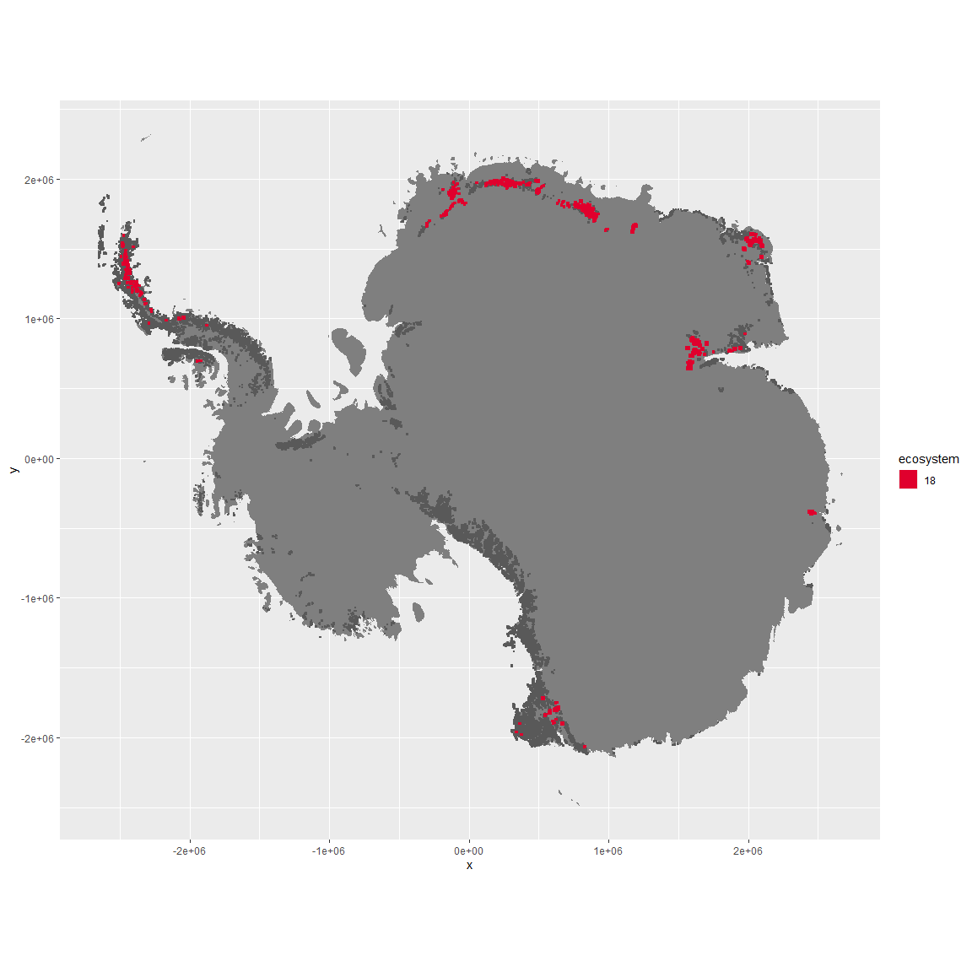

Regional maps

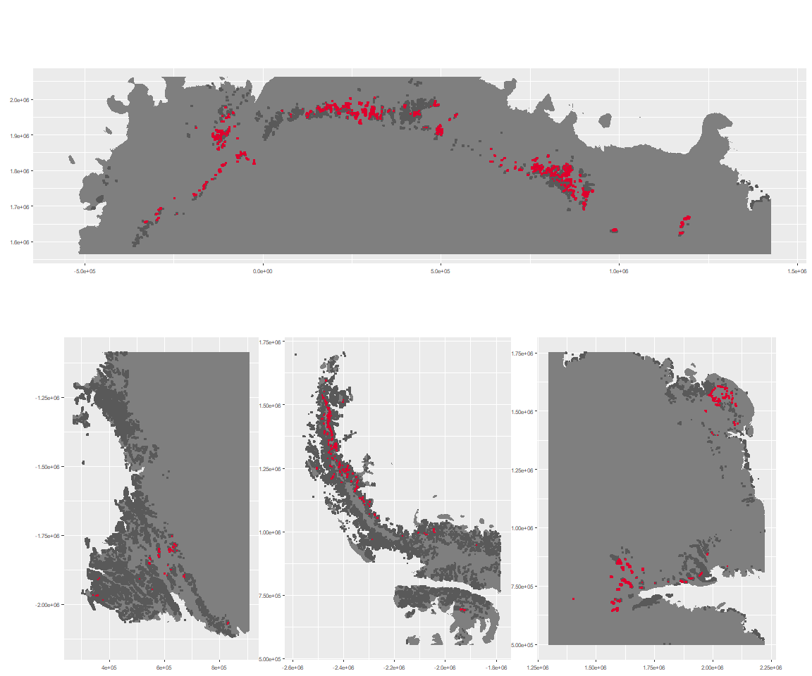

### Environment

The unit env4_sdm1 is part of the environmental supergroup env4.

This supergroup is, on average, substantially higher in wind, elev and rad than continental antarctica. It is substantially lower in rugos, sumtemp, slope, temp and cloud than the rest of the continent.

The elevation of unit env4_sdm1 ranges from 21 to 2952 metres above sea level, but 90% of its pixels fall above 662 and below 2110 metres. Its average elevation is 1399 metres.

The unit is higher in wind and cloud and lower in no variables than the rest of its environmental supergroup.

#### Distinctiveness of the unit from its group and the rest of Antarctica

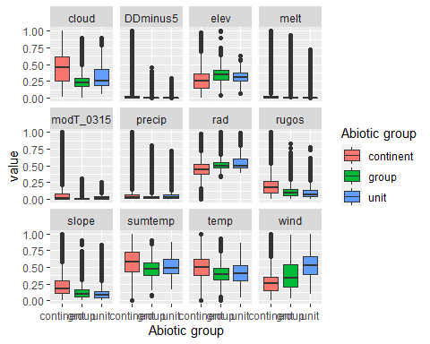

### Biota

Most widespread species in the unit (found in most pixels)

The top most widespread species in ecosystem env4_sdm1

| scientific | Functional_group | phylum | polar specialist? | count | relative_pct |
| --- | --- | --- | --- | --- | --- |
| Candelariella flava | Ascomycota_Lecanoromycetes_Candelariales_Candelariaceae__ | Ascomycota | TRUE | 2 | 6.6667 |
| Coscinodon lawianus | Bryophyta_Bryopsida_Grimmiales___ | Bryophyta | TRUE | 2 | 6.6667 |
| Macrobiotus blocki | Tardigrada_____ | Tardigrada | TRUE | 2 | 6.6667 |
| Pleopsidium chlorophanum | Ascomycota_Lecanoromycetes_Acarosporales_Acarosporaceae__ | Ascomycota | FALSE | 2 | 6.6667 |
| Pseudephebe minuscula | Ascomycota_Lecanoromycetes_Lecanorales_Parmeliaceae__ | Ascomycota | FALSE | 2 | 6.6667 |
| Acarospora gwynnii | Ascomycota_Lecanoromycetes_Acarosporales_Acarosporaceae__ | Ascomycota | TRUE | 1 | 3.3333 |
| Andreaea depressinervis | Bryophyta_Andreaeopsida_Andreaeales___ | Bryophyta | TRUE | 1 | 3.3333 |
| Buellia grisea | Ascomycota_Lecanoromycetes_Teloschistales_Physciaceae__ | Ascomycota | FALSE | 1 | 3.3333 |
| Buellia pallida | Ascomycota_Lecanoromycetes_Teloschistales_Physciaceae__ | Ascomycota | TRUE | 1 | 3.3333 |
| Carbonea cf. vorticosa | Ascomycota_Lecanoromycetes_Lecanorales_Lecanoraceae__ | Ascomycota | TRUE | 1 | 3.3333 |
| Chlorosphaera sp. | Chlorophyta_____ | Chlorophyta | TRUE | 1 | 3.3333 |
| Diphascon sanae | Tardigrada_____ | Tardigrada | TRUE | 1 | 3.3333 |
| Echiniscus jenningsi | Tardigrada_____ | Tardigrada | TRUE | 1 | 3.3333 |
| Grimmia lawiana | Bryophyta_Bryopsida_Grimmiales___ | Bryophyta | TRUE | 1 | 3.3333 |
| Grimmia reflexidens | Bryophyta_Bryopsida_Grimmiales___ | Bryophyta | FALSE | 1 | 3.3333 |
| Hypsibius antarcticus | Tardigrada_____ | Tardigrada | TRUE | 1 | 3.3333 |
| Lecidea andersonii | Ascomycota_Lecanoromycetes_Lecanorales_Lecideaceae__ | Ascomycota | TRUE | 1 | 3.3333 |
| Lecidea sp. | Ascomycota_Lecanoromycetes_Lecanorales_Lecideaceae__ | Ascomycota | TRUE | 1 | 3.3333 |
| Minibiotus stuckenbergi | Tardigrada_____ | Tardigrada | TRUE | 1 | 3.3333 |
| Parmelia griseola | Ascomycota_Lecanoromycetes_Lecanorales_Parmeliaceae__ | Ascomycota | TRUE | 1 | 3.3333 |
| Physcia llanoi | Ascomycota_Lecanoromycetes_Teloschistales_Physciaceae__ | Ascomycota | TRUE | 1 | 3.3333 |
| Rhizocarpon adarense | Ascomycota_Lecanoromycetes_Not assigned_Rhizocarpaceae__ | Ascomycota | TRUE | 1 | 3.3333 |
| Sarconeurum glaciale | Bryophyta_Bryopsida_Pottiales___ | Bryophyta | TRUE | 1 | 3.3333 |
| Umbilicaria aprina | Ascomycota_Lecanoromycetes_Umbilicariales_Umbilicariaceae__ | Ascomycota | FALSE | 1 | 3.3333 |
| Xanthoria elegans | Ascomycota_Lecanoromycetes_Teloschistales_Teloschistaceae__ | Ascomycota | FALSE | 1 | 3.3333 |

This supergroup is, on average, substantially higher in suitability for no variables functional groups than continental Antarctica. It is substantially lower in suitability for lichens_Lecanorid, Nematodes, lichens_Parmelid, mosses_Dicranales, mites_Sarcoptiformes, mosses_Pottiales, Springtails_slim, mosses_Bryales, mites_Trombidiformes, mosses_Hypnales_(feather), lichens,_Bacidiacid, mosses_Polytrichales, penguins_Chinstrap, lichens_Cladonid, mites_Mesostigmata, penguins_Gentoo and lichens_Stereocaulid than the rest of the continent.

Unit env4_sdm1 is higher in suitability for lichens_Parmelid, lichens_Rhizocarpid, lichens_Candelarid, mites_Mesostigmata, mites_Sarcoptiformes, lichens_Teloschistid and lichens_Lecanorid and lower in suitability for mosses_Bryales, lichens_Cladonid and lichens,_Bacidiacid than the rest of its environmental supergroup.

Distinctiveness of the unit from the environmental group and the rest of Antarctica

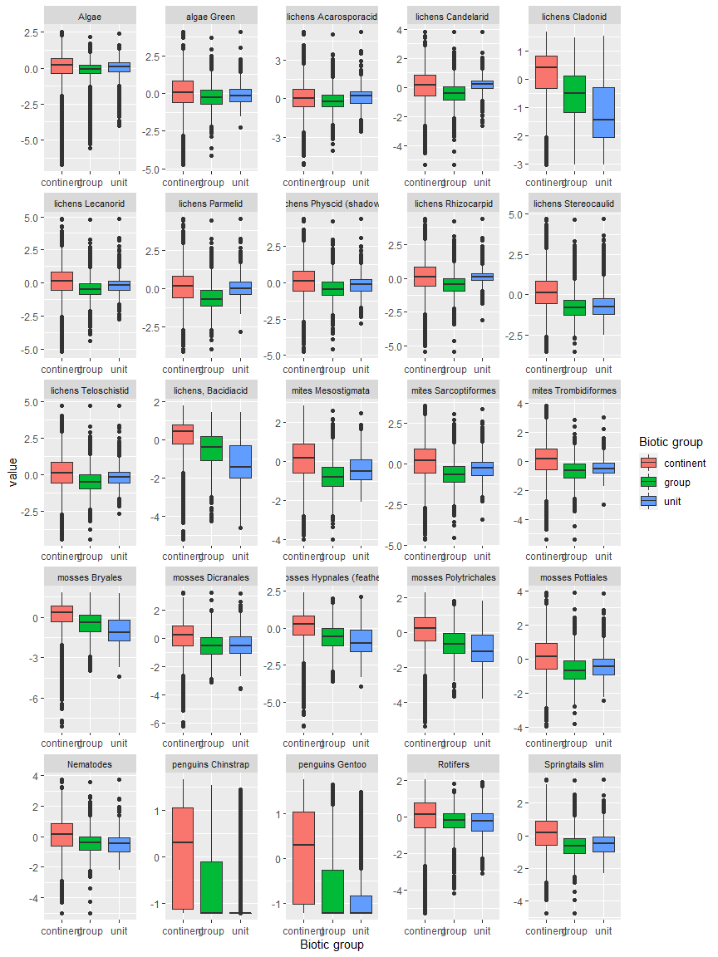

Ecosystem Description

## Ecosystem Env4_sdm2, Sheltered upper slopes and inclined plateaus

Env4_sdm2, Sheltered upper slopes and inclined plateaus. Occurs mainly on the eastern coast of the northern peninsula and in Victoria Land. This unit is on the milder end of the group, with more ruggedness and cloud and less wind/higher temp than the group average, though still high radiation. Most sampled faunas are Rotifers, though singletons of various other groups have been detected. Suitability appears to be especially low for many lichen functional groups (but high for Cladoniaceae and Bacidiaceae) and Trombidiformes (Arachnids) and high for chinstrap penguins and several moss groups.

### Photos (if available)

### Distribution

Maps - Full map

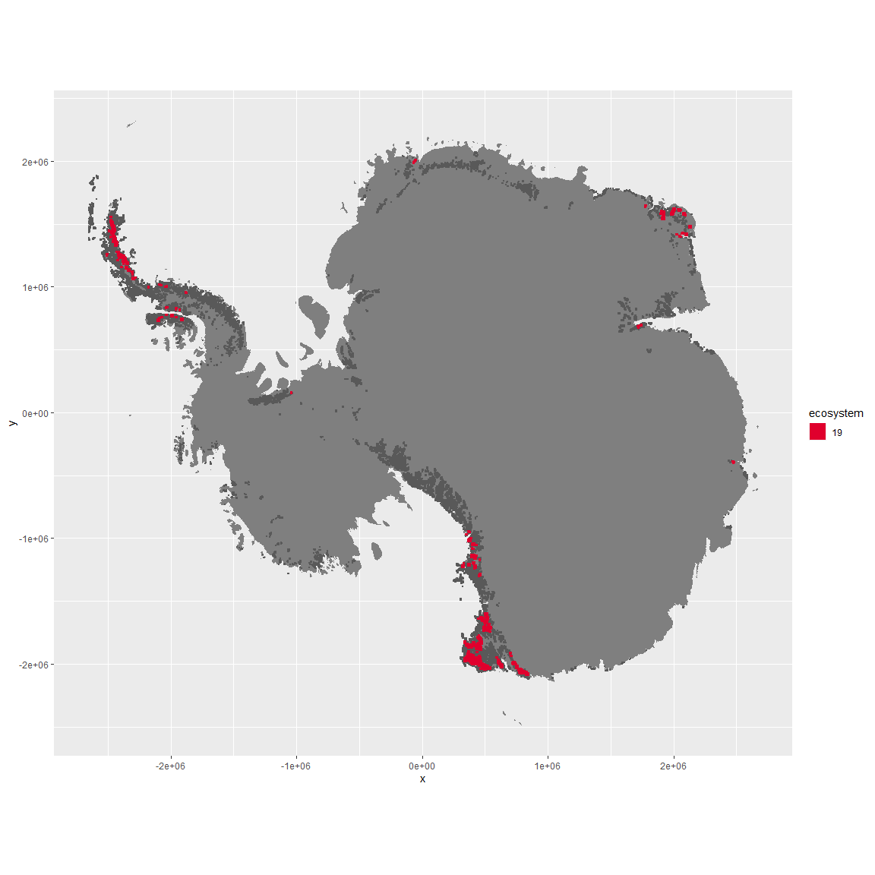

Regional maps

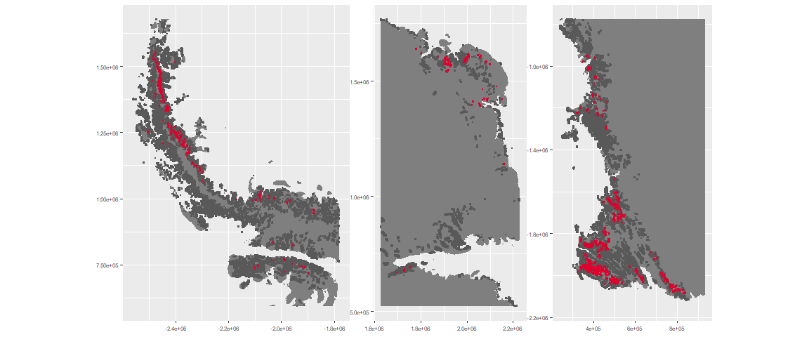

### Environment

The unit env4_sdm2 is part of the environmental supergroup env4.

This supergroup is, on average, substantially higher in wind, elev and rad than continental antarctica. It is substantially lower in rugos, sumtemp, slope, temp and cloud than the rest of the continent.

The elevation of unit env4_sdm2 ranges from 230 to 3472 metres above sea level, but 90% of its pixels fall above 678 and below 2777 metres. Its average elevation is 1669 metres.

The unit is higher in cloud, temp, slope, sumtemp, rugos, rad and precip and lower in wind than the rest of its environmental supergroup.

#### Distinctiveness of the unit from its group and the rest of Antarctica

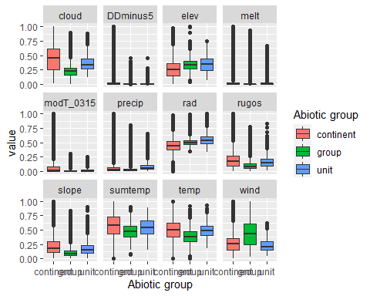

### Biota

Most widespread species in the unit (found in most pixels)

The top most widespread species in ecosystem env4_sdm2

| scientific | Functional_group | phylum | polar specialist? | count | relative_pct |
| --- | --- | --- | --- | --- | --- |
| Adineta gracilis | Rotifera_____ | Rotifera | FALSE | 1 | 2.6316 |
| Adineta steineri | Rotifera_____ | Rotifera | TRUE | 1 | 2.6316 |
| Adineta vaga | Rotifera_____ | Rotifera | FALSE | 1 | 2.6316 |
| Andreaea depressinervis | Bryophyta_Andreaeopsida_Andreaeales___ | Bryophyta | TRUE | 1 | 2.6316 |
| Aphanocapsa elachista | Cyanophycota_____ | Cyanophycota | FALSE | 1 | 2.6316 |
| Bacidia harrissoni | Ascomycota_Lecanoromycetes_Lecanorales_Ramalinaceae__ | Ascomycota | TRUE | 1 | 2.6316 |
| Campylopus pyriformis | Bryophyta_Bryopsida_Dicranales___ | Bryophyta | FALSE | 1 | 2.6316 |
| Catillaria inconspicua | Ascomycota_Lecanoromycetes_Lecanorales_Catillariaceae__ | Ascomycota | TRUE | 1 | 2.6316 |
| Cephaloziella exiliflora | Marchantiophyta_____ | Marchantiophyta | FALSE | 1 | 2.6316 |
| Ceratodon purpureus | Bryophyta_Bryopsida_Dicranales___ | Bryophyta | FALSE | 1 | 2.6316 |
| Chlorella sp. | Chlorophyta_____ | Chlorophyta | TRUE | 1 | 2.6316 |
| Coenochloris oleifera | Chlorophyta_____ | Chlorophyta | TRUE | 1 | 2.6316 |
| Corythion dubium | Cercozoa_____ | Cercozoa | TRUE | 1 | 2.6316 |
| Drepanocladus uncinatus | Bryophyta_Bryopsida_Hypnales___ | Bryophyta | TRUE | 1 | 2.6316 |
| Gloeocapsa magma | Cyanobacteria_____ | Cyanobacteria | FALSE | 1 | 2.6316 |
| Graesiella emersonii | Chlorophyta_____ | Chlorophyta | FALSE | 1 | 2.6316 |
| Habrotrocha elusa | Rotifera_____ | Rotifera | TRUE | 1 | 2.6316 |
| Hassallia bouteillei | Cyanobacteria_____ | Cyanobacteria | TRUE | 1 | 2.6316 |
| Huea smaragdula | Ascomycota_Lecanoromycetes_Teloschistales_Teloschistaceae__ | Ascomycota | TRUE | 1 | 2.6316 |
| Hygroamblystegium filum | Bryophyta_Bryopsida_Hypnales___ | Bryophyta | FALSE | 1 | 2.6316 |
| Macrobiotus ?fuciger | Tardigrada_____ | Tardigrada | TRUE | 1 | 2.6316 |
| Macrobiotus sp. | Tardigrada_____ | Tardigrada | TRUE | 1 | 2.6316 |
| Macrotrachela ambigua | Rotifera_____ | Rotifera | TRUE | 1 | 2.6316 |
| Macrotrachela cf. ligulata | Rotifera_____ | Rotifera | TRUE | 1 | 2.6316 |
| Mastigocladus laminosus | Cyanobacteria_____ | Cyanobacteria | FALSE | 1 | 2.6316 |
| Mniobia sp. | Rotifera_____ | Rotifera | TRUE | 1 | 2.6316 |
| Phormidium fragile | Cyanobacteria_____ | Cyanobacteria | FALSE | 1 | 2.6316 |
| Pleopsidium chlorophanum | Ascomycota_Lecanoromycetes_Acarosporales_Acarosporaceae__ | Ascomycota | FALSE | 1 | 2.6316 |
| Pohlia nutans | Bryophyta_Bryopsida_Bryales___ | Bryophyta | FALSE | 1 | 2.6316 |
| Pseudococcomyxa simplex | Chlorophyta_____ | Chlorophyta | TRUE | 1 | 2.6316 |
| Rhizocarpon adarense | Ascomycota_Lecanoromycetes_Not assigned_Rhizocarpaceae__ | Ascomycota | TRUE | 1 | 2.6316 |
| Rhizocarpon copelandii | Ascomycota_Lecanoromycetes_Not assigned_Rhizocarpaceae__ | Ascomycota | FALSE | 1 | 2.6316 |
| Rhizocarpon sp. | Ascomycota_Lecanoromycetes_Not assigned_Rhizocarpaceae__ | Ascomycota | TRUE | 1 | 2.6316 |
| Stereocaulon vesuvianum | Ascomycota_Lecanoromycetes_Lecanorales_Stereocaulaceae__ | Ascomycota | FALSE | 1 | 2.6316 |
| Stigonema ocellatum | Cyanobacteria_____ | Cyanobacteria | FALSE | 1 | 2.6316 |
| Toninia johnstonii | Ascomycota_Lecanoromycetes_Rhizocarpales_Catillariaceae__ | Ascomycota | TRUE | 1 | 2.6316 |
| Usnea sphacelata | Ascomycota_Lecanoromycetes_Lecanorales_Parmeliaceae__ | Ascomycota | TRUE | 1 | 2.6316 |
| Xanthoria elegans | Ascomycota_Lecanoromycetes_Teloschistales_Teloschistaceae__ | Ascomycota | FALSE | 1 | 2.6316 |

This supergroup is, on average, substantially higher in suitability for no variables functional groups than continental Antarctica. It is substantially lower in suitability for lichens_Lecanorid, Nematodes, lichens_Parmelid, mosses_Dicranales, mites_Sarcoptiformes, mosses_Pottiales, Springtails_slim, mosses_Bryales, mites_Trombidiformes, mosses_Hypnales_(feather), lichens,_Bacidiacid, mosses_Polytrichales, penguins_Chinstrap, lichens_Cladonid, mites_Mesostigmata, penguins_Gentoo and lichens_Stereocaulid than the rest of the continent.

Unit env4_sdm2 is higher in suitability for lichens_Bacidiacid, lichens_Cladonid, penguins_Chinstrap, mosses_Bryales, penguins_Gentoo, mosses_Hypnales_(feather), mosses_Polytrichales and mosses_Dicranales and lower in suitability for lichens_Physcid_(shadow), lichens_Teloschistid, lichens_Lecanorid, lichens_Acarosporacid, lichens_Rhizocarpid, Algae and lichens_Candelarid than the rest of its environmental supergroup.

Distinctiveness of the unit from the environmental group and the rest of Antarctica

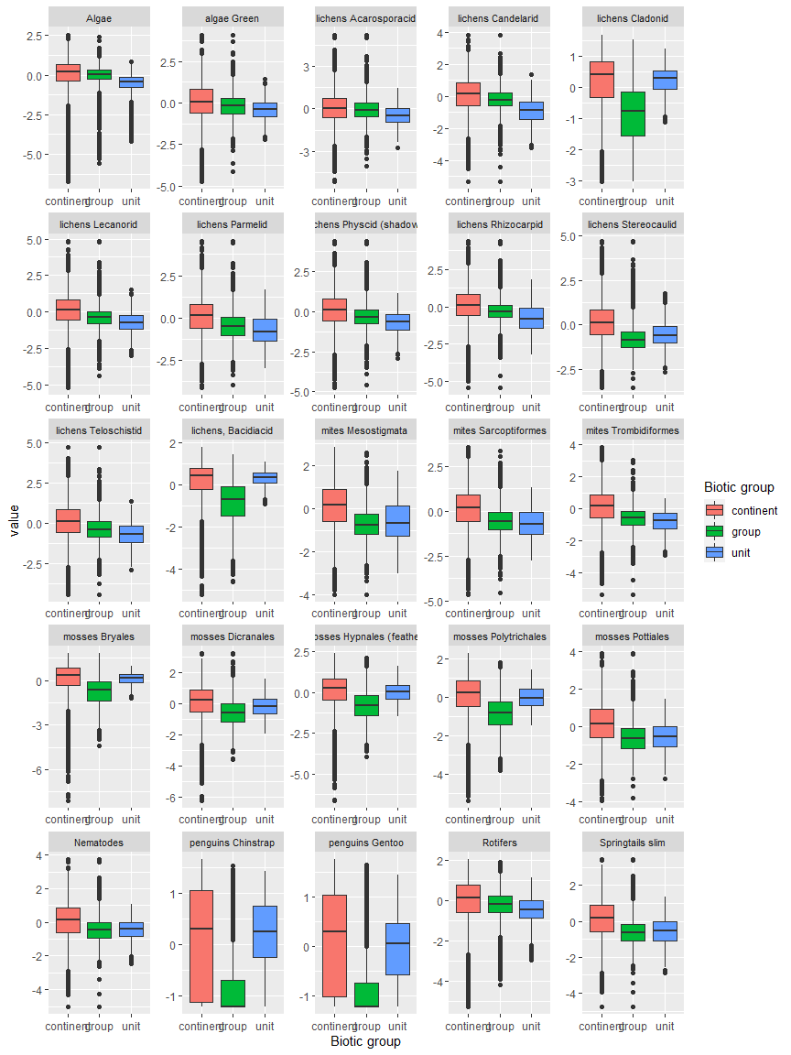

Ecosystem Description

## Ecosystem Env4_sdm3, Clear windy plateaus

Env4_sdm3, Clear windy plateaus. Occurs mainly in Victoria land, Enderby Land and in the Prince Charles mountains. Its elevation is lower than the rest of the group, but it is especially windy and low in cloud cover (radians are not especially high for the group, possibly due to aspect? East, west, and south-facing slopes?). Sampled biota are exclusively lichens. Though the group has lower suitability than the continental average for all functional groups, this unit nonetheless has higher-than-average suitability for Ochrophytes, Rotifers, and Acarosporaceae lichens.

### Photos (if available)



Ecosystem photo

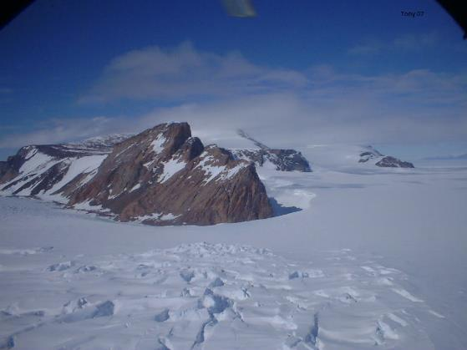

Ecosystem photo

### Distribution

Maps - Full map

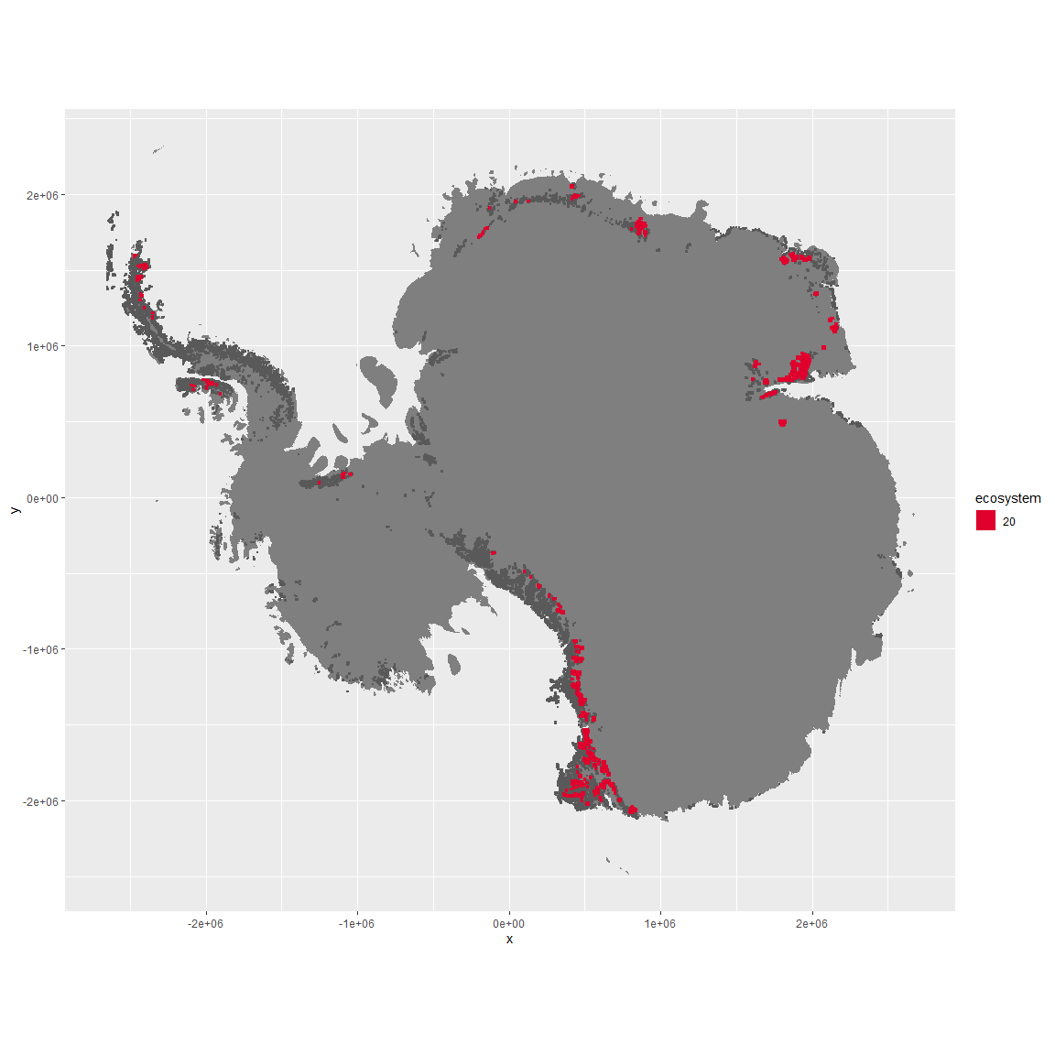

Regional maps

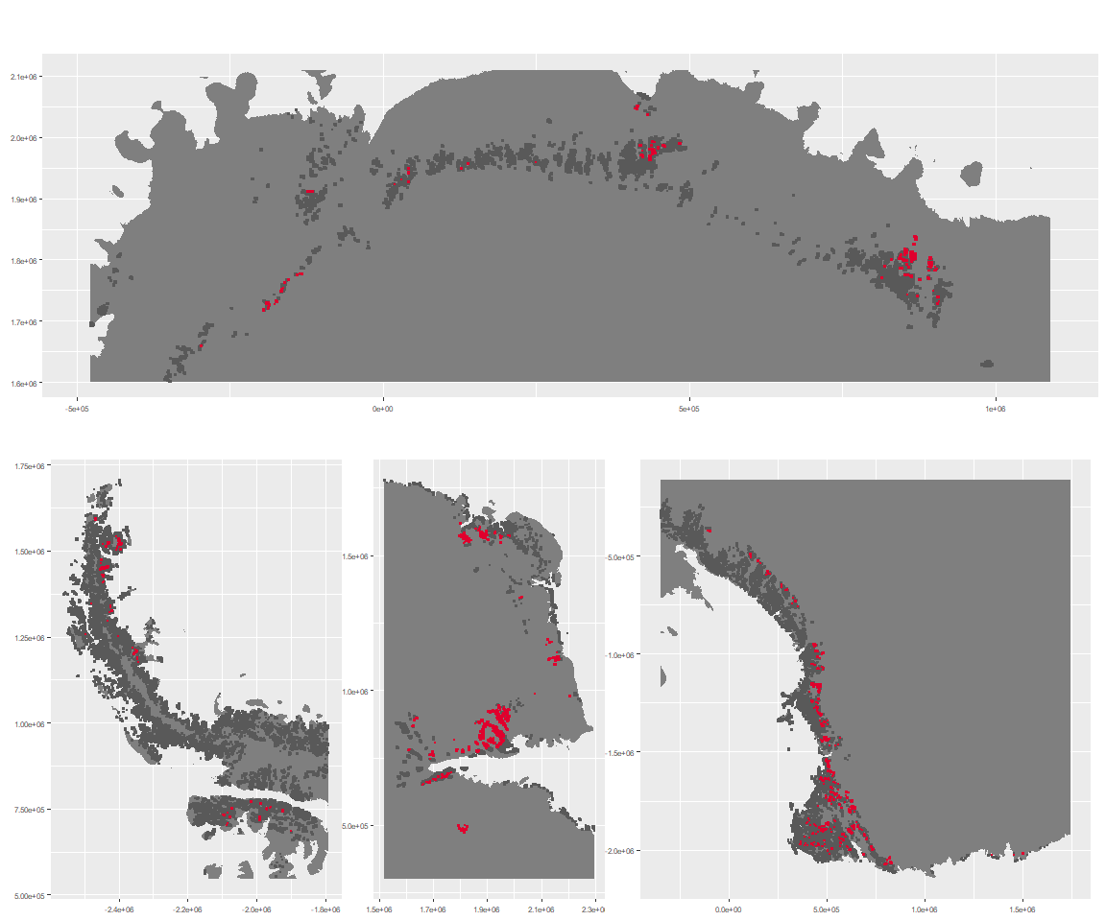

### Environment

The unit env4_sdm3 is part of the environmental supergroup env4.

This supergroup is, on average, substantially higher in wind, elev and rad than continental antarctica. It is substantially lower in rugos, sumtemp, slope, temp and cloud than the rest of the continent.

The elevation of unit env4_sdm3 ranges from 0 to 4700 metres above sea level, but 90% of its pixels fall above 676 and below 2357 metres. Its average elevation is 1405 metres.

The unit is higher in wind and lower in elev and cloud than the rest of its environmental supergroup.

#### Distinctiveness of the unit from its group and the rest of Antarctica

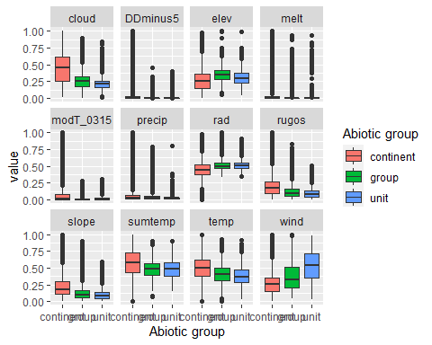

### Biota

Most widespread species in the unit (found in most pixels)

The top most widespread species in ecosystem env4_sdm3

| scientific | Functional_group | phylum | polar specialist? | count | relative_pct |
| --- | --- | --- | --- | --- | --- |
| Pleopsidium chlorophanum | Ascomycota_Lecanoromycetes_Acarosporales_Acarosporaceae__ | Ascomycota | FALSE | 5 | 9.2593 |
| Xanthoria elegans | Ascomycota_Lecanoromycetes_Teloschistales_Teloschistaceae__ | Ascomycota | FALSE | 5 | 9.2593 |
| Acarospora gwynnii | Ascomycota_Lecanoromycetes_Acarosporales_Acarosporaceae__ | Ascomycota | TRUE | 3 | 5.5556 |
| Buellia frigida | Ascomycota_Lecanoromycetes_Teloschistales_Physciaceae__ | Ascomycota | TRUE | 3 | 5.5556 |
| Pseudephebe minuscula | Ascomycota_Lecanoromycetes_Lecanorales_Parmeliaceae__ | Ascomycota | FALSE | 3 | 5.5556 |
| Lepraria cacuminum | Ascomycota_Lecanoromycetes_Lecanorales_Stereocaulaceae__ | Ascomycota | FALSE | 2 | 3.7037 |
| Rhizocarpon sp. | Ascomycota_Lecanoromycetes_Not assigned_Rhizocarpaceae__ | Ascomycota | TRUE | 2 | 3.7037 |
| Rhizocarpon superficiale | Ascomycota_Lecanoromycetes_Not assigned_Rhizocarpaceae__ | Ascomycota | FALSE | 2 | 3.7037 |
| Rhizoplaca melanophthalma | Ascomycota_Lecanoromycetes_Lecanorales_Lecanoraceae__ | Ascomycota | FALSE | 2 | 3.7037 |
| Umbilicaria decussata | Ascomycota_Lecanoromycetes_Umbilicariales_Umbilicariaceae__ | Ascomycota | FALSE | 2 | 3.7037 |
| Usnea sphacelata | Ascomycota_Lecanoromycetes_Lecanorales_Parmeliaceae__ | Ascomycota | TRUE | 2 | 3.7037 |

This supergroup is, on average, substantially higher in suitability for no variables functional groups than continental Antarctica. It is substantially lower in suitability for lichens_Lecanorid, Nematodes, lichens_Parmelid, mosses_Dicranales, mites_Sarcoptiformes, mosses_Pottiales, Springtails_slim, mosses_Bryales, mites_Trombidiformes, mosses_Hypnales_(feather), lichens,_Bacidiacid, mosses_Polytrichales, penguins_Chinstrap, lichens_Cladonid, mites_Mesostigmata, penguins_Gentoo and lichens_Stereocaulid than the rest of the continent.

Unit env4_sdm3 is higher in suitability for lichens_Acarosporacid, Rotifers, Algae, lichens_Teloschistid, lichens_Physcid_(shadow), mosses_Bryales, lichens_Lecanorid, mosses_Polytrichales and lichens_Cladonid and lower in suitability for no variables than the rest of its environmental supergroup.

Distinctiveness of the unit from the environmental group and the rest of Antarctica

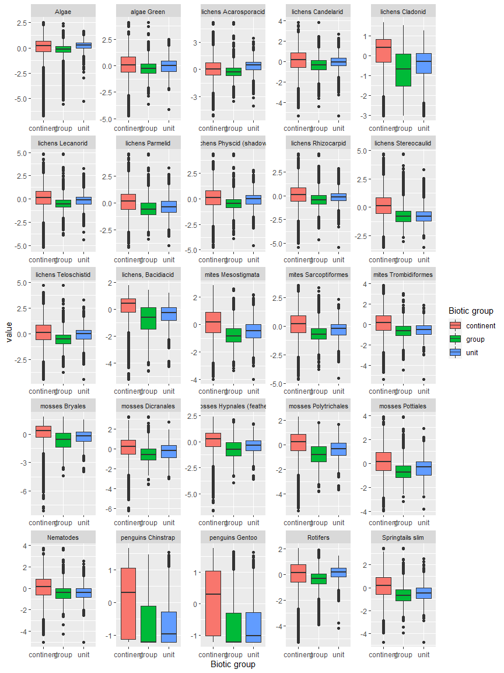

Ecosystem Description

## Ecosystem Env4_sdm4, Clear sheltered plateaus

Env4_sdm4, Clear sheltered plateaus. Mainly occurs in Victoria land with some representation on the eastern coast of the northern peninsula. Unit is lower in cloud and wind than the rest of its group (likely also south-facing?), so a milder version. Sampled biota is scarce and consists mainly of singletons. Most are lichens and cyanobacteria, along with some Ochrophyta and mosses. Suitability above group average but still below continental average for Ochrophyta, Rotifera, Nematoda, and Trombidiformes.

### Photos (if available)

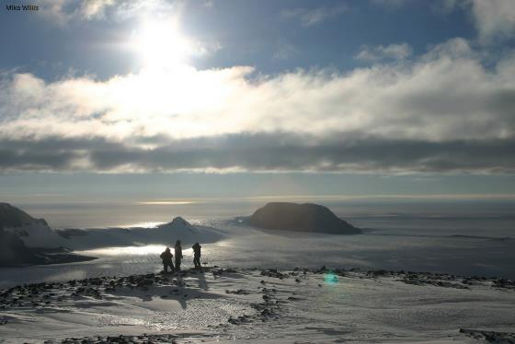

Ecosystem photo

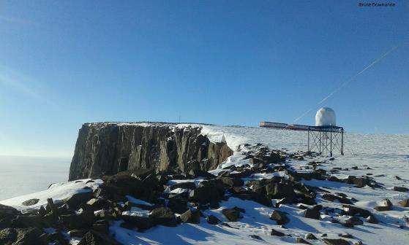

Ecosystem photo

### Distribution

Maps - Full map

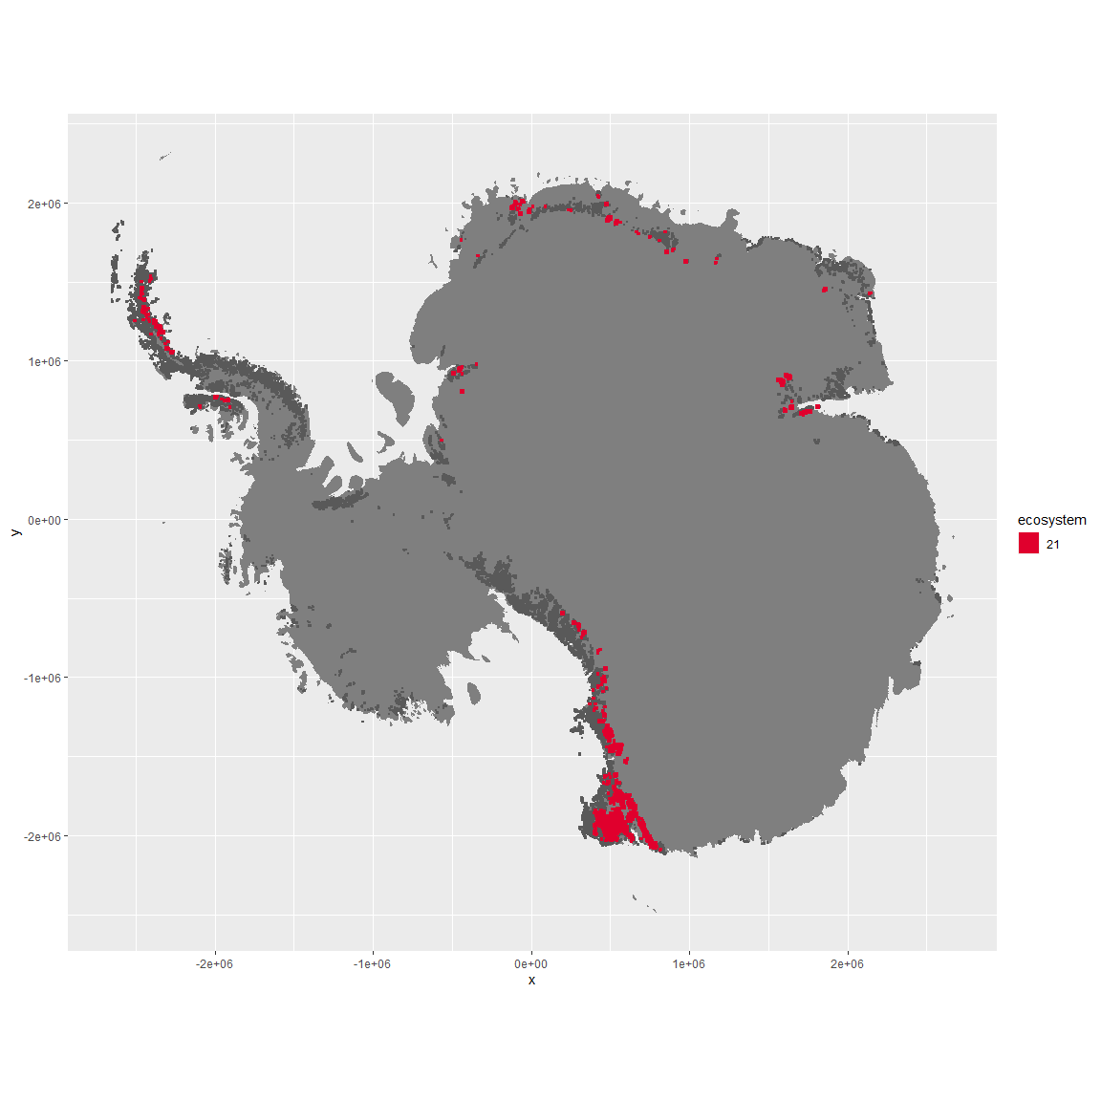

Regional maps

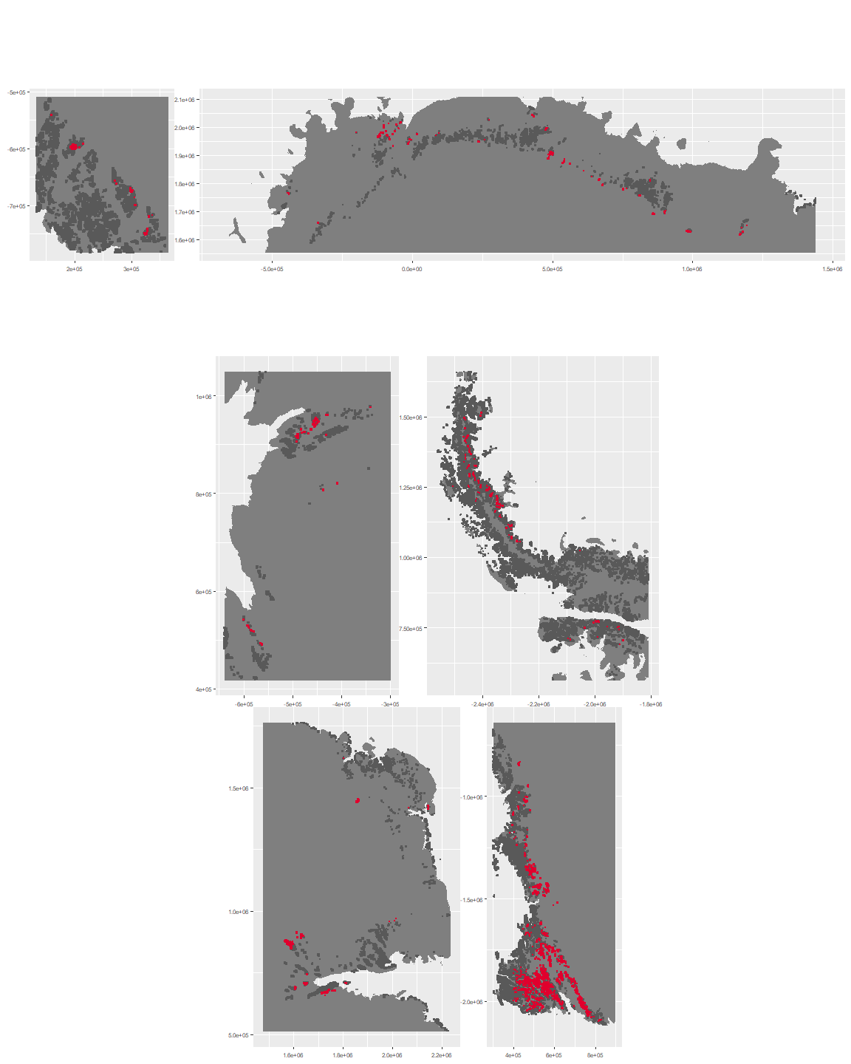

### Environment

The unit env4_sdm4 is part of the environmental supergroup env4.

This supergroup is, on average, substantially higher in wind, elev and rad than continental antarctica. It is substantially lower in rugos, sumtemp, slope, temp and cloud than the rest of the continent.

The elevation of unit env4_sdm4 ranges from 32 to 2707 metres above sea level, but 90% of its pixels fall above 754 and below 2262 metres. Its average elevation is 1657 metres.

The unit is higher in no variables and lower in cloud and wind than the rest of its environmental supergroup.

#### Distinctiveness of the unit from its group and the rest of Antarctica

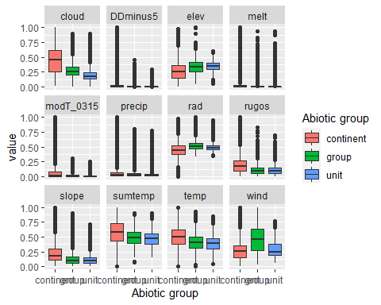

### Biota

Most widespread species in the unit (found in most pixels)

The top most widespread species in ecosystem env4_sdm4

| scientific | Functional_group | phylum | polar specialist? | count | relative_pct |
| --- | --- | --- | --- | --- | --- |
| Lepraria cacuminum | Ascomycota_Lecanoromycetes_Lecanorales_Stereocaulaceae__ | Ascomycota | FALSE | 2 | 2.8986 |
| Schizothrix antarctica | Cyanobacteria_____ | Cyanobacteria | TRUE | 2 | 2.8986 |
| Arthrorhaphis citrinella | Ascomycota_Lecanoromycetes_Not assigned_Arthrorhaphidaceae__ | Ascomycota | FALSE | 1 | 1.4493 |
| Binuclearia tectorum | Chlorophyta_____ | Chlorophyta | FALSE | 1 | 1.4493 |
| Brachythecium austroglareosum | Bryophyta_Bryopsida_Hypnales___ | Bryophyta | FALSE | 1 | 1.4493 |
| Bryum subrotundifolium | Bryophyta_Bryopsida_Bryales___ | Bryophyta | TRUE | 1 | 1.4493 |
| Buellia pallida | Ascomycota_Lecanoromycetes_Teloschistales_Physciaceae__ | Ascomycota | TRUE | 1 | 1.4493 |
| Buellia subfrigida | Ascomycota_Lecanoromycetes_Teloschistales_Physciaceae__ | Ascomycota | TRUE | 1 | 1.4493 |
| Calothrix braunii | Cyanobacteria_____ | Cyanobacteria | FALSE | 1 | 1.4493 |
| Calothrix parietina | Cyanobacteria_____ | Cyanobacteria | FALSE | 1 | 1.4493 |
| Carbonea capsulata | Ascomycota_Lecanoromycetes_Lecanorales_Lecanoraceae__ | Ascomycota | TRUE | 1 | 1.4493 |
| Chlorella minutissima | Chlorophyta_____ | Chlorophyta | TRUE | 1 | 1.4493 |
| Chlorosarcinopsis sp. | Chlorophyta_____ | Chlorophyta | TRUE | 1 | 1.4493 |
| Chlorosphaera kerguelensis | Chlorophyta_____ | Chlorophyta | TRUE | 1 | 1.4493 |
| Choricystis chodatii | Chlorophyta_____ | Chlorophyta | TRUE | 1 | 1.4493 |
| Chroococcus montanus | Cyanobacteria_____ | Cyanobacteria | TRUE | 1 | 1.4493 |
| Chroococcus westii | Cyanobacteria_____ | Cyanobacteria | FALSE | 1 | 1.4493 |
| Cladonia cf. pocillum | Ascomycota_Lecanoromycetes_Lecanorales_Cladoniaceae__ | Ascomycota | TRUE | 1 | 1.4493 |
| Cryptomonas sp. | Cryptophyta_____ | Cryptophyta | TRUE | 1 | 1.4493 |
| Desmococcus olivaceus | Chlorophyta_____ | Chlorophyta | FALSE | 1 | 1.4493 |
| Diphascon sanae | Tardigrada_____ | Tardigrada | TRUE | 1 | 1.4493 |
| Gloeocapsa kuetzingiana | Cyanobacteria_____ | Cyanobacteria | TRUE | 1 | 1.4493 |
| Gloeocapsa magma | Cyanobacteria_____ | Cyanobacteria | FALSE | 1 | 1.4493 |
| Gloeocapsa ralfsiana | Cyanobacteria_____ | Cyanobacteria | TRUE | 1 | 1.4493 |
| Heterotrichella gracilis | Ochrophyta_____ | Ochrophyta | TRUE | 1 | 1.4493 |
| Hypnum revolutum | Bryophyta_Bryopsida_Hypnales___ | Bryophyta | FALSE | 1 | 1.4493 |
| Lecanora fuscobrunnea | Ascomycota_Lecanoromycetes_Lecanorales_Lecanoraceae__ | Ascomycota | TRUE | 1 | 1.4493 |
| Minibiotus stuckenbergi | Tardigrada_____ | Tardigrada | TRUE | 1 | 1.4493 |
| Monodus chodatii | Ochrophyta_____ | Ochrophyta | TRUE | 1 | 1.4493 |
| Nephrodiella semilunaris | Ochrophyta_____ | Ochrophyta | FALSE | 1 | 1.4493 |
| Nodularia harveyana | Cyanobacteria_____ | Cyanobacteria | FALSE | 1 | 1.4493 |
| Nostoc commune | Cyanobacteria_____ | Cyanobacteria | TRUE | 1 | 1.4493 |
| Nostoc longstaffii | Cyanobacteria_____ | Cyanobacteria | TRUE | 1 | 1.4493 |
| Nostoc pruniforme | Cyanobacteria_____ | Cyanobacteria | FALSE | 1 | 1.4493 |
| Oscillatoria curviceps | Cyanobacteria_____ | Cyanobacteria | FALSE | 1 | 1.4493 |
| Oscillatoria tenuis | Cyanobacteria_____ | Cyanobacteria | FALSE | 1 | 1.4493 |
| Pannaria hookeri | Ascomycota_Lecanoromycetes_Peltigerales_Pannariaceae__ | Ascomycota | FALSE | 1 | 1.4493 |
| Parmelia saxatilis | Ascomycota_Lecanoromycetes_Lecanorales_Parmeliaceae__ | Ascomycota | FALSE | 1 | 1.4493 |
| Phormidium priestleyi | Cyanobacteria_____ | Cyanobacteria | TRUE | 1 | 1.4493 |
| Placopsis contortuplicata | Ascomycota_Lecanoromycetes_Baeomycetales_Trapeliaceae__ | Ascomycota | TRUE | 1 | 1.4493 |
| Pohlia nutans | Bryophyta_Bryopsida_Bryales___ | Bryophyta | FALSE | 1 | 1.4493 |
| Polytrichum piliferum | Bryophyta_Bryopsida_Polytrichales___ | Bryophyta | FALSE | 1 | 1.4493 |
| Prasiococcus calcarius | Chlorophyta_____ | Chlorophyta | TRUE | 1 | 1.4493 |
| Prasiola crispa | Chlorophyta_____ | Chlorophyta | FALSE | 1 | 1.4493 |
| Pseudephebe pubescens | Ascomycota_Lecanoromycetes_Lecanorales_Parmeliaceae__ | Ascomycota | FALSE | 1 | 1.4493 |
| Pseudotetraspora gainii | Chlorophyta_____ | Chlorophyta | TRUE | 1 | 1.4493 |
| Rhizocarpon distinctum | Ascomycota_Lecanoromycetes_Not assigned_Rhizocarpaceae__ | Ascomycota | FALSE | 1 | 1.4493 |
| Rhizoplaca melanophthalma | Ascomycota_Lecanoromycetes_Lecanorales_Lecanoraceae__ | Ascomycota | FALSE | 1 | 1.4493 |
| Rhodomonas sp. | Cryptophyta_____ | Cryptophyta | TRUE | 1 | 1.4493 |
| Sarconeurum glaciale | Bryophyta_Bryopsida_Pottiales___ | Bryophyta | TRUE | 1 | 1.4493 |
| Scotinosphaera paradoxa | Chlorophyta_____ | Chlorophyta | TRUE | 1 | 1.4493 |
| Stauroneis agrestis | Ochrophyta_____ | Ochrophyta | FALSE | 1 | 1.4493 |
| Stereocaulon glabrum | Ascomycota_Lecanoromycetes_Lecanorales_Stereocaulaceae__ | Ascomycota | FALSE | 1 | 1.4493 |
| Stereocaulon vesuvianum | Ascomycota_Lecanoromycetes_Lecanorales_Stereocaulaceae__ | Ascomycota | FALSE | 1 | 1.4493 |
| Stereotydeus mollis | Arthropoda_Arachnida_Trombidiformes___ | Arthropoda | TRUE | 1 | 1.4493 |
| Stichococcus bacillaris | Chlorophyta_____ | Chlorophyta | FALSE | 1 | 1.4493 |
| Synechocystis aquatilis | Cyanobacteria_____ | Cyanobacteria | FALSE | 1 | 1.4493 |
| Synechocystis crassa | Cyanobacteria_____ | Cyanobacteria | TRUE | 1 | 1.4493 |
| Synechocystis pevalekii | Cyanobacteria_____ | Cyanobacteria | FALSE | 1 | 1.4493 |
| Synechocystis sallensis | Cyanobacteria_____ | Cyanobacteria | TRUE | 1 | 1.4493 |
| Tetracystis sp. | Chlorophyta_____ | Chlorophyta | TRUE | 1 | 1.4493 |
| Tropidoneis laevissima | Ochrophyta_____ | Ochrophyta | TRUE | 1 | 1.4493 |
| Umbilicaria decussata | Ascomycota_Lecanoromycetes_Umbilicariales_Umbilicariaceae__ | Ascomycota | FALSE | 1 | 1.4493 |
| Umbilicaria umbilicarioides | Ascomycota_Lecanoromycetes_Umbilicariales_Umbilicariaceae__ | Ascomycota | FALSE | 1 | 1.4493 |
| Vitreochlamys sp. | Chlorophyta_____ | Chlorophyta | TRUE | 1 | 1.4493 |
| Xanthonema antarcticum | Ochrophyta_____ | Ochrophyta | TRUE | 1 | 1.4493 |
| Xanthoria elegans | Ascomycota_Lecanoromycetes_Teloschistales_Teloschistaceae__ | Ascomycota | FALSE | 1 | 1.4493 |

This supergroup is, on average, substantially higher in suitability for no variables functional groups than continental Antarctica. It is substantially lower in suitability for lichens_Lecanorid, Nematodes, lichens_Parmelid, mosses_Dicranales, mites_Sarcoptiformes, mosses_Pottiales, Springtails_slim, mosses_Bryales, mites_Trombidiformes, mosses_Hypnales_(feather), lichens,_Bacidiacid, mosses_Polytrichales, penguins_Chinstrap, lichens_Cladonid, mites_Mesostigmata, penguins_Gentoo and lichens_Stereocaulid than the rest of the continent.

Unit env4_sdm4 is higher in suitability for Nematodes and lower in suitability for mosses_Polytrichales, mosses_Hypnales_(feather), mosses_Dicranales and lichens_Parmelid than the rest of its environmental supergroup.

Distinctiveness of the unit from the environmental group and the rest of Antarctica

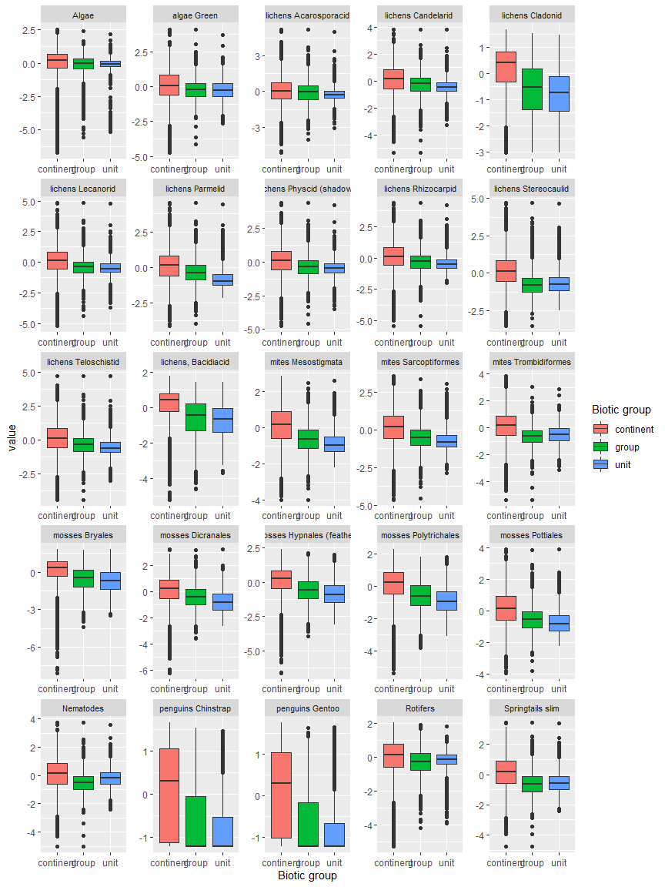

Ecosystem Description

## Ecosystem Env4_sdm5, High windy plateaus

Env4_sdm5, High windy plateaus. Mainly occurs in Victoria land and Dronning Maud land. Unit is higher elevation, wind, and radiation than the rest of the group, plus lower temp and lower ruggedness. Extremely low sampling but most are Athropods. Suitability is lower than group average for all functional groups except Parmeliaceae lichens, and especially bad for penguins.

### Photos (if available)

### Distribution

Maps - Full map

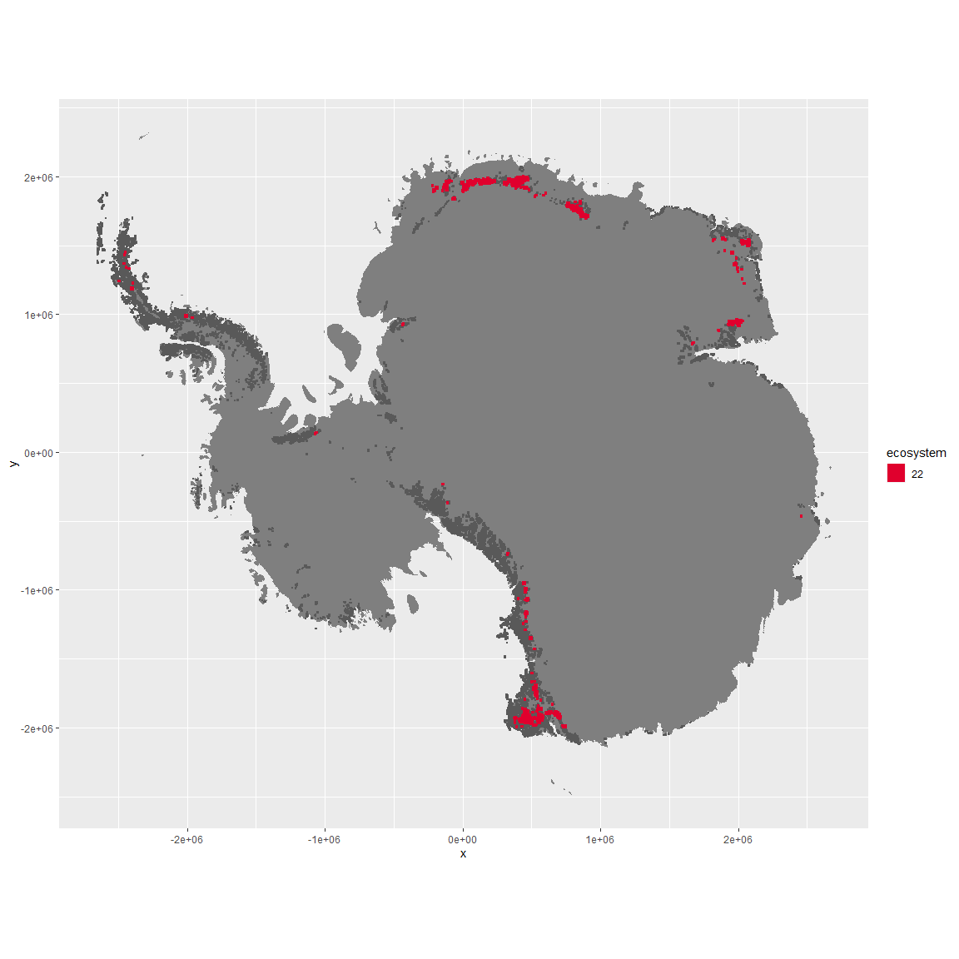

Regional maps

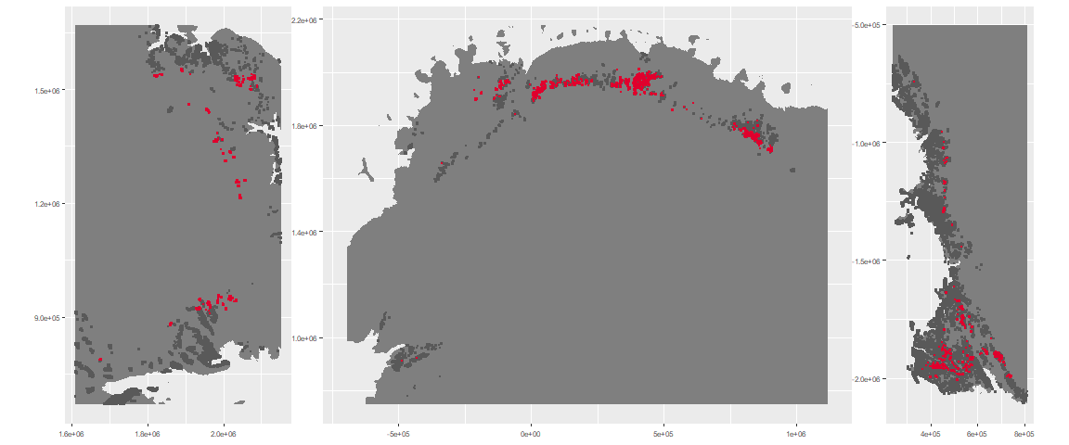

### Environment

The unit env4_sdm5 is part of the environmental supergroup env4.

This supergroup is, on average, substantially higher in wind, elev and rad than continental antarctica. It is substantially lower in rugos, sumtemp, slope, temp and cloud than the rest of the continent.

The elevation of unit env4_sdm5 ranges from 498 to 4645 metres above sea level, but 90% of its pixels fall above 1261 and below 2600 metres. Its average elevation is 1914 metres.

The unit is higher in wind and elev and lower in sumtemp than the rest of its environmental supergroup.

#### Distinctiveness of the unit from its group and the rest of Antarctica

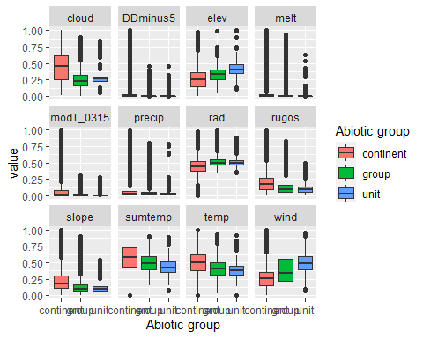

### Biota

Most widespread species in the unit (found in most pixels)

The top most widespread species in ecosystem env4_sdm5

| scientific | Functional_group | phylum | polar specialist? | count | relative_pct |
| --- | --- | --- | --- | --- | --- |
| Cryptopygus sverdrupi | Arthropoda_Entognatha_Entomobryomorpha___ | Arthropoda | TRUE | 1 | 25 |
| Maudheimia wilsoni | Arthropoda_Arachnida_Sarcoptiformes___ | Arthropoda | TRUE | 1 | 25 |
| Nanorchestes antarcticus | Arthropoda_Arachnida_Sarcoptiformes___ | Arthropoda | TRUE | 1 | 25 |
| Umbilicaria decussata | Ascomycota_Lecanoromycetes_Umbilicariales_Umbilicariaceae__ | Ascomycota | FALSE | 1 | 25 |

This supergroup is, on average, substantially higher in suitability for no variables functional groups than continental Antarctica. It is substantially lower in suitability for lichens_Lecanorid, Nematodes, lichens_Parmelid, mosses_Dicranales, mites_Sarcoptiformes, mosses_Pottiales, Springtails_slim, mosses_Bryales, mites_Trombidiformes, mosses_Hypnales_(feather), lichens,_Bacidiacid, mosses_Polytrichales, penguins_Chinstrap, lichens_Cladonid, mites_Mesostigmata, penguins_Gentoo and lichens_Stereocaulid than the rest of the continent.

Unit env4_sdm5 is higher in suitability for no variables and lower in suitability for lichens_Rhizocarpid, mosses_Pottiales, lichens_Physcid_(shadow), lichens_Lecanorid, lichens_Acarosporacid, mites_Sarcoptiformes, mites_Trombidiformes, lichens_Stereocaulid, mites_Mesostigmata, mosses_Hypnales_(feather), mosses_Bryales, mosses_Polytrichales, Springtails_slim, penguins_Gentoo, lichens,_Bacidiacid, Rotifers, penguins_Chinstrap, Nematodes and lichens_Cladonid than the rest of its environmental supergroup.

Distinctiveness of the unit from the environmental group and the rest of Antarctica

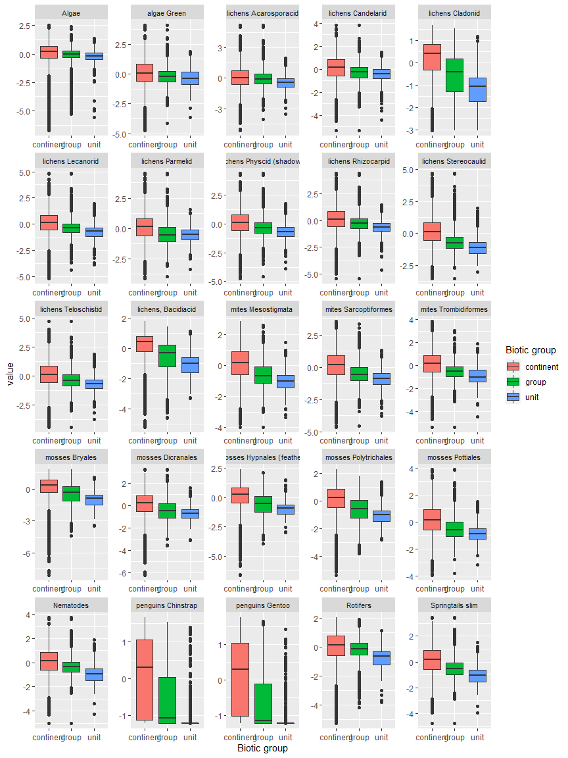

Ecosystem Description

## Ecosystem Env5_sdm1, Mild-climate arid nunataks

Env5_sdm1, Mild-climate arid nunataks. Occurs mainly along the east coast of the southern peninsula, in the Ellsworth mountains, throughout the Transantarctic mountains, and in North Victoria Land. This unit is a mild version of its group, with lower elev and higher temps than the rest of the group. Sampled fauna consists exclusively of lichens. Unit is separated from its group more by suitability; group has low suitability for all functional groups except Ochrophytes, but the unit has exceptionally high suitability for all lichens except Cladoniaceae and Bacidiaceae (for these latter two conditions are only slightly better than usual); all Arthropoda functional groups, and Pottiales mosses.

### Photos (if available)

### Distribution

Maps - Full map

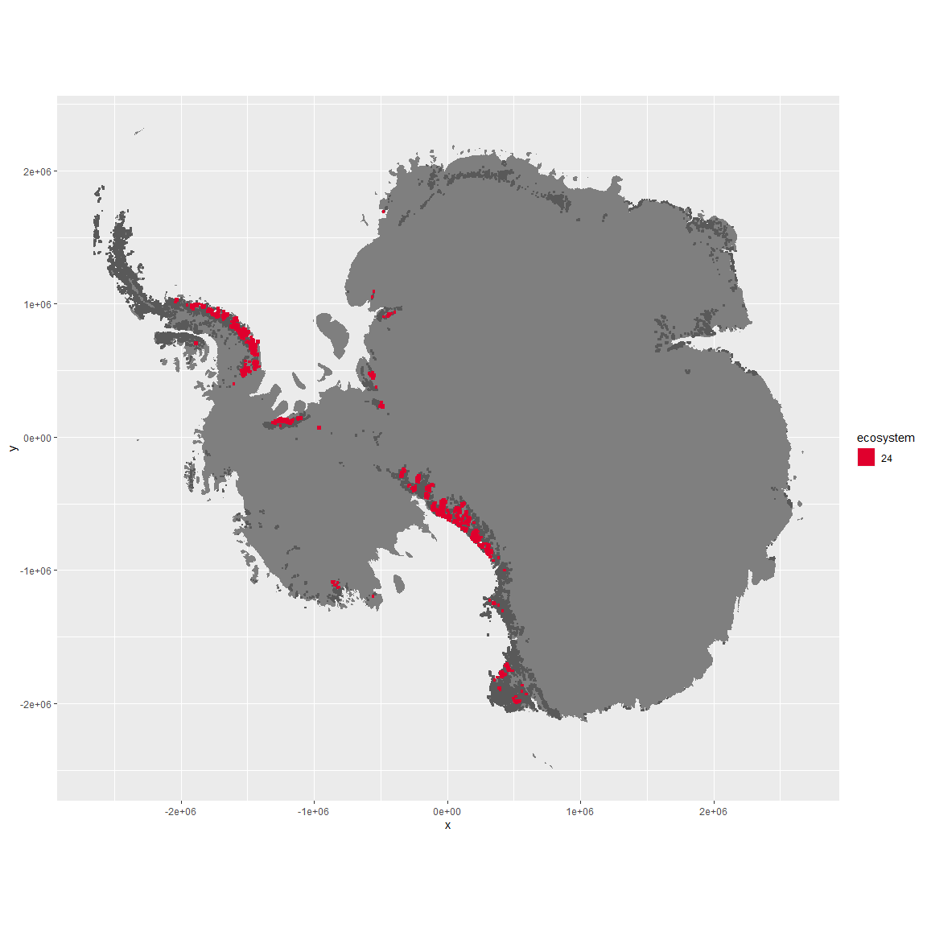

Regional maps

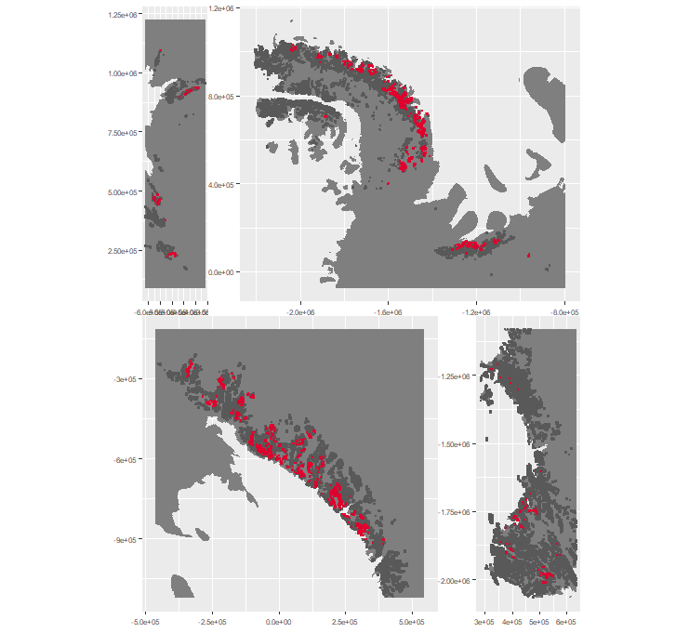

### Environment

The unit env5_sdm1 is part of the environmental supergroup env5.

This supergroup is, on average, substantially higher in elev than continental antarctica. It is substantially lower in modT_0315, rad, precip, temp, sumtemp and wind than the rest of the continent.

The elevation of unit env5_sdm1 ranges from 26 to 3032 metres above sea level, but 90% of its pixels fall above 364 and below 2042 metres. Its average elevation is 1062 metres.

The unit is higher in sumtemp, cloud and temp and lower in elev than the rest of its environmental supergroup.

#### Distinctiveness of the unit from its group and the rest of Antarctica

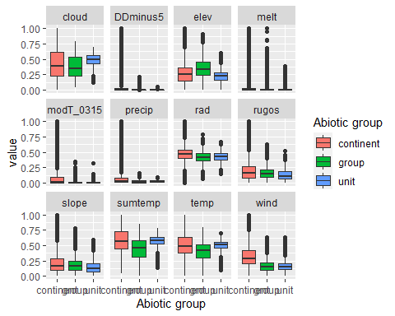

### Biota

Most widespread species in the unit (found in most pixels)

The top most widespread species in ecosystem env5_sdm1

| scientific | Functional_group | phylum | polar specialist? | count | relative_pct |
| --- | --- | --- | --- | --- | --- |
| Lecidea cancriformis | Ascomycota_Lecanoromycetes_Lecanorales_Lecideaceae__ | Ascomycota | TRUE | 11 | 12.7907 |
| Lecidea cf. cancriformis | Ascomycota_Lecanoromycetes_Lecanorales_Lecideaceae__ | Ascomycota | TRUE | 8 | 9.3023 |
| Pseudephebe minuscula | Ascomycota_Lecanoromycetes_Lecanorales_Parmeliaceae__ | Ascomycota | FALSE | 8 | 9.3023 |
| Acarospora gwynnii | Ascomycota_Lecanoromycetes_Acarosporales_Acarosporaceae__ | Ascomycota | TRUE | 6 | 6.9767 |
| Usnea sphacelata | Ascomycota_Lecanoromycetes_Lecanorales_Parmeliaceae__ | Ascomycota | TRUE | 6 | 6.9767 |
| Buellia cf. frigida | Ascomycota_Lecanoromycetes_Teloschistales_Physciaceae__ | Ascomycota | TRUE | 4 | 4.6512 |
| Buellia frigida | Ascomycota_Lecanoromycetes_Teloschistales_Physciaceae__ | Ascomycota | TRUE | 3 | 3.4884 |
| Buellia pallida | Ascomycota_Lecanoromycetes_Teloschistales_Physciaceae__ | Ascomycota | TRUE | 3 | 3.4884 |
| Carbonea vorticosa | Ascomycota_Lecanoromycetes_Lecanorales_Lecanoraceae__ | Ascomycota | FALSE | 3 | 3.4884 |
| Buellia grisea | Ascomycota_Lecanoromycetes_Teloschistales_Physciaceae__ | Ascomycota | FALSE | 2 | 2.3256 |
| Candelariella flava | Ascomycota_Lecanoromycetes_Candelariales_Candelariaceae__ | Ascomycota | TRUE | 2 | 2.3256 |
| Lepraria sp. | Ascomycota_Lecanoromycetes_Lecanorales_Stereocaulaceae__ | Ascomycota | TRUE | 2 | 2.3256 |
| Rhizocarpon sp. | Ascomycota_Lecanoromycetes_Not assigned_Rhizocarpaceae__ | Ascomycota | TRUE | 2 | 2.3256 |
| Rhizoplaca melanophthalma | Ascomycota_Lecanoromycetes_Lecanorales_Lecanoraceae__ | Ascomycota | FALSE | 2 | 2.3256 |
| Umbilicaria decussata | Ascomycota_Lecanoromycetes_Umbilicariales_Umbilicariaceae__ | Ascomycota | FALSE | 2 | 2.3256 |
| Xanthoria cf. mawsonii | Ascomycota_Lecanoromycetes_Teloschistales_Teloschistaceae__ | Ascomycota | TRUE | 2 | 2.3256 |

This supergroup is, on average, substantially higher in suitability for no variables functional groups than continental Antarctica. It is substantially lower in suitability for lichens_Acarosporacid, lichens_Parmelid, mites_Mesostigmata and lichens_Rhizocarpid than the rest of the continent.

Unit env5_sdm1 is higher in suitability for lichens_Candelarid, lichens_Parmelid, mites_Sarcoptiformes, lichens_Rhizocarpid, lichens_Lecanorid, mites_Mesostigmata, lichens_Physcid_(shadow), lichens_Teloschistid, Springtails_slim, lichens_Stereocaulid, mites_Trombidiformes, lichens_Acarosporacid, mosses_Pottiales, Nematodes, Rotifers, mosses_Dicranales, Algae, algae_Green, mosses_Polytrichales, mosses_Hypnales_(feather) and mosses_Bryales and lower in suitability for no variables than the rest of its environmental supergroup.

Distinctiveness of the unit from the environmental group and the rest of Antarctica

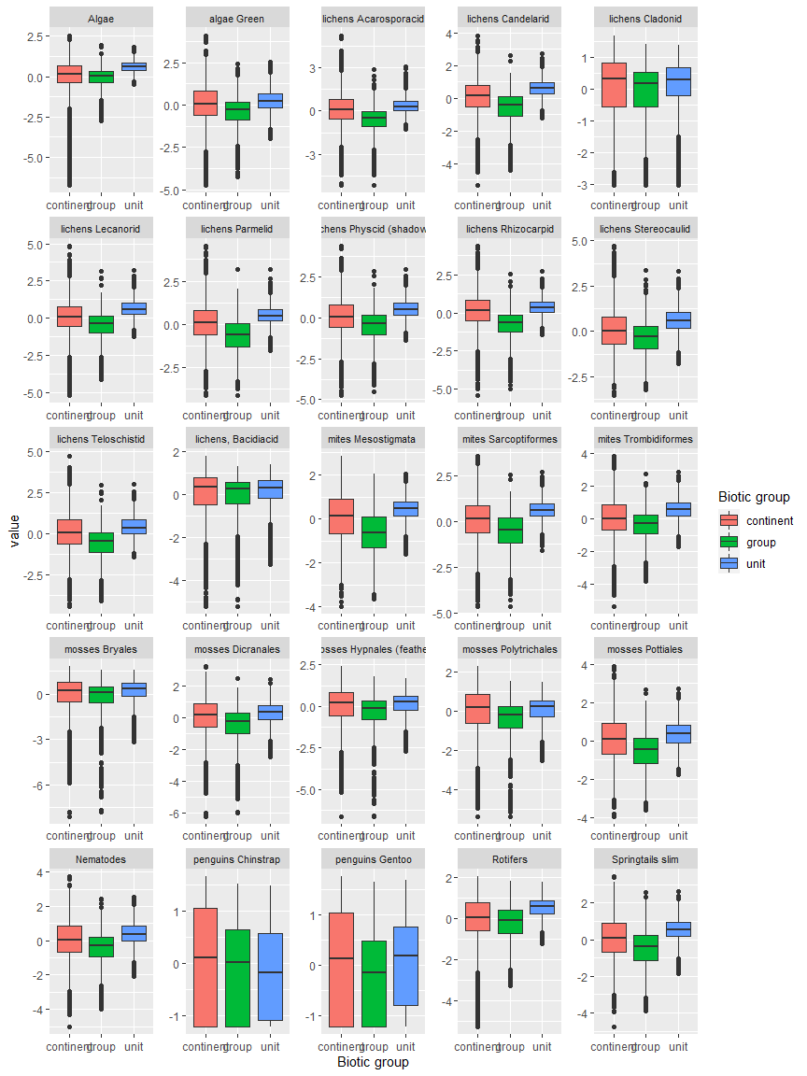

Ecosystem Description

## Ecosystem Env5_sdm2, Mild mesic coastal nunataks

Env5_sdm2, Mild mesic coastal nunataks. Occurs mainly along the east coast of the southern peninsula, throughout the Transantarctic mountains, and in North Victoria Land. Very similar to previous unit environmentally but has higher moisture availability (cloud, melt, precip) and insolation. Main sampled biota consists of lichens and mosses. Suitability again separates this unit from its group and the previous unit; it has highest suitability for penguins, Cladoniaceae and Bacidaceae lichens, and several functional groups of mosses.

### Photos (if available)

### Distribution

Maps - Full map

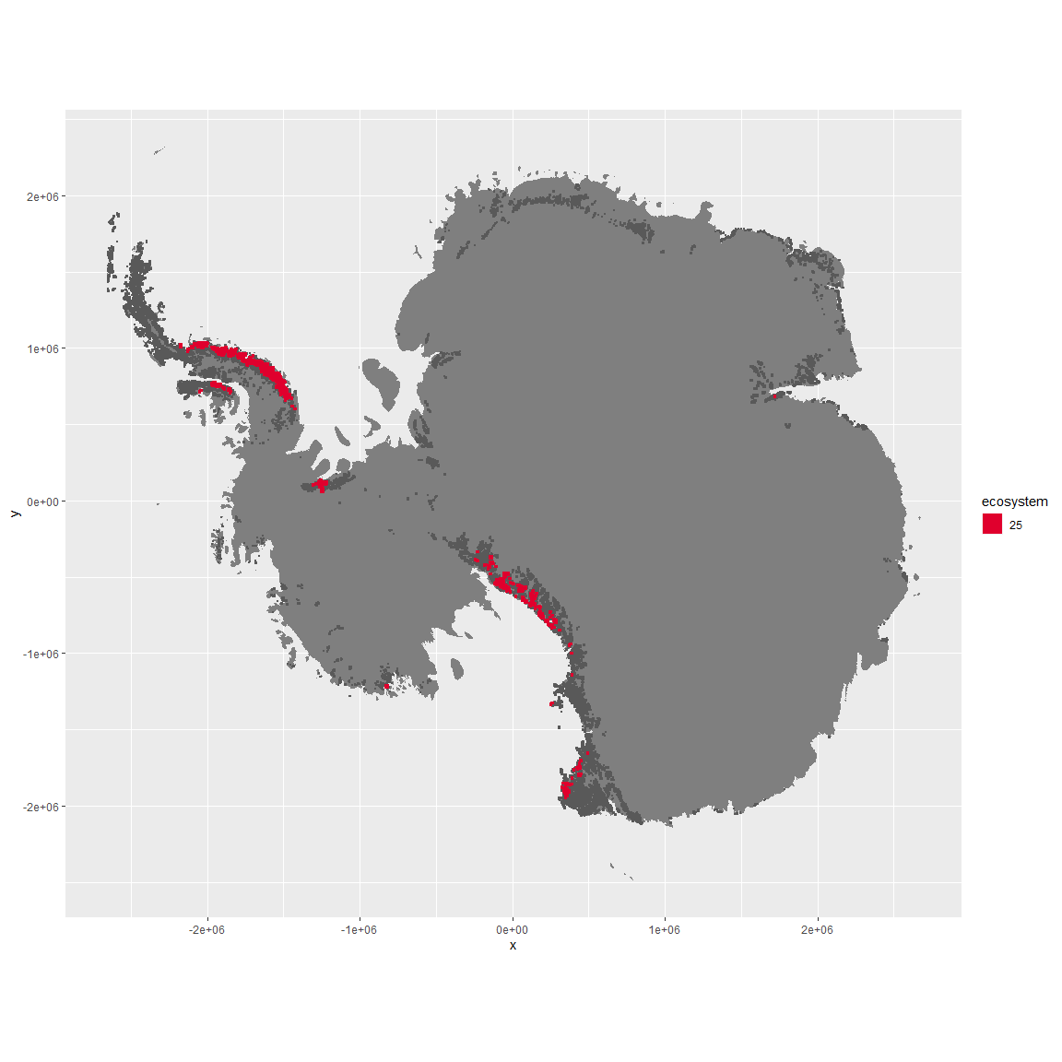

Regional maps

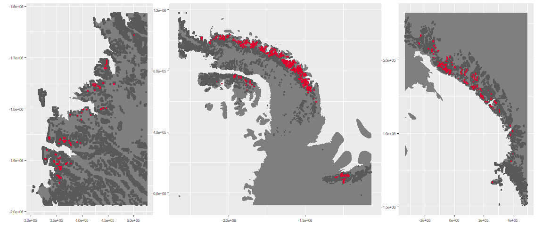

### Environment

The unit env5_sdm2 is part of the environmental supergroup env5.

This supergroup is, on average, substantially higher in elev than continental antarctica. It is substantially lower in modT_0315, rad, precip, temp, sumtemp and wind than the rest of the continent.

The elevation of unit env5_sdm2 ranges from 135 to 4231 metres above sea level, but 90% of its pixels fall above 651 and below 2735 metres. Its average elevation is 1310 metres.

The unit is higher in cloud, temp, sumtemp, rad and melt and lower in elev than the rest of its environmental supergroup.

#### Distinctiveness of the unit from its group and the rest of Antarctica

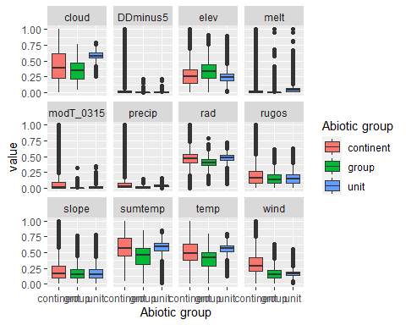

### Biota

Most widespread species in the unit (found in most pixels)

The top most widespread species in ecosystem env5_sdm2

| scientific | Functional_group | phylum | polar specialist? | count | relative_pct |
| --- | --- | --- | --- | --- | --- |
| Usnea sphacelata | Ascomycota_Lecanoromycetes_Lecanorales_Parmeliaceae__ | Ascomycota | TRUE | 14 | 10.0719 |
| Pseudephebe minuscula | Ascomycota_Lecanoromycetes_Lecanorales_Parmeliaceae__ | Ascomycota | FALSE | 8 | 5.7554 |
| Umbilicaria decussata | Ascomycota_Lecanoromycetes_Umbilicariales_Umbilicariaceae__ | Ascomycota | FALSE | 6 | 4.3165 |
| Acarospora gwynnii | Ascomycota_Lecanoromycetes_Acarosporales_Acarosporaceae__ | Ascomycota | TRUE | 4 | 2.8777 |
| Xanthoria elegans | Ascomycota_Lecanoromycetes_Teloschistales_Teloschistaceae__ | Ascomycota | FALSE | 4 | 2.8777 |
| Bryum pseudotriquetrum | Bryophyta_Bryopsida_Bryales___ | Bryophyta | FALSE | 3 | 2.1583 |
| Physcia caesia | Ascomycota_Lecanoromycetes_Teloschistales_Physciaceae__ | Ascomycota | FALSE | 3 | 2.1583 |
| Candelariella vitellina | Ascomycota_Lecanoromycetes_Candelariales_Candelariaceae__ | Ascomycota | FALSE | 2 | 1.4388 |
| Lecanora cf. orosthea | Ascomycota_Lecanoromycetes_Lecanorales_Lecanoraceae__ | Ascomycota | TRUE | 2 | 1.4388 |
| Lecanora cf. physciella | Ascomycota_Lecanoromycetes_Lecanorales_Lecanoraceae__ | Ascomycota | TRUE | 2 | 1.4388 |
| Lecidea cancriformis | Ascomycota_Lecanoromycetes_Lecanorales_Lecideaceae__ | Ascomycota | TRUE | 2 | 1.4388 |
| Lecidea cf. cancriformis | Ascomycota_Lecanoromycetes_Lecanorales_Lecideaceae__ | Ascomycota | TRUE | 2 | 1.4388 |
| Lepraria cacuminum | Ascomycota_Lecanoromycetes_Lecanorales_Stereocaulaceae__ | Ascomycota | FALSE | 2 | 1.4388 |
| Pannaria hookeri | Ascomycota_Lecanoromycetes_Peltigerales_Pannariaceae__ | Ascomycota | FALSE | 2 | 1.4388 |
| Pleopsidium chlorophanum | Ascomycota_Lecanoromycetes_Acarosporales_Acarosporaceae__ | Ascomycota | FALSE | 2 | 1.4388 |
| Pohlia cruda | Bryophyta_Bryopsida_Bryales___ | Bryophyta | FALSE | 2 | 1.4388 |
| Rhizoplaca melanophthalma | Ascomycota_Lecanoromycetes_Lecanorales_Lecanoraceae__ | Ascomycota | FALSE | 2 | 1.4388 |
| Syntrichia princeps | Bryophyta_Bryopsida_Pottiales___ | Bryophyta | FALSE | 2 | 1.4388 |
| Tortella alpicola | Bryophyta_Bryopsida_Pottiales___ | Bryophyta | FALSE | 2 | 1.4388 |

This supergroup is, on average, substantially higher in suitability for no variables functional groups than continental Antarctica. It is substantially lower in suitability for lichens_Acarosporacid, lichens_Parmelid, mites_Mesostigmata and lichens_Rhizocarpid than the rest of the continent.

Unit env5_sdm2 is higher in suitability for mosses_Hypnales_(feather), penguins_Gentoo, mosses_Polytrichales, mosses_Dicranales, lichens_Cladonid, lichens,*Bacidiacid, lichens_Parmelid, mosses_Bryales, mites_Mesostigmata, penguins_Chinstrap, mosses_Pottiales, lichens_Stereocaulid, mites_Sarcoptiformes, Springtails_slim, lichens_Teloschistid and lichens_Physcid*(shadow) and lower in suitability for no variables than the rest of its environmental supergroup.

Distinctiveness of the unit from the environmental group and the rest of Antarctica

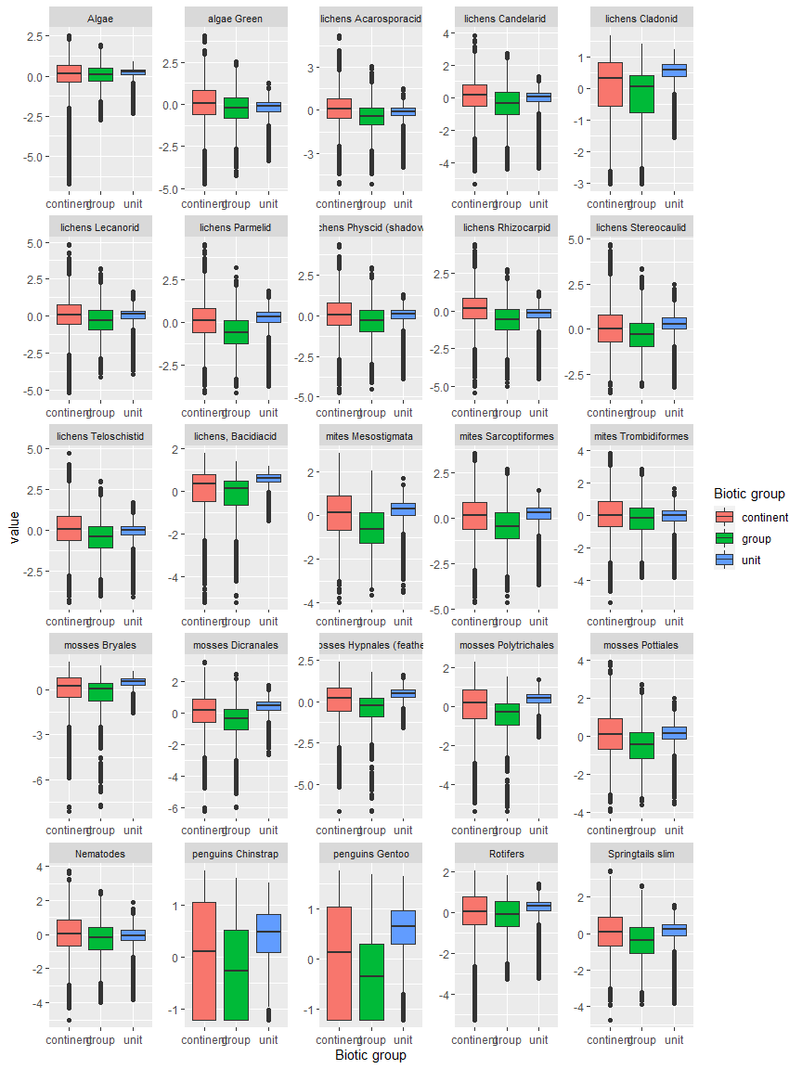

Ecosystem Description

## Ecosystem Env5_sdm3, High sheltered mountain slopes

Env5_sdm3, High sheltered mountain slopes. Occurs mainly throughout the Transantarctic mountains and in North Victoria Land. This unit has higher elev/ruggedness and colder temps than the rest of its group, constituting a more extreme example of the group. Sampled fauna mostly Cyanobacteria and Chlorophyta. Suitability is bad for everything, but slightly less bad for Cladoniaceae and Bacidiaceaelichens.

### Photos (if available)

### Distribution

Maps - Full map

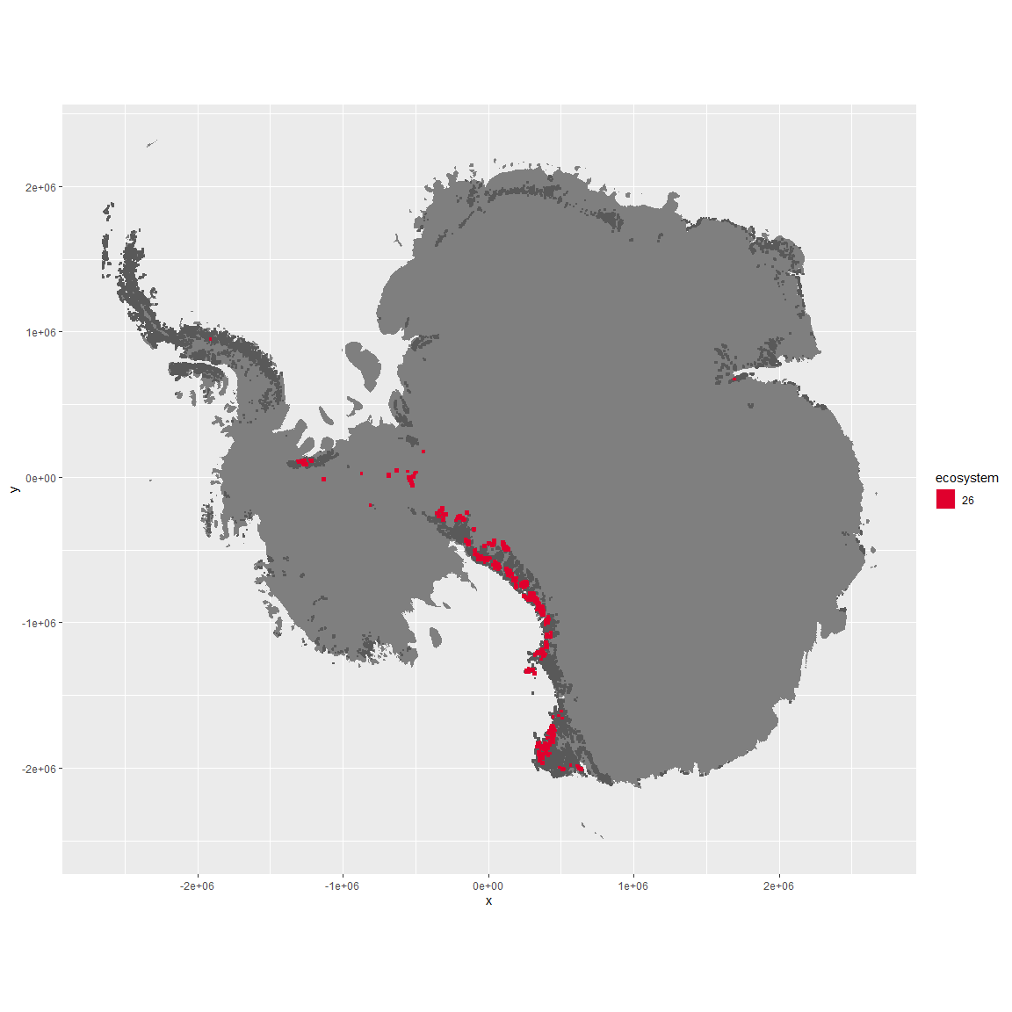

Regional maps

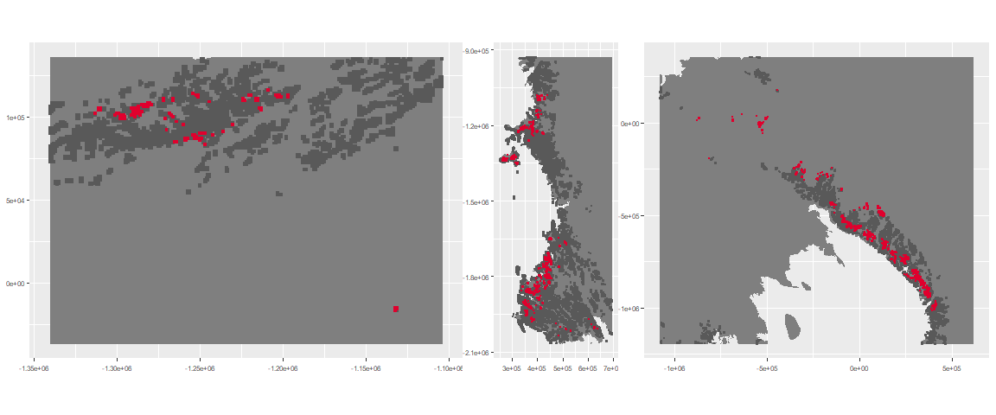

### Environment

The unit env5_sdm3 is part of the environmental supergroup env5.

This supergroup is, on average, substantially higher in elev than continental antarctica. It is substantially lower in modT_0315, rad, precip, temp, sumtemp and wind than the rest of the continent.

The elevation of unit env5_sdm3 ranges from 55 to 4338 metres above sea level, but 90% of its pixels fall above 1253 and below 3090 metres. Its average elevation is 2124 metres.

The unit is higher in elev, slope and rugos and lower in temp and sumtemp than the rest of its environmental supergroup.

#### Distinctiveness of the unit from its group and the rest of Antarctica

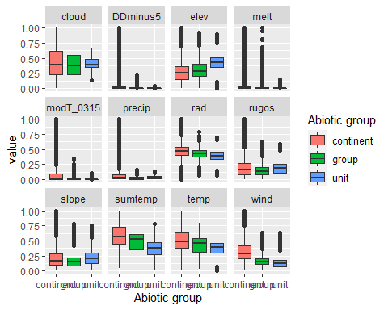

### Biota

Most widespread species in the unit (found in most pixels)

The top most widespread species in ecosystem env5_sdm3

| scientific | Functional_group | phylum | polar specialist? | count | relative_pct |
| --- | --- | --- | --- | --- | --- |
| Auxenochlorella┬á protothecoides | Chlorophyta_____ | Chlorophyta | TRUE | 2 | 3.3333 |
| Chloroidium saccharophilum | Chlorophyta_____ | Chlorophyta | FALSE | 2 | 3.3333 |
| Coccomyxa curvata | Chlorophyta_____ | Chlorophyta | TRUE | 2 | 3.3333 |
| Coccomyxa gloeobotrydiformis | Chlorophyta_____ | Chlorophyta | TRUE | 2 | 3.3333 |
| Coelastrella terrestris | Chlorophyta_____ | Chlorophyta | TRUE | 2 | 3.3333 |
| Elliptochloris subsphaerica┬á | Chlorophyta_____ | Chlorophyta | TRUE | 2 | 3.3333 |
| Graesiella emersonii | Chlorophyta_____ | Chlorophyta | FALSE | 2 | 3.3333 |
| Mastigocladus laminosus | Cyanobacteria_____ | Cyanobacteria | FALSE | 2 | 3.3333 |
| Pseudococcomyxa simplex | Chlorophyta_____ | Chlorophyta | TRUE | 2 | 3.3333 |
| Rhizocarpon geographicum | Ascomycota_Lecanoromycetes_Not assigned_Rhizocarpaceae__ | Ascomycota | FALSE | 2 | 3.3333 |
| Sarconeurum glaciale | Bryophyta_Bryopsida_Pottiales___ | Bryophyta | TRUE | 2 | 3.3333 |

This supergroup is, on average, substantially higher in suitability for no variables functional groups than continental Antarctica. It is substantially lower in suitability for lichens_Acarosporacid, lichens_Parmelid, mites_Mesostigmata and lichens_Rhizocarpid than the rest of the continent.

Unit env5_sdm3 is higher in suitability for no variables and lower in suitability for lichens_Cladonid, lichens,*Bacidiacid, mosses_Polytrichales, mosses_Hypnales*(feather), Algae, mosses_Bryales, lichens_Stereocaulid, mites_Mesostigmata, lichens_Lecanorid, Rotifers, lichens_Rhizocarpid, lichens_Acarosporacid, lichens_Teloschistid, mosses_Pottiales, mosses_Dicranales, mites_Sarcoptiformes, Springtails_slim, lichens_Parmelid, Nematodes, mites_Trombidiformes, lichens_Physcid_(shadow), lichens_Candelarid and algae_Green than the rest of its environmental supergroup.

Distinctiveness of the unit from the environmental group and the rest of Antarctica

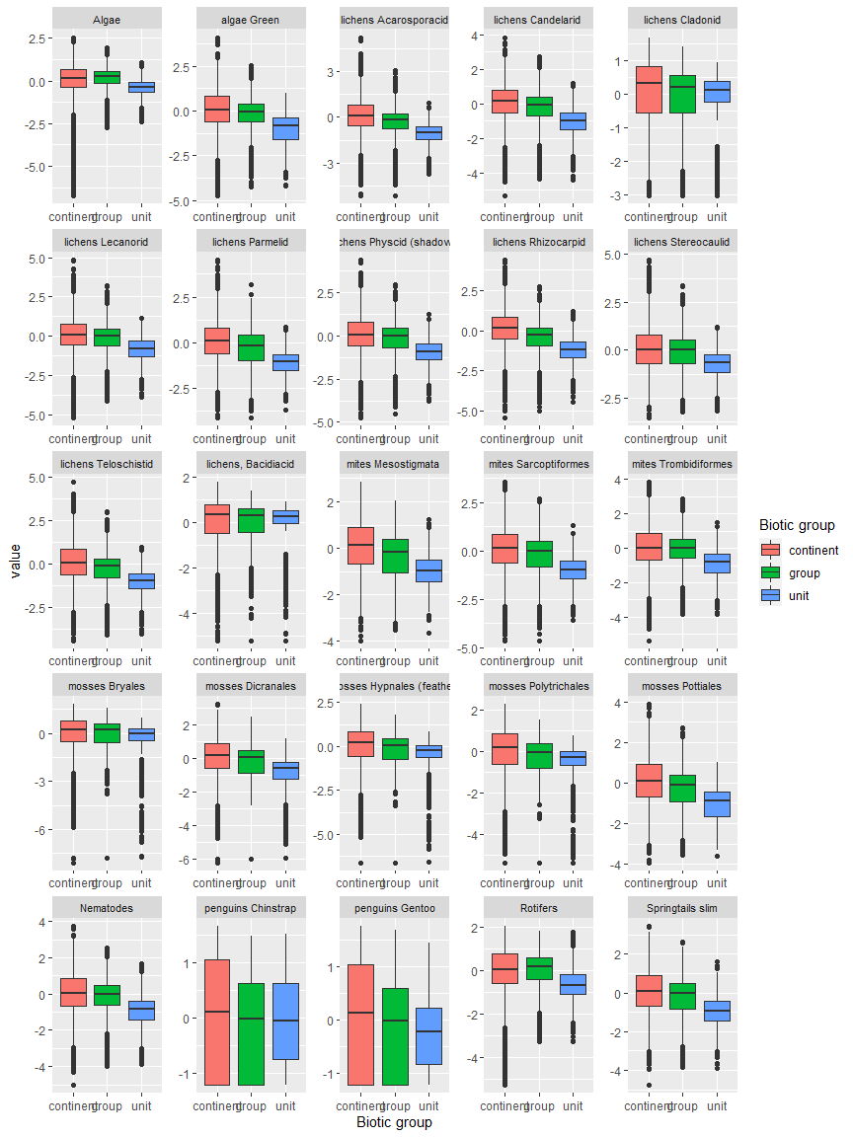

Ecosystem Description

## Ecosystem Env5_sdm4, Arid highland nunataks

Env5_sdm4, Arid highland nunataks. Occurs throughout the Transantarctic mountains and Victoria land. The main environmental group in the lower outcrops separating the dry valleys near McMurdo, this unit is higher in elev and lower in temp than the rest of its group (though not as high as previous unit). It has especially low cloud cover. Main sampled fauna are Athropods, Nematodes, and Chlorophytes. Suitability terrible for most functional groups except Chlorophyta and Ochrophyta.

### Photos (if available)

### Distribution

Maps - Full map

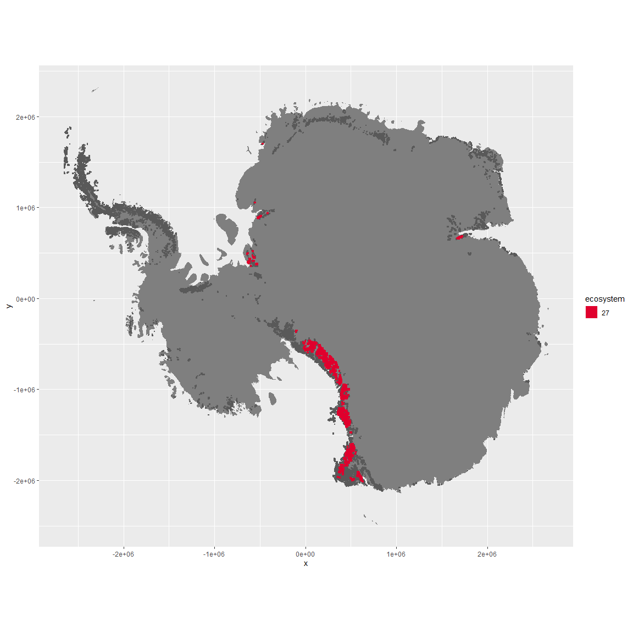

Regional maps

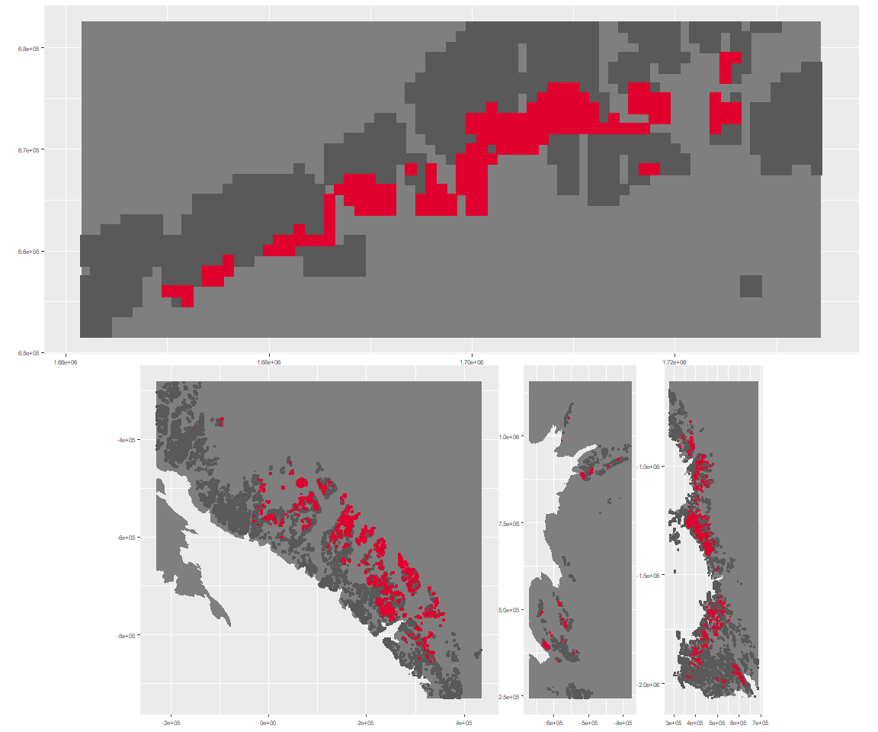

### Environment

The unit env5_sdm4 is part of the environmental supergroup env5.

This supergroup is, on average, substantially higher in elev than continental antarctica. It is substantially lower in modT_0315, rad, precip, temp, sumtemp and wind than the rest of the continent.

The elevation of unit env5_sdm4 ranges from 64 to 4329 metres above sea level, but 90% of its pixels fall above 819 and below 2943 metres. Its average elevation is 1809 metres.

The unit is higher in elev and lower in sumtemp, temp and cloud than the rest of its environmental supergroup.

#### Distinctiveness of the unit from its group and the rest of Antarctica

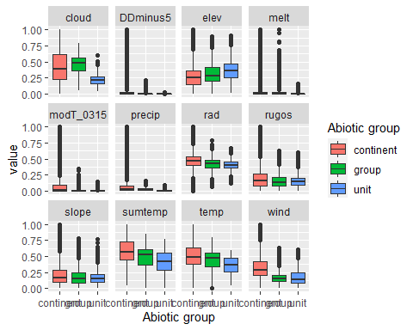

### Biota

Most widespread species in the unit (found in most pixels)

The top most widespread species in ecosystem env5_sdm4

| scientific | Functional_group | phylum | polar specialist? | count | relative_pct |
| --- | --- | --- | --- | --- | --- |
| Gomphiocephalus hodgsoni | Arthropoda_Entognatha_Poduromorpha___ | Arthropoda | TRUE | 5 | 12.1951 |
| Eudorylaimus antarcticus | Nematoda_____ | Nematoda | TRUE | 3 | 7.3171 |
| Prasiola calophylla | Chlorophyta_____ | Chlorophyta | FALSE | 3 | 7.3171 |
| Stereotydeus mollis | Arthropoda_Arachnida_Trombidiformes___ | Arthropoda | TRUE | 3 | 7.3171 |
| Lecidea cancriformis | Ascomycota_Lecanoromycetes_Lecanorales_Lecideaceae__ | Ascomycota | TRUE | 2 | 4.8780 |
| Scottnema lindsayae | Nematoda_____ | Nematoda | TRUE | 2 | 4.8780 |
| Acarospora gwynnii | Ascomycota_Lecanoromycetes_Acarosporales_Acarosporaceae__ | Ascomycota | TRUE | 1 | 2.4390 |
| Adineta grandis | Rotifera_____ | Rotifera | TRUE | 1 | 2.4390 |
| Buellia frigida | Ascomycota_Lecanoromycetes_Teloschistales_Physciaceae__ | Ascomycota | TRUE | 1 | 2.4390 |
| Buellia olivaceobrunnea | Ascomycota_Lecanoromycetes_Teloschistales_Physciaceae__ | Ascomycota | TRUE | 1 | 2.4390 |
| Calothrix braunii | Cyanobacteria_____ | Cyanobacteria | FALSE | 1 | 2.4390 |
| Collotheca ornata | Rotifera_____ | Rotifera | FALSE | 1 | 2.4390 |
| Cylindrocystis brebissonii | Charophyta_____ | Charophyta | FALSE | 1 | 2.4390 |
| Gloeocapsa kuetzingiana | Cyanobacteria_____ | Cyanobacteria | TRUE | 1 | 2.4390 |
| Habrotrocha constricta | Rotifera_____ | Rotifera | TRUE | 1 | 2.4390 |
| Hymenelia glacialis | Ascomycota_Lecanoromycetes_Lecanorales_Hymeneliaceae__ | Ascomycota | TRUE | 1 | 2.4390 |
| Hypsibius arcticus | Tardigrada_____ | Tardigrada | TRUE | 1 | 2.4390 |
| Lecanora fuscobrunnea | Ascomycota_Lecanoromycetes_Lecanorales_Lecanoraceae__ | Ascomycota | TRUE | 1 | 2.4390 |
| Macrotrachela habita | Rotifera_____ | Rotifera | FALSE | 1 | 2.4390 |
| Microcoleus paludosus | Cyanobacteria_____ | Cyanobacteria | FALSE | 1 | 2.4390 |
| Nanorchestes antarcticus | Arthropoda_Arachnida_Sarcoptiformes___ | Arthropoda | TRUE | 1 | 2.4390 |
| Philodina antarctica | Rotifera_____ | Rotifera | TRUE | 1 | 2.4390 |
| Philodina gregaria | Rotifera_____ | Rotifera | TRUE | 1 | 2.4390 |
| Phormidium corium | Cyanobacteria_____ | Cyanobacteria | FALSE | 1 | 2.4390 |
| Phormidium uncinatum | Cyanobacteria_____ | Cyanobacteria | FALSE | 1 | 2.4390 |
| Plectus murrayi | Nematoda_____ | Nematoda | TRUE | 1 | 2.4390 |
| Rinodina sordida | Ascomycota_Lecanoromycetes_Teloschistales_Physciaceae__ | Ascomycota | TRUE | 1 | 2.4390 |
| Sarconeurum glaciale | Bryophyta_Bryopsida_Pottiales___ | Bryophyta | TRUE | 1 | 2.4390 |
| Tetracystis sp. | Chlorophyta_____ | Chlorophyta | TRUE | 1 | 2.4390 |

This supergroup is, on average, substantially higher in suitability for no variables functional groups than continental Antarctica. It is substantially lower in suitability for lichens_Acarosporacid, lichens_Parmelid, mites_Mesostigmata and lichens_Rhizocarpid than the rest of the continent.

Unit env5_sdm4 is higher in suitability for algae_Green and lower in suitability for lichens_Stereocaulid, mosses_Hypnales_(feather), mites_Sarcoptiformes, mosses_Polytrichales, penguins_Gentoo, lichens_Parmelid and mites_Mesostigmata than the rest of its environmental supergroup.

Distinctiveness of the unit from the environmental group and the rest of Antarctica

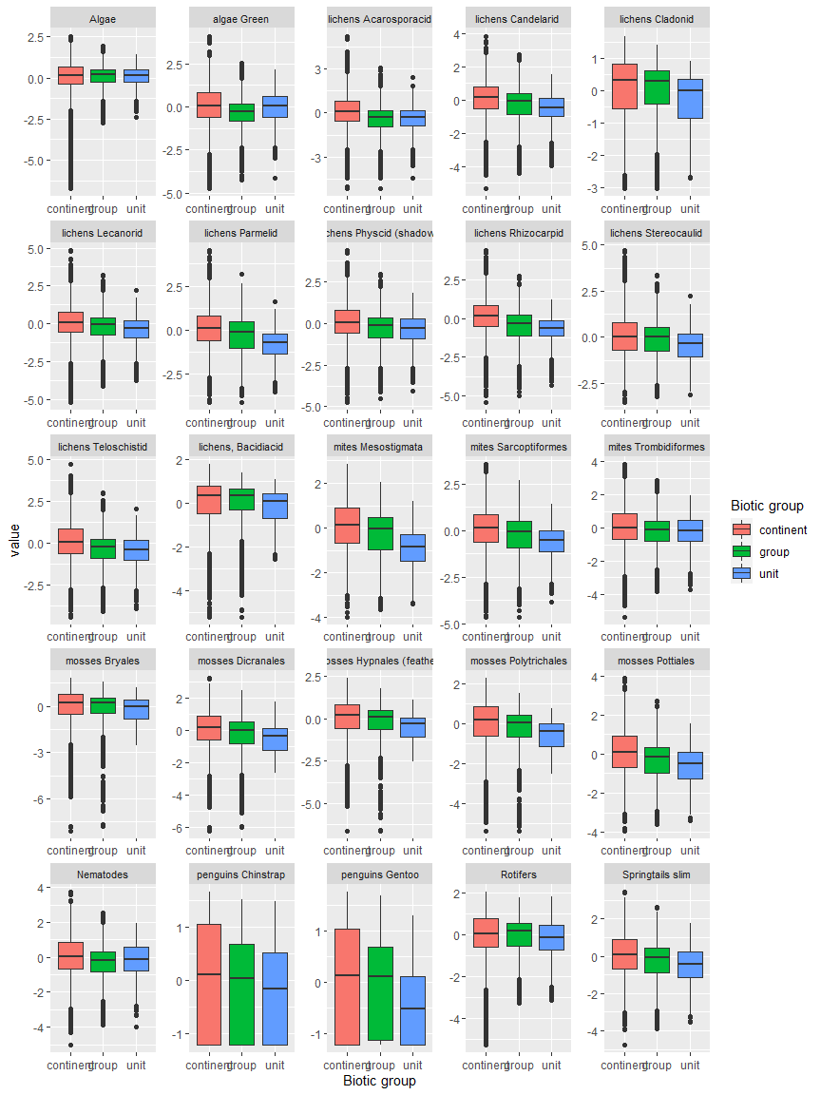

Ecosystem Description

## Ecosystem Env5_sdm5, High snowy mountain slopes

Env5_sdm5, High snowy mountain slopes. Occurs mainly along the east coast of the southern peninsula, in the Ellsworth mountains, throughout the Transantarctic mountains, and throughout Victoria Land. This unit is clearer and colder than the rest of its group, but very similar to 5.3, difference is mainly higher cloud cover on average. Sampled biota mainly Chlorophytes, Cyanobacteria, and lichens. Suitability is low for every group and especially some lichen groups.

### Photos (if available)

### Distribution

Maps - Full map

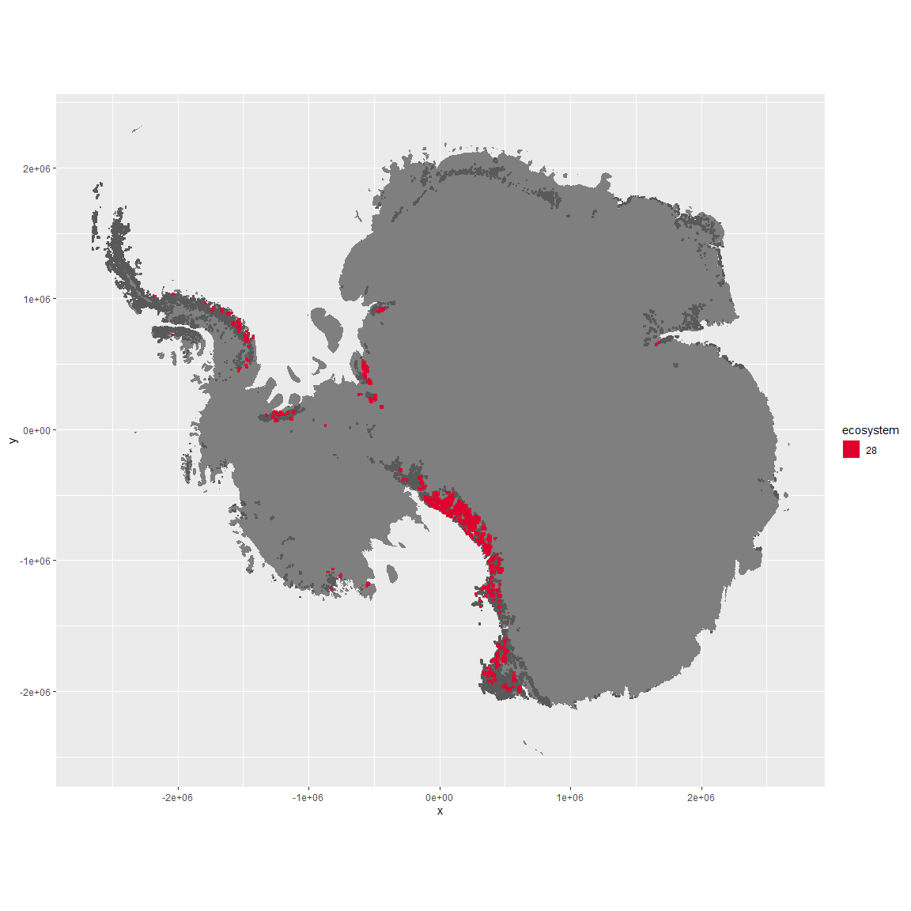

Regional maps

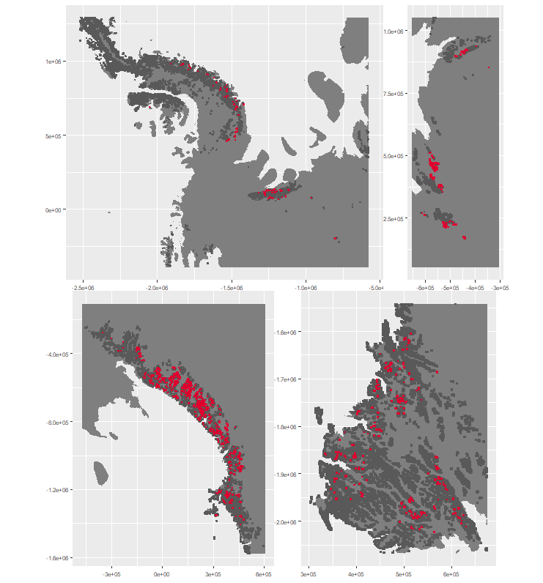

### Environment

The unit env5_sdm5 is part of the environmental supergroup env5.

This supergroup is, on average, substantially higher in elev than continental antarctica. It is substantially lower in modT_0315, rad, precip, temp, sumtemp and wind than the rest of the continent.

The elevation of unit env5_sdm5 ranges from 57 to 4260 metres above sea level, but 90% of its pixels fall above 711 and below 3010 metres. Its average elevation is 1754 metres.

The unit is higher in no variables and lower in sumtemp, temp and cloud than the rest of its environmental supergroup.

#### Distinctiveness of the unit from its group and the rest of Antarctica

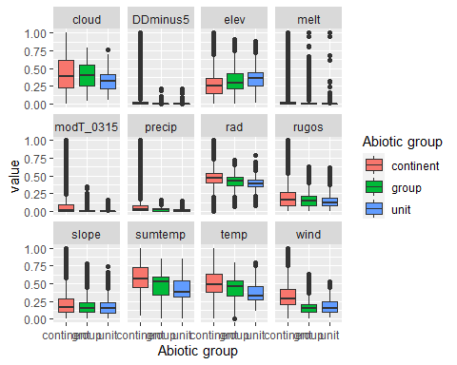

### Biota

Most widespread species in the unit (found in most pixels)

The top most widespread species in ecosystem env5_sdm5

| scientific | Functional_group | phylum | polar specialist? | count | relative_pct |
| --- | --- | --- | --- | --- | --- |
| Desmococcus olivaceus | Chlorophyta_____ | Chlorophyta | FALSE | 4 | 4 |
| Pseudephebe minuscula | Ascomycota_Lecanoromycetes_Lecanorales_Parmeliaceae__ | Ascomycota | FALSE | 4 | 4 |
| Stichococcus bacillaris | Chlorophyta_____ | Chlorophyta | FALSE | 4 | 4 |
| Gloeocapsa punctata | Cyanobacteria_____ | Cyanobacteria | TRUE | 3 | 3 |
| Gloeocapsa ralfsiana | Cyanobacteria_____ | Cyanobacteria | TRUE | 3 | 3 |
| Omphalodiscus bakeri | Ascomycota_Unknown_Unknown_Unknown__ | Ascomycota | TRUE | 3 | 3 |
| Physcia caesia | Ascomycota_Lecanoromycetes_Teloschistales_Physciaceae__ | Ascomycota | FALSE | 3 | 3 |
| Umbilicaria decussata | Ascomycota_Lecanoromycetes_Umbilicariales_Umbilicariaceae__ | Ascomycota | FALSE | 3 | 3 |
| Usnea sphacelata | Ascomycota_Lecanoromycetes_Lecanorales_Parmeliaceae__ | Ascomycota | TRUE | 3 | 3 |
| Acarospora gwynnii | Ascomycota_Lecanoromycetes_Acarosporales_Acarosporaceae__ | Ascomycota | TRUE | 2 | 2 |
| Buellia frigida | Ascomycota_Lecanoromycetes_Teloschistales_Physciaceae__ | Ascomycota | TRUE | 2 | 2 |
| Buellia pernigra | Ascomycota_Lecanoromycetes_Teloschistales_Physciaceae__ | Ascomycota | TRUE | 2 | 2 |
| Calothrix parietina | Cyanobacteria_____ | Cyanobacteria | FALSE | 2 | 2 |
| Candelariella flava | Ascomycota_Lecanoromycetes_Candelariales_Candelariaceae__ | Ascomycota | TRUE | 2 | 2 |
| Gloeocapsa alpina | Cyanobacteria_____ | Cyanobacteria | FALSE | 2 | 2 |
| Gloeocapsa kuetzingiana | Cyanobacteria_____ | Cyanobacteria | TRUE | 2 | 2 |
| Gomphiocephalus hodgsoni | Arthropoda_Entognatha_Poduromorpha___ | Arthropoda | TRUE | 2 | 2 |
| Huea smaragdula | Ascomycota_Lecanoromycetes_Teloschistales_Teloschistaceae__ | Ascomycota | TRUE | 2 | 2 |
| Lecidea cancriformis | Ascomycota_Lecanoromycetes_Lecanorales_Lecideaceae__ | Ascomycota | TRUE | 2 | 2 |
| Pseudococcomyxa simplex | Chlorophyta_____ | Chlorophyta | TRUE | 2 | 2 |
| Rinodina olivaceobrunnea | Ascomycota_Lecanoromycetes_Teloschistales_Physciaceae__ | Ascomycota | FALSE | 2 | 2 |
| Schistidium antarctici | Bryophyta_Bryopsida_Grimmiales___ | Bryophyta | TRUE | 2 | 2 |
| Umbilicaria cristata | Ascomycota_Lecanoromycetes_Umbilicariales_Umbilicariaceae__ | Ascomycota | TRUE | 2 | 2 |
| Usnea antarctica | Ascomycota_Lecanoromycetes_Lecanorales_Parmeliaceae__ | Ascomycota | FALSE | 2 | 2 |

This supergroup is, on average, substantially higher in suitability for no variables functional groups than continental Antarctica. It is substantially lower in suitability for lichens_Acarosporacid, lichens_Parmelid, mites_Mesostigmata and lichens_Rhizocarpid than the rest of the continent.

Unit env5_sdm5 is higher in suitability for no variables and lower in suitability for Algae, mites_Mesostigmata, mites_Trombidiformes, mosses_Bryales, Nematodes, lichens,*Bacidiacid, mosses_Polytrichales, lichens_Cladonid, lichens_Candelarid, mosses_Hypnales*(feather), algae_Green, Springtails_slim, mosses_Dicranales, mosses_Pottiales, penguins_Chinstrap, penguins_Gentoo, lichens_Rhizocarpid, lichens_Teloschistid, lichens_Physcid_(shadow), mites_Sarcoptiformes, lichens_Lecanorid, lichens_Stereocaulid, lichens_Parmelid and lichens_Acarosporacid than the rest of its environmental supergroup.

Distinctiveness of the unit from the environmental group and the rest of Antarctica

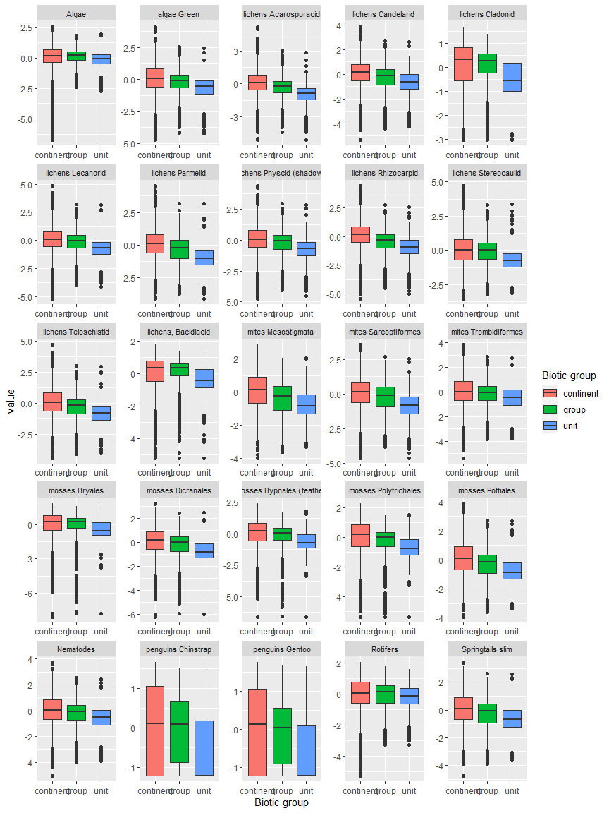

Ecosystem Description

## Ecosystem Env6_sdm1 Islands1

Env6_sdm1 Islands1. Occurs mainly on James Ross island, with a scattering of occurrences in other ACBRs. This unit’s most sampled biota are adelie penguins and Bryum pseudotriquetum (moss). Ochrophytes are also well-represented. Several Ochrophyte and Athropod species seem to prefer this unit over all others. Suitability is high for all functional groups in this environmental group, but this unit is especially suitable for Rotifers, Ochrophytes, and several Lichen groups (Acarosporaceae and Physcidaceae most pronounced).

### Photos (if available)

### Distribution

Maps - Full map

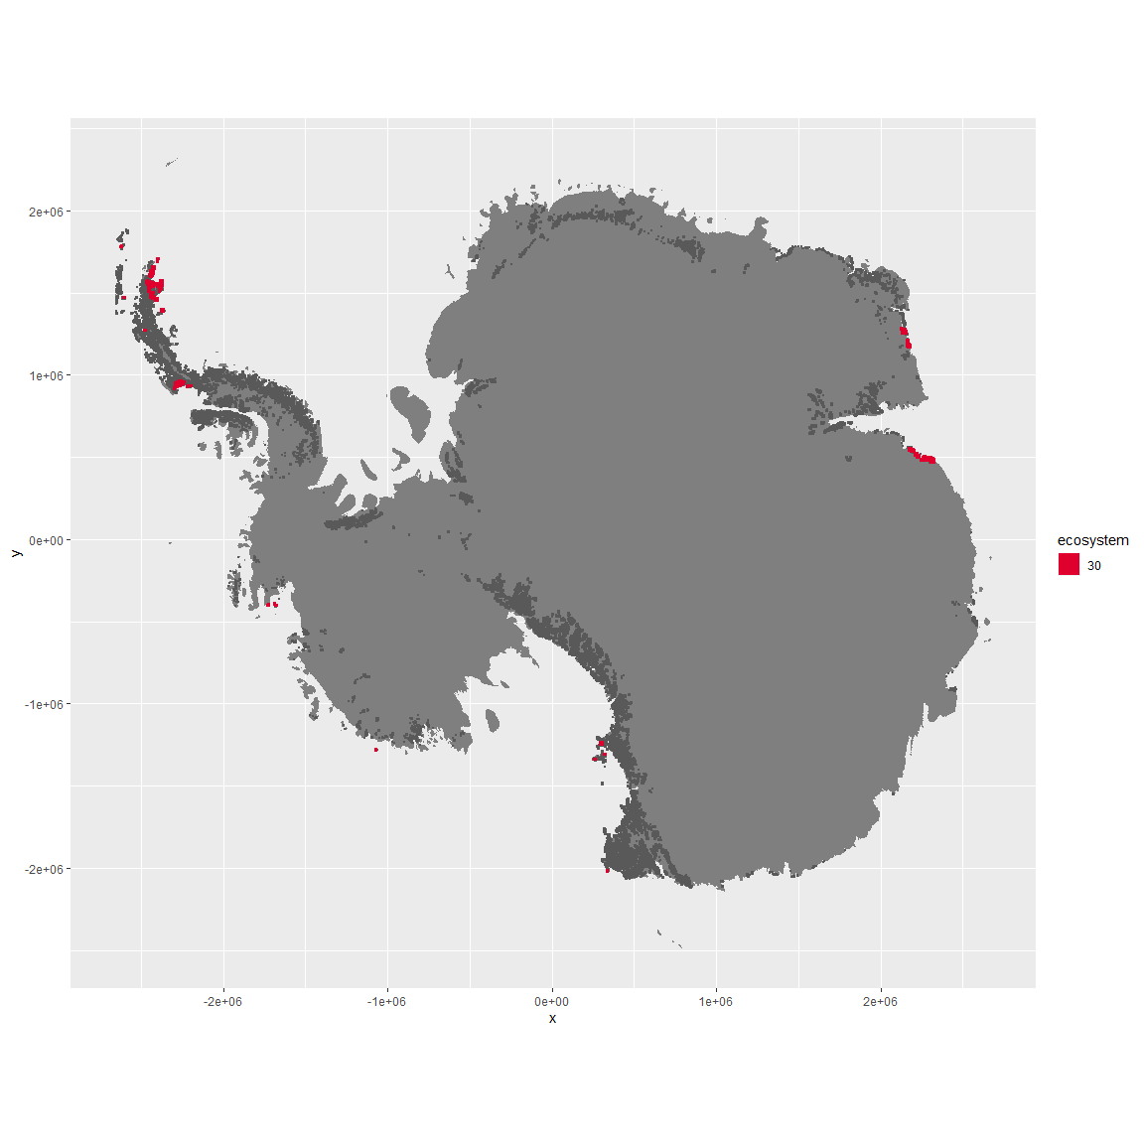

Regional maps

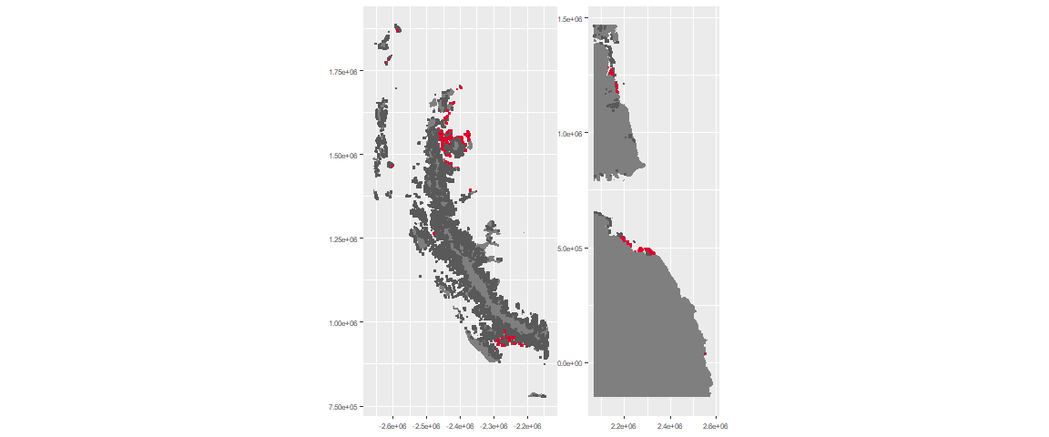

### Environment

The unit env6_sdm1 is part of the environmental supergroup env6.

The elevation of unit env6_sdm1 ranges from 0 to 792 metres above sea level, but 90% of its pixels fall above 0 and below 302 metres. Its average elevation is 40 metres.

#### Distinctiveness of the unit from its group and the rest of Antarctica

NA

### Biota

Most widespread species in the unit (found in most pixels)

The top most widespread species in ecosystem env6_sdm1

| scientific | Functional_group | phylum | polar specialist? | count | relative_pct |
| --- | --- | --- | --- | --- | --- |
| Pygoscelis adeliae | Chordata_Aves_Sphenisciformes_Spheniscidae_Pygoscelis_adeliae | Chordata | FALSE | 32 | 3.3438 |
| Bryum pseudotriquetrum | Bryophyta_Bryopsida_Bryales___ | Bryophyta | FALSE | 19 | 1.9854 |
| Umbilicaria decussata | Ascomycota_Lecanoromycetes_Umbilicariales_Umbilicariaceae__ | Ascomycota | FALSE | 16 | 1.6719 |
| Buellia frigida | Ascomycota_Lecanoromycetes_Teloschistales_Physciaceae__ | Ascomycota | TRUE | 12 | 1.2539 |
| Caloplaca citrina | Ascomycota_Lecanoromycetes_Teloschistales_Teloschistaceae__ | Ascomycota | TRUE | 12 | 1.2539 |
| Fragilaria sp. | Ochrophyta_____ | Ochrophyta | TRUE | 12 | 1.2539 |
| Navicula salinarum | Ochrophyta_____ | Ochrophyta | FALSE | 12 | 1.2539 |
| Pinnularia microstauron | Ochrophyta_____ | Ochrophyta | FALSE | 12 | 1.2539 |
| Xanthoria elegans | Ascomycota_Lecanoromycetes_Teloschistales_Teloschistaceae__ | Ascomycota | FALSE | 12 | 1.2539 |
| Chaetoceros sp. | Ochrophyta_____ | Ochrophyta | TRUE | 11 | 1.1494 |
| Navicula directa | Ochrophyta_____ | Ochrophyta | FALSE | 11 | 1.1494 |
| Physcia caesia | Ascomycota_Lecanoromycetes_Teloschistales_Physciaceae__ | Ascomycota | FALSE | 11 | 1.1494 |
| Rhizoplaca melanophthalma | Ascomycota_Lecanoromycetes_Lecanorales_Lecanoraceae__ | Ascomycota | FALSE | 11 | 1.1494 |

This supergroup is, on average, substantially higher in suitability for mites_Mesostigmata, lichens_Rhizocarpid, penguins_Gentoo, lichens_Parmelid, mites_Sarcoptiformes, penguins_Chinstrap, Springtails_slim, mosses_Pottiales, mosses_Polytrichales, mosses_Dicranales, mites_Trombidiformes, mosses_Hypnales_(feather), algae_Green, Nematodes, lichens_Physcid_(shadow), lichens_Acarosporacid, lichens_Teloschistid, lichens_Stereocaulid, lichens_Candelarid, lichens_Lecanorid, lichens_Cladonid, mosses_Bryales, lichens,_Bacidiacid, Algae and Rotifers functional groups than continental Antarctica. It is substantially lower in suitability for no variables than the rest of the continent.

Unit env6_sdm1 is higher in suitability for Rotifers, Algae, lichens_Acarosporacid, lichens_Lecanorid, lichens_Physcid_(shadow), lichens_Candelarid and lichens_Teloschistid and lower in suitability for no variables than the rest of its environmental supergroup.

Distinctiveness of the unit from the environmental group and the rest of Antarctica

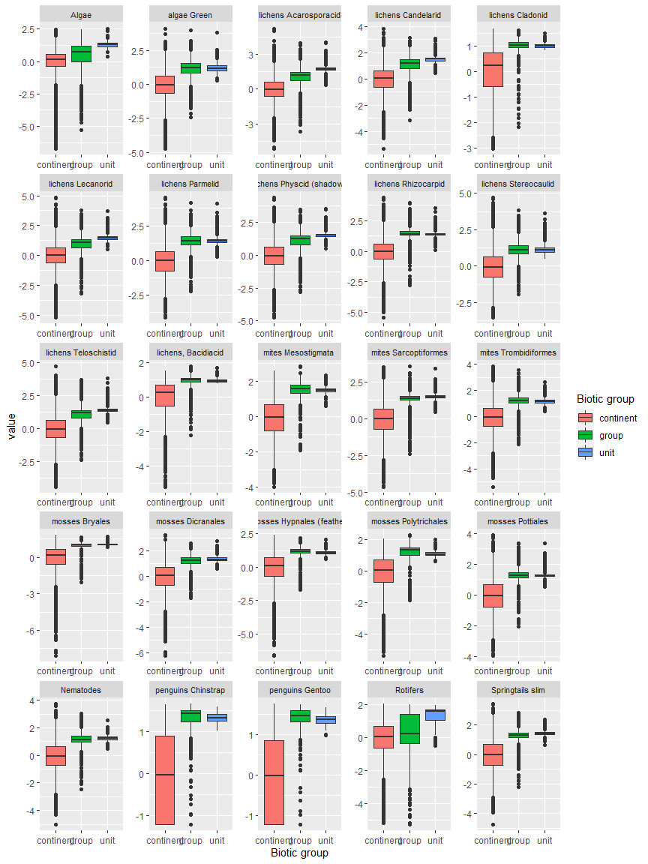

Ecosystem Description

## Ecosystem Env6_sdm2 Coastal/Island tundra

Env6_sdm2 Coastal/Island tundra. This unit occurs exclusively on the outer tip of the Antarctic peninsula and surrounding islands. It is teeming with penguins, features antarctic hair grass, two moss species, followed by a variety of lichens and arthropods. Snowy Sheathbill is found primarily in this unit, as are gentoo penguins, both vascular plants, and several moss and lichen species. Suitability is high for pretty much everything except Rotifers, but especially high for Parmeliaceae, Cladoniaceae, and Bacidiaceae lichens as well as Mesostigmatid mites, chinstrap penguins, and Hypnales/Polytrichiales mosses. This is probably the most habitable unit on the continent.

### Photos (if available)

### Distribution

Maps - Full map

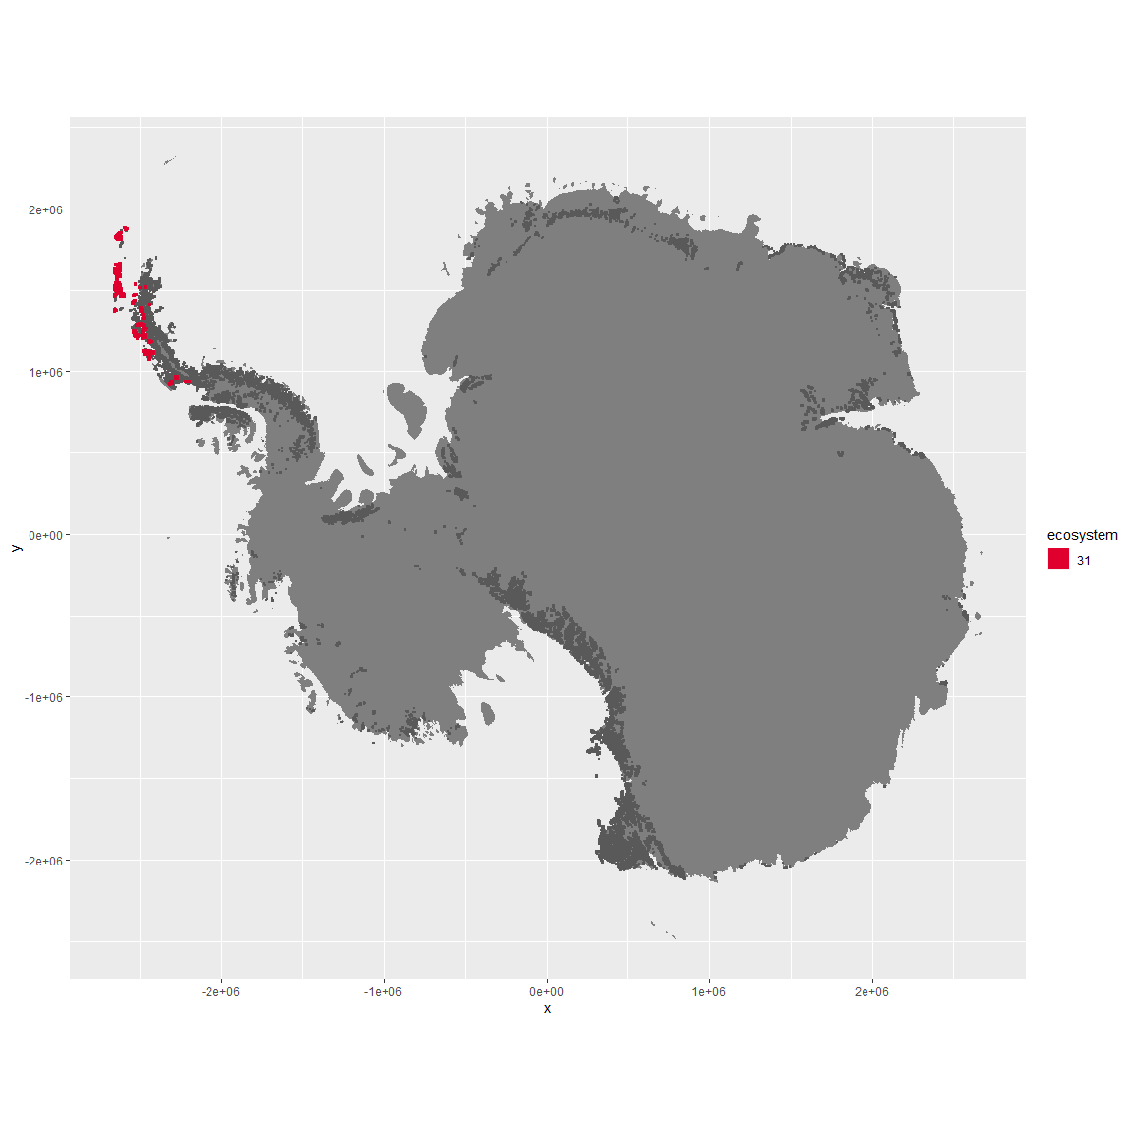

Regional maps

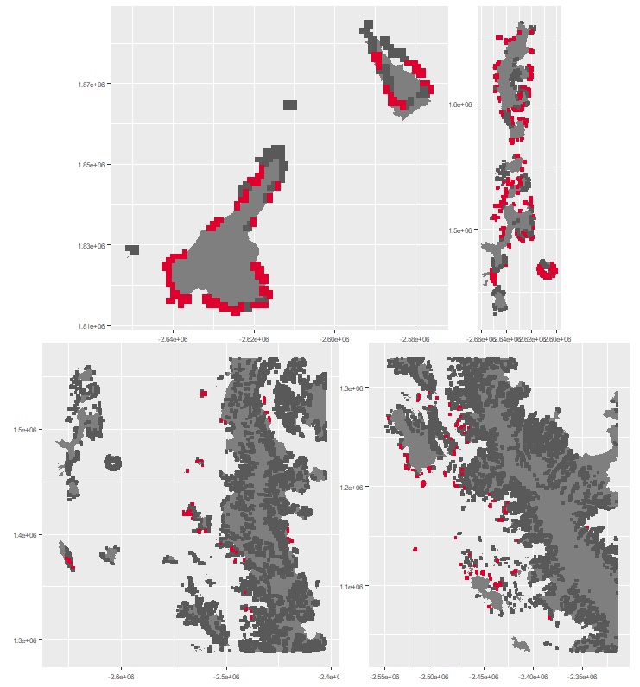

### Environment

The unit env6_sdm2 is part of the environmental supergroup env6.

The elevation of unit env6_sdm2 ranges from 0 to 1778 metres above sea level, but 90% of its pixels fall above 0 and below 407 metres. Its average elevation is 72 metres.

#### Distinctiveness of the unit from its group and the rest of Antarctica

NA

### Biota

Most widespread species in the unit (found in most pixels)

The top most widespread species in ecosystem env6_sdm2

| scientific | Functional_group | phylum | polar specialist? | count | relative_pct |
| --- | --- | --- | --- | --- | --- |
| Pygoscelis antarctica | Chordata_Aves_Sphenisciformes_Spheniscidae_Pygoscelis_antarctica | Chordata | TRUE | 90 | 4.2135 |
| Polytrichastrum alpinum | Bryophyta_Bryopsida_Polytrichales___ | Bryophyta | FALSE | 42 | 1.9663 |
| Syntrichia princeps | Bryophyta_Bryopsida_Pottiales___ | Bryophyta | FALSE | 32 | 1.4981 |
| Usnea antarctica | Ascomycota_Lecanoromycetes_Lecanorales_Parmeliaceae__ | Ascomycota | FALSE | 32 | 1.4981 |
| Pygoscelis papua | Chordata_Aves_Sphenisciformes_Spheniscidae_Pygoscelis_papua | Chordata | FALSE | 30 | 1.4045 |
| Sanionia uncinata | Bryophyta_Bryopsida_Hypnales___ | Bryophyta | FALSE | 30 | 1.4045 |
| Bryum pseudotriquetrum | Bryophyta_Bryopsida_Bryales___ | Bryophyta | FALSE | 29 | 1.3577 |
| Ceratodon purpureus | Bryophyta_Bryopsida_Dicranales___ | Bryophyta | FALSE | 29 | 1.3577 |
| Bartramia patens | Bryophyta_Bryopsida_Bryales___ | Bryophyta | FALSE | 25 | 1.1704 |
| Brachythecium austro-salebrosum | Bryophyta_Bryopsida_Hypnales___ | Bryophyta | TRUE | 25 | 1.1704 |
| Cryptopygus antarcticus | Arthropoda_Entognatha_Entomobryomorpha___ | Arthropoda | TRUE | 25 | 1.1704 |
| Syntrichia filaris | Bryophyta_Bryopsida_Pottiales___ | Bryophyta | TRUE | 25 | 1.1704 |

This supergroup is, on average, substantially higher in suitability for mites_Mesostigmata, lichens_Rhizocarpid, penguins_Gentoo, lichens_Parmelid, mites_Sarcoptiformes, penguins_Chinstrap, Springtails_slim, mosses_Pottiales, mosses_Polytrichales, mosses_Dicranales, mites_Trombidiformes, mosses_Hypnales_(feather), algae_Green, Nematodes, lichens_Physcid_(shadow), lichens_Acarosporacid, lichens_Teloschistid, lichens_Stereocaulid, lichens_Candelarid, lichens_Lecanorid, lichens_Cladonid, mosses_Bryales, lichens,_Bacidiacid, Algae and Rotifers functional groups than continental Antarctica. It is substantially lower in suitability for no variables than the rest of the continent.

Unit env6_sdm2 is higher in suitability for mosses_Polytrichales, lichens_Parmelid, lichens_Stereocaulid and mosses_Hypnales_(feather) and lower in suitability for Rotifers than the rest of its environmental supergroup.

Distinctiveness of the unit from the environmental group and the rest of Antarctica

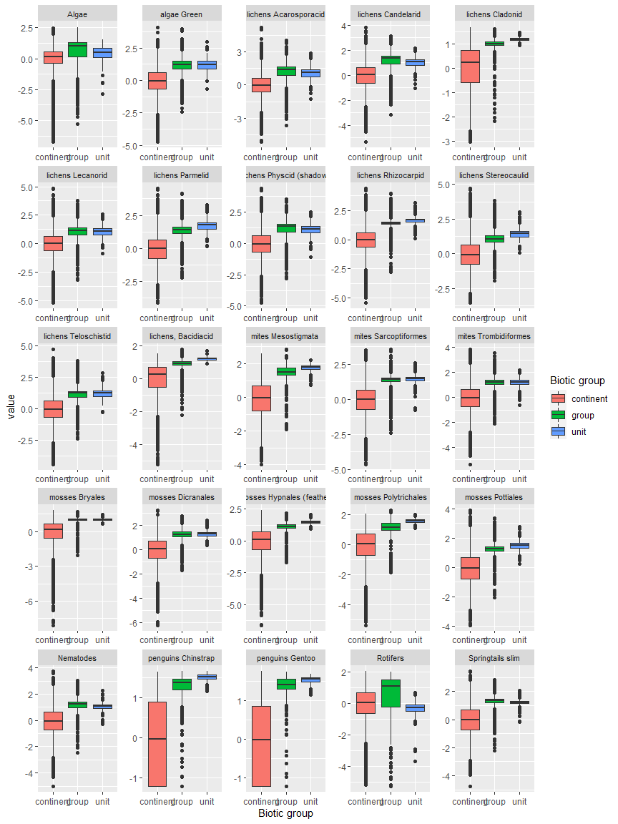

Ecosystem Description

## Ecosystem Env6_sdm3 Islands3

Env6_sdm3 Islands3. Occurs mainly on the northernmost parts of the peninsula and on the coast of Victoria land. Most common biota is Adelie penguins, but also Emperor penguins and south polar skua. Several Arthropod, moss, and lichen species are also present in numbers. It is the most popular ecosystem for several Rotifer species, two Arthropods, and the skua. Suitability is high for everything, especially Arthropod functional groups (Trombidiformes and Springtails) and Nematodes.

### Photos (if available)

### Distribution

Maps - Full map

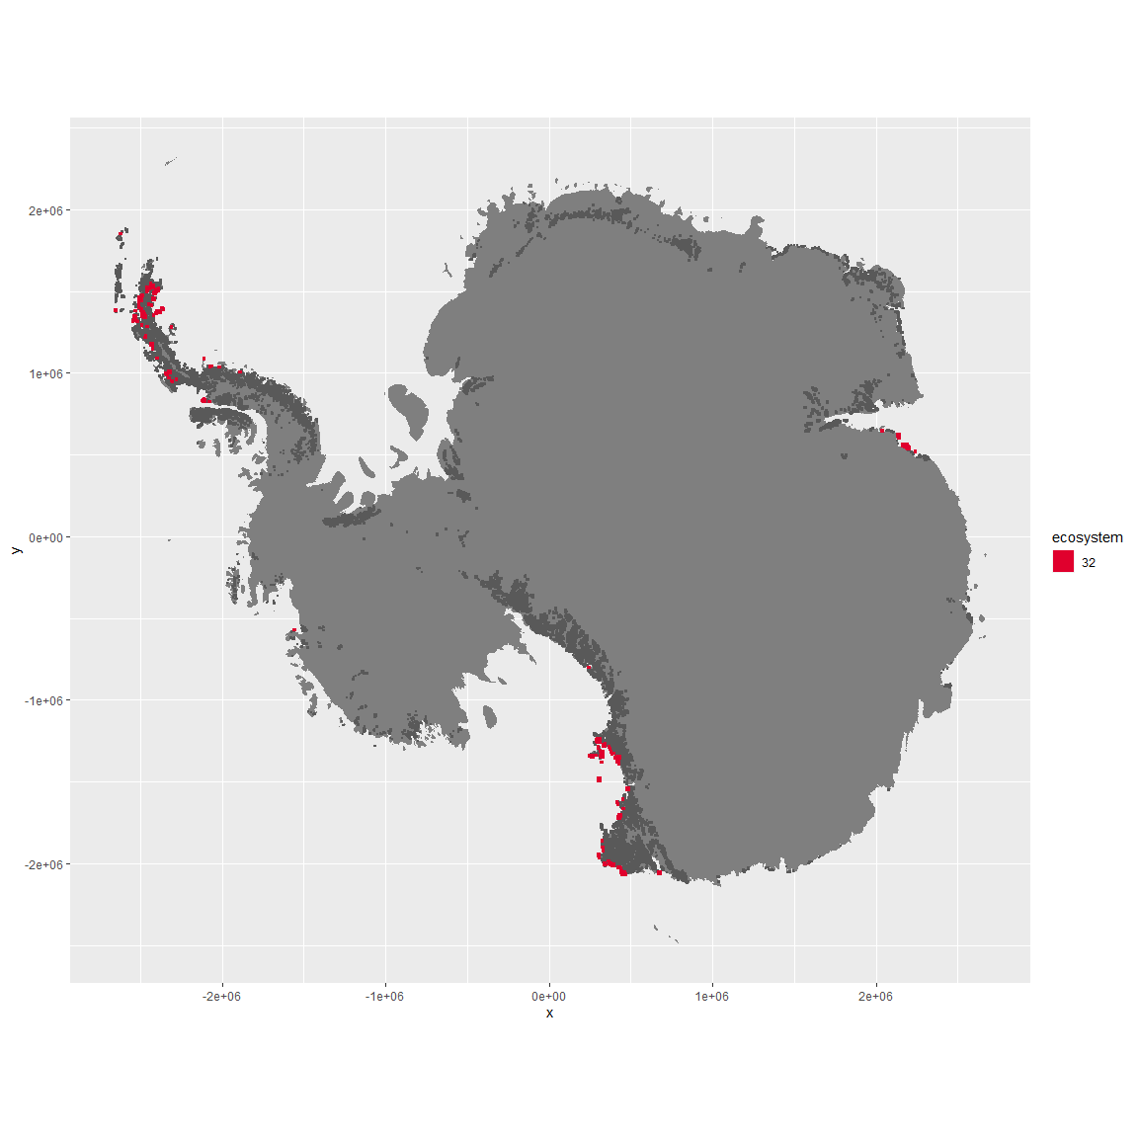

Regional maps

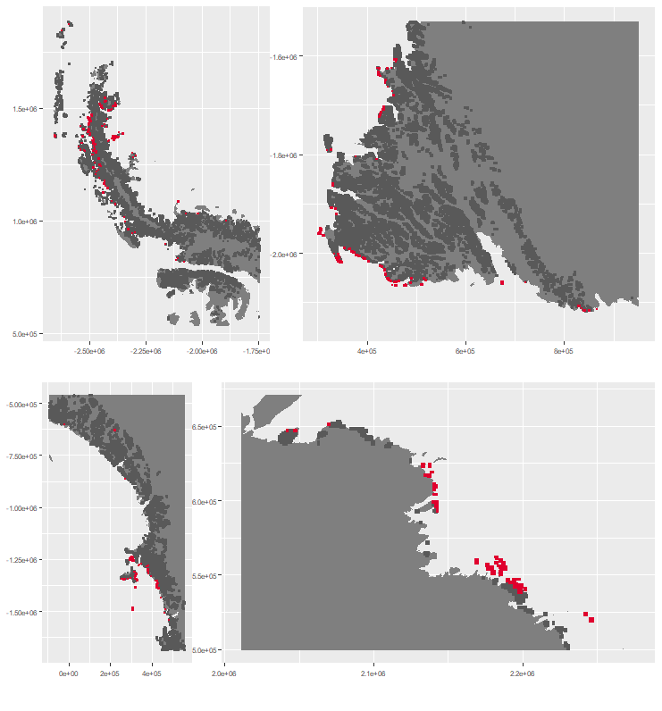

### Environment

The unit env6_sdm3 is part of the environmental supergroup env6.

The elevation of unit env6_sdm3 ranges from 0 to 2374 metres above sea level, but 90% of its pixels fall above 0 and below 314 metres. Its average elevation is 63 metres.

#### Distinctiveness of the unit from its group and the rest of Antarctica

NA

### Biota

Most widespread species in the unit (found in most pixels)

The top most widespread species in ecosystem env6_sdm3

| scientific | Functional_group | phylum | Polar specialist? | count | relative_pct |
| --- | --- | --- | --- | --- | --- |
| Pygoscelis adeliae | Chordata_Aves_Sphenisciformes_Spheniscidae_Pygoscelis_adeliae | Chordata | FALSE | 23 | 1.9409 |
| Gomphiocephalus hodgsoni | Arthropoda_Entognatha_Poduromorpha___ | Arthropoda | TRUE | 19 | 1.6034 |
| Bryum pseudotriquetrum | Bryophyta_Bryopsida_Bryales___ | Bryophyta | FALSE | 17 | 1.4346 |
| Stereotydeus mollis | Arthropoda_Arachnida_Trombidiformes___ | Arthropoda | TRUE | 16 | 1.3502 |
| Buellia frigida | Ascomycota_Lecanoromycetes_Teloschistales_Physciaceae__ | Ascomycota | TRUE | 15 | 1.2658 |
| Bryum argenteum | Bryophyta_Bryopsida_Bryales___ | Bryophyta | FALSE | 13 | 1.0970 |
| Xanthoria elegans | Ascomycota_Lecanoromycetes_Teloschistales_Teloschistaceae__ | Ascomycota | FALSE | 13 | 1.0970 |
| Lecanora expectans | Ascomycota_Lecanoromycetes_Lecanorales_Lecanoraceae__ | Ascomycota | TRUE | 12 | 1.0127 |
| Stercorarius maccormicki | Chordata_Aves_Charadriiformes___ | Chordata | FALSE | 11 | 0.9283 |
| Caloplaca citrina | Ascomycota_Lecanoromycetes_Teloschistales_Teloschistaceae__ | Ascomycota | TRUE | 10 | 0.8439 |
| Candelariella flava | Ascomycota_Lecanoromycetes_Candelariales_Candelariaceae__ | Ascomycota | TRUE | 10 | 0.8439 |
| Nanorchestes antarcticus | Arthropoda_Arachnida_Sarcoptiformes___ | Arthropoda | TRUE | 10 | 0.8439 |
| Sarconeurum glaciale | Bryophyta_Bryopsida_Pottiales___ | Bryophyta | TRUE | 10 | 0.8439 |
| Xanthoria mawsonii | Ascomycota_Lecanoromycetes_Teloschistales_Teloschistaceae__ | Ascomycota | TRUE | 10 | 0.8439 |

This supergroup is, on average, substantially higher in suitability for mites_Mesostigmata, lichens_Rhizocarpid, penguins_Gentoo, lichens_Parmelid, mites_Sarcoptiformes, penguins_Chinstrap, Springtails_slim, mosses_Pottiales, mosses_Polytrichales, mosses_Dicranales, mites_Trombidiformes, mosses_Hypnales_(feather), algae_Green, Nematodes, lichens_Physcid_(shadow), lichens_Acarosporacid, lichens_Teloschistid, lichens_Stereocaulid, lichens_Candelarid, lichens_Lecanorid, lichens_Cladonid, mosses_Bryales, lichens,_Bacidiacid, Algae and Rotifers functional groups than continental Antarctica. It is substantially lower in suitability for no variables than the rest of the continent.

Unit env6_sdm3 is higher in suitability for Rotifers, Nematodes, mites_Trombidiformes, Algae, lichens_Lecanorid, Springtails_slim, lichens_Physcid_(shadow) and lichens_Stereocaulid and lower in suitability for no variables than the rest of its environmental supergroup.

Distinctiveness of the unit from the environmental group and the rest of Antarctica

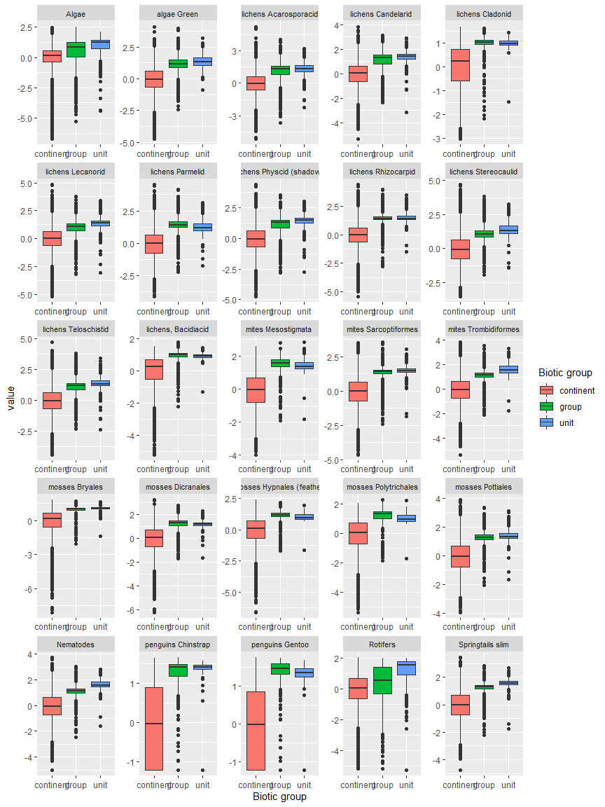

Ecosystem Description

## Ecosystem Env6_sdm4 Coastal/Island tundra

Env6_sdm4 Coastal/Island tundra. Occurs primarily on the western coast of the north peninsula, and sampling is dominated by penguins (Adelie, gentoo, and chinstrap). Imperial shag and southern giant petrel also present in good numbers. Hair grass and several Arthopod species are also abundant. This is the most popular ecosystem for the imperial shag and many arthropod species. Suitability is low for Ochrophytes and Rotifers but high for basically everything else, especially Mesostigmatid mites and Gentoo penguins.

### Photos (if available)

### Distribution

Maps - Full map

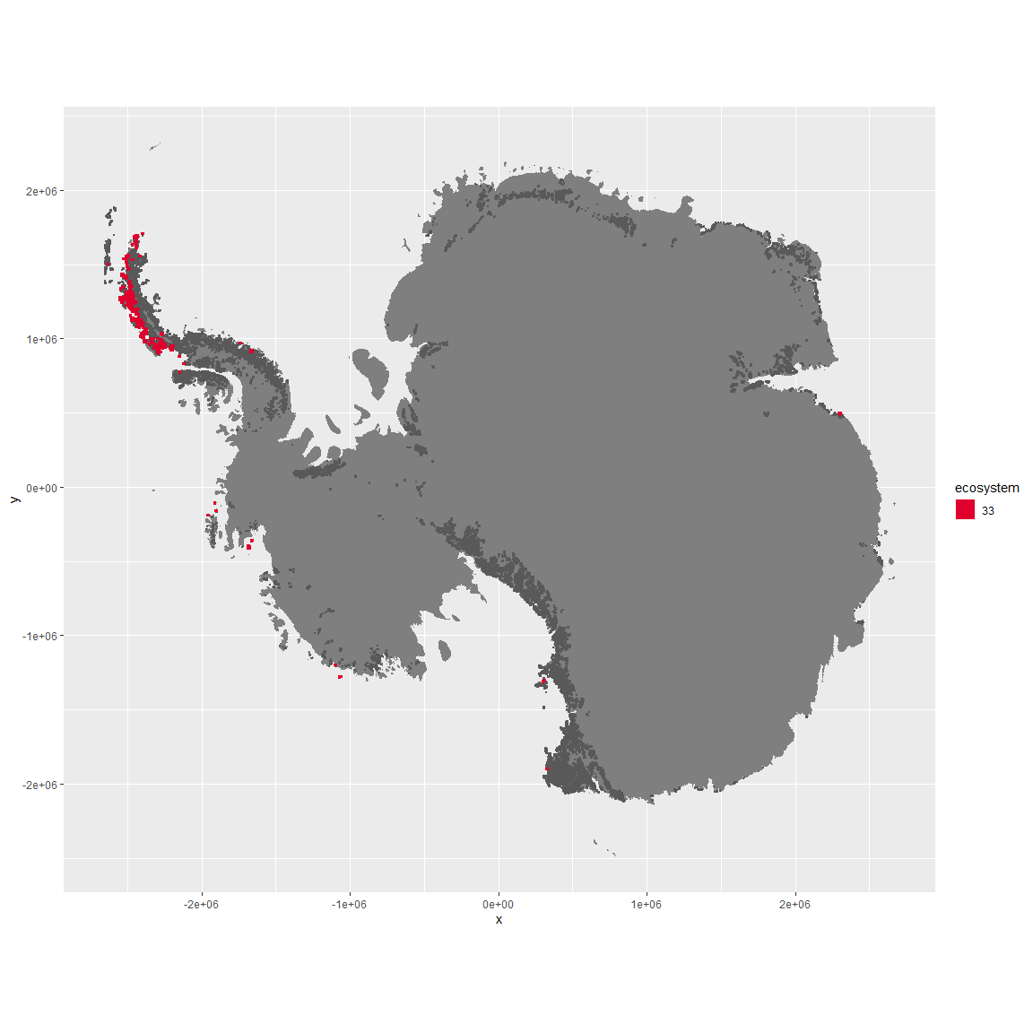

Regional maps

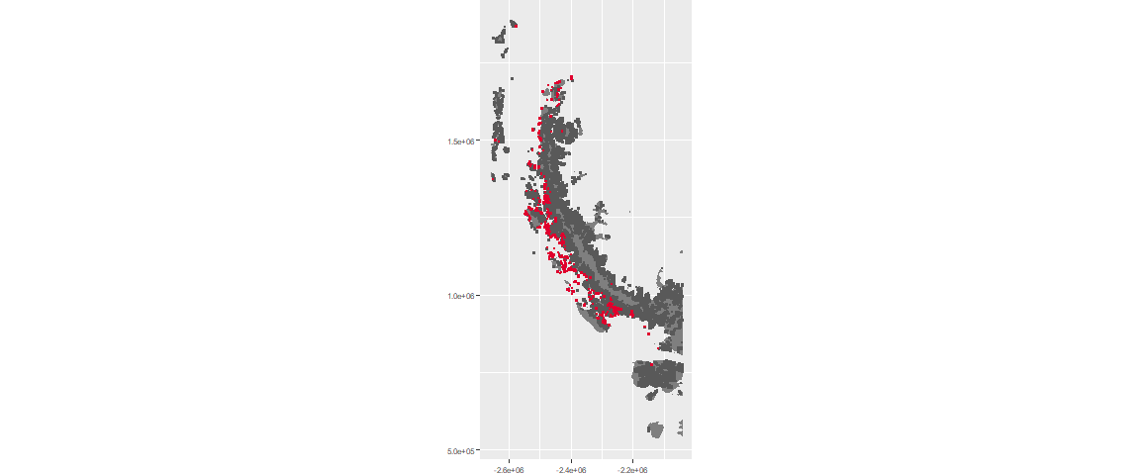

### Environment

The unit env6_sdm4 is part of the environmental supergroup env6.

The elevation of unit env6_sdm4 ranges from 0 to 742 metres above sea level, but 90% of its pixels fall above 0 and below 163 metres. Its average elevation is 21 metres.

#### Distinctiveness of the unit from its group and the rest of Antarctica

NA

### Biota

Most widespread species in the unit (found in most pixels)

The top most widespread species in ecosystem env6_sdm4

| scientific | Functional_group | phylum | Polar specialist? | count | relative_pct |
| --- | --- | --- | --- | --- | --- |
| Pygoscelis adeliae | Chordata_Aves_Sphenisciformes_Spheniscidae_Pygoscelis_adeliae | Chordata | FALSE | 38 | 3.7291 |
| Pygoscelis antarctica | Chordata_Aves_Sphenisciformes_Spheniscidae_Pygoscelis_antarctica | Chordata | TRUE | 27 | 2.6497 |
| Pygoscelis papua | Chordata_Aves_Sphenisciformes_Spheniscidae_Pygoscelis_papua | Chordata | FALSE | 26 | 2.5515 |
| Friesea grisea | Arthropoda_Entognatha_Poduromorpha___ | Arthropoda | FALSE | 25 | 2.4534 |
| Cryptopygus antarcticus | Arthropoda_Entognatha_Entomobryomorpha___ | Arthropoda | TRUE | 24 | 2.3553 |
| Halozetes belgicae | Arthropoda_Arachnida_Sarcoptiformes___ | Arthropoda | TRUE | 21 | 2.0608 |
| Alaskozetes antarcticus | Arthropoda_Arachnida_Sarcoptiformes___ | Arthropoda | TRUE | 19 | 1.8646 |
| Leucocarbo atriceps | Chordata_Aves_Suliformes___ | Chordata | FALSE | 16 | 1.5702 |
| Rhagidia gerlachei | Arthropoda_Arachnida_Trombidiformes___ | Arthropoda | TRUE | 16 | 1.5702 |
| Usnea antarctica | Ascomycota_Lecanoromycetes_Lecanorales_Parmeliaceae__ | Ascomycota | FALSE | 16 | 1.5702 |

This supergroup is, on average, substantially higher in suitability for mites_Mesostigmata, lichens_Rhizocarpid, penguins_Gentoo, lichens_Parmelid, mites_Sarcoptiformes, penguins_Chinstrap, Springtails_slim, mosses_Pottiales, mosses_Polytrichales, mosses_Dicranales, mites_Trombidiformes, mosses_Hypnales_(feather), algae_Green, Nematodes, lichens_Physcid_(shadow), lichens_Acarosporacid, lichens_Teloschistid, lichens_Stereocaulid, lichens_Candelarid, lichens_Lecanorid, lichens_Cladonid, mosses_Bryales, lichens,_Bacidiacid, Algae and Rotifers functional groups than continental Antarctica. It is substantially lower in suitability for no variables than the rest of the continent.

Unit env6_sdm4 is higher in suitability for no variables and lower in suitability for mosses_Dicranales, mosses_Pottiales, lichens_Stereocaulid, Nematodes, lichens_Candelarid, lichens_Physcid_(shadow), algae_Green, lichens_Lecanorid, lichens_Teloschistid, lichens_Acarosporacid, Rotifers and Algae than the rest of its environmental supergroup.

Distinctiveness of the unit from the environmental group and the rest of Antarctica

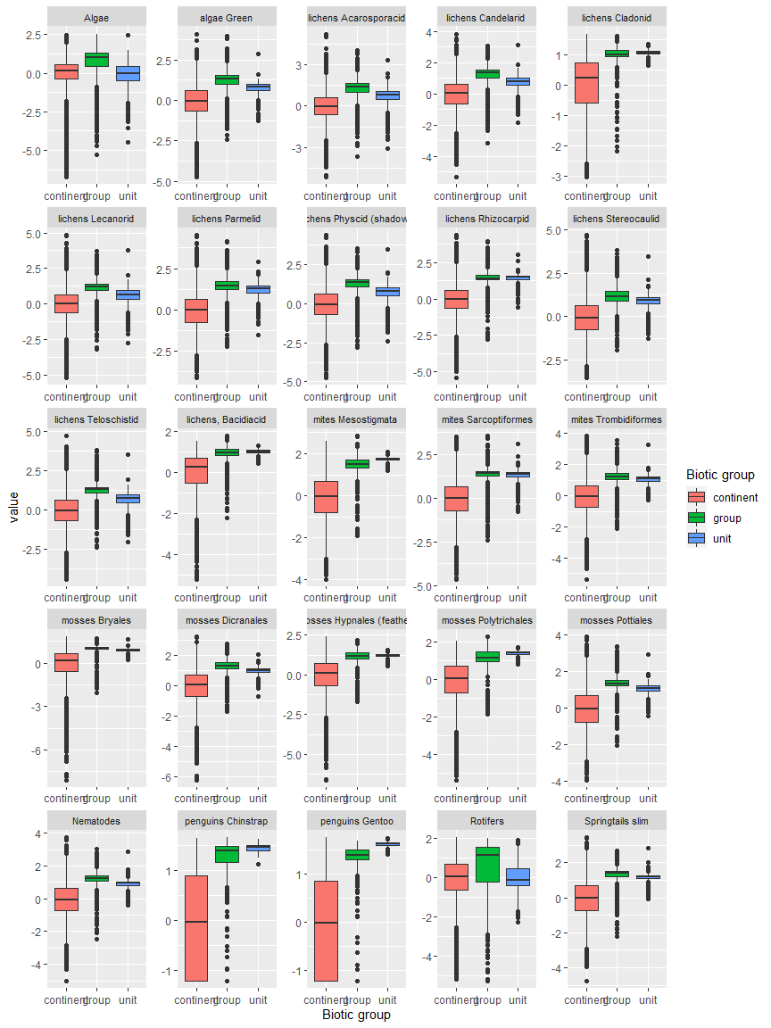

Ecosystem Description

## Ecosystem Env6_sdm5 Islands

Env6_sdm5 Islands. Occurs mainly on the coast of Enderby land, with a scattering of pixels on the north peninsula. Sampled biota mainly mosses and some common lichens, good representation of Adelies, southern giant petrels, snow petrels, wilsons storm petrels, and antarctic petrels, being the most preferred habitat for the latter three. Several Buellia (lichen) species also prefer this habitat, along with a chlorophyte and two tardigrade species. Suitability is relatively highest for Chlorophyta and Dicranales mosses, and also good for Rotifers.

### Photos (if available)

### Distribution

Maps - Full map

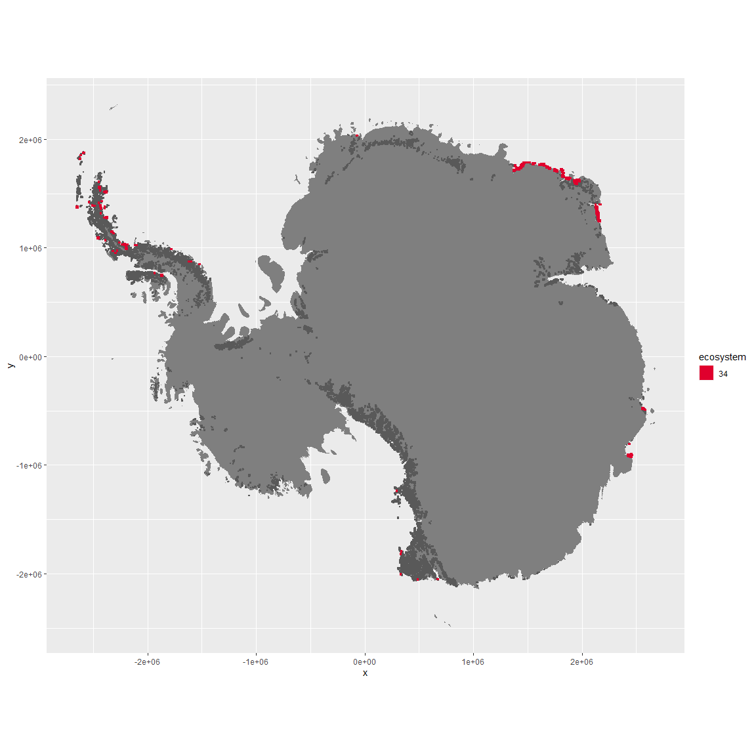

Regional maps

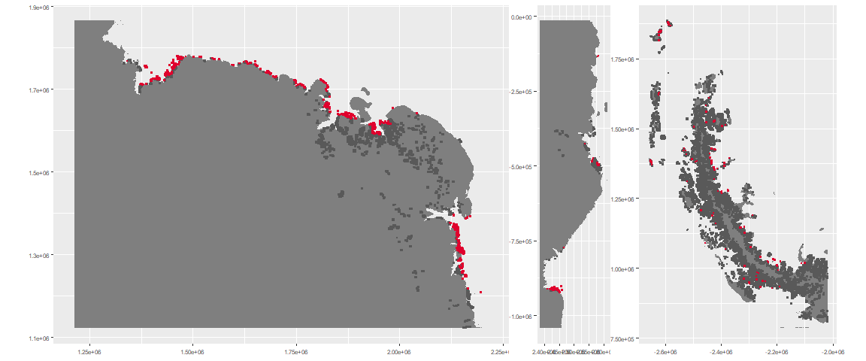

### Environment

The unit env6_sdm5 is part of the environmental supergroup env6.

The elevation of unit env6_sdm5 ranges from 0 to 2301 metres above sea level, but 90% of its pixels fall above 0 and below 327 metres. Its average elevation is 67 metres.

#### Distinctiveness of the unit from its group and the rest of Antarctica

NA

### Biota

Most widespread species in the unit (found in most pixels)

The top most widespread species in ecosystem env6_sdm5

| scientific | Functional_group | phylum | Polar specialist? | count | relative_pct |
| --- | --- | --- | --- | --- | --- |
| Ceratodon purpureus | Bryophyta_Bryopsida_Dicranales___ | Bryophyta | FALSE | 44 | 3.9604 |
| Bryum pseudotriquetrum | Bryophyta_Bryopsida_Bryales___ | Bryophyta | FALSE | 40 | 3.6004 |
| Pygoscelis adeliae | Chordata_Aves_Sphenisciformes_Spheniscidae_Pygoscelis_adeliae | Chordata | FALSE | 27 | 2.4302 |
| Umbilicaria decussata | Ascomycota_Lecanoromycetes_Umbilicariales_Umbilicariaceae__ | Ascomycota | FALSE | 19 | 1.7102 |
| Buellia frigida | Ascomycota_Lecanoromycetes_Teloschistales_Physciaceae__ | Ascomycota | TRUE | 17 | 1.5302 |
| Candelariella flava | Ascomycota_Lecanoromycetes_Candelariales_Candelariaceae__ | Ascomycota | TRUE | 17 | 1.5302 |
| Rhizoplaca melanophthalma | Ascomycota_Lecanoromycetes_Lecanorales_Lecanoraceae__ | Ascomycota | FALSE | 16 | 1.4401 |
| Rinodina olivaceobrunnea | Ascomycota_Lecanoromycetes_Teloschistales_Physciaceae__ | Ascomycota | FALSE | 15 | 1.3501 |
| Usnea antarctica | Ascomycota_Lecanoromycetes_Lecanorales_Parmeliaceae__ | Ascomycota | FALSE | 15 | 1.3501 |
| Caloplaca athallina | Ascomycota_Lecanoromycetes_Teloschistales_Teloschistaceae__ | Ascomycota | TRUE | 13 | 1.1701 |
| Pseudephebe minuscula | Ascomycota_Lecanoromycetes_Lecanorales_Parmeliaceae__ | Ascomycota | FALSE | 13 | 1.1701 |
| Xanthoria elegans | Ascomycota_Lecanoromycetes_Teloschistales_Teloschistaceae__ | Ascomycota | FALSE | 13 | 1.1701 |

This supergroup is, on average, substantially higher in suitability for mites_Mesostigmata, lichens_Rhizocarpid, penguins_Gentoo, lichens_Parmelid, mites_Sarcoptiformes, penguins_Chinstrap, Springtails_slim, mosses_Pottiales, mosses_Polytrichales, mosses_Dicranales, mites_Trombidiformes, mosses_Hypnales_(feather), algae_Green, Nematodes, lichens_Physcid_(shadow), lichens_Acarosporacid, lichens_Teloschistid, lichens_Stereocaulid, lichens_Candelarid, lichens_Lecanorid, lichens_Cladonid, mosses_Bryales, lichens,_Bacidiacid, Algae and Rotifers functional groups than continental Antarctica. It is substantially lower in suitability for no variables than the rest of the continent.

Unit env6_sdm5 is higher in suitability for Rotifers, Algae and mosses_Dicranales and lower in suitability for no variables than the rest of its environmental supergroup.

Distinctiveness of the unit from the environmental group and the rest of Antarctica

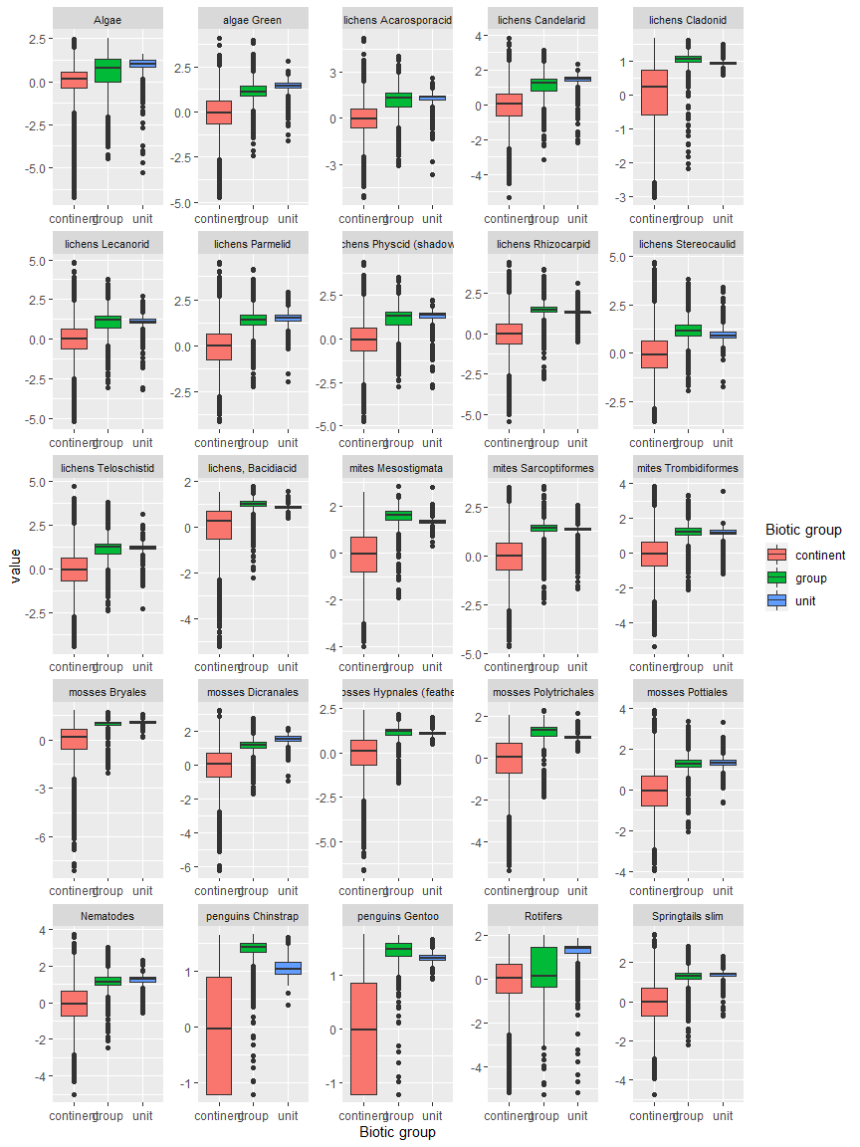

Ecosystem Description

## Ecosystem Env6_sdm6 Islands

Env6_sdm6 Islands. Occurs mainly on the west coast of the north peninsula. Adelie, SP skua, Cape petrel, southern fulmar, chinstrap and gentoo pengins dominate along with a variety of moss species. Suitability low for ochrophytes and rotifers but high for everything else.

### Photos (if available)

### Distribution

Maps - Full map

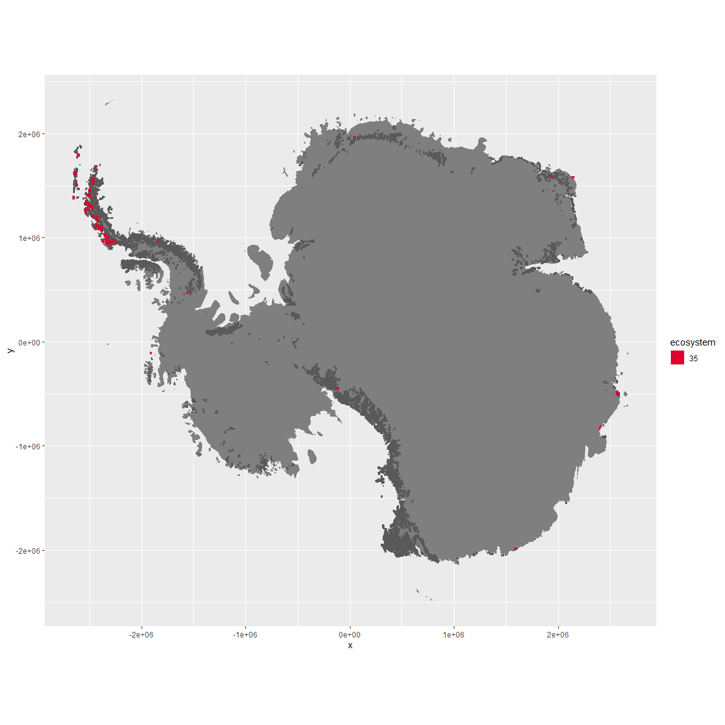

Regional maps

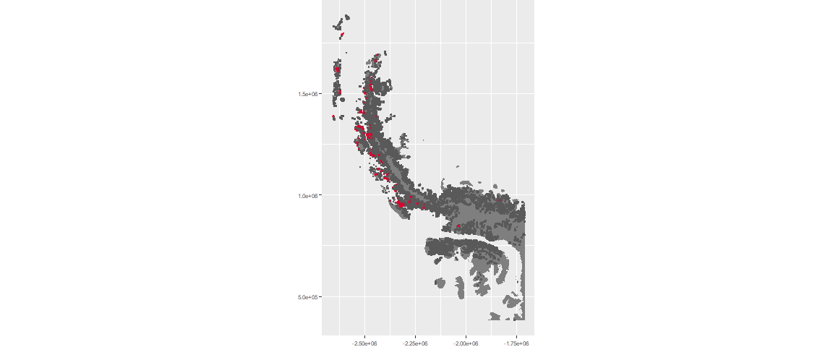

### Environment

The unit env6_sdm6 is part of the environmental supergroup env6.

The elevation of unit env6_sdm6 ranges from 0 to 2930 metres above sea level, but 90% of its pixels fall above 0 and below 669 metres. Its average elevation is 171 metres.

#### Distinctiveness of the unit from its group and the rest of Antarctica

NA

### Biota

Most widespread species in the unit (found in most pixels)

The top most widespread species in ecosystem env6_sdm6

| scientific | Functional_group | phylum | Polar specialist? | count | relative_pct |
| --- | --- | --- | --- | --- | --- |
| Pygoscelis adeliae | Chordata_Aves_Sphenisciformes_Spheniscidae_Pygoscelis_adeliae | Chordata | FALSE | 10 | 3.4247 |
| Pygoscelis antarctica | Chordata_Aves_Sphenisciformes_Spheniscidae_Pygoscelis_antarctica | Chordata | TRUE | 7 | 2.3973 |
| Sanionia uncinata | Bryophyta_Bryopsida_Hypnales___ | Bryophyta | FALSE | 7 | 2.3973 |
| Syntrichia princeps | Bryophyta_Bryopsida_Pottiales___ | Bryophyta | FALSE | 7 | 2.3973 |
| Cryptopygus antarcticus | Arthropoda_Entognatha_Entomobryomorpha___ | Arthropoda | TRUE | 6 | 2.0548 |
| Pohlia nutans | Bryophyta_Bryopsida_Bryales___ | Bryophyta | FALSE | 6 | 2.0548 |
| Polytrichastrum alpinum | Bryophyta_Bryopsida_Polytrichales___ | Bryophyta | FALSE | 6 | 2.0548 |
| Pygoscelis papua | Chordata_Aves_Sphenisciformes_Spheniscidae_Pygoscelis_papua | Chordata | FALSE | 5 | 1.7123 |
| Usnea antarctica | Ascomycota_Lecanoromycetes_Lecanorales_Parmeliaceae__ | Ascomycota | FALSE | 5 | 1.7123 |
| Friesea grisea | Arthropoda_Entognatha_Poduromorpha___ | Arthropoda | FALSE | 4 | 1.3699 |
| Leucocarbo atriceps | Chordata_Aves_Suliformes___ | Chordata | FALSE | 4 | 1.3699 |
| Oppia loxolineata | Arthropoda_Arachnida_Sarcoptiformes___ | Arthropoda | TRUE | 4 | 1.3699 |
| Rhagidia gerlachei | Arthropoda_Arachnida_Trombidiformes___ | Arthropoda | TRUE | 4 | 1.3699 |

This supergroup is, on average, substantially higher in suitability for mites_Mesostigmata, lichens_Rhizocarpid, penguins_Gentoo, lichens_Parmelid, mites_Sarcoptiformes, penguins_Chinstrap, Springtails_slim, mosses_Pottiales, mosses_Polytrichales, mosses_Dicranales, mites_Trombidiformes, mosses_Hypnales_(feather), algae_Green, Nematodes, lichens_Physcid_(shadow), lichens_Acarosporacid, lichens_Teloschistid, lichens_Stereocaulid, lichens_Candelarid, lichens_Lecanorid, lichens_Cladonid, mosses_Bryales, lichens,_Bacidiacid, Algae and Rotifers functional groups than continental Antarctica. It is substantially lower in suitability for no variables than the rest of the continent.

Unit env6_sdm6 is higher in suitability for no variables and lower in suitability for lichens_Acarosporacid, lichens_Teloschistid, lichens_Physcid_(shadow), lichens_Candelarid, lichens_Lecanorid, Rotifers and Algae than the rest of its environmental supergroup.

Distinctiveness of the unit from the environmental group and the rest of Antarctica

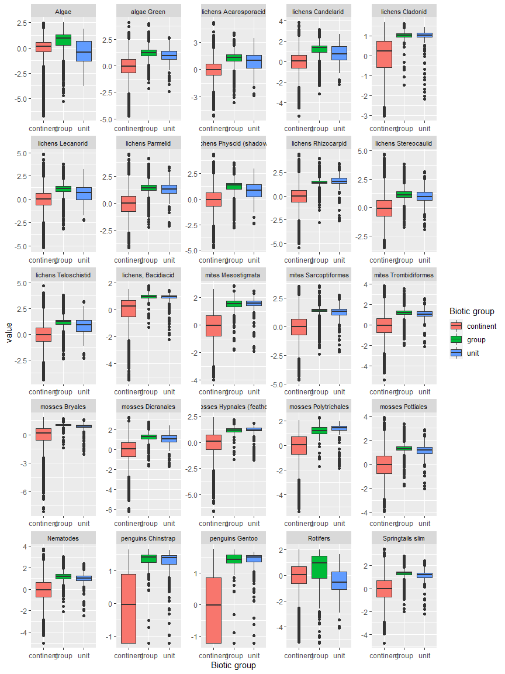

Ecosystem Description

## Ecosystem Env6_sdm7 Outlying coastal islands

Env6_sdm7 Outlying coastal islands. Occurs mainly on the north peninsula and in Adelie land; may be slightly more isolated from mainland than other units in the group. Pengins are most commonly sampled but several other bird species make an appearance. It is not the favourite of any species. Several mosses and a common lichen group dominate the sampled flora. Low suitability for rotifers but high for everything else, particularly ochrophytes, chlorophytes, and Chinstrap penguins.

### Photos (if available)

### Distribution

Maps - Full map

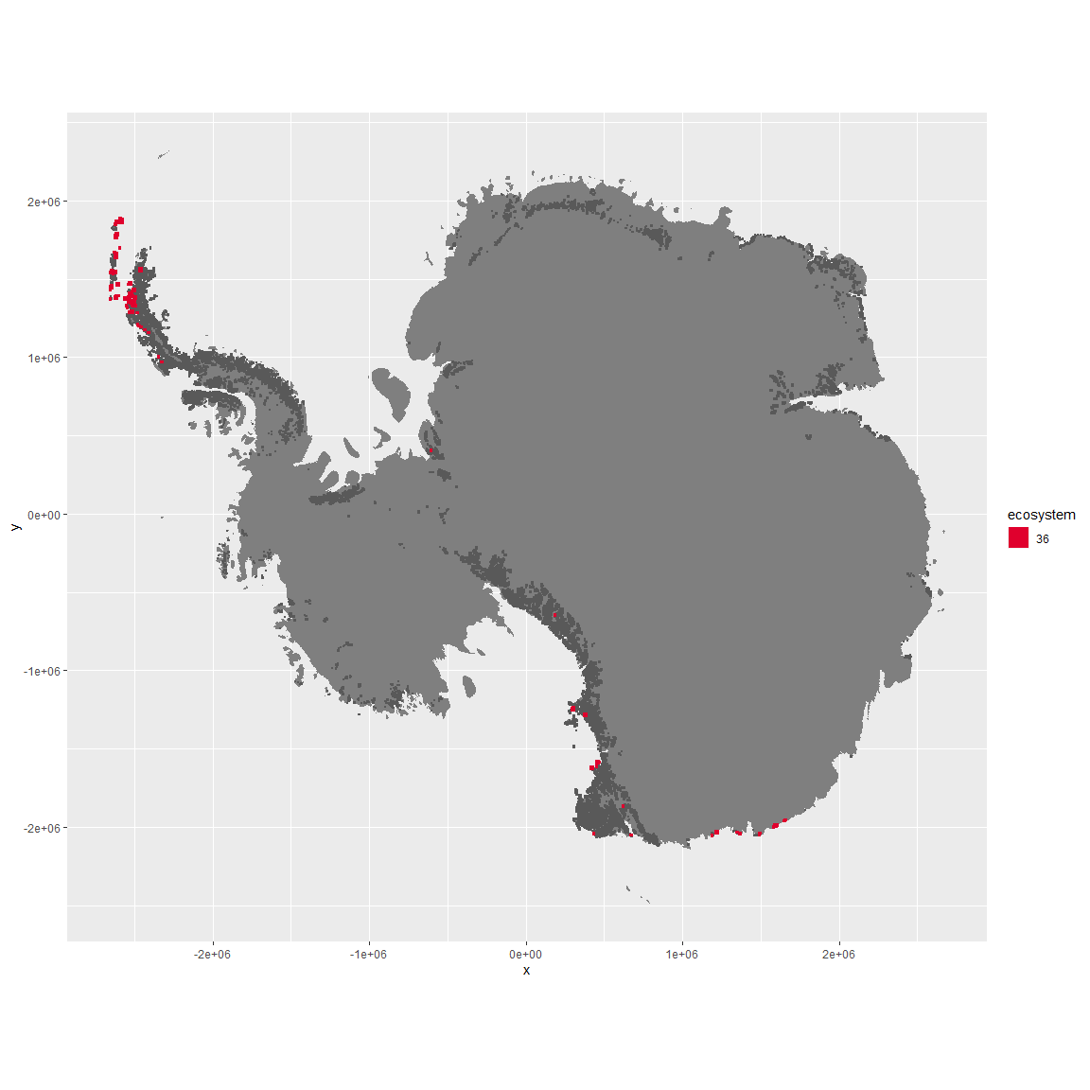

Regional maps

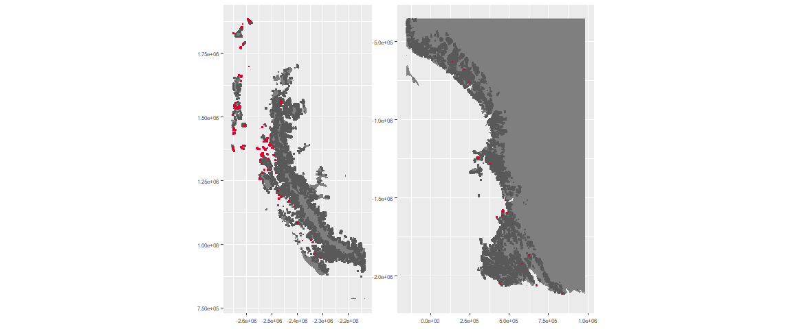

### Environment

The unit env6_sdm7 is part of the environmental supergroup env6.

The elevation of unit env6_sdm7 ranges from 0 to 2869 metres above sea level, but 90% of its pixels fall above 0 and below 781 metres. Its average elevation is 121 metres.

#### Distinctiveness of the unit from its group and the rest of Antarctica

NA

### Biota

Most widespread species in the unit (found in most pixels)

The top most widespread species in ecosystem env6_sdm7

| scientific | Functional_group | phylum | restricted | count | relative_pct |
| --- | --- | --- | --- | --- | --- |
| Pygoscelis antarctica | Chordata_Aves_Sphenisciformes_Spheniscidae_Pygoscelis_antarctica | Chordata | TRUE | 51 | 12.8141 |
| Pygoscelis adeliae | Chordata_Aves_Sphenisciformes_Spheniscidae_Pygoscelis_adeliae | Chordata | FALSE | 14 | 3.5176 |
| Usnea antarctica | Ascomycota_Lecanoromycetes_Lecanorales_Parmeliaceae__ | Ascomycota | FALSE | 9 | 2.2613 |
| Pygoscelis papua | Chordata_Aves_Sphenisciformes_Spheniscidae_Pygoscelis_papua | Chordata | FALSE | 8 | 2.0101 |
| Macronectes giganteus | Chordata_Aves_Procellariiformes___ | Chordata | FALSE | 6 | 1.5075 |
| Polytrichastrum alpinum | Bryophyta_Bryopsida_Polytrichales___ | Bryophyta | FALSE | 6 | 1.5075 |
| Ceratodon purpureus | Bryophyta_Bryopsida_Dicranales___ | Bryophyta | FALSE | 5 | 1.2563 |
| Brachythecium austro-salebrosum | Bryophyta_Bryopsida_Hypnales___ | Bryophyta | TRUE | 4 | 1.0050 |
| Leucocarbo atriceps | Chordata_Aves_Suliformes___ | Chordata | FALSE | 4 | 1.0050 |
| Ochrolechia frigida | Ascomycota_Lecanoromycetes_Pertusariales_Ochrolechiaceae__ | Ascomycota | FALSE | 4 | 1.0050 |
| Polytrichum strictum | Bryophyta_Bryopsida_Polytrichales___ | Bryophyta | FALSE | 4 | 1.0050 |
| Sanionia uncinata | Bryophyta_Bryopsida_Hypnales___ | Bryophyta | FALSE | 4 | 1.0050 |

This supergroup is, on average, substantially higher in suitability for mites_Mesostigmata, lichens_Rhizocarpid, penguins_Gentoo, lichens_Parmelid, mites_Sarcoptiformes, penguins_Chinstrap, Springtails_slim, mosses_Pottiales, mosses_Polytrichales, mosses_Dicranales, mites_Trombidiformes, mosses_Hypnales_(feather), algae_Green, Nematodes, lichens_Physcid_(shadow), lichens_Acarosporacid, lichens_Teloschistid, lichens_Stereocaulid, lichens_Candelarid, lichens_Lecanorid, lichens_Cladonid, mosses_Bryales, lichens,_Bacidiacid, Algae and Rotifers functional groups than continental Antarctica. It is substantially lower in suitability for no variables than the rest of the continent.

Unit env6_sdm7 is higher in suitability for no variables and lower in suitability for Rotifers than the rest of its environmental supergroup.

Distinctiveness of the unit from the environmental group and the rest of Antarctica

